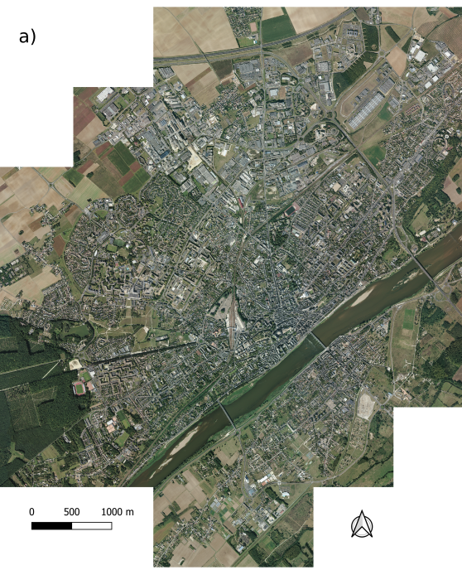
Appendix 1 Presentation of Blois and spatial distributions of the explicative variables used to describe the city on the 100m grid. a) aerial pictures of Blois city, IGN 2018; b) values of impervious soil index; c) area of secondary road; d) area of first road; e) distance to first road; f) area of railways; g) distance to railways: h) Julian day of observation, classified by week.
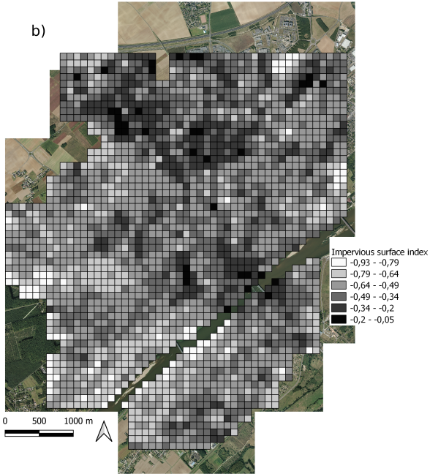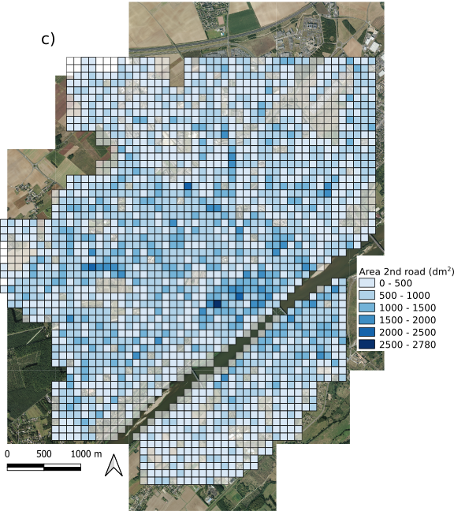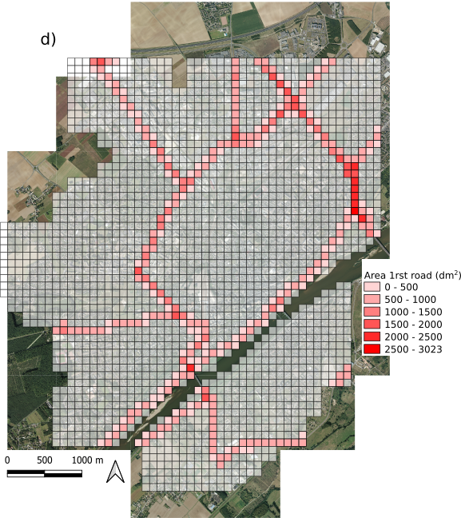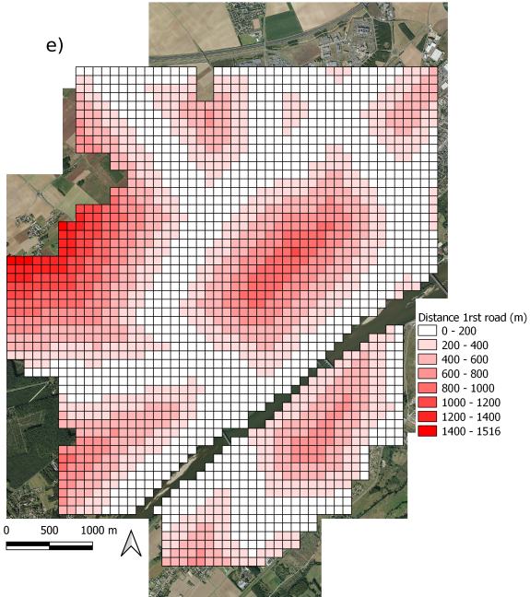
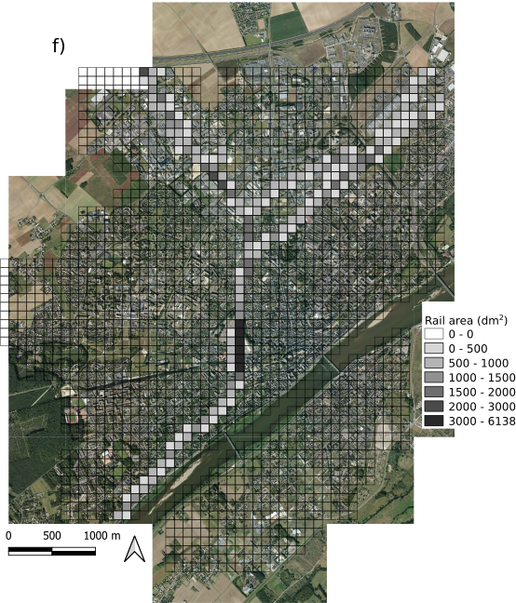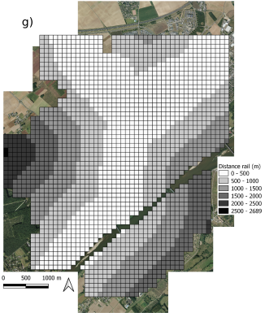
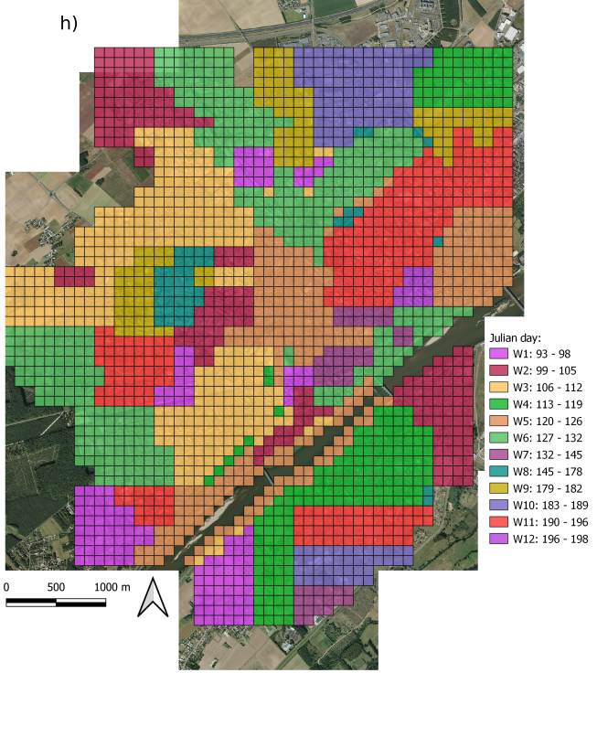

Appendix 2 Evolution of the construction of Blois. First image shows all the parcels built in 1959, with aerial photo of 1949, second image shows all the parcels built in 1989, with aerial photo of 1986 and third image shows all parcels built in 2019, with aerial photo of 2018. All aerial photos come from IGN database. Red lines correspond to the border of the 100m grid.
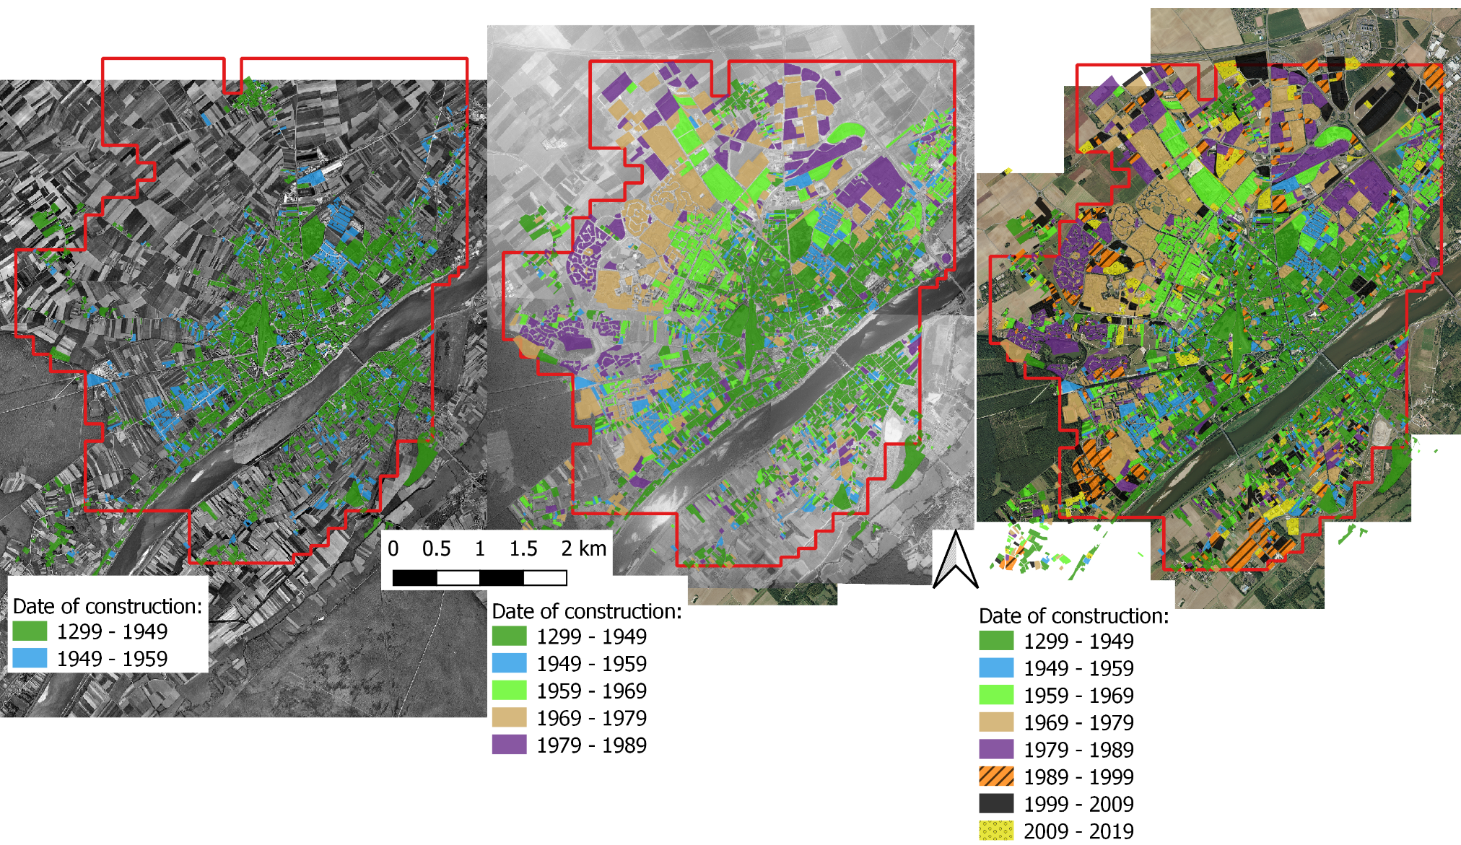
Appendix 3 Grid of 100m, 200m and 400m and neighborhood main cover and use (NMCU) classification used to describe Blois.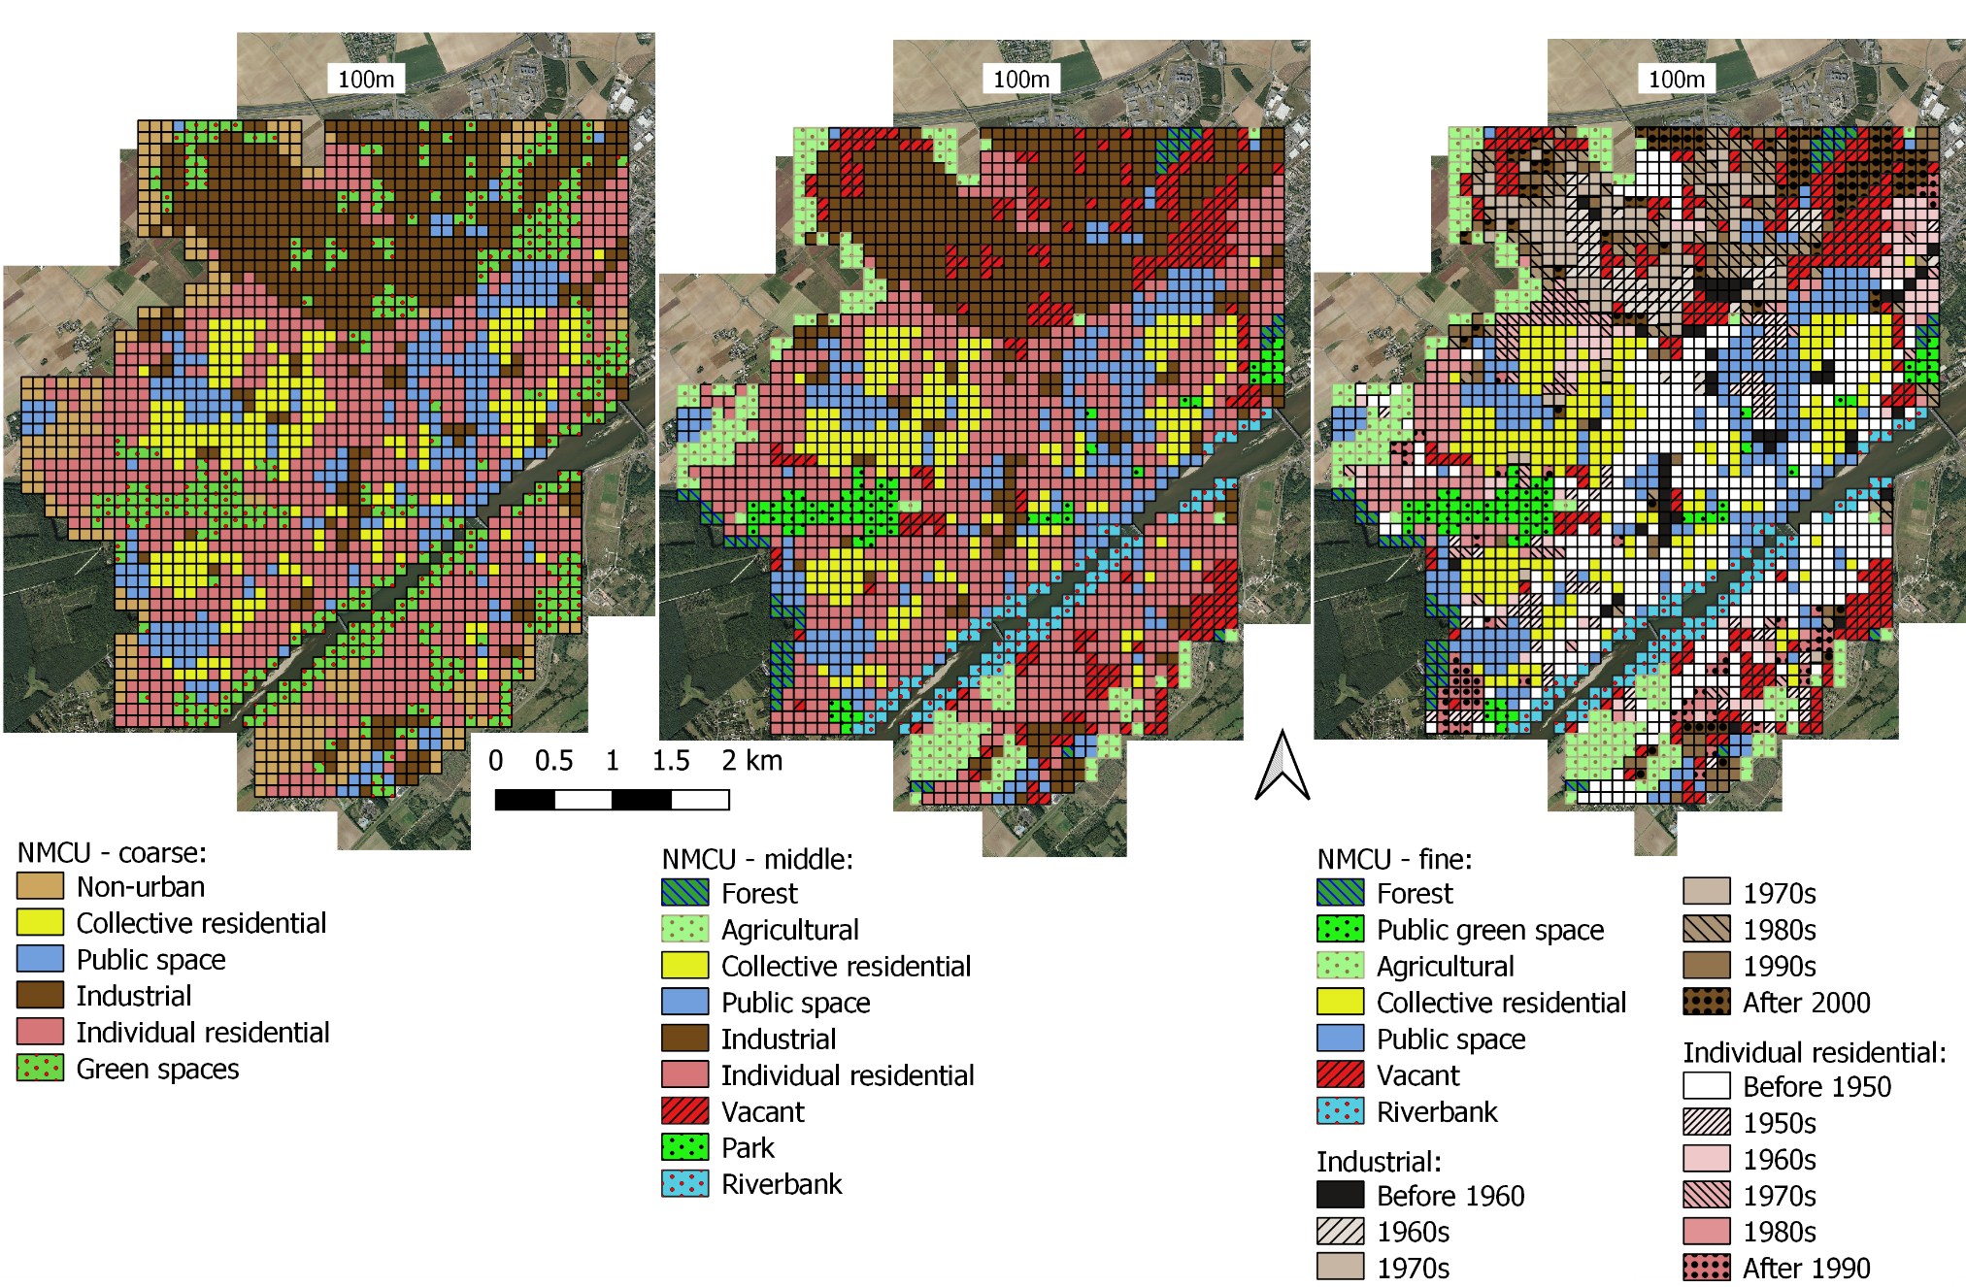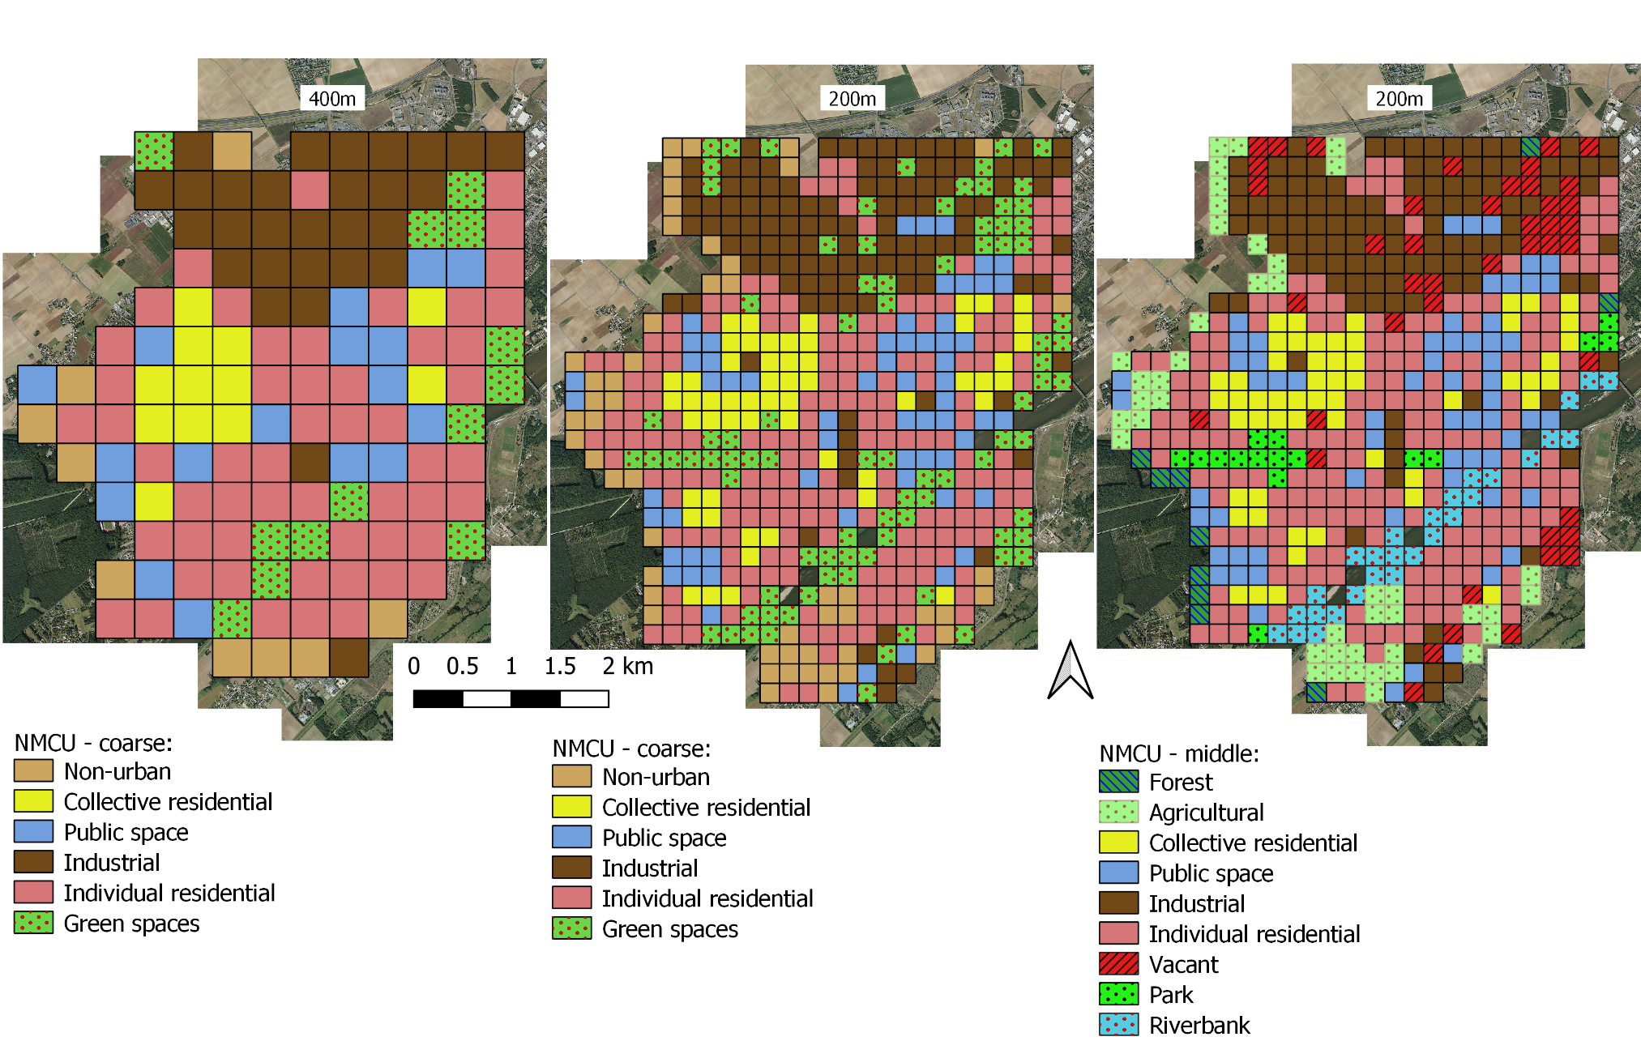

Appendix 4 Known dispersion vectors and features of preferred habitats for all of the species studied and literature cited.
Species | Dispersion | Habitat features
Acer negundo | Wind 5-30m (Erfmeier et al. 2011)  Water >1 200m (see in Säumel and Kowarik 2013)  Vehicles >150m motorways (see in Säumel et Kowarik 2013) | Riparian and floodable areas (Saccone et al. 2010; Erfmeier et al. 2011; Straigytė et al. 2015)
Ailanthus altissima | Wind 200-300m majority less than 100m (Säumel et Kowarik 2013 and references therein, Sladonja et al., 2015)  Water >1 200 m in urban areas (see in Säumel et Kowarik 2013)  Vehicles >150m motorways (see in Säumel et Kowarik 2013)  Vegetative: stolons > 27m from parent, stem and root fragments (Sladonja et al. 2015) | Temperate climate, resistant to heat rather than cold, especially juveniles. Shade intolerant (Sladonja et al. 2015)
Berberis aquifolium | Gravity, animals  Vegetative: stolons (Auge and Brandl 1997) | No data
Buddleja davidii | Wind >10m for 95 % of seed (Tallent-Halsell and Watt 2009)  Water, even salt (see in Tallent-Halsell et Watt 2009)  Vehicles and wind created by trains (see in Tallent-Halsell et Watt 2009)  Vegetative: leaf fragments (Sheppard et al., 2006; Tallent-Halsell et Watt 2009) | Temperate climate, resistant to cold stress not to hot stress (Tallent-Halsell et Watt 2009).
Cortaderia selloana | Wind (Saura-Mas and Lloret 2005) | Abandonned agriculutural areas, wetlands, roads embankment (Domenech et al. 2005). Sandy and disturbed habitats (Domènech and Vilà 2008; Tarabon et al. 2018)
Reynoutria japonica | In Europe, only vegetative: stem, leaf and roots fragments, rhizomes (Sheppard et al. 2006) | Shade intolerant (see in Duquette et al. 2016)
Robinia pseudoacacia | Wind 15-70m (see in Säumel et Kowarik 2013)  Water >1 200m (Säumel et Kowarik 2013)  Vehicles (Kowarik and Säumel 2008)  Vegetative : rhizomes (Cierjacks et al. 2013) | Temperate climate, sensible to drought and strong frost. Supports many soil types with a preference for aerated and drained soils (Cierjacks et al. 2013).

Auge H, Brandl R (1997) Seedling recruitment in the invasive clonal shrub, Mahonia aquifolium Pursh (Nutt.). Oecologia 110:205–211. https://doi.org/10.1007/s004420050151
Domènech R, Vilà M (2008) Cortaderia selloana seed germination under different ecological conditions. Acta Oecologica 33:93–96. https://doi.org/10.1016/j.actao.2007.09.004
Domenech R, Vila M, Pino J, Gesti J (2005) Historical land-use legacy and Cortaderia selloana invasion in the Mediterranean region. Glob Change Biol 11:1054–1064. https://doi.org/10.1111/j.1365-2486.2005.00965.x
Duquette M-C, Compérot A, Hayes LF, et al (2016) From the Source to the Outlet: understanding the Distribution of Invasive Knotweeds along a North American River: Invasive Knotweeds and North American Rivers. River Res Appl 32:958–966. https://doi.org/10.1002/rra.2914
Erfmeier A, Böhnke M, Bruelheide H (2011) Secondary invasion of Acer negundo: the role of phenotypic responses versus local adaptation. Biol Invasions 13:1599–1614. https://doi.org/10.1007/s10530-010-9917-2
Kowarik I, Säumel I (2008) Water dispersal as an additional pathway to invasions by the primarily wind-dispersed tree Ailanthus altissima. Plant Ecol 198:241–252. https://doi.org/10.1007/s11258-008-9398-x
Saccone P, Pagès JP, Girel J, et al (2010) Acer negundo invasion along a successional gradient: early direct facilitation by native pioneers and late indirect facilitation by conspecifics. New Phytol 187:831–842
Säumel I, Kowarik I (2013) Propagule morphology and river characteristics shape secondary water dispersal in tree species. Plant Ecol 214:1257–1272. https://doi.org/10.1007/s11258-013-0249-z
Saura-Mas S, Lloret F (2005) Wind effects on dispersal patterns of the invasive alien Cortaderia selloana in Mediterranean wetlands. Acta Oecologica 27:129–133. https://doi.org/10.1016/j.actao.2004.12.001
Sheppard A, Shaw R, Sforza R (2006) Top 20 environmental weeds for classical biological control in Europe: a review of opportunities, regulations and other barriers to adoption. Weed Res 46:93–117. https://doi.org/10.1111/j.1365-3180.2006.00497.x
Sladonja B, Sušek M, Guillermic J (2015) Review on Invasive Tree of Heaven (Ailanthus altissima (Mill.) Swingle) Conflicting Values: Assessment of Its Ecosystem Services and Potential Biological Threat. Environ Manage 56:1009–1034. https://doi.org/10.1007/s00267-015-0546-5
Straigytė L, Cekstere G, Laivins M, Marozas V (2015) The spread, intensity and invasivenessof the Acer negundo in Riga and Kaunas. Dendrobiology 74:157–168. https://doi.org/10.12657/denbio.074.016
Tallent-Halsell NG, Watt MS (2009) The Invasive Buddleja davidii (Butterfly Bush). Bot Rev 75:292–325. https://doi.org/10.1007/s12229-009-9033-0
Tarabon S, Bertrand R, Lavoie C, et al (2018) The effects of climate warming and urbanised areas on the future distribution of Cortaderia selloana, pampas grass, in France. Weed Res 58:413–423. https://doi.org/10.1111/wre.12330

Appendix 5 Description of each class of the middle classification. Pictures are fragments of IGN aerial photo of 2018, corresponding to a 100m cell.
Middle classification | Description | Pictures
Individual residential | Individual housing, house with or without garden | 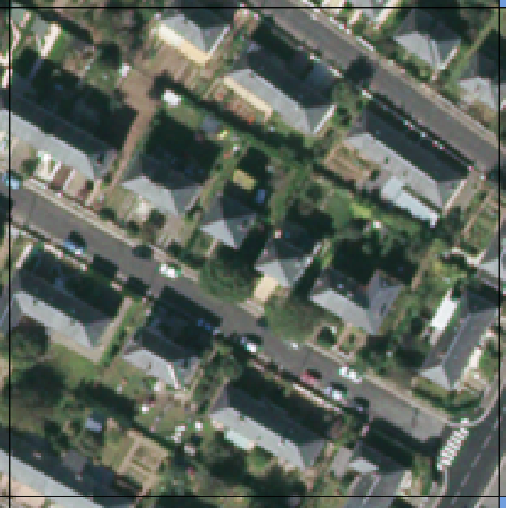  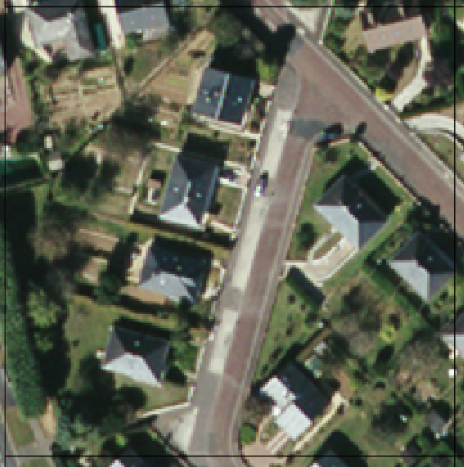
Collective residential | Collective housing, apartment buildings and associated green spaces. | 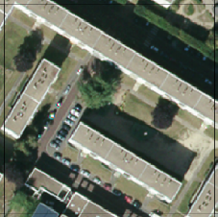  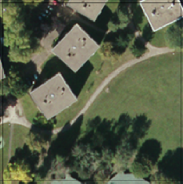
Industrial | Built-up areas for industrial (business, parking) and commercial purposes (supermarkets, shopping areas). Also included, train station and railroad. Presumed private management. | 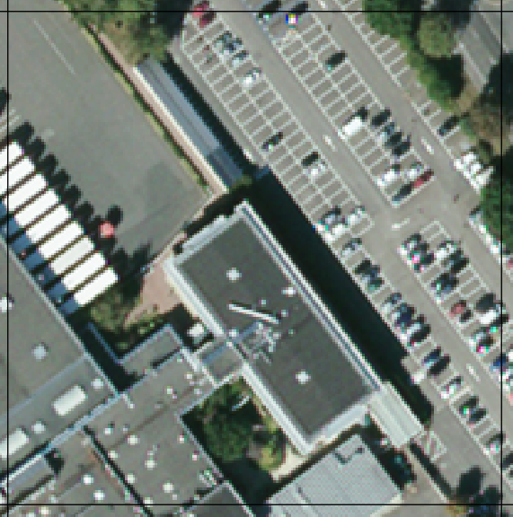  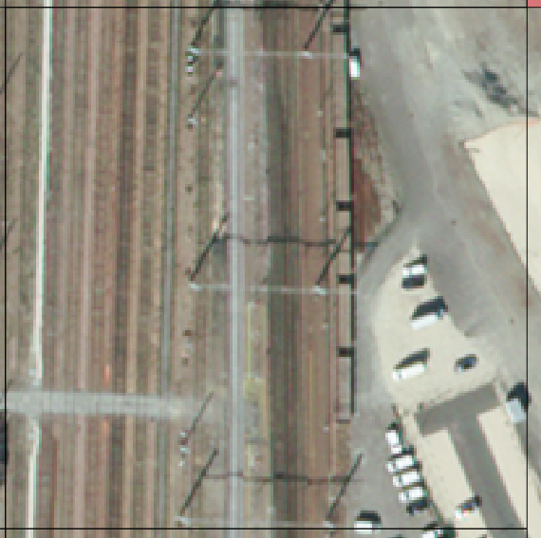
Public space | Built-up areas with public buildings (town hall, prefecture), schools, cemeteries. Undeveloped areas under municipal management: sports ground, rondabout. | 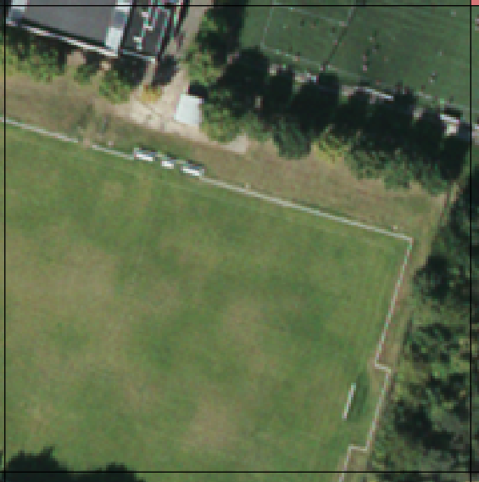  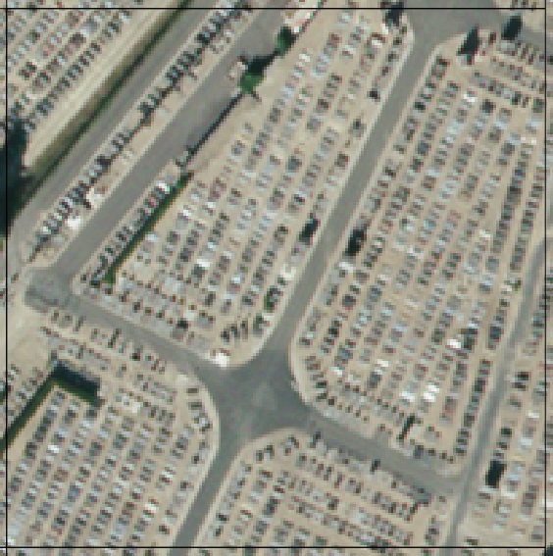  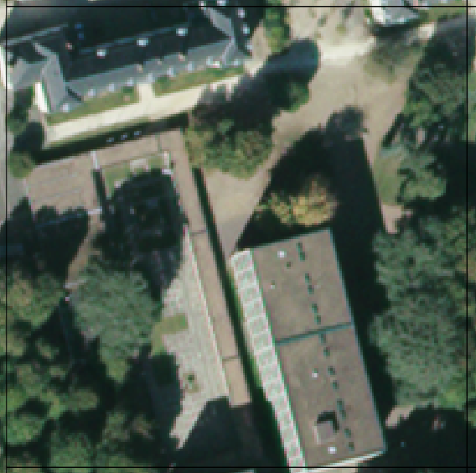  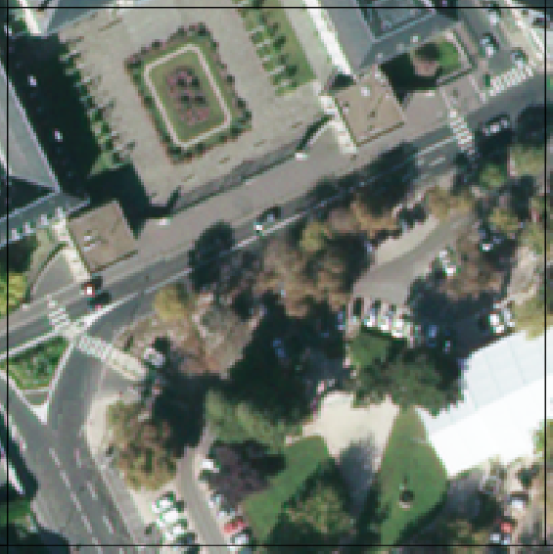
Agricultural | Cultivated areas, including allotments | 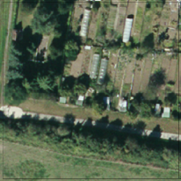  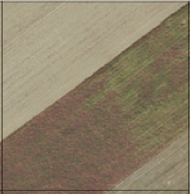
Forest | Urban forest and woods | 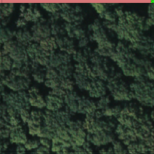
Park | Parks, unbuilt areas maintained for leisure activities. Management assumed by municipal departments. | 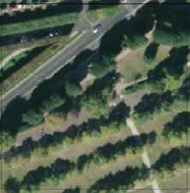  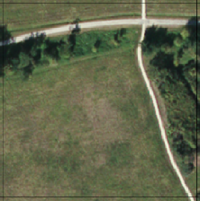
Riverbank | Unbuilt, permeable areas in contact with the Loire River. Management assumed by regional services. | 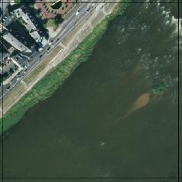
Vacant | Unbuilt areas, unknown use or no specific destination, maintenance assumed to be nil or very punctual. All undeveloped areas that do not correspond to any of the above categories. | 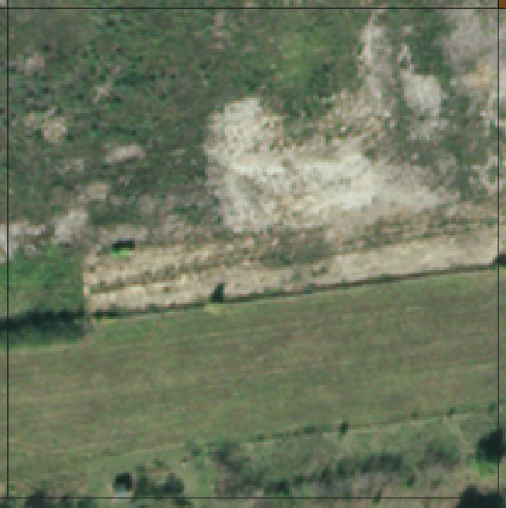

Appendix 6 Description of explicative variables for the three grids, and related correlations.
Description of the explicative variable on the 400m grid:
Variable | Stats / Values | Freqs (% of Valid) | Graph | Missing
Julian day  [numeric] | Mean (sd) : 134.4 (28.2)  min < med < max:  94 < 126.5 < 194.7  IQR (CV) : 43.9 (0.2) | 91 distinct values | 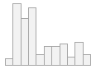 | 0  (0%)
Impervious  [numeric] | Mean (sd) : -0.5 (0.1)  min < med < max:  -0.8 < -0.5 < -0.3  IQR (CV) : 0.1 (-0.2) | 134 distinct values | 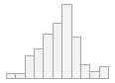 | 0  (0%)
1st road area  [numeric] | Mean (sd) : 1752.3 (2408.7)  min < med < max:  0 < 278.6 < 10077  IQR (CV) : 3086.6 (1.4) | 68 distinct values | 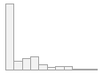 | 0  (0%)
2nd road area  [numeric] | Mean (sd) : 8403.4 (3895.2)  min < med < max:  12.5 < 8391.1 < 19137.2  IQR (CV) : 5715.4 (0.5) | 134 distinct values | 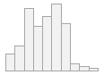 | 0  (0%)
Rail area  [numeric] | Mean (sd) : 1284.3 (3033.3)  min < med < max:  0 < 0 < 18492.4  IQR (CV) : 400.2 (2.4) | 36 distinct values | 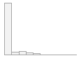 | 0  (0%)
Distance 1st road  [numeric] | Mean (sd) : 320.5 (257.8)  min < med < max:  1.4 < 230.3 < 1141.7  IQR (CV) : 343.5 (0.8) | 134 distinct values | 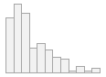 | 0  (0%)
Distance rail  [numeric] | Mean (sd) : 742.6 (589)  min < med < max:  4.9 < 619.8 < 2605.8  IQR (CV) : 867 (0.8) | 134 distinct values | 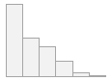 | 0  (0%)
coarse  [factor] | 1. collective residential  2. green spaces  3. individual residential  4. industrial  5. non-urban  6. public space | 12 ( 9.0%)  13 ( 9.7%)  54 (40.3%)  29 (21.6%)  9 ( 6.7%)  17 (12.7%) |  | 0  (0%)
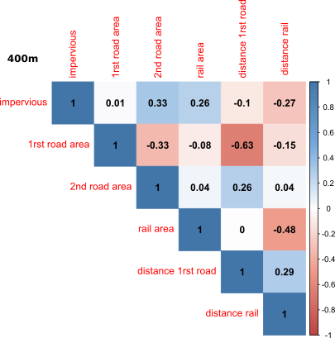

Description of explicative variables on the 200m grid:
Variable | Stats / Values | Freqs (%) | Graph | Missing
Julian day  [numeric] | Mean (sd) : 134.9 (33.3)  min < med < max:  93 < 123 < 198  IQR (CV) : 69 (0.2) | 75 distinct values | 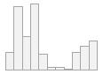 | 0  (0%)
Impervious  [numeric] | Mean (sd) : -0.5 (0.1)  min < med < max:  -0.9 < -0.5 < 0  IQR (CV) : 0.2 (-0.2) | 561 distinct values | 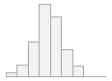 | 0  (0%)
1st road area  [numeric] | Mean (sd) : 489 (1029.7)  min < med < max:  0 < 0 < 6372.2  IQR (CV) : 363 (2.1) | 154 distinct values | 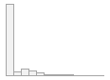 | 0  (0%)
2nd road area  [numeric] | Mean (sd) : 2194.2 (1318.1)  min < med < max:  0 < 2119.4 < 6393.6  IQR (CV) : 1949.7 (0.6) | 533 distinct values | 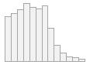 | 0  (0%)
Rail area  [numeric] | Mean (sd) : 331.5 (1144.3)  min < med < max:  0 < 0 < 12581.7  IQR (CV) : 0 (3.5) | 83 distinct values | 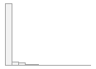 | 0  (0%)
Distance 1st road  [numeric] | Mean (sd) : 336.9 (280.8)  min < med < max:  0.8 < 266.1 < 1456.1  IQR (CV) : 370.8 (0.8) | 561 distinct values | 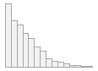 | 0  (0%)
Distance rail  [numeric] | Mean (sd) : 771 (597.9)  min < med < max:  0.5 < 646.3 < 2619.2  IQR (CV) : 917.3 (0.8) | 561 distinct values | 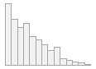 | 0  (0%)
coarse  [factor] | 1. collective residential  2. green spaces  3. individual residential  4. industrial  5. non-urban  6. public space | 55 ( 9.8%)  88 (15.7%)  190 (33.9%)  112 (20.0%)  53 ( 9.4%)  63 (11.2%) |  | 0  (0%)
middle  [factor] | 1. agricultural  2. collective residential  3. forest  4. individual residential  5. industrial  6. park  7. public space  8. riverbank  9. vacant | 43 ( 7.7%)  55 ( 9.8%)  10 ( 1.8%)  190 (33.9%)  112 (20.0%)  16 ( 2.8%)  63 (11.2%)  28 ( 5.0%)  44 ( 7.8%) |  | 0  (0%)
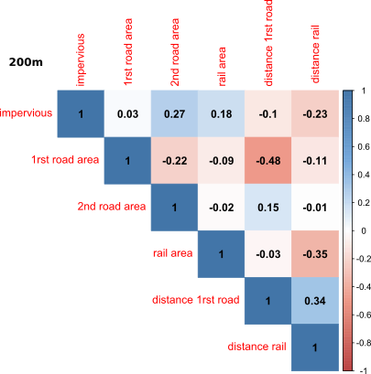

Description of explicative variables on the 100m grid:
Variable | Stats / Values | Freqs (%) | Graph | Missing
Julian day  [numeric] | Mean (sd) : 135.3 (33.9)  min < med < max:  93 < 123 < 198  IQR (CV) : 70 (0.3) | 60 distinct values | 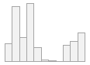 | 0  (0%)
Impervious  [numeric] | Mean (sd) : -0.5 (0.1)  min < med < max:  -0.9 < -0.5 < 0  IQR (CV) : 0.2 (-0.3) | 2198 distinct values | 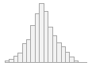 | 0  (0%)
1st road area  [numeric] | Mean (sd) : 99.5 (303.6)  min < med < max:  0 < 0 < 3023.3  IQR (CV) : 0 (3.1) | 322 distinct values | 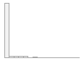 | 0  (0%)
2nd road area  [numeric] | Mean (sd) : 497.4 (412.2)  min < med < max:  0 < 459 < 2780.2  IQR (CV) : 625.3 (0.8) | 1788 distinct values | 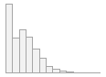 | 0  (0%)
Rail area  [numeric] | Mean (sd) : 71.3 (373)  min < med < max:  0 < 0 < 6432.4  IQR (CV) : 0 (5.2) | 178 distinct values |  | 0  (0%)
Distance 1st road  [numeric] | Mean (sd) : 340.6 (284)  min < med < max:  0 < 277.2 < 1516.2  IQR (CV) : 373.6 (0.8) | 2198 distinct values | 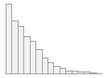 | 0  (0%)
Distance rail  [numeric] | Mean (sd) : 776.6 (602.5)  min < med < max:  0.3 < 656.1 < 2689.4  IQR (CV) : 909.3 (0.8) | 2198 distinct values | 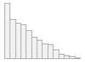 | 0  (0%)
coarse  [factor] | 1. collective residential  2. green spaces  3. individual residential  4. industrial  5. non-urban  6. public space | 220 (10.0%)  372 (16.9%)  726 (33.0%)  454 (20.7%)  199 ( 9.0%)  227 (10.3%) |  | 0  (0%)
middle  [factor] | 1. agricultural  2. collective residential  3. forest  4. individual residential  5. industrial  6. park  7. public space  8. riverbanks  9. vacant | 158 ( 7.2%)  220 (10.0%)  41 ( 1.9%)  726 (33.0%)  454 (20.7%)  70 ( 3.2%)  227 (10.3%)  81 ( 3.7%)  221 (10.1%) |  | 0  (0%)
fine  [factor] | 1. agricultural  2. collective residential  3. forest  4. indu_60s  5. indu_70s  6. indu_80s  7. indu_90s  8. indu_bfr_60  9. indu_ftr_2000  10. public green space  [ 9 others ] | 158 ( 7.2%)  220 (10.0%)  41 ( 1.9%)  58 ( 2.6%)  102 ( 4.6%)  102 ( 4.6%)  52 ( 2.4%)  48 ( 2.2%)  92 ( 4.2%)  70 ( 3.2%)  1255 (57.1%) |  | 0  (0%)
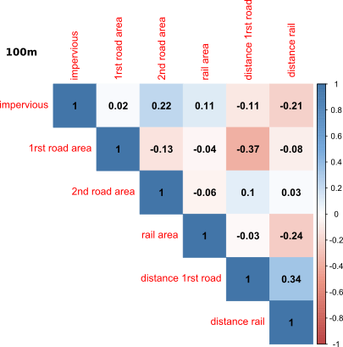

Appendix 7 Spatial distribution of the seven species inventoried on the 100m grid. Species have been recorded in colored cells. Colors correspond to the fine NMCU classification. A picture of each species is presented, take on the field by Deparis M. In the order of appearance: Acer negundo, Ailanthus altissima, Berberis aquifolium, Buddleja davidii, Cortaderia selloana, Reynoutria japonica, Robinia pseudoacacia.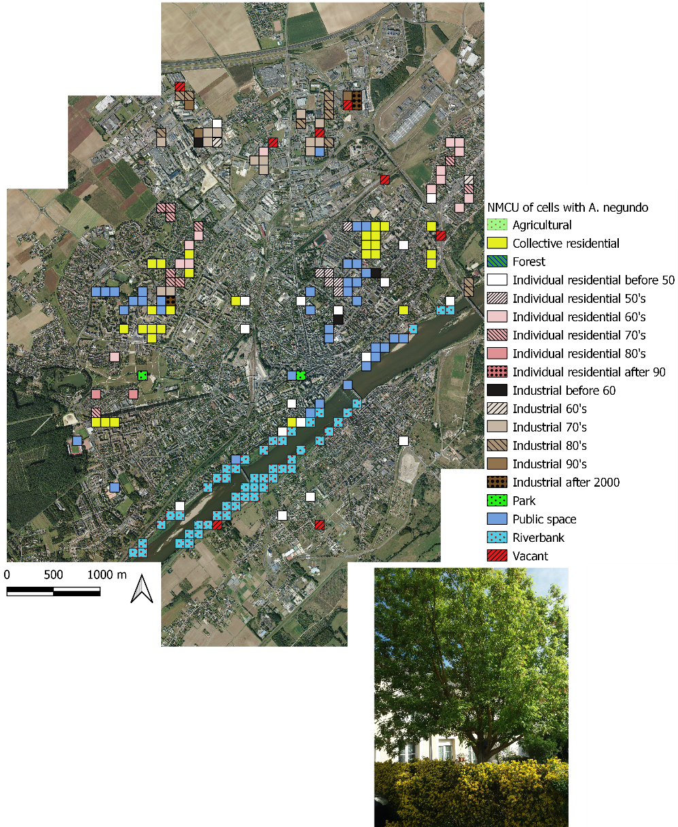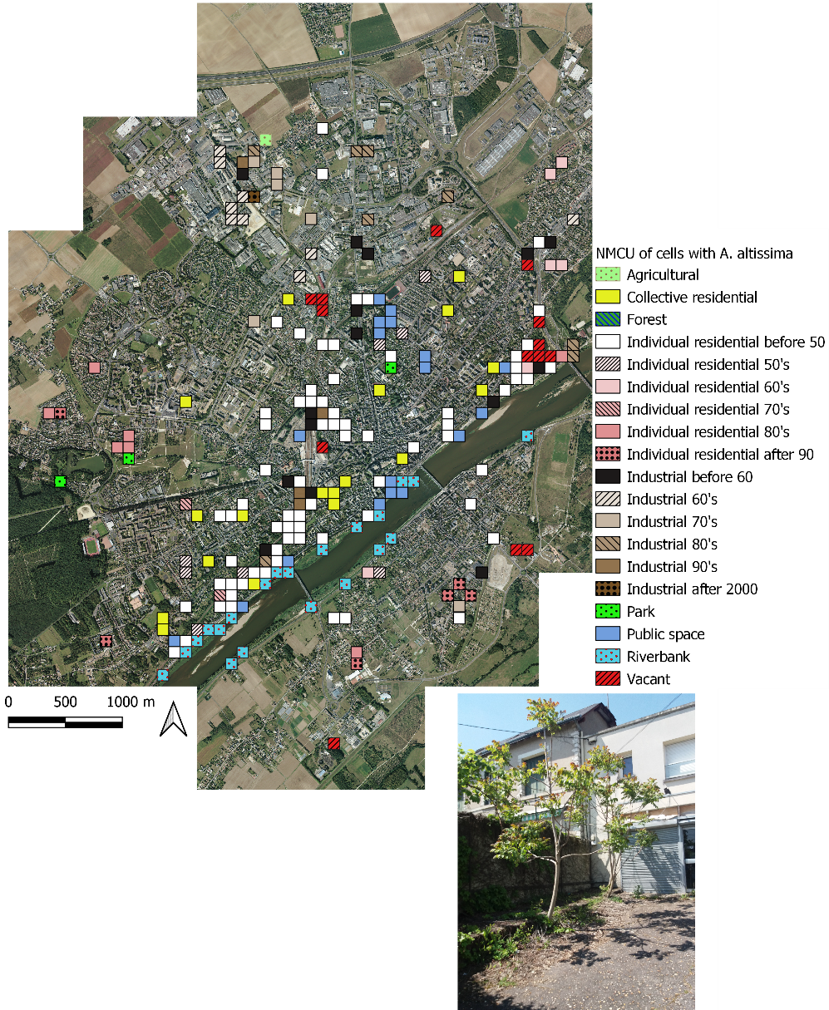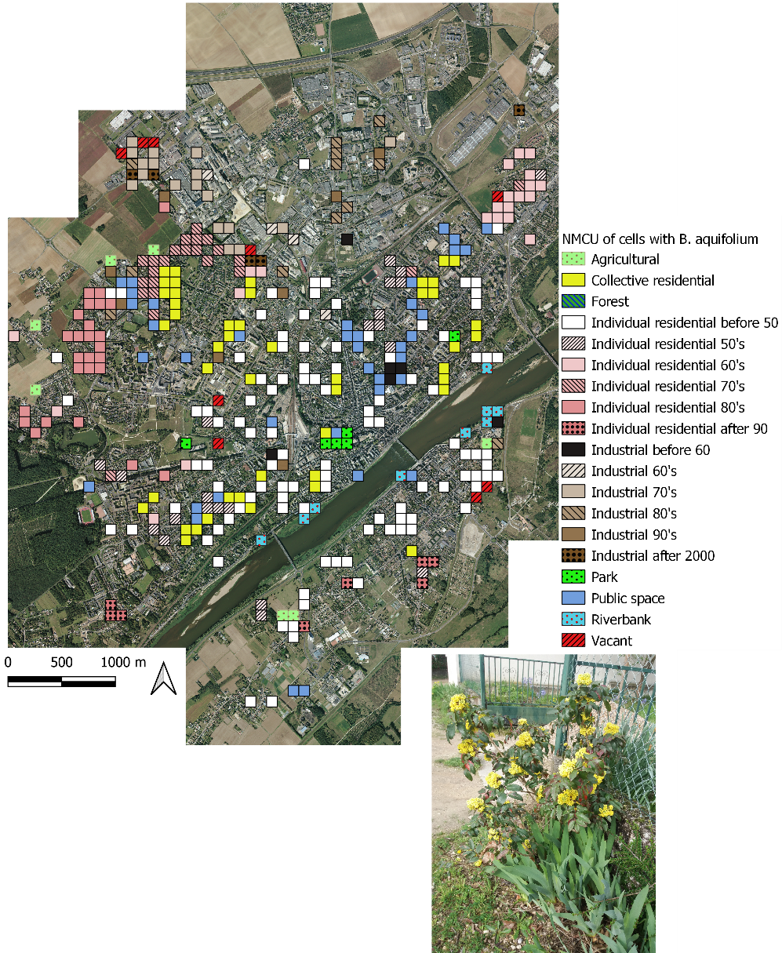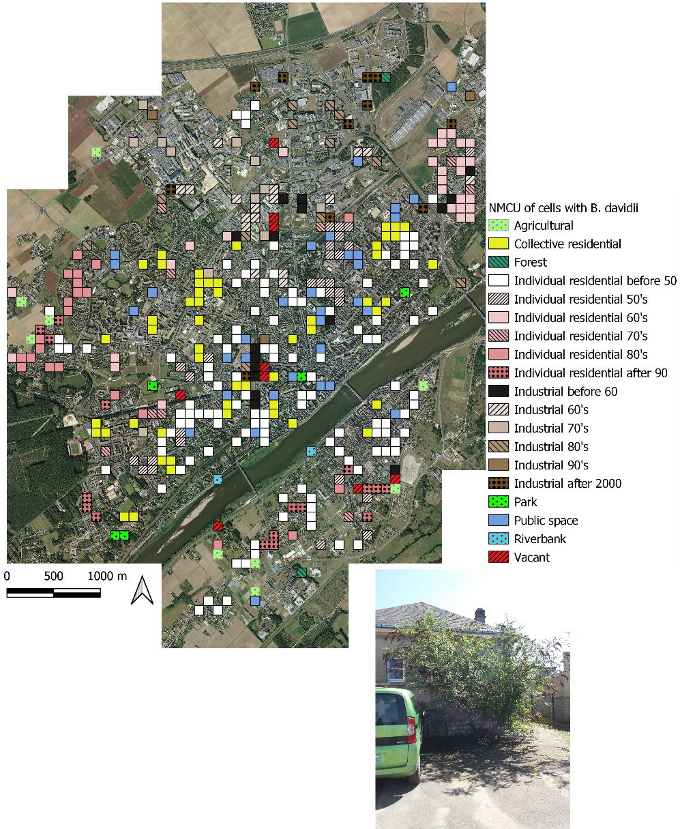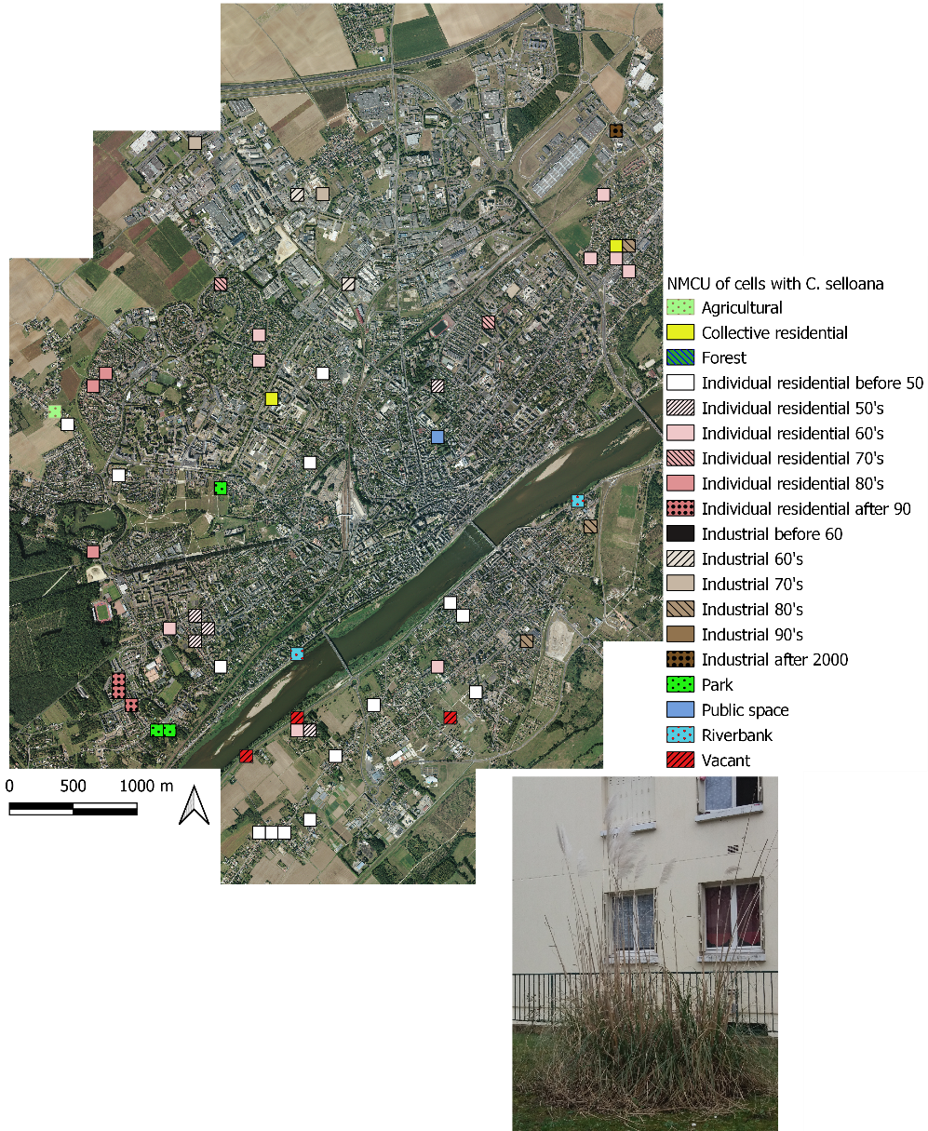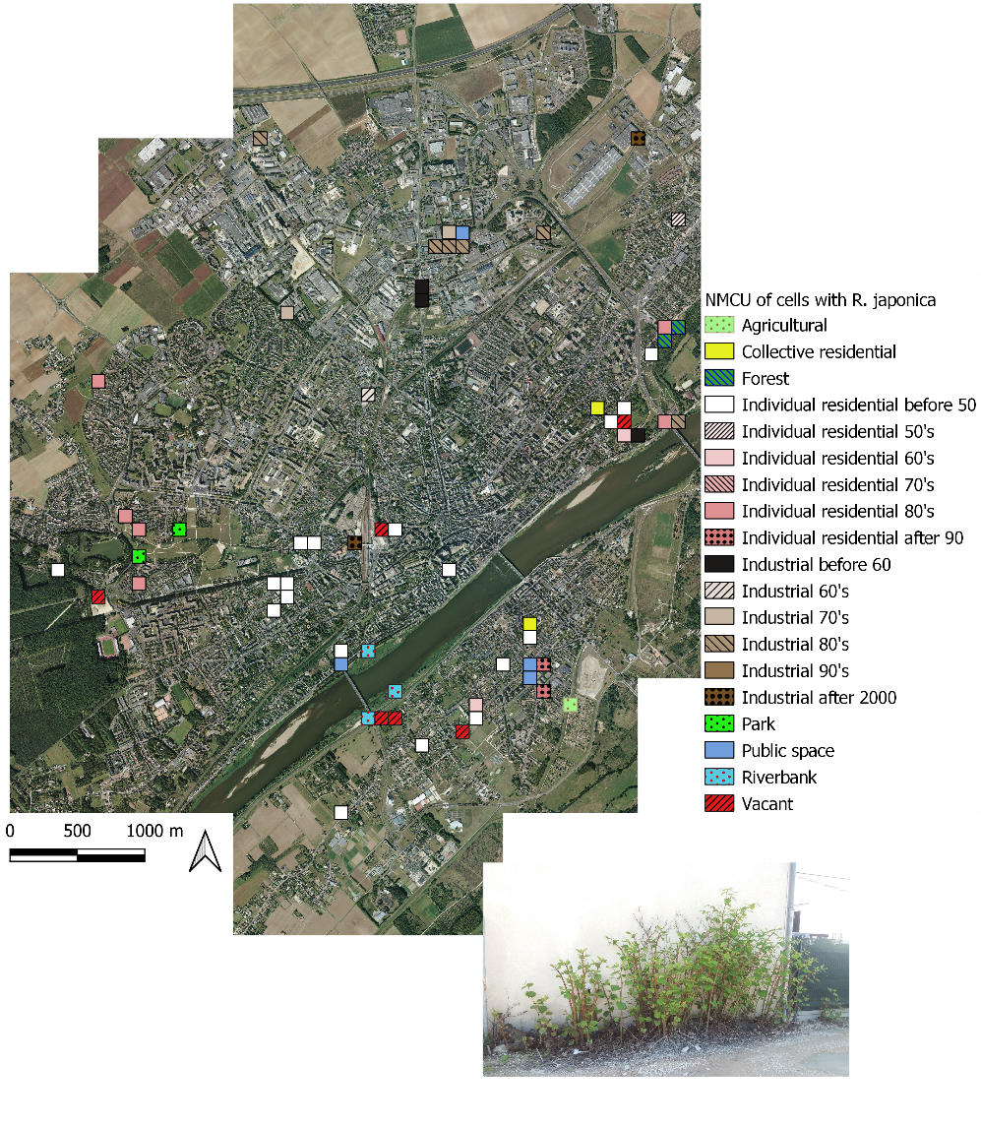

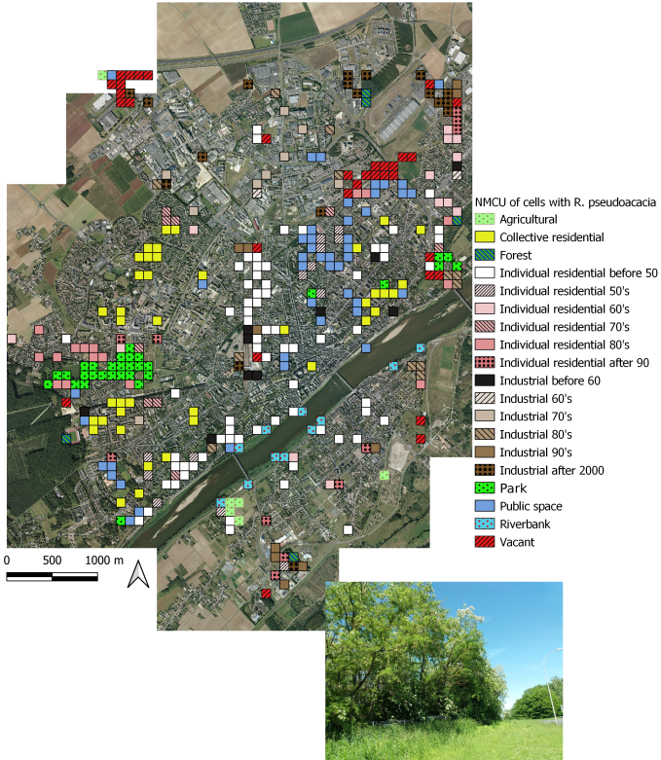
Appendix 8a results of the presence-absence GLM analysis of the spatial distribution for all the species. All variables are showed. The horizontal bars represent the relative importance of each variable, based on the average model for each species. Total explained deviance was calculated on the total model. indicate a significant and positive effect, indicate a significant and negative effect, * indicate significant pairs comparison between NMCU and ns indicate a non-significant variable. Coarse/middle/fine NMCU: respective neighborhood main cover and use classification of the grid considered; impervious: impervious surface index; 1rst road area: area of primary road in each cell; distance 1rst road: distance from the center of the cell to the nearest section of primary road; 2nd road area: area of secondary road in each cell; rail area: area of railway in each cell; distance rail: distance from the center of the cell to the nearest section of railway.

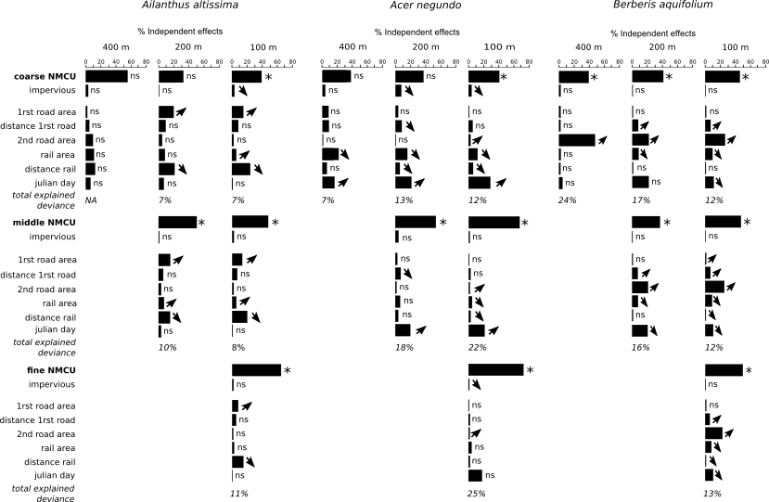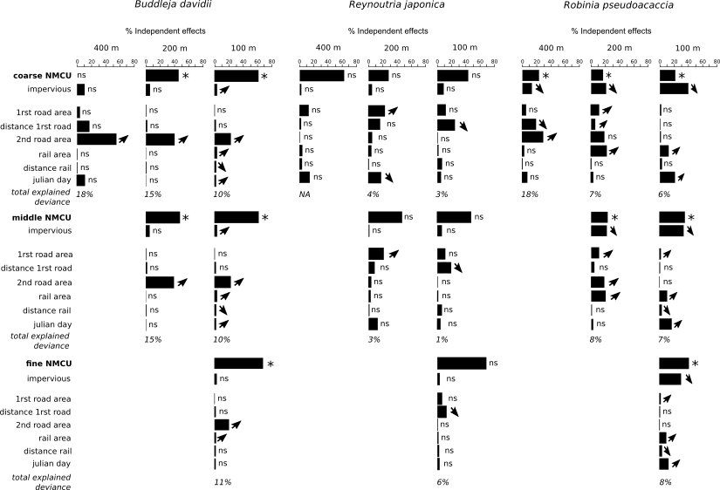

Appendix 8b Counts, for each variable, of the number of times its effect is significantly positive, significantly negative, or non-significant (NS), among the 36 models.
