SUPPLEMENTARY MATERIAL

Machine Learning Algorithms to Detect Patient-Ventilator Asynchrony. A Feasibility Study.
Jeffrey Williams, MD¹
Jalil Ahari, MD²
Kendrew Wong, MD³
Arun Jose, MD⁴
Guillermo Gutierrez, MD, PhD⁵

1. Department of Anesthesiology, The George Washington University
2. Department of Medicine, The George Washington University
3. Department of Medicine, NYU Grossman School of Medicine
4. Department of Medicine, University of Cincinnati
5. Emeritus Professor of Medicine, Anesthesiology and Engineering,
The George Washington University

Table 1E. Patient Demographics and Admission Data

Demographics:
Age (Years) | 62.5 [57.0,70.8]
Gender | 50% female
Ethnicity (%):
Black | 68.2
Caucasian | 18.2
Hispanic | 11.4
Asian | 2.3
Admission diagnosis:
Pulmonary | 52.3%
Sepsis or septic shock | 18.2%
Neurologic | 15.9%
Cardiac | 4.5%
Gastroenterological | 4.5%
Oncological | 2.3%
Renal | 2.3%
Reason for intubation:
Airway protection | 45.5%
Hypoxemia | 34.1%
Hypercapnia | 20.5%
Other admission data:
SOFA | 7.0 [6,9]
SAPS | 54.5 [47.0,63.8]
Glasgow scale* | 7 [6,9]
BMI (kg/m²) | 28.9 [25.9,36.0]

- Ventilator modified Glasgow scale with a maximum of 10 points.

Data acquisition system
We acquired ventilator data continuously with a Raspberry 3B microcontroller (Raspberry Pi) connected to the ventilator’s RS-232 port via a DB9 cable. The microprocessor was programmed to interact with the Servo_i ventilator Computer Interface Emulator. Data gathering begins with the microprocessor signaling the ventilator to acquire, in parallel, 4096 samples of the airway flow and pressure signals at 31.25 Hz, a rate that satisfies the Nyquist-Shannon criterion to avoid aliasing of data. Once signal sampling is completed (131.07 seconds, or approximately 2.2 minutes), frequency spectra for airway pressure and the inspiratory and expiratory phases of the airway flow signals were computed by the microprocessor using the Fast Fourier Transform (FFT) algorithm (Duhamel P, Vetterli M: Fast Fourier transforms: a tutorial review and a state of the art. Signal Processing 1990, 19:259-299). Spectral frequency granularity was 0.458 cycles per minute.

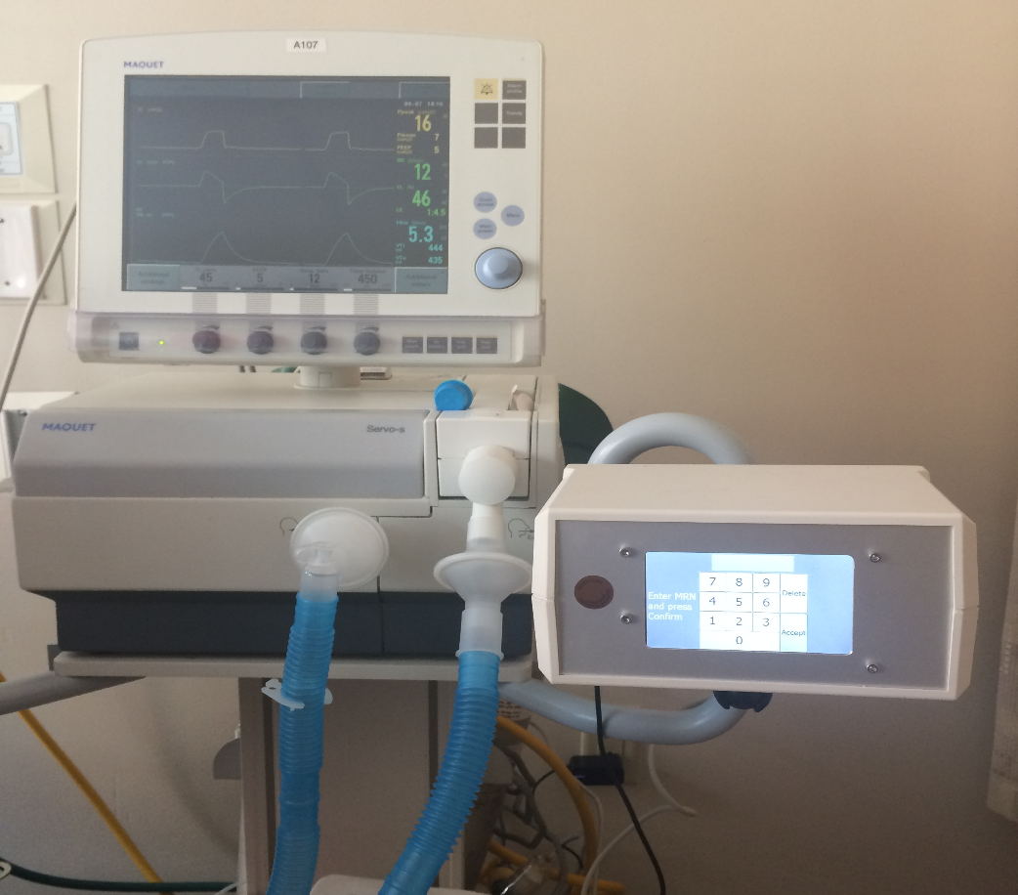

Figure 1E: An epoch's dashboard, displaying demographic data, ventilator settings, and measured patient data. A slider provides access to data from different days and times, while radio buttons are used for epoch classification. The lower panel shows flow and pressure signals sampled at 31.25 Hz over a duration of 131 seconds.
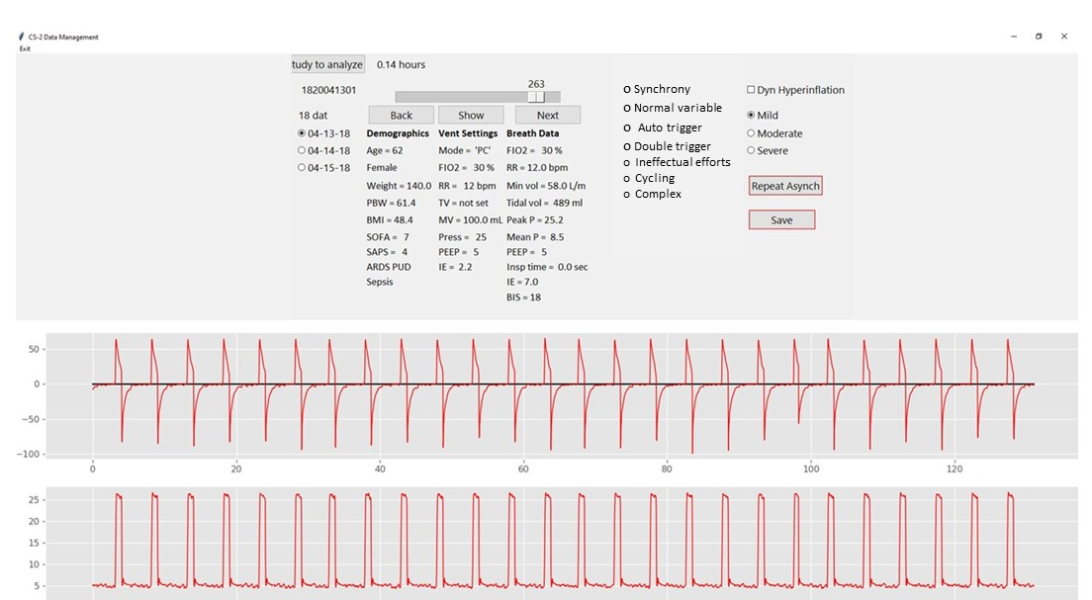

Figure 2E. Examples of the different breathing patterns used in epoch classification.
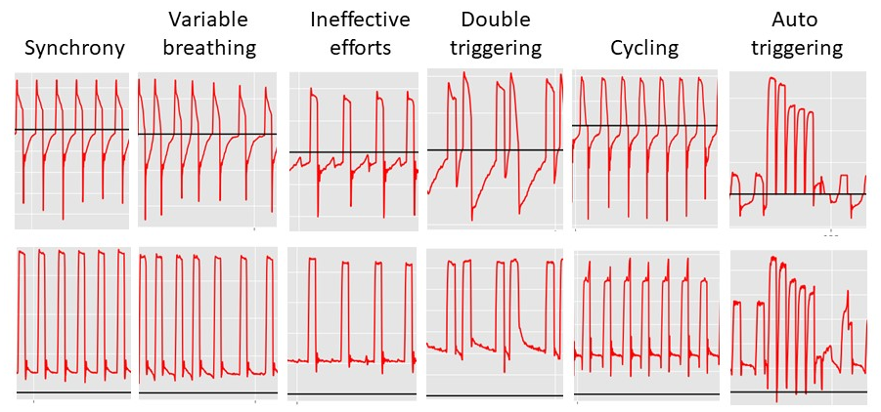
Figure 2E

Table 2E |  | Epoch classification for each enrollee according to asynchrony type
Patient | Synch | Variable | Double | Ineffective | Cycling | Complex | Auto |  | Monitored | # of | % Time
Number |  | Breathing | Trigger | Efforts |  |  | Trigger |  | Time (hr) | Asynchs | Asynch
1820022301 | 0 | 80 | 56 | 6 | 341 | 13 | 1 |  | 20.7 | 416 | 84%
1820022601 | 207 | 588 | 17 | 1 | 272 | 9 | 2 |  | 45.7 | 299 | 27%
1820030701 | 414 | 595 | 49 | 4 | 22 | 23 | 5 |  | 46.3 | 98 | 9%
1820030801 | 5 | 1 | 3 | 35 | 0 | 1 | 0 |  | 1.9 | 39 | 87%
1820030802 | 102 | 638 | 6 | 1 | 354 | 22 | 2 |  | 46.9 | 383 | 34%
1820030803 | 0 | 0 | 0 | 1 | 54 | 0 | 0 |  | 2.3 | 55 | 100%
1820030804 | 35 | 273 | 29 | 55 | 108 | 8 | 1 |  | 21.2 | 200 | 39%
1820031601 | 197 | 854 | 49 | 397 | 470 | 277 | 9 |  | 93.9 | 1193 | 53%
1820031602 | 689 | 318 | 42 | 3 | 546 | 47 | 9 |  | 68.9 | 638 | 39%
1820032001 | 413 | 37 | 30 | 536 | 65 | 55 | 11 |  | 47.8 | 686 | 60%
1820032101 | 143 | 43 | 6 | 8 | 301 | 6 | 5 |  | 21.3 | 321 | 63%
1820032201 | 927 | 663 | 3 | 9 | 16 | 43 | 6 |  | 69.5 | 71 | 4%
1820032301 | 80 | 0 | 7 | 4 | 3 | 7 | 1 |  | 4.3 | 21 | 21%
1820032401 | 417 | 138 | 6 | 30 | 35 | 13 | 2 |  | 26.7 | 84 | 13%
1820033101 | 28 | 521 | 1 | 0 | 25 | 24 | 3 |  | 25.1 | 50 | 8%
1820040101 | 5 | 851 | 8 | 59 | 1101 | 24 | 9 |  | 85.7 | 1192 | 58%
1820040201 | 0 | 404 | 1 | 32 | 137 | 33 | 2 |  | 25.4 | 203 | 33%
1820040501 | 393 | 195 | 0 | 20 | 22 | 24 | 0 |  | 27.3 | 66 | 10%
1820040502 | 459 | 517 | 9 | 13 | 87 | 32 | 3 |  | 46.7 | 141 | 13%
1820040601 | 680 | 490 | 10 | 2 | 620 | 7 | 8 |  | 75.7 | 639 | 35%
1820041301 | 217 | 760 | 11 | 24 | 88 | 26 | 6 |  | 47.2 | 149 | 13%
1820042401 | 0 | 214 | 2 | 3 | 368 | 44 | 0 |  | 26.3 | 417 | 66%
1820042701 | 303 | 149 | 14 | 5 | 16 | 8 | 6 |  | 20.9 | 43 | 9%
1820050801 | 75 | 229 | 66 | 25 | 91 | 48 | 2 |  | 22.3 | 230 | 43%
1820051401 | 65 | 304 | 5 | 104 | 108 | 13 | 3 |  | 25.1 | 230 | 38%
1820051501 | 243 | 935 | 24 | 15 | 344 | 59 | 23 |  | 68.5 | 442 | 27%
1820053001 | 534 | 317 | 136 | 212 | 825 | 161 | 10 |  | 91.5 | 1334 | 61%
1820061301 | 0 | 917 | 313 | 31 | 338 | 61 | 6 |  | 69.4 | 743 | 45%
1820071201 | 216 | 154 | 32 | 0 | 313 | 4 | 3 |  | 30.1 | 349 | 48%
1820071801 | 279 | 281 | 11 | 28 | 27 | 18 | 6 |  | 27.1 | 84 | 13%
1820072401 | 74 | 318 | 40 | 1 | 50 | 27 | 4 |  | 21.4 | 118 | 23%
1820073101 | 0 | 34 | 4 | 434 | 12 | 0 | 2 |  | 20.3 | 450 | 93%
1820080101 | 18 | 218 | 1 | 274 | 1692 | 229 | 14 |  | 101.9 | 2196 | 90%
1820081601 | 352 | 1292 | 32 | 86 | 712 | 32 | 9 |  | 104.8 | 862 | 34%
1820082201 | 410 | 615 | 35 | 728 | 262 | 19 | 32 |  | 87.5 | 1044 | 50%
1820082801 | 163 | 26 | 9 | 230 | 55 | 15 | 0 |  | 20.8 | 309 | 62%
1820090401 | 124 | 281 | 149 | 252 | 813 | 44 | 6 |  | 69.5 | 1258 | 75%
1820091301 | 88 | 418 | 1478 | 11 | 407 | 124 | 11 |  | 105.7 | 2020 | 80%
1820103101 | 490 | 179 | 36 | 201 | 169 | 36 | 0 |  | 46.3 | 442 | 40%
1820110101 | 183 | 1085 | 0 | 0 | 346 | 54 | 4 |  | 69.7 | 400 | 24%
1820110801 | 426 | 885 | 31 | 120 | 115 | 25 | 11 |  | 67.2 | 291 | 18%
1820111601 | 703 | 1355 | 43 | 150 | 129 | 35 | 12 |  | 101.1 | 357 | 15%
1820121101 | 89 | 209 | 0 | 188 | 150 | 33 | 3 |  | 28.0 | 371 | 55%
1820121201 | 387 | 147 | 9 | 2 | 325 | 26 | 3 |  | 37.5 | 362 | 40%
 |  |  |  |  |  |  |  |  | MEAN | VALUES
 | No | TI | DT | IE | DC | CM | DX |  | Time (hr) | Asynchs | % Time
Total | 10633 | 18528 | 2813 | 4340 | 12334 | 1809 | 255 |  | 48.0 | 484.0 | 42.0%
 | 21.1% | 36.7% | 5.6% | 8.6% | 24.4% | 3.6% | 0.5% |  | 30.2
Modes of Ventilation |  |  |  |  |  |  | Median |  | 46.0 | 353.0 | 38.9%
Total | 50712 |  |  | Total Epochs = | 50,712 |  | 1st Q |  | 24.4 | 135.3 | 20.0%
PRVC | 30994 | 61.1% |  |  |  |  | 3rd Q |  | 69.5 | 638.8 | 59.3%
PC | 15769 | 31.1% |  |  |  |  | min |  | 1.9 | 21.0 | 4.3%
VC | 1054 | 2.1% |  |  |  |  | max |  | 105.7 | 2196.0 | 100.0%
PSPC | 2895 | 5.7%

MACHINE LEARNING ALGORITHMS

We used scikit-learn, an open source machine learning library for the Python programming language, to develop the classification supervised machine learning algorithms. We tested several algorithms to determine the best predictor. These were Random Forest, k-Nearest Neighbors, Convolutional Neural Networks, Quadratic Discriminant Analysis, Logistic Regression, Gradient Boosted Decision Trees, Ada Boost, Naïve Bayes Classifiers and Support Vector Machines. For the purpose model development, the classified epochs were distributed randomly into a Train data set encompassing 70% of the instances. The remaining 30% were assigned to a Test data set and used to evaluate model performance.

Algorithm comparison: We initially identified 33 variables related to patient demographics and ventilator data as model features. From these, we further selected 19 having ≥ 5% correlations with the predicted asynchronies. The Random Forest algorithm yielded the highest accuracy score and Support Vector Machines the worst for all three models. The k-Nearest Neighbors and Convolutional Neural Networks and ADA Boost algorithms also performed well.

Table 3E. Overall accuracies (%) of machine-learning algorithms when applied to the Test dataset.

Classifier Algorithm | Model 1  Asynchrony Present | Model 2  Asynchrony  Identification | Model 3  Severity | Model 4  AutoPEEP  Present
Random Forest | 91.1 | 81.7 | 87.4 | 92.8
k-Nearest Neighbors, n= 3 | 85.3 | 74.8 | 80.6 | 88.7
Neural Networks | 81.2 | 68.5 | 0.80 | 87.2
Quadratic Discriminant | 73.3 | 59.7 | 75.1 | 42.9
Logistic Regression | 75.9 | 65.0 | 79.6 | 87.1
Decision Tree | 79.7 | 64.8 | 81.1 | 87.5
ADA Boost | 82.0 | 61.3 | 80.2 | 88.5
Naïve Bayes | 74.4 | 58.2 | 72.7 | 70.4
Support Vector Machines | 58.2 | 40.5 | 57.3 | 73.8

Comparison of different machine-learning algorithms used to train Model 2.
No null values found in the database
Study Day Epoch ... Med Dx_6 Gender_0 Gender_1
0 1820022601 180227 134 ... False True False
1 1820022601 180227 143 ... False True False
2 1820022601 180227 168 ... False True False
3 1820022601 180227 176 ... False True False
4 1820022601 180227 188 ... False True False
5 1820022601 180227 190 ... False True False
6 1820022601 180227 192 ... False True False
7 1820022601 180227 211 ... False True False
8 1820022601 180227 215 ... False True False
9 1820022601 180227 221 ... False True False

0 = Synchrony
1 = Variable breathing
2 = Double triggering
3 = Ineffectual efforts
4 = Cycling
5 = Complex
6 = Auto triggering

[10 rows x 46 columns]
Number of 0 cases: 18528 (20.97%)
Number of 1 cases: 18528 (36.54%)
Number of 2 cases: 2813 (5.55%)
Number of 3 cases: 4340 (8.56%)
Number of 4 cases: 12334 (24.32%)
Number of 5 cases: 1809 (3.57%)
Number of 6 cases: 255 (0.50%)

Creating train and test sets

70.00% in training set
30.00% in test set
Original 0 : 10633 (20.97%)
Original 1 : 18528 (36.54%)
Original 2 : 2813 (5.55%)
Original 3 : 4340 (8.56%)
Original 4 : 12334 (24.32%)
Original 5 : 1809 (3.57%)
Original 6 : 255 (0.50%)

Training 0 : 7356 (20.72%)
Training 1 : 13047 (36.75%)
Training 2 : 1933 (5.45%)
Training 3 : 3029 (8.53%)
Training 4 : 8679 (24.45%)
Training 5 : 1261 (3.55%)
Training 6 : 193 (0.54%)

Test 0 : 3277 (21.54%)
Test 1 : 5481 (36.03%)
Test 2 : 880 (5.78%)
Test 3 : 1311 (8.62%)
Test 4 : 3655 (24.02%)
Test 5 : 548 (3.60%)
Test 6 : 62 (0.41%)

Features used to train the algorithm
Total instances 50,712

H1DCe = H1/DC for the expiratory portion of the flow signal frequency spectrum
H1DCi = H1/DC for the inspiratory portion of the flow signal frequency spectrum
H1DCp = H1/DC for the pressure signal frequency spectrum
Ins/Exp = H1DCi/ H1DCe
Pre/Exp = H1DCp/ H1DCe
Pre/Ins = H1DCp/ H1DCi
FIO2 = Fraction inspired oxygen
RR = Respiratory rate
TV = Tidal volume
MV = Minute ventilation
Peak P = Peak pressure
PEEP = Positive End Expiratory Pressure
COV Ttot = Covariance of the total breathing cycle time (Ttotal)
COV PPre = Covariance of peak pressure
Age = Patient’s age
SpecHead = Mean value of the first five cpm of the inspiratory frequency spectrum
Insp H2DC = H2/DC for the inspiratory portion of the flow signal frequency spectrum
Insp H3DC = H3/DC for the inspiratory portion of the flow signal frequency spectrum
Area = Inspiratory spectrum’s area

Correlation matrix
H1DCe -0.502009
H1DCi -0.491316
H1DCp -0.434080
Ins/Exp 0.080394
Pre/Exp -0.108517
Pre/Ins -0.263684
FIO2 0.084131
RR 0.195331
TV -0.105130
MV 0.059583
Peak P -0.214461
PEEP -0.065990
COV Ttot 0.426755
COV PPre 0.460087
Age 0.149975
SpecHead 0.387298
Insp H2DC -0.448347
Insp H3DC -0.366241
Area 0.324640

Random Forest Classifier

Accuracy with training data
Accuracy: 1.0000

Accuracy with test data
Accuracy: 0.8169

Classification Report
precision recall f1-score support

0 0.92 0.91 0.91 3277
1 0.80 0.86 0.83 5481
2 0.84 0.65 0.74 880
3 0.83 0.66 0.73 1311
4 0.76 0.81 0.78 3655
5 0.71 0.54 0.61 548
6 1.00 0.73 0.84 62

accuracy 0.82 15214
macro avg 0.84 0.74 0.78 15214
weighted avg 0.82 0.82 0.81 15214

===========================================================================

Naive Bayes Gaussian model

Accuracy with training data
Accuracy: 0.5771

Accuracy with test data
Accuracy: 0.5815

===========================================================================

KNeighbors model x 3

Accuracy with training data
Accuracy: 0.5771

Accuracy with test data
Accuracy: 0.7483

===========================================================================

QuadraticDiscriminantAnalysis model

Accuracy with training data
Accuracy: 0.5771

Accuracy with test data
Accuracy: 0.5972

macro avg 0.56 0.59 0.55 15138
weighted avg 0.62 0.60 0.57 15138

===========================================================================

LogisticRegression

Accuracy with training data
Accuracy: 0.5771

Accuracy with test data
Accuracy: 0.6500

===========================================================================

ADA Boost Classifier

Accuracy with training data
Accuracy: 0.5771

Accuracy with test data
Accuracy: 0.6127

===========================================================================

Decision Tree Classifier

Accuracy with training data
Accuracy: 0.5771

Accuracy with test data
Accuracy: 0.6476

===========================================================================

Neural network model

Accuracy with training data
Accuracy: 0.5771

Accuracy with test data
Accuracy: 0.6848

macro avg 0.71 0.57 0.60 15138
weighted avg 0.70 0.68 0.67 15138

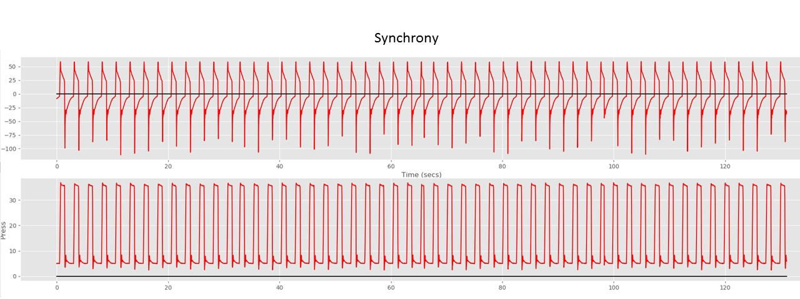
Examples of Epoch Classification
