Supplement material – Descriptive of Erasme ICU follow-up program
Erasme University Hospital, an 858-bed tertiary hospital, launched a multidisciplinary ICU follow-up program in November 2017. A multidisciplinary model provides a direct interaction of all stakeholders with the ICU survivors. However, communication among stakeholders can be fragile and there is no active participation from the patient in the system (Fig.1). Time is necessary for each part of the team to assess the patient to complete the circle and the dynamic of this model.
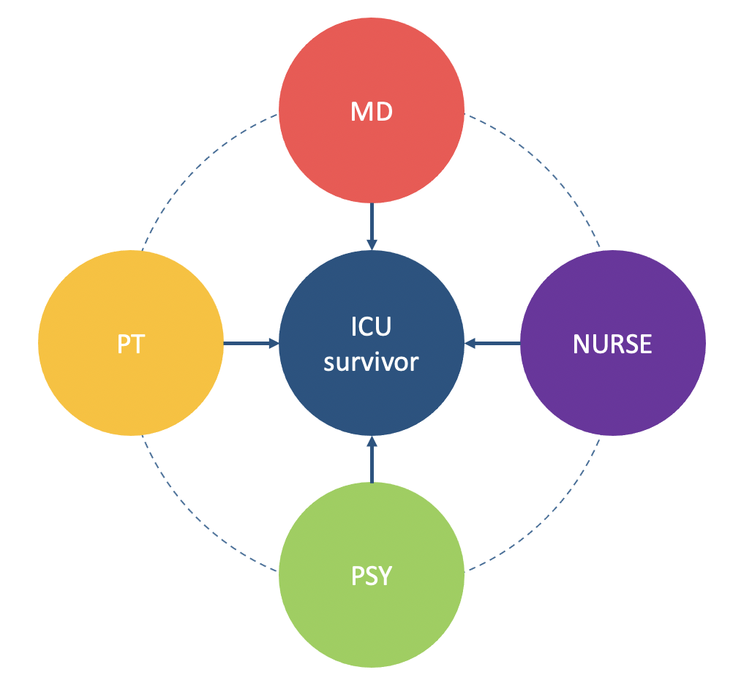
FIG.1. MULTIDISCIPLINARY MODEL
MD medical doctor; PT physiotherapist; PSY psychologist; ICU intensive care unit

The organization phase of the project started in September 2016. The ICU has 32-beds and admits surgical and medical patients. This polyvalent ICU has around 2700 admissions per year, with a mean patient length of stay (LOS) of 3.8 days. The ICU follow-up program aimed to offer specific and adapted care to post-ICU discharge patients, improve ICU practice, and consequently to increase the overall quality of care.
Patients (≥ 18 years) who spent at least five days in the ICU were invited to participate to the program. Exclusion criteria were presence of a language barrier, transfer to another institution, neurological sequelae, social problems, and pregnancy. The follow-up evaluation consisted of four time points: ICU discharge, hospital discharge, and 3 and 6 months after ICU discharge.
Within one week of ICU discharge, patients were visited on the ward by a member of the follow-up team to maintain contact with the patient. Before hospital discharge, the nurse and the physiotherapist from the ICU follow-up team visited the patient to evaluate their status, complete the second assessment and give an appointment for the 3-month follow up.
After hospital discharge, a nurse responsible for keeping track of the patients telephoned them at two different time points: one week before the 3-month consultation and the day before the consultation. The objectives of those calls were to confirm the patient’s attendance, to offer to postpone the consultation if necessary, and to help with any urgent question about their health. The 3- and 6-month consults were conducted outside the ICU with the multidisciplinary team. During these consults, the follow-up team proactively offered patients and relatives an ICU visit, and those who were interested were taken to see the team and visit the unit. The 3- and 6-month consultations were done in two parts: physiotherapy assessment and medical-nurse assessment. The physiotherapy assessment has the goal to evaluate the physical status of the patients, analyzing their strength, functionality, balance, pulmonary capacity, and percentage of non-fat mass. The medical-nurse assessment is conducted by a doctor, a nurse and a psychologist with the goal of evaluating the patient’s quality of life, anxiety and depression, post-traumatic stress disorder (PTSD), food intake and independence in activities of daily living (Table 1).

◆Table 1. Assessments at the different follow-up appointments
 | ICU discharge | Hospital discharge | 3-m and 6-m consultations
MRC Score  Handgrip  Sit-to-stand test  Psychological and functional sequelae  6MWT  CAS-ICU  Katz index | X  X  X  X  X | X  X  X  X  X  X if abnormal at ICU discharge  X | X  X  X  X  X  X if abnormal at hospital discharge  X
Spirometry (optional) | X | X | X
MOCA | X | X if abnormal at ICU discharge | X if abnormal at hospital discharge
IPREA  ICU memory tool  HADS  IES-R  SF-36  BIA | X  X | X  X  X | X  X  X  X  X
Food intake*  Weight/ BMI | X  X | X  X | X  X
Report sent to GP |  | X | X
ICU intensive care unit; MRC Score Medical Research Council Score; 6MWT six-minute walk test; CAS-ICU functional assessment of swallowing; Katz index of Independence in Activities of daily living; MOCA Montreal cognitive assessment; IPREA Inconforts Perçus par les patients de REAnimation (Discomfort perceived by ICU patients); HADS Hospital Anxiety Depression Scale; IES-R Impact of event scale-revised; SF-36 36 item Short From Survey; BIA bioimpedance; BMI body mass index; GP general practitioner
*evaluated using the Nutrition Day Worldwide Questionnaire v.2010

