Supplementary material

sTable 1: Multiplex and targeted PCRs used for testing of Mycoplasma pneumoniae and other respiratory viral and bacterial pathogens. x = testing performed by this PCR, *testing since 2022.

Pathogens | Panel 1 | Panel 2 | targeted  M. pneumoniae PCR | positive Tests
Viral pathogens:  - Adenovirus | x | x |  | 26
- Human bocavirus |  | x |  | 0
- Coronavirus (229E, HKU1, NL63, OC43) |  | x |  | 14
- Influenza A/B | x | x |  | 92
- Human Metapneumovirus | x | x |  | 39
- Parainfluenza virus 1-4 | x | x |  | 8
- Rhino-/Enterovirus |  | x |  | 19
- Human rhinovirus A/B/C | x |  |  | 44
- Respiratory syncytial virus | x | x |  | 29
- SARS-Cov-2* |  | x |  | 0
Bacterial pathogens:  - Bordetella pertussis / parapertussis | x |  |  | 17
- Chlamydophila pneumoniae | x | x |  | 18
- Haemophilus influenzae | x |  |  | 3
- Mycoplasma pneumoniae | x | x | x | 1448
- Streptococcus pneumoniae | x |  |  | 0
- Legionella pneumophila | x | x |  | 0
Total tests | 7874 | 24898 | 5432 | 1757

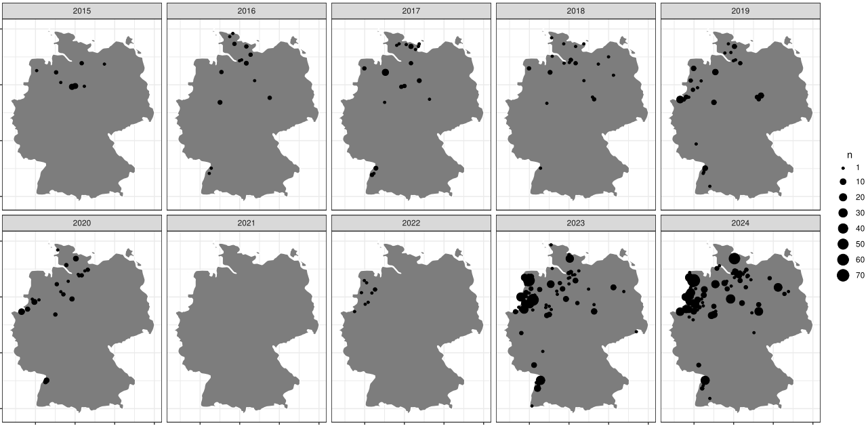
sFigure 1 Geographical distribution of Mycoplasma pneumoniae cases from 2015 - 2024

