Submitted to Behavioral Ecology and Sociobiology
Supplementary Materials
Higher proactivity in later-borns: effects of birth date on personality in a small mammal

Jingyu Qiu^{1,2*}, Neville Pillay¹, Carsten Schradin^{1,2}, Lindelani Makuya¹, Heiko G. Rödel³

¹School of Animal, Plant and Environmental Sciences, University of the Witwatersrand, South Africa
² Université de Strasbourg, CNRS, IPHC UMR 7178, F-67000 Strasbourg, France
³Laboratoire d'Ethologie Expérimentale et Comparée UR 4443 (LEEC), Université Sorbonne Paris Nord, F-93430 Villetaneuse, France

*Corresponding author. Jingyu Qiu
Address: CNRS, UMR7178, 67087 Strasbourg, France
Email: jqjingyuqiu@gmail.com

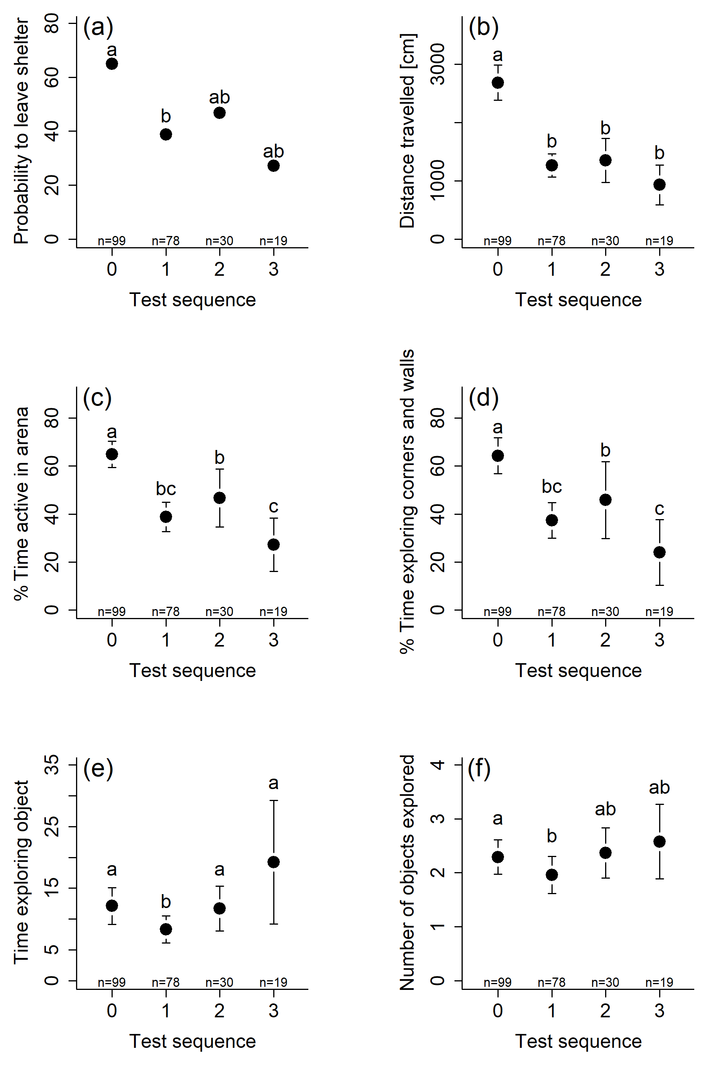
Fig. A Effects of number of tests done before (experience) on all six behavioral parameters measured in the starting box, open field and novel odor test. Note that only in (b-d), there were statistically significant differences; see Table 3 for details. Probabilities are given in (a) and mean values with 95% confidence intervals are given in (b-f) Significant post hoc comparisons after sequential Bonferroni correction (Holm 1979) are indicated by different letters.

Table A Correlation coefficients and 95% credible interval s (CI) between the different behavioral parameters recorded in repeated starting box, open field and novel odor tests, based on measurements taken from 99 bush Karoo rats of different age classes (same model from Table 1a). Analysis by a multivariate LMM including individual identity as a random factor, and year, sex and test sequence (number of tests the individual has done before, 4 levels) as fixed variance. Lines given in bold indicate that the 95% credible interval s do not overlap zero, and thus these associations can be considered as statistically significant.
Association | mean R | 95% CI [lower, upper]
PEA - DT | 0.763 | [0.573, 0.930]
PEA - % TA | 0.840 | [0.644, 0.982]
PEA - %TEA | 0.780 | [0.530, 0.974]
PEA - TEO | 0.549 | [−0.534, 0.988]
PEA - NOE | 0.454 | [−0.833, 0.970]
DT - % TA | 0.786 | [0.579, 0.955]
DT - %TEA | 0.620 | [0.325, 0.864]
DT - TEO | 0.484 | [−0.372, 0.963]
DT - NOE | 0.429 | [−0.755, 0.973]
% TA - %TEA | 0.848 | [0.637, 0.979]
% TA - TEO | 0.605 | [−0.507, 0.994]
% TA - NOE | 0.470 | [−0.857, 0.992]
%TEA - TEO | 0.494 | [−0.534, 0.984]
%TEA - NOE | 0.372 | [−0.838, 0.979]
TEO - NOE | 0.614 | [−0.611, 0.992]
PEA: Probability to enter arena; DT: Distance travelled (square-root transformed); %TA: % Time active; %TEA: % Time exploring walls and corners of arena (square-root transformed); TEO: Time exploring object (log [x+1] transformed); NOE: Number of objects explored

Table B Effects of different behavioral variables on the probability of precocious reproduction in females born early in the breeding season (with a birth date during the first 5 weeks, n = 27). Analysis by multifactorial GLMMs for binomial data including individual identity as a random factor and year a as fixed variance. Note that the effects of the different behavioral variables were tested in separate models, since several of these were strongly collinear (see Table 3). None of the effects were statistically significant.
Predictors | χ² | df | β ± SE | P
Probability to enter arena | 0.061 | 1 | 0.896 ± 3.617 | 0.804
Year [2nd] | 0.225 | 1 | 2.044 ± 4.308 | 0.635
Distance travelled ¹ | 0.002 | 1 | −0.004 ± 0.107 | 0.967
Year [2nd] | 0.180 | 1 | 1.771 ± 4.176 | 0.672
Time active | 0.002 | 1 | 0.001 ± 0.053 | 0.989
Year [2nd] | 0.181 | 1 | 1.732 ± 4.076 | 0.671
Time exploring walls and corners of arena ¹ | 0.009 | 1 | 0.090 ± 0.927 | 0.923
Year [2nd] | 0.172 | 1 | 1.693 ± 4.088 | 0.679
Time exploring object ² | 0.024 | 1 | 0.211 ± 1.376 | 0.878
Year [2nd] | 0.202 | 1 | 1.894 ± 4.216 | 0.653
Number of objects explored | 0.045 | 1 | 0.270 ± 1.280 | 0.833
Year [2nd] | 0.216 | 1 | 2.080 ± 4.475 | 0.642
¹ square-root transformation of dependent variable
² log [x+1] transformation of dependent variable

References
Holm S (1979) A simple sequentially rejective multiple test procedure. Scand J Statist 6:65-70

