Extended Data Fig. 1 | Heat storage pattern in different datasets. Patterns of 0-2000 m ocean heat content (OHC) trend (W m⁻²) based on WOA (a), ORA-S4 (b), Ishii (c), and EN4 (d). Stippling indicates significant trends at the 95% confidence level. The black boxes remark the regions with enhanced heat uptake: the mid-latitude North Pacific (MNP; 155°E-150°W, 40°-55°N) and the northwest tropical Pacific (NWTP; 125°-180°E, 8°-18°N).

Extended Data Fig. 2 | Relationship between the evolution of OHC in the North Pacific and modes of natural variability. a, Regional OHC of the NWTP derived from WND run of HYCOM 0.5° simulation and observed Oceanic Niño Index (ONI) and PDO indices for 1958-2019. b Same as a, but for regional OHC of the MNP and the PDO index. The linear trends of regional OHC anomalies of the NWTP and MNP are removed. All timeseries are normalized by their standard deviations. The PDO index is smoothed by LOWESS (locally weighted scatterplot smoothing) with a span width of 8 years. The monthly ONI is downloaded from the Climate Prediction Center of the National Weather Service website and averaged to the annual mean.
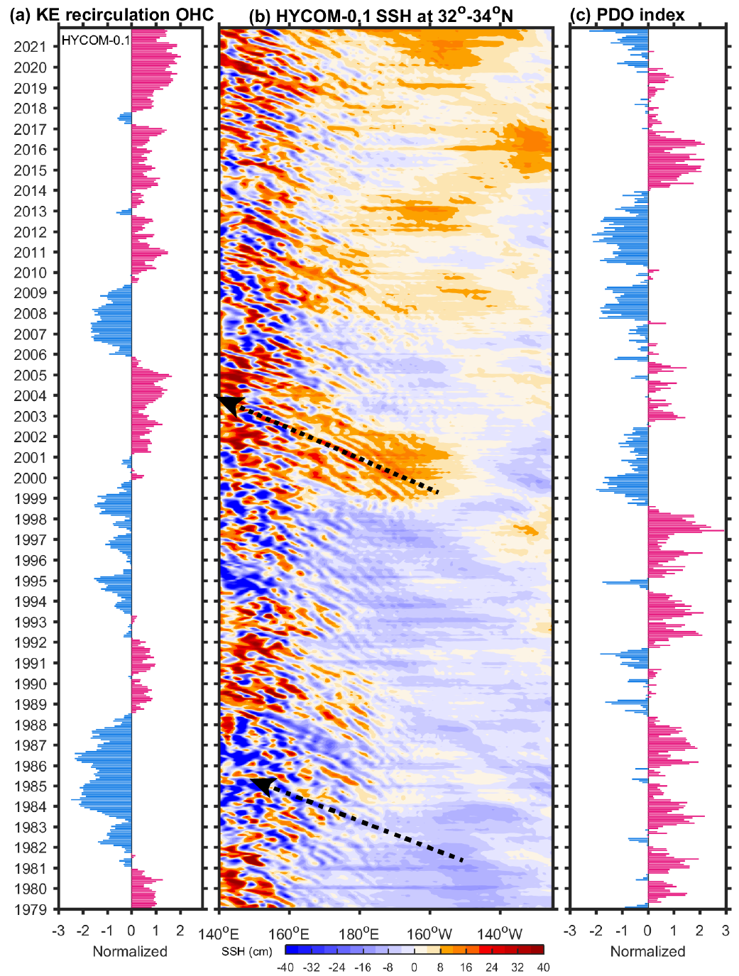

Extended Data Fig. 3 | Simulated impacts of the PDO on the Kuroshio Extension (KE). a, The normalized OHC anomaly of the southern recirculation region (140°-165°E, 31°-36°N). b, Time-longitude plot of SSH anomaly along the zonal band of 32°-34°N. a, b are based on monthly HYCOM 0.1° simulation of 1979-2021. The black arrows in (b) indicate the propagation of Rossby waves. c, The normalized monthly PDO index based on HadISST data.
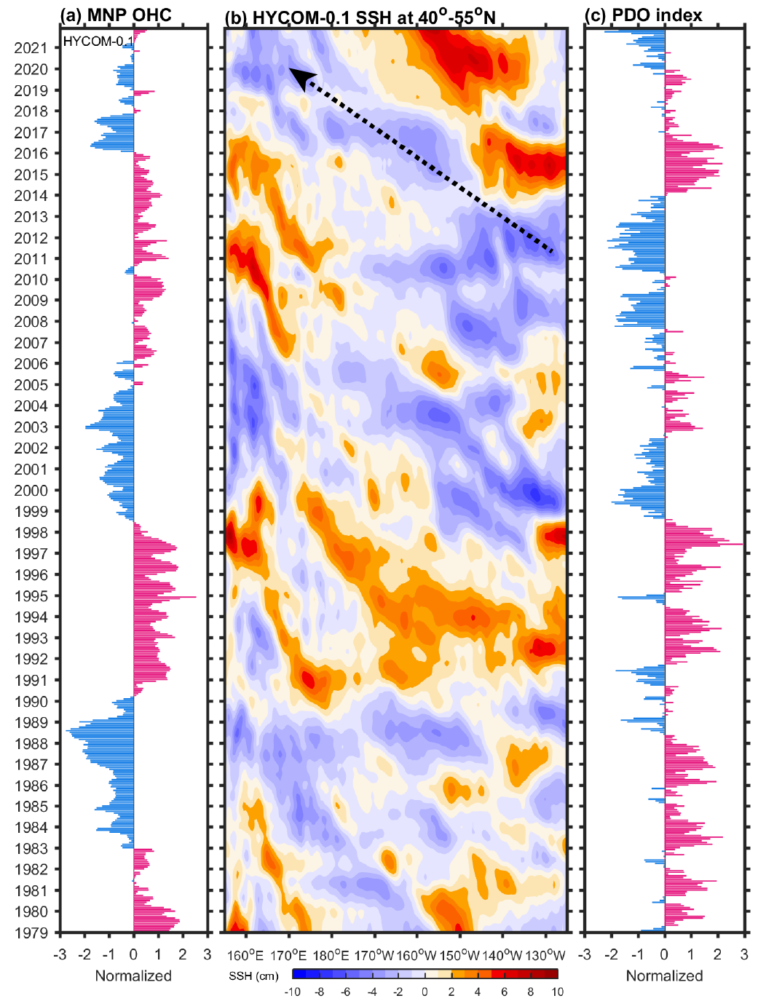

Extended Data Fig. 4 | Simulated impacts of the PDO on MNP. a, The normalized OHC anomaly of the MNP region (155°E-150°W, 40°-55°N). Linear trend of the OHC anomaly is removed. b, Time-longitude plot of SSH anomaly along the zonal band of 40°-55°N. To highlight interannual-to-interdecadal variations, the SSH anomalies are detrended and smoothed by LOWESS (locally weighted scatterplot smoothing) with a span width of 2 years. a, b are based on monthly HYCOM 0.1° simulation of 1979-2021. The black arrow in (b) indicates the propagation of Rossby waves. c, The normalized PDO index based on HadISST data.

Extended Data Fig. 5 | Impacts of the PDO on simulated winds. Regressions of wind stress (Pa) and ω_{E} (10⁻⁶ m s⁻¹) on the negative PDO index (-PDO) derived from CMIP6 MMM and 20 CMIP6 models for 1958-2021.

Extended Data Fig. 6 | Impacts of the PDO on heat storage derived from HYCOM 0.5° simulations. a, b, Lagged regression map of OHC on -PDO derived from CTRL run of the HYCOM 0.5° simulation for 1958-2019, with the former lagging the latter by 4 (a) and 9 years (b). c, d, and e, f, Same as a, b, but from WND and HTFL runs, respectively. Stippling indicates the fields exceeding the 95% confidence level.
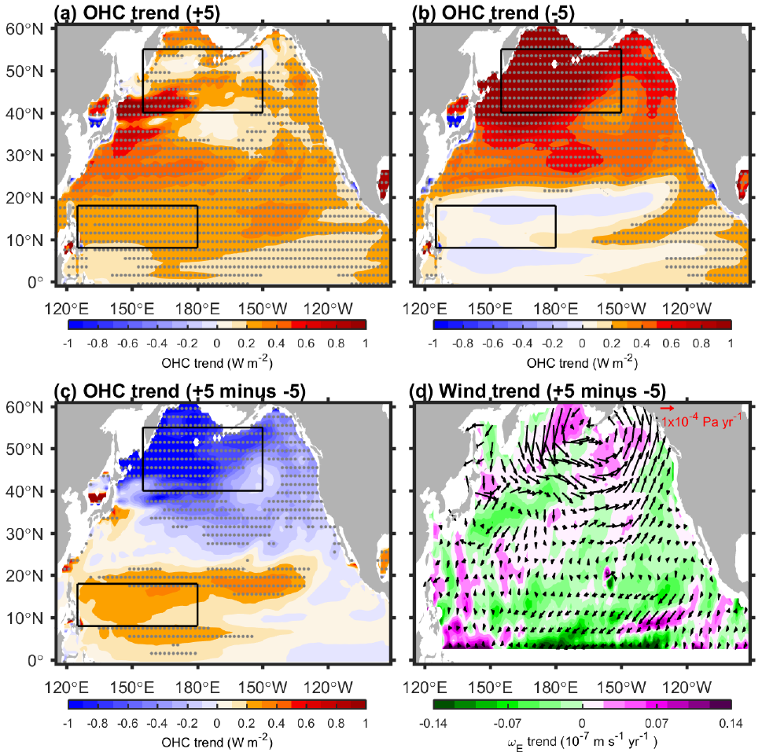

Extended Data Fig. 7 | Heat storage pattern and wind trends associated with the PDO in CMIP6 models. a, b, Linear OHC trends of 1958-2021 derived from the +5 models (a) and -5 models (b) of CMIP6. c, The difference between (a) and (b). The +5 and -5 models have the highest positive and negative correlation coefficients between the simulated and observed PDO indices since 1998. Stippling indicates the fields exceeding the 95% confidence level. d, The composite difference in trends of wind stress and Ekman pumping velocity ω_{E} for 1958-2021 between the +5 and -5 models of CMIP6. The +5 models include BCC-CSM2-MR, CAMS-CSM1-0, GFDL-ESM4, MRI-ESM2-0, and NorESM2-MM, and the -5 models include ACCESS-ESM1-5, EC-Earth3-Veg, FIO-ESM-2-0, NESM3, and NorESM2-LM.

Extended Data Fig. 8 | Time of emergence (ToE) for anthropogenic heat storage. Multi-model median ToE of the anthropogenic OHC trend under the SSP1-2.6 (a) and SSP5-8.5 (b) scenarios. The ToE is the year when the climate change trend exceeds the range of the twofold natural interannual standard deviation (Methods). Grey shading denotes the signal that has not emerged by 2099. The boxes from west to east represent the NWTP, Kuroshio Extension (141°-165°E, 33°-40°N), the Bering Sea (160°E-170°W, 52°-60°N), central MNP (170°E-155°W, 40°-48°N), and Eastern boundary (132°-117°W, 30°-55°N).
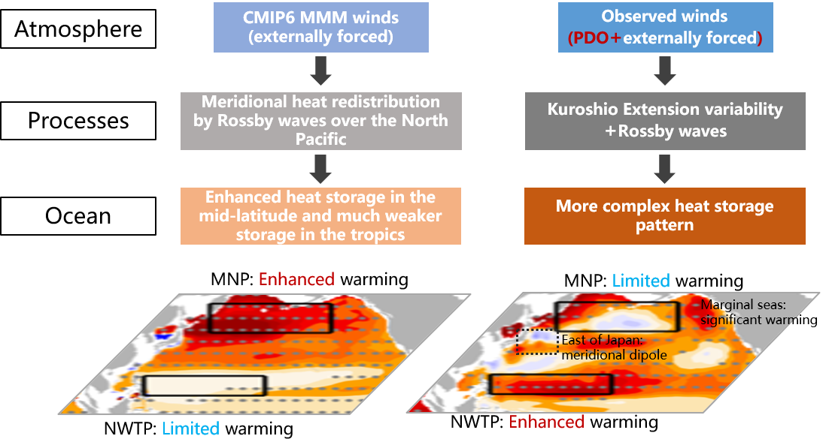

Extended Data Fig. 9 | Schematic of causes of data-model discrepancies in heat storage over the North Pacific. The phase shift of the PDO in recent decades has led to significant meridional heat redistribution through Rossby waves and variability of the KE system, strongly masking the anthropogenic fingerprints.

