Table S1 Prevalence cases, incidence cases of PD in 1990 and 2021
 | Incidence |  | Prevalence
 | Number  （95% UI）  2019 | Number  （95% UI）  2021 | Number  （95% UI）  2019 | Number  （95% UI）  2021
Global | 417135  (370655-466860) | 1335142  (1196373-1485217) | 3148395  (2749314-3629278) | 11767272  (10438278-13419875)
Sex
Female | 194356  (172763-217681) | 573000  (514626-637747) | 1589427 (1396726-1826889) | 5328632  (4748783-6042537)
Male | 222778  (198559-249410) | 762142  (683407-850675) | 1558967 (1360361-1801028) | 6438640  (5672344-7401533)
Age group
20-24 years | 618  (159-1206) | 812  (203-1584) | 1048  (270-2047) | 1378  (345-2678)
25-29 years | 1670  (432-3262) | 2383  (595-4630) | 6496  (1681-12689) | 9275  (2318-18023)
30-34 years | 3023  (1849-4429) | 5516  (3415-8030) | 16252  (7084-28519) | 27959  (13221-47770)
35-39 years | 4715  (1909-8703) | 9324  (3736-16564) | 32929  (20092-47844) | 61406  (38042-89011)
40-44 years | 7516  (5026-10682) | 20478  (14231-28054) | 52359  (34275-79666) | 117863  (79942-171391)
45-49 years | 10724  (5779-16851) | 42533  (25981-63467) | 81402  (58378-109573) | 265992  (194994-353636)
50-54 years | 17202  (11896-22715) | 70040  (51679-91384) | 132849  (94054-180445) | 525899  (391248-703354)
55-59 years | 24036  (14378-36992) | 92049  (56449-140185) | 201728  (151572-257924) | 836714  (651212-1066129)
60-64 years | 45116  (34316-57104) | 128003  (98272-163068) | 308180  (236474-399766) | 1060264  (825631-1366791)
65-69 years | 65793  (46324-88039) | 196501  (134365-263739) | 450619  (364842-557115) | 1676423  (1383237-2060677)
70-74 years | 73654  (58930-88321) | 236234  (187603-284528) | 528921  (422285-653765) | 1999449  (1630855-2417048)
75-79 years | 80382  (59939-101183) | 228210  (167075-287353) | 606246  (505861-722880) | 1950770  (1630159-2305021)
80-84 years | 53182  (41536-64220) | 174717  (137677-210363) | 456088  (370242-548057) | 1732587  (1427649-2076016)
85-89 years | 21874  (16209-29056) | 87634  (62339-119403) | 205773  (169428-247818) | 1017289  (848112-1200132)
90-94 years | 6102 (4320-8234) | 31458  (21188-43423) | 55051  (44313-68608) | 380063  (311897-467026)
95+ years | 1526  (785-2595) | 9248  (4737-16113) | 12453  (9134-16917) | 103941  (80214-134144)
SDI region
High-middle SDI | 120875  (107308-135761) | 367914  (322894-418791) | 950116  (834882-1092577) | 3455525  (3004051-4008210)
High SDI | 130050  (117352-143567) | 327962  (304409-352286) | 1043331  (930294-1177957) | 2822912  (2608236-3048228)
Low-middle SDI | 51953  (46224-58310) | 158406  (141541-176127) | 353411  (302918-413110) | 1210607  (1049177-1415664)
Low SDI | 16987  (15193-18976) | 44822  (40182-49573) | 110964  (94274-130094) | 320800  (276425-372376)
Middle SDI | 96794  (84662-110440) | 435098  (379286-492734) | 687049  (590858-814398) | 3949952  (3413736-4611872)
GBD region
Andean Latin  America | 2184  (1983-2401) | 9788  (8729-10928) | 17994  (15491-20866) | 92645  (78379-108909)
Australasia | 2320  (2058-2516) | 6710  (6132-7500) | 15896  (13328-18306) | 50041  (42900-59827)
Caribbean | 2062  (1908-2207) | 5338  (4975-5725) | 14304  (12351-16235) | 40119  (35115-45311)
CentralAsia | 4446  (3978-4921) | 8714  (7946-9480) | 33155  (28027-38423) | 60309  (51415-69116)
Central Europe | 17217  (15758-18641) | 28542  (26432-30625) | 127263  (112462-142900) | 227815  (203147-249502)
Central  Latin America | 7064  (6442-7739) | 29015  (26477-31820) | 53186  (46766-60991) | 241563  (212860-274751)
Central  Sub-Saharan Africa | 1423  (1239-1616) | 3861  (3408-4413) | 9591  (7876-11557) | 27790  (22920-33249)
East Asia | 94427  (80166-109879) | 523099  (445050-607919) | 672346  (565540-807514) | 5212483  (4415845-6184114)
Eastern Europe | 29599  (25435-34236) | 39438  (34172-44856) | 249711  (210306-296978) | 332573  (279155-391578)
Eastern  Sub-Saharan Africa | 4968  (4422-5529) | 12486  (11259-13758) | 32284  (27237-37990) | 86053  (74397-98844)
High-income  Asia Pacific | 15676  (13559-18119) | 40940  (36459-45745) | 125907  (107091-148914) | 295707  (255167-341780)
High-income  North America | 42384  (36182-48801) | 102845  (95283-111011) | 333847  (282525-393498) | 843347  (786078-906807)
North Africa  and Middle East | 14691  (13242-16211) | 54380  (48760-59977) | 96660  (82758-113106) | 404384  (349761-463328)
Oceania | 253  (221-290) | 691  (610-770) | 1723  (1416-2036) | 4945  (4151-5812)
South Asia | 49019  (42579-56332) | 162627  (141805-185043) | 333200  (283776-394943) | 1265216  (1069411-1504597)
Southeast Asia | 20675  (18665-22838) | 67603  (61544-74556) | 144544  (125453-169291) | 502950  (443328-572657)
Southern  Latin America | 5937  (5464-6376) | 12895  (11757-14525) | 41985  (37088-46445) | 98467  (85013-116369)
Southern  Sub-Saharan Africa | 1958  (1730-2232) | 4872  (4250-5543) | 13490  (11598-15833) | 34071  (29186-39593)
Tropical  Latin America | 7661  (6556-8800) | 27301  (23728-30991) | 57719  (49031-68467) | 228978  (195204-269204)
Western Europe | 85896  (79497-92555) | 175482  (162556-188776) | 728665  (667679-800684) | 1599324  (1439668-1754089)
Western  Sub-Saharan Africa | 7276  (6514-8126) | 18516  (16702-20440) | 44923  (38367-51655) | 118495  (103384-136012)

Table S2 Mortality cases and disability-adjusted life years (DALYs) of PD in 1990 and 2021
 | DALYs |  | Mortality
 | Number  （95% UI）  2019 | Number  （95% UI）  2021 | Number  （95% UI）  2019 | Number  （95% UI）  2021
Global | 2854050  (2642178-3069764) | 7471821  (6736685-8137067) | 148068  (135802-158149) | 388194  (347250-417388)
Sex
Female | 1325686  (1204600-1439419) | 3199827 (2841371-3536423) | 69792  (62875-75968) | 168241  (143293-184612)
Male | 1528364  (1409605-1661599) | 4271995  (3843068-4706573) | 78276  (72411-85192) | 219953  (198989-239246)
Age group
20-24 years | 1210  (1007-1450) | 1184  (993-1427) | 15  (13-17) | 14  (13-16)
25-29 years | 2224  (1411-3290) | 2905  (1757-4410) | 18  (16-20) | 21  (19-24)
30-34 years | 4535  (2897-6719) | 7158  (4495-10755) | 31  (27-34) | 43  (39-48)
35-39 years | 8000  (5416-11285) | 13700  (8976-19941) | 47  (41-51) | 65  (58-71)
40-44 years | 29663  (24954-35251) | 52905  (43535-64619) | 437  (372-483) | 698  (613-794)
45-49 years | 46944  (40755-54399) | 102473  (86233-123879) | 787  (691-866) | 1404  (1252-1543)
50-54 years | 85029  (73899-97142) | 195882  (160574-234274) | 1677  (1485-1859) | 3003  (2705-3343)
55-59 years | 123276  (108699-139564) | 296688  (246734-350658) | 2776  (2463-3046) | 5092  (4607-5637)
60-64 years | 202231  (181193-224309) | 433995  (374424-501238) | 5433  (4826-5951) | 9603  (8808-10523)
65-69 years | 329579  (297346-364181) | 790574  (696626-884188) | 10873  (9781-11824) | 22523  (20688-24582)
70-74 years | 493824  (453188-542895) | 1277332  (1148465-1410502) | 20951  (19096-22760) | 49702  (45334-54314)
75-79 years | 661105  (613645-715924) | 1519124  (1395183-1653084) | 36138  (33487-38985) | 78256  (71647-85529)
80-84 years | 529491  (482824-573458) | 1457939  (1298401-1582686) | 37373  (33854-40144) | 98151  (86539-106195)
85-89 years | 254672  (227176-278412) | 895593  (775077-989372) | 22891  (20073-24900) | 76986  (65651-84397)
90-94 years | 68964  (59684-76095) | 340376  (284523-375598) | 7176  (6102-7965) | 33841  (27617-37549)
95+ years | 13304  (10694-15141) | 83993  (66432-95373) | 1444  (1136-1649) | 8793  (6561-10018)
SDI region
High-middle SDI | 794054  (732075-851404) | 1859319  (1656530-2072134) | 40717  (37635-42939) | 93054  (82111-102044)
High SDI | 856555  (794337-910111) | 2012287  (1802337-2167257) | 48120  (43828-50121) | 119319  (102312-128104)
Low-middle SDI | 364128  (316910-426574) | 1053495  (933747-1172787) | 18064  (15284-21486) | 53896  (47095-60577)
Low SDI | 133979 (115316-160066) | 322628  (274810-378299) | 6541  (5478-7932) | 16357  (13718-19476)
Middle SDI | 701919  (634977-763785) | 2217518 (1971932-2467379) | 34438  (31305-37739) | 105192  (93677-116228)
GBD region
Andean Latin America | 15939  (14263-17648) | 55083  (46988-64116) | 859  (757-959) | 2852  (2399-3398)
Australasia | 18026  (16830-19116) | 46462  (41208-50051) | 1048  (964-1094) | 2905  (2505-3126)
Caribbean | 18143  (16940-19251) | 43022  (38600-47701) | 1033  (963-1086) | 2512  (2225-2778)
CentralAsia | 28050  (25028-31840) | 46866  (42727-51382) | 1483  (1298-1740) | 2400  (2180-2619)
Central Europe | 119822  (113173-125877) | 205702  (189999-221098) | 6575  (6269-6779) | 12111  (11051-12873)
Central  Latin America | 52941  (50161-55754) | 180812  (162821-200168) | 2915  (2751-2997) | 9679  (8551-10584)
Central  Sub-Saharan Africa | 11981  (10034-14242) | 29039  (22453-35480) | 544  (451-651) | 1358  (1009-1711)
East Asia | 709321  (620296-790943) | 2234333  (1898278-2598616) | 33759  (29765-37467) | 95609  (79327-111812)
Eastern Europe | 188245  (174682-203538) | 272732  (249597-296743) | 9620  (9049-10028) | 15243  (13866-16432)
Eastern  Sub-Saharan Africa | 40139  (33815-46332) | 88083  (68861-111837) | 1929  (1570-2257) | 4397  (3301-5841)
High-income  Asia Pacific | 110466  (101397-118555) | 336581  (289249-368739) | 5940  (5398-6306) | 22491  (18344-24833)
High-income  North America | 261021  (238831-280383) | 688599  (612954-739622) | 14762  (13068-15541) | 41509  (35667-44444)
North Africa  and Middle East | 122306  (108767-134926) | 322773  (288211-354299) | 6412  (5689-7193) | 16536  (14605-18304)
Oceania | 2024  (1629-2474) | 4803  (3902-6101) | 90  (72-112) | 217  (174-279)
South Asia | 322779  (266380-403225) | 1054949  (892664-1214220) | 15566  (12277-20171) | 53450  (44536-62886)
Southeast Asia | 153530  (136759-172958) | 474793  (421930-542496) | 7763  (6790-8942) | 24684  (21731-28689)
Southern  Latin America | 39060  (36813-41367) | 76949  (70720-82629) | 2166  (2044-2242) | 4459  (4028-4715)
Southern  Sub-Saharan Africa | 12470  (10849-14421) | 34008  (30969-36836) | 669  (566-792) | 1802  (1634-1925)
Tropical  Latin America | 53765  (50343-57288) | 182535  (165240-196904) | 2836  (2592-2956) | 10116  (8860-10824)
Western Europe | 520636  (482219-555766) | 967935  (863141-1052275) | 29207  (26680-30350) | 57005  (48617-61212)
Western  Sub-Saharan Africa | 53385  (46992-60160) | 125762  (105969-143305) | 2891  (2530-3253) | 6860  (5829-7763)

Supplementary figure 1. Number of cases and age-standardised rates of incidence, prevalence, mortality, DALYs for Parkinson’s disease in different GBD regions in 1990

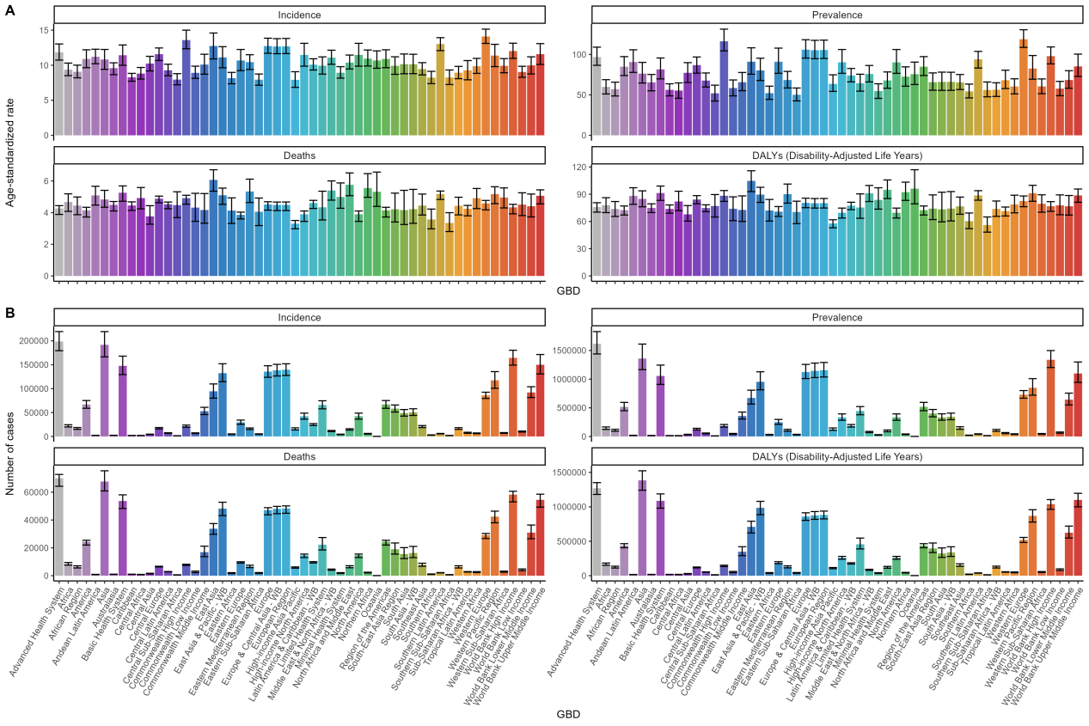

Supplementary figure 2. Number of cases and age-standardised rates of incidence, prevalence, mortality, DALYs for Parkinson’s disease in different GBD regions in2021

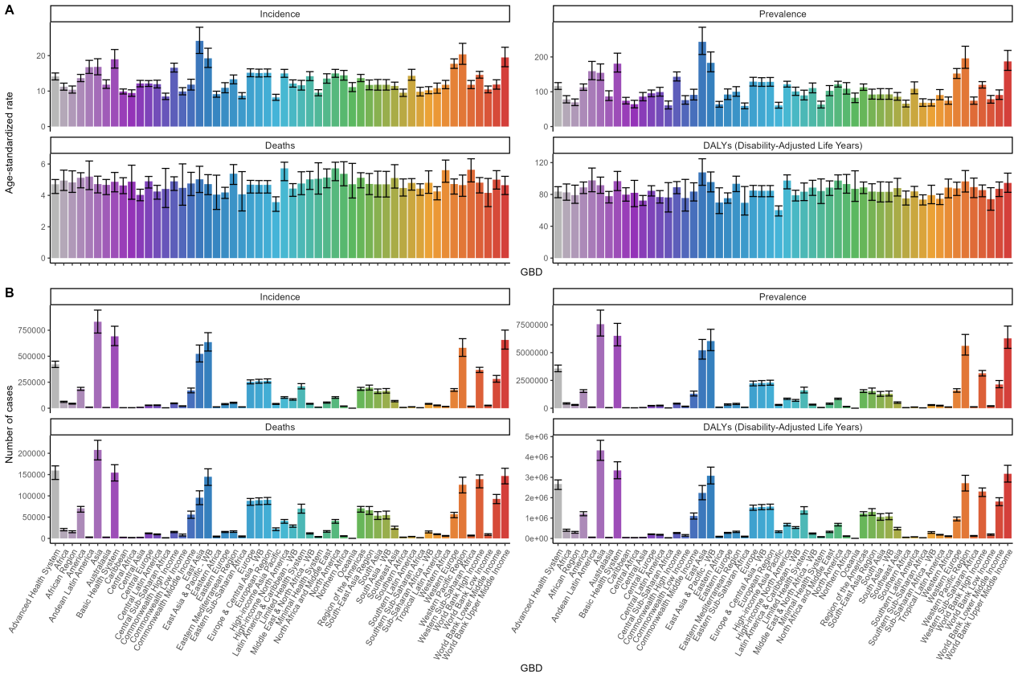

Supplementary figure 3. A hierarchical cluster analysis was conducted for regions based on the temporal trends in etiologies related to PD ASRs.
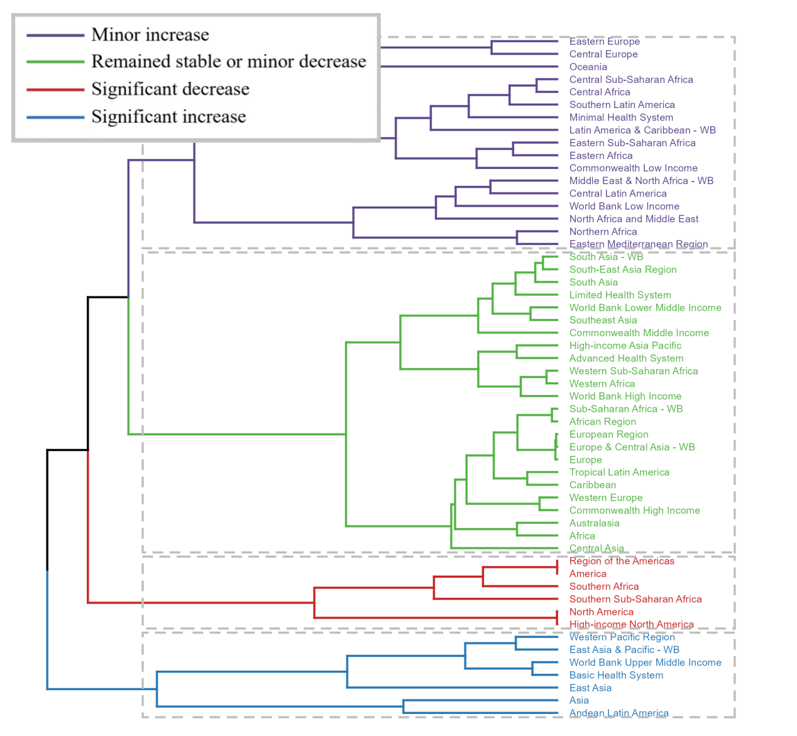

Supplementary figure 4.Number of cases and age-standardised rates of incidence, prevalence, mortality, DALYs for Parkinson’s disease at the national level in 1990

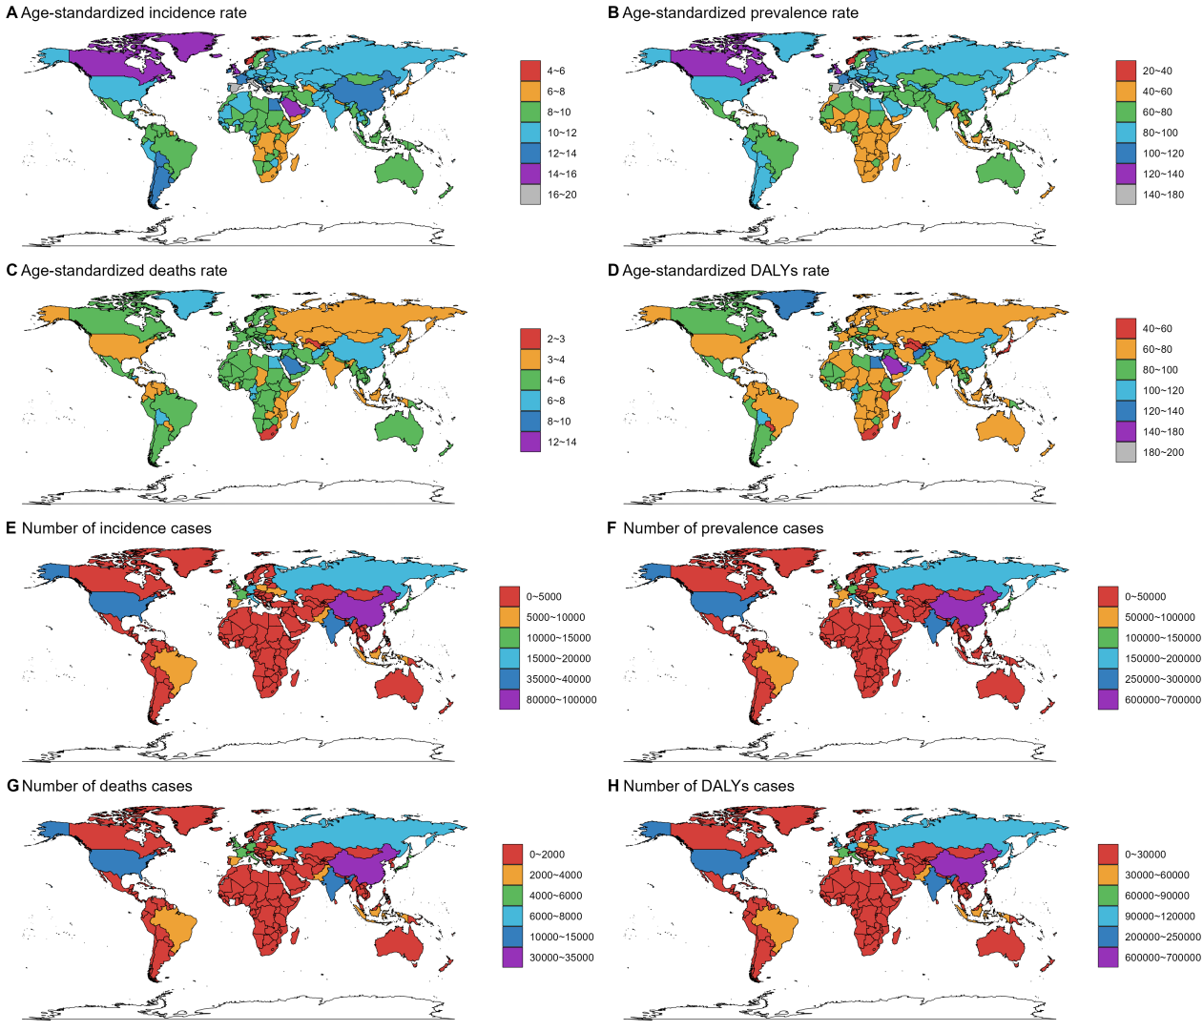

Supplementary figure 5.Number of cases and age-standardised rates of incidence, prevalence, mortality, DALYs for Parkinson’s disease at the national level in 2021
