Supplementary figures:
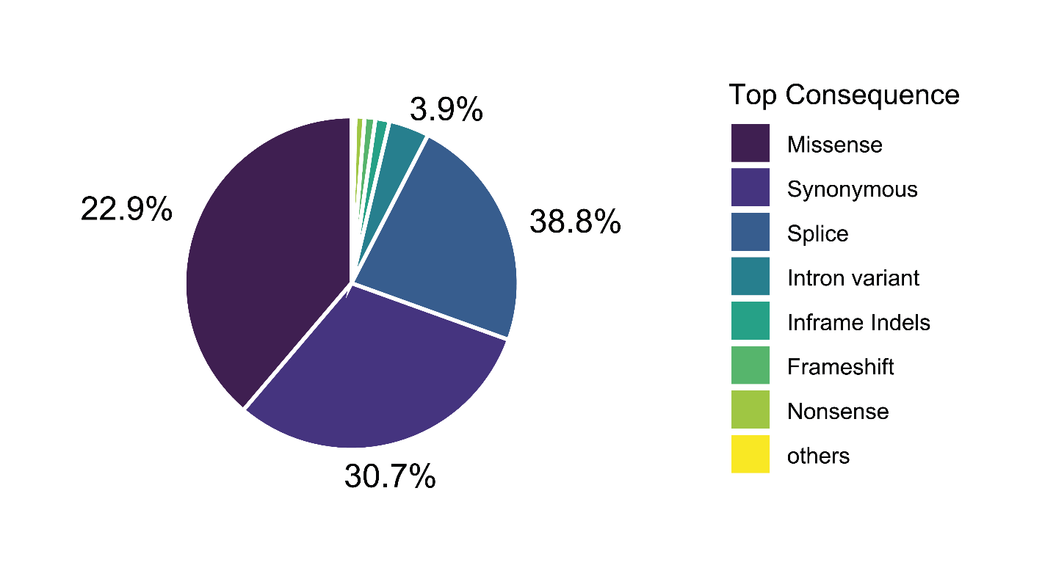
Figure S1: Top consequences of the variants across the exome
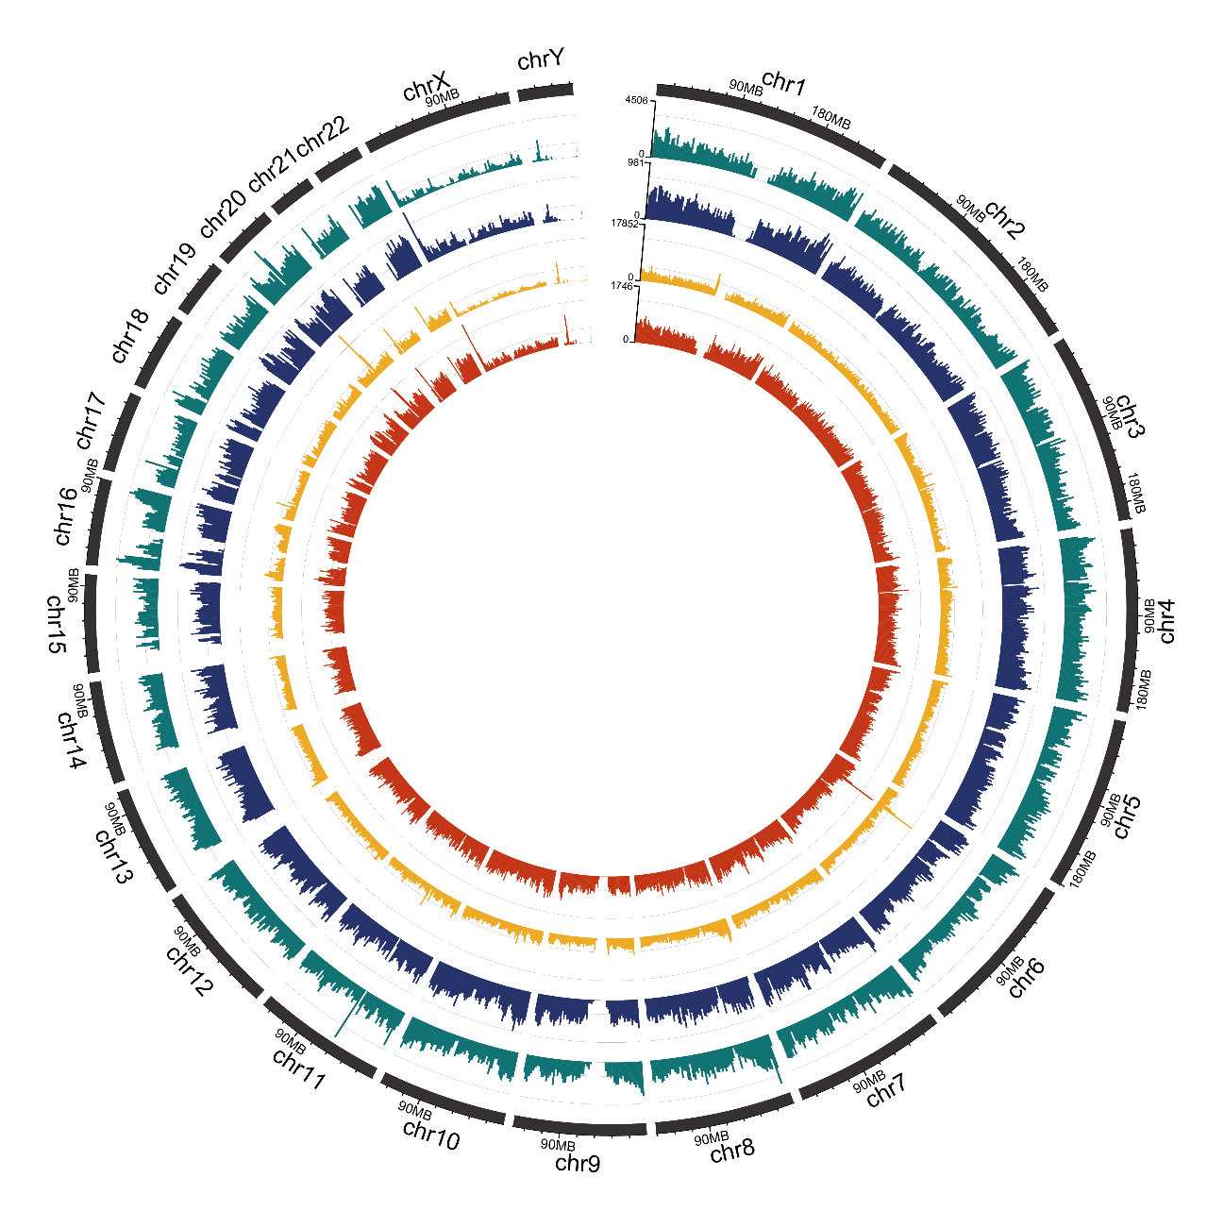

Figure S2: Impact of MMARG and GRCh38 References on Variant Calling: This circular plot illustrates the reduction in variant calls achieved by utilizing the MMARG compared to the standard GRCh38 reference. The outermost and second rings depict the density of single nucleotide variant (SNV) calls within 2Mb windows across the genome using GRCh38 and MMARG, respectively. The third and innermost rings show the distribution of insertions/deletions (indels) calls with GRCh38 and MMARG, respectively. (Note: Scales adjusted for visibility).

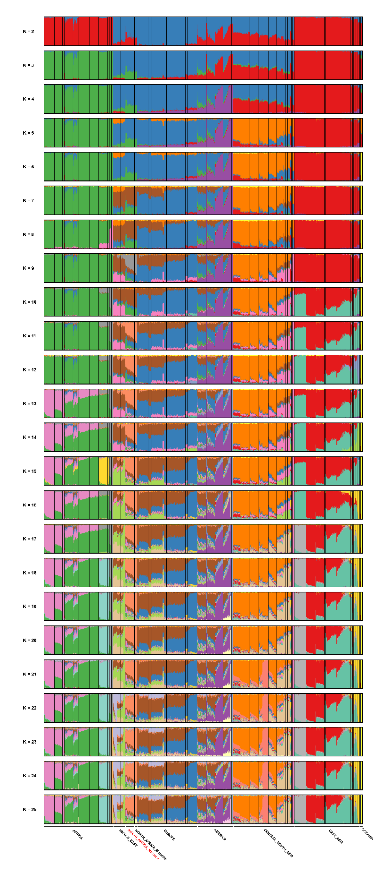
Figure S3: Admixture plot comprising clustering solutions from k = 2 to k = 25 of the 109 Moroccan genomes with 3,477 individuals from Africa, North Africa, Europe, America, Oceania, Asia and Middle east.

