Association Between Humidity and Lung Function: the 2016-2018 Korea National Health and Nutrition Examination Survey

Jinwoo Seok^{1†}, Bo young Lee^{1†}, Hee-Young Yoon^{1*}

¹Division of Allergy and Respiratory Diseases, Soonchunhyang University Seoul Hospital, Seoul, Republic of Korea

Table S1 Relative humidity across different lag days for the study participants
Lags | Mean | SD | Q1 | Q2 | Q3 | Q4
0 day | 64.5 | 14.9 | 21.0 | 54.6 | 65.5 | 76.0
1 day | 64.7 | 14.5 | 24.9 | 54.9 | 65.1 | 75.9
2 days | 64.8 | 14.3 | 20.5 | 55.3 | 64.6 | 75.4
3 days | 65.0 | 14.4 | 20.5 | 55.2 | 64.8 | 75.7
4 days | 64.2 | 14.4 | 20.5 | 54.2 | 64.7 | 74.8
5 days | 63.7 | 14.5 | 20.9 | 53.4 | 64.9 | 74.6
6 days | 64.2 | 15.0 | 18.5 | 54.0 | 65.3 | 75.0
7 days | 64.6 | 14.5 | 13.7 | 54.7 | 65.4 | 75.4
8 days | 64.2 | 14.2 | 13.7 | 54.6 | 65.3 | 74.9
9 days | 64.6 | 14.5 | 19.6 | 55.3 | 65.5 | 74.6
10 days | 64.8 | 14.9 | 19.6 | 54.7 | 65.7 | 75.4
11 days | 64.6 | 14.6 | 19.6 | 55.3 | 65.4 | 74.8
12 days | 64.6 | 14.5 | 21.1 | 55.2 | 65.5 | 75.1
13 days | 64.6 | 15.0 | 18.1 | 54.4 | 65.6 | 75.3
14 days | 65.0 | 15.1 | 18.1 | 54.4 | 65.6 | 76.1
30-day average | 64.8 | 8.9 | 38.0 | 58.3 | 64.4 | 70.8
60-day average | 65.1 | 8.2 | 45.5 | 59.0 | 64.4 | 70.5
90-day average | 65.2 | 7.7 | 46.8 | 59.7 | 64.3 | 70.5
120-day average | 65.3 | 7.3 | 50.0 | 59.7 | 64.4 | 70.3
150-day average | 65.5 | 6.9 | 50.0 | 60.1 | 64.8 | 70.2
180-day average | 65.6 | 6.4 | 50.0 | 60.6 | 64.9 | 70.0
1-year average | 66.0 | 5.1 | 55.0 | 61.9 | 65.1 | 70.6
2-year average | 66.5 | 5.2 | 57.2 | 62.4 | 65.2 | 71.3
3-year average | 66.9 | 5.1 | 57.1 | 62.9 | 65.4 | 71.9
4-year average | 67.5 | 4.9 | 57.6 | 63.4 | 66.0 | 72.2
5-year average | 67.8 | 4.7 | 57.8 | 63.9 | 66.9 | 72.5
Data presented in the table are relative humidity (%).
SD standard deviation, Q1 first quartile, Q2 second quartile, Q3 third quartile, Q4 fourth quartile

Table S2 Simple regression analysis of the effect of relative humidity on lung function over various time lags
 | FEV₁/FVC |  |  | FEV₁ |  |  | FVC
Lags | Beta, % | SE | p-value | Beta, % | SE | p-value | Beta, % | SE | p-value
0 day | -0.030 | 0.005 | <0.001 | -0.018 | 0.009 | 0.047 | 0.003 | 0.008 | 0.682
1 day | -0.034 | 0.005 | <0.001 | -0.019 | 0.009 | 0.035 | 0.004 | 0.008 | 0.666
2 days | -0.029 | 0.005 | <0.001 | -0.018 | 0.009 | 0.048 | -0.001 | 0.009 | 0.912
3 days | -0.025 | 0.005 | <0.001 | -0.022 | 0.009 | 0.016 | -0.009 | 0.008 | 0.281
4 days | -0.022 | 0.005 | <0.001 | -0.019 | 0.009 | 0.039 | -0.005 | 0.008 | 0.548
5 days | -0.022 | 0.005 | <0.001 | 0.006 | 0.009 | 0.505 | 0.018 | 0.008 | 0.033
6 days | -0.019 | 0.005 | <0.001 | 0.000 | 0.009 | 0.991 | 0.012 | 0.008 | 0.150
7 days | -0.024 | 0.005 | <0.001 | -0.023 | 0.009 | 0.010 | -0.014 | 0.008 | 0.106
8 days | -0.035 | 0.005 | <0.001 | -0.025 | 0.009 | 0.008 | -0.004 | 0.009 | 0.662
9 days | -0.034 | 0.005 | <0.001 | -0.020 | 0.009 | 0.031 | -0.001 | 0.008 | 0.939
10 days | -0.026 | 0.005 | <0.001 | -0.015 | 0.009 | 0.090 | -0.005 | 0.008 | 0.579
11 days | -0.018 | 0.005 | <0.001 | -0.014 | 0.009 | 0.127 | -0.010 | 0.008 | 0.237
12 days | -0.015 | 0.005 | 0.003 | -0.009 | 0.009 | 0.315 | -0.006 | 0.008 | 0.487
13 days | -0.018 | 0.005 | <0.001 | -0.015 | 0.009 | 0.082 | -0.011 | 0.008 | 0.166
14 days | -0.020 | 0.005 | <0.001 | -0.012 | 0.009 | 0.186 | -0.001 | 0.008 | 0.881
30-day average | -0.065 | 0.008 | <0.001 | -0.041 | 0.015 | 0.006 | -0.008 | 0.014 | 0.561
60-day average | -0.067 | 0.009 | <0.001 | -0.034 | 0.016 | 0.035 | -0.005 | 0.015 | 0.749
90-day average | -0.072 | 0.010 | <0.001 | -0.042 | 0.017 | 0.015 | -0.017 | 0.016 | 0.290
120-day average | -0.074 | 0.010 | <0.001 | -0.047 | 0.018 | 0.011 | -0.026 | 0.017 | 0.127
150-day average | -0.073 | 0.011 | <0.001 | -0.048 | 0.019 | 0.013 | -0.031 | 0.018 | 0.079
180-day average | -0.073 | 0.011 | <0.001 | -0.033 | 0.021 | 0.108 | -0.026 | 0.019 | 0.173
1-year average | -0.130 | 0.014 | <0.001 | -0.012 | 0.026 | 0.641 | 0.011 | 0.024 | 0.638
2-year average | -0.138 | 0.014 | <0.001 | -0.025 | 0.026 | 0.323 | 0.006 | 0.024 | 0.794
3-year average | -0.145 | 0.014 | <0.001 | -0.019 | 0.026 | 0.462 | 0.017 | 0.024 | 0.482
4-year average | -0.146 | 0.015 | <0.001 | -0.012 | 0.027 | 0.645 | 0.022 | 0.025 | 0.376
5-year average | -0.151 | 0.016 | <0.001 | -0.034 | 0.028 | 0.223 | 0.001 | 0.026 | 0.971
The beta coefficients (β) indicate the change in lung function parameters per unit increase in relative humidity.
FEV₁ forced expiratory volume per 1 second, FVC forced vital capacity, SE standard error

Fig. S1 Effect of various lagged relative humidity levels on obstructive lung disease.
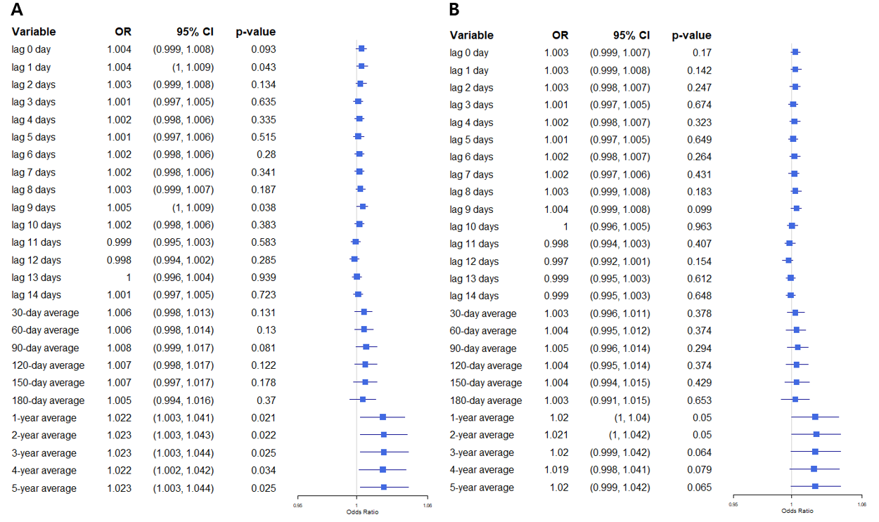
(A) Model 1: unadjusted model. (B) Model 2: adjusted for clinical variables.
This forest plot represents the ORs and 95% CIs for the effect of relative humidity at various lag periods on obstructive lung disease, as determined by univariate (A, Model 1) and multivariable (B, Model 2) logistic regression analysis. The X-axis displays the OR, and the variables on the Y-axis represent relative humidity lagged by different time periods, ranging from the same day (lag 0 day) to 5 years (5-year moving average).
OR odds ratio, CI confidence interval.

Fig. S2 Effect of various lagged relative humidity levels on obstructive lung disease based on obstruction severity.
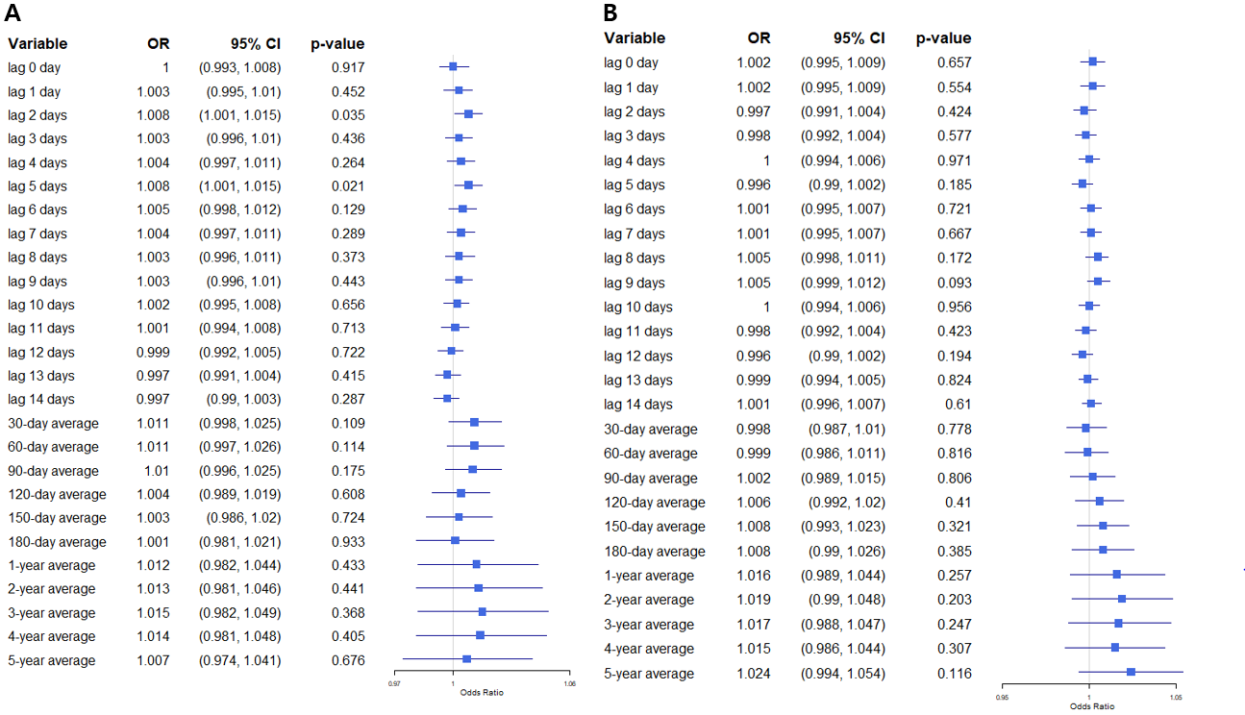
(A) Mild obstructive lung disease. (B) Moderate obstructive lung disease.
This forest plot represents the ORs and 95% CIs for the effect of relative humidity at various lag periods on (A) mild and (B) moderate obstructive lung disease, as determined by multivariable logistic regression analysis (Model 3). The X-axis displays the OR, and the variables on the Y-axis represent relative humidity lagged by different time periods, ranging from the same day (lag 0 day) to 5 years (5-year moving average).
OR odds ratio, CI confidence interval.

Fig. S3 Effect of various lagged relative humidity levels on restrictive lung disease.
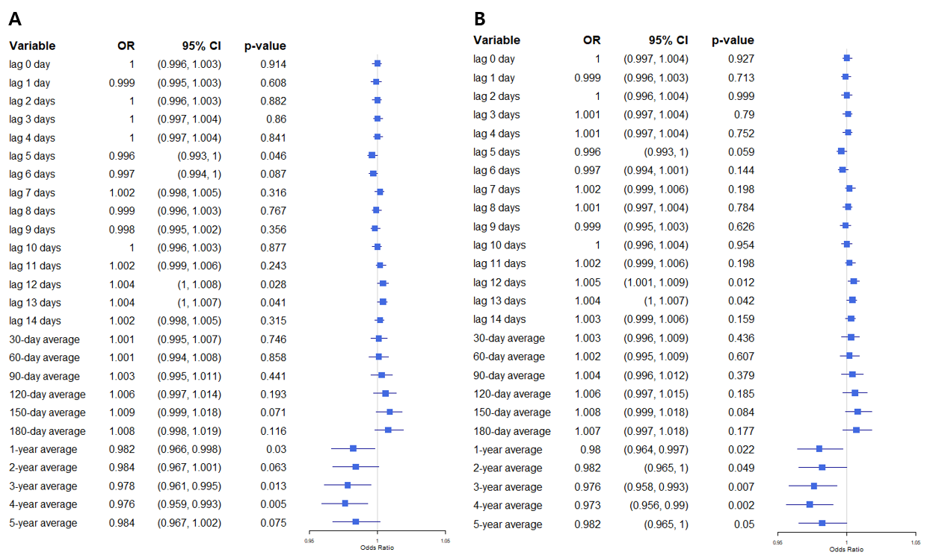
(A) Model 1: unadjusted model. (B) Model 2: adjusted for clinical variables.
This forest plot represents the ORs and 95% CIs for the effect of relative humidity at various lag periods on restrictive lung disease, as determined by univariate (A, Model 1) and multivariable (B, Model 2) logistic regression analysis. The X-axis displays the OR, and the variables on the Y-axis represent relative humidity lagged by different time periods, ranging from the same day (lag 0 day) to 5 years (5-year moving average).
OR odds ratio, CI confidence interval.

Fig. S4 Effect of various lagged relative humidity levels on chronic cough.
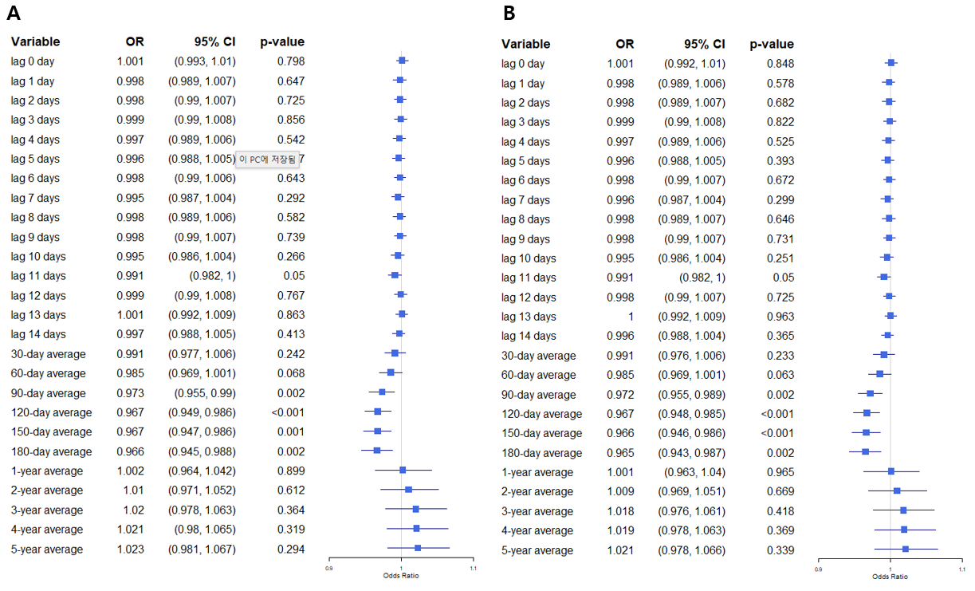
(A) Model 1: unadjusted model. (B) Model 2: adjusted for clinical variables.
This forest plot represents the ORs and 95% CIs for the effect of relative humidity at various lag periods on chronic cough, as determined by univariate (A, Model 1) and multivariable (B, Model 2) logistic regression analysis. The X-axis displays the OR, and the variables on the Y-axis represent relative humidity lagged by different time periods, ranging from the same day (lag 0 day) to 5 years (5-year moving average).
OR odds ratio, CI confidence interval.

Fig. S5 Effect of various lagged relative humidity levels on sputum production.
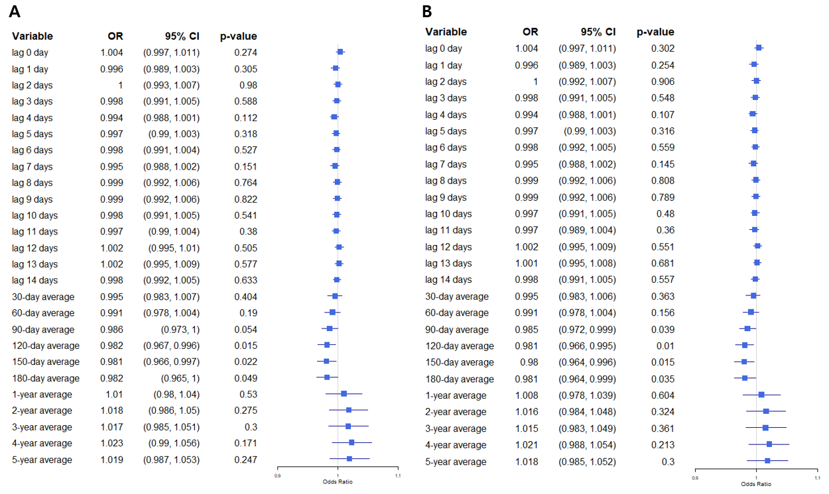
(A) Model 1: unadjusted model. (B) Model 2: adjusted for clinical variables.
This forest plot represents the ORs and 95% CIs for the effect of relative humidity at various lag periods on sputum production, as determined by univariate (A, Model 1) and multivariable (B, Model 2) logistic regression analysis. The X-axis displays the OR, and the variables on the Y-axis represent relative humidity lagged by different time periods, ranging from the same day (lag 0 day) to 5 years (5-year moving average).
OR odds ratio, CI confidence interval.

