Supplementary materials

Occurrence, partition behavior and environmental risk of PAHs in water and sediment of a typical Karst wetland, southwest China

Li Xinª; Xinli Xing ^{a, b *}, Cheng Chengª, Weijie Liu ª, Zou Yanminª Tianpeng Huª, Zhang Yuanª, Shihua Qi ^{a, b}
a, School of Environmental Studies, China University of Geosciences, Wuhan 430074, China
b, State Key Laboratory of Biogeology and Environmental Geology, China University of Geosciences, Wuhan 430074, China
c, Hubei Key Laboratory of Mine Environmental Pollution Control and Remediation, School of Environmental Science and Engineering, Hubei Polytechnic University, Huangshi, 435003, China
* To whom correspondence should be addressed Email: xlxing@cug.edu.cn

Contents of this file
- Texts
Text S1 Detail of GC-MS analysis
Text S2 Detail of PMF model running
Text S3 Detail of TOC analysis

- Tables
Table S1. Basic statistical parameters of PAHs in water (ng·L⁻¹) and sediment (ng·g⁻¹) during dry and wet season in Huixian Wetland
Table S2. The effects range-low (ERL), effects range median (ERM), and threshold effect levels (TEL) and probable effect levels (PEL) in concentration ranges for PAHs ng·g⁻¹
Table S3. Risk level of individual PAHs and Σ₁₆PAH
Table S4. The methods detection limit (MDL) for 16 PAHs
Table S5. Species category and the correlation between observed and predicted concentrations in
sediment during the dry season of chemistry species obtained from PMF model
Table S6. DISP error estimation of PMF model in sediment during the dry season
Table S7. Mapping of bootstrap factors to constrained factors in sediment during the dry season for the PMF model
Table S8. Species category and the correlation between observed and predicted concentrations in
sediment during the wet season of chemistry species obtained from PMF model
Table S9. DISP error estimation of PMF model in sediment during the wet season
Table S10. Mapping of bootstrap factors to constrained factors in sediment during the wet season for the PMF model
Table S11. Species category and the correlation between observed and predicted concentrations in
water during the dry season of chemistry species obtained from PMF model
Table S12. DISP error estimation of PMF model in water during the dry season
Table S13. Mapping of bootstrap factors to constrained factors in water during the dry season for
the PMF model
Table S14. Species category and the correlation between observed and predicted concentrations in
water during the wet season of chemistry species obtained from PMF model.
Table S15. DISP error estimation of PMF model in water during the wet season
Table S16. Mapping of bootstrap factors to constrained factors in water during the wet season for
the PMF model

- Figures
Fig S1. Diagnostic ratios of PAHs in the sediment: (a)sediment, (b)water
Fig S2. Measured and predicted values of PAHs in dry and wet seasons in the Huixian Wetland
based on PMF model
Fig S3. Cosine theta similarity metric (cos θ) at different sampling sites in the Huixian Wetland in dry and wet seasons
Text S1 Detail of GC-MS analysis
A gas chromatography-mass spectrometry (GC-MS, Agilent 7890 N GC-5975MSD) installed with a DB-5MS capillary column (30 m × 0.25 mm × 0.25 μm, Agilent, USA) was used to analyze the target 16 PAHs. The carrier gas was helium (purity > 99.999%) at a constant flow rate of 1.2 mL·min⁻¹. The Temperature of GC inlet was 280℃ and the temperature program of GC oven as follows: initial temperature was 80℃ for 2 min, then increased to 290℃ at a rate of 4℃ min⁻¹ and held for 25 min. And with the condition of mass spectrum of electronic impact (EI) ionization, the energy of ionization was 70 eV, the ionization temperature was 230℃. Five standard solutions (0.2, 1, 2, 5, and 10 mg L⁻¹) were used to establish the calibration curve, and target PAHs were qualified by selected ions at certain retention time and quantified with an internal standard. 16 priority PAHs include naphthalene (Nap), acenaphthylene (Acy), acenaphthene (Ace), fluorene (Flu), phenanthrene (Phe), anthracene (Ant), fluoranthene (Fla), pyrene (Pyr), benzo[a]anthracene (BaA), chrysene (Chr), benzo[b]fluoranthene (BbF), benzo[k]fluoranthene(BkF), benzo[e]pyrene (BeP), benzo[a]pyrene(BaP), indeno [1,2,3-cd] pyrene (IcdP), dibenz[a,h]anthracene (DiBahA), benzo[g,h,i]perylene (BghiP).

Text S2 Detail of PMF model running
PMF is a multivariate factor analysis tool that decomposes a matrix of speciated sample data into two matrices: factor contributions (G) and factor profiles (F). The species profile f of each source, and the amount of mass g contributed by each factor to each sample (Equation 1):
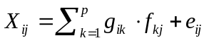 (1)
where X_{ij} was the concentration of j_{th} measured species in the i_{th} sample; g_{ik} represented the contribution of the k_{th} source to the i_{th} sample; f_{kj} represented the mass fraction of the j_{th} compound from the k_{th} source; e_{ij} was the residual for each sample/species.
The method detection limit (MDL) and measurement uncertainties (MU%) are employed to calculate the uncertainty of each sample based on the following equations:
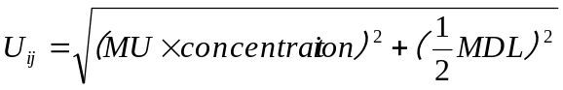 (2)
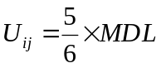 (3)
When the species concentration is higher than its MDL, Eq. (2) is used to calculate the uncertainty. Otherwise, Eq. (3) is used. For the PMF model, species category was decided into strong, weak and bad based on the signal-noise ratio (S/N): strong (S/N>1), weak (0.5<S/N<1) and bad (S/N<0.5). All species category and the correlation between observed and predicted concentrations of chemistry species were shown in Table S5, 8, 11, 14. We run different number factors (2-6) for the optimum result of PMF model. The contrast of PAHs between observed and predicted concentrations were presented in Fig S3. In this study, we considered 4 factors as the optimal solution in water, and 3 in sediment. Meanwhile, the analytical residuals of the selected chemical species were mainly distributed in the range of -3 to 3, which indicated that the modeling was representative.
The DISP clearly investigate the rotational ambiguity in a PMF solution by assessing the largest range of source profile values without an appreciable increase in the Q-value. DISP error estimation of PMF model was shown in Table S6-S7, S9-S10, S12-13, S15-16. Error code was 0 means no error; 6 or 9 indicates that the run was aborted. If this first value is non-zero, the DISP analysis results are considered invalid. The second value is the largest observed drop of Q during DISP. The selected results were evaluated by running different F_{peak} strength (±0.5, ±1, 1.5) to assess the stability of the operating results of the selected source factors. As value was -0.5, the most reasonable source profile was presented by F_{peak} strength.
Text S3 Detail of TOC analysis
The dried and ground sediment sample (0.5 g) was added with 1 mol· L⁻¹ hydrochloric acid to remove the inorganic carbon until no bubbles appeared and the reaction was complete, measurements were made with Vario TOC cube total organic carbon analyzer (Elementar, Germany).
Table S1. Basic statistical parameters of PAHs in water (ng·L⁻¹) and sediment (ng·g⁻¹) during dry and wet seasons in Huixian Wetland
Compounds | Aromatic  rings | Concentration in water (ng/L) |  |  |  |  |  |  |  | Concentration in sediment (ng/g)
Compounds | Aromatic  rings | Dry season |  |  |  | Wet season |  |  |  | Dry season |  |  |  | Wet season
Compounds | Aromatic  rings | Min. | Max. | Mean | Standard  deviation | Min. | Max. | Mean | Standard  deviation | Min. | Max. | Mean | Standard  deviation | Min. | Max. | Mean | Standard  deviation
Nap | 2 | 13.65 | 82.56 | 39.05 | 14.06 | 4.31 | 324.62 | 55.36 | 54.74 | 4.96 | 26.64 | 14.20 | 5.24 | 4.96 | 26.64 | 14.20 | 5.24
Acy | 3 | 1.42 | 18.11 | 6.36 | 3.09 | 0.30 | 31.29 | 4.45 | 4.26 | 0.55 | 147.24 | 20.13 | 22.69 | 0.55 | 147.24 | 20.13 | 22.69
Ace | 3 | 0.43 | 5.97 | 2.31 | 0.89 | 0.14 | 17.57 | 3.12 | 3.04 | 0.41 | 173.99 | 14.64 | 19.12 | 0.41 | 173.99 | 14.64 | 19.12
Flu | 3 | 4.64 | 46.74 | 19.86 | 8.58 | 0.35 | 124.51 | 21.89 | 21.41 | 1.70 | 291.86 | 33.75 | 40.18 | 1.70 | 291.86 | 33.75 | 40.18
Phe | 3 | 17.67 | 136.69 | 62.84 | 26.25 | 1.88 | 253.72 | 49.67 | 47.46 | 5.46 | 1195.70 | 137.26 | 162.48 | 5.46 | 1195.70 | 137.26 | 162.48
Ant | 3 | 0.30 | 9.92 | 2.20 | 1.07 | 0.04 | 22.48 | 3.46 | 3.86 | 0.40 | 140.99 | 20.16 | 23.95 | 0.40 | 140.99 | 20.16 | 23.95
Fla | 4 | 4.97 | 55.40 | 26.08 | 10.62 | 0.64 | 57.10 | 11.45 | 10.27 | 1.91 | 870.64 | 103.82 | 110.00 | 1.91 | 870.64 | 103.82 | 110.00
Pyr | 4 | 2.58 | 43.09 | 14.27 | 6.03 | 0.32 | 26.94 | 6.39 | 5.45 | 1.43 | 790.47 | 87.11 | 94.41 | 1.43 | 790.47 | 87.11 | 94.41
BaA | 4 | 1.24 | 10.48 | 2.16 | 0.80 | 0.64 | 3.17 | 0.97 | 0.27 | 0.44 | 481.66 | 47.07 | 54.06 | 0.44 | 481.66 | 47.07 | 54.06
Chr | 4 | 0.60 | 11.40 | 2.72 | 1.46 | 0.29 | 1.92 | 0.77 | 0.42 | 0.28 | 864.74 | 80.61 | 89.90 | 0.28 | 864.74 | 80.61 | 89.90
BbF | 5 | 0.07 | 7.01 | 0.71 | 0.71 | 0.02 | 1.10 | 0.13 | 0.12 | 0.20 | 738.97 | 66.82 | 72.41 | 0.20 | 738.97 | 66.82 | 72.41
BkF | 5 | 0.13 | 5.13 | 0.89 | 0.70 | 0.08 | 1.07 | 0.31 | 0.16 | 0.09 | 434.94 | 40.33 | 43.82 | 0.09 | 434.94 | 40.33 | 43.82
BaP | 5 | 0.12 | 9.04 | 0.93 | 0.78 | 0.09 | 0.75 | 0.28 | 0.15 | 0.09 | 866.98 | 74.22 | 84.18 | 0.09 | 866.98 | 74.22 | 84.18
DahA | 5 | 0.01 | 1.77 | 0.29 | 0.28 | 0.03 | 0.30 | 0.11 | 0.06 | 0.05 | 201.32 | 19.08 | 20.82 | 0.05 | 201.32 | 19.08 | 20.82
IcdP | 6 | 0.07 | 3.46 | 0.38 | 0.33 | 0.01 | 0.42 | 0.08 | 0.05 | 0.10 | 875.15 | 90.81 | 93.14 | 0.10 | 875.15 | 90.81 | 93.14
BghiP | 6 | 0.02 | 7.47 | 0.75 | 0.67 | 0.08 | 0.34 | 0.18 | 0.04 | 0.63 | 916.09 | 98.84 | 100.00 | 0.63 | 916.09 | 98.84 | 100.00

Table S2 The effects range-low (ERL), effects range median (ERM), and threshold effect levels (TEL) and probable effect levels (PEL) in concentration ranges for PAHs ng·g⁻¹
PAHs | ERL-ERM | TEL-PEL | Dry season |  |  |  |  |  |  | Wet season
PAHs | ERL-ERM | TEL-PEL | Range  (ng/g) | Stations |  |  |  |  |  | Range  (ng/g) | Stations
 |  |  |  | ＜ERL | ERL-ERM | ＞ERM | ＜TEL | TEL-PEL | ＞PEL | Range  (ng/g) | ＜ERL | ERL-ERM | ＞ERM | ＜TEL | TEL-PEL | ＞PEL
NaP | 160-2100 | 34.6-391 | 0.29-37.01 | 28 | 0 | - | 28 | 0 | - | 4.96-26.64 | 29 | 0 | - | 29 | 0 | -
Acy | 16-500 | 6.71-88.9 | 0.62-132.33 | 20 | 8 | - | 20 | 8 | - | 0.55-147.24 | 21 | 8 | - | 21 | 8 | -
Ace | 44-640 | NA | 0.39-82.29 | 26 | 2 | - | 26 | 2 | - | 0.41-173.99 | 26 | 3 | - | 26 | 3 | -
Flu | 19-540 | 21.2-144 | 1.33-199.83 | 23 | 5 | - | 23 | 5 | - | 1.70-291.86 | 21 | 8 | - | 21 | 8 | -
Phe | 240-1500 | 86.7-544 | 3.43-623.3 | 26 | 2 | - | 26 | 2 | - | 5.46-1195.7 | 24 | 5 | - | 24 | 5 | -
Ant | 85.3-1100 | 46.9-245 | 0.24-136.94 | 27 | 1 | - | 27 | 1 | - | 0.40-140.99 | 26 | 3 | - | 26 | 3 | -
Fla | 600-5100 | 133-1494 | 2.07-816.48 | 27 | 1 | - | 27 | 1 | - | 1.91-870.64 | 28 | 1 | - | 28 | 1 | -
Pyr | 665-2600 | 153-1398 | 1.02-680.29 | 27 | 1 | - | 27 | 1 | - | 1.43-790.47 | 28 | 1 | - | 28 | 1 | -
BaA | 261-1600 | 74.8-693 | 0.41-382.44 | 27 | 1 | - | 27 | 1 | - | 0.44-481.66 | 28 | 1 | - | 28 | 1 | -
Chr | 384-2800 | 108-846 | 0.63-539.84 | 27 | 1 | - | 27 | 1 | - | 0.28-864.74 | 28 | 1 | - | 28 | 1 | -
BbF | 320-1880 | NA | 0.43-424.43 | 27 | 1 | - | 27 | 1 | - | 0.20-738.97 | 28 | 1 | - | 28 | 1 | -
BkF | 280-1620 | NA | 0.50-244.38 | 28 | 0 | - | 28 | 0 | - | 0.09-434.94 | 28 | 1 | - | 28 | 1 | -
BaP | 430-1600 | 88.8-763 | 0.26-463.70 | 27 | 1 | - | 27 | 1 | - | 0.09-866.98 | 28 | 1 | - | 28 | 1 | -
DahA | 63.4-260 | 6.22-135 | 0.10-94.83 | - | - | - | - | - | - | 0.05-201.32 | - | - | - | - | - | -
IcdP | NA | NA | 0.13-381.49 | 27 | 1 | - | 27 | 1 | - | 0.10-875.15 | 27 | 2 | - | 27 | 2 | -
BghiP | 430-1600 | NA | 0.57-428.92 | 28 | 0 | - | 28 | 0 | - | 0.63-916.09 | 28 | 1 | - | 28 | 1 | -

Table S3. Risk level of individual PAHs and Σ₁₆PAH
Single PAHs |  |  | ∑₁₆PAHs
Risk level | RQ_{(NCs)} | RQ_{(MCPs)} | Risk level | RQ_{(NCs)} | RQ_{(MCPs)}
 |  |  | no risk | =0
low risk | ＜1 |  | low risk | ≥1;＜800 | =0
moderate risk | ≥1 | ＜1 | moderate risk 1 | ≥800 | =0
 |  |  | moderate risk 2 | ＜800 | ≥1
high risk |  | ≥1 | high risk | ≥800 | ≥1

Table S4. The methods detection limit (MDL) for 16 PAHs
Compounds | MDL(ng·m⁻³) | Compounds | MDL(ng·m⁻³)
Nap | 0.0012 | BaA | 0.0090
Acy | 0.0027 | Chr | 0.0043
Ace | 0.0030 | BbF | 0.0068
Flu | 0.0059 | BkF | 0.0068
Phe | 0.0059 | BaP | 0.0089
Ant | 0.0078 | IcdP | 0.0076
Fla | 0.0040 | DaA | 0.0044
Pyr | 0.0060 | BghiP | 0.0081

Table S5. Species category and the correlation between observed and predicted concentrations in sediment during the dry season of chemistry species obtained from PMF model
Species | Category | Slope | R² | Species | Category | Slope | R²
Nap | Strong | 0.9843 | 0.9958 | BaA | Strong | 0.8689 | 0.9943
Acy | Strong | 0.9091 | 0.9583 | Chr | Strong | 0.9253 | 0.9991
Ace | Strong | 0.6856 | 0.9619 | BbF | Strong | 0.9389 | 0.9975
Flu | Strong | 0.9202 | 0.9885 | BkF | Strong | 0.9762 | 0.9985
Phe | Strong | 1.0666 | 0.9695 | BaP | Strong | 0.8789 | 0.9964
Ant | Strong | 0.9645 | 0.9604 | IcdP | Strong | 1.1617 | 0.9940
Fla | Strong | 0.9897 | 0.9902 | DahA | Strong | 0.9221 | 0.9742
Pyr | Strong | 0.9156 | 0.9900 | BghiP | Strong | 1.1805 | 0.9913

Table S6. DISP error estimation of PMF model in sediment during the dry season
Error code | Drop of %dQ | - | Factor 1 | Factor 2 | Factor 3
0 | -0.0130 | Swaps by Factor | 0 | 0 | 0

Table S7. Mapping of bootstrap factors to constrained factors in sediment
during the dry season period for the PMF model
 | Factor 1 | Factor 2 | Factor 3 | Unmapped
Boot Factor 1 | 100 | 0 | 0 | 0
Boot Factor 2 | 0 | 99 | 0 | 1
Boot Factor 3 | 0 | 0 | 100 | 0

Table S8. Species category and the correlation between observed and predicted concentrations in sediment during the wet season of chemistry species obtained from PMF model
Species | Category | Slope | R² | Species | Category | Slope | R²
Nap | Strong | 1.0356 | 0.9953 | BaA | Strong | 0.8674 | 0.9938
Acy | Strong | 1.2065 | 0.9686 | Chr | Strong | 0.9501 | 0.9977
Ace | Strong | 0.9072 | 0.9880 | BbF | Strong | 0.9904 | 0.9961
Flu | Strong | 0.9433 | 0.9970 | BkF | Strong | 1.0292 | 0.9965
Phe | Strong | 0.8385 | 0.9503 | BaP | Strong | 0.9297 | 0.9955
Ant | Strong | 0.8956 | 0.9949 | IcdP | Strong | 1.0813 | 0.9968
Fla | Strong | 0.9420 | 0.9951 | DahA | Strong | 1.0306 | 0.9974
Pyr | Strong | 0.8747 | 0.9909 | BghiP | Strong | 1.0953 | 0.9898

Table S9. DISP error estimation of PMF model in sediment during the wet season
Error code | Drop of %dQ | - | Factor 1 | Factor 2 | Factor 3
0 | -0.0102 | Swaps by Factor | 0 | 0 | 0

Table S10. Mapping of bootstrap factors to constrained factors in sediment
during the wet season for the PMF model
 | Factor 1 | Factor 2 | Factor 3 | Unmapped
Boot Factor 1 | 95 | 5 | 0 | 0
Boot Factor 2 | 0 | 100 | 0 | 0
Boot Factor 3 | 3 | 0 | 97 | 0

Table S11. Species category and the correlation between observed and predicted concentrations in water during the dry season of chemistry species obtained from PMF model
Species | Category | Slope | R² | Species | Category | Slope | R²
Nap | Strong | 0.9878 | 0.9995 | BaA | Weak | 0.8056 | 0.7812
Acy | Strong | 0.9835 | 0.9916 | Chr | Strong | 0.9224 | 0.9705
Ace | Strong | 0.8085 | 0.7233 | BbF | Strong | 0.7170 | 0.8845
Flu | Strong | 1.0100 | 0.9781 | BkF | Weak | 0.7754 | 0.7624
Phe | Strong | 1.0073 | 0.9963 | BaP | Weak | 0.6429 | 0.7753
Ant | Strong | 0.7887 | 0.8911 | IcdP | Weak | 0.6641 | 0.7428
Fla | Strong | 0.9852 | 0.9893 | BghiP | Weak | 0.5401 | 0.6507
Pyr | Strong | 0.9177 | 0.9839

Table S12. DISP error estimation of PMF model in water during the dry season
Error code | Drop of %dQ | - | Factor 1 | Factor 2 | Factor 3 | Factor 4
0 | -0.3037 | Swaps by Factor | 15 | 16 | 28 | 13

Table S13. Mapping of bootstrap factors to constrained factors in water
during the dry season for the PMF model
 | Factor 1 | Factor 2 | Factor 3 | Factor 4 | Unmapped
Boot Factor 1 | 95 | 3 | 1 | 1 | 0
Boot Factor 2 | 8 | 91 | 0 | 1 | 0
Boot Factor 3 | 23 | 15 | 54 | 8 | 0
Boot Factor 4 | 3 | 0 | 1 | 96 | 0

Table S14. Species category and the correlation between observed and predicted concentrations in water during the wet season of chemistry species obtained from PMF model.
Species | Category | Slope | R² | Species | Category | Slope | R²
Nap | Strong | 1.0110 | 0.9987 | Fla | Strong | 1.0008 | 0.9950
Acy | Strong | 0.9394 | 0.9767 | Pyr | Strong | 1.0034 | 0.9936
Ace | Strong | 0.9820 | 0.9741 | BaA | Strong | 1.1868 | 0.6724
Flu | Strong | 1.0071 | 0.9985 | Chr | Strong | 1.1309 | 0.8100
Phe | Strong | 0.9847 | 0.9962 | BbF | Weak | 0.3652 | 0.3157
Ant | Strong | 0.9940 | 0.9995 | BkF | Weak | 0.6570 | 0.3939

Table S15. DISP error estimation of PMF model in water during the wet season
Error code | Drop of %dQ | - | Factor 1 | Factor 2 | Factor 3 | Factor 4
0 | -0.0202 | Swaps by Factor | 3 | 15 | 11 | 19

Table S16. Mapping of bootstrap factors to constrained factors in water
during the wet season for the PMF model
 | Factor 1 | Factor 2 | Factor 3 | Factor 4 | Unmapped
Boot Factor 1 | 100 | 0 | 0 | 0 | 0
Boot Factor 2 | 6 | 90 | 1 | 3 | 0
Boot Factor 3 | 3 | 2 | 84 | 8 | 3
Boot Factor 4 | 24 | 4 | 4 | 66 | 2

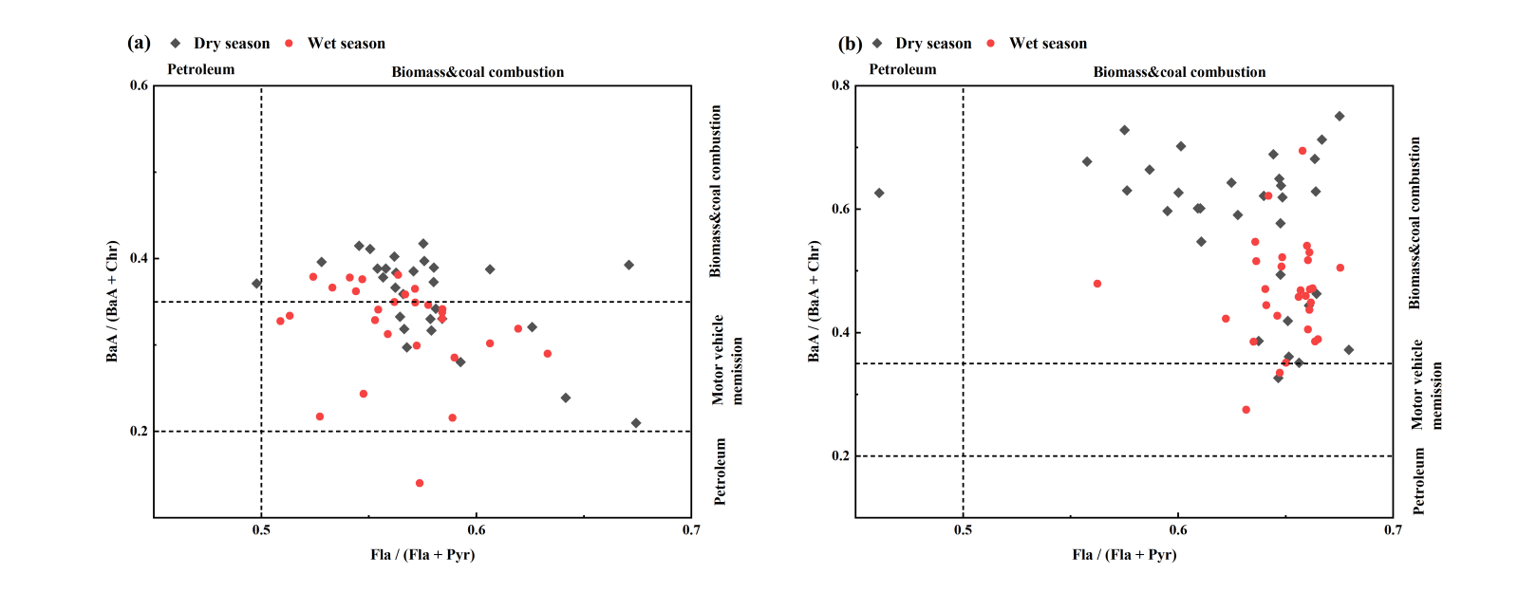
Fig.S1 Diagnostic ratios of PAHs in the wet and dry seasons: (a)sediment, (b)water
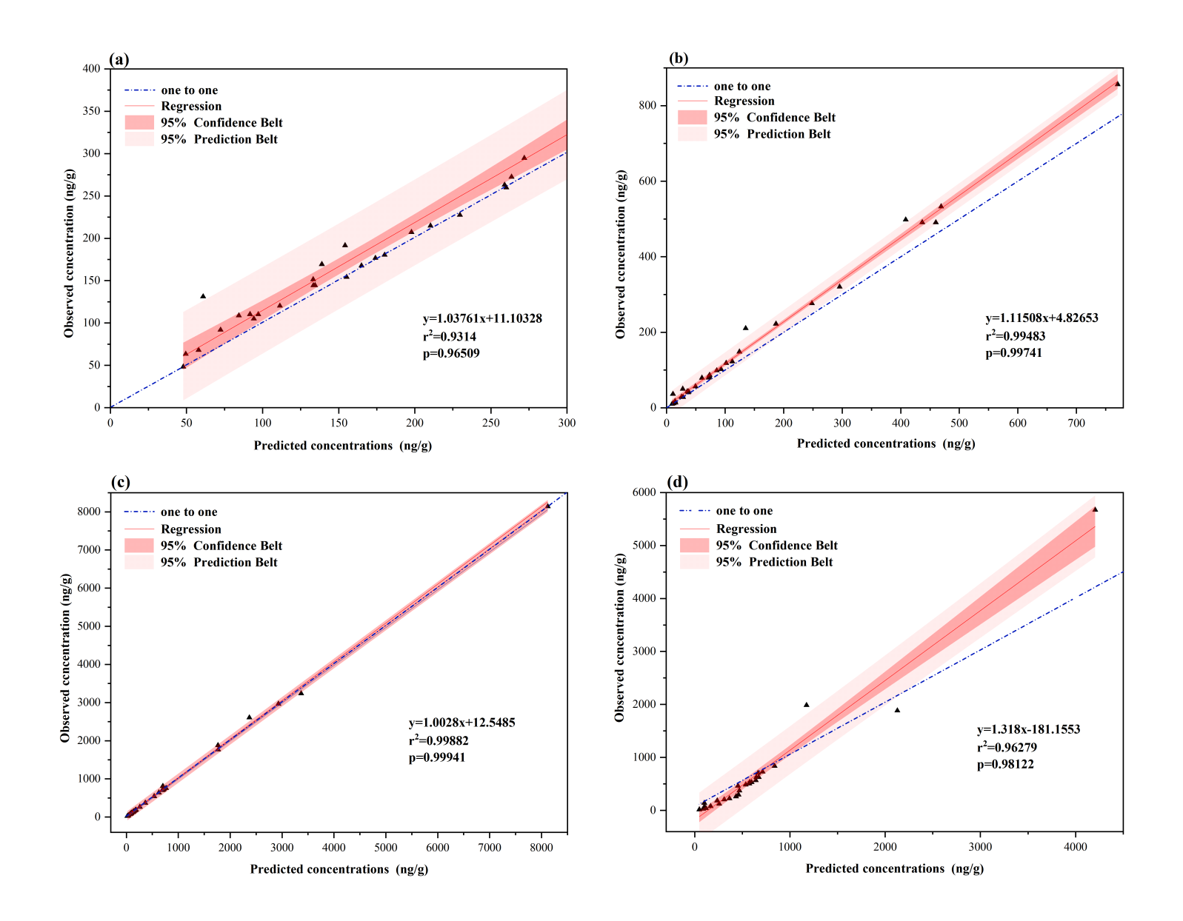
Fig. S2 Measured and predicted values of PAHs in dry and wet seasons in the Huixian Wetland based on PMF model
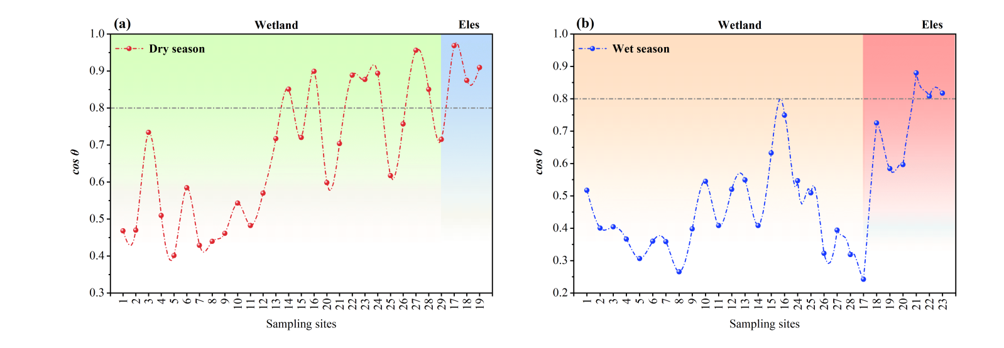
Fig.S3 Cosine theta similarity metric (cos θ) at different sampling sites in the Huixian Wetland in(a) dry season and (b)wet season.

