Additional file for
A new method for measuring very high resistances in dry rocks with high contact resistance
Takeshi Suzuki, Ryokei Yoshimura, Ken'ichi Yamazaki, Naoto Oshiman

To demonstrate that sample resistivity can be determined by our estimation process regardless of the arrangement of the current and potential electrodes, we derived the resistivity of a conductive plastic sample repeatedly while changing the electrode arrangement.
The cylindrical plastic measurement target (52 mm diameter, 100 mm length) (MC501CD R2, Mitsubishi Chemical Advanced Materials, Tokyo, Japan) used here is shown in Fig. S1(A). The manufacturer gives representative resistivity data for this conductive plastic as 10⁰–10² Ω·m at 23 °C (Mitsubishi Chemical Advanced Materials, 2020), although the accuracy of the data is not guaranteed.
The electrodes were conductive epoxy adhesive (CW2400 Epoxy, Chemtronics, Mansfield, England). A small electrode area of 100 mm² was used here, as for the dry granite sample (Fig. S1(B)).
We adopted the measurement set-up and measurement method described in the main text. However, a constant current source (R6243, ADC, Saitama, Japan) was used as a current source instead of a resistance meter with high input resistance. This is because the conductive plastic’s low resistivity requires a current source that can inject large current to create a detectable potential difference. The instrumentation for measurements was otherwise the same as described in the main text.
The measurements used the nine electrodes shown in Fig. S1 (C) for the multiple electrode arrangement. Measurement results for several electrode combinations are provided in Additional Table S1. In each layout, the potential difference between two potential electrodes and the injected current were measured. Sample resistivity was determined as described in the main text. As representative data for the sample’s resistivity are known, we can assess whether our estimation was correct and whether it depended on the electrode arrangement.
Sample resistivity was estimated as about 5 Ω·m from the results in Additional Table S1, which is within the range of the representative data. This agreement indicates the validity of the estimation process for sample resistivity, and therefore sample resistance. The fluctuation (standard deviation) of determined values was about 2 Ω·m. This precision does not affect the discussion of the log-scale graphs in the main text.

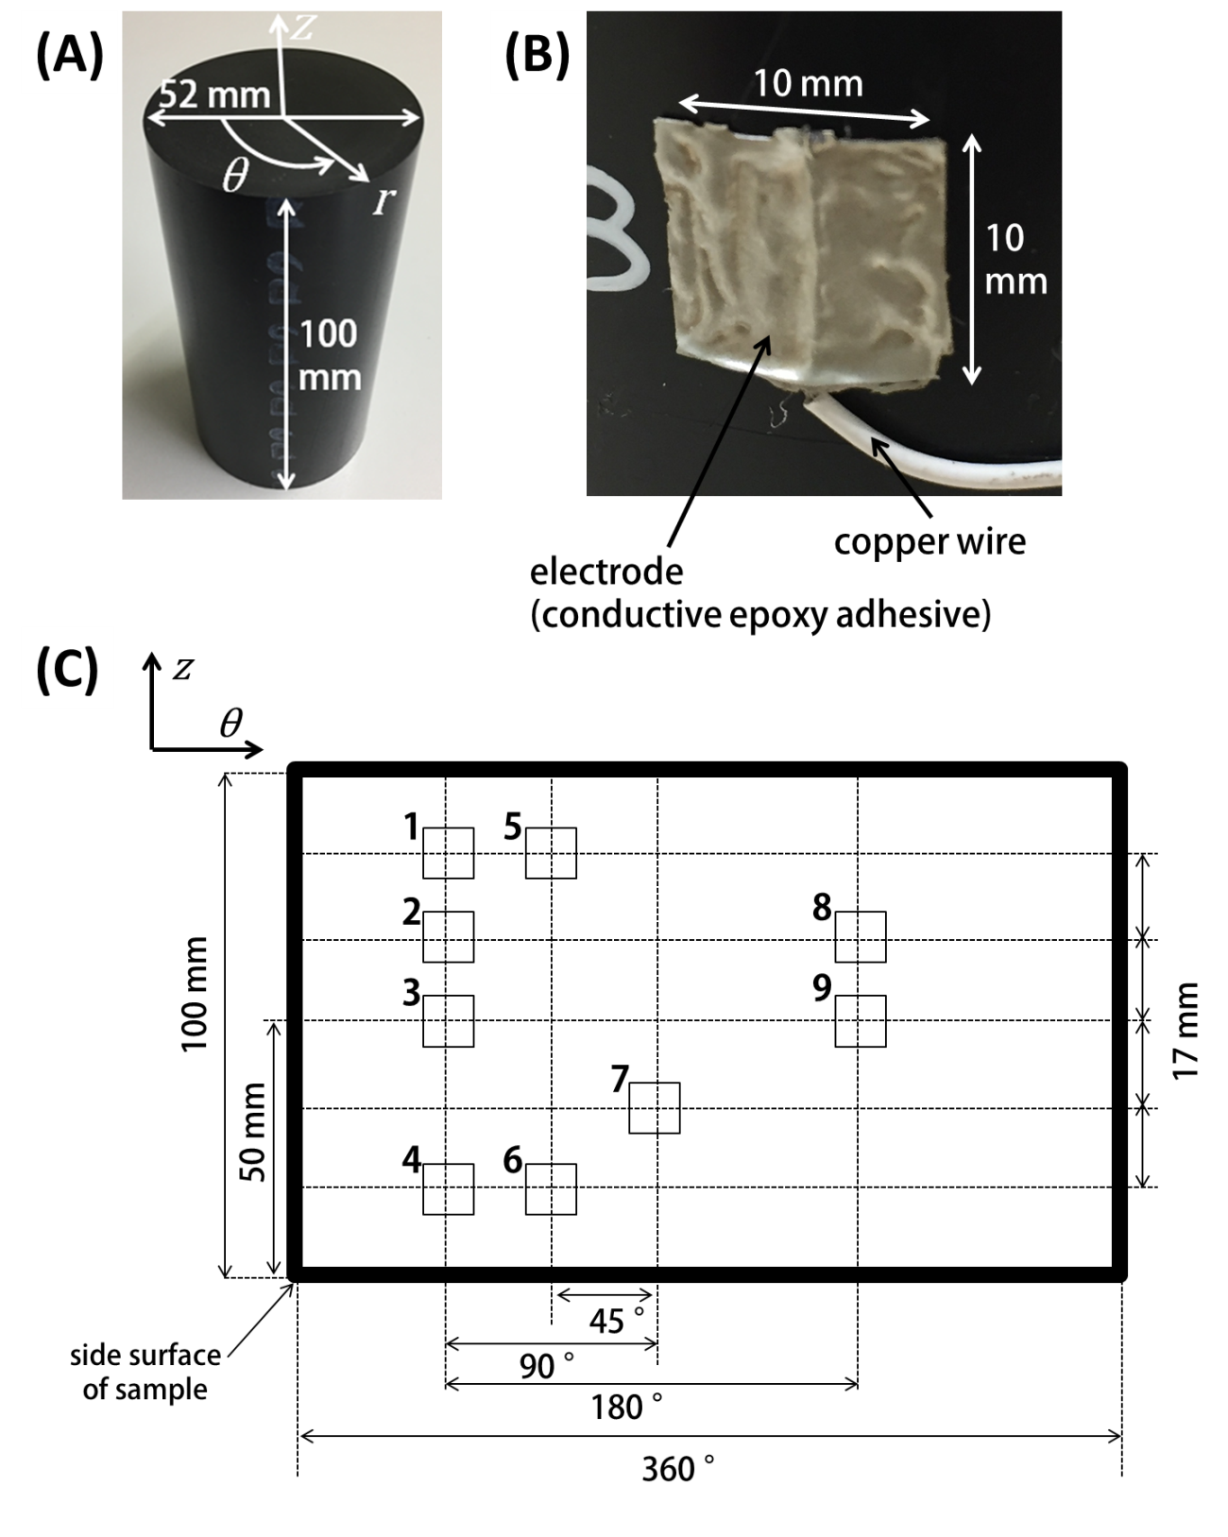
Additional Fig. S1
Photographs and measurement scheme. (A) The cylindrical conductive plastic sample (52 mm diameter, 100 mm length) overlaid with the dimensions r, θ, and z defining its coordinate axis. (B) Conductive epoxy adhesive attached to the sample surface as a high-conductivity electrode. A wire attached to the adhesive provided a connection for measuring instruments. (C) Electrode arrangement. z and θ are the coordinates defined in (A). The numbered squares are the electrodes. Electrodes numbered 1, 2, 3, 4, and 9 are current electrodes, those numbered 1, 2, 5, 6, 7, and 8 are potential electrodes.

Additional Table 1 Statistical comparison of repeated measurements of conductive plastic
Pair of current electrodes | Pair of potential electrodes | Injected current  [mA] | Potential difference [mV] | Obtained sample resistivity  [$Ω$・m]
1-4 | 5-6 | 1.1 ± 0.0 | 119.0 ± 3.9 | 3.1 ± 0.1
1-4 | 5-7 | 1.1 ± 0.0 | 80.2 ± 4.0 | 3.0 ± 0.3
1-4 | 5-8 | 1.1 ± 0.0 | 53.5 ± 3.8 | 4.1 ± 0.6
3-9 | 2-8 | 5.8 ± 0.0 | 354.6 ± 4.1 | 4.3 ± 0.1
3-9 | 1-7 | 5.8 ± 0.0 | 85.2 ± 0.1 | 8.4 ± 0.0
3-9 | 7-8 | 5.8 ± 0.0 | 254.8 ± 0.2 | 6.1 ± 0.0

Reference
MITSUBISHI CHEMICAL ADVANCED MATERIALS (2020) Product Information. http://www.polypenco.co.jp/products_e/mc_ny/product00_cha.html#mc501cdr2. Accessed 07 Jan 2020

