Supplementary Material

Cardiac extracellular vesicles aggravate cardiomyocyte ferroptosis in myocardial ischemia-reperfusion injury via miR-155-5p-Nfe2l2 signaling

Xinyu Ge¹⁻³, Jing Liu¹⁻⁴, Qingshu Meng^{1,2}, Enhao Wang^{1,2}, Xuan Liu¹⁻³, Shanshan Shi^{1,2}, Xin Gong⁵, Zhongmin Liu^{1,6,7}, Wei Han^{5*}, Xiaohui Zhou^{1,2 *}
- Research Center for Translational Medicine, Shanghai East Hospital, School of Medicine, Tongji University, Shanghai 200120, P.R. China;
- Shanghai Heart Failure Research Center, Shanghai East Hospital, School of Medicine, Tongji University, Shanghai 200120, P.R. China;
- Department of Thoracic Surgery, Shanghai East Hospital, School of Medicine, Tongji University, Shanghai 200120, P.R. China;
- Department of Burn & Plastic Surgery, Beijing Children's Hospital, Capital Medical University, National Center for Children's Health, Beijing, 100045, P.R. China;
- Department of Heart Failure, Shanghai East Hospital, School of Medicine, Tongji University, Shanghai 200120, P.R. China;
- Department of Cardiovascular Surgery, Shanghai East Hospital, School of Medicine, Tongji University, Shanghai, 200120, China
- Shanghai Institute of Stem Cell Research and Clinical Translation, Shanghai 200120, China

* To whom correspondence should be addressed:
Xiaohui Zhou, M.D., Ph.D.
Research Center for Translational Medicine,
Shanghai East Hospital, School of Medicine, Tongji University
150 Jimo Rd, Pudong, Shanghai, 200120, China
Tel: 86-21-61569884
E-mail: zxh100@tongji.edu.cn or xhzhou100@126.com

Wei Han, M.D., Ph.D.
Department of Heart failure,
Shanghai East Hospital, School of Medicine, Tongji University
150 Jimo Rd, Pudong, Shanghai, China 200120.
Tel: 0086-38804518-18351
E-mail address: dr.hanwei@foxmail.com

Running title
Cardiac EVs aggravate cardiomyocyte ferroptosis post IR via miR-155-5p

Supplementary Tables
Supplementary Table 1. Primers of RT-qPCR
Genes | Forward primers (5'-3') | Reverse primers (5'-3')
Ptgs2 | CTCACGAAGGAACTCAGCAC | GGATTGGAACAGCAAGGATTTG
Acsl4 | TTGGCTACTTACCTTTGGCTC | AATCACCCTTGCTTCCCTTC
Atp5g3 | GGTATTGGAACAGTCTTTGGC | AAACAAGATCAAGAACGCAACC
Nfe2l2 | TCCCATTTGTAGATGACCATGAG | CCATGTCCTGCTCTATGCTG
GPX4 | GCAATGAGGCAAAACTGACG | CTTGATTACTTCCTGGCTCCTG
SLC7A11 | TCTTCGATACAAACGCCCAG | TGATAAGAAAACCGACCCCG
NQO1 | GCCGAACACAAGAAGCTGGAAG | GGCAAATCCTGCTACGAGCACT
HO1 | CACTCTGGAGATGACACCTGAG | GTGTTCCTCTGTCAGCATCACC
FTH1 | CTTTGCAACTTCGTCGTTCC | AGGTTGATCTGGCGGTTG
Pri-mir155 | GGCTTGCTGAAGGCTGTATG | TGGACTTGTCATCCTCCCAC
β-actin | ACCTTCTACAATGAGCTGCG | CTGGATGGCTACGTACATGG
miR-155-5p | ACGCGCGTTAATGCTAATTGTGATAGGGGT | Universal reverse primer
miR-484 | TCAGGCTCAGTCCCCTCCC | Universal reverse primer
miR-novel-chr7_40384 | CGGCGAGGGGAATCTGACTGTCT | Universal reverse primer
Mouse U6 | TGGCCCCTGCGCAAGGATG | Universal reverse primer

Supplementary Table 2. The top 10 predicted target genes of miR-155-5p
Target | TargetScan |  | miRanda
GeneSymbol | Context+ | Context | Structure | Energy
Tenm3 | -0.507 | -0.853 | 314 | -26.13
Pld5 | -0.418 | -0.645 | 300 | -27.09
Lrrcc1 | -0.409 | -0.556 | 304 | -28.62
D5Ertd579e | -0.383 | -0.494 | 156 | -15.95
Lcorl | -0.374 | -0.503 | 309 | -29.72
Nfe2l2 | -0.373 | -0.481 | 154 | -13.59
Trim32 | -0.364 | -0.485 | 157 | -16.78
Pkn3 | -0.35 | -0.477 | 152 | -14.25
Aadat | -0.35 | -0.483 | 149 | -13.73
Ctso | -0.341 | -0.508 | 314 | -21.92

Supplementary Figures
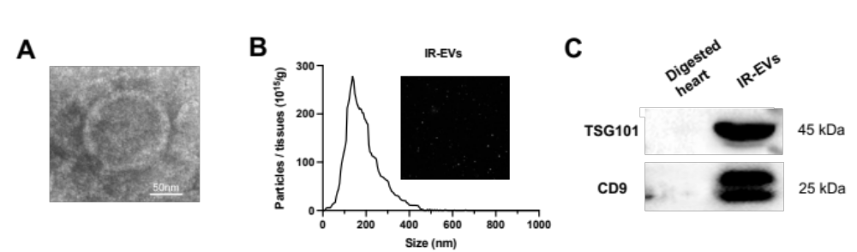
Supplementary Figure 1. The isolation and identification of IR-EVs. (A) A representative TEM image of IR-EVs, (bar=50 nm). (B) Particle size distribution of IR-EVs was measured using nanoparticle tracking analysis. (C) Protein immunoblots of IR-EVs, including four typical exosomal markers (CD9 and Tsg101).
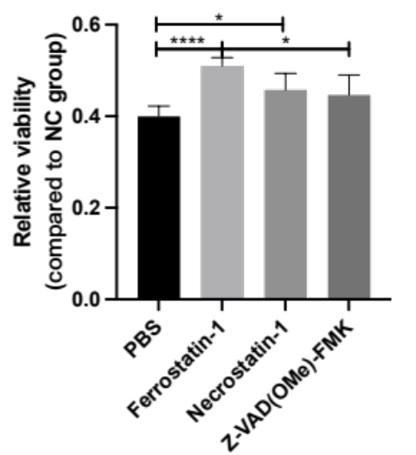
Supplementary Figure 2. The effect of different RCD inhibitors on cell viability of MCMs treated with H₂O₂. The cell viability was massured using the Cell Counting Kit-8 (CCK-8). RCD, regulated cell death; *, P <0.05; ****, P <0.0001.

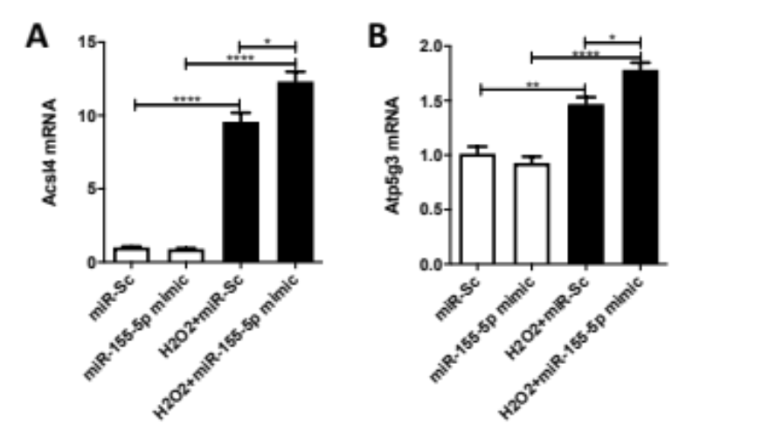
Supplementary Figure 3. The transfection of miR-155-5p mimics increased the expression of ferroptosis related genes including (A) Acsl4 and (B) Atp5g3 in MCMs treated with H₂O₂. *, P <0.05; **, P <0.01; ****, P <0.0001.

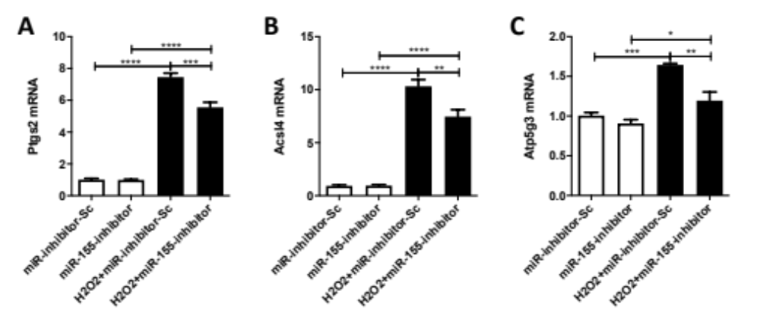
Supplementary Figure 4. Inhibition of miR-155-5p reduced the expression of ferroptosis related genes including (A) Ptgs2, (B) Acsl4 and (C) Atp5g3 in MCMs treated with H₂O₂. *, P <0.05; **, P <0.01; ***, P <0.001; ****, P <0.0001.

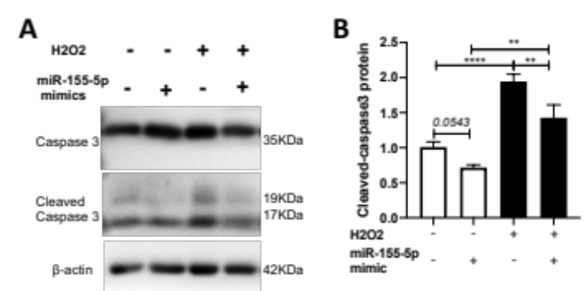
Supplementary Figure 5. The transfection of miR-155-5p mimics reduced the activation of the caspase3 pathway. **, P <0.01; ****, P <0.0001.

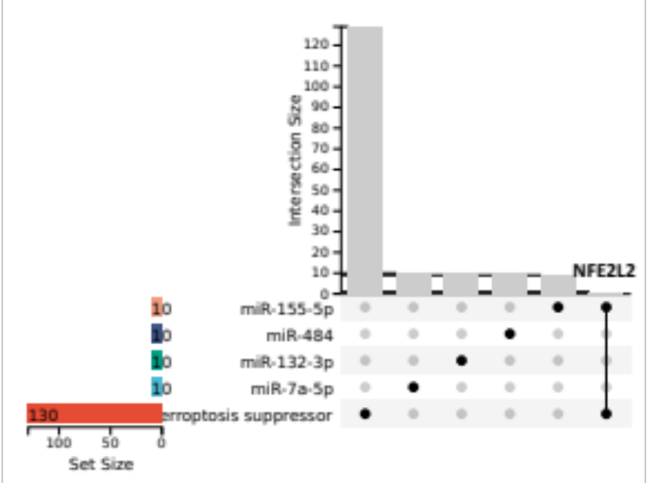
Supplementary Figure 6. Veen diagram shown the involvement of the top 10 target genes of high-expressed miRNAs including miR-155-5p, miR-484, miR132-3p and miR-7a-5p in ferroptosis regulation. The 130 genes related to ferroptosis suppressor were obtained from the FerrDb database (http://www.zhounan.org/ferrdb/current/) that dedicates to ferroptosis regulators and ferroptosis-disease associations.

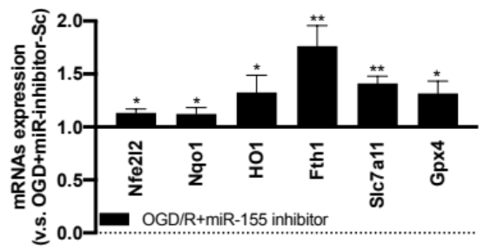
Supplementary Figure 7. Transfection of miR-155-5p inhibitor increased the expression of the Nfe2l2 pathway genes including Nfe2l2, Nqo1, Ho1, Fth1, Slc7a11,as well as the expression of GPX4 in OGD/R treated MCMs. *, P <0.05; **, P <0.01.

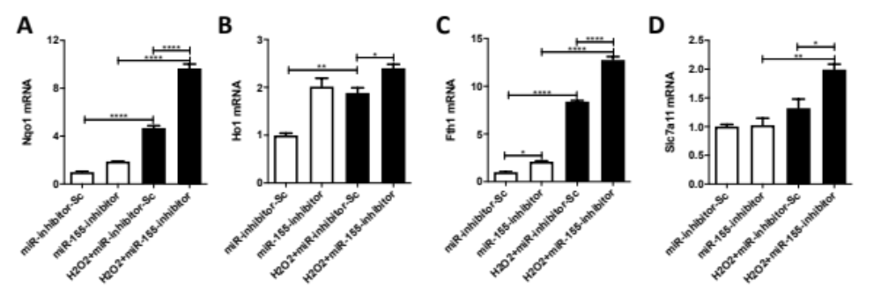
Supplementary Figure 8. Transfection of miR-155-5p inhibitor increased the expression of the downstream AREs of the Nfe2l2 pathway including (A) Nqo1, (B) Ho1, (C) Fth1, and (D) Slc7a11 in H₂O₂ induced MCMs. *, P <0.05; **, P <0.01; ***, P <0.001; ****, P <0.0001.

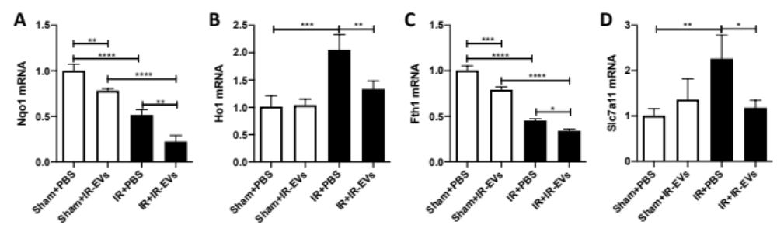
Supplementary Figure 9. Injection of IR-EVs reduced the expression of the downstream AREs of the Nfe2l2 pathway including (A) Nqo1, (B) Ho1, (C) Fth1, and (D) Slc7a11 in the heart of IR injured mice. *, P <0.05; **, P <0.01; ***, P <0.001; ****, P <0.0001.

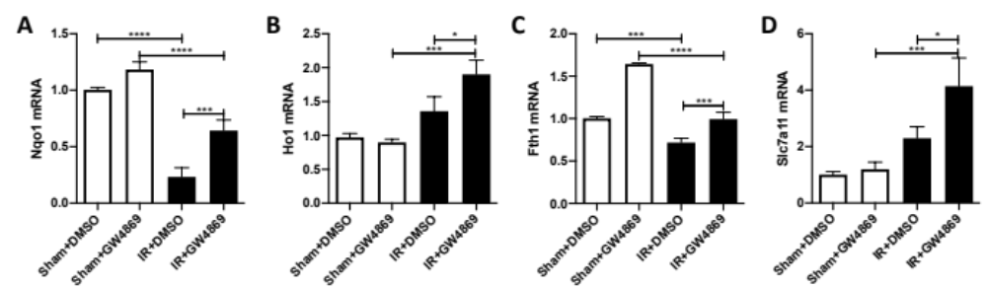
Supplementary Figure 10. Suppression of IR-EVs by GW4869 promoted the expression of the downstream AREs of the Nfe2l2 pathway including (A) Nqo1, (B) Ho1, (C) Fth1, and (D) Slc7a11 in the heart of IR injured mice. *, P <0.05; **, P <0.01; ***, P <0.001; ****, P <0.0001.

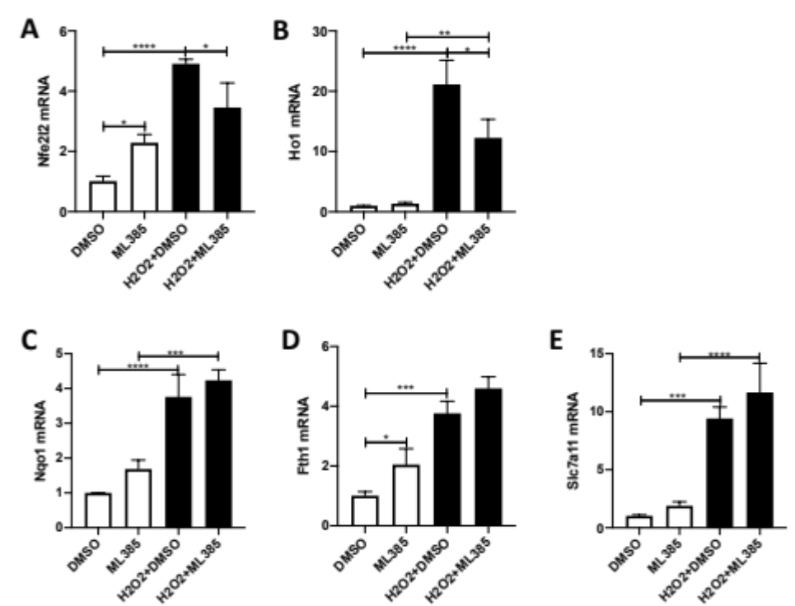
Supplementary Figure 11. Nfe2l2 inhibitor ML385 decreased the expression of (A) Nfe2l2, (B) Ho1, rather than (C) Nqo1, (D) Fth1, and (E) Slc7a11 in H₂O₂ induced MCMs. *, P <0.05; **, P <0.01; ***, P <0.001; ****, P <0.0001.

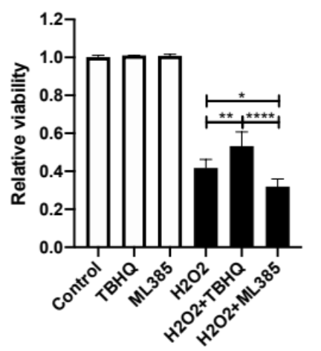
Supplementary Figure 12. Nfe2l2 was involved in H₂O₂ induced cell injury. Pretreatment with Nfe2l2 activator TBHQ enhanced the cell viability in MCMs stimulated with H₂O₂, while, Nfe2l2 inhibitor ML385 promoted H₂O₂ induced cell injury. *, P <0.05; **, P <0.01; ****, P <0.0001.

