DNA methylation abnormalities of imprinted genes in congenital heart disease
Shaoyan Chang^{1#}, Yubo Wang^{1#}, Yu Xin¹, Shuangxing Wang², Yi Luo², Li Wang¹, Hui Zhang^{2*}, Jia Li^{3,4*}

1 Beijing Municipal Key Laboratory of Child Development and Nutriomics, Capital Institute of Pediatrics, Beijing, China, 100020
2 Department of Cardiac Surgery, Children‘s Hospital Affiliated to the Capital Institute of Pediatrics, Beijing, China, 100020
3 Heart Center, Institute of Pediatrics, Guangzhou Women and Children’s Medical Center, Guangzhou Medical University, Guangdong Province, China, 510000
4 Clinical Physiology Laboratory, Capital Institute of Pediatrics, Beijing, China, 100020
#These authors contributed equally to this work.

* Corresponding authors
Hui Zhang, Department of Cardiac Surgery, Children‘s Hospital Affiliated to the Capital Institute of Pediatrics. No. 2 Yabao Road, Chao Yang District, Beijing, China.100020. E-mail: zhanghui7012@aliyun.com.

Jia Li, Institute of Pediatrics, Guangzhou Women and Children’s Medical Center, Guangzhou Medical University. No. 9 Jinsui Road, Pearl River New Town, Tianhe District, Guangzhou City, Guangdong Province, China. 510000. E-mail: jiali_beijing@126.com.

SUPPLEMENTARY MATERIALS

Table S1 DMR sequence information of 18 imprinted genes
Source | Gene ID | DMR Position (UCSC hg18)
maternal imprinting | GRB10 | chr7: 50,817,247- 50,818,365
 | PEG10 | chr7: 94,124,118- 94,124,493
 | MEST | chr7: 129,919,302- 129,919,592
 | NAP1L5 | chr4: 89,837,390- 89,839,620
 | INPP5F | chr10: 121,567,520- 121,568,375
 | PLAGL1 | chr6: 144,371,101- 144,371,640
 |  | chr6: 144,370,610- 144,371,540
 | MCTS2 | chr20: 29,598,738- 29,598,953
 | NNAT | chr20: 35,580,532- 35,584,472
 | NESPAS | chr20: 56,863,391- 56,864,195
 | GNAS | chr20: 56,898,138- 56,898,355
 | KCNQ1OT1 | chr11: 2,677,111- 2,678,664
 |  | chr11: 2,677,602- 2,678,664
 |  | chr11: 2,677,672- 2,678,044
 |  | chr11: 2,677,757- 2,678,763
 | SNRPN | chr15: 22,751,027- 22,751,436
 |  | chr15: 22,751,106- 22,751,320
 |  | chr15: 22,750,755- 22,750,990
 | ZIM2 | chr19: 62,043,540- 62,043,985
paternal imprinting | NESP | chr20: 56,848,246- 56,850,403
 | GTL2/DLK1 | chr14: 100,345,426- 100,345,735
 | (MEG3, IG) | chr14: 100,346,924- 100,347,309
 |  | chr14: 100,346,990- 100,347,246
 | H19/IGF2 | chr11: 1,975,944- 1,976,304
 |  | chr11: 1,977,410- 1,977,914
 |  | chr11: 1,977,575- 1,978,014
 |  | chr11: 1,977,644- 1,980,075
 |  | chr11: 1,977,647- 1,977,977
 |  | chr11: 1,977,647- 1,977,970
 |  | chr11: 1,977,647- 1,977,878

Table S2 Primer sequence information of 18 imprinted genes
Gene ID | Primer name | Primer sequence
GRB10 | GRB10_L | aggaagagagAGGAATTTTAGGATTAAATTTATGTGA
 | GRB10_R | cagtaatacgactcactatagggagaaggctTTCTTCAAAATTACCATAAAAACCA
PEG10 | PEG10-L | aggaagagagGGGAAATTAAGTTTTAAAGGTTTGG
 | PEG10-R | cagtaatacgactcactatagggagaaggctCCAATTATAACTCCCATCAATTT
MEST | MEST_1L | aggaagagagTAGTTAAAGGAATTAGGAAGGGAAAT
 | MEST_1R | cagtaatacgactcactatagggagaaggctCTAAAACCAAAACTACTTCCCACAC
 | MEST_2L | cagtaatacgactcactatagggagaaggctAATACCTAAATCTTAAAATCCTAAACTACACC
 | MEST_2R | cagtaatacgactcactatagggagaaggctAATACCTAAATCTTAAAATCCTAAACTACACC
NAP1L5 | NAP1L5_1L | aggaagagagTGTTTTTAGGGGAGTTTTGTTGA
 | NAP1L5_1R | cagtaatacgactcactatagggagaaggctCCAAACCCTTCTACAAATACCAA
 | NAP1L5_2L | aggaagagagTTGGTATTTGTAGAAGGGTTTGG
 | NAP1L5_2R | cagtaatacgactcactatagggagaaggctCACTTAACTAACTTCCCACTATCAA
INPP5F | INPP5F_1L | aggaagagagGTTTTGAGATTGGAGAGGAAATTA
 | INPP5F_1R | cagtaatacgactcactatagggagaaggctAACCACTCCATTACCACTACTAAACC
 | INPP5F_2L | aggaagagagGTTGGGTGTAGGTAGTTGTTTGAGT
 | INPP5F_2R | cagtaatacgactcactatagggagaaggctCTTTAACCATAAACCCTACAAAAAAA
 | INPP5F_3L | aggaagagagTGTATGGGAGAAGGGTTAGGATAG
 | INPP5F_3R | cagtaatacgactcactatagggagaaggctAATCCCAACAAAAAAATAAACCTAACT
 | INPP5F_4L | aggaagagagGAAGTAAGTTGGGAATATTATTTGG
 | INPP5F_4R | cagtaatacgactcactatagggagaaggctCTATCCTAACCCTTCTCCCATACA
PLAGL1 | PLAGL1_1L | aggaagagagGGGTTGAATGATAAATGGTAGATG
 | PLAGL1_1R | cagtaatacgactcactatagggagaaggctACCTTAACTTTACCCCCACC
 | PLAGL1_2L | cagtaatacgactcactatagggagaaggctAAAAACAATAAAAATTCCCTTCAAT
 | PLAGL1_2R | aggaagagagTATTTTTGTGGGGATGGAGGAATTA
NESP | NESP_1L | 5'-aggaagagagGTTAAATTGGGGAGTTTGAGGG-3'
 | NESP_1R | 5'-cagtaatacgactcactatagggagaaggctCAACAAACCTTTAACCACCAAAAC-3'
 | NESP_2L | 5'-aggaagagagTTTTAAATAAGTTGGTTTTTTTAGGTGT-3'
 | NESP_2R | 5'-cagtaatacgactcactatagggagaaggctCTTAATTATCAACTCTAAAACCTAAACTCC-3'
MEG3 | MEG3_L | aggaagagagTTGTGTTTGAATTTATTTTGTTT
 | MEG3_R | cagtaatacgactcactatagggagaaggctCCCCAAATTCTATAACAAATTACT
MCST2 | MCST2_1L | aggaagagagGGTTTTTTTGTAGGGGATTTTAT
 | MCST2_1R | cagtaatacgactcactatagggagaaggctACAATTAAACACACTTTCCTTTTCA
 | MCST2_2L | aggaagagagGGTGGAGTTTTTTGTAGGAAGGT
 | MCST2_2R | cagtaatacgactcactatagggagaaggctTTTCTAACTTATCAAACCCTACTATTTCAA
NNAT | NNAT_L | aggaagagagTTTTTTTTGTAGGAAGAATTTTTTG
 | NNAT_R | cagtaatacgactcactatagggagaaggctAAACCCACAACTTAAATATACCTCA
NESPAS | NESPAS_1L | 5'-aggaagagagTTTTTAAGGTTAAGAAGGTATTTTTGG-3'
 | NESPAS_1R | 5'-cagtaatacgactcactatagggagaaggctCTTTAACTAAACCCCCTCCTCC-3'
NESPAS | NESPAS_2L | 5'-aggaagagagTTGTTAGAAAGTTTTAGGGAGGGAT-3'
 | NESPAS_2R | 5'-cagtaatacgactcactatagggagaaggctCCACCAACCTAACCAAAAAAATC-3'
GNAS | GNAS_L | aggaagagagTGTTTTTTGGTTTGTTTTTGTTTTT
 | GNAS_R | cagtaatacgactcactatagggagaaggctCATAACCATCTTCAACATAATAACCC
IGF2 | IGF2_1L | aggaagagagTTTTAGGGTTTGGTTTGAGGGTA
 | IGF2_1R | cagtaatacgactcactatagggagaaggctTCCAAAAAAACCAAATCACAACTAC
 | IGF2_2L | aggaagagagGGTTTTTGTTTTTGGTTAAGAGGT
 | IGF2_2R | cagtaatacgactcactatagggagaaggctCAACTATAACCTAACCCTCCTAAAA
 | IGF2_3L | aggaagagagATTGTTGGTTATTTTTGGGGG
 | IGF2_3R | cagtaatacgactcactatagggagaaggctTAAACAAATTCTTCCAATATAACACCT
 | IGF2_4L | aggaagagagTTATTTAGGGTGGTGTTTGTGG
 | IGF2_4R | cagtaatacgactcactatagggagaaggctACCTAACACTAAAAATAAAAAATACACAC
H19 | H19_1L | aggaagagagTATGGGTATTTTTGGAGGTTTTTTT
 | H19_1R | cagtaatacgactcactatagggagaaggctAACTTAAATCCCAAACCATAACACT
 | H19_2L | aggaagagagTTTTTATTAAAGGTTAAGGTGGTGAT
 | H19_2R | cagtaatacgactcactatagggagaaggctCAAAACAAAATCCCCACAACC
IG | IG_L | aggaagagagGTTAAGAGTTTGTGGATTTGTGAGAAATG
 | IG_R | cagtaatacgactcactatagggagaaggctACAATTCCTACTACAAAATTTCAACA
KCNQ1OT1 | KCNQ1OT1_L | aggaagagagGGTTTTTGTGATTTAGGTTTTTGTTT
 | KCNQ1OT1_R | cagtaatacgactcactatagggagaaggctAACATACCAAACCACCCACC
SNRPN | SNRPN_L | aggaagagagTGTGGGGTTTTAGGGGTTTAG
 | SNRPN_R | cagtaatacgactcactatagggagaaggctCTCCCCAAACTATCTCTTAAAAAAA
ZIM2 | ZIM2_L | aggaagagagGGTGAGGTTGTTGATTGGTTAGTAT
 | ZIM2_R | cagtaatacgactcactatagggagaaggctCCACCAACCCAAAATAAACAT

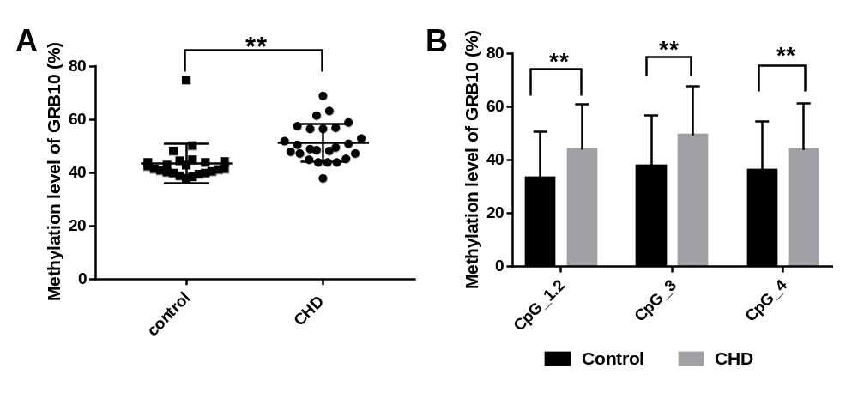
Fig. S1 Analysis of methylation level of GRB10. A) The mean methylation of DMR of GRB10 between CHD group and control group. (B) Methylation level of specific CpG site in GRB10 between CHD group and control group. CpG sites included numbered 1-4 from the 5' end to the 3' end. Independent sample t-test was used to assess the difference between CHD and control. All the values was shown as the mean ± SD. *, p<0.05; **, p<0.01.
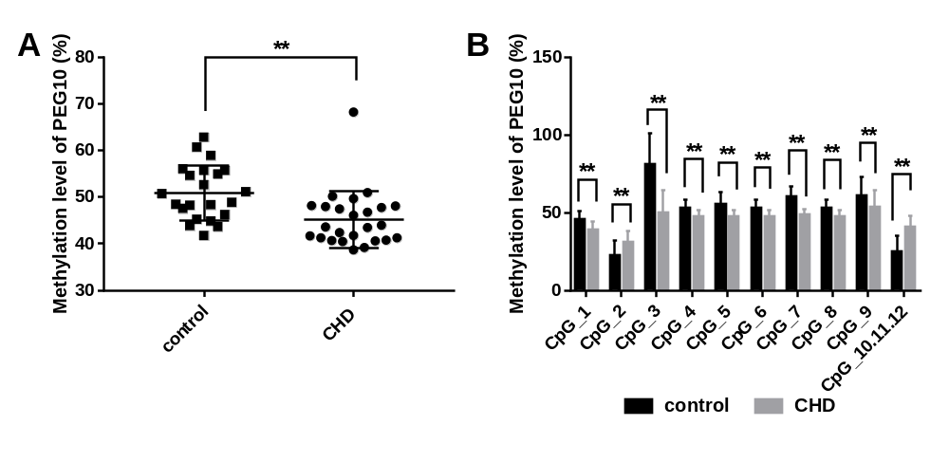
Fig. S2 Analysis of methylation level of PEG10. A) The mean methylation of DMR of PEG10 between CHD group and control group. (B) Methylation level of specific CpG site in PEG10 between CHD group and control group. CpG sites included numbered 1-12 from the 5' end to the 3' end. Independent sample t-test was used to assess the difference between CHD and control. All the values was shown as the mean ± SD. *, p<0.05; **, p<0.01.
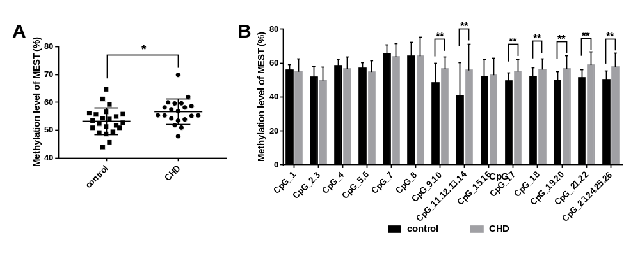
Fig. S3 Analysis of methylation level of MEST. A) The mean methylation of DMR of MEST between CHD group and control group. (B) Methylation level of specific CpG site in MEST between CHD group and control group. CpG sites included numbered 1-26 from the 5' end to the 3' end. Independent sample t-test was used to assess the difference between CHD and control. All the values was shown as the mean ± SD. *, p<0.05; **, p<0.01.
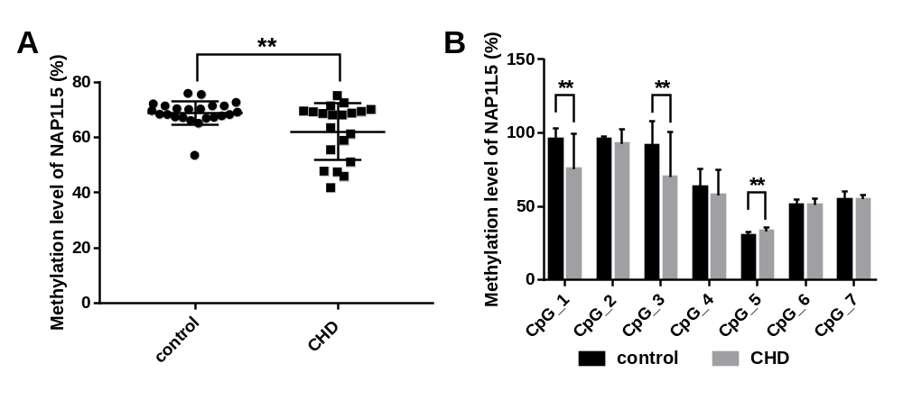
Fig. S4 Analysis of methylation level of NAP1L5. A) The mean methylation of DMR of NAP1L5 between CHD group and control group. (B) Methylation level of specific CpG site in NAP1L5 between CHD group and control group. CpG sites included numbered 1-7 from the 5' end to the 3' end. Independent sample t-test was used to assess the difference between CHD and control. All the values was shown as the mean ± SD. *, p<0.05; **, p<0.01.
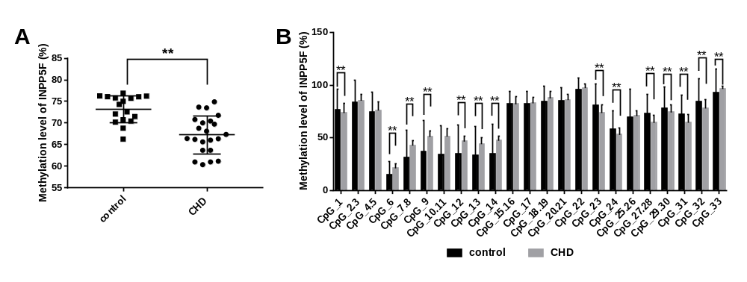
Fig. S5 Analysis of methylation level of INPP5F. A) The mean methylation of DMR of INPP5F between CHD group and control group. (B) Methylation level of specific CpG site in INPP5F between CHD group and control group. CpG sites included numbered 1-33 from the 5' end to the 3' end. Independent sample t-test was used to assess the difference between CHD and control. All the values was shown as the mean ± SD. *, p<0.05; **, p<0.01.
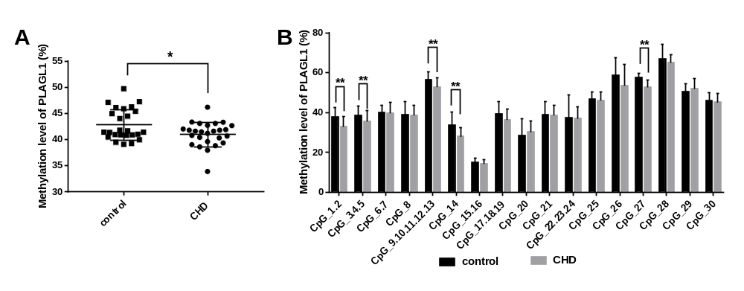
Fig. S6 Analysis of methylation level of PLAGL1. A) The mean methylation of DMR of PLAGL1 between CHD group and control group. (B) Methylation level of specific CpG site in PLAGL1 between CHD group and control group. CpG sites included numbered 1-30 from the 5' end to the 3' end. Independent sample t-test was used to assess the difference between CHD and control. All the values was shown as the mean ± SD. *, p<0.05; **, p<0.01.
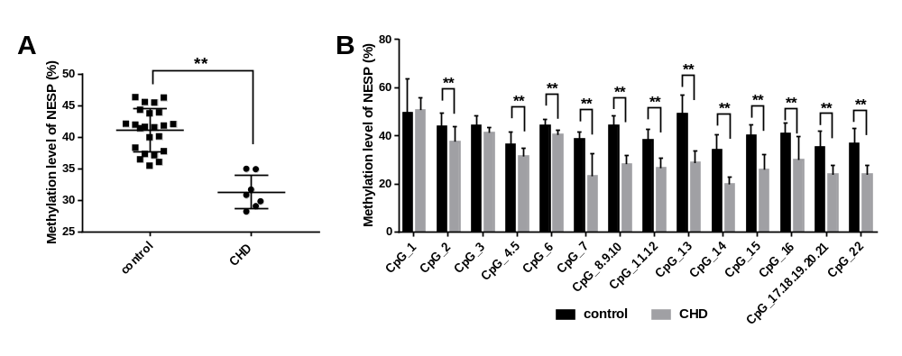
Fig. S7 Analysis of methylation level of NESP. A) The mean methylation of DMR of NESP between CHD group and control group. (B) Methylation level of specific CpG site in NESP between CHD group and control group. CpG sites included numbered 1-22 from the 5' end to the 3' end. Independent sample t-test was used to assess the difference between CHD and control. All the values was shown as the mean ± SD. *, p<0.05; **, p<0.01.
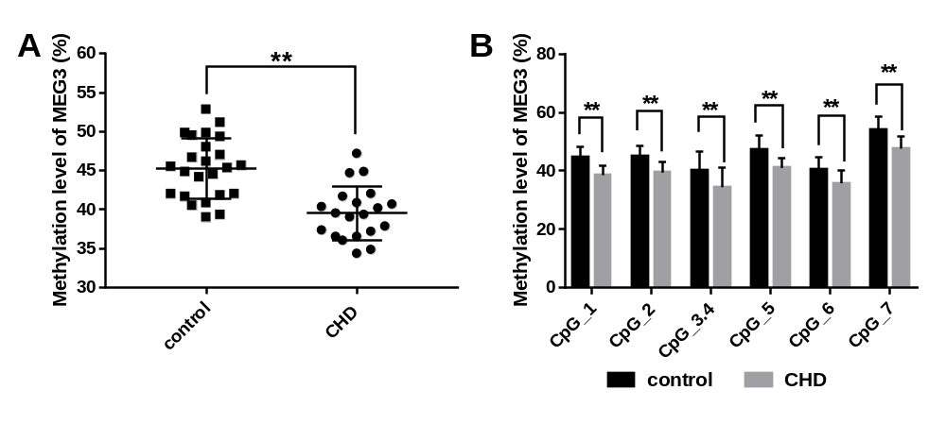
Fig. S8 Analysis of methylation level of MEG3. A) The mean methylation of DMR of MEG3 between CHD group and control group. (B) Methylation level of specific CpG site in MEG3 between CHD group and control group. CpG sites included numbered 1-7 from the 5' end to the 3' end. Independent sample t-test was used to assess the difference between CHD and control. All the values was shown as the mean ± SD. *, p<0.05; **, p<0.01.

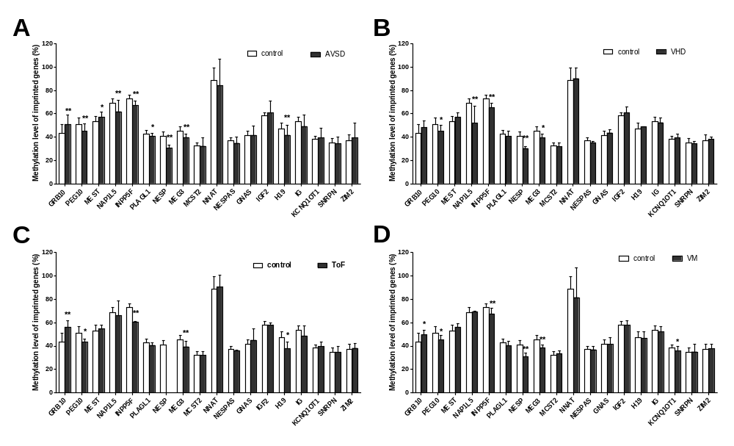
Fig. S9 Abnormal methylation level of the imprinted genes between multiple CHDs classification and control groups. A) Abnormal methylation level of the imprinted genes between AVSD and control groups. B) Abnormal methylation level of the imprinted genes between VHD and control groups. C) Abnormal methylation level of the imprinted genes between ToF and control groups. D) Abnormal methylation level of the imprinted genes between VM and control groups. Independent sample t-test was used to assess the difference between AVSD and controls. All the values was shown as the mean ± SD. AVSD, atrioventricular septal defect. *, p<0.05; **, p<0.01.

