Appendix

Table 1. Definitions of Joint Monitoring Program (JMP) Service Level Indicators for Water and Sanitation
Service Ladders | Definition | FBoS Indicators*
Drinking Water
Safely managed | Available when needed premises in sufficient quantity and of adequate quality. The water source is protected from contamination, including faecal and priority chemical contaminants. | Drink_Metered_Piped_Dwelling  Drink_Metered_Piped_Outside  Drink_Fiji Sugar Corporation (FSC)/Emperor Gold Mine (EGM)
Basic | Drinking water from an improved source provided collection time is less than 30 min for a roundtrip. | Drink_Metered_Standpipe  Drink_Metered_Neighbor  Drink_Dug_Protected
Limited | Drinking water from an improved source where collection time exceeds 30 min for a roundtrip, including queuing. | Drink_Rain_Tap_Outside  Drink_Communal_Tank  Drink_Other
Unimproved | Drinking water from an unprotected dug well or unprotected spring. | Drink_Dug_Unprotected  Drink_Spring_Unprotected
Surface Water | Drinking water is directly collected from a river, creek, and spring | Drink_Surface_Water
Sanitation
Safely managed Sanitation service | Use of an improved sanitation facility*, which is not shared with other households and where excreta are safely disposed in situ or transported and treated off-site | Flush to piped sewer system,  Flush to septic tank.
Basic | Private improved facility which separates excreta from human contact | Flush to pit latrine,  Pit latrine with slab,  Water sealed
Limited | Improved facility shared with 2 or more households | Shared toilet  Other (specify)
Unimproved | Unimproved facility which does not separate excreta from human contact | Pit latrine without slab - open pit
Open defecation | Disposal of human faeces in fields, forests, open bodies of water, beaches, or other open spaces or with solid waste | No facility, beach, bush etc.
* Fiji Bureau of Statistics (FBoS) Water and Sanitation Census Indicators
* Improved sanitation facilities include flush/pour-flush to a piped sewer system, septic tank, pit latrine, ventilated improved pit latrine, composting toilet, or pit latrine with a slab

Table 2. PAR of AWD Associated with Water & Sanitation Service Levels (Fiji, 2016-2021)
Service Level | No. of AWD Cases | Person-Years | Incidence Rate (per 100,000 person-years) | PAR
Water
Non-exposed | 92,826 | 3,907,740 | 2,376.64 | -
Exposed | 40,088 | 715,590 | 5,593.72 | 17.46%
Total | 132,914 | 4,623,330 | 2,878.76 | -
Sanitation
Non-exposed | 106,520 | 4,520,430 | 2,356.40 | -
Exposed | 26,394 | 118,860 | 22,206.00 | 17.80%
Total | 132,914 | 4,639,290 | 2,865.00 | -

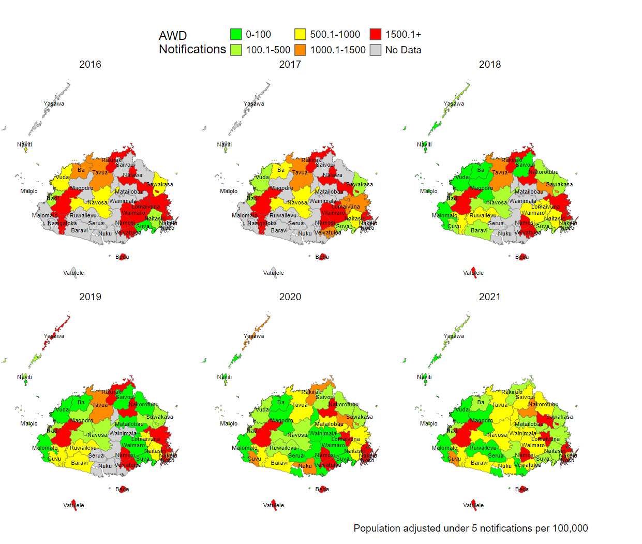
A

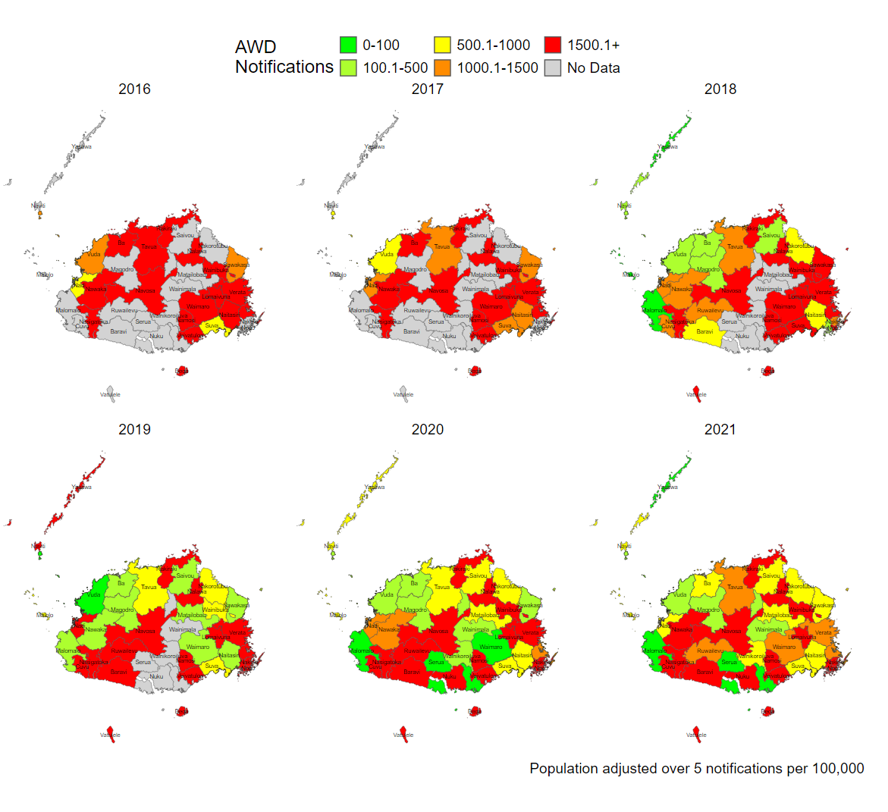
B

Figure 1. Annual notifications per 10,000 persons of Acute Watery Diarrhea (AWD) cases by districts for Under 5 (A) and Over 5 (B) populations in the Central (19 Districts) and Western (20 Districts) Divisions of Fiji between 2016 and 2021
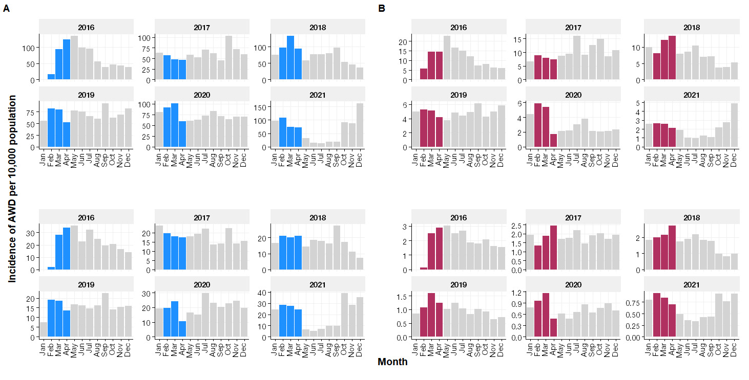
Figure 2. Incidence of Acute Watery Diarrhea (AWD) cases from 2016 to 2021, separately for the Under 5 age (A) and the Over 5 age (B). The data visualized seasonal surge in AWD cases occurring between February and April each year, as indicated by the coloured bars.

