Supplementary Information

Kinetic Liquid Metal Synthesis of Flexible 2D Conductive Oxides for Multimodal Wearable Sensing

Md Saifur Rahman, Simon A. Agnew, Samuel Ong, and William J. Scheideler*

Thayer School of Engineering
Dartmouth College, Hanover, NH 03755, United States
E-mail: william.j.scheideler@dartmouth.edu

Keywords: liquid metal printing, 2D oxides, transparent electronics, wearable sensors, bioelectrodes

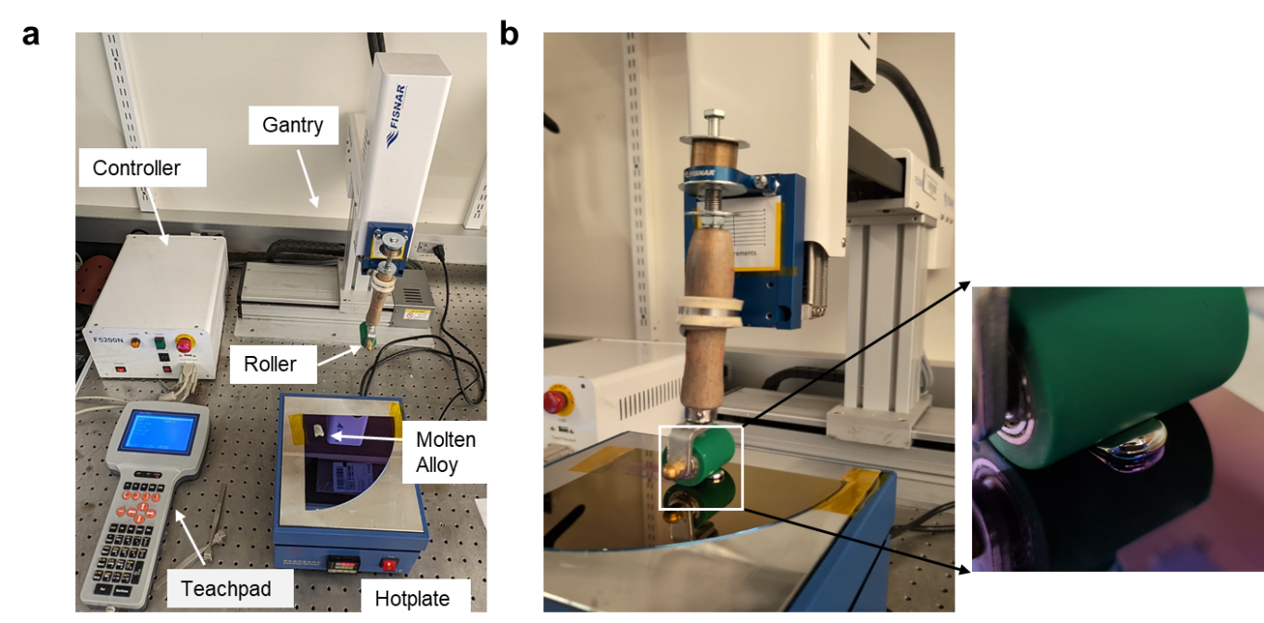
Figure S1. (a) Setup for automatic robotic gantry for depositing 2D ITO on SiO₂/Si substrate (b) The gantry is controlling the roller and moving the liquid metal meniscus. The inset shows the enlarged view of the meniscus.

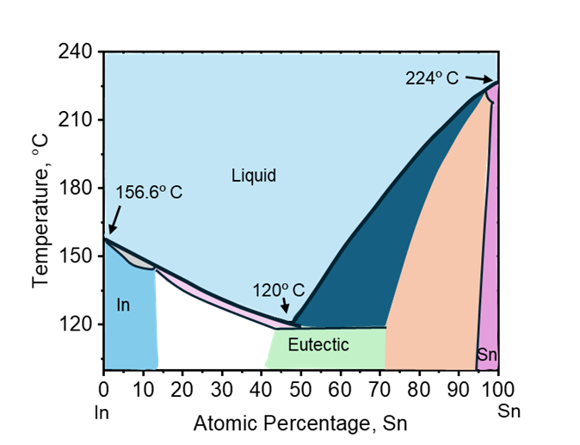
Figure S2. A simplified phase diagram of In-Sn alloy using the Thermocalc database.

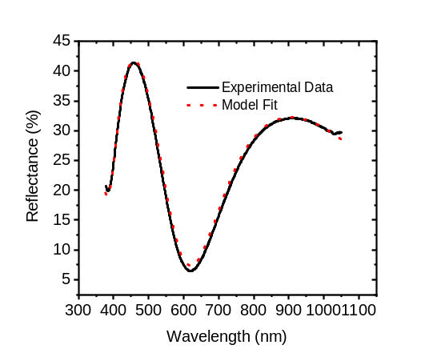
Figure S3. (a) Schematics for material stacks for measuring thickness of ITO on SiO₂ (300 nm)/Si substrate in air with the F3 spectroscopic tool. (b)Reflectometry fits of ITO (5 nm) on 300 nm SiO₂ substrate with a goodness of fit of 0.995
b
a
Air
ITO (5 nm)
SiO₂ (300nm)
Si

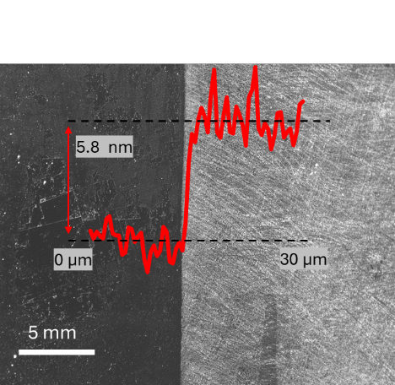

Figure S4. AFM line scan overlaid with the optical microscope image.

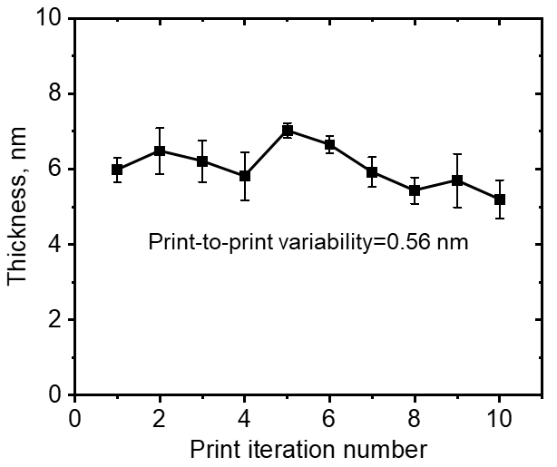

Figure S5. Film thickness vs. print iteration number with the same condition in 10 different ITO films on SiO2 substrates. Print condition- 1 layer, 260 ºC, 0.5 cm/s. Films are as deposited, not post-annealed.

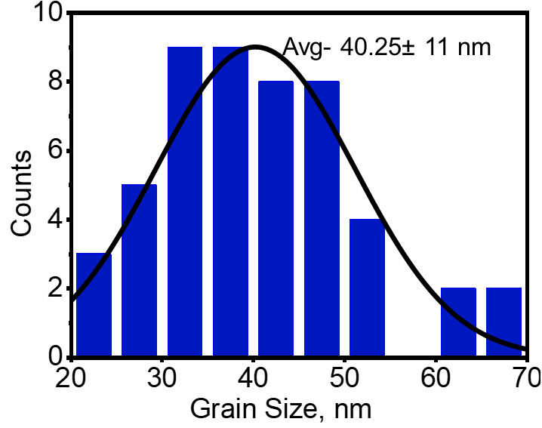
Figure S6. Grain size distribution from AFM image for 2D ITO film with a single printed layer

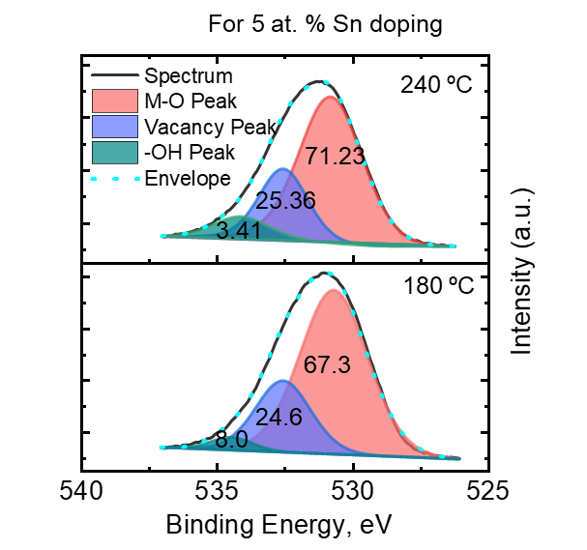
Figure S7. O1s signal deconvoluted for different temperature deposited 2D ITO film for 5 at. % doping of Sn.

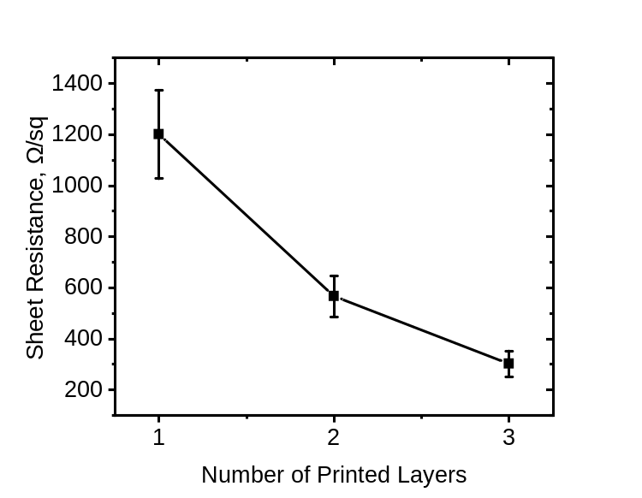
Figure S8. Sheet resistance of a film vs. number of printed layers stacked on top. Films are printed at 0.5 cm/s at 260 ºC with 7 at. % of Sn in alloy.

