Phosphorus fertilizer responsive bacteria and fungi in canola (Brassica napus L.) roots are correlated with plant performance
Mengying Liu^{1,5}, S. Patrick Mooleki³, Yunliang Li⁵, Dave Schneider⁴, Leon V. Kochian^{1,2}, Bobbi L. Helgason^{5*}
¹Department of Plant Science, University of Saskatchewan, 51 Campus Drive, Saskatoon, SK, Canada S7N 5A8
² Global Institute for Food Security, 421 Downey Road, Saskatoon, SK, Canada S7N 4L8
³ Agriculture and Agri-Food Canada, Saskatoon Research and Development Centre, SK, Canada
⁴ School of Environment and Sustainability, University of Saskatchewan, 117 Science Pl, Saskatoon, SK Canada S7N 5C8
⁵ Department of Soil Science, University of Saskatchewan, 51 Campus Drive, Saskatoon, SK, Canada S7N 5A8
* Corresponding author: Bobbi L. Helgason; Email: Bobbi.Helgason@usask.ca
Supplementary Information
Method S1 Site information, field sampling and sample processing
Method S2 Soil and plant parameter measurements
Method S3 Library preparation for Illumina Miseq
Method S4 Sequence Data Processing and Statistical Analysis
Fig. S1 Bacterial alpha diversity (observed richness, Pielou’s evenness, and Shannon diversity) in the bulk soil, rhizosphere soil (Rhizo), and root endophyte from 2019 and 2020 at the 4-5 leaf vegetative stage (L) and the full-flowering stage (F) (different letters indicated statistical significance at p<0.001, determined using ANOVA followed by Tukey’s test, n=4)
Fig. S2 Principal component analyses of bacterial community structure obtained using 16S rRNA V3-V4 amplicon sequencing and fungal taxa obtained using ITS amplicon sequencing of bulk soil, rhizosphere soil and roots at the 4-5 leaf vegetative stage (L) and the full-flowering stage (F) in 2019 and 2020 (PERMANOVA p-values indicated impacts of sample type, or sampling time (year and growth stage) on bacterial and fungal community structures
Fig. S3 Redundant analysis on the impact of soil properties, including soil total P (STP), soil available P (SAP), soil total N (STN), soil available N (SAN), gravimetric water content (GWC), on the root fungal community in 2019 and 2020 at the vegetative stage, under phosphorus fertilizations of phosphorus rates (PR) at 0 (LP), 17 (RP), and 32 kg ha⁻¹ (HP) in combinations of opener widths (OW) at the narrow 2.5 cm (1) and the wide 10 cm (2). Only the soil properties significantly impacted the microbial community were shown as arrows (p<0.05, n=4)
Fig. S4 Relative abundance of the dominant root bacterial and fungal classes in the root at 4-5 leaf vegetative stage (L) and full-flowering stage (F) in 2019 and 2020 under six different soil phosphorus treatments of phosphorus rates (PR) at 0 (LP), 17 (RP), and 32 kg ha⁻¹ (HP) in combinations of narrower (1) and wider (2) opener widths (OW)
Table S1 Soil and plant physical and chemical properties under soil P treatments of P rates (PR) at 0 (LP), 17 (RP), and 32 kg ha⁻¹ (HP) in combinations of in combinations of narrower (1) and wider (2) opener widths (OW) at 4-5 leaf stage (L) and full-flowering stage (F) in 2019 and 2020 (pairwise comparisons were conducted within a specific sampling year and growth stage, where means followed by different letters indicated statistical significance, determined using ANOVA followed by Tukey’s test, p < 0.05)
Table S2 P-values of ANOVA for bacterial and fungal alpha diversity indices (Observed richness, Pielou's evenness, and Shannon diversity) in the bulk soil, the rhizosphere soil, and the root in different sampling years (2019 and 2020), growth stages (the 4-5 leaf vegetative and the full-flowering) and soil P fertilization treatments in combinations of different P rates (PR) at 0 (LP), 17 (RP), and 32 kg ha⁻¹ (HP) in combinations of narrower (1) and wider (2) opener widths (OW)
Table S3 P-values of ANOVA for root bacterial and fungal alpha diversity indices in 2019 and 2020 at the 4-5 leaf vegetative (V) and the full-flowering (F) stages under different P rates (PR) and placements (opener width; OW)
Table S4 PERMANOVA for bacterial and fungal communities in all sample types, and separately in the bulk soil, the rhizosphere soil, and the root under different sampling years, growth stages, and P treatments
Method S1 Site information, field sampling and sample processing
The plot locations in 2019 and 2020 were in different but adjacent areas of the same field which had been cropped to wheat in the season prior to conducting our experiments. The plot size was 15 m x 1.7 m at seeding row spacing of 30.5 cm with seedbed utilization of 8.3% for OW1 and 33.3% for OW2. To minimize the edge effect, each plot was divided into 15 blocks of 1 m² area at 1 m x 1 m to conduct sampling.
To sample the microbiome, the whole plant and its surrounding bulk soil were excavated with an ethanol-sterilized hand trowel to an approximate depth of 15 cm and radius of 10 cm, then put into a pre-labeled polypropylene sample bag. Samples were immediately transported on ice, stored at 4 °C overnight, and processed the following day.
More specifically, plant shoots were separated from the root system using a sterilized scalpel. After recording the shoot fresh weights, shoots were put in pre-labeled paper bags for further analysis. The excised root system with soil attached was shaken vigorously 5 times to remove the loosely attached soil. The soil that remained adhered to the root was defined the rhizosphere soil. The root and the attached rhizosphere soil were then placed in an 250ml Erlenmeyer flask which contained 100mL of 0.05M NaCl solution and shaken on an orbital shaker (Innova 2100 Platform Shaker) at speed of 180rpm for 15 min at room temperature. Following shaking, the root was removed from the solution and rinsed 5 times with autoclaved distilled water until clean and then chopped into approximately 0.5cm root segments with a sterilized scalpel. The solution containing the rhizosphere soil was transferred into two 50mL Falcon tubes and centrifuged at speed of 3000rpm for 15 min at room temperature. The supernatant was discarded, leaving the rhizosphere soil pellet. Soil that was not attached to the roots was considered bulk soil and was passed through a 2mm sieve for sub-sampling. The bulk soil, the rhizosphere soil, and the root samples were sub-sampled respectively into two 1.5mL Eppendorf tubes, then stored at -80°C for DNA extraction and analysis. Two Whirl-Pak bags of the sieved bulk soil were stored at 4°C for further physical and chemical property analysis.
Method S2 Soil and plant parameter measurements
In both sampling years, plant emergence on 14, 21 and 28 days after seeding, plant density at harvest, plant shoot biomass and grain yield in each plot were measured for the evaluation of plant performances under different P fertilizations. More specifically, in each plot, 3 blocks of 1m² area were randomly selected to count plant numbers, and the average were taken as the plant density at certain plant growth stage; 6 blocks of 1m² area were randomly selected, and the average grain weight were taken as the grain yield for the plot; 2 blocks of 1m² area from the front and back respectively were selected, where 2 representative plants from each end were collected and then dried until stable weight for biomass measurement.
For soil collected from pre-planting, the physical and chemical property analyses were evaluated by Farmeredge Laboratories in Winnipeg, MB, Canada. For soil harvested during the growing seasons, analyses were conducted in Soil Nutrient Management Lab at the University of Saskatchewan. More specifically, to measure soil gravimetric water content (GWC), 10 g of bulk soil from the Whirl-Pak bag was oven-dried at 105 °C for 24 hours. The remaining soil in the Whirl-Pak bag was air-dried at room temperature for a month, and then homogenized and sub-sampled for the measurement of physical and chemical properties. Plant shoot samples were placed in a drying room (50-60 °C) until weights stabilized and dry weights were determined. The dried shoot samples were then ground into fine powder using a Wiley Laboratory Mill (Thomas Scientific, Model 4). After this, soil available P (orthophosphate) and available N, and plant shoot P were extracted using a modified Kelowna method (Qian et al., 1994; Thomas et al., 1967). Plant shoot P uptake was calculated thereafter by multiplying the shoot P concentration by the shoot biomass. For soil total N and P, the air-dried soil (< 2 mm) was first ground into powder using a Mixer Mill (Retsch, MM 200). Then, soil total P was digested with the hot sulfuric acid-peroxide method (Thomas et al., 1967). Soil total N and plant shoot total N digested with sulfuric acid (H₂SO₄) were extracted with the Kjeldahl method (Bremner, 1960). Finally, all the extracted solutions from soil and plant were analyzed with a SEAL AutoAnalyzer 3 High Resolution (AA3HR)®.
Method S3 Library preparation for Illumina Miseq
Total DNA from the bulk and rhizosphere soil was extracted using 250 mg of soil with the DNeasy PowerSoil Pro Kit (QIAGEN, Germany), and root-associated microbial DNA from the roots was extracted using 100 mg of fresh roots with the DNeasy Plant Mini Kit (QIAGEN, Germany). All PCR reactions were conducted in the T100TM Thermal cycler (BIO-RAD, California). For bacteria, PCR was conducted in 20-ml reactions, comprising 0.625 U of DreamTaq™ Hot Start DNA Polymerase (Thermo Scientific, CA), 1.25X DreamTaq Buffer (includes 2.5 mM MgCl₂), 0.25 mM of each dNTP (Invitrogen, CA), 0.125 µM of each primer (IDT®, Coralville, IA), and 10 ng of DNA. The PCR conditions were as follows: 95 °C for 5 min; followed by 30 cycles of 95 °C for 30 s, 54 °C for 45 s and 72 °C for 1 min; then at 72 °C for 7 min. PCR clamps were used in root bacterial PCR reactions to reduce the amplification of plastid and mitochondrial DNA, where the anti-plastid PNA (pPNA-GGCTCAACCCTGGACAG) (PNA Bio Inc, Newbury Park, CA) was added to the PCR reaction (Lundberg et al., 2013) at a concentration of 50 µM. An additional PNA annealing step at 75 °C for 10 s was performed before the primer annealing step in the PCR. For fungal ITS amplification, PCR was conducted in 25-ml reactions, containing 1X Platinum™ Green Hot Start PCR Master Mix (Thermo Scientific, CA), 0.4 µM of each primer (IDT®, Coralville, IA) and 10 ng of DNA. The PCR conditions were as follows: 95 °C for 5 min; followed by 35 cycles of 95 °C for 30 s, 51 °C for 45 s and 72 °C for 1 min; then at 72 °C for 7 min.
PCR products were then purified using NucleoMag magnetic beads (NucleoMag® NGS cleanup and size selection, Macherey-Nagel, Düren, Germany), following the protocol from the manufacturer generating a 15ul of the purified product. After purification, index PCR was conducted on the purified products to attach dual indices and Illumina sequencing adapters using the Nextera XT Index Kit (Illumina Inc., CA). The cycling conditions for Index PCR was as follows: 95°C for 3mins; followed by 8 cycles of 95°C for 30s, 55°C for 30s and 72°C for 30s; then at 72°C for 5mins and finally held at 4°C. Extraction controls, no template PCR controls, PCR duplicates, and indexing controls were included in the libraries as well. The Index PCR products were then purified following the purification method described above. Subsequently, all products were quantified on a Qubit 4 fluorimeter (Invitrogen™, CA) and standardized to 4nM, then pooled together and diluted to 8pM for high throughput Illumina sequencing with the Miseq platform (San Diego. California), using the MiSeq Reagent Kit v3 (600-cycle) targeting the 16S rRNA gene for bacteria and MiSeq Reagent Kit v2 (500-cycle) targeting the ITS gene for fungi.
Method S4 Sequence Data Processing and Statistical Analysis
Quality-controlled sequence data of both bacteria and fungi generated from the Illumina MiSeq platform were processed using QIIME2 v2022.8 software (Bolyen et al. 2019), where Cutadapt v2022.8 (Martin 2011) was used to demultiplex the sequence data by detecting barcode sequences and mapping them back to the samples. Subsequently, the data were denoised to eliminate noisy reads and reduce repetition, generating representative sequences as Amplicon Sequence Variants (ASVs) (Callahan et al. 2017). More specifically, to keep only the high-quality reads with a quality score higher than 30, Deblur (Amir et al. 2017) was used for the 16S rRNA on the joined sequence reads where sequences were truncated at a length of 400 bp, and DADA2 (Callahan et al. 2016) was used for ITS on the pair-end reads to truncate sequences at a length of 230 bp for forward reads and 160 bp for reverse reads. Then the SILVA database (Silva_138) was trained as the classifier for 16S rRNA (Quast et al. 2013) UNITE database (version 9.0) for ITS (Abarenkov et al. 2010), to determine the taxonomic classification of the above generated ASVs. After removing singletons and doubletons, the abundance and taxonomy tables containing all the sample information were finally generated and imported into R (v. 4.3.3) for downstream analyses.
For microbial analyses in R, Vegan (Oksanen et al. 2020) and Phyloseq (McMurdie and Holmes 2013) packages were used to generate a phyloseq object containing information of the microbiome and the metadata. Then we calculated the bacterial and fungal alpha diversity (indices including Pielou’s evenness, richness of observed ASVs, and Shannon diversity) in each sample type (bulk soil, rhizosphere soil, and roots). Prior to alpha diversity assessment, samples were first randomly normalized by discarding sequence depth lower than 2500 reads per sample for bacteria and 12000 reads per sample for fungi. After this, the effects of sample type, sampling year, plant growth stage and phosphorus fertilizer rate and placement on the alpha diversity indices were assessed using analysis of variance (ANOVA) followed by a pairwise comparison on the results of ANOVA using false-discovery-rate-corrected (FDR) post hoc test.
To summarize the shared and identical bacterial and fungal ASVs in different sample types, Venn diagrams were produced using the R package, MicEco (Russel 2020). To investigate the impact of phosphorus fertilization on the root microbiomes, differential abundance analyses were conducted using the Analysis of Compositions of Microbiomes with Bias Correction function (ANCOM-BC2) (Lin and Peddada 2020). ASVs with relative abundance less than 1% were removed and the absolute abundance data was modeled using a linear regression framework so that ASVs that exhibited significant differential abundance under different phosphorus fertilizer applications were identified. The identified ASVs were then plotted on a heatmap, using log-transformed abundance data to illustrate their abundance under different phosphorus fertilizer applications.
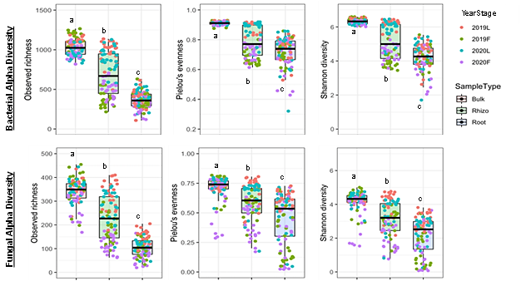
Fig. S1 Bacterial alpha diversity (observed richness, Pielou’s evenness, and Shannon diversity) in the bulk soil, rhizosphere soil (Rhizo), and root endophyte from 2019 and 2020 at the 4-5 leaf vegetative stage (L) and the full-flowering stage (F) (different letters indicated statistical significance at p<0.001, determined using ANOVA followed by Tukey’s test, n=4)
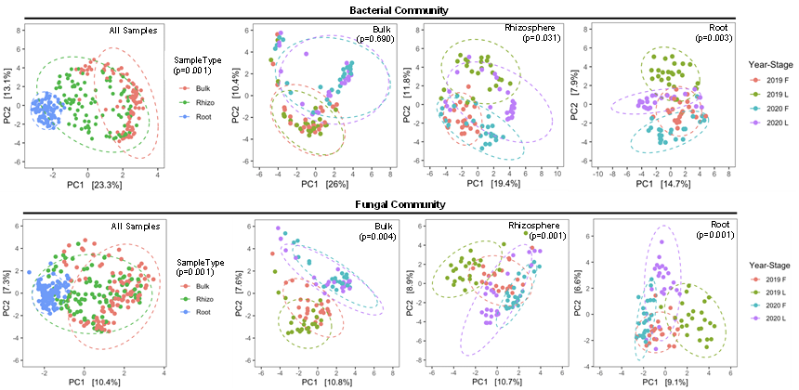
Fig. S2 Principal component analyses of bacterial community structure obtained using 16S rRNA V3-V4 amplicon sequencing and fungal taxa obtained using ITS amplicon sequencing of bulk soil, rhizosphere soil and roots at the 4-5 leaf vegetative stage (L) and the full-flowering stage (F) in 2019 and 2020 (PERMANOVA p-values indicated impacts of sample type, or sampling time (year and growth stage) on bacterial and fungal community structures
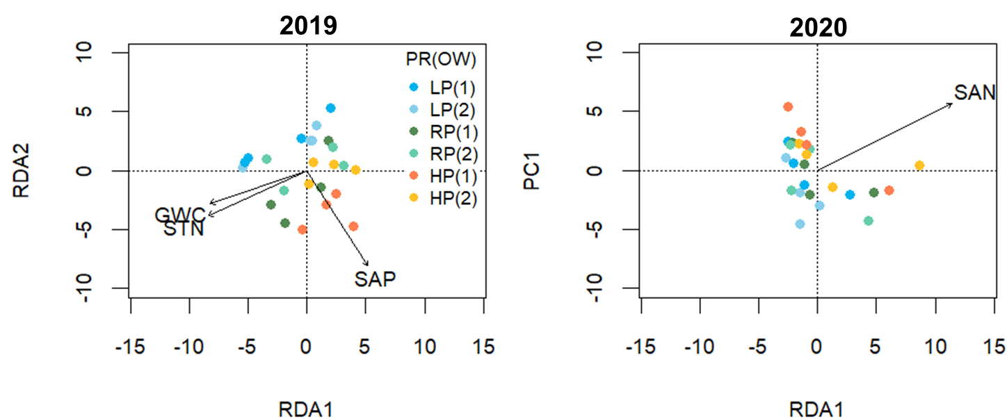
Fig. S3 Redundant analysis on the impact of soil properties, including soil total P (STP), soil available P (SAP), soil total N (STN), soil available N (SAN), gravimetric water content (GWC), on the root fungal community in 2019 and 2020 at the vegetative stage, under phosphorus fertilizations of phosphorus rates (PR) at 0 (LP), 17 (RP), and 32 kg ha⁻¹ (HP) in combinations of opener widths (OW) at the narrow 2.5 cm (1) and the wide 10 cm (2). Only the soil properties significantly impacted the microbial community were shown as arrows (p<0.05, n=4)
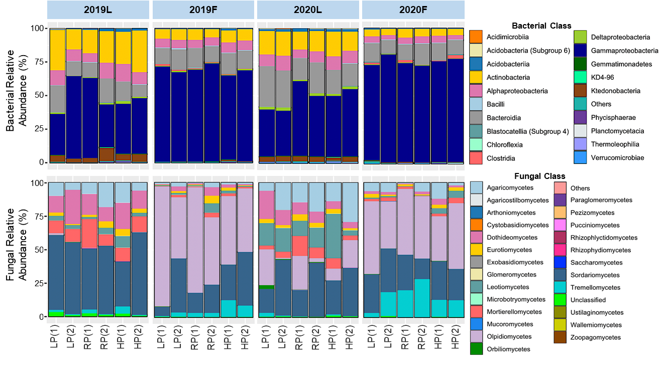
Fig. S4 Relative abundance of the dominant root bacterial and fungal classes in the root at 4-5 leaf vegetative stage (L) and full-flowering stage (F) in 2019 and 2020 under six different soil phosphorus treatments of phosphorus rates (PR) at 0 (LP), 17 (RP), and 32 kg ha⁻¹ (HP) in combinations of narrower (1) and wider (2) opener widths (OW)
Table S1 Soil and plant physical and chemical properties under soil P treatments of P rates (PR) at 0 (LP), 17 (RP), and 32 kg ha⁻¹ (HP) in combinations of in combinations of narrower (1) and wider (2) opener widths (OW) at 4-5 leaf stage (L) and full-flowering stage (F) in 2019 and 2020 (pairwise comparisons were conducted within a specific sampling year and growth stage, where means followed by different letters indicated statistical significance, determined using ANOVA followed by Tukey’s test, p < 0.05)
Year | Growth stage |  | P treatment  [PR (OW)] | Soil total P (mg kg⁻¹) | Soil available P (mg kg⁻¹) | Soil total N (mg kg⁻¹) | Soil available N (mg kg⁻¹) | GWC (%) | Soil pH | Shoot P concentration (mg g⁻¹ DW) | Shoot P uptake (mg) | Shoot N concentration (mg g⁻¹ DW) | Shoot N uptake (mg)
2019 | L |  | LP(1) | 705 c | 29.3 d | 2652 a | 27.9 c | 22.9 a | 6.0 a | 4.0 c | 5.5 b | 55.0 a | 75 a
2019 |  |  | RP(1) | 800 ab | 87.2 bc | 2689 a | 61.5 ab | 22.4 a | 5.6 a | 4.9 a | 14.1 a | 56.4 a | 163 a
2019 |  |  | HP(1) | 851 a | 136.1 a | 2573 a | 80.4 a | 20.6 a | 5.3 a | 5.3 a | 9.2 ab | 54.3 a | 95 a
2019 |  |  | LP(2) | 701 c | 40.6 d | 2553 a | 41.3 bc | 20.8 a | 5.4 a | 4.0 c | 5.9 b | 54.3 a | 81 a
2019 |  |  | RP(2) | 767 ab | 70.0 c | 2680 a | 40.5 b | 21.3 a | 5.3 a | 4.7 ab | 7.7 ab | 53.4 a | 86 a
2019 |  |  | HP(2) | 797 ab | 96.4 b | 2495 a | 62.2 ab | 19.9 a | 5.3 a | 4.6 abc | 9.2 ab | 55.4 a | 110 a
2019 | F |  | LP(1) | 696 a | 24.6 d | 2841 a | 14.3 a | 15.8 a | 6.1 a | 3.1 b | 125.2 ab | 42.3 a | 1697 ab
2019 |  |  | RP(1) | 731 a | 43.7 c | 2952 a | 19.7 a | 16.0 a | 6.0 a | 3.3 ab | 143.5 ab | 35.7 a | 1456 ab
2019 |  |  | HP(1) | 772 a | 77.7 a | 2708 a | 18.8 a | 14.5 a | 5.5 a | 3.9 a | 174.2 a | 43.1 a | 1886 a
2019 |  |  | LP(2) | 683 a | 33.1 cd | 2898 a | 17.7 a | 15.1 a | 5.6 a | 3.0 b | 80.2 b | 38.3 a | 1025 b
2019 |  |  | RP(2) | 740 a | 42.2 c | 2784 a | 16.8 a | 14.3 a | 5.5 a | 3.4 ab | 135.3 ab | 37.5 a | 1491 ab
2019 |  |  | HP(2) | 775 a | 65.8 ab | 2631 a | 19.8 a | 13.3 a | 5.5 a | 3.4 ab | 113.2 ab | 35.4 a | 1185 ab
2020 | L |  | LP(1) | 662 c | 43.6 d | 2015 b | 6.0 b | 15.5 ab | 5.3 a | 5.6 ab | 10.9 b | 56.4 a | 111 ab
2020 |  |  | RP(1) | 806 ab | 86.6 b | 2467 ab | 12.4 ab | 15.6 a | 5.3 a | 5.4 b | 18.7 a | 51.8 b | 178 a
2020 |  |  | HP(1) | 848 a | 116.4 a | 2570 a | 15.1 ab | 15.6 a | 5.4 a | 6.2 a | 13.1 b | 55.3 ab | 118 ab
2020 |  |  | LP(2) | 656 c | 44.6 d | 2164 ab | 5.5 b | 18.0 a | 5.6 a | 5.3 b | 5.1 c | 59.4 a | 57 b
2020 |  |  | RP(2) | 686 b | 60.4 c | 2171 ab | 12.4 ab | 17.0 a | 5.5 a | 5.7 ab | 10.5 bc | 56.4 a | 105 b
2020 |  |  | HP(2) | 741 ab | 87.9 b | 2113 ab | 22.5 a | 15.8 a | 5.5 a | 5.7 ab | 15.0 b | 55.8 ab | 147 a
2020 | F |  | LP(1) | 625 b | 33.5 b | 2116 a | 3.6 a | 17.2 a | 5.6 a | 3.6 ab | 116.4 bc | 30.5 a | 954 b
2020 |  |  | RP(1) | 694 ab | 57.2 ab | 2150 a | 3.1 a | 17.3 a | 5.6 a | 3.7 ab | 143.3 bc | 30.0 a | 1152 b
2020 |  |  | HP(1) | 738 a | 79.9 a | 2023 a | 4.2 a | 19.1 a | 6.0 a | 4.7 a | 484.4 a | 34.9 a | 3609 a
2020 |  |  | LP(2) | 640 b | 42.0 b | 2086 a | 4.5 a | 18.4 a | 5.4 a | 3.4 b | 205.0 b | 26.2 a | 1570 b
2020 |  |  | RP(2) | 627 b | 38.0 b | 1957 a | 3.0 a | 16.7 a | 5.7 a | 3.5 ab | 262.3 b | 26.7 a | 1982 ab
2020 |  |  | HP(2) | 636 b | 45.9 b | 1821 a | 3.8 a | 17.3 a | 5.4 a | 3.8 ab | 259.8 b | 26.7 a | 1854 ab
2019 |  | L  F | / | 770 a | 76.6 a | 2608 b | 52.3 a | 21.3 a | 5.5 a | 4.6 a | 8.6 b | 54.8 a | 102 b
 |  | L  F | / | 733 b | 47.8 b | 2802 a | 17.8 b | 14.8 b | 5.7 a | 3.4 b | 128.6 a | 38.7 b | 1457 a
2020 |  | L  F | / | 733 a | 73.3 a | 2250 a | 12.3 a | 16.2 b | 5.4 a | 5.6 a | 12.2 b | 55.9 a | 119 b
 |  | L  F | / | 661 a | 49.4 b | 2028 a | 3.7 b | 17.6 a | 5.6 a | 3.8 b | 242.3 a | 29.2 b | 1826 a

Table S2 P-values of ANOVA for bacterial and fungal alpha diversity indices (Observed richness, Pielou's evenness, and Shannon diversity) in the bulk soil, the rhizosphere soil, and the root in different sampling years (2019 and 2020), growth stages (the 4-5 leaf vegetative and the full-flowering) and soil P fertilization treatments in combinations of different P rates (PR) at 0 (LP), 17 (RP), and 32 kg ha⁻¹ (HP) in combinations of narrower (1) and wider (2) opener widths (OW)
 | Bacterial Alpha Diversity |  |  |  | Fungal Alpha Diversity
 | Observed richness | Pielou's evenness | Shannon diversity |  | Observed richness | Pielou's evenness | Shannon diversity
Bulk soil
Year | <.0001 | 0.0030 | <.0001 |  | <.0001 | 0.0334 | 0.0044
Stage | 0.6505 | 0.3646 | 0.7275 |  | 0.0028 | 0.0149 | 0.0084
Ptreatment | 0.1349 | 0.3197 | 0.1831 |  | 0.7838 | 0.3998 | 0.4305
Year x Stage | 0.9668 | 0.3063 | 0.4841 |  | 0.1579 | 0.0145 | 0.0136
Year x Ptreatment | 0.1010 | 0.9834 | 0.4966 |  | 0.9856 | 0.9995 | 0.9995
Stage x Ptreatment | 0.4647 | 0.5007 | 0.6406 |  | 0.6804 | 0.6215 | 0.5802
Year x Stage x Ptreatment | 0.4770 | 0.8261 | 0.5115 |  | 0.7817 | 0.9917 | 0.9924
Rhizosphere soil
Year | 0.1106 | 0.0825 | 0.0365 |  | <.0001 | 0.0008 | <.0001
Stage | <.0001 | <.0001 | <.0001 |  | <.0001 | <.0001 | <.0001
Ptreatment | 0.1588 | 0.2365 | 0.1884 |  | 0.7678 | 0.9669 | 0.9517
Year x Stage | <.0001 | 0.0140 | 0.0010 |  | 0.4803 | 0.2056 | 0.2935
Year x Ptreatment | 0.0831 | 0.1783 | 0.1332 |  | 0.2000 | 0.1812 | 0.1644
Stage x Ptreatment | 0.1042 | 0.0603 | 0.0580 |  | 0.0609 | 0.1854 | 0.1260
Year x Stage x Ptreatment | 0.5433 | 0.2660 | 0.3867 |  | 0.3767 | 0.8972 | 0.8741
Root
Year | 0.5850 | 0.1567 | 0.2276 |  | <.0001 | 0.3658 | 0.0976
Stage | 0.0005 | 0.0079 | 0.0027 |  | <.0001 | <.0001 | <.0001
Ptreatment | 0.0147 | 0.3597 | 0.1986 |  | 0.0490 | 0.3747 | 0.2910
Year x Stage | 0.0163 | 0.4536 | 0.1906 |  | 0.1084 | 0.0310 | 0.0171
Year x Ptreatment | 0.2763 | 0.8540 | 0.7474 |  | 0.7245 | 0.9834 | 0.9831
Stage x Ptreatment | 0.3564 | 0.6577 | 0.5809 |  | 0.3491 | 0.7799 | 0.6569
Year x Stage x Ptreatment | 0.1444 | 0.5845 | 0.3843 |  | 0.0193 | 0.4119 | 0.2338
Note: Bold values denote statistical significance at the p < 0.05 level
Table S3 P-values of ANOVA for root bacterial and fungal alpha diversity indices in 2019 and 2020 at the 4-5 leaf vegetative (V) and the full-flowering (F) stages under different P rates (PR) and placements (opener width; OW)
 | Root Bacterial Alpha Diversity |  |  |  | Root Fungal Alpha Diversity
 | Observed richness | Pielou's evenness | Shannon diversity |  | Observed richness | Pielou's evenness | Shannon diversity
2019V
PR | 0.0111 | 0.2133 | 0.1163 |  | 0.3040 | 0.6662 | 0.4127
OW | 0.0118 | 0.8891 | 0.3344 |  | 0.0001 | <.0001 | <.0001
PR:OW | 0.0002 | 0.0124 | 0.0029 |  | 0.2158 | 0.7436 | 0.3895
2019F
PR | 0.4102 | 0.8594 | 0.7063 |  | 0.8722 | 0.6985 | 0.7424
OW | 0.0529 | 0.5578 | 0.2947 |  | 0.1624 | 0.0970 | 0.0954
PR:OW | 0.2625 | 0.5660 | 0.4093 |  | 0.1287 | 0.2198 | 0.1821
2020V
PR | 0.4218 | 0.2399 | 0.2458 |  | 0.4956 | 0.8886 | 0.9297
OW | 0.9852 | 0.8051 | 0.8550 |  | 0.5266 | 0.6040 | 0.6086
PR:OW | 0.9103 | 0.9923 | 0.9822 |  | 0.5236 | 0.2858 | 0.2878
2020F
PR | 0.9865 | 0.9118 | 0.9661 |  | 0.0010 | 0.0285 | 0.0108
OW | 0.3648 | 0.3755 | 0.3483 |  | 0.0245 | 0.4660 | 0.3010
PR:OW | 0.7589 | 0.4749 | 0.5762 |  | 0.3831 | 0.1688 | 0.1823
Note: Bold values denote statistical significance at the p < 0.05 level
Table S4 PERMANOVA for bacterial and fungal communities in all sample types, and separately in the bulk soil, the rhizosphere soil, and the root under different sampling years, growth stages, and P treatments
 | Bacteria |  |  | Fungi
 | R² | Pr(>F) |  | R² | Pr(>F)
All samples
SampleType | 0.205 | 0.001 |  | 0.092 | 0.001
Year | 0.043 | 0.001 |  | 0.045 | 0.001
Stage | 0.027 | 0.001 |  | 0.024 | 0.001
SampleType x Year | 0.019 | 0.001 |  | 0.016 | 0.001
SampleType x Stage | 0.020 | 0.001 |  | 0.019 | 0.001
Year x Stage | 0.005 | 0.039 |  | 0.008 | 0.001
SampleType x Year x Stage | 0.005 | 0.243 |  | 0.008 | 0.014
Bulk soil
Year | 0.101 | 0.001 |  | 0.066 | 0.001
Stage | 0.014 | 0.060 |  | 0.025 | 0.001
Ptreatment | 0.050 | 0.233 |  | 0.050 | 0.200
Year x Stage | 0.007 | 0.690 |  | 0.016 | 0.004
Year x Ptreatment | 0.047 | 0.332 |  | 0.047 | 0.430
Stage x Ptreatment | 0.030 | 1.000 |  | 0.037 | 1.000
Year x Stage x Ptreatment | 0.034 | 0.994 |  | 0.038 | 1.000
Rhizosphere soil
Year | 0.066 | 0.001 |  | 0.066 | 0.001
Stage | 0.101 | 0.001 |  | 0.057 | 0.001
P treatment | 0.046 | 0.289 |  | 0.047 | 0.291
Year x Stage | 0.015 | 0.031 |  | 0.019 | 0.001
Year x Ptreatment | 0.040 | 0.691 |  | 0.044 | 0.707
Stage x Ptreatment | 0.035 | 0.951 |  | 0.040 | 0.960
Year x Stage x Ptreatment | 0.033 | 0.976 |  | 0.037 | 0.998
Root
Year | 0.063 | 0.001 |  | 0.051 | 0.001
Stage | 0.066 | 0.001 |  | 0.058 | 0.001
Ptreatment | 0.056 | 0.023 |  | 0.055 | 0.010
Year x Stage | 0.020 | 0.003 |  | 0.019 | 0.001
Year x Ptreatment | 0.047 | 0.251 |  | 0.053 | 0.017
Stage x Ptreatment | 0.041 | 0.761 |  | 0.049 | 0.131
Year x Stage x Ptreatment | 0.039 | 0.908 |  | 0.051 | 0.036
Note: Bold values denote statistical significance at the p < 0.05 level

