Supplementary Materials for:
Immobilization of a Multi-Template Imprinted Polymer on Biochar for Sorption of Short- and Long-Chain Per- and Polyfluoroalkyl Substances (PFAS)

Jessica M. Steigerwald, and Jessica R. Ray*

Department of Civil & Environmental Engineering
University of Washington, Seattle, Washington 98195-2700 USA

30 pages
experimental description
12 tables
5 figures
references
S1. Adsorbent Materials and Chemicals
Spent coffee grounds for biochar production were donated by the Bay Laurel Catering Services at the University of Washington (Seattle, WA) from Starbucks® Pike Place® grounds, medium roast, arabica coffee sourced from Latin America after use in an industrial drip coffee maker. For column testing, the commercially available activated carbon Filtrasorb® 400 (F400) was obtained from Calgon Carbon (Pittsburg, PA). F400 was chosen because it is a commonly used adsorbent for PFAS treatment owing to its high point of zero charge (pzc) which allows it to have a slightly positive surface charge at neutral pH to improve PFAS adsorption via electrostatic attraction.^{1,2} Prior to use, the spent coffee grounds were ground, sieved to obtain the #30 – 50 mesh fraction (595 – 297 μm), and washed with deionized water to remove fine particulates. Sand (Atlanta, GA) was obtained from The Home Depot, Inc. to be used as an inert column packing. Coarse gravel was obtained from The Home Depot and was used to pack the ends of the columns to distribute flow and prevent washout of column packing. Prior to use, sand was washed with 1 M nitric acid and gravel was washed with 0.5 mM nitric acid (ACS grade nitric acid obtained from Macron Fine ChemicalsTM was diluted with ultrapure water), and then both were washed with deionized water until the rinse reached a pH of approximately 7.0.
All chemicals used for this study were ACS reagent grade or equivalent unless otherwise noted. High purity nitrogen gas (99.998%) and potassium hydroxide pellets from Praxair (Danbury, CT) and Thermo Fisher Scientific (Waltham, MA) were purchased for biochar production and activation, respectively. Molecularly imprinted polymers (MIPs) were synthesized using perfluorobutanesulfonate (PFBS) and perfluoropentanoate (PFPeA) purchased from Sigma Aldrich (St Louis, MO), and 6:2-fluorotelomer sulfonate (6:2-FTS) from AA Blocks (San Diego, CA) as templates; vinylbenzyl trimethylammonium chloride (VBTAC, 96.0%) purchased from Acros Organics (Waltham, MA) as the functional monomer; N,N'-methylenebisacrylamide (MBA, 96.0%) purchased from Thermo Fisher Scientific as the crosslinker; and 2,2’-azobis(2-methylpropionitrile) (AIBN, 98%) purchased from Sigma Aldrich (St. Louis, MO) as the initiator. Methanol purchased from Thermo Fisher Scientific and sodium chloride (NaCl) purchased from VWR Chemical were used for template washing and regeneration of spent adsorbent.
OptimaTM LC/MS grade methanol purchased from Thermo Fisher Scientific was used for preparation of stock solutions and LC-MS/MS samples for all batch tests. Perfluorooctanesulfonate (PFOS) potassium salt from Matrix Scientific; perfluorohexanesulfonate (PFHxS) potassium salt, PFBS, perfluorooctanoic acid (PFOA), PFPeA, perfluorohexanoic acid (PFHxA), perfluorobutanoic acid (PFBA), and trifluoroacetic acid (TFA) from Sigma Aldrich (St Louis, MO); and 6:2-FTS from AA Blocks (San Diego, CA) were used as adsorbates. Batch test and wastewater samples were processed using 0.22 μm cellulose acetate (CA) syringe filters from Sigma Aldrich.
Puriss p.a. grade potassium hydrogen phthalate monobasic for preparation of dissolved organic carbon (DOC) calibration standards was procured from Sigma Aldrich (St. Louis, MO). A 1.6-micron glass fiber (GF/A) 42.5 mm filter paper from Whatman (United Kingdom) was purchased for filtration of wastewater to evaluate DOC and total suspended solids (TSS). The following inorganic salts were purchased to characterize the total dissolved salt concentration in the wastewater treatment plant effluent samples: sodium chloride (VWR), sodium nitrate (VWR), sodium sulfite (Fisher Chemical), sodium sulfate (VWR), trace metals grade nitric acid (Thermo Fisher Scientific), and Inductively Coupled Plasma (ICP) standards from Inorganic Ventures (Christiansburg, PA). Fipronil from Chem Impex International (Wood Dale, IL), ultrapure acetaminophen (99.0%) from Spectrum Chemical Manufacturing Corporation (New Brunswick, NJ), and high performance liquid chromatography (HPLC) grade benzotriazole and HPLC-grade sulfamethoxazole from TCI Chemicals (Tokyo, Japan) were used for spiking co-occurring organics into the column test influent solution along with the nine PFAS used in batch testing (see section S8 and section 4.5 in the main text).
S2. Synthesis of Biochar-Molecularly Imprinted Polymer [BC@mMIP] Composite
MIP was immobilized directly on the surface of the BC via a three-step process. Pre-polymerization: First, 0.1820 g of the functional monomer (VBTAC) and PFAS template(s) were pre-mixed by stirring for 10 h at 150 rpm in 170 mL of deaerated ultrapure water to allow time for alignment in solution. Water was deaerated with nitrogen gas sparging to reduce the consumption of radicals by dissolved oxygen during the polymerization step. Alignment of functional monomers and templates during pre-polymerization occurs due to electrostatic attraction between the quaternary nitrogen on VBTAC and the negative head group of the PFAS template(s), as well as hydrophobic attraction between the aromatic ring of the VBTAC and the fluorocarbon tails of the template(s). For all MIP composites, a 4:1 molar ratio of total template to functional monomer was maintained. In syntheses where more than one template was used, equimolar quantities of each template were added to achieve this ratio. Concurrently with pre-polymerization, 0.5 g of BC was added to 50 mL of water in a glass beaker and allowed to sit for 10 h to pre-wet the BC surface. Polymerization: Second, 1.3240 g crosslinker (MBA) and pre-wetted BC were added to the pre-polymerization mixture and allowed to mix for 30 min (150 rpm) before adding 0.1642 g of initiator (AIBN). Polymerization was initiated by heating the solution to 60 °C in an oil bath while maintaining stirring at 150 rpm. Polymerization was allowed to proceed for 15 h (which was assumed to be sufficient time to allow natural termination of the polymerization) before removing the solution from the oil bath and decanting off the polymerization solution. The separated BC@mMIP composites were placed in a 100 mL glass jar for the final stage of synthesis. Template(s) Extraction: Finally, the PFAS template(s) was/were extracted from the BC@mMIP by adding 100 mL of a template wash solution (70% methanol, 1% sodium chloride, and 2.8 mM sodium hydroxide in water) to the glass jar. The jar was placed in a temperature-controlled shaker (Thermo Fisher Scientific Maxq 4000 Orbital benchtop shaker) and allowed to mix at 200 rpm and 33 °C for a minimum of 24 h before decanting to separate the wash solution from the composite solids. This wash process was repeated for a total of five times with template wash solution followed by one ultrapure water wash. Template extraction was considered successful if PFAS concentrations in the fifth wash solution were at or below 200 μg/L (around three orders of magnitude lower than the concentration in the polymerization solution). Following washing, BC@mMIPs were oven-dried at 60 °C for 24 h, sieved to obtain the #50 – 30 mesh (297 – 595 micron) fraction, and then stored in glass vials in a desiccator for further analysis. A non-imprinted polymer composite (BC@NP) was synthesized via the same process without the use of a template PFAS analyte, and the final washing was limited to a 24 h ultrapure water wash to remove excess monomers and polymer.
S3. TEM Embedding Resin Recipe
Transmission electron microscopy (TEM) samples were embedded in a resin prepared as shown in table S1. Approximately 5 mg of sample was placed in a plastic conical tube mold approximately 1 x 2 cm and allowed to harden overnight at 60 °C in an oven.
Table S1 TEM Embedding Resin Recipe.
component | quantity
epoxy resin (Poly/Bed 812) | 24 g
dodecenyl succinic anhydride (DDSA) | 16 g
nadic methyl anhydride (NMA) | 10 g
2,4,6-tris(dimethylaminomethyl)phenol (DMP-30)  or  benzyldimethylamine (BDMA) | 1.5% – 2%
S4. High BC@MIP specific surface area is attributed to biochar morphology and templated binding sites
Specific surface area (SSA) was measured for the unmodified and polymer-modified BC sorbents via nitrogen adsorption at 77K with a Micromeritics 3Flex Version 5.00 (Norcross, GA). Degassing was conducted in situ at 300 °C for 12 h prior to analysis followed by a two min leak test with a pressure fluctuation limit of 0.0025 mmHg/min to confirm successful degassing. Free space analysis was conducted with helium gas after adsorption to eliminate the effects of trapped helium gas in the micropores on nitrogen adsorption. Adsorption data was evaluated using the Brunauer-Emmett-Teller (BET) model to obtain the SSA, and the Barrett-Joyner-Halenda (BJH) model to obtain average pore diameter and cumulative pore surface area.
Brunauer-Emmett-Teller (BET) surface area analysis and TEM imaging revealed a thin, non-uniform polymer coating of variable thickness on the BC@mMIP composite. The composite had high SSA derived from both the microporous biochar morphology and templated binding sites in the polymer layer. Only a minor reduction in SSA was observed following immobilization of the single- and multi-template imprinted polymers to the biochar surface (table 2 of the main text). All four BC@MIP materials had a SSA of around 1000 m²/g compared to 1319 m²/g for the unmodified biochar. The average pore diameter increased slightly following MIP immobilization from 3.3 nm for the BC to 4.1 – 9.8 nm for the BC@MIP materials. This increase in pore size can be primarily attributed to the formation of templated binding sites since the non-imprinted polymer (BC@NP) did not experience a similar increase in pore size (3.0 nm following polymerization). Polymer thickness for the BC@mMIP material can be estimated in the range of 10 – 500 nm from the TEM image shown in figure 1 of the main text. It should be noted that significant spatial variability in polymer thickness appears to be present, likely a result of the irregular morphology of the biochar surface as well as irregularity inherent in the radical initiated polymerization process. This high SSA is expected to contribute to high PFAS adsorption capacities, as discussed further in section 2.
The effect of polymer swelling on BC@MIP/NP morphology was evaluated via a 4-day equilibration in ultrapure water. First, BET surface area, pore size, and pore surface area of the BC@mMIP and BC@NP were measured as prepared via nitrogen adsorption (as described above). The materials were then subjected to wetting in ultrapure water for 4-days followed by oven-drying at 60 °C. Subsequently, the surface area, pore size, and pore surface area were remeasured. Swelling appeared to have minimal impact on surface area, but significantly increased the pore size and surface area (table S2). These changes could impact adsorption kinetics over multiple cycles of adsorption and regeneration with these materials, particularly if the adsorbent is allowed to dry out during this process.
Table S.2 Changes in BET surface area (SA), pore size, and pore surface area following polymer layer swelling and redrying.
adsorbent name | BET SA (m²/g) | pore size (nm) | pore SA (m²/g)
BC@NP pre-swelling | 580 | 3.0 | 39
BC@NP post-swelling | 562 | 66.9 | 230
BC@mMIP pre-swelling | 625 | 9.0 | 54
BC@mMIP post-swelling | 653 | 20.3 | 36
S5. PFAS Competition Batch Test Methods and Calculations
A PFAS competition test was conducted using all six adsorbates in table 2 of the main text and nine PFAS adsorbents with initial concentrations of 58 ± 3.7 μg/L PFOS, 50 ± 5.5 μg/L PFHxS, 49 ± 5.1 μg/L PFBS, 48 ± 3.2 μg/L 6:2-FTS, 50 ± 4.9 μg/L PFOA, 58 ± 4.8 μg/L PFHxA, 52 ± 5.4 μg/L PFPeA, 53 ± 5.5 μg/L PFBA, and 41 ± 7.8 μg/L TFA in ultrapure water, pH 7.00. Briefly, 5.0 mg of adsorbent was added to a 50 mL polypropylene tube, with triplicate samples of each adsorbent prepared in separate tubes. At the same time, the PFAS solution was prepared in ultrapure water in a 1 L Erlenmeyer flask with concentrated methanolic stocks to achieve an initial concentration of 50 μg/L of each PFAS while maintaining a methanol concentration of no more than 0.02 % v/v. This solution was allowed to mix for 10 min and then the pH was measured and adjusted if needed with dilute sodium hydroxide or hydrochloric acid solutions to achieve a pH of 7.00. This method of pH control was chosen over buffering to eliminate potential effects of the buffer compound on PFAS adsorption. A 50-mL aliquot of the initial PFAS solution was added to each sample, and tubes were placed on a FisherbrandTM Multi-Purpose Tube Rotator (Fisher Scientific, Waltham, MA) and rotated at 40 rpm for 4 days.
Following the 4-day equilibration period, tubes were removed from the rotator and filtered through 0.22 μm cellulose acetate syringe filters. To minimize PFAS losses on the filter, approximately 25 mL of sample was collected for filtration and the first 20 mL were wasted before collecting around 1.5 mL for subsequent analysis. Samples were prepared and analyzed via liquid chromatography tandem mass spectrometry (LC-MS/MS) as detailed in section S13. The final sample pH was measured following removal of the LC-MS/MS sample, and ranged from 6.21 – 7.33.
Percent removal, equilibrium adsorption capacity (q_{e,}), solid-liquid distribution coefficient (K_{d}), and selectivity coefficients were calculated from adsorption data using equations (S.1) – (S.7) below. Selectivity calculations were performed using template compound(s) as the reference adsorbate and the unmodified BC as the reference adsorbent.^{3,4}
$\text{Percent removal} \text{=} \frac{\left({\text{C}}_{\text{0}}-{\text{C}}_{\text{e}}\right)}{{\text{C}}_{\text{0}}}\text{*100\%}$ Eqn. (S.1)
${\text{q}}_{\text{e}} \text{=} \left({\text{C}}_{\text{0}}-{\text{C}}_{\text{e}}\right)\text{*}\frac{\text{V}}{{\text{m}}_{\text{ads}}}$ Eqn. (S.2)
${\text{K}}_{\text{d}}\text{ = }\frac{{\text{C}}_{\text{0}}-{\text{C}}_{\text{e}}}{{\text{C}}_{\text{e}}}\text{*}\frac{\text{V}}{{\text{m}}_{\text{ads}}}$ Eqn. (S.3)
${\text{K}}_{\text{imprinted}} \text{=} \frac{{\text{q}}_{\text{e,BC@MIP,template}}}{{\text{q}}_{\text{e,BC@MIP, adsorbate}}}$ Eqn. (S.4)
${\text{K}}_{\text{comparison} }\text{=} \frac{{\text{q}}_{\text{e,BC@NP,template}}}{{\text{q}}_{\text{e,BC@NP, adsorbate}}}$ Eqn. (S.5)
${\text{K}}_{\text{selectivity} }\text{=} \frac{{\text{K}}_{\text{imprinted}}}{{\text{K}}_{\text{comparision}}}$ Eqn. (S.6)
$\text{IF = }\frac{{\text{q}}_{\text{e,BC@MIP, template}}}{{\text{q}}_{\text{e,BC@NP,template}}}$ Eqn. (S.7)
Where C₀ and C_{e} are the initial and equilibrium adsorbent concentrations (mg/L), V is the sample volume (L), and m_{ads} is the mass of adsorbate on the adsorbent (g).
S6. Adsorption Isotherm Test Methods and Calculations
Similar to section S5, adsorption isotherm samples were run in triplicate in 50-mL polypropylene tubes containing 50 mL of PFAS solution in ultrapure water and 100 mg/L adsorbent. Initial concentrations ranged from 5‒5000 μg/L of PFBS, PFPeA, and 6:2-FTS for each single adsorbate sample. Multiple methanolic stock solutions were used to prepare these samples such that the methanol concentration remained below 0.2% v/v and pipetted volumes of methanol were no smaller than 10 μL. The initial pH of the two highest concentration PFPeA replicate sets was adjusted with dilute hydrochloric acid to 6.7 ± 0.7 to match the pH of the rest of the isotherm samples. This step was necessary for these samples only because the methanolic stock solutions for the perfluorocarboxylic acids (PFCAs) contain four mole equivalents of sodium hydroxide to prevent methylation of PFCAs during long term storage.⁵ Once prepared, sample tubes were placed on a tube rotator at 40 rpm and allowed to equilibrate for 4 d before filtering as described in section S5 and preparing LC-MS/MS samples for PFAS quantification as described in section S13. Adsorption results were fit to the Langmuir and Freundlich isotherm models described in equations (8) and (9) to gain a better understanding of adsorption behavior:
${\text{q}}_{\text{e}}\text{ = }\frac{{\text{q}}_{\text{max}}{\text{K}}_{\text{L}}{\text{C}}_{\text{e}}}{\text{1+}{\text{K}}_{\text{L}}{\text{C}}_{\text{e}}}$ Eqn. (S.8)
${\text{q}}_{\text{e}}\text{=}{\text{K}}_{\text{F}}{\text{C}}_{\text{e}}^{\text{1/n}}$ Eqn. (S.9)
Where q_{e} and q_{max} are the equilibrium and maximum adsorption densities (mg/g), C_{e} is the equilibrium adsorbate concentration (mg/L), K_{L} (L/mg) and K_{F} [mg/g)(L/mg)^{1/n}] are the Langmuir and Freundlich adsorption rate constants, respectively, and 1/n is the Freundlich coefficient of non-linearity.
S7. Low Concentration Adsorption and Regeneration Batch Test Methods
Prior to the start of the low concentration adsorption and regeneration experiment, all glassware was washed three times with methanol and once with ultrapure water. First, 3.3 L of ultrapure water were added to a 4 L Erlenmeyer flask and spiked with methanolic stocks of each PFAS to achieve initial PFAS concentrations of: 217 ± 93 ng/L PFOS, 114 ± 28 ng/L PFHxS, 109 ± 29 ng/L PFBS, 112 ± 10 ng/L 6:2-FTS, 93 ± 10 ng/L PFOA, 87 ± 19 ng/L PFHxA, 96 ± 19 ng/L PFPeA, 98 ± 6 ng/L PFBA, and 197 ± 50 ng/L TFA. The solution was stirred for 10 min to fully mix the reagents, and then the initial pH was adjusted to 7.0 with a dilute sodium hydroxide solution. The PFAS solution was then measured into six 500 mL high density polyethylene (HDPE) bottles (i.e., three BC@mMIP replicates and three PFAS control replicates with no added sorbent) and three 50 mL polypropylene tubes (i.e., PFAS initial concentration replicates). Three additional 500 mL HDPE bottles were filled with ultrapure water for blank control replicates. BC@mMIP was added to the samples where relevant to achieve an adsorbent concentration of 100 mg/L and then all HDPE sample bottles were placed on a shaker table at 180 rpm and allowed to equilibrate for 4 d. The initial concentration controls were concentrated via solid phase extraction (SPE; see section S14) and stored in the refrigerator for no more than two weeks prior to analysis via LC-MS/MS (section S13). After 4 d, the solid and liquid phases of the BC@mMIP samples were separated via decanting, and all nine liquid samples were concentrated via SPE and PFAS concentrations were quantified via LC-MS/MS.
PFAS loaded on spent BC@mMIP adsorbents were recovered using the template wash solution described in section S2 for 7 d to better understand PFAS recovery and material lifetimes for the BC@mMIP materials. Briefly, spent adsorbent from each BC@mMIP sample bottle was placed in individual 50 mL tubes and suspended in 50 mL of template wash solution. Tubes were capped, wrapped in parafilm, and placed on a tube rotator at 40 rpm. Note: The liquid in the tubes did not make contact with the parafilm wrapping during mixing. A 0.05 mL sample aliquot was collected at 1 d and 3 d timepoints to evaluate regeneration kinetics, and an equal volume of fresh template wash solution was added to maintain a total volume of 50 mL throughout the regeneration test. After 7 d, the regeneration samples were removed from the rotator and a sample was collected from each. PFAS concentrations in all samples were quantified via LC-MS/MS (section S13).
S8. Column Set-Up
Triplicate columns were run for each of four packing types [sand (control), F400 (commercial AC), BC@NP, and BC@mMIP] for twelve columns in total, as shown in figure S1 below. Columns were constructed from PVC pipes and fittings with HDPE tubing and tubing fittings and run in an up-flow configuration. Influent solution was stored in a covered 55 L linear low-density polyethylene (LLDPE) tank at room temperature with constant stirring. An Ismatec IP High Precision Multichannel peristaltic pump was used to convey water to the columns, and PharMed® BPT tubing was used within the pump housing. Sample ports were located at the top of the columns and effluent was subsequently collected in a PVC pipe and collected for disposal. Adsorbents (BC@mMIP, BC@NP and F400) were packed at 1 weight percent (wt. %) with 99 wt. % pre-washed sand (approximately 56 g sand and 0.56 g adsorbent media per column). Columns were weighed pre- and post-packing, and both wet and dry to quantify the pore volume in each column (table S3). A flow of 1 mL/min of deionized (DI) water was started through the first column replicate of each adsorbent type (for a total of four columns) in up-flow configuration. The columns were allowed to equilibrate for 60 min, and then a 1-minute duration sample was collected from each column and weighed to confirm the flow rate.
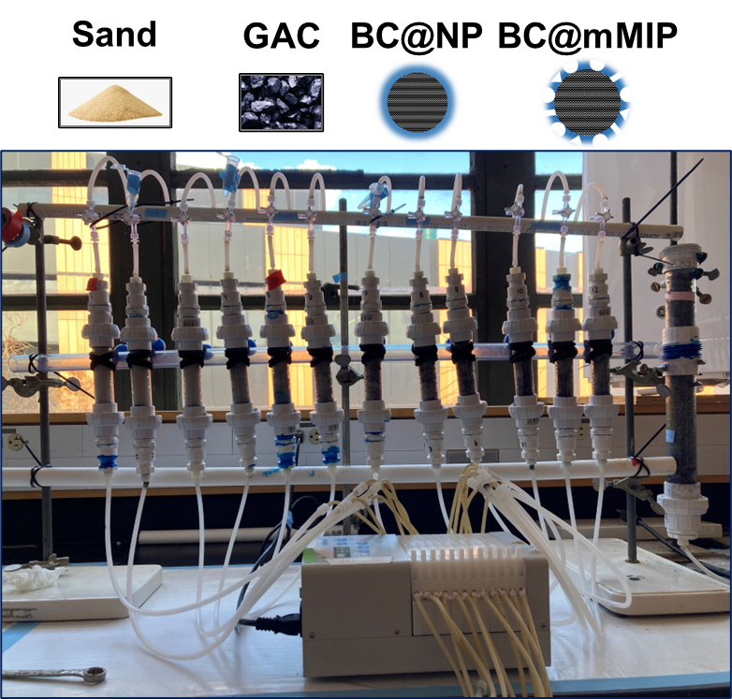
Figure S1 Column test set-up. Test columns contain 1 wt.% of adsorbate in sand.
Following column assembly, a tracer test was performed using sodium borate to confirm the column pore volumes calculated during packing. Tracer stock solutions of 2.5 mM and 50 mM Br⁻ as NaBr were prepared in ultrapure water. The lower concentration stock was used for the sand, BC@NP, and BC@mMIP columns while the high concentration stock was used for the F400 columns to account for the moderate levels of bromide adsorption by the media. Once the columns were equilibrated at the correct flow rate and the pore volume determined, influent lines were removed from the DI water, placed in the appropriate NaBr stock for 8 seconds, and then placed back in the DI water. Small air bubbles were allowed to form in the tubing lines on either side of the NaBr stock to track the location of the tracer. The movement of the tracer aliquot through the influent lines to the start of the column was timed and recorded for future reference. Tracer test sampling was started once the tracer stock reached the column with 1-minute (1 mL) samples collected every two minutes from each column.
Table S3 presents average adsorbent media masses for triplicate columns and column pore volumes calculated from both the mass change in wet versus dry column weights and from tracer test results. Graphical tracer test results are provided in figure S2.
Table S3 Column packing characteristics and calculated pore volumes.
media type | Sand | F400 (1 wt. %) | BC@NP (1 wt. %) | BC@mMIP (1 wt. %)
mass active media (g) | --- | 0.52 | 0.54 | 0.54
PV_{mass calculation} (mL) | 11.1 | 12.5 | 9.7 | 11.0
PV_{tracer test} (mL) | 27.1 | 27.4 | 37.2 | 27.9

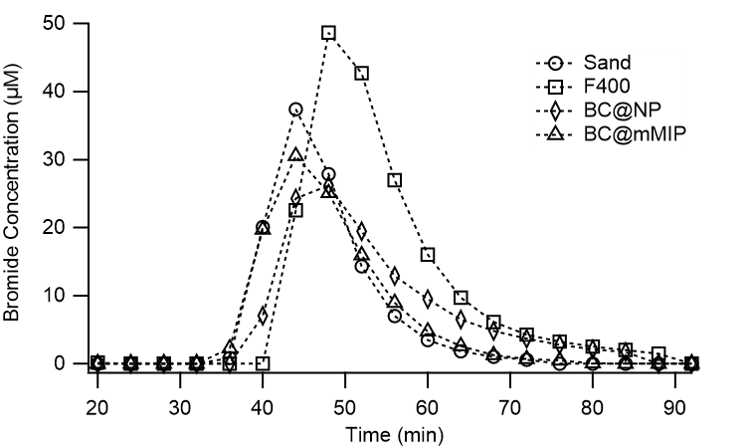
Figure S2 Column tracer test graphical results.
Wastewater treatment plant (WWTP) final effluent for column testing was obtained from the King County West Point Treatment Plant located in Seattle, WA. Aliquots of each weekly sample were characterized as described in sections S15 and S16 to gain a better understanding of the chemical composition of the WWTP effluent and results from all analyses are tabulated in table 3. Initial concentrations of adsorbates of interest were quantified via LC-MS/MS and high performance liquid chromatography followed by ultra-violet spectroscopy (HPLC-UV) as described in sections S13 and S17. No quantifiable amounts of PFAS, fipronil, or sulfamethoxazole were found in the wastewater effluent samples; however, benzotriazole was quantified in the wastewater effluent at 7.7 ± 1.9 μg/L and was factored into the initial concentration of the column test influent accordingly.
Column influent stock comprised of WWTP effluent spiked with approximately 20 μg/L each of PFOS, PFHxS, PFBS, 6:2-FTS, PFOA, PFHxA, PFPeA, PFBA, TFA, acetaminophen, fipronil, sulfamethoxazole, and benzotriazole was prepared in batches of no more than 55 L. Briefly, a concentrated adsorbate stock was prepared in ultrapure water from individual methanolic stocks. The ultrapure water stock was stirred for 10 minutes to completely mix, and then a 1-mL aliquot was collected for adsorbate quantification. This stock was then added to the appropriate volume of WWTP effluent to obtain the desired goal concentration and stirred overnight to obtain a homogeneous mixture. Slow stirring was maintained for the duration of the column test and influent stock was refreshed every 3–4 days as needed. The WWTP column influent was fed to the control and test columns in an upflow configuration. WWTP effluent samples were collected weekly to maintain the volume of influent required for the duration of the column study.
Column regeneration was done with the template wash solution (70% methanol, 1% sodium chloride and 2.8 mM sodium hydroxide in ultrapure water). During the regeneration phase, column wash was delivered at 0.5 mL/min for six hours in the same upflow configuration as the adsorption phase. Samples were collected as two-minute composites (1 mL sample volume) and stored at -20 °C prior to analyte quantification. Following regeneration, DI water was passed through the columns at 0.5 mL/min for 18 hours to wash out any residual methanol or sodium chloride in preparation for the next adsorption phase.

S9. Chemical Properties of PFAS and Organics
Table S4 Chemical properties of nine PFAS adsorbates and four co-occurring organics.
analyte name | structure | pKaª | solubility^{b} (mg/L) | logK_{oc}^{b} | logD_{oc}^{c}  (at pH 7)
PFOS | 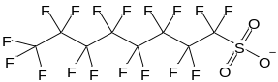 | -6 to -2.6 | 0.104 | 4.86 | -4.74
PFHxS | 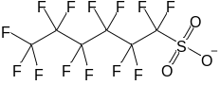 | -6 to -5.0 | 6.17 | 3.55 | -8.45
PFBS | 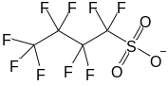 | -6 to -5.0 | 344 | 2.25 | -9.75
6:2-FTS | 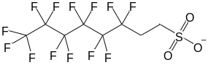 | 1.31 | 11.0 | 4.05 | -1.64
PFOA | 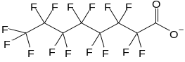 | -0.16 to 3.8 | 0.481 | 4.42 | -2.74
PFHxA | 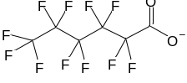 | -0.13 | 27.1 | 3.12 | -4.01
PFPeA | 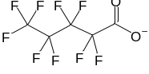 | -0.06 | 197 | 2.46 | -4.60
PFBA | 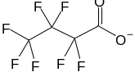 | -0.2 to 0.7 | 1370 | 1.81 | -4.49
TFA | 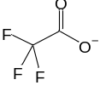 | 0.23 | 97,500 | 0.51 | -6.26
fipronil | 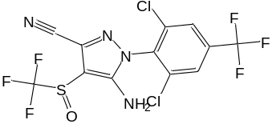 | no dissociation | 1.90 | 3.77 | 3.77
acetaminophen | 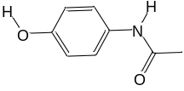 | 9.38 | 30,400 | 1.65 | 1.65
benzotriazole | 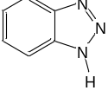 | 8.37 | 19,800 | 1.72 | 1.70
sulfamethoxazole | 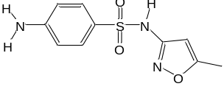 | pK_{a1}: 1.6  pK_{a2}: 5.7 | 3,940 | 2.41 | 1.09
a. PFAS source: SGS. “Physical and Chemical Properties of PFAS Compounds.” (accessed 10/4/2022).⁶ Fipronil source: Bonmatin et al. 2015.⁷ Other compounds source: PubChem.⁸
b. US EPA. 2020. Estimation Programs Interface Suite™ for Microsoft® Windows, v 4.1. United States Environmental Protection Agency, Washington, DC, USA.⁹
c. Calculated from pKa and logK_{oc}
S10. Limits of Detection and Quantification
Method limits of detection (LoD) and quantification (LoQ) were calculated for LC-MS/MS and HPLC-UV samples run in either (A) 50% v/v ultrapure water and Optima Grade methanol, and (B) 50% v/v Optima Grade methanol and 25% v/v each of ultrapure water and wastewater final effluent (table S5) using equations (C.10) through (C.13) below. LoD and LoQ represent analytical method limits only and do not account for concentration factors resulting from solid phase extraction (see section S14). Values presented are the average of LoD and LoQ values calculated for each analysis run (+/-) the standard deviation
${\text{s}}^{\text{2}} \text{=} \frac{\sum_{\text{i=1}}^{\text{n}}{{\text{(}{\text{y}}_{\text{i}}\text{-}{\text{f}}_{\text{i}}\text{)}}^{\text{2}}}}{\text{n-2}}$ Eqn. (S.10)
${\text{s}}_{\text{intercept}}\text{=}\sqrt{\frac{{\text{s}}^{\text{2}}\text{×}\sum_{\text{i=1}}^{\text{n}}{{\text{x}}_{\text{i}}^{\text{2}}}}{\text{n×}\sum_{\text{i=1}}^{\text{n}}{{\text{x}}_{\text{i}}^{\text{2}}\text{-}{\text{(}\sum_{\text{i=1}}^{\text{n}}{{\text{x}}_{\text{i}}}\text{)}}^{\text{2}}}}}$ Eqn. (S.11)
$\text{LoD} \text{=} {\text{3.3×}{\text{s}}_{\text{intercept}}}/{\text{slope}}$ Eqn. (S.12)
$\text{LoQ=}{\text{10×}{\text{s}}_{\text{intercept}}}/{\text{slope}}$ Eqn. (S.13)
where: s² is the sum of the squared differences between the calibration curve data and a linear regression fit, y_{i} is the measured dependent variable from the calibration curve (i.e., the signal), f_{i} is the predicted dependent variable (i.e., the signal calculated using the slope and intercept from a linear regression of the calibration curve data), n is the number of data points in the calibration curve, s_{intercept} is the standard deviation of the intercept, x_{i} [μg/L] is the known dependent variable from the calibration curve (i.e., the concentration), LoD [μg/L] is the limit of detection, slope is the slope value of a linear regression of the calibration curve, and LoQ [μg/L] is the limit of quantification. A similar calculation was performed to determine the LoD and LoQ from the standard deviation of the slope; however, these values were consistently lower than the LoD and LoQ presented here and have thus been excluded from this discussion.
Table S5 Limit of detection and limit of quantification for nine PFAS and four organic contaminants in (A) 50% v/v ultrapure water and Optima Grade methanol, and (B) 50% v/v Optima Grade methanol and 25% v/v each of ultrapure water and wastewater final effluent.
 | (A) |  | (B)
Analyte | LoD | LoQ | LoD | LoQ
PFOS | 0.15 ± 0.09 | 0.47 ± 0.26 | 0.43 ± 0.31 | 1.29 ± 0.93
PFHxS | 0.33 ± 0.15 | 1.00 ± 0.46 | 0.52 ± 0.23 | 1.57 ± 0.70
PFBS | 0.23 ± 0.11 | 0.71 ± 0.34 | 0.38 ± 0.21 | 1.15 ± 0.64
6:2-FTS | 0.32 ± 0.21 | 0.97 ± 0.64 | 0.77 ± 0.39 | 2.34 ± 1.18
PFOA | 0.15 ± 0.09 | 0.44 ± 0.26 | 0.22 ± 0.11 | 0.66 ± 0.32
PFHxA | 0.28 ± 0.09 | 0.84 ± 0.26 | 0.38 ± 0.15 | 1.17 ± 0.45
PFPeA | 0.27 ± 0.08 | 0.82 ± 0.24 | 0.35 ± 0.19 | 1.05 ± 0.59
PFBA | 0.19 ± 0.11 | 0.59 ± 0.34 | 0.40 ± 0.16 | 1.21 ± 0.48
TFA | 0.32 ± 0.19 | 0.98 ± 0.59 | 0.73 ± 0.36 | 2.21 ± 1.08
Fipronil |  |  | 0.68 ± 0.52 | 1.51 ± 0.69
Acetaminophen |  |  | 0.74 ± 0.29 | 2.26 ± 0.88
Benzotriazole |  |  | 1.00 ± 0.28 | 3.04 ± 0.86
Sulfamethoxazole |  |  | 0.94 ± 0.34 | 2.86 ± 1.02

S11. Selectivity Coefficient Calculations
Table S6 Selectivity coefficient calculations from adsorption of nine PFAS onto single and multi-template BC@MIP adsorbents.
 |  | 6:2-FTS template |  |  | PFBS template |  |  | PFPeA template
adsorbent | COI | K_{imprinted} | K_{comparison} | K_{selectivity} | K_{imprinted} | K_{comparison} | K_{selectivity} | K_{imprinted} | K_{comparison} | K_{selectivity}
BC@NP | PFOS |  | 0.74 |  |  | 0.46 |  |  | 0.16
BC@MIP | PFOS | 0.82 |  | 1.11 | 0.54 |  | 1.17 | 0.35 |  | 2.22
BC@mMIP | PFOS | 0.86 |  | 1.16 | 0.87 |  | 1.88 | 0.65 |  | 4.14
BC@NP | PFHxS |  | 0.97 |  |  | 0.60 |  |  | 0.21
BC@MIP | PFHxS | 0.87 |  | 0.90 | 0.79 |  | 1.31 | 0.49 |  | 2.38
BC@mMIP | PFHxS | 0.97 |  | 1.00 | 0.98 |  | 1.62 | 0.73 |  | 3.57
BC@NP | PFBS |  | 1.60 |  |  |  |  |  | 0.34
BC@MIP | PFBS | 1.92 |  | 1.20 |  |  |  | 0.52 |  | 1.53
BC@mMIP | PFBS | 0.99 |  | 0.61 |  |  |  | 0.75 |  | 2.20
BC@NP | 6:2-FTS |  |  |  |  | 0.62 |  |  | 0.21
BC@MIP | 6:2-FTS |  |  |  | 0.92 |  | 1.47 | 0.48 |  | 2.27
BC@mMIP | 6:2-FTS |  |  |  | 1.01 |  | 1.63 | 0.76 |  | 3.58
BC@NP | PFOA |  | 1.00 |  |  | 0.62 |  |  | 0.21
BC@MIP | PFOA | 1.11 |  | 1.11 | 0.97 |  | 1.56 | 0.47 |  | 2.24
BC@mMIP | PFOA | 0.90 |  | 0.90 | 0.91 |  | 1.47 | 0.69 |  | 3.24
BC@NP | PFHxA |  | 1.45 |  |  | 0.91 |  |  | 0.31
BC@MIP | PFHxA | 1.63 |  | 1.12 | 1.06 |  | 1.17 | 0.50 |  | 1.63
BC@mMIP | PFHxA | 0.91 |  | 0.62 | 0.92 |  | 1.02 | 0.69 |  | 2.24
BC@NP | PFPeA |  | 4.71 |  |  | 2.94
BC@MIP | PFPeA | 4.98 |  | 1.06 | 1.49 |  | 0.51
BC@mMIP | PFPeA | 1.32 |  | 0.28 | 1.33 |  | 0.45
BC@NP | PFBA |  | 28.75 |  |  | 17.92 |  |  | 6.10
BC@MIP | PFBA | 40.70 |  | 1.42 | 3.37 |  | 0.19 | 5.72 |  | 0.94
BC@mMIP | PFBA | 2.33 |  | 0.08 | 2.36 |  | 0.13 | 1.77 |  | 0.29

S12. Desorption Kinetics Following Adsorption of (Waste)water Relevant Concentrations of Nine PFAS on BC@mMIP
Desorption kinetics from the batch sorption and desorption test described in section 2.4.3 are presented in figure S3 below and indicate fast desorption of all nine PFAS from the BC@mMIP adsorbent material.
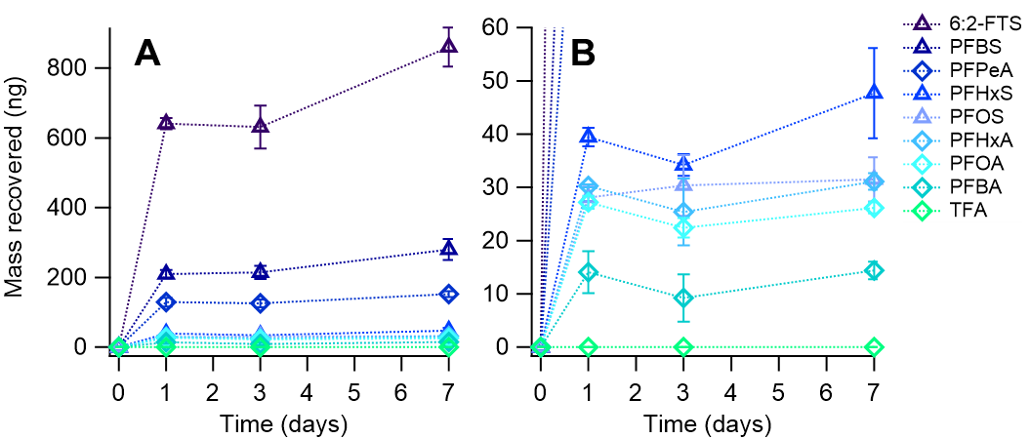
Figure S3 PFAS desorption kinetics over 7 days from BC@mMIP following a 4-day adsorption test of (waste)water relevant concentrations in ultrapure water. PFAS recovery was achieved in a 70% methanol, 1% sodium chloride, 2.8 mM sodium hydroxide solution with a solids concentration of 1 g/L. Graph (A) displays the full dataset while (B) displays a closer look at the PFAS with recovered mass from 0 – 60 ng over the 7-day period.

S12. Additional Column Test Plots of Time Series Adsorption and Mass Change
Time series and mass change plots of column test results for analytes not included in figures 5 and 6 are presented in figures S4 and S5 below. A discussion of these results is included in sections 2.4 and 2.5.
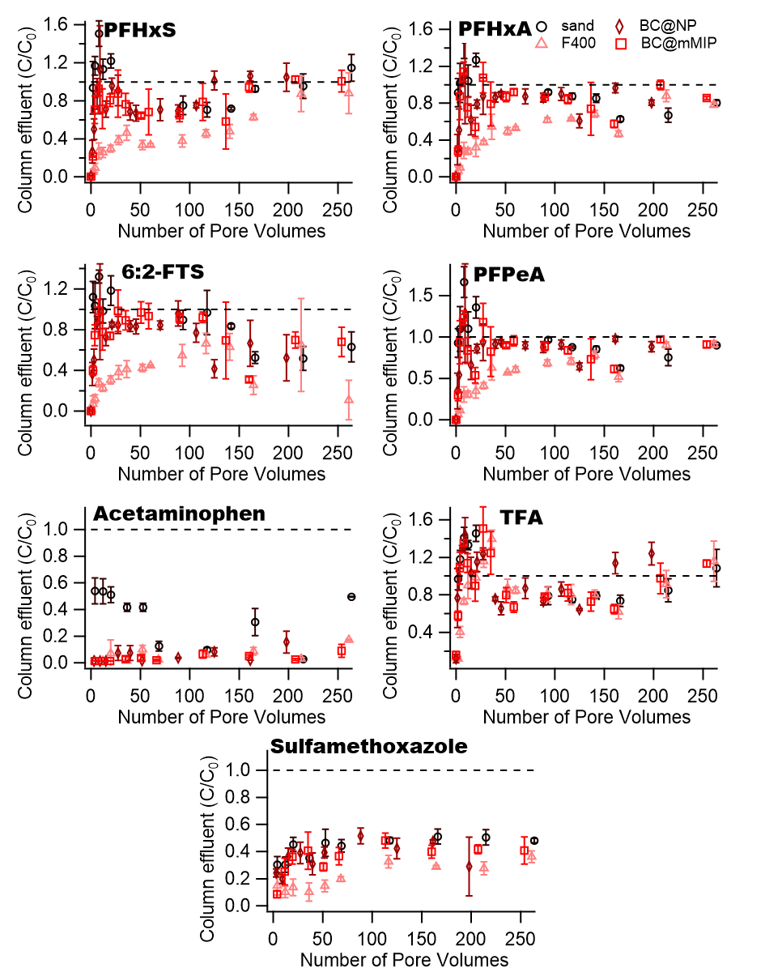
Figure S4 Time series adsorption of PFAS and organic compounds not shown in Figure 5. Initial concentrations for each compound during adsorption was approximately 20 μg/L in a wastewater effluent matrix delivered at 1 mL/min. Error bars represent standard deviation from triplicate columns for each media type.
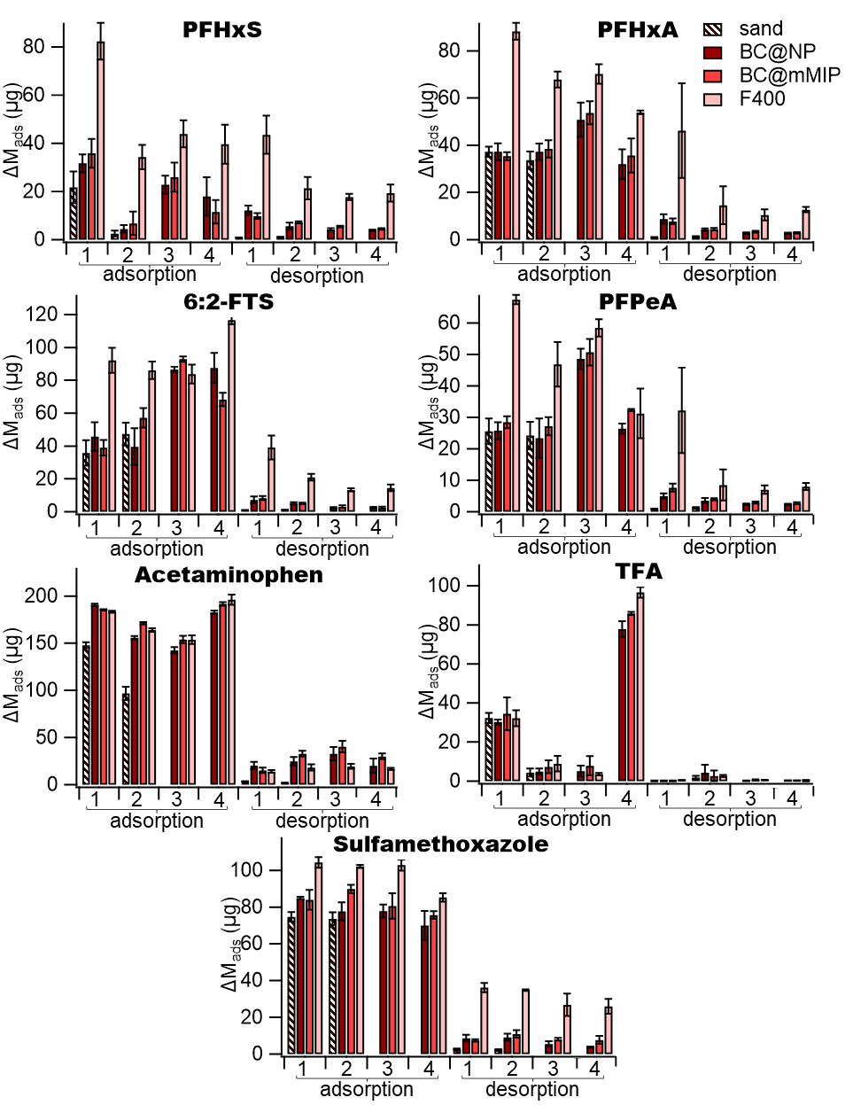
Figure S5 Cumulative analyte mass adsorbed and desorbed from column media over four sequential cycles for PFAS and organic compounds not shown in Figure 6. Initial concentrations for each compound during adsorption was approximately 20 μg/L in a wastewater effluent matrix delivered at 1 mL/min. Desorption was achieved by flushing with 70% methanol and 1% sodium chloride at 0.5 mL/min. Error bars represent standard deviation from triplicate columns for each media type.
S13. LC-MS/MS Analysis for Quantification of PFAS and Fipronil
Concentrations of all PFAS were quantified by mass spectroscopy using a Waters Corporation (Milford, MA) triple quadrupole mass spectrometer (MS/MS) preceded by liquid chromatography (LC). Prior to analysis, samples were filtered to remove composite fines and (where applicable) organic compounds (e.g., wastewater effluent organic matter) that would negatively impact instrument performance. Briefly, samples were filtered with a 0.22 μm cellulose acetate (CA) syringe filter by first filtering 20 mL of sample into waste and then collecting 1.5 mL of filtered sample. Cellulose acetate was chosen as a filter media for its low PFAS loss, as detailed in prior publications.^{10,11} All liquid chemicals used in LC-MS/MS analysis of PFAS were Optima® LCMS Grade and the Ammonium Acetate was certified ACS Grade (98.1% purity), all purchased from Fisher Chemical (Hampton, NH). All PFAS calibration and internal standards were purchased from Wellington Laboratories (Ontario, CA) unless otherwise noted.
PFOS (C₈F₁₇SO₃), PFHxS (C₆F₁₃SO₃), PFBS (C₄F₉SO₃), 6:2-FTS (C₈F₁₃H₄SO₃), PFOA (C₈HF₁₅O₂), PFHxA (C₆HF₁₁O₂), PFPeA (C₅HF₉O₂), PFBA (C₄HF₇O₂), TFA (C₂HF₃O₂), and fipronil (C₁₂H₄Cl₂F₆N₄OS) were analyzed via LC-MS/MS using an Agilent (Santa Clara, CA) Zorbax Rapid Resolution Eclipse XBD-18C column (2.1 x 50 mm, 1.8 µm). An Agilent, XDB-C18 guard cartridge (80Å, 4.6 x 12.5 mm, 5 µm) was placed before the LC column to pre-filter the sample. For samples run without solid phase extraction (SPE), mass labeled PFOS (¹³C₄-PFOS), PFOS (¹⁸O₂-PFHxS), PFOA (¹³C₄-PFOA), PFHxA (¹³C₂-PFHxA), and PFBA (¹³C₄-PFBA) were used as performance internal standards as shown in table S7. For samples requiring SPE concentration, SPE was performed as described in section S14; mass labeled PFOS (¹³C₄-PFOS), PFOS (¹⁸O₂-PFHxS), 6:2-FTS (¹³C₂-6:2-FTS), PFOA (¹³C₄-PFOA), PFHxA (¹³C₂-PFHxA), and PFBA (¹³C₄-PFBA) were used as extraction internal standards while mass labeled PFNA (¹³C₉-PFNA) purchased from Cambridge Isotope Laboratories (Tewksbury, MA) was used as a performance internal standard, as shown in table S8.
The MS/MS operation mode was set to negative electrospray ionization with multiple reaction monitoring (MRM) transitions (table S9). The LC was operated with a stationary phase of HPLC grade water with 10 mM ammonium acetate (A) and a mobile phase of HPLC grade methanol with 10 mM ammonium acetate (B). Details of the gradient program are given in table S10. Batch test calibration standards and samples were prepared with a 50:50 volumetric ratio of methanol and ultrapure water (or sample in ultrapure water) to minimize PFOS losses to the walls of the polypropylene LCMS vials. Column test samples and the corresponding calibration standards were prepared in a 50:25:25 volumetric ratio of methanol, ultrapure water, and filtered effluent wastewater (or sample in wastewater matrix). This matrix matching of column test samples allowed for normalization of the impact of high wastewater total dissolved solids (TDS) on analyte retention on/recovery from the chromatography column, particularly for low molecular weight PFAS (i.e., TFA and PFBA).
Table S7 Performance internal standards for unconcentrated PFAS samples.
PFAS compound | performance standard
PFBS | ¹³C₂-PFHxA
PFHxS | ¹⁸O₂-PFHxS
PFOS | ¹³C₄-PFOS
6:2-FTS | ¹³C₄-PFOA
TFA | ¹³C₄-PFBA
PFBA | ¹³C₄-PFBA
PFPeA | ¹³C₂-PFHxA
PFHxA | ¹³C₂-PFHxA
PFOA | ¹³C₄-PFOA
fipronil | ¹³C₄-PFOA

Table S8 Extraction and performance internal standards for analysis of PFAS samples including solid phase extraction (SPE).
analyte | extraction standard | performance standard
PFBS | ¹³C₂-PFHxA | ¹³C₉-PFNA
PFHxS | ¹⁸O₂-PFHxS | ¹³C₉-PFNA
PFOS | ¹³C₄-PFOS | ¹³C₉-PFNA
6:2-FTS | ¹³C₄-6:2-FTS | ¹³C₉-PFNA
TFA | ¹³C₄-PFBA | ¹³C₉-PFNA
PFBA | ¹³C₄-PFBA | ¹³C₉-PFNA
PFPeA | ¹³C₂-PFHxA | ¹³C₉-PFNA
PFHxA | ¹³C₂-PFHxA | ¹³C₉-PFNA
PFOA | ¹³C₄-PFOA | ¹³C₉-PFNA

Table S9 LC-MS/MS parameters used for quantification of PFAS.
analyte | ionization mode | parent (m/z) | product ion (m/z) | cone energy (V) | collision energy (V) | RT  (min)
TFA | - | 112.70 | 68.40 | 19.0 | 10.0 | 1.5
PFBA | - | 213.00 | 169.00 | 11.0 | 13.0 | 5.6
¹³C₄-PFBA | - | 217.00 | 172.00 | 11.0 | 13.0 | 5.6
PFPeA | - | 263.00 | 219.00 | 17.0 | 8.0 | 7.2
PFBS | - | 299.00 | 79.40 | 20.0 | 35.0 | 7.3
PFBS | - | 299.00 | 98.50 | 25.0 | 35.0 | 7.3
PFHxA | - | 313.10 | 118.60 | 18.0 | 22.0 | 8.0
PFHxA | - | 313.10 | 269.10 | 18.0 | 9.0 | 8.0
¹³C₂-PFHxA | - | 315.00 | 270.00 | 18.0 | 9.0 | 8.0
PFHxS | - | 399.00 | 79.40 | 54.0 | 35.0 | 8.6
PFHxS | - | 399.00 | 98.50 | 54.0 | 35.0 | 8.6
¹⁸O₂-PFHxS | - | 403.00 | 83.50 | 65.0 | 35.0 | 8.6
6:2-FTS | - | 427.00 | 79.40 | 47.0 | 35.0 | 9.2
6:2-FTS | - | 427.00 | 407.00 | 47.0 | 19.0 | 9.2
¹³C₄-6:2-FTS | - | 429.00 | 409.00 | 47.0 | 19.0 | 9.2
PFOA | - | 413.10 | 169.00 | 18.0 | 19.0 | 9.2
PFOA | - | 413.10 | 369.00 | 18.0 | 10.0 | 9.2
¹³C₄-PFOA | - | 417.10 | 372.00 | 18.0 | 10.0 | 9.2
PFOS | - | 498.95 | 79.40 | 53.0 | 40.0 | 9.6
PFOS | - | 498.95 | 98.50 | 53.0 | 35.0 | 9.6
¹³C₄-PFOS | - | 503.10 | 79.40 | 53.0 | 40.0 | 9.6
¹³C₉-PFNA | - | 463.00 | 219.00 | 18.0 | 11.0 | 9.6
fipronil | - | 436.90 | 330.20 | 32 | 16 | 9.9

Table S10 LC gradient program for elution of PFAS compounds using 10 mM ammonium acetate in water and methanol as the stationary and mobile phases.
time  (min) | %A (10 mM ammonium acetate) | %B (10 mM ammonium acetate in methanol) | flow rate  (mL/min)
0.0 | 80 | 20 | 0.4
8.0 | 5 | 95 | 0.4
10.0 | 5 | 95 | 0.4
10.5 | 80 | 20 | 0.4
16.0 | 80 | 20 | 0.4

S14. Concentration of PFAS Samples via Solid Phase Extraction
Low concentration PFAS samples from the batch test described in sections S7 and 2.3 were processed via solid phase extraction (SPE) prior to LC-MS/MS analysis to concentrate the sample using a modified version of the EPA Draft Method 1633.¹² Solvents used were OptimaTM LC-MS/MS grade unless otherwise noted. Briefly, 2.5 μg of each extraction internal standard (¹³C₄-PFOS, ¹⁸O₂-PFHxS, ¹³C₂-6:2-FTS, ¹³C₄-PFOA, ¹³C₂-PFHxA, and ¹³C₄-PFBA) were added to each sample as methanolic stocks, and the samples were inverted approximately 20 times to mix. Phenomenex Strata X-AW SPE cartridges were preconditioned with 1% ammonium hydroxide (ACS grade) in methanol and 0.3 M formic acid (ACS grade) in ultrapure water as described in the Environmental Protection Agency Draft Method 1633 and then the sample was passed through under low vacuum at 5 mL/min. Sample bottles and cartridges were washed with two 5 mL aliquots of ultrapure water followed by 5 mL of 1:1 methanol and 0.1 M formic acid in ultrapure water and then dried by applying low vacuum for 10 min followed by high vacuum for 30 s. The sample was eluted by passing through approximately 7 mL of 1% v/v ammonium hydroxide in methanol under low vacuum at a flow rate of 1 mL/min, and collected in a 15 mL polypropylene tube. Samples were evaporated to dryness in a nitrogen evaporator with the water bath at 50 °C and a nitrogen flow of 30 SCFH. Samples were reconstituted in the polypropylene tube with 500 μL of ultrapure water and 490 μL of methanol, vortexed for 30 s, allowed to sit at 4 °C overnight, and then vortexed for 30 s before transferring to a polypropylene LC-MS/MS vial. A 10 μL aliquot of a 600 μg/L methanolic stock of the performance internal standard (¹³C₉-PFNA) was added to each LC-MS/MS vial for a total volume of 1 mL. Samples were stored at 4 °C before LC-MS/MS analysis was performed as described in section S13.

S15. Quantification of Organic Matter, Total Dissolved Solids, and pH in Wastewater Effluent
Dissolved organic carbon was quantified as described by Standard Method 5310¹³ using a Shimadzu TOC-L analyzer (Kyoto, Japan) using the non-purgeable organic carbon analysis mode. A 20 mL sample of wastewater effluent was filtered with a 0.22 μm cellulose acetate syringe filter by first wasting approximately 10 mL of sample through the filter prior to collecting a 9 mL aliquot for DOC analysis.
TDS and total suspended solids (TSS) were quantified as described by Standard Methods 5240C and 2540D, respectively.¹³ Briefly, a Whatman glass fiber filter was pre-washed with 60 mL of ultrapure water, dried at 100 °C overnight, weighed, and washed with an additional 30 mL of ultrapure water. A 250 mL glass beaker was also washed with ultrapure water, dried at 180 °C overnight and weighed. A 250 mL aliquot of WWTP effluent sample was passed through this filter using high vacuum, and the filtrate was collected in the 250 mL beaker. Filtrate was evaporated to dryness at 100 °C, then heated at 180 °C for 1 h and weighed once cool. The difference in mass compared to the washed beaker was attributed to TDS. Organics retained on the filter were dried at 100 °C overnight and weighed, and the change in mass compared to the washed filter was attributed to TSS.
Sample pH was measured with an Orion Star A111 pH meter equipped with an Orion Ross Ultrap pH/ATC Triode probe.

S16. Ion Chromatography and ICP-OES Analysis for Quantification of Ionic Salts in Wastewater Treatment Plant Effluent
Selected anions (chloride, nitrate, sulfate) were quantified in the wastewater final effluent samples obtained from King County West Point Treatment Plant via ion chromatography (IC). IC analysis was performed on a Thermo ScientificTM DionexTM ICS 3000 instrument equipped with a Thermo ScientificTM DionexTM IonPacTM AS-9 high capacity analytical column preceded by an AG-9 guard column and an ERS 500 carbonate suppressor. The instrument was operated using the gradient described in table S11. Prior to analysis, samples were filtered with a 0.22 μm cellulose acetate syringe filter by first wasting 10 mL of sample through the filter before collecting approximately 1.5 mL for analysis. Differentiation between sulfate and sulfite peaks was not possible with this method; however, the presence of sulfite species in aerobic waters (e.g., wastewater effluent) is unlikely, thus the entire peak area was attributed to sulfate.
Table S11 Ion Chromatography Gradient for Determination of Selected Anions in Wastewater.
time  (min) | %A (deaerated ultrapure water) | %B (9 mM sodium carbonate in water) | flow rate  (mL/min)
0.0 | 67 | 33 | 0.25
10.0 | 85 | 15 | 0.25
16.0 | 0 | 100 | 0.25
18.0 | 67 | 33 | 0.25
25.0 | 67 | 33 | 0.25

Selected cations (calcium, magnesium, iron, lead, aluminum, and sodium) were quantified by ion coupled plasma optical emission spectroscopy (ICP-OES) on a Perkin Elmer Optima 8300 instrument using a modified version of Standard Method 3010.¹³ Briefly, prior to analysis samples were filtered with a 0.45 μm nylon syringe filter by first wasting 10 mL of sample through the filter before collecting approximately 10 mL for analysis. Nitric acid was added to filtered samples to achieve a concentration of 1% v/v, then the acidified samples were stored at 4 °C until analysis.

S17. HPLC-UV Analysis for Quantification of Acetaminophen, Benzotriazole, and Sulfamethoxazole
Acetaminophen, benzotriazole, and sulfamethoxazole in column test samples were quantified via high performance liquid chromatography coupled with UV spectrophotometry. Analysis was performed on a Thermo ScientificTM DionexTM UltiMateTM 3000 instrument equipped with a Millipore SigmaTM SupelcoTM AscentisTM C18 analytical column (3 μm particle size, 15 cm x 2.1 mm) preceded by a SupelcoTM AscentisTM C18 SupelguardTM guard column (3 μm particle size). An isometric mobile phase of (A) 81% v/v of HPLC grade water containing 0.1% v/v HPLC grade formic acid and (B) 19% v/v of HPLC grade methanol was delivered at 0.2 mL/min for the duration of the run. Analyte retention times, detection wavelengths, and chemical structure are given in table S12 below. All samples were run without dilution to account for the relatively high limits of quantification (table S5) compared to the expected concentrations. Matrix matching of calibration standards was performed to account for any impact of wastewater salts and organics on HPLC performance.
Table S12 HPLC Analysis Conditions and molecular structures of select organic compounds.
analyte | RT (min) | wavelength (nm)
acetaminophen | 6.1 | 244
benzotriazole | 19.0 | 270
sulfamethoxazole | 23.0 | 272

REFERENCES
1 Park, M. et al. Adsorption of perfluoroalkyl substances (PFAS) in groundwater by granular activated carbons: Roles of hydrophobicity of PFAS and carbon characteristics. Water Res. 170, 115364 (2020).
2 Zhang, Y., Thomas, A., Apul, O. & Venkatesan, A. K. Coexisting ions and long-chain per-and polyfluoroalkyl substances (PFAS) inhibit the adsorption of short-chain PFAS by granular activated carbon. J. Hazard. Mater. 460, 132378 (2023).
3 de Escobar, C. C., Moreno Ruiz, Y. P., dos Santos, J. H. Z. & Ye, L. Molecularly imprinted TiO2 photocatalysts for degradation of diclofenac in water. Colloids and Surfaces A: Physicochemical and Engineering Aspects 538, 729-738 (2018). https://doi.org:https://doi.org/10.1016/j.colsurfa.2017.11.044
4 Fan, Y., Zeng, G. & Ma, X. Effects of prepolymerization on surface molecularly imprinted polymer for rapid separation and analysis of sulfonamides in water. Journal of Colloid and Interface Science 571, 21-29 (2020).
5 Hanari, N., Itoh, N., Ishikawa, K., Yarita, T. & Numata, M. Variation in concentration of perfluorooctanoic acid in methanol solutions during storage. Chemosphere 94, 116-120 (2014).
6 SGS.
7 Bonmatin, J. M. et al. Environmental fate and exposure; neonicotinoids and fipronil. Environmental Science and Pollution Research 22, 35-67 (2015). https://doi.org:10.1007/s11356-014-3332-7
8 National Institutes of Health. PubChem, <https://pubchem.ncbi.nlm.nih.gov/> (
9 U.S. Environmental Protection Agency. (Washington, DC).
10 Steigerwald, J. M. & Ray, J. R. Adsorption behavior of perfluorooctanesulfonate (PFOS) onto activated spent coffee grounds biochar in synthetic wastewater effluent. JHM Letters 2, 100025 (2021). https://doi.org:https://doi.org/10.1016/j.hazl.2021.100025
11 Lath, S., Knight, E. R., Navarro, D. A., Kookana, R. S. & McLaughlin, M. J. Sorption of PFOA onto different laboratory materials: Filter membranes and centrifuge tubes. Chemosphere 222, 671-678 (2019).
12 USEPA. (ed Office of Science and Technology Office of Water, Engineering and Analysis Division) (Washington, D.C., 2021).
13 Pawlowski, L. Standard methods for the examination of water and wastewater. Sci. Total Environ. 142, 227-228 (1994).

