Supporting information

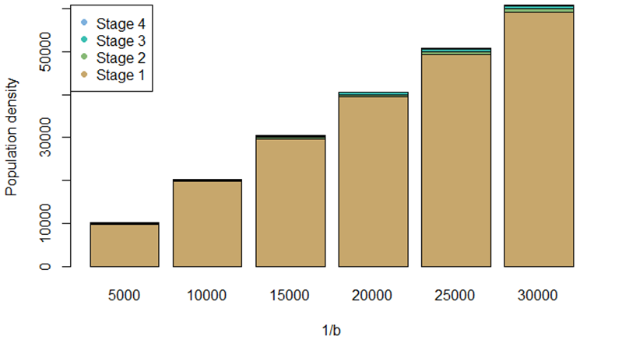
Figure S1: Bar chart generated by the auxiliary function getLocalisedEquilPop, using demographic parameters from the model to simulate a time series for population density of individuals per hectare in a single closed population for different values of 1/b. In response, the function returns equilibrium population densities by stages at the provided density dependence values. Through comparison with real data from heart palm populations (SOUZA; PORTELA; MATTOS, 2018), it is possible to determine a maximum value for demographic density dependence (1/b) or K_or_DensDep of around 30,000.

Table S1: Estimated coefficients for the best model for adult abundance of Euterpe edulis selected by AICc < 2. Estimated parameters for each predictor variable, followed by standard error, t-values, and p-values.
VARIABLES | ESTIMATE | STD. ERROR | T-VALUE | P-VALUE
(INTERCEPTO) | 108.85 | 21.52 | 5.057 | 6.96e-07 ***
DEFAUNATION STATUS | 78.60 | 30.44 | 2.582 | 0.0102 *
50% OF HABITAT | 250.40 | 30.44 | 8.226 | 4.10e-15 ***
90% OF HABITAT | 614.80 | 30.44 | 20.196 | < 2e-16 ***
0.3 OF PERCOLATION | 39.00 | 30.44 | 1.281 | 0.2010
0.5 OF PERCOLATION | 245.45 | 30.44 | 8.063 | 1.26e-14 ***
DEFAUNATION STATUS*50% OF HABITAT | 597.20 | 43.05 | 13.872 | < 2e-16 ***
DEFAUNATION STATUS*90% OF HABITAT | 1567.65 | 43.05 | 36.414 | < 2e-16 ***
DEFAUNATION STATUS*0.3 OF PERCOLATION | 17.40 | 43.05 | 0.404 | 0.6863
DEFAUNATION STATUS*0.5 OF PERCOLATION | 138.70 | 43.05 | 3.222 | 0.0014 **
50% OF HABITAT*0.3 OF PERCOLATION | -12.25 | 43.05 | -0.285 | 0.7762
90% OF HABITAT*0.3 OF PERCOLATION | -23.05 | 43.05 | -0.535 | 0.5927
50% OF HABITAT*0.5 OF PERCOLATION | -53.05 | 43.05 | -1.232 | 0.2187
90% OF HABITAT*0.5 OF PERCOLATION | -215.75 | 43.05 | -5.012 | 8.68e-07 ***
DEFAUNATION STATUS*50% OF HABITAT*0.3 OF PERCOLATION | 28.25 | 60.88 | 0.464 | 0.6429
DEFAUNATION STATUS*90% OF HABITAT*0.3 OF PERCOLATION | -3.30 | 60.88 | -0.054 | 0.9568
DEFAUNATION STATUS*50% OF HABITAT*0.5 OF PERCOLATION | 89.90 | 60.88 | 1.477 | 0.1407
DEFAUNATION STATUS*90% OF HABITAT*0.5 OF PERCOLATION | -105.90 | 60.88 | -1.739 | 0.0829

Table S2: Estimated coefficients for the best model for adult density of Euterpe edulis selected by AICc < 2. Estimated parameters for each predictor variable, followed by standard error, t-values, and p-values.
VARIABLES | ESTIMATE | STD. ERROR | T-VALUE | P-VALUE
(INTERCEPTO) | 0.0017274 | 0.0001763 | 9.797 | < 2e-16 ***
DEFAUNATION STATUS | 0.0012474 | 0.0002494 | 5.002 | 9.08e-07 ***
50% OF HABITAT | -0.0006045 | 0.0002494 | -2.424 | 0.015867 *
90% OF HABITAT | -0.0004748 | 0.0002494 | -1.904 | 0.057728
0.3 OF PERCOLATION | 0.0006943 | 0.0002494 | 2.784 | 0.005664 **
0.5 OF PERCOLATION | 0.0043353 | 0.0002494 | 17.385 | < 2e-16 ***
DEFAUNATION STATUS*50% OF HABITAT | 0.0008651 | 0.0003527 | 2.453 | 0.014663 *
DEFAUNATION STATUS*90% OF HABITAT | 0.0016022 | 0.0003527 | 4.543 | 7.69e-06 ***
DEFAUNATION STATUS*0.3 OF PERCOLATION | 0.0003251 | 0.0003527 | 0.922 | 0.357292
DEFAUNATION STATUS*0.5 OF PERCOLATION | 0.0024710 | 0.0003527 | 7.007 | 1.30e-11 ***
50% OF HABITAT*0.3 OF PERCOLATION | -0.0006142 | 0.0003527 | -1.742 | 0.082469
90% OF HABITAT*0.3 OF PERCOLATION | -0.0006668 | 0.0003527 | -1.891 | 0.059501
50% OF HABITAT*0.5 OF PERCOLATION | -0.0037433 | 0.0003527 | -10.615 | < 2e-16 ***
90% OF HABITAT*0.5 OF PERCOLATION | -0.0042851 | 0.0003527 | -12.151 | < 2e-16 ***
DEFAUNATION STATUS*50% OF HABITAT*0.3 OF PERCOLATION | -0.0001890 | 0.0004987 | -0.379 | 0.704998
DEFAUNATION STATUS*90% OF HABITAT*0.3 OF PERCOLATION | -0.0003009 | 0.0004987 | -0.603 | 0.546683
DEFAUNATION STATUS*50% OF HABITAT*0.5 OF PERCOLATION | -0.0017720 | 0.0004987 | -3.553 | 0.000434 ***
DEFAUNATION STATUS*90% OF HABITAT*0.5 OF PERCOLATION | -0.0024170 | 0.0004987 | -4.846 | 1.91e-06 ***

