Graphical abstract

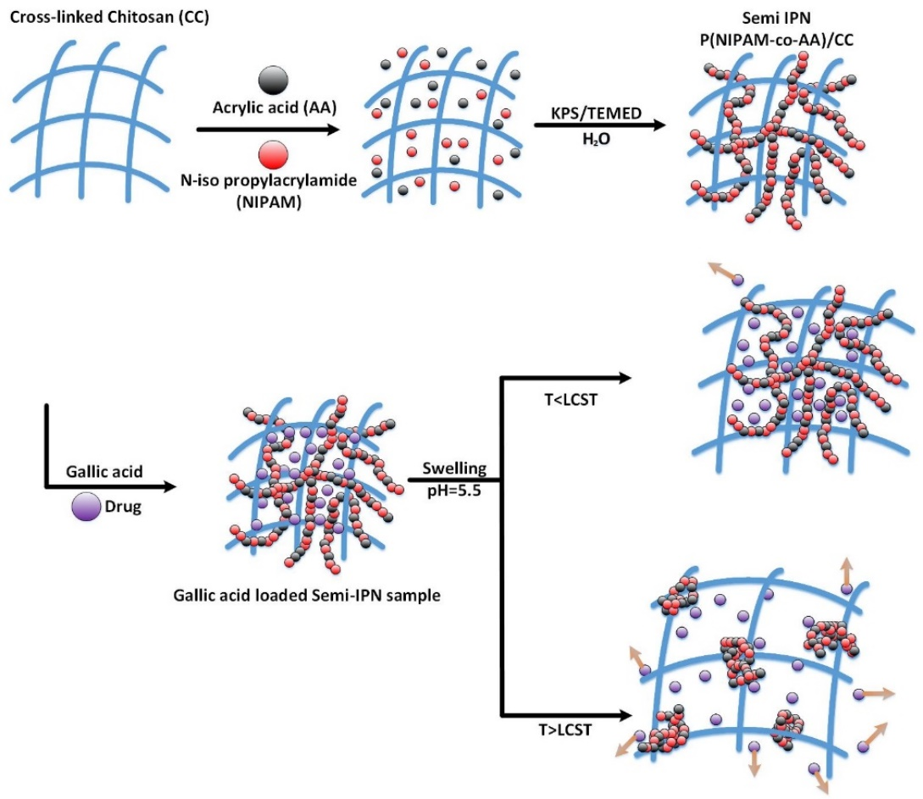
The temperature dependence of the gallic acid release behavior from the P(NIPAM-co-AA)/CC thermo-responsive semi-IPN hydrogel.

