Fig. 1S depicts the method by which copolymers polymerize. For ¹H and ¹³C NMR analysis, the D₂O solvent is used. Notably, the ¹H NMR resonances of certain functional groups such as ( OH, NH, and SH) disappear when reacted with D₂O, as deuterium replaces the protium atom.

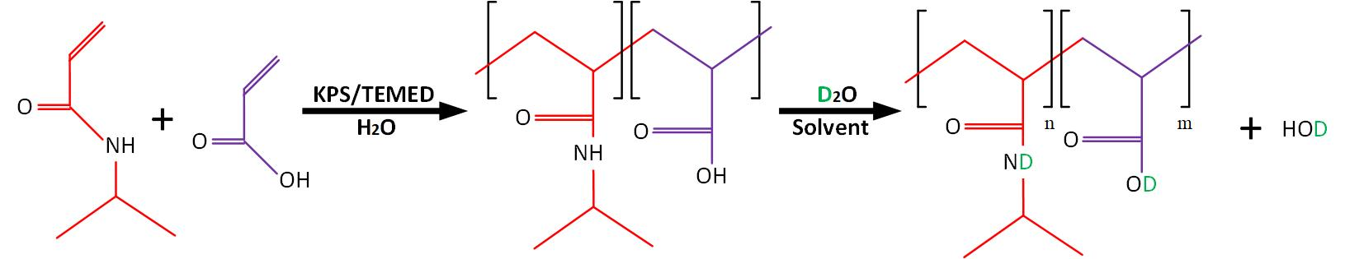
Fig.1S The preparation of P(NIPAM-co-AA) for the ¹H NMR and ¹³C NMR analysis

Fig. 2S depicts the derivative diagram or the variations of LCST in relationship to temperature, which is crucial for the precise determination of LCST values.

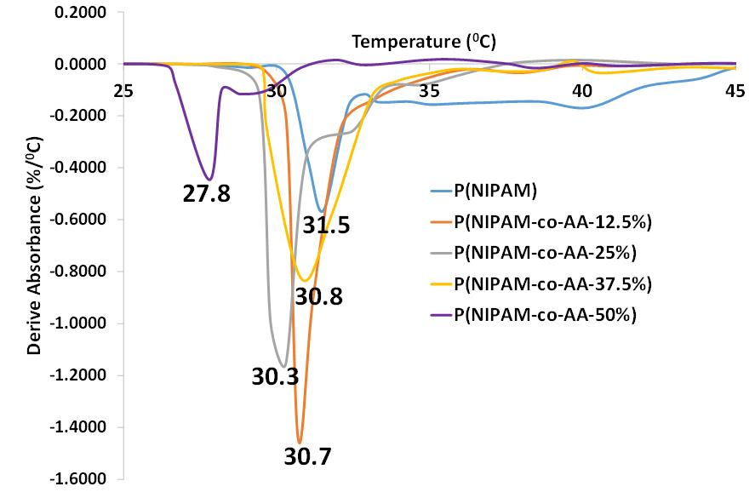

Fig.2S Derivative of UV/VIS absorbance spectra of the thermo-responsive polymer at pH=3.5

