Supporting information
Fine-tuning dye adsorption capacity of UiO-66 by mixed-ligand approach
Chompoonoot Nanthamatheeª, Chantamalinee Chantarangkulª, Chanida Jakkrawhad ª, Apirak Payakaª and Pongsathorn Dechatiwongse^{b}*
ªDepartment of Chemistry, School of Science, Walailak University, Nakhon Si Thammarat, Thailand, 80160.
^{b}Department of Chemical Engineering, School of Engineering and Technology, Walailak University, Nakhon Si Thammarat, Thailand, 80160.
*Coresponding author

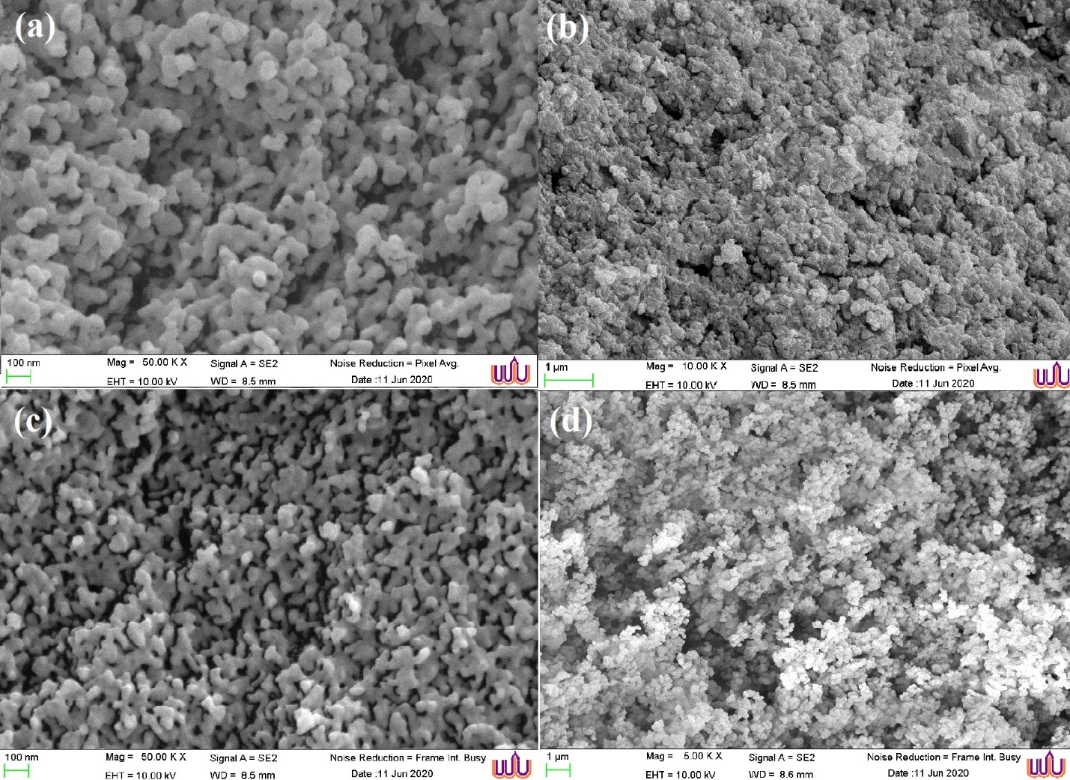
Figure. S1 SEM images of (a) UiO-66 (b) UiO-66-0.5ATA (c) UiO-66-0.75ATA (d) UiO-66-ATA
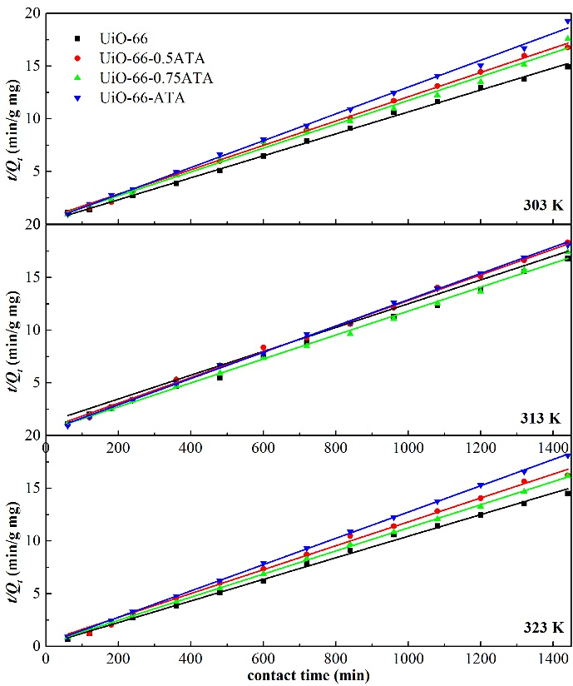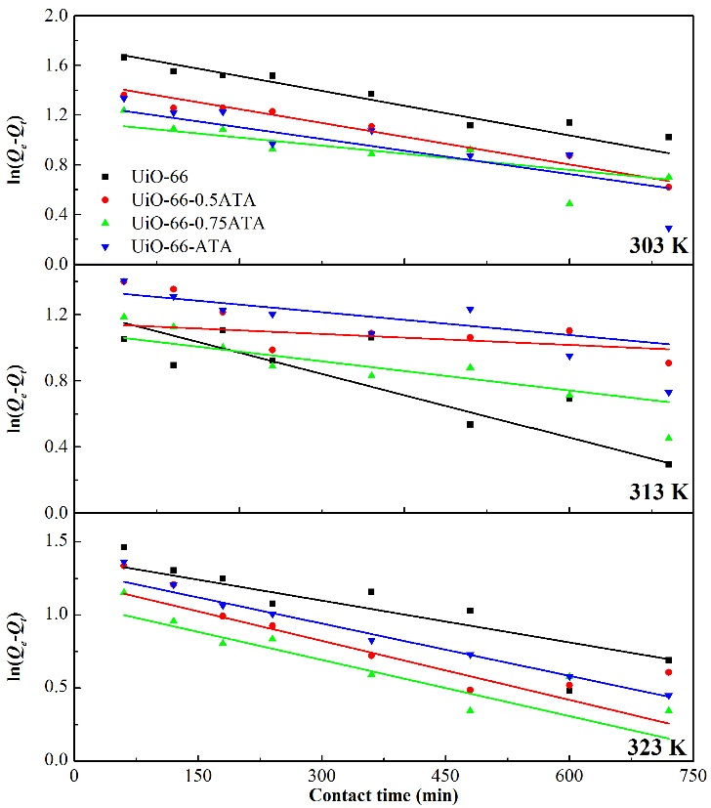
Figure. S2 Plots of (a) pseudo-second-order kinetics (b) pseudo-first-order kinetics of IC adsorption onto UiO-66, UiO-66-0.5ATA, UiO-66-0.75ATA and UiO-66-ATA at 303 K, 313 K and 323 K at initial concentration of 100 ppm
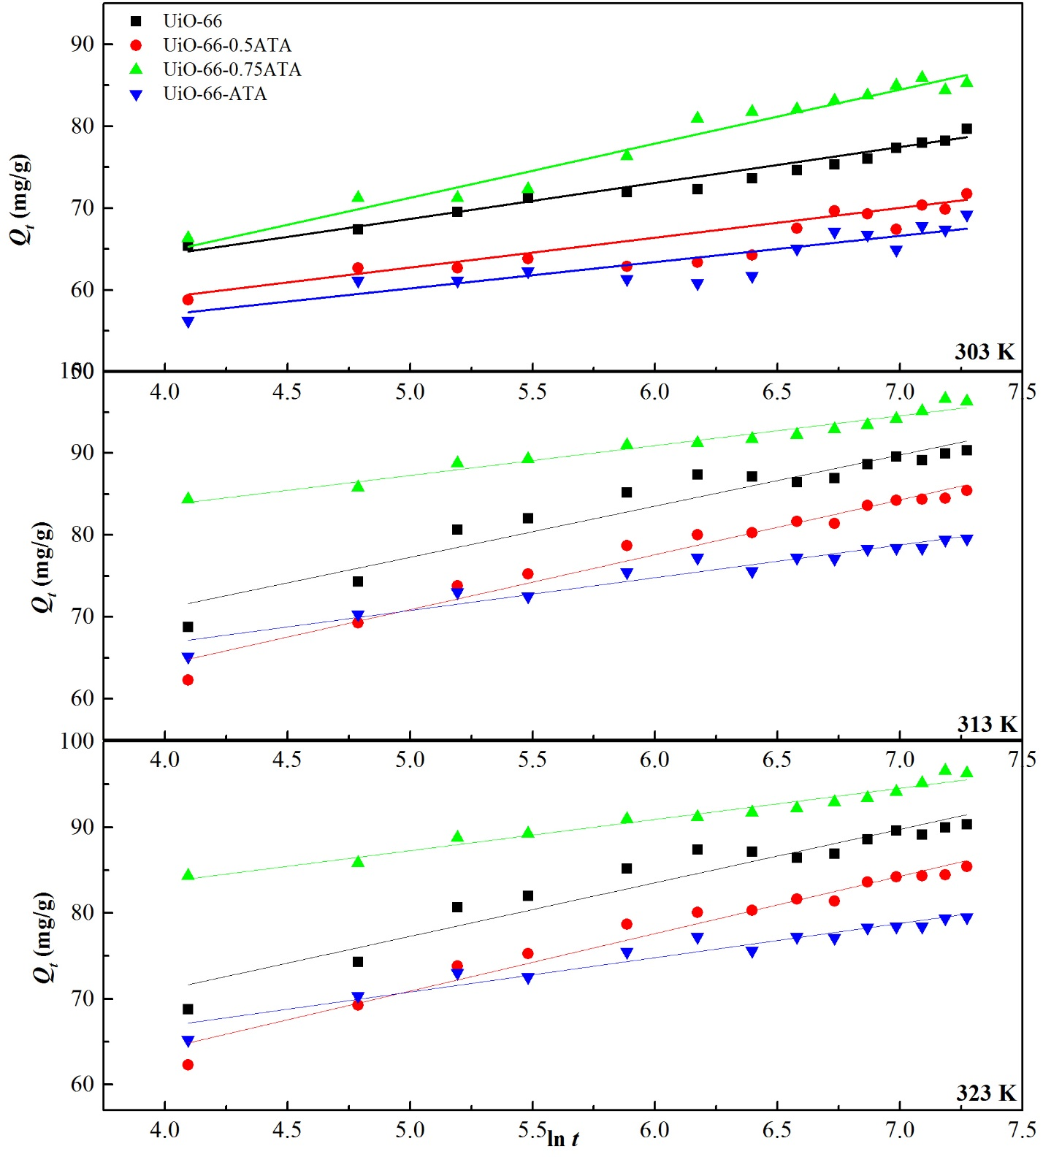
Figure. S3 Elovich kinetic model for IC adsorption onto UiO-66, UiO-66-0.5ATA, UiO-66-0.75ATA and UiO-66-ATA at 303 K, 313 K and 323 K at initial concentration of 100 ppm

Table S1 Kinetic parameters of the adsorption of IC on UiO-66, UiO-66-0.5ATA, UiO-66-0.75ATA and UiO-66-ATA at initial concentration of 100 ppm, temperture = 303 K.
Pseudo first order model | UiO-66 | UiO-66-0.5ATA | UiO-66-0.75ATA | UiO-66-ATA
k₁ (1/min) x 10³ | 2.3 | 2.3 | 2.07 | 2.76
Q_{e}(exp) (mg/g) | 86.46 | 79.55 | 89.23 | 79.67
Q_{e}(cal) (mg/g) | 53.77 | 27.35 | 16.68 | 25.96
R² | 0.9529 | 0.964 | 0.787 | 0.8183
Pseudo second order model | UiO-66 | UiO-66-0.5ATA | UiO-66-0.75ATA | UiO-66-ATA
k₂ (g/ min mg) x 10^3 | 0.21 | 0.32 | 0.28 | 0.36
Q_{e}(cal) (mg/g) | 89.28 | 81.3 | 87.72 | 80
R² | 0.9975 | 0.9982 | 0.9976 | 0.999
Elovich model | UiO-66 | UiO-66-0.5ATA | UiO-66-0.75ATA | UiO-66-ATA
$α$ (mg/g min) | 174.10 | 43.91 | 44.41 | 1.95 x 10³
$β$ (g/mg) | 0.13 | 0.11 | 0.10 | 0.20
R² | 0.7178 | 0.8999 | 0.9068 | 0.9454
Intra-particular diffusion model | UiO-66 | UiO-66-0.5ATA | UiO-66-0.75ATA | UiO-66-ATA
K1d (g/mg min^{1/2}) | 2.4498 | 0.9001 | 1.4645 | 1.0018
R² | 0.9863 | 0.9618 | 0.9494 | 0.9857
K2d (g/mg min^{1/2}) | 1.101 | 0.7977 | 1.014 | 0.4152
R² | 0.9987 | 0.9644 | 0.9772 | 0.9497
K3d (g/mg min^{1/2}) | 1.2045 | 0.2123 | 0.1175 | 0.3732
R² | 0.9651 | 0.6092 | 0.6988 | 0.8862
Boyd kinetic model | UiO-66 | UiO-66-0.5ATA | UiO-66-0.75ATA | UiO-66-ATA
B (1/s) x 10³ | 2 | 3.4 | 3.3 | 2
R² | 0.9806 | 0.9785 | 0.9183 | 0.9545
Di x 10⁻¹⁸(m²/s) | 3.58 | 6.09 | 2.63 | 3.58

Table S2 Kinetic parameters of the adsorption of IC on UiO-66, UiO-66-0.5ATA, UiO-66-0.75ATA and UiO-66-ATA at initial concentration of 100 mg/L, temperture = 313 K.
Pseudo first order model | UiO-66 | UiO-66-0.5ATA | UiO-66-0.75ATA | UiO-66-ATA
k₁ (1/min) x 10³ | 2.3 | 1.38 | 2.07 | 1.84
Q_{e}(exp) (mg/g) | 96.15 | 85.92 | 89.72 | 79.67
Q_{e}(cal) (mg/g) | 14.95 | 21.76 | 16.07 | 26.76
R² | 0.7152 | 0.6305 | 0.8945 | 0.8207
Pseudo second order model | UiO-66 | UiO-66-0.5ATA | UiO-66-0.75ATA | UiO-66-ATA
k₂ (g/ min mg) x 10^3 | 0.38 | 0.41 | 0.33 | 0.44
Q_{e}(cal) (mg/g) | 96.15 | 85.47 | 88.5 | 78.74
R² | 0.9983 | 0.998 | 0.9946 | 0.9978
Elovich model | UiO-66 | UiO-66-0.5ATA | UiO-66-0.75ATA | UiO-66-ATA
$α$ (mg/g min) | 2910.94 | 29.38 | 460.44 | 4.42 x 10⁴
$β$ (g/mg) | 0.14 | 0.13 | 0.13 | 0.21
R² | 0.8842 | 0.9639 | 0.9081 | 0.963
Intra-particular diffusion model | UiO-66 | UiO-66-0.5ATA | UiO-66-0.75ATA | UiO-66-ATA
K1d (g/mg min^{1/2}) | 3.2294 | 1.259 | 1.638 | 1.0372
R² | 0.9089 | 0.9559 | 0.9637 | 0.9682
K2d (g/mg min^{1/2}) | 0.1465 | 0.6287 | 0.8018 | 0.432
R² | 0.6428 | 0.9072 | 0.9601 | 0.9169
K3d (g/mg min^{1/2}) | 0.4566 | 0.732 | 0.1553 | 0.4566
R² | 0.9217 | 0.8889 | 0.9669 | 0.9217
Boyd kinetic model | UiO-66 | UiO-66-0.5ATA | UiO-66-0.75ATA | UiO-66-ATA
B (1/s) x 10³ | 1.3 | 1.9 | 3.2 | 2
R² | 0.5114 | 0.9689 | 0.9596 | 0.9423
Di x 10⁻¹⁸(m²/s) | 2.33 | 3.4 | 2.55 | 3.58

Table S3 Kinetic parameters of the adsorption of IC on UiO-66, UiO-66-0.5ATA, UiO-66-0.75ATA and UiO-66-ATA at initial concentration of 100 mg/L, temperture = 323 K.
Pseudo first order model | UiO-66 | UiO-66-0.5ATA | UiO-66-0.75ATA | UiO-66-ATA
k₁ (1/min) x 10³ | 2.76 | 2.76 | 2.53 | 2.99
Q_{e}(exp) (mg/g) | 97.12 | 85.43 | 90.45 | 79.42
Q_{e}(cal) (mg/g) | 30.75 | 18.51 | 12.02 | 22.66
R² | 0.8288 | 0.8158 | 0.8174 | 0.9761
Pseudo second order model | UiO-66 | UiO-66-0.5ATA | UiO-66-0.75ATA | UiO-66-ATA
k₂ (g/ min mg) x 10^3 | 0.48 | 0.52 | 0.42 | 0.56
Q_{e}(cal) (mg/g) | 98.04 | 86.95 | 90.91 | 80.19
R² | 0.9971 | 0.9971 | 0.9997 | 0.9997
Elovich model | UiO-66 | UiO-66-0.5ATA | UiO-66-0.75ATA | UiO-66-ATA
$α$ (mg/g min) | 2377.00 | 1031.02 | 10284.08 | 1.30 x 10⁶
$β$ (g/mg) | 0.14 | 0.14 | 0.16 | 0.25
R² | 0.8668 | 0.9576 | 0.9205 | 0.9417
Intra-particular diffusion model | UiO-66 | UiO-66-0.5ATA | UiO-66-0.75ATA | UiO-66-ATA
K1d (g/mg min^{1/2}) | 1.0229 | 1.6995 | 1.832 | 1.1661
R² | 0.973 | 0.9579 | 0.9678 | 0.9266
K2d (g/mg min^{1/2}) | 0.4179 | 0.4046 | 0.2269 | 0.2928
R² | 0.9941 | 0.9781 | 0.9792 | 0.9376
K3d (g/mg min^{1/2}) | 0.2815 | 0.8326 | 0.2266 | 0.2638
R² | 0.9276 | 0.8981 | 0.7938 | 0.6183
Boyd kinetic model | UiO-66 | UiO-66-0.5ATA | UiO-66-0.75ATA | UiO-66-ATA
B (1/s) x 10³ | 1.8 | 1.3 | 2.9 | 0.8
R² | 0.9683 | 0.9376 | 0.9234 | 0.7827
Di x 10⁻¹⁸(m²/s) | 3.22 | 1.33 | 2.31 | 1.43

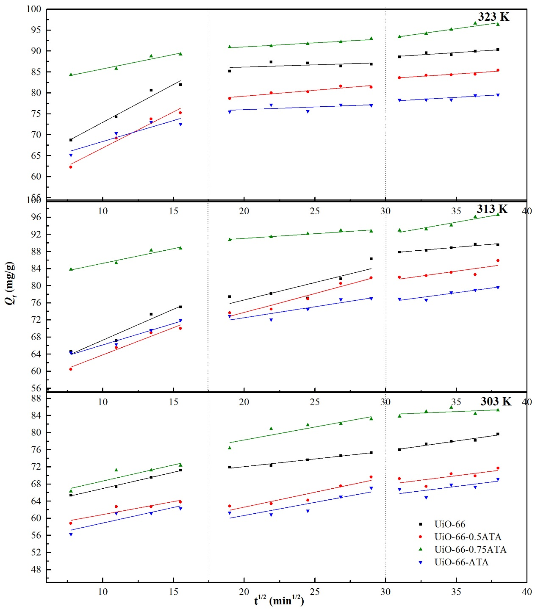
Figure. S4 Plots of variation of IC adsorption kinetics onto UiO-66, UiO-66-0.5ATA, UiO-66-0.75ATA and UiO-66-ATA at IC concentration of 100 ppm according to the intra-particle diffusion
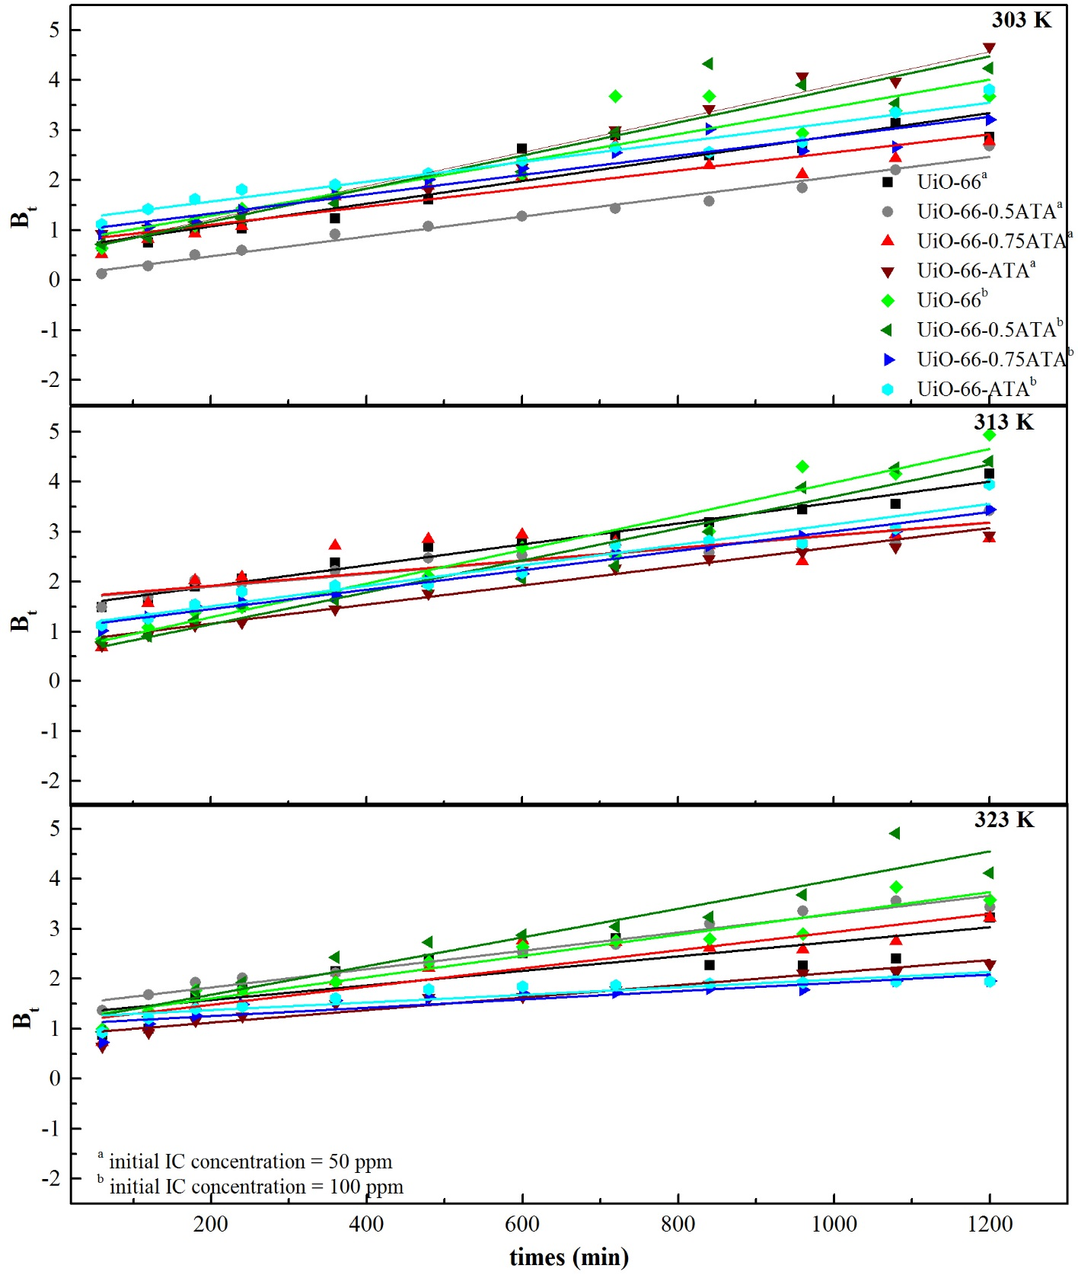
Figure. S5 The plot of Bt versus time for UiO-66, UiO-66-0.5ATA, UiO-66-0.75ATA and UiO-66-ATA at IC concentration of 50 and 100 ppm, T = 303 K
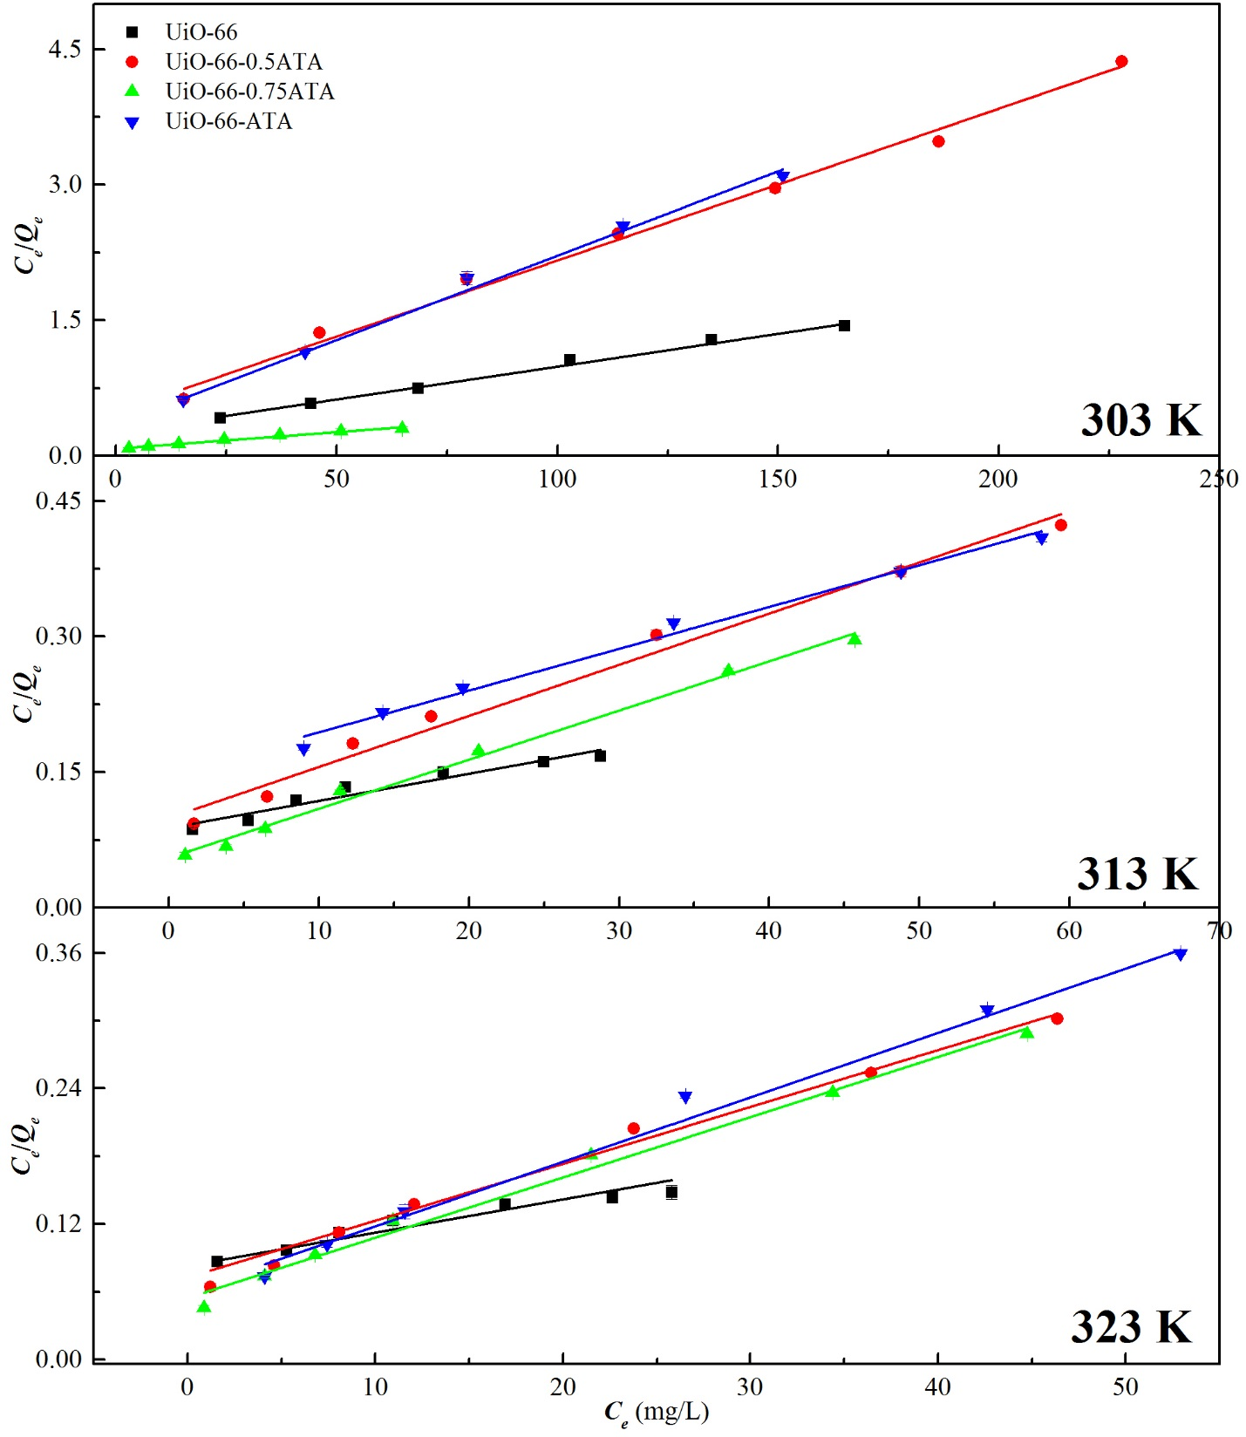Figure. S6 Langmuir adsorption isotherms for the adsorption of IC by UiO-66, UiO-66-0.5ATA, UiO-66-0.75ATA and UiO-66-ATA at initial concentration of 100 ppm and temperature of 303 K, 313 K and 323 K.
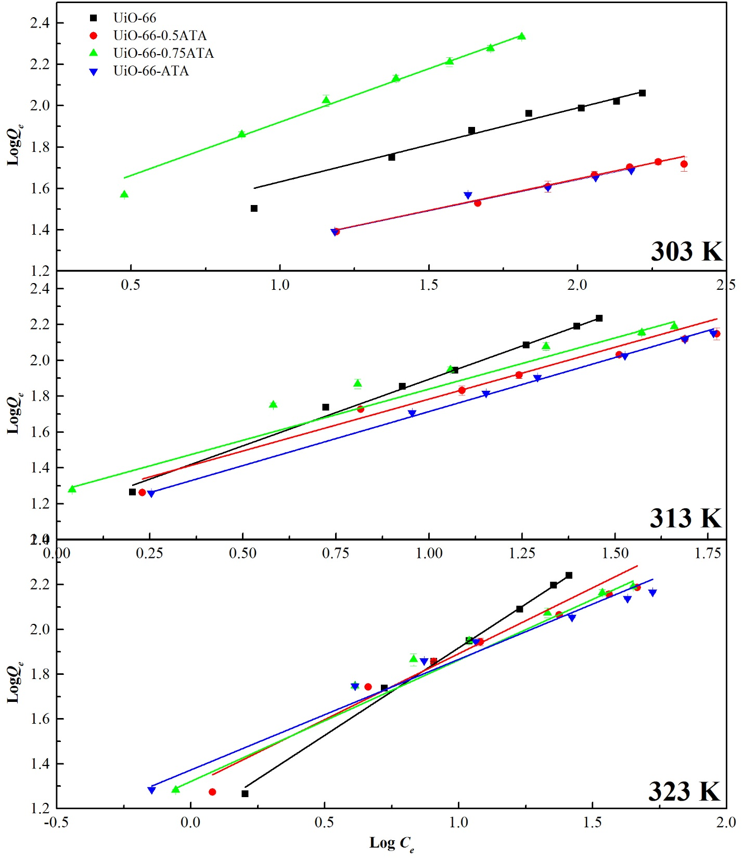
Figure. S7 Freundlich adsorption isotherms for the adsorption of IC by UiO-66, UiO-66-0.5ATA, UiO-66-0.75ATA and UiO-66-ATA at 303 K, 313 K and 323 K

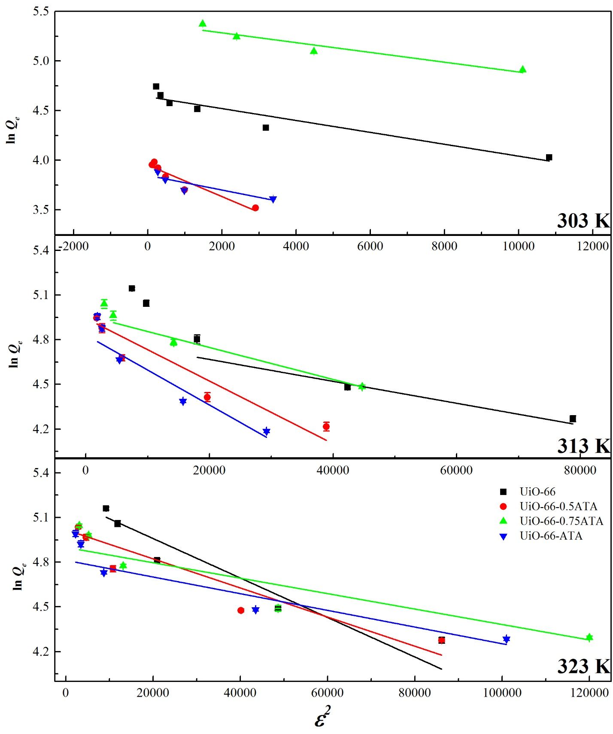
Figure. S8 Dubinin-Radushkevich (D-R) isotherms for the adsorption of IC by UiO-66, UiO-66-0.5ATA, UiO-66-0.75ATA and UiO-66-ATA at 303 K, 313 K and 323 K

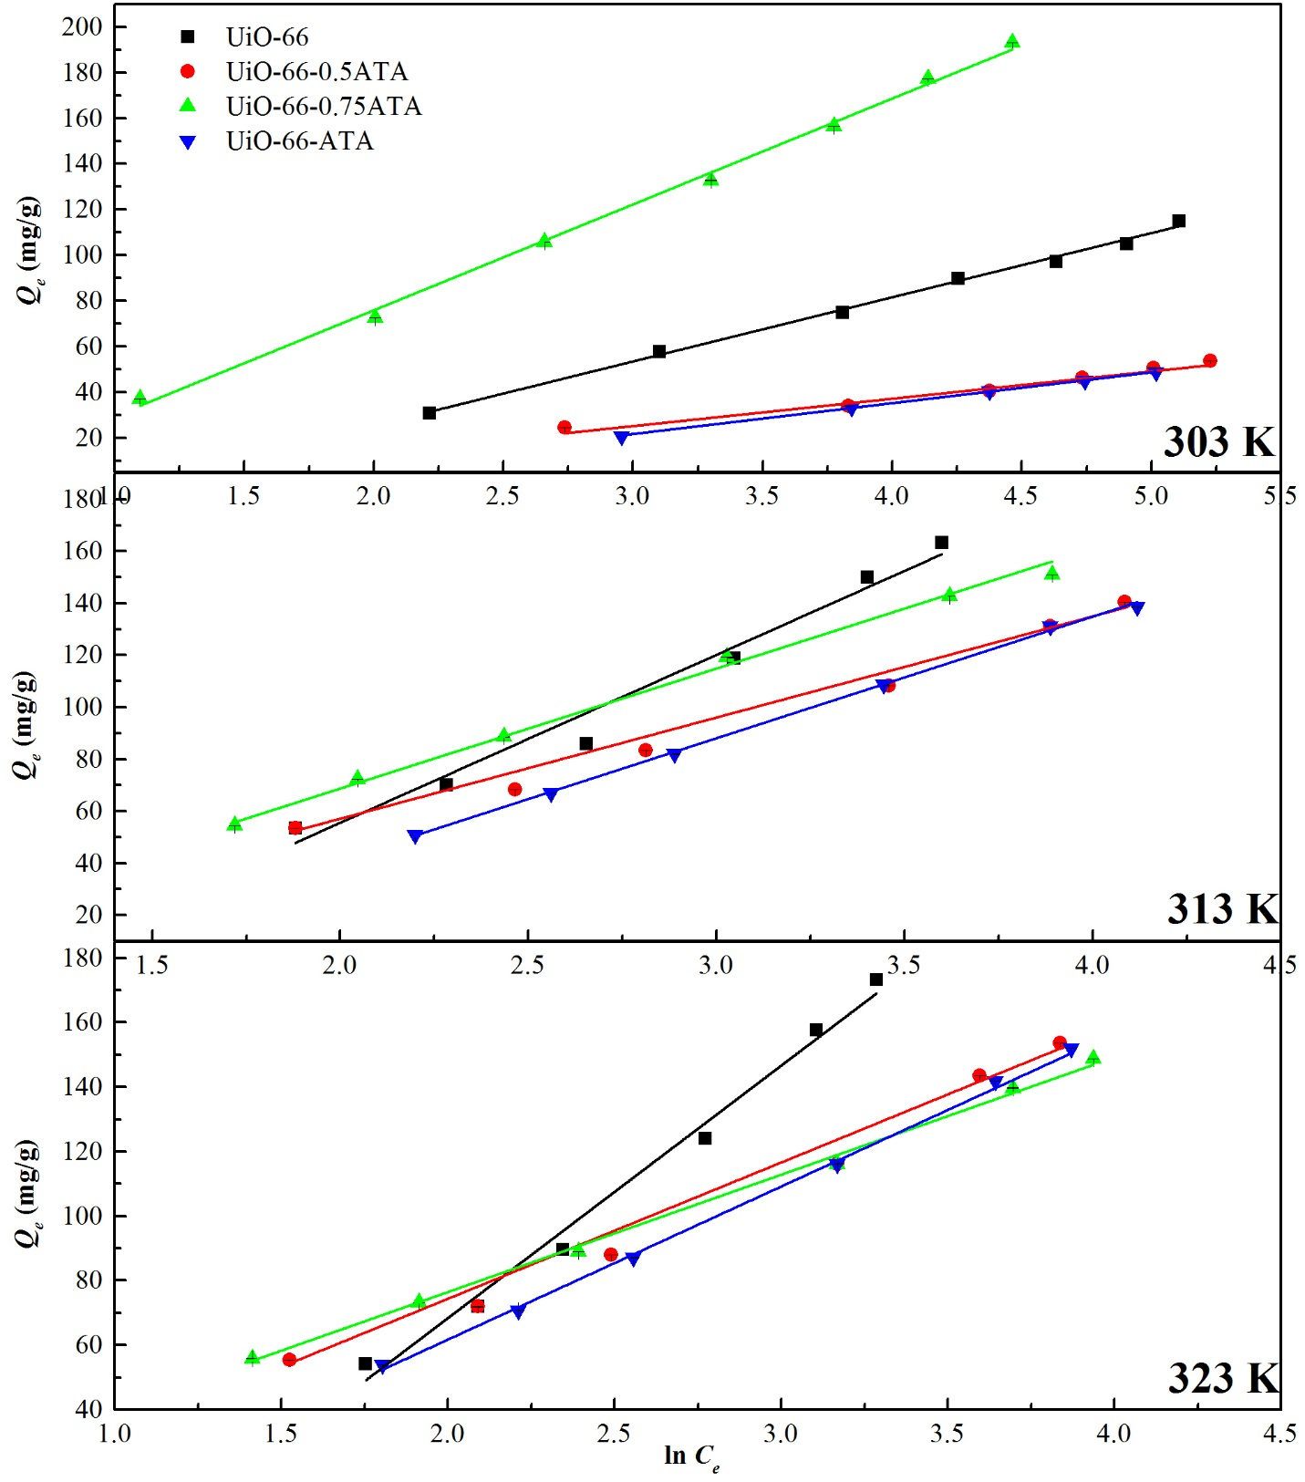
Figure. S9 Temkin isotherms for the adsorption of IC by UiO-66, UiO-66-0.5ATA, UiO-66-0.75ATA and UiO-66-ATA at 303 K, 313 K and 323 K

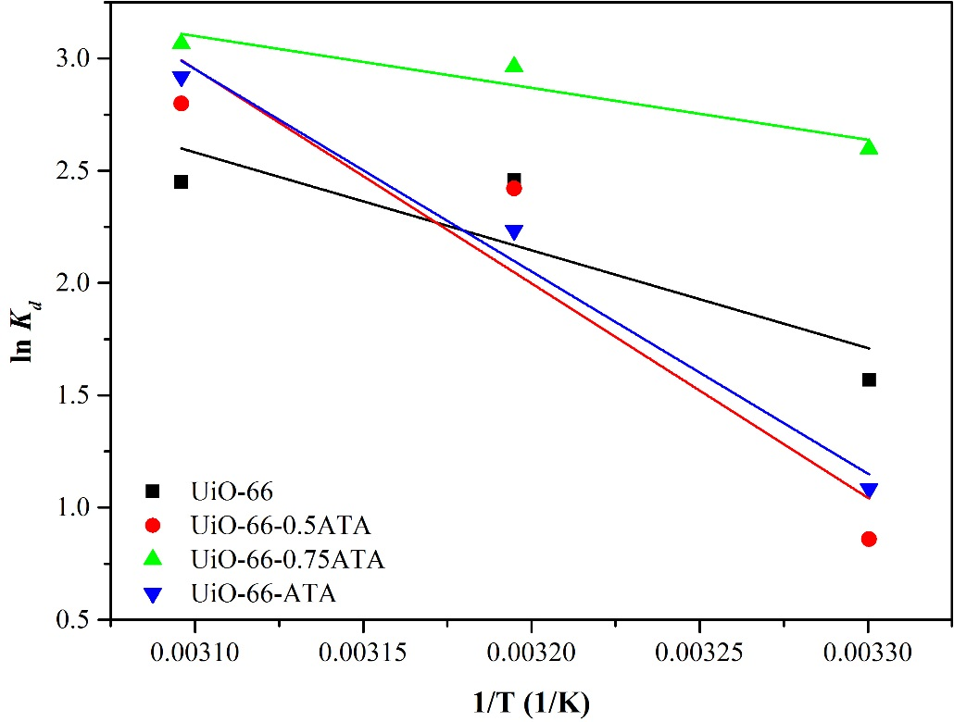
Figure. S10 Plot of lnKd versus 1/T of IC adsorption on UiO-66, UiO-66-0.5ATA, UiO-66-0.75ATA and UiO-66-ATA
Table S4 Comparison of IC adsorption capacities of different adsorbents
Adsorbents | Adsorption capacity (mg/g) | Reference
CuAl-LDH/SWCNTs nanocomposites | 196.78 | ¹
Mg/Fe layered double hydroxide nanoparticles | 62.8 | ²
activated carbon doped with Mn oxide (Bio-MnO_{x}-C) | 45.95 | ³
nanotube carbon (CNTs) | 88.5 | ⁴
COOH-functionalized CNTs | 136 | ⁴
Brazil nut shells | 1.09 | ⁵
Rice husk ash | 29.28 | ⁶
Chitin | 0.0058 | ⁷
Chitosan | 0.0072 | ⁷
Activated carbon (AC) prepared from peanut shell | 24.35 | ⁸

Table S5 Adsorption capacity of UiO-66, UiO-66-0.5ATA, UiO-66-0.75ATA and UiO-66-ATA at different types of dyes solution (dye concentration = 100 ppm, pH = 6.5, contact time = 24 hours, adsorbent dosage = 10.0000 mg in 10.00 mL dye solution).
Dye | Adsorption capacity (Q_{e}) (mg/g)
Dye | UiO-66 | UiO-66-0.5ATA | UiO-66-0.75ATA | UiO-66-ATA
Methylene blue  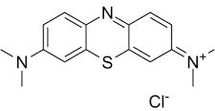 | 69.26 | 81.58 | 89.74 | 72.34
Indigo Carmine  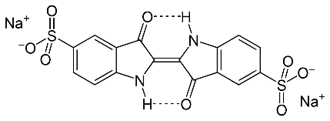 | 75.89 | 69.55 | 84.26 | 66.67
Methyl orange  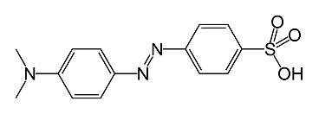 | 44.52 | 57.64 | 48.90 | 34.34
Phenol red  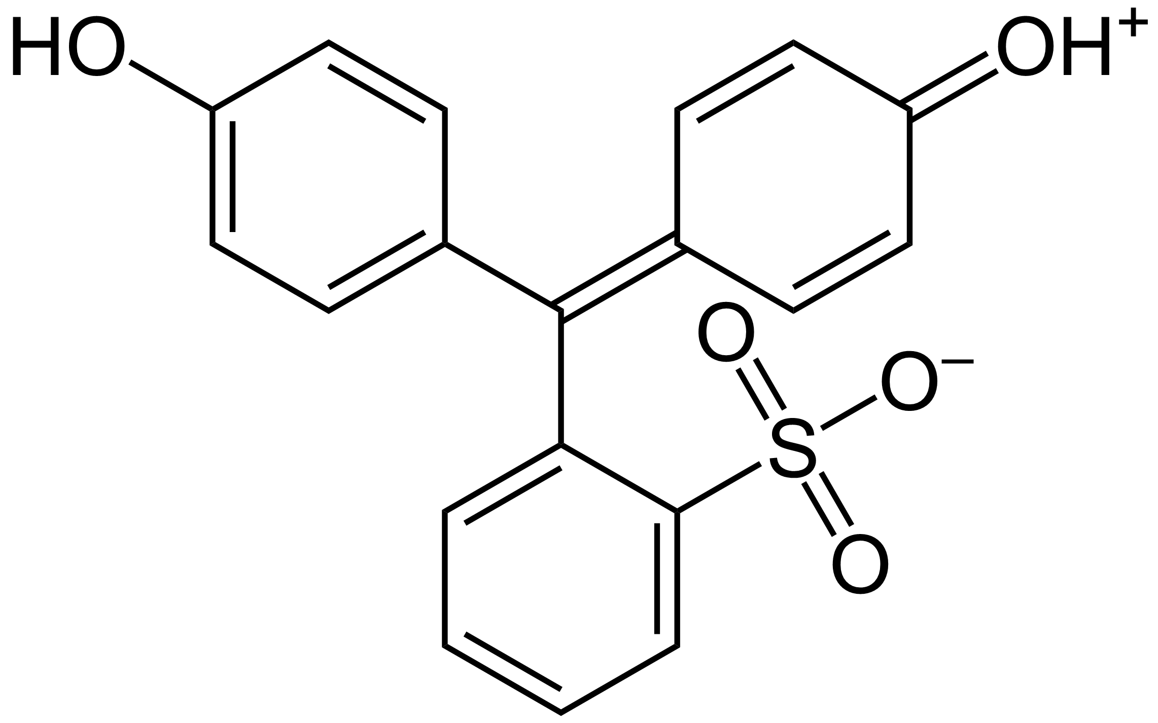 | 30.56 | 69.25 | 63.96 | 55.69
Congo red  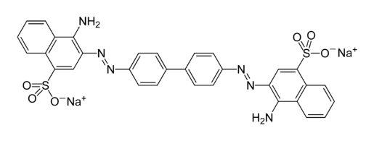 | 35.00 | 45.34 | 52.82 | 37.30

E = -8172.45410327 a.u.
[Zr₆O₄(OH)₄(OOC-C₆H₄-COO)₁₂]^{12–}
E = -8504.21712182 a.u. | E = -8504.20809961 a.u.
[Zr₆O₄(OH)₄(OOC-C₆H₄-COO)₆(OOC-C₆H₆N-COO)₆]^{12–_}A | [Zr₆O₄(OH)₄(OOC-C₆H₄-COO)₆(OOC-C₆H₆N-COO)₆]^{12–_}B
E = -8504.21341557 a.u. | E = -8504.21320031 a.u.
[Zr₆O₄(OH)₄(OOC-C₆H₄-COO)₆(OOC-C₆H₆N-COO)₆]^{12–_}C | [Zr₆O₄(OH)₄(OOC-C₆H₄-COO)₆(OOC-C₆H₆N-COO)₆]^{12–_}D
E = -8504.21353798 a.u. | E = -8504.20949533 a.u.
[Zr₆O₄(OH)₄(OOC-C₆H₄-COO)₆(OOC-C₆H₆N-COO)₆]^{12–_}E | [Zr₆O₄(OH)₄(OOC-C₆H₄-COO)₆(OOC-C₆H₆N-COO)₆]^{12–_}F
E = -8504.20594593 a.u. | E = -8504.21363441 a.u.
[Zr₆O₄(OH)₄(OOC-C₆H₄-COO)₆(OOC-C₆H₆N-COO)₆]^{12–_}G | [Zr₆O₄(OH)₄(OOC-C₆H₄-COO)₆(OOC-C₆H₆N-COO)₆]^{12–_}H
E = -8504.20869663 a.u. | E = -8504.20789128 a.u.
[Zr₆O₄(OH)₄(OOC-C₆H₄-COO)₆(OOC-C₆H₆N-COO)₆]^{12–_}I | [Zr₆O₄(OH)₄(OOC-C₆H₄-COO)₆(OOC-C₆H₆N-COO)₆]^{12–_}J
E = -8670.10076069 a.u. | E = -8670.10152076 a.u.
[Zr₆O₄(OH)₄(OOC-C₆H₄-COO)₃(OOC-C₆H₆N-COO)₉]^{12–}-A | [Zr₆O₄(OH)₄(OOC-C₆H₄-COO)₃(OOC-C₆H₆N-COO)₉]^{12–}-B
E = -8835.74195856 a.u.
[Zr₆O₄(OH)₄(OOC-C₆H₆N-COO)₁₂]^{12–}
Figure S11. All possible structures of [Zr₆O₄(OH)₄(OOC-C₆H₄-COO)₁₂]^{12–}, [Zr₆O₄(OH)₄(OOC-C₆H₄-COO)₃(OOC-C₆H₆N-COO)₉]^{12–}, [Zr₆O₄(OH)₄(OOC-C₆H₄-COO)₃(OOC-C₆H₆N-COO)₉]^{12–} and [Zr₆O₄(OH)₄(OOC-C₆H₆N-COO)₁₂]^{12–} are presented optimizing at PM6 level of theory. Their structural energies were calculated at PBE1PBE/LanL2DZ level of accuracy.
HOMO | LUMO
[Zr₆O₄(OH)₄(OOC-C₆H₄-COO)₁₂]^{12–}
[Zr₆O₄(OH)₄(OOC-C₆H₄-COO)₆(OOC-C₆H₆N-COO)₆]^{12–_}A
[Zr₆O₄(OH)₄(OOC-C₆H₄-COO)₆(OOC-C₆H₆N-COO)₆]^{12–_}B
[Zr₆O₄(OH)₄(OOC-C₆H₄-COO)₆(OOC-C₆H₆N-COO)₆]^{12–_}C
[Zr₆O₄(OH)₄(OOC-C₆H₄-COO)₆(OOC-C₆H₆N-COO)₆]^{12–_}D
[Zr₆O₄(OH)₄(OOC-C₆H₄-COO)₆(OOC-C₆H₆N-COO)₆]^{12–_}E
[Zr₆O₄(OH)₄(OOC-C₆H₄-COO)₆(OOC-C₆H₆N-COO)₆]^{12–_}F
[Zr₆O₄(OH)₄(OOC-C₆H₄-COO)₆(OOC-C₆H₆N-COO)₆]^{12–_}G
[Zr₆O₄(OH)₄(OOC-C₆H₄-COO)₆(OOC-C₆H₆N-COO)₆]^{12–_}H
[Zr₆O₄(OH)₄(OOC-C₆H₄-COO)₆(OOC-C₆H₆N-COO)₆]^{12–_}I
[Zr₆O₄(OH)₄(OOC-C₆H₄-COO)₆(OOC-C₆H₆N-COO)₆]^{12–_}J
[Zr₆O₄(OH)₄(OOC-C₆H₄-COO)₃(OOC-C₆H₆N-COO)₉]^{12–}-A
[Zr₆O₄(OH)₄(OOC-C₆H₄-COO)₃(OOC-C₆H₆N-COO)₉]^{12–}-B
[Zr₆O₄(OH)₄(OOC-C₆H₆N-COO)₁₂]^{12–}
Figure S12. The HOMO and LUMO orbitals of [Zr₆O₄(OH)₄(OOC-C₆H₄-COO)₁₂]^{12–}, [Zr₆O₄(OH)₄(OOC-C₆H₄-COO)₆(OOC-C₆H₆N-COO)₆]^{12–}, [Zr₆O₄(OH)₄(OOC-C₆H₄-COO)₃(OOC-C₆H₆N-COO)₉]^{12–} and [Zr₆O₄(OH)₄(OOC-C₆H₆N-COO)₁₂]^{12–} are presented calculating from TD-DFT calculations at PBE1PBE/LanL2DZ level of accuracy.

References
1. Almoisheer, N.; Alseroury, F. A.; Kumar, R.; Aslam, M.; Barakat, M. A., Adsorption and anion exchange insight of indigo carmine onto CuAl-LDH/SWCNTs nanocomposite: kinetic, thermodynamic and isotherm analysis. RSC Advances 2019, 9, (1), 560-568.
2. Ahmed, M. A.; brick, A. A.; Mohamed, A. A., An efficient adsorption of indigo carmine dye from aqueous solution on mesoporous Mg/Fe layered double hydroxide nanoparticles prepared by controlled sol-gel route. Chemosphere 2017, 174, 280-288.
3. Hu, Y.; Chen, X.; Liu, Z.; Wang, G.; Liao, S., Activated carbon doped with biogenic manganese oxides for the removal of indigo carmine. Journal of Environmental Management 2016, 166, 512-518.
4. Dastgerdi, Z. H.; Meshkat, S. S.; Esrafili, M. D., Enhanced adsorptive removal of Indigo carmine dye performance by functionalized carbon nanotubes based adsorbents from aqueous solution: equilibrium, kinetic, and DFT study. Journal of Nanostructure in Chemistry 2019, 9, (4), 323-334.
5. de Oliveira Brito, S. M.; Andrade, H. M. C.; Soares, L. F.; de Azevedo, R. P., Brazil nut shells as a new biosorbent to remove methylene blue and indigo carmine from aqueous solutions. Journal of Hazardous Materials 2010, 174, (1), 84-92.
6. Mittal, A.; Mittal, J.; Kurup, L., Batch and bulk removal of hazardous dye, indigo carmine from wastewater through adsorption. Journal of Hazardous Materials 2006, 137, (1), 591-602.
7. Prado, A. G. S.; Torres, J. D.; Faria, E. A.; Dias, S. l. C. L., Comparative adsorption studies of indigo carmine dye on chitin and chitosan. Journal of Colloid and Interface Science 2004, 277, (1), 43-47.
8. Zhang, J.; Zhou, Q.; Ou, L., Removal of indigo carmine from aqueous solution by microwave-treated activated carbon from peanut shell. Desalination and Water Treatment 2016, 57, (2), 718-727.

