Insights into the Electrochemical Hydrogenation Reaction Mechanisms of Aromatic Compounds Mixtures over Bimetallic PtRu Catalyst
Authors: Cesar Catizane¹, Ying Jiang^{1,2}* and Joy Sumner^{1*}
1. School of Water, Energy and Environment, Cranfield University, Cranfield, MK43 0AL, UK
2. Renewable and Sustainable Energy Research Centre, Technology Innovation Institute, Abu Dhabi, UAE
*Corresponding authors: ying.jiang@tii.ae, j.sumner@cranfield.ac.uk
Figure S1 – Relative energies of one-to-one hydrogenation step of Benzoic acid into Cyclohexane carboxylic acid. Grey spheres represent carbons, white spheres hydrogens and red oxygens. The optimal condition for each step is highlighted in blue and placed on the lower line. All energies are calculated in difference to the optimal state
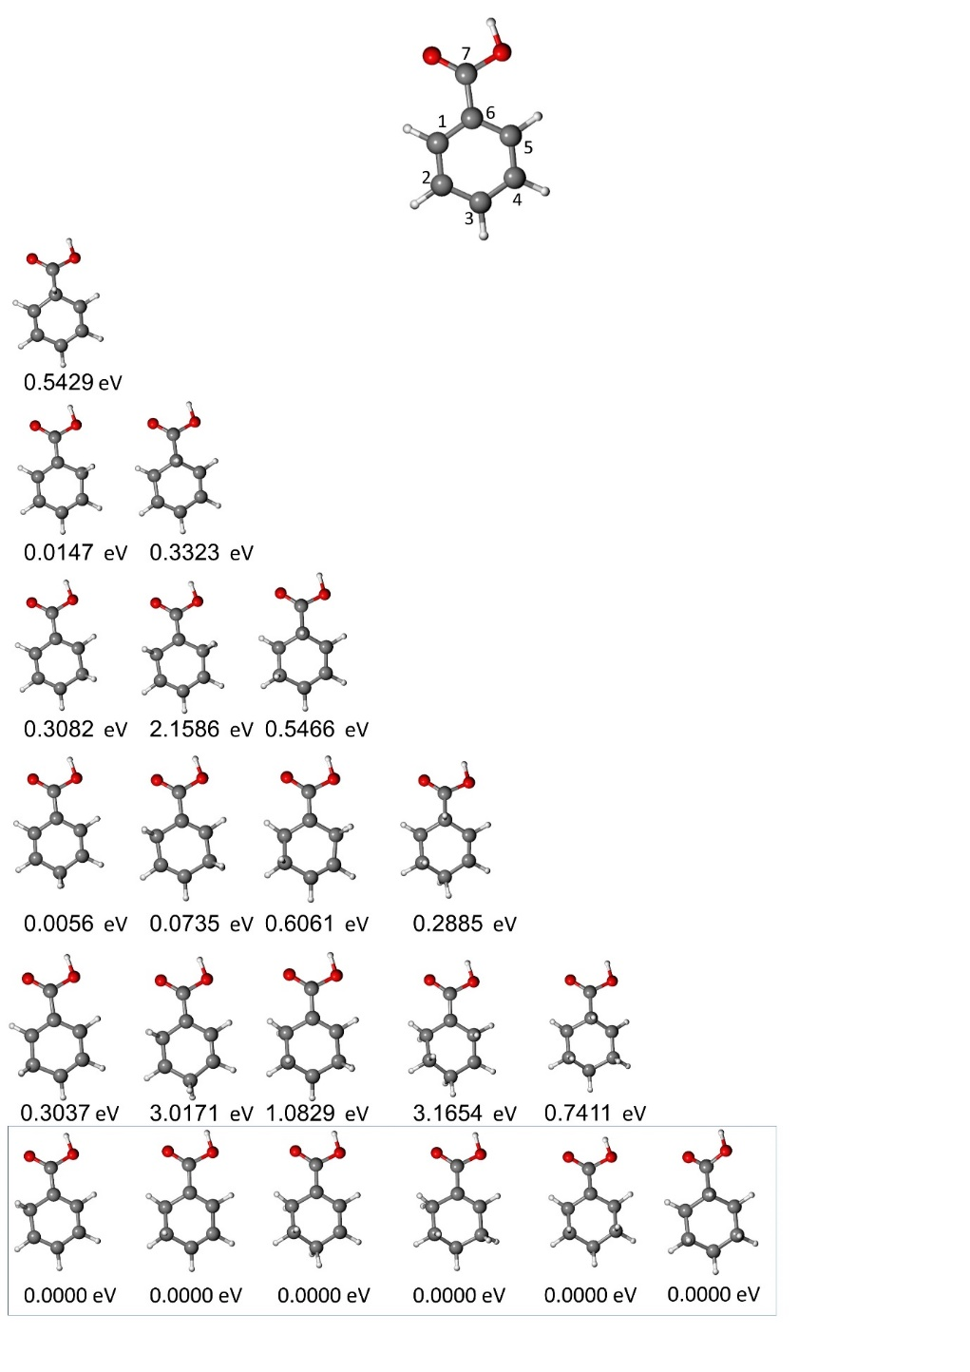
LSV analysis
Figure S2 – Linear-sweep voltammetry of PtRu/ACC before (in yellow) and after the addition BA (in grey), P (in purple) and BA+P (in indigo), into the system (1.0M H2SO4, 55°C). Where ∆E₁, ∆E₃ and ∆E₄ are the differences between no added compound and BA, BA+P and P at 10 mA cm⁻² respectively. (BA = benzoic acid, P = phenol)
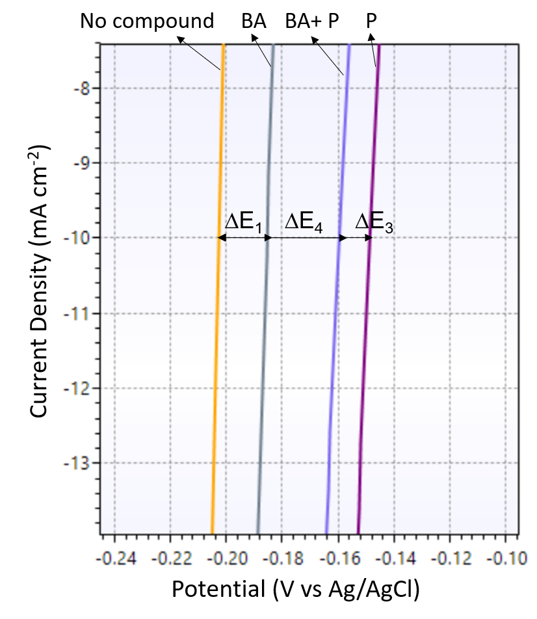
Figure S3 – Linear-sweep voltammetry of PtRu/ACC before (in yellow) and after the addition of G (in green), G+P (in red) and P (in purple) into the system (1.0M H2SO4, 55°C). Where ∆E₂, ∆E₅ and ∆E₄ are the differences between no added compound and G, G+P and P at 10 mA cm⁻² respectively. (G = guaiacol, P = phenol)

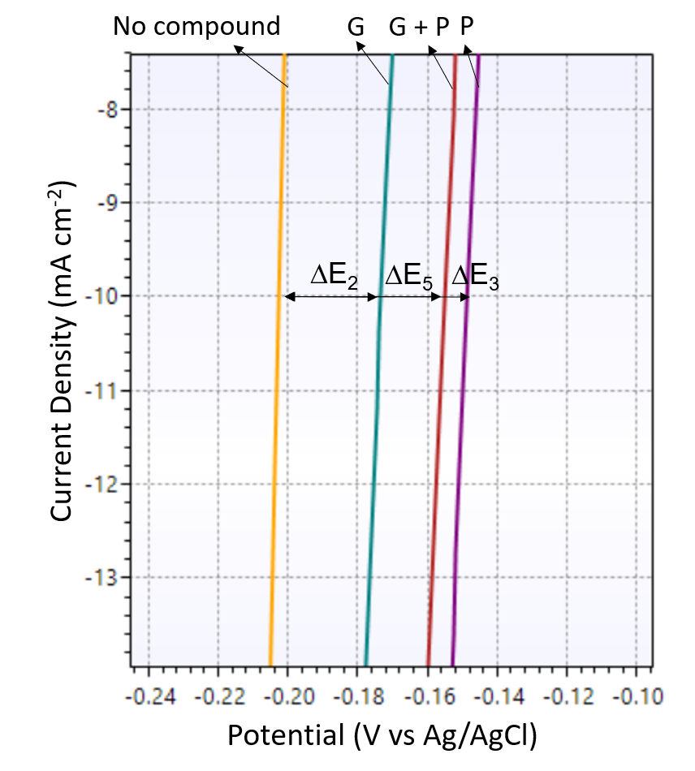
Figure S4 – Linear-sweep voltammetry of PtRu/ACC before (in yellow) and after the addition of BA (in grey), BA+G (in blue) and G (in green) into the system (1.0M H2SO4, 55°C). Where ∆E₁, ∆E₆ and ∆E₂ are the differences between no added compound and BA, BA+G and G at 10 mA cm⁻² respectively. (BA = benzoic acid, G = guaiacol)
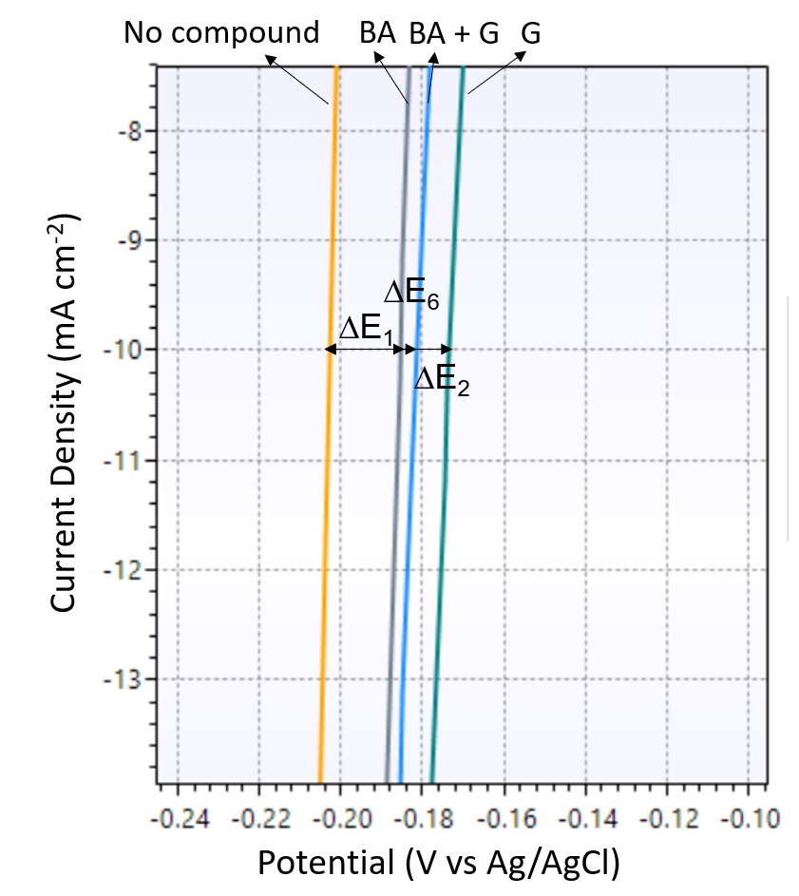

GC-MS spectrum
Figure S5 – GC-MS spectrum of benzoic acid before ECH.
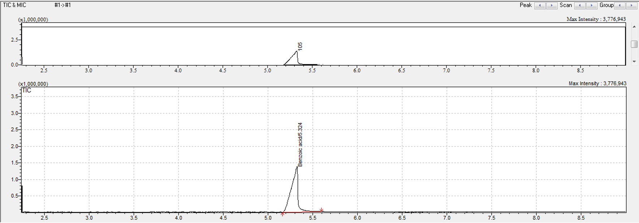
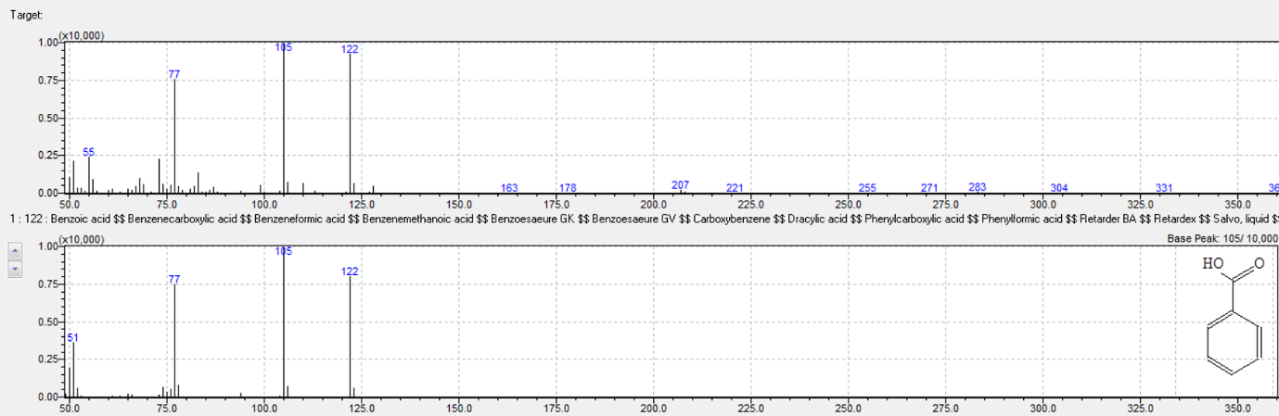

Figure S6 – GC-MS spectrum of benzoic acid after ECH (a) and cyclohexane carboxylic acid (b).
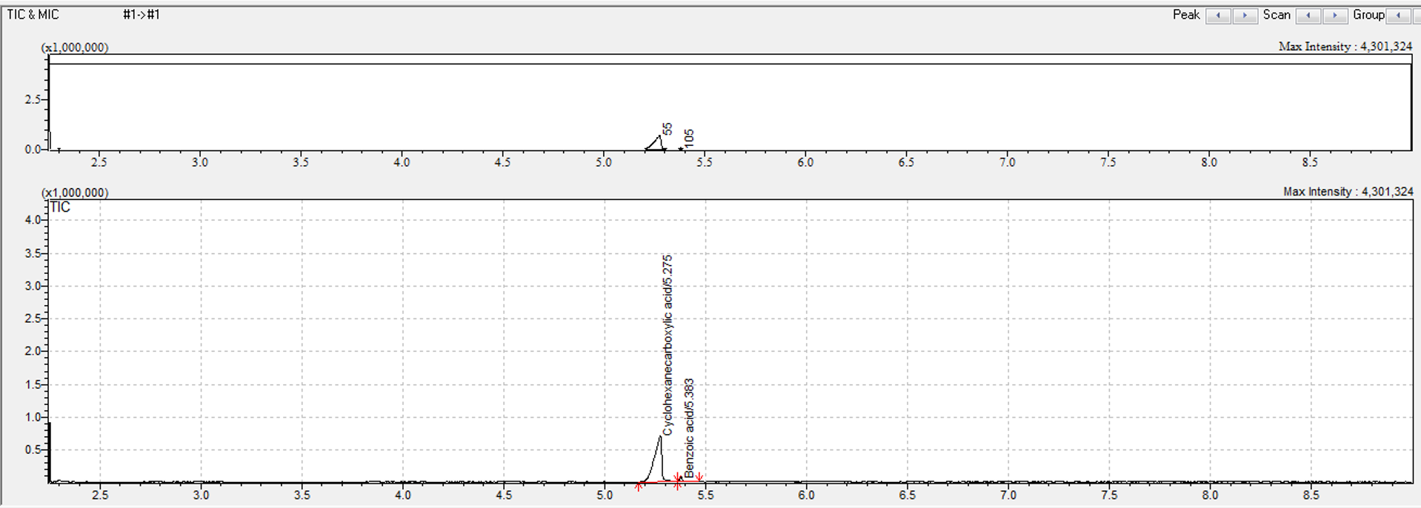
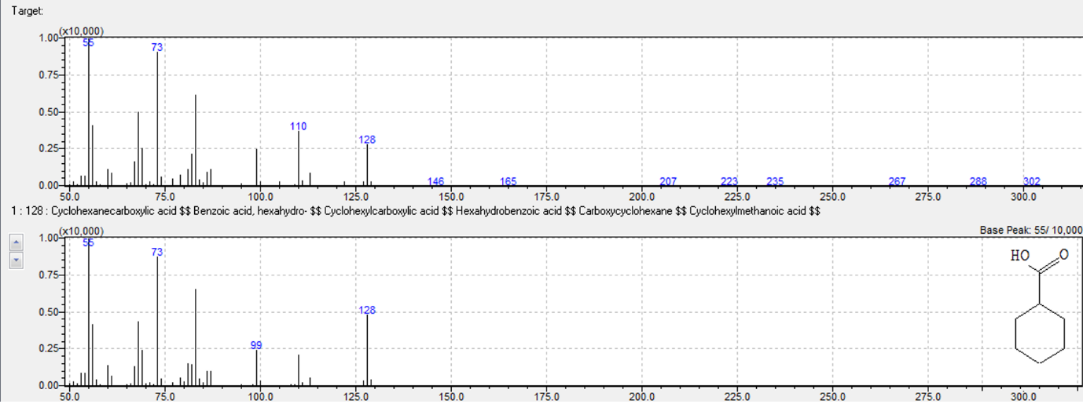

Figure S7 – GC-MS spectrum of phenol before ECH.
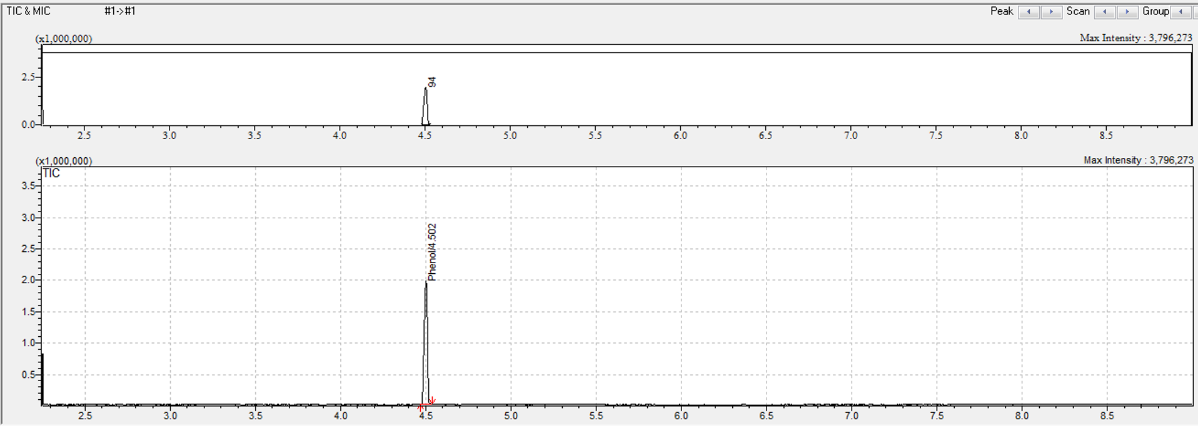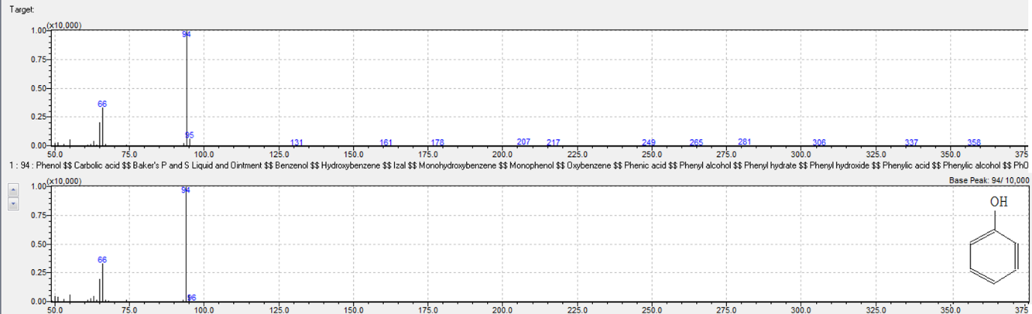

Figure S8 – GC-MS spectrum of phenol after ECH (a), cyclohexanol (b) and cyclohexanone (c).
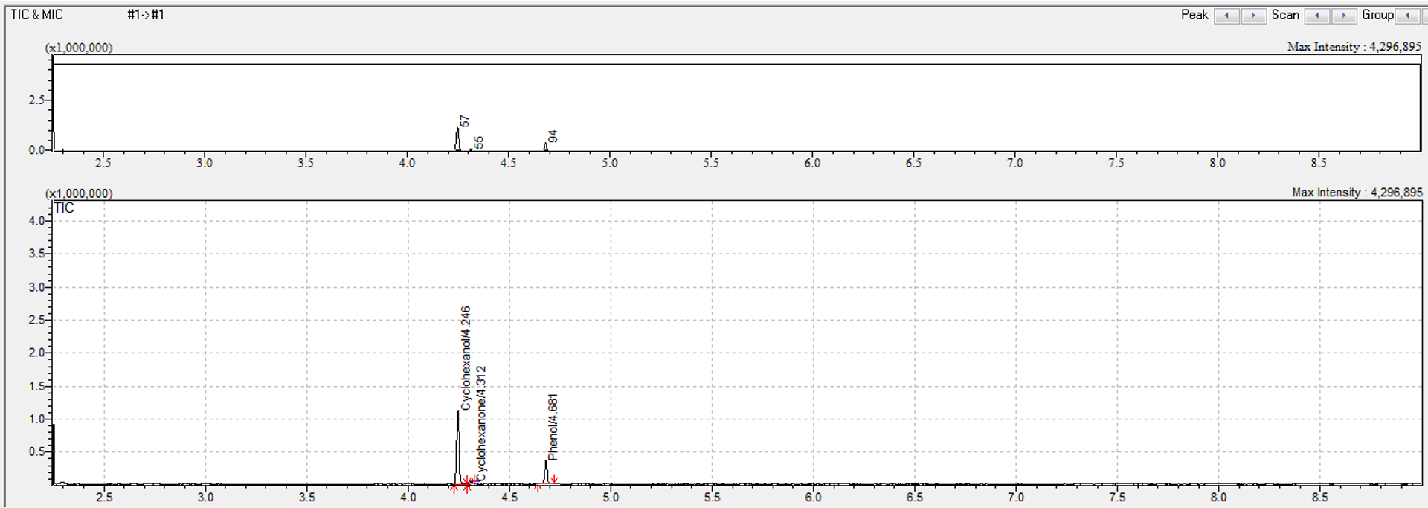
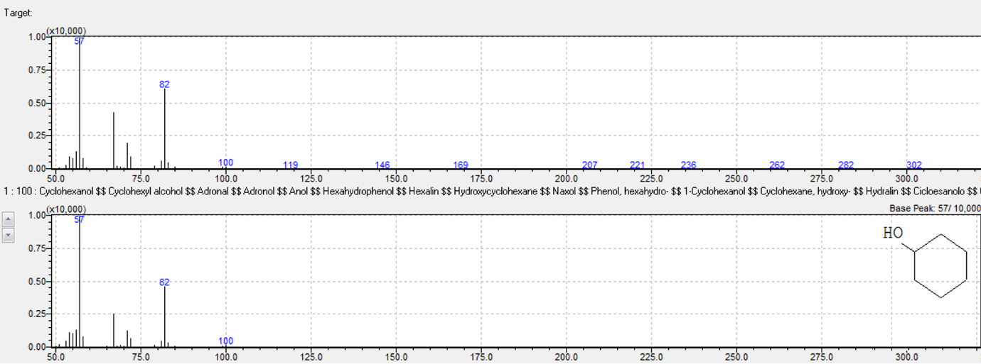
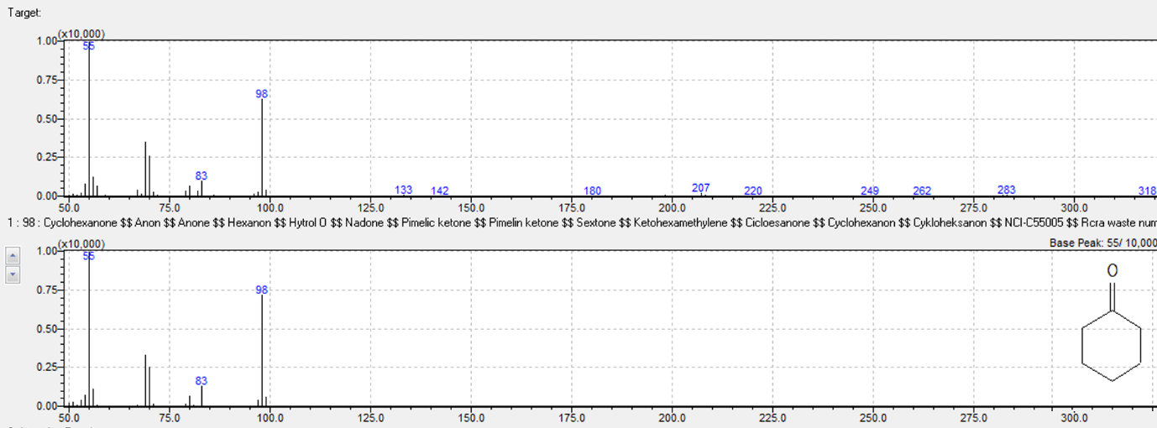

Figure S9 – GC-MS spectrum of guaiacol before ECH.
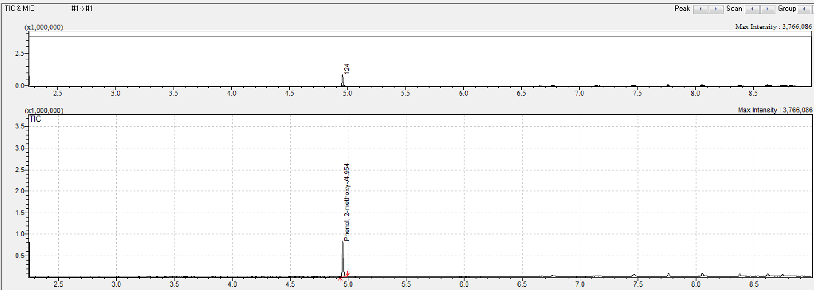
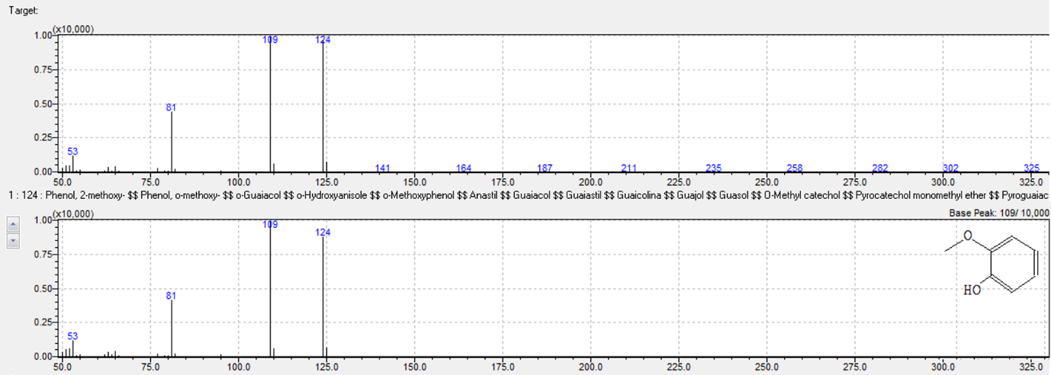

Figure S10 – GC-MS spectrum of guaiacol after ECH (a), methoxycyclohexanol (b) and methoxyclyclohexane (c).
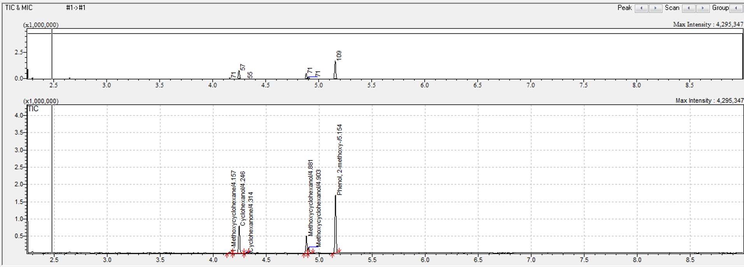
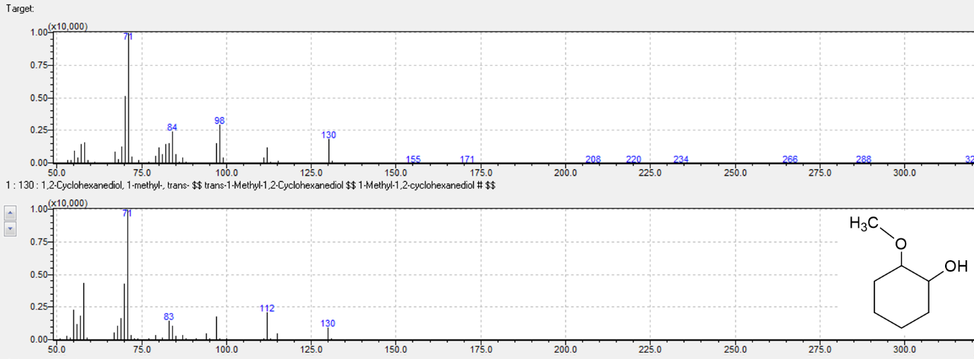
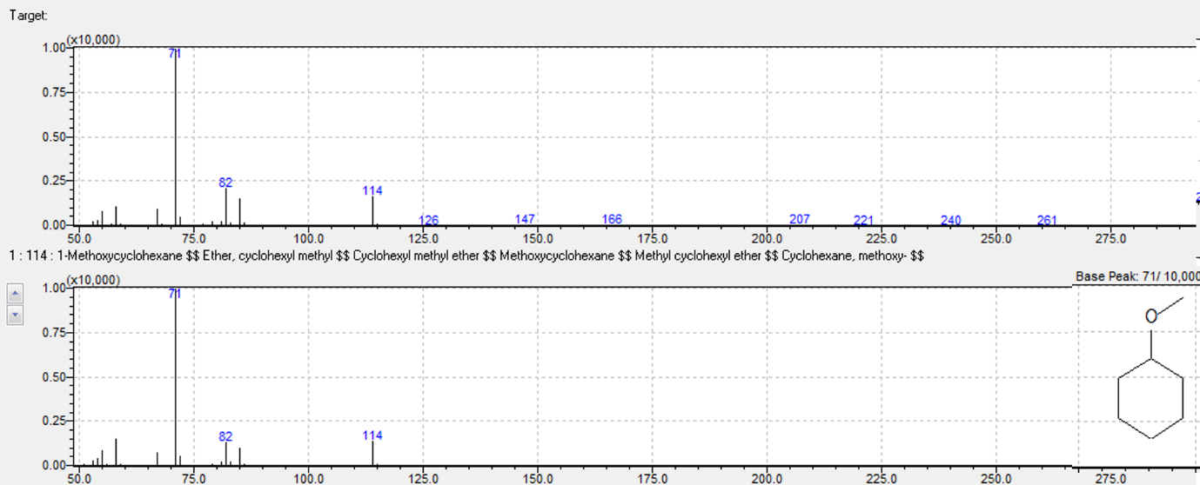

Figure S11 – GC-MS spectrum of benzoic acid and guaiacol mixture before (a) and after (b) ECH. (c) Spectrum of cyclohexane.
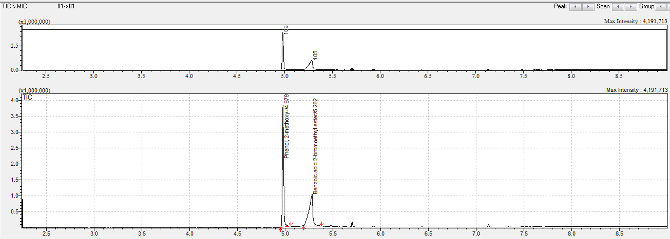
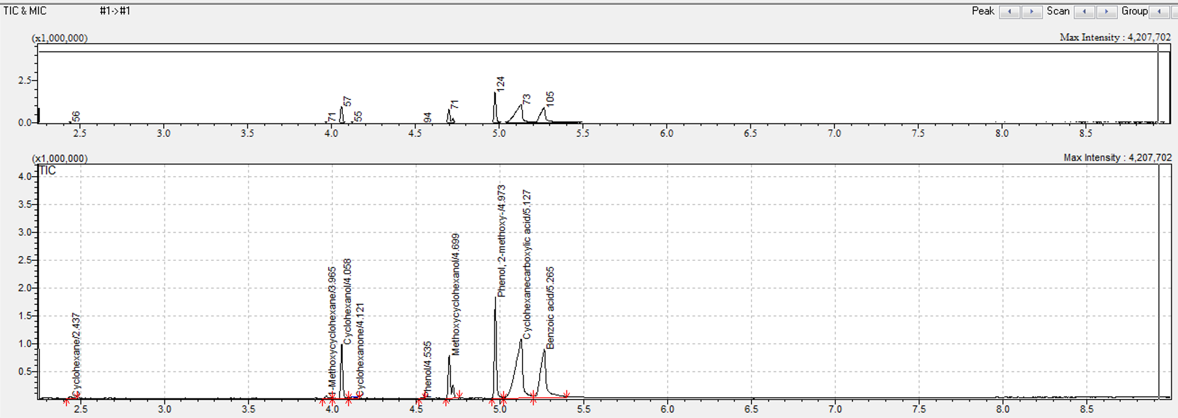
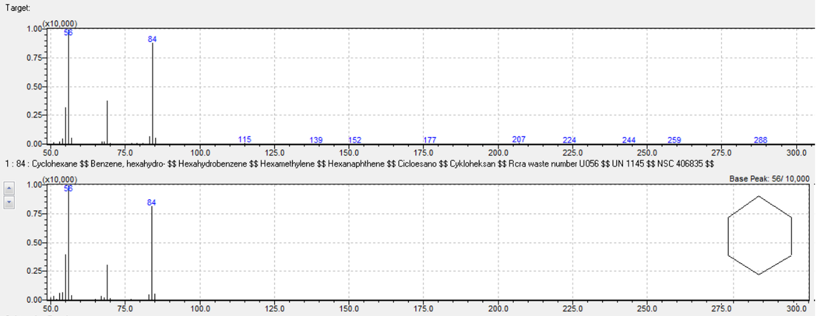

Figure S12 – GC-MS spectrum of benzoic acid and phenol mixture before (a) and after (b) ECH.
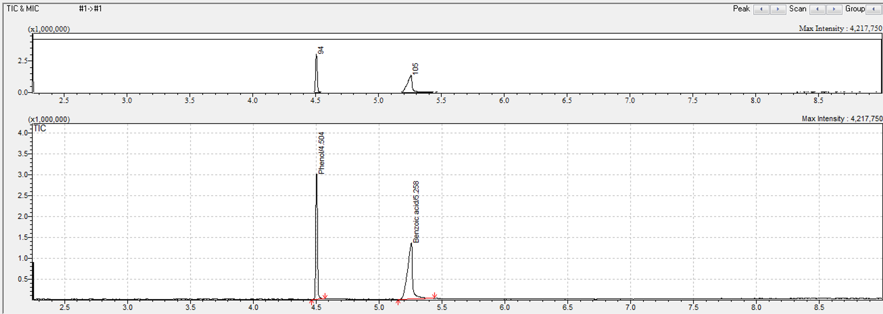
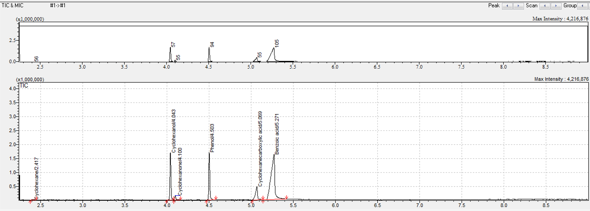

Figure S13 – GC-MS spectrum of guaiacol and phenol mixture before (a) and after (b) ECH.
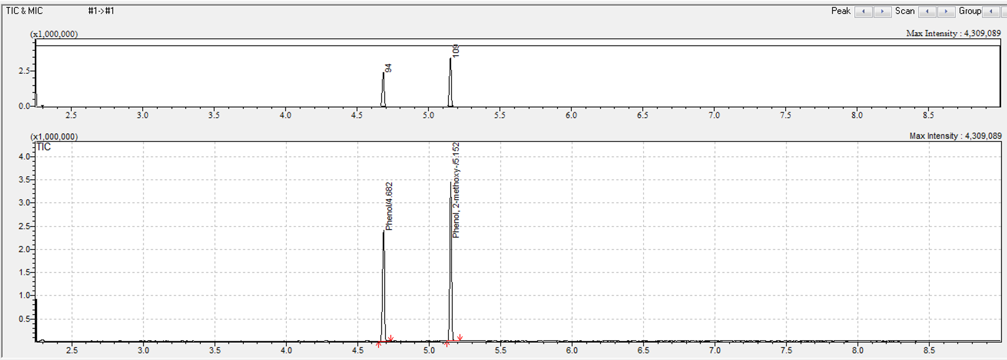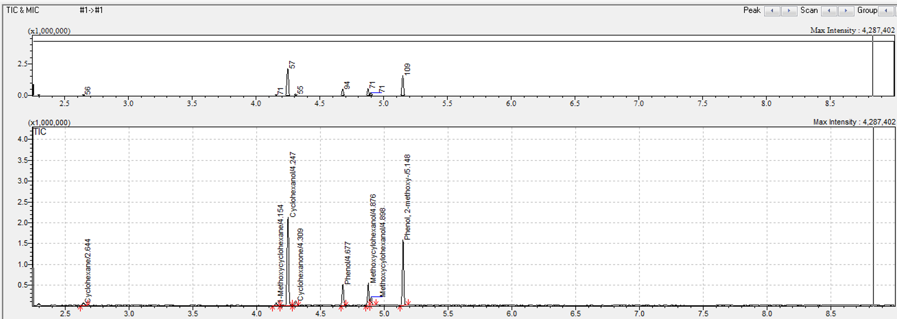

Figure S14 – GC-MS spectrum of benzoic acid, guaiacol and phenol mixture before (a) and after (b) ECH.
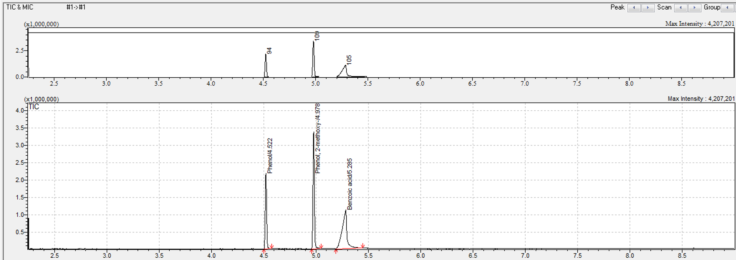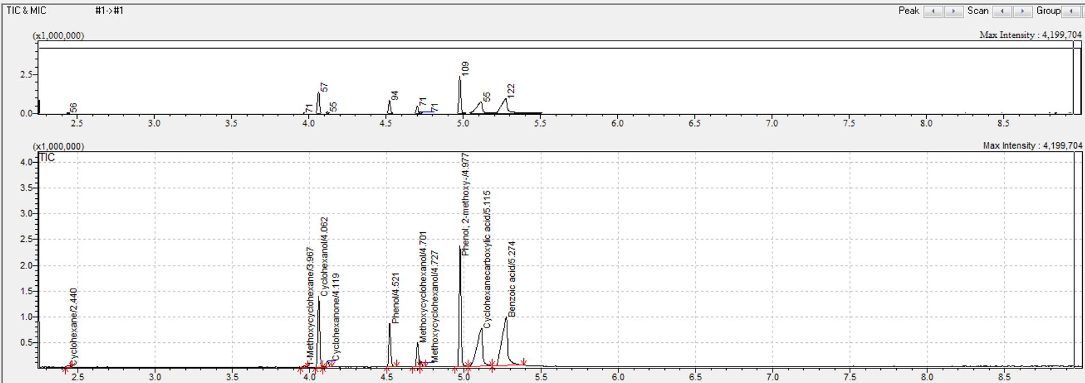
Graphical Kinetic studies
Benzoic acid
Order | Linear form | Rate Constant | Constant value | T (°C) | R²
Zero | $$C_{A}= C_{A0}-kt$$ | $$k=\frac{C_{A0}-C_{A}}{t} ;[M s^{-1}]$$ | k = 2.7  k = 4.0  k = 3.9  k = 3.9  k = 3.8 | 40  50  55  60  80 | 0.98962  0.96636  0.94221  0.91704  0.94380
First | $$lnC_{A}= {lnC}_{A0}-kt$$ | $$k=\frac{ln⁡(C_{A0}-C_{A})}{t} ;[s^{-1}]$$ | k = 0.19  k = 0.41  k = 0.40  k = 0.41  k = 0.37 | 40  50  55  60  80 | 0.99887  0.99122  0.99910  0.99789  0.99602
Second | $$1/{C_{A}}= 1/{C_{A0}}+kt$$ | $$k=\frac{1/{C_{A}}-1/{C_{A0}}}{t} ;[M^{-1}s^{-1}]$$ | k = 0.014  k = 0.051  k = 0.047  k = 0.052  k = 0.044 | 40  50  55  60  80 | 0.97671  0.87041  0.93662  0.91846  0.90476

Phenol
Order | Linear form | Rate Constant | Constant value | R²
Zero | $$C_{A}= C_{A0}-kt$$ | $$k=\frac{C_{A0}-C_{A}}{t} ;[M s^{-1}]$$ | k = 4.5 | 0.97746
First | $$lnC_{A}= {lnC}_{A0}-kt$$ | $$k=\frac{ln⁡(C_{A0}-C_{A})}{t} ;[s^{-1}]$$ | k = 0.55 | 0.96396
Second | $$1/{C_{A}}= 1/{C_{A0}}+kt$$ | $$k=\frac{1/{C_{A}}-1/{C_{A0}}}{t} ;[M^{-1}s^{-1}]$$ | k = 0.096 | 0.75812

Guaiacol
Order | Linear form | Rate Constant | Constant value | R²
Zero | $$C_{A}= C_{A0}-kt$$ | $$k=\frac{C_{A0}-C_{A}}{t} ;[M s^{-1}]$$ | k = 3.5 | 0.99557
First | $$lnC_{A}= {lnC}_{A0}-kt$$ | $$k=\frac{ln⁡(C_{A0}-C_{A})}{t} ;[s^{-1}]$$ | k = 0.29 | 0.94152
Second | $$1/{C_{A}}= 1/{C_{A0}}+kt$$ | $$k=\frac{1/{C_{A}}-1/{C_{A0}}}{t} ;[M^{-1}s^{-1}]$$ | k = 0.026 | 0.83006

References
1. Peng J, Fan X, Goenaga GA, Weiss CM, Neal CA, Cantillo N, et al. Effect of Boiling Pretreatment on Physicochemical and Transport Properties of Perfluorosulfonic Acid Membrane. ACS Appl Polym Mater. 2023 Dec 8;5(12):9940–51.
2. Giannozzi P, Baseggio O, Bonfà P, Brunato D, Car R, Carnimeo I, et al. Quantum ESPRESSO toward the exascale. J Chem Phys. 2020 Apr 21;152(15).
3. Giannozzi P, Andreussi O, Brumme T, Bunau O, Buongiorno Nardelli M, Calandra M, et al. Advanced capabilities for materials modelling with Quantum ESPRESSO. Journal of Physics: Condensed Matter. 2017 Nov 22;29(46):465901.
4. Giannozzi P, Baroni S, Bonini N, Calandra M, Car R, Cavazzoni C, et al. QUANTUM ESPRESSO: a modular and open-source software project for quantum simulations of materials. Journal of Physics: Condensed Matter. 2009 Sep 30;21(39):395502.

