Supplementary Material
Section SGM: Supplemental general methods
To produce the t-SNE embedding used to visualize the clusters in Fig 1 of the main text, we produced a set of N=500 randomly parameterised t-SNE embeddings of the symptom data by selecting parameters from the ranges given in table STG1. For each embedding we computed the silhouette score for clusterings A, B and C. The maximum silhouette scores across the 500 embeddings were -0.03, 0.24, 0.01 for clusterings A, B and C respectively. This suggested that it is easier to find (via random search) a 2D embedding where clustering B is well separated, than it is for clusterings A and C. For each of the 500 embeddings we calculated the mean silhouette score across the three clusterings, and selected the embedding that maximized this value. This produced an embedding with individual silhouette scores of -0.11, 0.24 and -0.05, which was found to have good clinical interpretability (Supp Fig G2) and is the one chosen to represent the clusters in Fig 1 of the main text. To investigate alternative embeddings we defined a weighted average silhouette score as:
$S_{α }={(1- α) s}_{A} + { s}_{B} + {(1- α) s}_{C}$,
where ${ s}_{i}$ is the raw silhouette score of embedding i and $α$ is a weighting coefficient. We selected the embedding that maximized $S_{α } for α ∊ [0,0.5$] and visualized the results in Supp Fig G1. The figure locates two candidate embeddings at $α$=0.50 (main text Fig 1 and Supp Fig G2), and $α$=0.27 (Supp Fig G3). It was notable that all of the embeddings examined showed approximately homogeneous densities in 2D with no clear structure visible, which supports our interpretation of the dataset in the main text. The same was true for the projection onto the first two principal components obtained using PCA, which is illustrated in Supp Fig G4.

Parameter | Search space
perplexity | [5, 100]
learning_rate | [10, 1000]
init | ['random', 'pca']
metric | ['euclidean', 'manhattan', 'hamming', 'jaccard', 'dice', 'russellrao', 'kulsinski', 'rogerstanimoto', 'sokalmichener', 'sokalsneath', 'yule']
Supplemental Table G1: Parameter ranges used to produce the set of 500 random t-SNE embeddings. For categorical parameters the search space is given as a list, for numerical parameters it is given as a closed interval on either ℝ or ℤ as determined by the parameter.

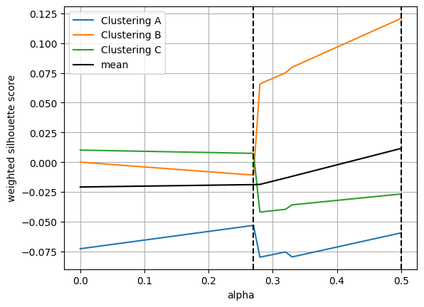
Supplemental Figure G1: The methodology for choosing a t-SNE embedding to plot all three clusterings by maximizing the weighted silhouette score (procedure described in the text of section SGM). The dashed line at $α$=0.5 indicates the embedding used in Fig 1 of the main text and in Supp Fig G2 below. The dashed line at $α$=0.27 indicates the alternative embedding illustrated in Supp Fig G3.
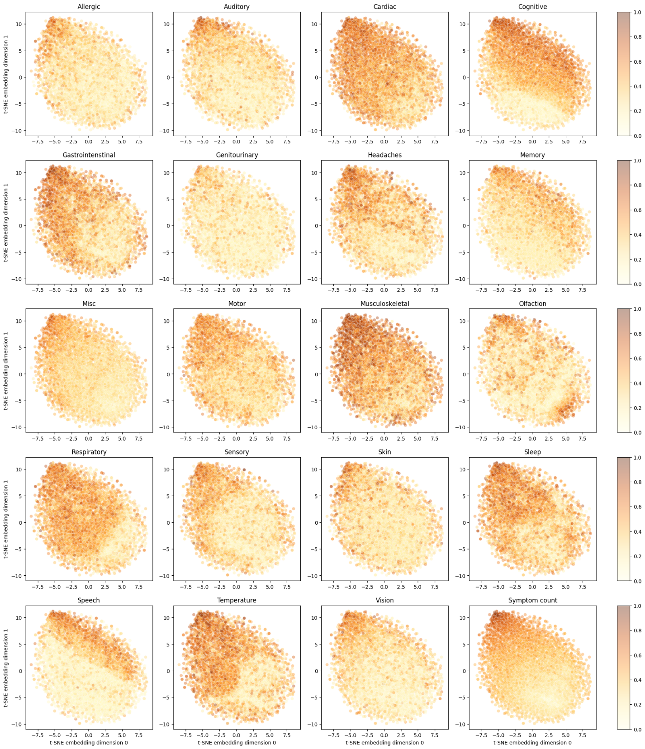
Supplemental Figure G2: The mean values for the symptom groups across the dataset, plotted using the same t-SNE embedding as for Fig 1 in the main text.

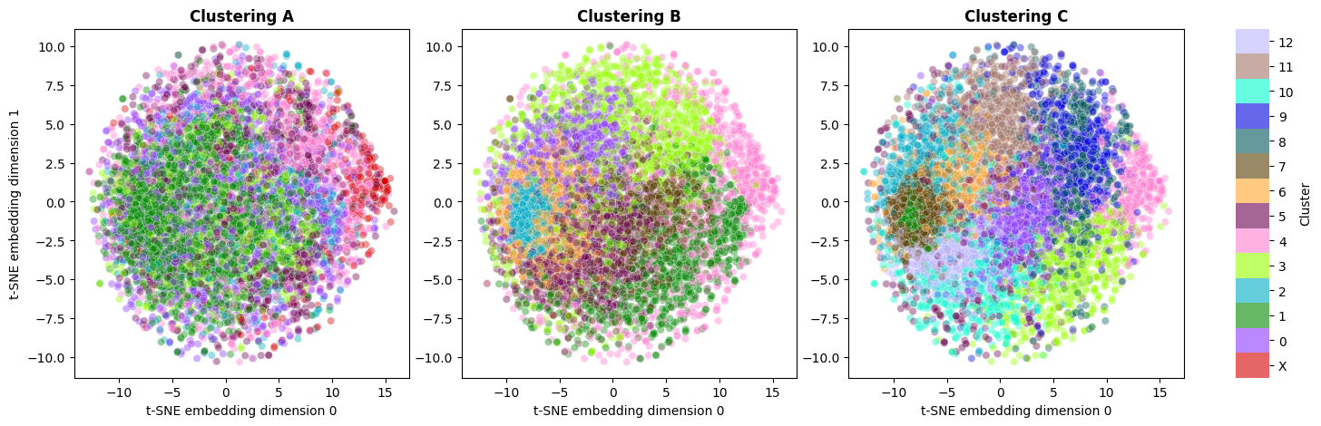
Supplemental Figure G3: Alternative t-SNE embedding of symptom data, selected at ⍺=0.27 (see Supp Fig G1).

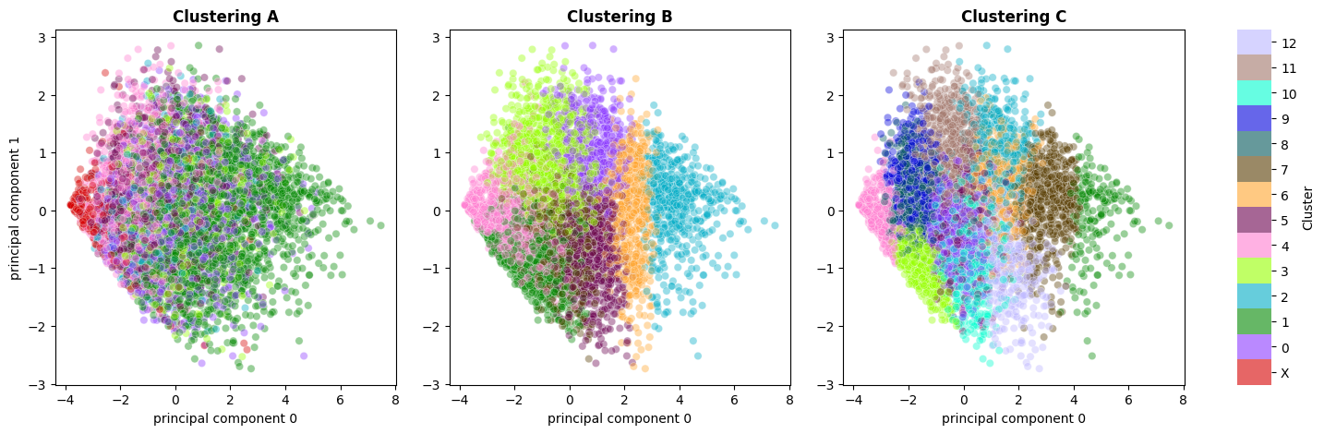
Supplemental Figure G4: Projection of symptom data onto first two principal components.

Section SA.1: Supplemental methods for method A.
Feature cleaning:

Approach | Optimised Threshold | Features
Skewness | 0.2 < X <0.8 | Symptom_Eye_Vision_loss_of_vision: 0.0111, Symptom_Reproductive_early_menopause: 0.0139, Symptom_Reproductive_postmenopausal_bleeding: 0.0161, Symptom_Hallucinations_other: 0.0234, Symptom_SkinAllergy_shingles: 0.0257, Symptom_Heightened_taste: 0.0308, Symptom_Sensations_facial_paralysis: 0.0320, Symptom_Hallucinations_tactile: 0.0337, Symptom_Reproductive_testicle_penis_pain_changes: 0.0365, Symptom_Eye_Vision_tunnel_vision: 0.0383, Symptom_New_anaphylaxis: 0.0429, Symptom_Speech_other: 0.0431, Symptom_Coughing_up_blood: 0.0479, Symptom_Ear_numbness: 0.0494, Symptom_Inability_to_yawn: 0.0541, Symptom_Speech_changes_to_secondary_languages: 0.0557, Symptom_SkinAllergy_other_itchy: 0.0574, Symptom_Sensations_facial_pressure_other: 0.0602, Symptom_Sensations_facial_pressure_right: 0.0680, Symptom_Hallucinations_auditory: 0.0711, Symptom_Sensations_facial_pressure_left: 0.0793, Symptom_Eye_Vision_double_vision: 0.0796, Symptom_Dermatographia: 0.0804, Symptom_Heightened_smell: 0.0822, Symptom_Eye_Vision_redness_outside_eye: 0.0832, Symptom_Respiratory_other: 0.0861, Symptom_Cognitive_Functioning_other: 0.0871, Symptom_Memory_no_new_memories: 0.0875, Symptom_Reproductive_other_menstrual_issues: 0.0900, Symptom_Speech_speaking_unrecognizable_words: 0.0947, Symptom_Skin_Allergy_other: 0.0947, Symptom_Reproductive_abnormally_heavy_periods_clotting: 0.0953, Symptom_Hearing_loss: 0.0970, Symptom_Phantom_taste: 0.0990, Symptom_Hallucinations_visual: 0.1033, Symptom_Cognitive_Functioning_agnosia: 0.1083, Symptom_SkinAllergy_brittle_nail: 0.1094, Symptom_New_allergies: 0.1111, Symptom_Reproductive_sexual_dysfunction: 0.1129, Symptom_Memory_other: 0.1200, Symptom_Headaches_brain_warmth: 0.1205, Symptom_Reproductive_abnormally_irregular_periods: 0.1207, Symptom_SkinAllergy_heighted_reaction_allergies: 0.1239, Symptom_Peeling_skin: 0.1260, Symptom_Sleep_apnea: 0.1262, Symptom_Eye_Vision_pink_eye: 0.1270, Symptom_Fainting: 0.1277, Symptom_Sensations_numbness_one_sided_weakness: 0.1282, Symptom_Covid_toes: 0.1290, Symptom_Headaches_other: 0.1333, Symptom_Eye_Vision_seeing_things_peripheral_vision: 0.1336, Symptom_Memory_forget_tasks: 0.1380, Symptom_Eye_Vision_bloodshot_eyes: 0.1411, Symptom_Vomiting: 0.1499, Symptom_Reproductive_other_urinary_issues: 0.1535, Symptom_Lucid_dreams: 0.1567, Symptom_Bladder_control: 0.1569, Symptom_Petechiae: 0.1632, Symptom_Bradycardia: 0.1643, Symptom_Bulging_veins: 0.1648, Symptom_Slurring_words: 0.1670, Symptom_Speech_difficulty_communicating_writing: 0.1673, Symptom_Cognitive_Functioning_fastthoughts: 0.1733, Symptom_Rattling_breath: 0.1749, Symptom_Reproductive_all_menstrual_issues: 0.1836, Symptom_Restless_leg: 0.1899, Symptom_Acute_confusion: 0.1935, Symptom_Low_temp: 0.1942
Correlation | 0.5 | Symptom_Loss_of_smell - Symptom_Loss_of_taste: 0.72  Symptom_Eye_vision_symptoms - Symptom_Eye_Vision_blurred_vision: 0.68  Symptom_Speech_difficulty_finding_words - Symptom_Speech_difficulty_communicating_verbally: 0.65  Symptom_Insomnia - Symptom_Waking_up_in_night: 0.64  Symptom_Speech_difficulty_communicating_verbally - Symptom_Speech_difficulty_speaking_complete_sentences: 0.58  Symptom_Speech_difficulty_finding_words - Symptom_Speech_difficulty_reading_processing_text: 0.58  Symptom_Insomnia - Symptom_Difficulty_falling_asleep: 0.55  Symptom_Speech_difficulty_finding_words - Symptom_Speech_difficulty_speaking_complete_sentences: 0.55  Symptom_Temp_lability - Symptom_Elevated_temp: 0.54  Symptom_Altered_taste - Symptom_Altered_smell: 0.53  Symptom_Speech_difficulty_communicating_verbally - Symptom_Speech_difficulty_reading_processing_text: 0.52
Supplemental Table A1: Features dropped before final clustering based on optimized skewness and correlation thresholds. Features that were highly skewed (most patients had a symptom present or no patients had that symptom) were dropped. Features that were heavily correlated with one another were also dropped.

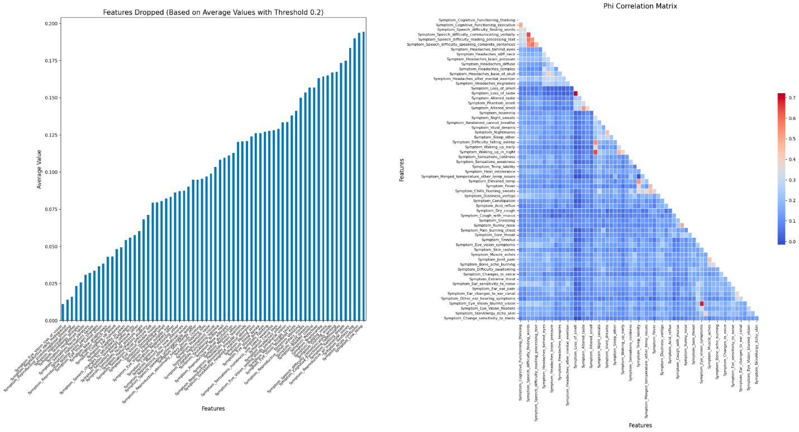
Supplemental Fig A1:

Left: Binary symptom features were excluded based on their average values being either below 0.2 or above 0.8.
Right: Features remaining after the initial filtration were further analyzed for Phi correlation; those with a correlation exceeding 0.5 were dropped.

Parameters:

Algorithm | Parameter | Search Space | Optimized Parameter
Autoencoder | Hidden Layer Size | (32, 64, 128, 256) | 64
Autoencoder | Latent Dimension | (2, 8, 16, 32, 64) | 2
Autoencoder | Learning Rate | (0.001, 0.01) | 0.01
Autoencoder | Epochs | (250, 500, 1000) | 500
HDBSCAN | Minimum Cluster Size | (20, 50, 100, 125, 150) | 135 (refined manually)
HDBSCAN | Minimum Sample Size | (2, 5, 10, 15) | 2
Supplemental Table A2: Parameter search space used for optimisation of autoencoder embeddings and HDBSCAN clustering.
Section SA.2: Supplemental results for method A.

Cluster Pair | Feature | Distance
0-1 | Sleep | 0.361
0-1 | Motor | 0.111
0-1 | Musculoskeletal | 0.110
2-3 | Sleep | 0.308
2-3 | Musculoskeletal | 0.014
2-3 | Headaches | 0.095
4-5 | Sleep | 0.313
4-5 | Motor | 0.076
4-5 | Cardiac | 0.071

Supplemental Table A3: Dimension 1 interpretation of axes for Fig 2; for each cluster pair above norm distance was calculated across all features. Feature differences between pairs indicate that there is variance in this feature along the axis. These pairs were chosen on the basis that they are similar when compared along Dimension 2 but dissimilar along Dimension 1.

Cluster Pair | Feature | Distance
1-5 | Temperature | 0.517
1-5 | Muskuloskeletal | 0.203
1-5 | Gastrointestinal | 0.193
0-4 | Temperature | 0.464
0-4 | Gastrointestinal | 0.153
0-4 | Muskuloskeletal | 0.149
Supplemental Table A4: Dimension 2 interpretation of axes for Fig 2; for each cluster pair above norm distance was calculated across all features. Features differences between pairs indicate that there is variance in this feature along the axis. These pairs were chosen on the basis that they are similar when compared along Dimension 1 but dissimilar along Dimension 2.

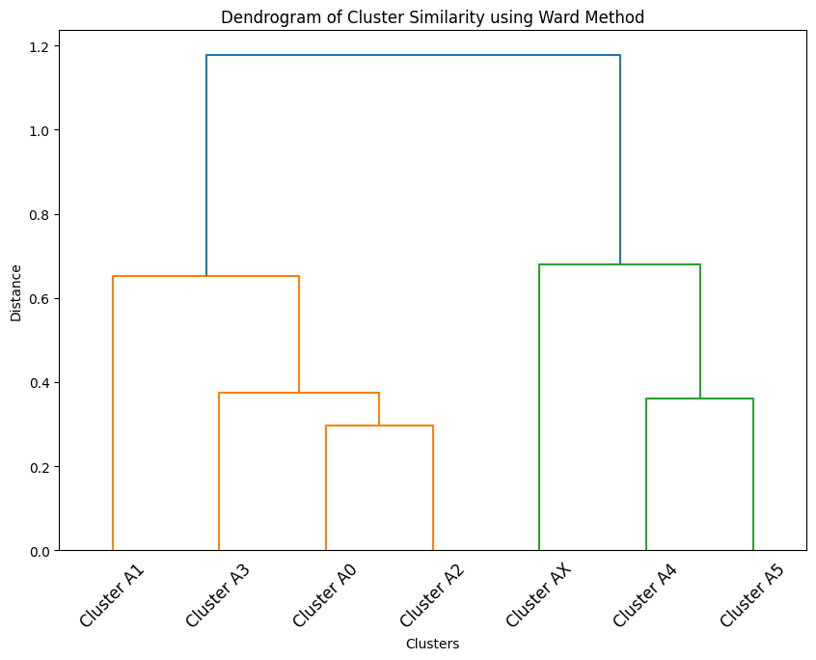
Supplemental Figure A2: Ward Method dendrogram showing similarity between clusters of solution A.

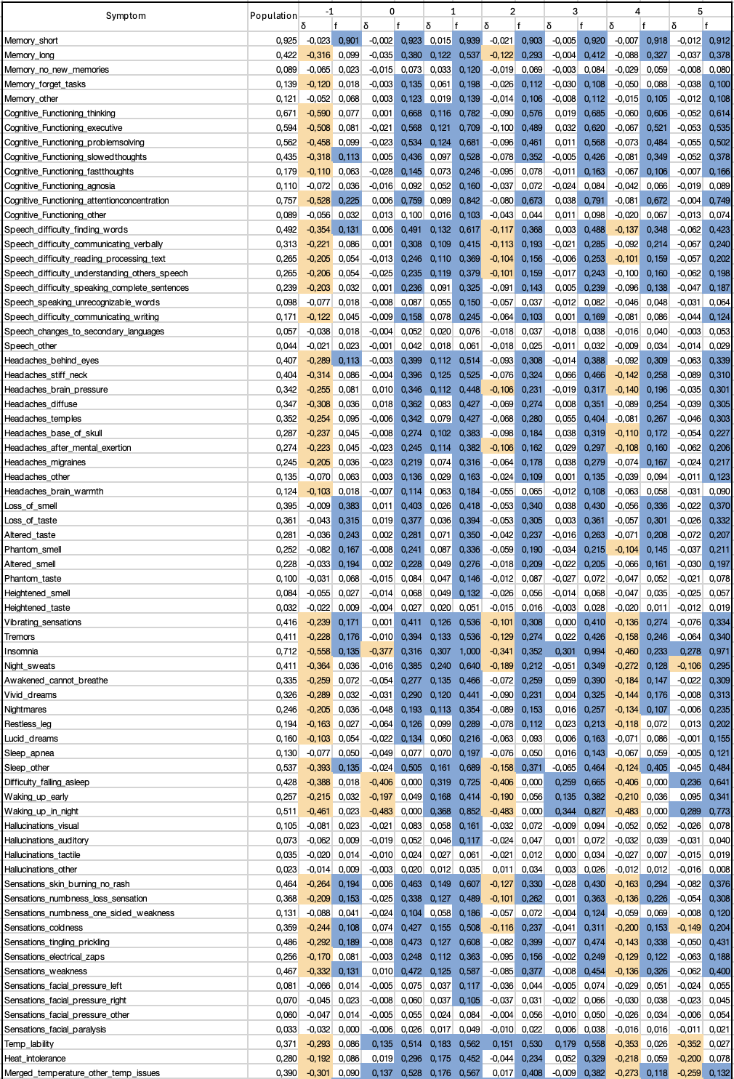

Supplemental Table A5: The above table shows the full set of symptoms, their frequency in the whole population and each cluster, as well as the difference δ between the cluster and population frequencies. Enriched symptoms, highlighted in blue, are those for which δ > 0.1. Conversely dis-enriched symptoms, in orange, have δ < -0.1. Also supplied as Supp Data 2.

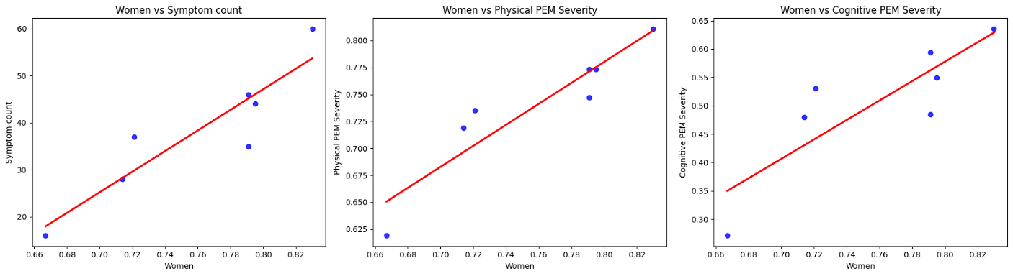
Supplemental Figure A3: Correlations between demographic variable “Women” and outcomes across clusters.

Section SB.1: Supplemental methods for method B (ensemble clustering).
To construct the pipelines that would be used to produce base clusterings for the ensemble method, we needed to select a dimensionality reduction method and a shallow clustering algorithm. We initially experimented with both PCA and UMAP as dimensionality reduction methods, and both k-means and HDBSCAN as clustering algorithms. We ran at least 1000 randomly parameterized clusterings using the 8 combinations of these methods with parameter values drawn from the ranges given in table STB1. This stage of the ensemble clustering method is referred to as ‘library generation’ and the goal is to produce a large and diverse set of high-quality clusterings from which to select the ensemble. One way to do this is to perform multiple runs of the same stochastic algorithm with different random seeds (Boongoen and Iam-On, 2018). However, given the complexity of the dataset we felt it would be better to use multiple algorithms with diverse parameterizations. However, HDBSCAN was found to work poorly with this approach and tended to label most patients as noise. For example, for 1000 randomly parameterised runs of UMAP + HDBSCAN, the mean and standard deviation of the fraction of the dataset labeled as noise were 0.75 and 0.08 respectively. This poor performance of HDBSCAN, which persisted under manual parameter exploration, reflects the high level of noise in this dataset and the resulting difficulty in producing robust cluster assignments, as discussed in the main text.

We therefore determined to use only k-means as the clustering algorithm. For simplicity we decided to use only UMAP as the dimensionality reduction method, as it is more powerful than PCA with the ability to capture more complex structures from this high dimensional dataset. Therefore our base clusterings were all generated from the single pipeline consisting of UMAP + k-means, and the diversity of our ensemble relied on the random parameterisation of these algorithms using values selected from the ranges given in Supplemental Table B1.

Having produced a library of base clusterings, we then employed an ensemble selection approach to choose clusterings that optimized the joint criterion (Fern and Lin, 2008) with the aim of balancing the quality and diversity of the ensemble.

Algorithm | Parameter | Search space
PCA | n_components | (2, 40)
HDBSCAN | cluster_selection_method | [‘eom’, ‘leaf’]
HDBSCAN | metric | ['euclidean', 'manhattan']
HDBSCAN | min_cluster_size | (2, 100)
HDBSCAN | min_samples | (1, 50)
UMAP | n_neighbors | (2, 1000)
UMAP | min_dist | (0, 1)
UMAP | n_components | (2, 40)
UMAP | metric | ['euclidean', 'manhattan']
K-MEANS | n_clusters | (2, 20)
K-MEANS | n_init | (1, 10)
K-MEANS | init | ['k-means++', 'random']
Supplemental Table B1: Parameter search space used for initial experiments with library generation using Bayes Search and Randomized search.

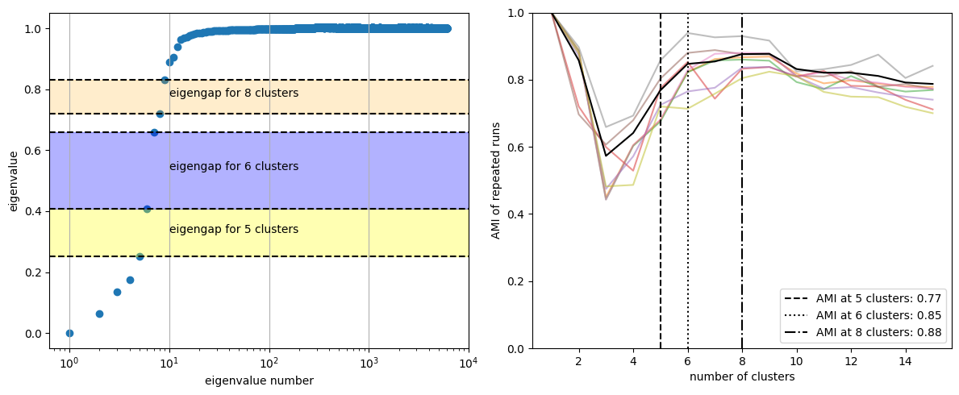
Supplemental Figure B1: Left: illustration of the eigengaps of the normalized graph Laplacian produced by the co-association matrix of the selected ensemble, which were used to select candidates for the best number of clusters to use. Right: the stability of the cluster structure (for 1 to 15 clusters) under repeated runs, calculated as AMI value with first run. Each coloured line is a separate run of the full methodology, the solid black line is the mean over these runs. The three dashed lines indicate the location of the three highest eignegaps from the left panel at 5, 6, and 8 clusters.
Section SB.2: Supplemental results for method B (ensemble clustering).

There was a good diversity of base clusterings in the library. Supp Fig B2 shows the clusterings with the lowest and highest AMI values compared to the final clustering B from the main text. The mean AMI value in the library was 0.62, and all pipeline parameters displayed approximately uniform distributions over the ranges defined in table Supplemental Table B1 as expected.
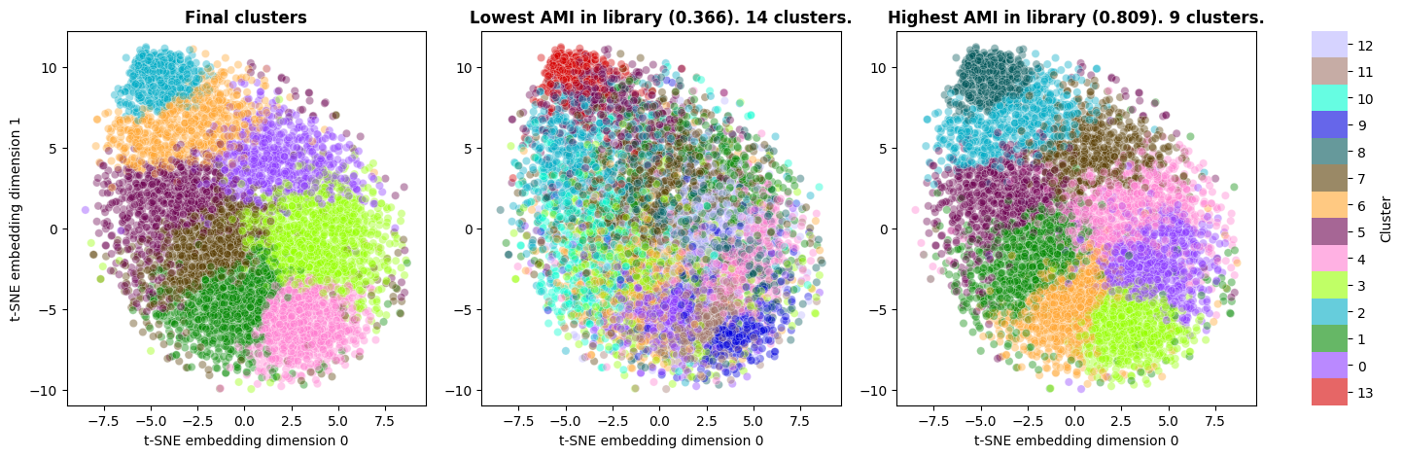
Supplemental Figure B2: Embeddings of the symptom data with patients coloured by cluster, using the same t-SNE embedding as Fig 1 in the main text. Right: final clusters (‘clustering B’). Middle: library clustering with lowest AMI with final clusters. Right: library clustering with highest AMI with final clusters.

Supplemental Table B2: The following table shows the full set of symptoms, their frequency in the whole population and each cluster, as well as the difference δ between the cluster and population frequencies. Enriched symptoms, highlighted in blue, are those for which δ > 0.1. Conversely dis-enriched symptoms, in orange, have δ < -0.1.
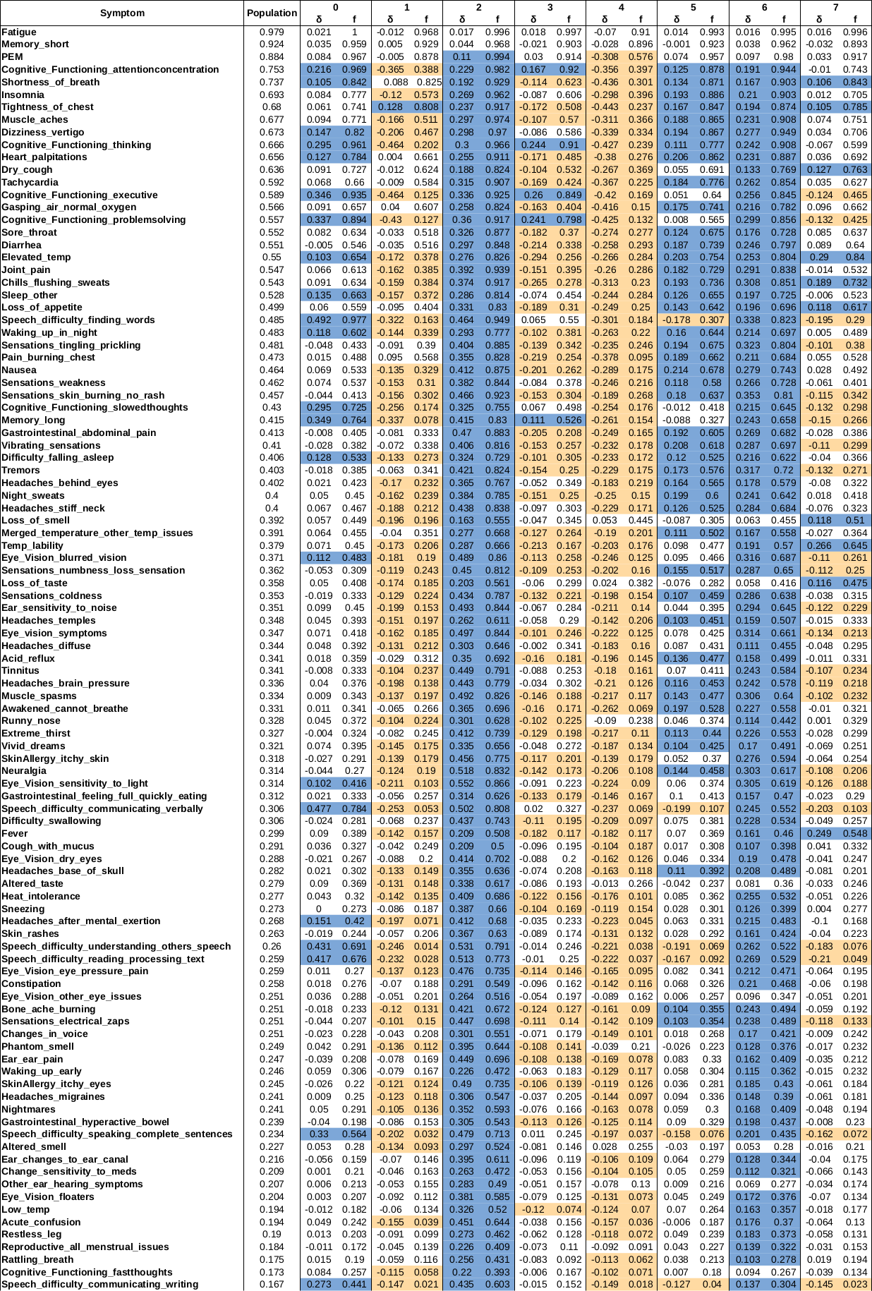

 | Most Enriched | Most dis-enriched | Cluster Name
0 | Speech_difficulty_finding_words Speech_difficulty_communicating_verbally, Speech_difficulty_understanding_others_speech Speech_difficulty_reading_processing_text  Memory_long Cognitive_Functioning_executive Cognitive_Functioning_problemsolving  Speech_difficulty_speaking_complete_sentencs Cognitive_Functioning_slowedthoughts Cognitive_Functioning_thinking | Inability_to_yawn  Ear_numbness  Coughing_up_blood  New_anaphylaxis  Reproductive_testicle_penis_pain_changes  Hallucinations_tactile  Sensations_facial_paralysis  SkinAllergy_shingles  Hallucinations_other  Reproductive_postmenopausal_bleeding | Speech, memory, cognition, sleep and eye/vision (neurological).
1 | Tightness_of_chest  Pain_burning_chest  Shortness_of_breath Gasping_air_normal_oxygen  Memory_short  Heart_palpitations  Respiratory_other | Eye_Vision_tunnel_vision  Reproductive_testicle_penis_pain_changes  Hallucinations_tactile  Sensations_facial_paralysis  Heightened_taste  SkinAllergy_shingles  Hallucinations_other  Reproductive_postmenopausal_bleeding  Reproductive_early_menopause  Eye_Vision_loss_of_vision | Shortness of breath, chest burning pain, short term memory, heart palpitations.
2 | Eye_Vision_sensitivity_to_light Speech_difficulty_understanding_others_speech  Neuralgia Speech_difficulty_reading_processing_text Speech_difficulty_communicating_verbally  Eye_vision_symptoms  Ear_sensitivity_to_noise  Muscle_spasms  SkinAllergy_itchy_eyes Eye_Vision_blurred_vision |  | Sensory sensitivity, difficulty communicating verbally and processing information, neuropathy, itchy eyes and blurred vision.
3 | Cognitive_Functioning_executive Cognitive_Functioning_thinking Cognitive_Functioning_problemsolving Cognitive_Functioning_attentionconcentration  Memory_long Cognitive_Functioning_slowedthoughts Speech_difficulty_finding_words  PEM  Speech_difficulty_communicating_verbally  Fatigue | Eye_Vision_tunnel_vision  Reproductive_testicle_penis_pain_changes  Hallucinations_tactile  Sensations_facial_paralysis  Heightened_taste  SkinAllergy_shingles  Hallucinations_other  Reproductive_postmenopausal_bleeding  Reproductive_early_menopause  Eye_Vision_loss_of_vision | Cognition, long term memory, speech, PEM, and fatigue.
4 | Loss_of_smell  Altered_smell  Loss_of_taste  Respiratory_other | Eye_Vision_tunnel_vision  Reproductive_testicle_penis_pain_changes  Hallucinations_tactile  Sensations_facial_paralysis  Heightened_taste  SkinAllergy_shingles  Hallucinations_other  Reproductive_postmenopausal_bleeding  Reproductive_early_menopause  Eye_Vision_loss_of_vision | Altered smell and taste, respiratory.
5 | Nausea  Vibrating_sensations Heart_palpitations  Elevated_temp 'Night_sweats Awakened_cannot_breathe Sensations_tingling_prickling Dizziness_vertigo Chills_flushing_sweats  Insomnia | Cognitive_Functioning_other  Respiratory_other  Heightened_smell  Hallucinations_auditory  SkinAllergy_other_itchy  Speech_changes_to_secondary_languages  Speech_other  Eye_Vision_tunnel_vision  Heightened_taste  Reproductive_postmenopausal_bleeding | Nausea, temperature dysregulation, sleep disturbance, paresthesia and vibrations, palpitations, dizziness and vertigo.
6 | Sensations_skin_burning_no_rash Speech_difficulty_finding_words Sensations_tingling_prickling  Tremors  Eye_Vision_blurred_vision  Eye_vision_symptoms  Chills_flushing_sweats  Muscle_spasms  Eye_Vision_sensitivity_to_light  Neuralgia | Respiratory_other  SkinAllergy_shingles | Paresthesia, speech, vision problems, neuropathy, tremors, temperature dysregulation.
7 | Elevated_temp  Temp_lability  Fever  Chills_flushing_sweats  Dry_cough  Loss_of_appetite  Loss_of_smell  Loss_of_taste  Shortness_of_breath  Tightness_of_chest | Speech_other  New_anaphylaxis  Eye_Vision_tunnel_vision  Reproductive_testicle_penis_pain_changes  Hallucinations_tactile  Sensations_facial_paralysis  Heightened_taste  SkinAllergy_shingles  Reproductive_early_menopause  Eye_Vision_loss_of_vision | Temperature dysregulation, dry cough, loss of smell, taste and appetite, shortness of breath.

Supplemental Table B3: The most enriched and dis-enriched symptoms for each cluster up to a maximum of 10 symptoms. Names were allocated to each cluster by the research team based on these symptoms.
Section SB.3: Robustness analysis for method B (ensemble clustering)
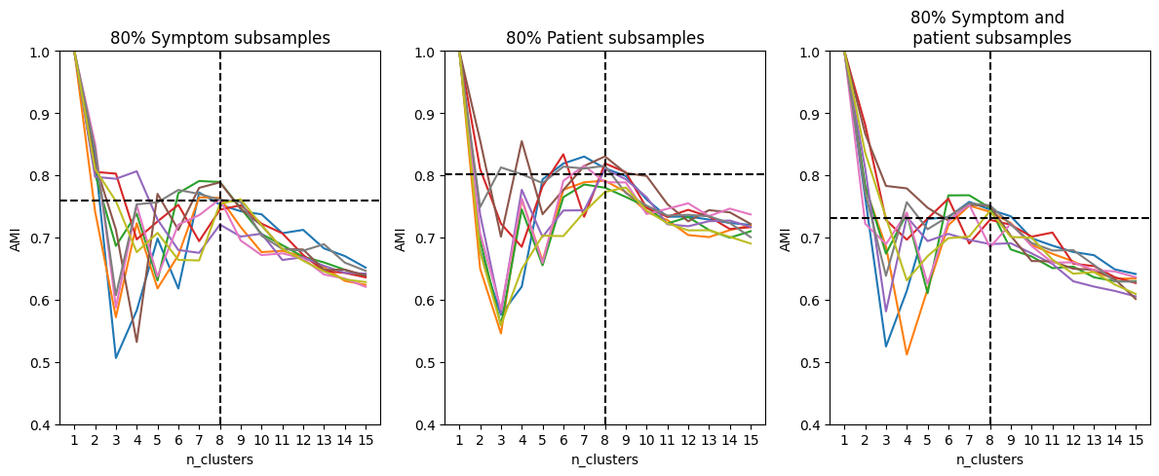

Supplemental Figure B2: Showing robustness of clustering B under different sub-sampling regimes, as measured by the AMI calculated against the equivalent run of the ensemble method using the full dataset. Each subsampling is repeated 10 times and the black dashed lines show the location of the mean AMI at n_clusters = 8.
Section SC.1: Supplemental results for method C (LCA).

Supplemental Fig C.1
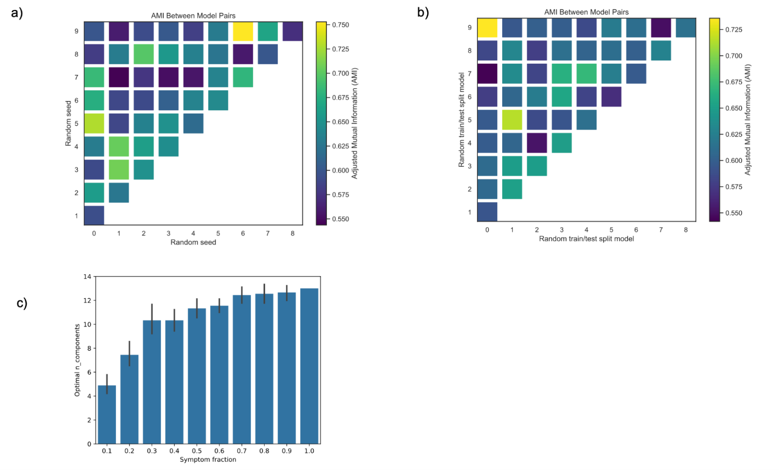
Supplemental Figure C1: Supplemental information on model robustness a) AMI between models trained with different random seeds on the full dataset. b) AMI between models trained with different random subsets of the data, with the AMI computed on the full dataset. c) Optimal StepMix n_components as determined by BIC for decreasing fractions of measured symptoms.

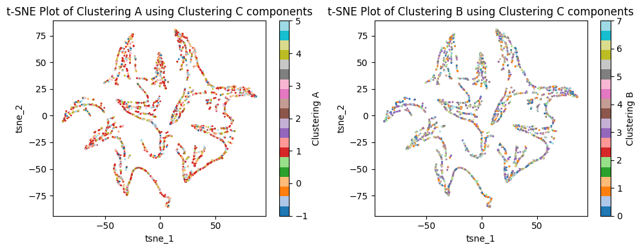
Supplemental Figure C2: Clusterings A and B projected onto the tSNE components produced from the probabilistic output of Methodology C.

Supplemental Table C1: Cluster labeling information for Clustering C. Adaptive thresholds shown here are used for discussion purposes only, and were defined manually such that relevant symptoms fit on the page. Enriched symptoms marked with an asterisk (*) are dis-enriched and reported with reduced prevalence. Full parameter values are available in Supp Data 4, with the comparisons by cluster in Supp Data 5.
C. | Name | Enriched symptoms | threshold | prevalent symptoms | threshold
0 | Temperature dysregulation, sleep disturbance, cognition (attention/concentration) and shortness of breath | Insomnia, Elevated_temp, Waking_up_in_night, Fever, Temp_lability, Night_sweats, Cognitive_functioning_attentionconcentration | 0.1 | PEM, Memory_short, Insomnia, Cognitive-Functioning_attentionconcentration, Shortness_of_breath | 0.8
1 | High symptom burden with cognitive dysfunction, difficulty reading and communicating, and sensory and allergic symptoms  Elevated musculoskeletal symptom count | Eye_Vision_sensitivity_to_light, Difficulty_swallowing, SkinAllergy_itchy_eyes, SkinAllergy_itchy_skin, Muscle_spasms, Speech_difficulty_reading_processing_text, Ear_pain, Speech_difficulty_understanding_others_speech, Sensations_numbness_loss_sensation | 0.58 | Cognitive_Functioning_thinking, Cognitibe_Functioning_attentionconcentration, PEM, Memory_short, Sensations_skin_burning_no_rash | 0.98
2 | Difficulty reading and communicating, high prevalence of cognitive symptoms | Speech_difficulty_finding_words, Speech_difficulty_communicating_verbally, Speech_difficulty_understanding_others_speech, Speech_dificulty_reading_processing_text, Speech_difficulty_speaking_complete_sentences | 0.4 | Speech_difficulty_finding_words, PEM, Cognitive_Functioning_attentionconcentration, Cognitive_function_thinking, Cognitive_Functioning_executive, Memory_short | 0.95
3 | Low symptom burden, cognitive symptoms reduced with short term memory difficulty still reported | Cognitive_Functioning_thinking*, Cognitive_Functioning_executive*, Cognitive_Functioning_attentionconcentration*, Cognitive_Functioning_problemsolving*, | -0.6 | Memory_short, PEM | 0.79
4 | Lowest symptom burden, Lowest cognitive PEM severity, reduced frequency of PEM, cognitive symptoms reduced | Cognitive_Functioning_thinking*, Insomnia*, Cognitive_Functioning_attentionconcentration*, Cognitive_Functioning_executive* | -0.6 | Memory_short (0.79), PEM (0.52) | 0.5
5 | Chest tightness, dizziness/vertigo, shortness of breath, gasping for air while oxygen normal | Gasping_air_normal_oxygen, tightness_of_chest, dizziness_vertigo, heart_palpitations | 0.1 | PEM, Memory_short, Shortness_of_breath, Tightness_of_chest, Dizziness_vertigo | 0.8
6 | Impaired reading and communication, elevated temperature and chills/sweats, sleep difficulty and elevated average musculoskeletal symptom count | Speech_difficulty_finding_words, Speech_difficulty_communicating_verbally, Speech_difficulty_reading_processing_text, Speech_difficulty_understanding-others_speech, Elevated_temp, Cognitive_Functionin_problemsolving, Difficulty_falling_asleep, Chills_flushing_sweats, Sleep_other | 0.25 | Speech_difficulty_finding_words, PEM, Cognitive_Functioning_attentionconcentration, Shortness_of_breath, Memory_short | 0.9
7 | High symptom burden with impaired speech, auditory and visual comprehension, blurred vision, pain: muscle aches, muscle spasms, neuralgia and skin burning without associated rash. | Speech_difficulty_finding_words, Speech_difficulty_communicating_verbally, Speech_difficulty_understanding-others_speech, Speech_difficulty_reading_processing_text,Eye_vision_symptoms, Speech_difficulty_speaking_complete_sentences, Muscle_spasms, Neuralgia, Sensations_skin_burning_no_rash, Blurred_vision | 0.4 | Symptom_Speech_difficulty_finding_words, PEM, Dizziness_vertigo, Memory_short, Muscle_aches | 0.95
8 | Insomnia, difficulty falling asleep and waking up in night | Insomnia, Waking_up_in_night, Difficulty_falling_asleep | 0.1 | Insomnia | 1
9 | Consistent sleepers with PEM and cognitive impairment | Difficulty_falling_asleep*, Waking_up_in_night*, Insomnia* | -0.4 | Memory_short, PEM, Cognitive_Functioning_attentionconcentration, Cognitive_Functioning_thinking | 0.7
10 | Insomnia, tremors, sensory features: tingling/prickling, skin burning without rash, vibrations. | Insomnia, Sensations_tingling_prickling, Waking_up_in_night, Sensations_skin_burning_no_rash, Vibrating_sensations, Tremors | 0.2 | Insomnia | 0.99
11 | Speech and cognition with fewer symptoms per person | Speech_difficulty_finding_words, Speech_difficulty_communicating_verbally, Cognitive_functioning_executive, Speech_difficulty_speaking_complete_sentences | 0.25 | Speech_difficulty_finding_words, PEM, Memory_short, Cognitive_functioning_attentionconcentration, Cognitive_functioning_thinking | 0.9
12 | High burden with reduced cognitive/speech | Sensations_skin_burning_no_rash, Joint_pain, Neuralgia, Gastrointestinal_abdominal_pain, Sensations_tingling_prickling | 0.28 | PEM, Memory_short, Insomnia, Dizziness_vertigo, Muscle_aches | 0.9

