SUPPLEMENTARY INFORMATION

The PulE ATPase is required for twitching motility and DNA donation during Thermus thermophilus transjugation

Alba Blesa Esteban¹*, Mercedes Sánchez-Costa² and José Berenguer Carlos²

- Departamento de Microbiología II, Facultad de Farmacia, Universidad Complutense de Madrid, Plaza de Ramón y Cajal s/n, E-28040Madrid, Spain
*corresponding author: albblesa@ucm.es

- Centro de Biología Molecular “Severo Ochoa” (UAM-CSIC), Nicolás Cabrera 1, 28049, Madrid, Spain.
Departamento de Biología Molecular, Facultad de Ciencias, Universidad Autónoma de Madrid, Campus de Cantoblanco, 28049, Madrid, Spain

SI1
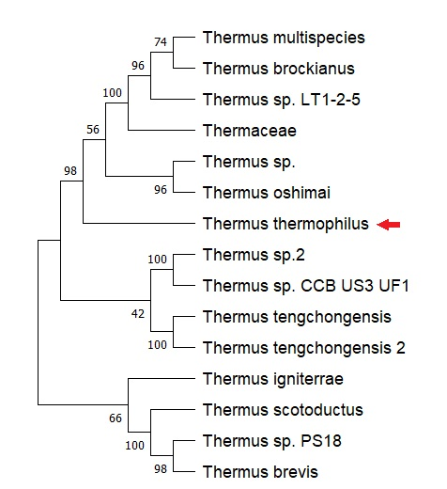
Supplementary information 1. Phylogenetic relationships of pulE homologues. Phylogenetic NJ tree compiled by average of 100 bootstrap values of the 14 Thermus genomes harboring homologues with>75% identity (BLASTp). T. thermophilus HB27 pulE sequence used as template is indicated with a red arrow. Values represent branch length.

SI2.
Supplementary information 2. Alphafold2 prediction protein 3D structures of the pilA5-pulE genetic cluster, combined with its subcellular location predicted by PSORT and CELLO servers (OM: outer membrane, P: periplasmic space, IM: inner membrane; C:cytoplasmic)..

SI3.
Supplementary information 3. Transcriptomic analysis of the pulE region in T. thermophilus HB27 strain. Genetic cluster of TT_C1844 (shadowed in light blue) shows 2 putative operons. Red arrows represent forward strand genes and blue arrows reverse strand genes. Green arrows relate to TSSof antisense and Rfam sRNA are represented with purple lines yellow arrows represent operons already annotated. Information retrieved from Cohen et al server (https://exploration.weizmann.ac.il/TCOL/viewer/index.php?meta=thermus)

SI4.
Transjugation frequencies of pilA5 mutants. Figure shows transjugation between a mutant lacking the narrow pili (ΔpilA5::kat) and the ΔtdtA::hyg strain that can only function as recipient in mating experiments. The gdh::kat strain was used as a wild type control donor. The DNA transfer efficiency is expressed as the number of conjugants per number of viable cells. (n=3)

