Appendices

Appendix 1: Location, category and number of participants
Mozambique
Location | Category of participant | Number
Gile | Caregiver researchers | 2
 | Caregivers | 9
 | Healthcare Workers responsible for EPI | 2
 | Community leadership | 2
 | District health officials | 4
Namarroi | Caregiver researchers
 | Caregivers | 3
 | Healthcare Workers responsible for EPI | 2
 | Community leadership | 4
 | District health officials | 4
Zambezia Province | Provincial health officials | 3
Malawi
Location | Category | Number
Lilongwe | Caregiver researchers | 1
 | Caregivers | 2
 | Health Surveillance Assistants | 4
 | Community leadership | 1
 | Community volunteers | 2
 | District health officials | 2
 | Drama group representative | 1
Mzimba North | Caregiver researchers | 1
 | Caregivers | 2
 | Health Surveillance Assistants | 4
 | Community leadership | 1
 | Community volunteers | 2
 | District health officials | 2
 | Drama group representative | 1
 | Mothercare Group representative | 2

Appendix 2: HCD feedback surveys
Summary of responses from the HCD feedback survey in Mozambique at the prototype workshop
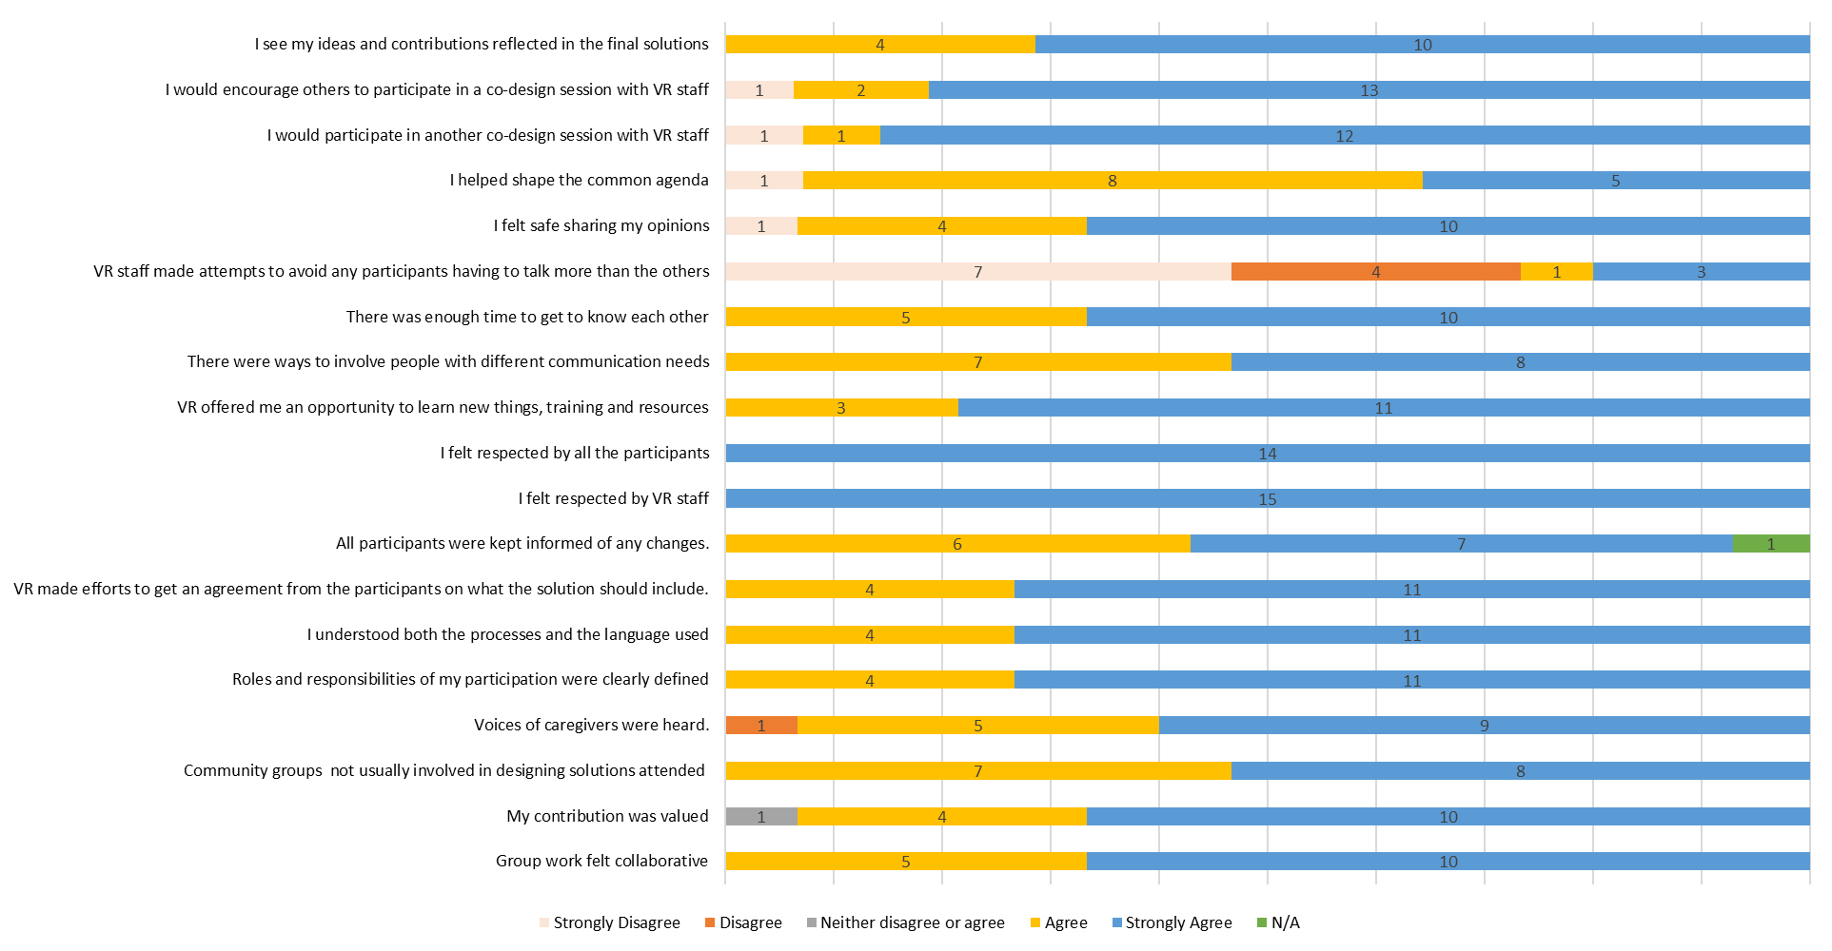

Summary of responses from the HCD feedback survey with Lilongwe participants at the HCD ideation workshop
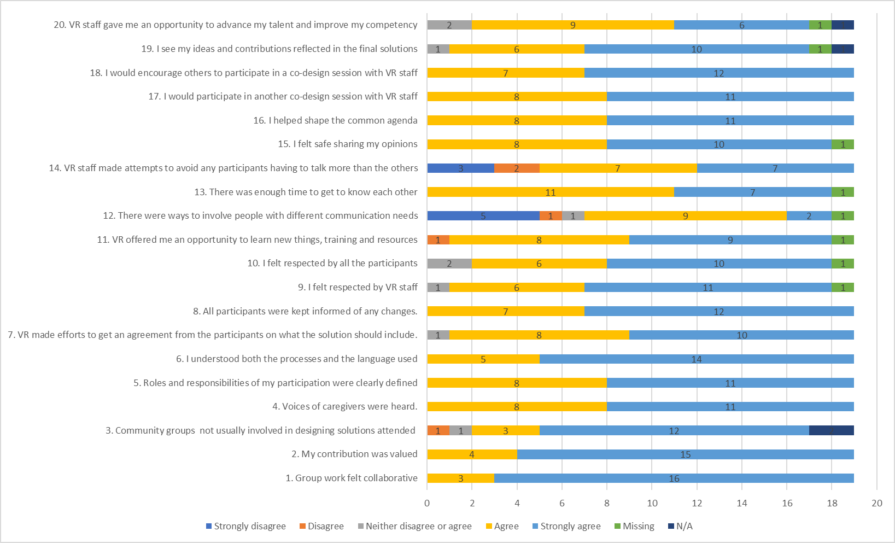
Summary responses of the HCD feedback survey in Mzimba North at the HCD ideation workshop
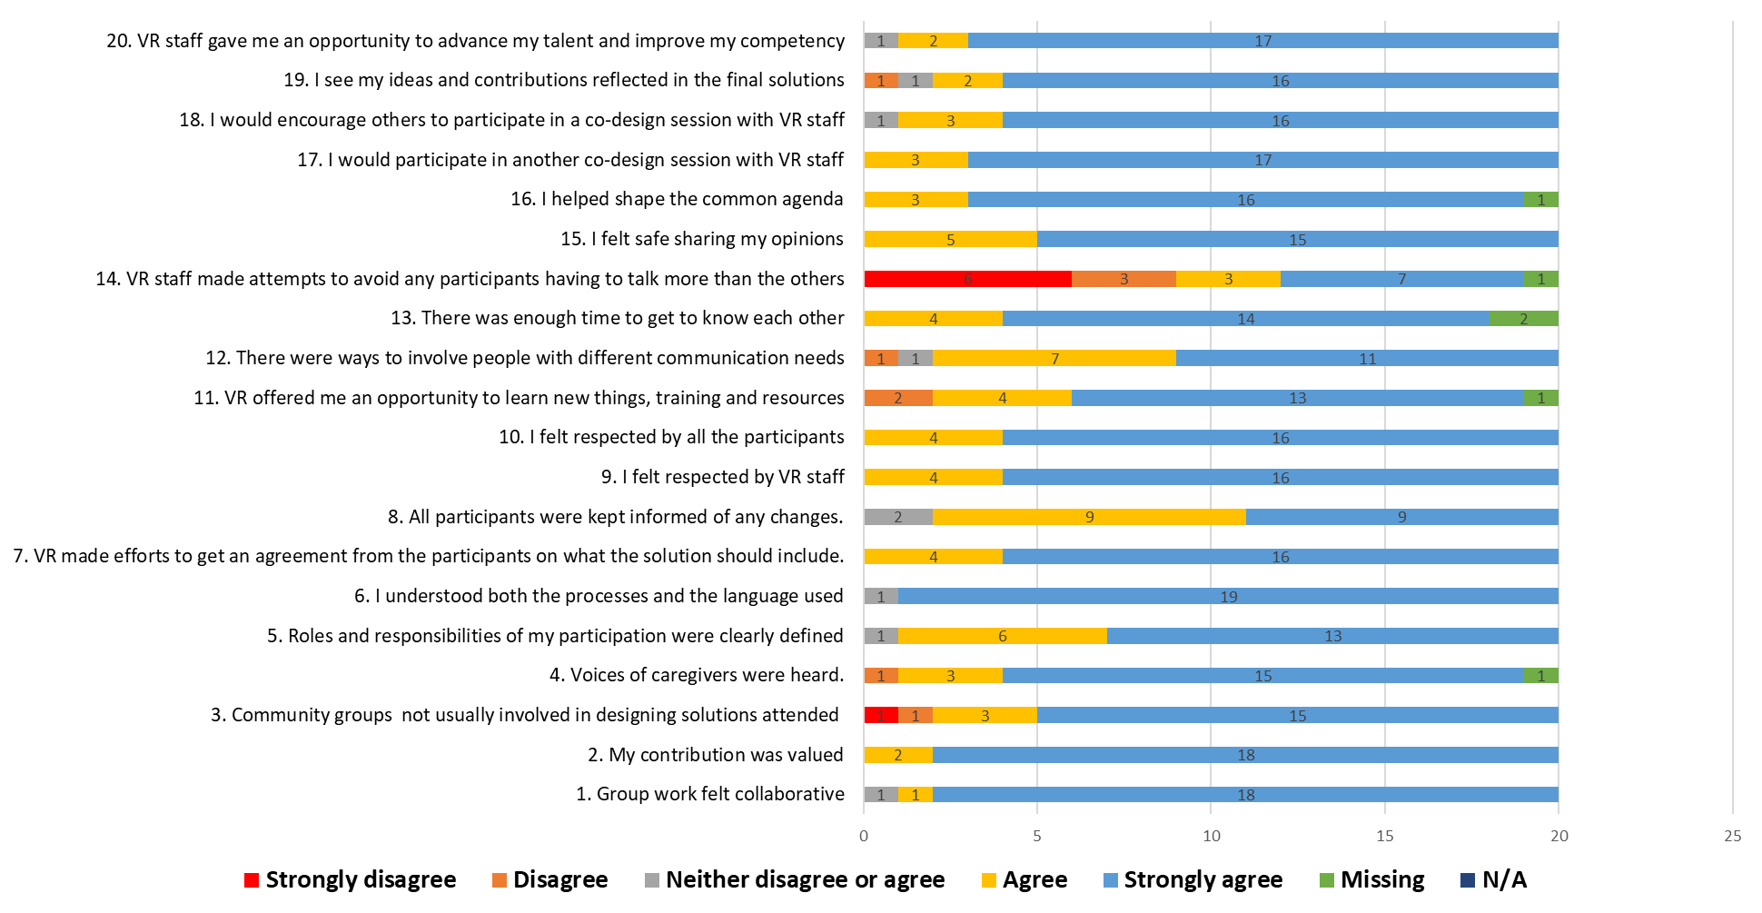

Appendix 3: Alignment to the core CBPR principles in Mozambique and Malawi
CBPR Principle | Degree met | VillageReach project and alignment
Recognizes community as a unit of identity | Substantial | The project established a shared sense of identity by fostering collaboration among caregivers, stakeholders in immunization, and those influencing immunization uptake to work together.  A detailed definition of community and setting (2 districts) established. VillageReach had a clearly defined population with the main target population as caregivers with children between 25 and 34 months and other intended users (health care workers) and stakeholders involved in childhood immunization programming (district and provincial health officials).
Builds on strengths and resources within the community. | Substantial | In Mozambique, the research was driven by the provincial, district and community structures and relied on community and resources to identify participants.  In Malawi, the research relied on community and health structures, employing tools like health register books, tally sheets, and collaboration with community volunteers, Health Surveillance Assistants, and community leaders to identify and track missing children and their caregivers.
Facilitates collaborative, equitable involvement of all partners in all phases of the research through an empowering and power sharing process that attends to social inequalities. | Substantial but limited in the initial start of the project | VillageReach created a diverse study team with complementary roles and included the intended target population/user as a caregiver researcher helped shape purpose and scope of the project to ensure more validity in the research approach and promote input/ buy-in of the findings among communities and provincial/district governments. Training and feedback processes on qualitative research and co-analysis were incorporated, promoting mutual learning. Virtual debriefs were frequently conducted, enhancing capacity building.  However, caregiver researchers were not initially involved in conceptualization, i.e., IRB protocol development and development of initial tools.
Promotes colearning and capacity building among all partners | Substantial | VillageReach created opportunities for exchange of knowledge, experience and training through orientation training, virtual data collection debrief sessions on the data collection, training on CBPR, caregiver researcher training and support, etc. The joint knowledge and experiences were applied sufficiently to the planning (joint development of proposal and tools) and implementation of the research project.  there was evidence of mutual knowledge transfer, with the study and HCD creating opportunities to understand context and barriers. This resulted in increased capacity among different stakeholders in research and under two immunization.
Integrate and achieve a balance between data generation and intervention for the mutual benefit of all partners. | Substantial | VillageReach satisfactorily used participatory tools (photovoice, telegram) to generate data and HCD methods to validate findings and generate community driven solutions based on the data and representative participants contributions.  A clear process was followed with all partners and caregivers, from data collection on barriers to solution generation and the commencement of implementing the solution components
Focus on the local relevance of public health problems and on ecological perspectives that attend to multiple determinants of health. | Substantial to a lesser extent | VillageReach used participatory data collection methods with caregiver and health care workers to identify relevant determinants of childhood immunization access and uptake in order understand drivers of under two routine immunization (RI) dropout from the perspectives of caregivers.  The approach notably tackled locally relevant barriers faced by caregivers but showed limitations in addressing the multiple determinants of low under two immunization access and uptake, primarily due to funding constraints.
Involve systems development in a cyclical and iterative process. | Substantial | VillageReach undertook to commit to a time intensive process to generate data through CBPR, presenting findings to participants, consultation with health officials, other relevant partners and health promotion expertise, a situational analysis and an iterative HCD process (ideation, prototype) to generate solutions.  The approach incorporated several steps to develop solutions, consult stakeholders on findings, and create tailored solutions.
Disseminate results to all partners and involve them in the wider dissemination of results; and | Substantial | VillageReach established a significant number of opportunities to present the findings of the study with the participants at the health facility level, district, and provincial health leadership, MISAU and met with other partners in the immunization space. VillageReach also facilitated co-authorship with those involved to ensure that their contributions are recognized through peer-reviewed authorship. The CBPR results were published in BMJ Open –  “Determinants of immunisation dropout among children under the age of 2 in Zambézia province, Mozambique: a community-based participatory research study using Photovoice)”.  Using community-based, participatory qualitative research to identify determinants of routine vaccination drop-out for children under 2 in Lilongwe and Mzimba North Districts, Malawi  Results were disseminated at various stages to all stakeholders.
Involve a long-term process and commitment to sustainability. | To a limited degree but with initial planning and consideration | VillageReach established a monitoring system of solution implementation; however, it is too early to determine sustainability aspects or securing grants to expand the program, but initial sustainability planning is underway.  Collaborative teams and mutual relations were established at various stages, suggesting potential continuity beyond the research project.

Appendix 4: Supporting quotations on adoption
CFIR Construct | Supporting Quotations
Intervention source | A health official and SHSA described how they identified barriers and interventions locally and the feasibility of the solutions:  “The study arrived in the district and we did the interviews, we brought the problems. Each district realized what the problems were and we created solutions, the district welcomed these solutions and now we are waiting for a change of scenery. Meanwhile, those basic solutions (low expensive) are being implemented at the local level.” Health official, Mozambique  “Yes, from the solutions we identified if they get implemented, they have the capacity to address the problems or reduce them.” Senior Health Surveillance Assistant, Malawi
Evidence strength and quality | Health officials, in both Malawi and Mozambique, reflected on the satisfaction with the alignment of results with community and stakeholders’ perspectives:  “These findings [CBPR study findings] were shared in a meeting [referring to HCD workshop] like we would organize a meeting where we shared. We also discussed about these things where they are saying because of lack of support, lack of male involvement let’s say … there were shared in a meeting.”  “… and the results were also satisfactory because after finishing the data collection, we had a workshop that involved the health facilities, the community leaders, and some participants. Because after we gather the information [immunization barriers] we have those preliminary results, ….” Health official, Mozambique
Relative advantage | In Mozambique a health official emphasized:  “The project had an important component of involving mothers and/or caregivers with children under 2 years old. Are the mothers who knew that they had children that they should vaccinate, because if it involved, for example, men OR women who did not have these children, at some point they might not understand in that period what that means, so this was a great advantage”. Health official Mozambique  Similarly, in Malawi, a senior health surveillance assistant underscored the benefits of the new approach in improving vaccination records and reducing instances of missing vaccinations:  “The method that was before, children were missing a lot, not knowing which vaccine the kid has received, …that’s why the new method…has helped us.” Senior Health Surveillance Assistant, Malawi
Complexity | A health official and health surveillance assistant noted:  “It’s not that much complicated… But in terms of moving on having it [solution components] being used I think it’s not that complicated but the start-up is what is giving out some complications we really need to agree on what it is that we are really going to disseminate”. Health official, Malawi  “The decisions that were made are relevant but they cannot end all the problems in our area. Like on the issue of shelter, it can help, but the issue of transport still remains a challenge when it comes to getting the vaccine from the health center to the outreach clinic. These decisions they have the possibility of reducing the challenges but not ending them. Health surveillance assistant, Malawi
Effective networks and communication | Participants emphasized the impact of these efforts:  “This Bate-Papo project, in fact, as the name says, helped positively in the reduction of absent children in health facilities, because after all these meetings, since they included all community leaders, religious leaders, APEs, traditional medicine practitioners, the Government itself, the district, the locality, they realized the consequences that can arise if the children does not finish the vaccine”. Health official Mozambique  “Now the specific teams we have established are drama groups, community volunteers, the ones that will assist to give messages to the villages normally is composed of caregivers because those caregivers are normally are doing well in immunization because they have to be role models to the community how do they see the important of immunization. So, we have these care givers that understands the concept of immunization and these are the ones that we give them the task to teach others in the community like PR.” Health official Malawi
In Mozambique, a healthcare worker described how the HCD process involved discussing difficulties and proposing interventions collectively:

“Normally we did HCD where we put the difficulties and the possible answers, the possible solutions. For example, in the case of long distances, we talked about the need for the family to help and not only that, we talked about mobile brigades and the need to associate the formation of these brigades with the involvement of the community (from the community leaders for mobilization). So, that was the consensus.” Health care worker, Mozambique

Similarly, in Malawi, a caregiver researcher emphasized the collaborative nature of decision-making, where participants worked in groups to identify and prioritize solutions:

“Yes, people were working in groups, then in those groups, they were agreeing, they would discuss, ok how best do you think this can be dealt, how then they had to come up with as this group this is what we have agreed and then they come up with three points in each group and then out of those the whole team called the, it’s what participants voted against who come at the top priorities.” Caregiver Researcher, Malawi
Implementation climate | In response to the question “So, where the solution is now, do you see that your contribution is evident in that solution?”; participants commented:  “I believe so, because at the beginning of the workshop, throughout and until now, when I see the points raised there, I see some points that I reported, for example, the issue of distance.” Healthcare worker, Mozambique  “…, one of the examples was to form the APEs, within the scope of REDREC, and it has already happened. Another is to form the APEs to carry out the mobilization and it is already happening. And besides that, there are the regular meetings that we are having with the Community Leaders in order to guarantee the mobilization ...My contributions were recognized,” Health official Mozambique  Additionally, a caregiver from Malawi highlighted the inclusive nature of the decision-making process, where everyone was given an opportunity to contribute:  "Everyone was given a chance and it was your choice not to speak but the opportunity was given to everyone.” Caregiver Malawi
A health official emphasized the potential for integration, stating:
“See, we cannot talk about integration without the mobilization and the Bate-Papo project is strong in the community mobilization component. Then it could be integrated there with more and more capacity building for the focal points, APEs, even the members of the health committees, thus entering into the vaccination program. Later it can be integrated into logistics.” Health Official Mozambique
External policies and incentives | In Mozambique, a health official noted the project's alignment with provincial objectives, particularly with regards to the Expanded Program on Immunization:  “The Bate-Papo project identifies with the health province objectives, especially with the EPI. And at the level of each districts, it is welcomed because it is perceived that the Bate-Papo helps the district to improve its indicators at the program level and reduce the number of children with zero dose and increase the coverage of fully vaccinated children." Health official Mozambique  Similarly, in Malawi, a health official highlighted the project's origins from within the community, indicating a sense of ownership and investment in its success:  So, for us, I feel like we cannot have much resistance because it is something which came from us and we looked into in some area, district, community behavior and some approaches which we can take up.” Health official Malawi

