Table S1. Frequency and type of received intervention for the 53 children in the Community Treatment group.
Children | Hours per week | Type of intervention
CT_1 | 0
CT_2 | 0
CT_3 | 0
CT_4 | 0
CT_5 | 0
CT_6 | 0
CT_7 | 0
CT_8 | 0
CT_9 | 0
CT_10 | 0
CT_11 | 0
CT_12 | 0
CT_13 | 0
CT_14 | 0
CT_15 | 0
CT_16 | 0
CT_17 | 0
CT_18 | 0
CT_19 | 0
CT_20 | 0
CT_21 | 0.5 | Speech Therapy
CT_22 | 0.5 | Occupational Therapy
CT_23 | 0.5 | Speech Therapy
CT_24 | 0.8 | Speech Therapy, Specialized Educator
CT_25 | 1 | Speech Therapy
CT_26 | 1 | Occupational Therapy
CT_27 | 1 | Specialized Educator
CT_28 | 1 | Occupational Therapy
CT_29 | 1 | Specialized Educator
CT_30 | 1 | Psychologist
CT_31 | 1.3 | Speech Therapy, Psychologist
CT_32 | 1.3 | Speech Therapy, Occupational Therapy
CT_33 | 1.5 | Speech Therapy, Psychologist
CT_34 | 1.5 | Occupational Therapy
CT_35 | 2 | Occupational Therapy, Speech Therapy, Specialized Educator
CT_36 | 2.5 | Occupational Therapy
CT_37 | 3 | Psychologist
CT_38 | 3 | Speech Therapy
CT_39 | 3 | Speech Therapy, Specialized Educator, Psychologist
CT_40 | 3 | Speech Therapy, Occupational Therapy
CT_41 | 3 | Specialized Educator
CT_42 | 3 | Speech Therapy, Specialized Educator
CT_43 | 3 | Occupational Therapy
CT_44 | 3 | Speech Therapy, Occupational Therapy
CT_45 | 3 | Speech Therapy, Specialized Educator
CT_46 | 3 | Occupational Therapy, Speech Therapy, Specialized Educator
CT_47 | 4 | Occupational Therapy, Specialized Educator, Psychologist
CT_48 | 4.2 | Occupational Therapy, Speech Therapy, Specialized Educator
CT_49 | 4.5 | Occupational Therapy, Speech Therapy, Specialized Educator, Psychologist
CT_50 | 4.5 | Occupational Therapy, Speech Therapy, Psychologist
CT_51 | 4.75 | Occupational Therapy, Specialized Educator
CT_52 | 10 | Speech Therapy, Specialized Educator
CT_53 | 11 | Occupational Therapy, Speech Therapy, Psychologist

Table S2. Sample characteristics with statistical comparison between the Community treatment and ESDM intervention groups at the follow-up assessment. MSEL: Mullen Scales of Early Learning (MSEL), DQ: Developmental Quotient. Note: unpaired parametric t-tests denoted with *) were conducted when the normality test was passed. Mann-Whitney t-tests were conducted aswhen the normality tests failed.
N = 109 | Community treatment |  | ESDM intervention |  | p
 | CT Low DQ | CT High DQ | ESDM Low DQ | ESDM High DQ
N  (Females) | 22 (5) | 21 (4) | 34 (6) | 32 (6) | >0.05
Age  M (range) | 3.21 (2.38-3.94) | 2.91 (1.94-3.82) | 3.13 (1.88-3.90) | 2.94 (1.78-3.60) | >0.05
Developmental quotient at follow-up  MSEL Total DQ | 50.40 (±14.40) | 97.46 (20.52) | 55.61 (±10.03) | 89.85 (±12.98) | <0.001

Table S3. Wilcoxon signed rank test for the 18 items of the questionnaire. Items are ranked by the effect size. The effect size was calculated by dividing the Z value by the square root of the N. The **** corresponds to p<0.0001.
 | Wilcoxon Signed Rank Test |  |  | Effect size
 | Z | N | p
Establishing rapport and communicating with your child | 9,984 | 130 | **** | 0,876
Understanding child needs | 9,968 | 130 | **** | 0,874
Autonomy | 9,798 | 130 | **** | 0,859
Attention | 9,655 | 130 | **** | 0,847
Social reciprocity with parents | 9,540 | 129 | **** | 0,840
Non-verbal communication | 9,538 | 130 | **** | 0.837
Verbal communication | 9,539 | 130 | **** | 0,837
Positive impact on mood, work, and social relationships | 9,531 | 130 | **** | 0,836
Interests | 9,468 | 129 | **** | 0,834
Eye contact | 9,430 | 130 | **** | 0,827
Handling tough times | 9,424 | 130 | **** | 0,827
Positive impact on family life | 9,426 | 130 | **** | 0,827
Time spent alone | 9,267 | 130 | **** | 0,813
Play | 8,845 | 130 | **** | 0,776
Perceptions of people surrounding the family | 8,645 | 127 | **** | 0,758
Social reciprocity with children | 8,020 | 130 | **** | 0,703
Preferred relationships | 7,762 | 127 | **** | 0,688
Repetitive behaviors | 7,247 | 127 | **** | 0,643

Table S4. Spearman correlations between the 18 questionnaire items and the rate of developmental change. P-values that survived False Discovery Rate are in bold.
 | Questionnaire item | r_{s} | p
1 | Perceptions of people surrounding the family | 0.006 | 0.436
2 | Positive impact on family life | 0.023 | 0.086
3 | Positive impact on mood, work, social relationships | 0.010 | 0.309
4 | Handling tough times | 0.070 | 0.005
5 | Establishing rapport and communicating with your child | 0.103 | <0.001
6 | Understanding child needs | 0.118 | <0.001
7 | Time spent alone | 0.023 | 0.114
8 | Eye contact | 0.003 | 0.591
9 | Preferred relationships | 0.076 | 0.004
10 | Social reciprocity with children | 0.039 | 0.040
11 | Social reciprocity with parents | 0.072 | 0.005
12 | Play | 0.187 | <0.001
13 | Interests | 0.066 | 0.007
14 | Repetitive behaviors | 0.008 | 0.363
15 | Non-verbal communication | 0.058 | 0.012
16 | Verbal communication | 0.289 | <0.001
17 | Autonomy | 0.066 | 0.007
18 | Attention | 0.062 | 0.009

Table S5. Results of Mann-Whitney U tests comparing CT and ESDM groups (N=130) on parental responses to the 18 items of the questionnaire. P-values that survived False Discovery Rate are in bold.
 | Questionnaire item | CT (median, N) | ESDM  (median, N) | U | P-value
1 | Perceptions of people surrounding the family | 1, 53 | 2, 74 | 1351 | 0.002
2 | Positive impact on family life | 1, 53 | 2, 77 | 1264 | <0.001
3 | Positive impact on mood, work, social relationships | 2, 53 | 2, 77 | 1656 | 0.042
4 | Handling tough times | 1, 53 | 2, 77 | 1696 | 0.087
5 | Establishing rapport and communicating with your child | 2, 53 | 2, 77 | 1703 | 0.089
6 | Understanding child needs | 2, 53 | 2, 77 | 1746 | 0.1423
7 | Time spent alone | 1, 53 | 2, 77 | 1437 | 0.002
8 | Eye contact | 1, 53 | 1, 77 | 1641 | 0.047
9 | Preferred relationships | 1, 53 | 1, 77 | 1758 | 0.300
10 | Social reciprocity with children | 1, 53 | 1, 77 | 1717 | 0.110
11 | Social reciprocity with parents | 2, 52 | 2, 77 | 1595 | 0.038
12 | Play | 1, 53 | 2, 77 | 1615 | 0.035
13 | Interests | 2, 52 | 2, 77 | 1688 | 0.105
14 | Repetitive behaviors | 1, 52 | 2, 75 | 1477 | 0.016
15 | Non-verbal communication | 2, 53 | 2, 77 | 1339 | <0.001
16 | Verbal communication | 2, 53 | 2, 77 | 1751 | 0.153
17 | Autonomy | 2, 53 | 2, 77 | 1973 | 0.727
18 | Attention | 2, 53 | 2, 77 | 1445 | 0.002

Table S6. Results of Mann-Whitney U tests comparing CT and ESDM groups (N=130) on parental responses to the 18 items of the questionnaire. Given that the ESDM group showed a significantly faster rate of developmental change compared to the CT group, responses to the questionnaire were regressed out for rate of developmental change between baseline and follow-up assessment. Note that the sample of 109 children was used to conduct this analysis as we excluded children without a developmental assessment. Mann-Whitney tests were computed using the new regressed values of the parental responses to the questionnaire. Significant items are highlighted in gray. P-values that survived False Discovery Rate are in bold.
 | Questionnaire item | CT | ESDM | U | P-value
1 | Perceptions of people surrounding the family | 1.000, 43 | 1.999, 64 | 956 | 0.007
2 | Positive impact on family life | 0.999, 43 | 1.999, 66 | 832 | <0.001
3 | Positive impact on mood, work, social relationships | 1.981, 43 | 1.999, 66 | 1091 | 0.042
4 | Handling tough times | 1.413, 43 | 1.974, 66 | 1094 | 0.044
5 | Establishing rapport and communicating with your child | 1.952, 43 | 2.154, 66 | 1154 | 0.101
6 | Understanding child needs | 1.949, 43 | 2.216, 66 | 1132 | 0.076
7 | Time spent alone | 1.014, 43 | 1.995, 66 | 923 | 0.002
8 | Eye contact | 1.986, 43 | 2.002, 66 | 1024 | 0.014
9 | Preferred relationships | 0.994, 43 | 1.081, 65 | 1139 | 0.106
10 | Social reciprocity with children | 1.057, 43 | 1.703, 66 | 1124 | 0.068
11 | Social reciprocity with parents | 1.811, 43 | 2.086, 66 | 1084 | 0.038
12 | Play | 1.065, 43 | 1.826, 66 | 984 | 0.007
13 | Interests | 1.810, 42 | 2.009, 65 | 1110 | 0.083
14 | Repetitive behaviors | 1.018, 42 | 1.995, 65 | 1057 | 0.050
15 | Non-verbal communication | 1.865, 43 | 2.070, 66 | 885 | <0.001
16 | Verbal communication | 1.814, 43 | 2.196, 66 | 1129 | 0.073
17 | Autonomy | 1.984, 43 | 2.049, 66 | 1330 | 0.585
18 | Attention | 1.949, 43 | 2.015, 66 | 999 | 0.009

 | Questionnaire item | CT_Low_DQ  (median, N) | CT_High_DQ  (median, N) | ESDM_Low_DQ  (median, N) | ESDM_High_DQ  (median, N) | CT_Low_DQ  vs.  ESDM_Low_DQ | CT_High_DQ  vs.  ESDM_High_DQ | CT_Low_DQ  vs.  CT_High_DQ | ESDM_Low_DQ  vs.  ESDM_High_DQ
1 | Perceptions of people surrounding the family | 1, 22 | 1, 21 | 2, 33 | 2.50, 31 | 0.039 | 0.051 | 0.999 | 0.681
2 | Positive impact on family life | 1, 22 | 1, 21 | 2, 34 | 2, 32 | 0.012 | 0.002 | 0.999 | 0.532
3 | Positive impact on mood, work, social relationships | 2, 22 | 2, 21 | 2, 34 | 2, 32 | 0.254 | 0.098 | 0.861 | 0.421
4 | Handling tough times | 1, 22 | 2, 21 | 2, 34 | 2, 32 | 0.031 | 0.775 | 0.072 | 0.658
5 | Establishing rapport and communicating with your child | 2, 22 | 2, 21 | 2, 34 | 2, 32 | 0.226 | 0.427 | 0.034 | 0.021
6 | Understanding child needs | 2, 22 | 2, 21 | 2, 34 | 2.50, 32 | 0.263 | 0.193 | 0.099 | 0.216
7 | Time spent alone | 1, 22 | 1, 21 | 2, 34 | 2, 32 | 0.056 | 0.017 | 0.728 | 0.580
8 | Eye contact | 2, 22 | 1, 21 | 2, 34 | 2, 32 | 0.287 | 0.024 | 0.068 | 0.179
9 | Preferred relationships | 1, 22 | 1, 21 | 1, 33 | 1.50, 32 | 0.807 | 0.150 | 0.797 | 0.065
10 | Social reciprocity with children | 1, 22 | 2, 21 | 1, 34 | 2, 32 | 0.155 | 0.363 | 0.152 | 0.163
11 | Social reciprocity with parents | 1, 22 | 2, 21 | 2, 34 | 2, 32 | 0.085 | 0.329 | 0.057 | 0.147
12 | Play | 1, 22 | 1, 21 | 2, 34 | 2, 32 | 0.080 | 0.041 | 0.083 | 0.017
13 | Interests | 1, 21 | 2, 21 | 2, 34 | 2, 32 | 0.143 | 0.409 | 0.141 | 0.279
14 | Repetitive behaviors | 1, 22 | 1, 20 | 2, 33 | 2, 32 | 0.286 | 0.069 | 0.813 | 0.585
15 | Non-verbal communication | 2, 22 | 2, 21 | 2, 34 | 2, 32 | 0.015 | 0.012 | 0.999 | 0.834
16 | Verbal communication | 1, 22 | 3, 21 | 2, 34 | 3, 32 | 0.043 | 0.501 | <0.001 | <0.001
17 | Autonomy | 2, 22 | 2, 21 | 2, 34 | 2, 32 | 0.782 | 0.577 | 0.132 | 0.015
18 | Attention | 2, 22 | 2, 21 | 2, 34 | 2, 32 | 0.340 | 0.010 | 0.954 | 0.084
Table S7. Results of Mann-Whitney U tests comparing the four subgroups based on type of intervention and DQ level at follow-up assessment, on the 18 items of the questionnaire. P-values that survived False Discovery Rate are underlined and in bold, those who did not survive are in bold only.

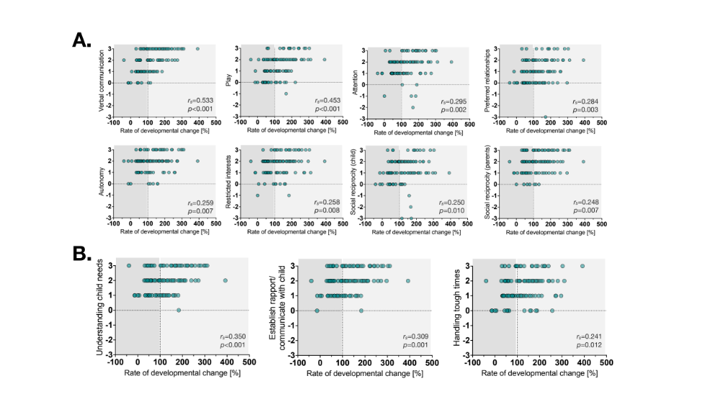
Figure S1. Spearman correlations between the questionnaire items (A. Areas of perceived change and B. Perceived self-efficacy and well-being) and the rate of developmental change. Only the p-values that survived False Discovery Rate are reported. The dotted line at 100 indicates the threshold for developmental gains (lighter gray section) or loss (darker gray section) measured by the MSEL.

Figure S2. Rate of developmental change (i.e., between the baseline and the follow-up assessment) measured by the MSEL for the CT and ESDM groups. The Mann-Whitney U test indicated that children in the ESDM group (Median = 145.60, N=66) show statistically higher gains than children in the CT group (Median = 106.40, N=43), U = 939, p = 0.003. The dotted line at 100 indicates the threshold for developmental gains (lighter gray section) or loss (darker gray section) measured by the MSEL. * p < 0.05; ** p < 0.01

