SUPPLEMENTARY MATERIAL
Table S1 Demographic Characteristics of Participants (n=312)
variable | overall (n=312) | n(%) or P50 (P25,P75) |  |  | P-value
variable | overall (n=312) | non-responder (n=5) | low responder (n=33) | active responder (n=274) | P-value
age | 18.77  (18.43, 19.01) | 18.77  (18.60, 18.84) | 18.77  (18.43, 19.10) | 18.77  (18.43, 19.01) | 0.889
HBsAb value before booster, mIU/ml |  |  |  |  | < 0.0001
< 1 | 115 (36.86) | 4 (80.00) | 26 (78.79) | 85 (31.02)
1 ~ 3 | 103 (33.01) | 1 (20.00) | 7 (21.21) | 95 (34.67)
> 3 | 94 (34.31) | 0 (0.00) | 0 (0.00) | 94 (34.31)
gender |  |  |  |  | 0.743
male | 102 (32.69) | 2 (40.00) | 9 (27.27) | 91 (33.21)
female | 210 (67.31) | 3 (60.00) | 24 (72.73) | 183 (66.79)
ethnicity |  |  |  |  | 0.609
Han | 305 (97.76) | 5 (100.00) | 33 (100.00) | 267 (97.45)
other | 7 ( 2.24) | 0 ( 0.00) | 0 ( 0.00) | 7 ( 2.55)
Note: HBsAb, hepatitis B antibody.
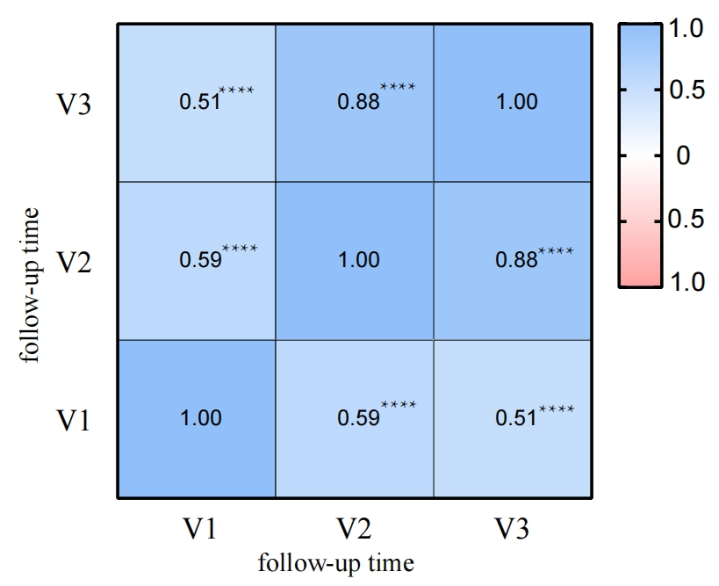
Figure S1 Correlation heatmap of antibody values
Note: ****: P < 0.0001; V1, V2 and V3 correspond to the detection of HBsAb values pre-vaccination and after the first and second doses of vaccination, respectively.Blue is the positive correlation while red is for negative correlation. Numbers on the matrix are the exact r value for each group.

