Antonie van Leeuwenhoek
Oryzicola mucosus gen. nov., sp. nov., a novel slime producing bacterium belonging to the family Phyllobacteriaceae isolated from the rhizosphere of rice plants
Geeta Chhetri, Jiyoun Kim, Inhyup Kim, Minchung Kang, Yoonseop So and Taegun Seo*

Department of Life Science, Dongguk University-Seoul, Goyang, 10326, South Korea

*Corresponding author:
Taegun Seo
Department of Life Science, Dongguk University-Seoul, Goyang, 10326, South Korea
Tel: +82-31-961-5135
Fax: +82-31-961-5348
E-mail: tseo@dongguk.edu

Footnote: The draft genome and 16S rRNA gene sequences of strain ROOL2^{T} have been deposited in GenBank/EMBL/DDBJ under accession numbers JACVVX000000000 and MN904860 respectively.
Fig. S1. Transmission electron microscopy of strain ROOL2^{T} negatively stained with phosphotungstic acid after growth for 4 days (a) and 7 days (b) at 30℃ on R2A agar. Bar 0.2μm and 0.5μm.
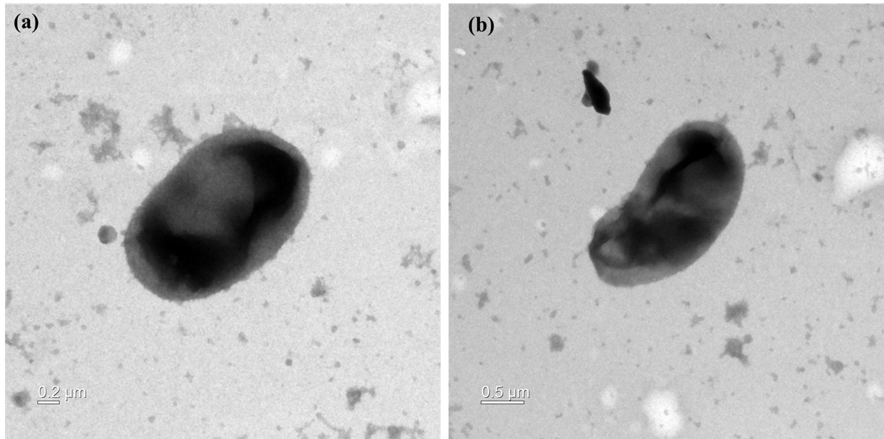

Table S1. Comparison of numbers of genes associated with functional categories in genomes of strain ROOL2^{T} and phylogenetically related species in the family Phyllobacteriaceae.
Strains: 1, ROOL2^{T}; 2, Tianweitania sediminis Z8^{T}; 3, Mesorhizobium tamadayense DSM 28320^{T}; 4, Aquamicrobium lusatiense DSM 11099^{T}.

Strains | 1 | 2 | 3 | 4
Cofactors, Vitamins, Prosthetic Groups, Pigments | 181 | 155 | 241 | 170
Cell Wall and Capsule | 31 | 26 | 12 | 13
Virulence, Disease and Defense | 37 | 53 | 62 | 39
Potassium metabolism | 7 | 9 | 10 | 7
Photosynthesis | - | - | - | -
Miscellaneous | 34 | 35 | 28 | 20
Phages, Prophages, Transposable elements, Plasmids | 19 | 33 | 23 | 33
Membrane Transport | 81 | 119 | 156 | 91
Iron acquisition and metabolism | 12 | 6 | 8 | 32
RNA Metabolism | 37 | 36 | 45 | 35
Nucleosides and Nucleotides | 113 | 77 | 118 | 85
Protein Metabolism | 189 | 179 | 201 | 181
Cell Division and Cell Cycle | - | - | - | -
Motility and Chemotaxis | - | 20 | 58 | 50
Regulation and Cell signaling | 26 | 21 | 68 | 22
Secondary Metabolism | 5 | 4 | 7 | 4
DNA Metabolism | 98 | 77 | 118 | 69
Fatty Acids, Lipids, and Isoprenoids | 136 | 168 | 85 | 98
Nitrogen Metabolism | 11 | 16 | 37 | 15
Dormancy and Sporulation | 1 | 1 | 1 | 1
Respiration | 114 | 118 | 166 | 101
Stress Response | 72 | 71 | 132 | 59
Metabolism of Aromatic Compounds | 42 | 33 | 77 | 33
Amino Acids and Derivatives | 388 | 295 | 462 | 314
Sulfur Metabolism | 26 | 6 | 23 | 8
Phosphorus Metabolism | 28 | 23 | 31 | 24
Carbohydrates | 307 | 250 | 400 | 279

Fig. S2. Maximum-likelihood tree based on 16S rRNA gene sequences showing the relationship between strain ROOL2^{T} and related species. Bootstrap values (based on 1000 replications) greater than 50% are shown at branch points. Flavobacterium aquatile LMG 4008^{T} (JRH01000003) was used as an out-group. Bar, 0.050 substitutions per nucleotide position.
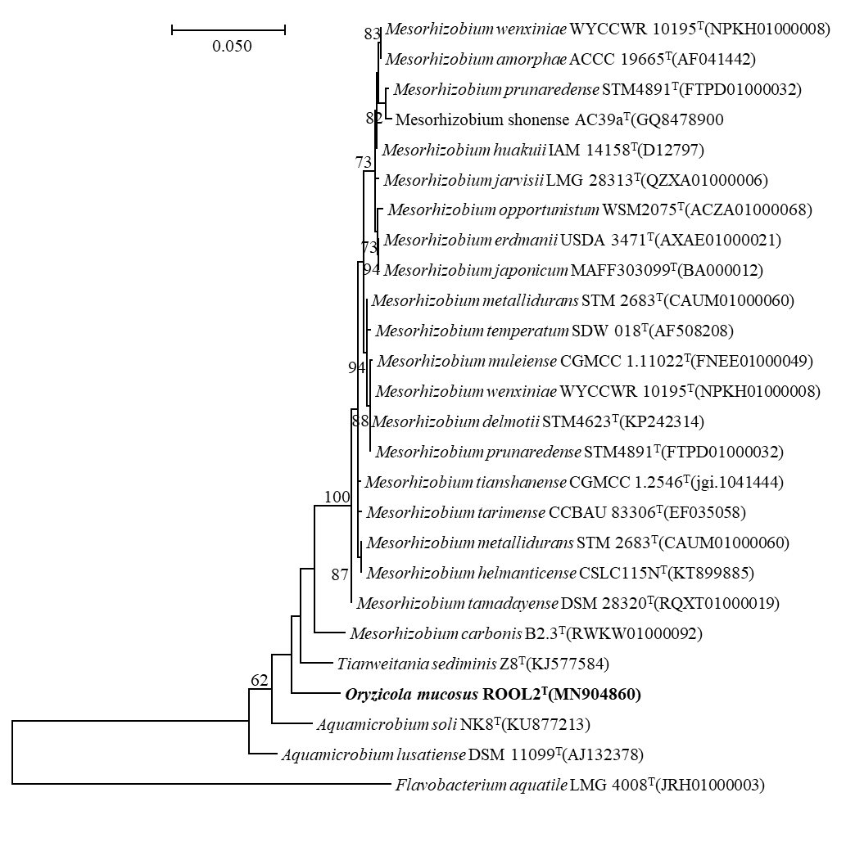

Fig. S3. Maximum parsimony tree based on 16S rRNA gene sequences showing the relationship between strain ROOL2^{T} and related species. Bootstrap values (based on 1000 replications) greater than 50% are shown at branch points. Flavobacterium aquatile LMG 4008^{T} (JRH01000003) was used as an out-group. Bar, 50 substitutions per nucleotide position.
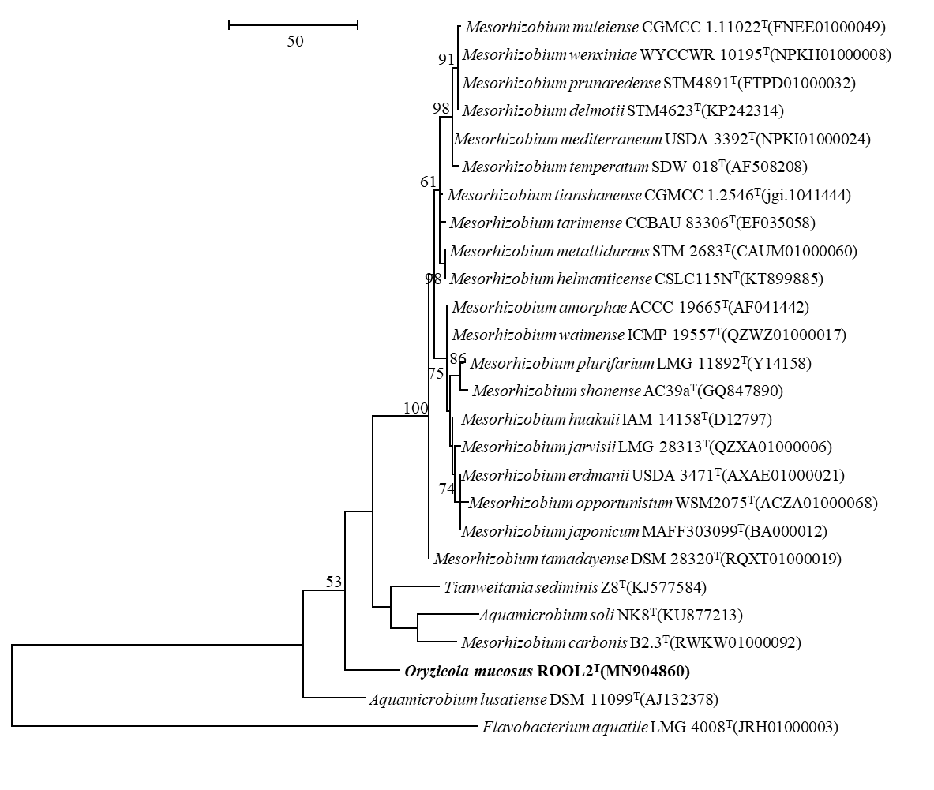

Fig. S4. Phylogenomic tree of strain ROOL2^{T} and closely related strains based on core genomes was constructed using UBCG, all genomes of 17 related strains were available on NCBI GenBank. GenBank accession numbers are shown in parentheses. Bootstrap analysis was carried out using 100 replications. Percentage bootstrap values (>50%) are given at branching points. Bar, 0.020 substitution per position.

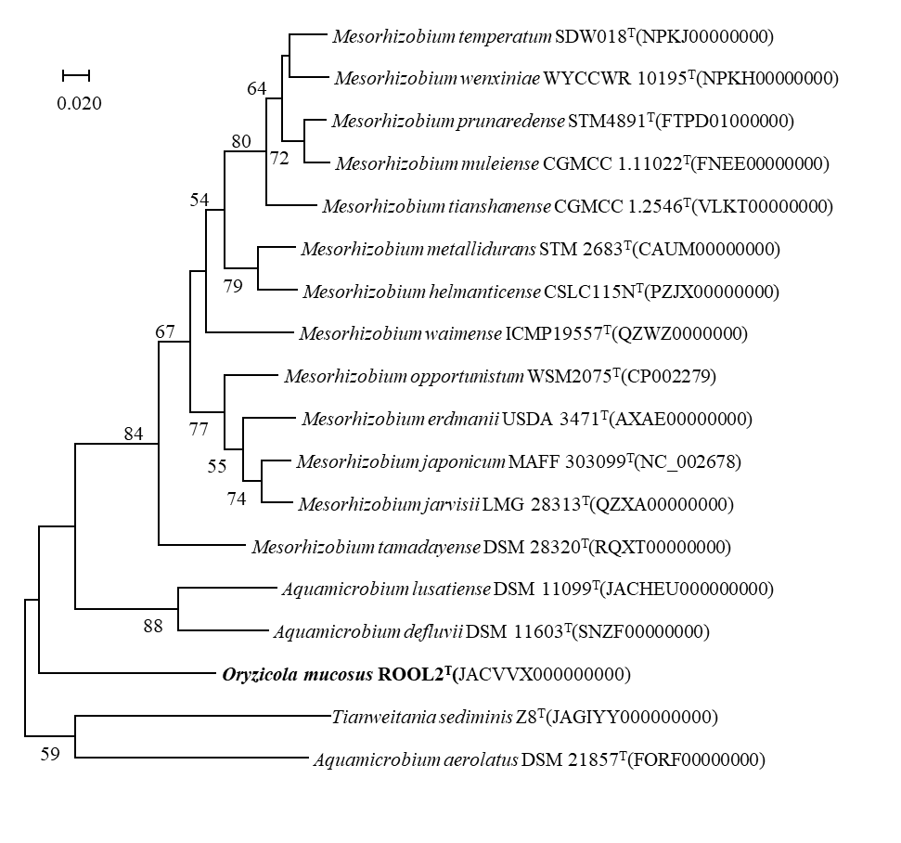

Fig. S5. Two-dimensional thin-layer chromatogram of the polar lipids from strain KVB23^{T} detected with reagents: 5% molybdophosphoric acid (a), molybdenum blue spray reagent (b), ninhydrin reagent (c), and a-napthol reagent (d). Abbreviations: DPG, diphosphatidylglycerol; PE, phosphatidylethanolamine; PC, phosphatidylcholine; PME, phosphatidylmonomethylethanolamine; PG, phosphatidylglycerol; PL, unidentified phospholipid; AL, unidentified aminolipid and L1-L2, unidentified lipids.

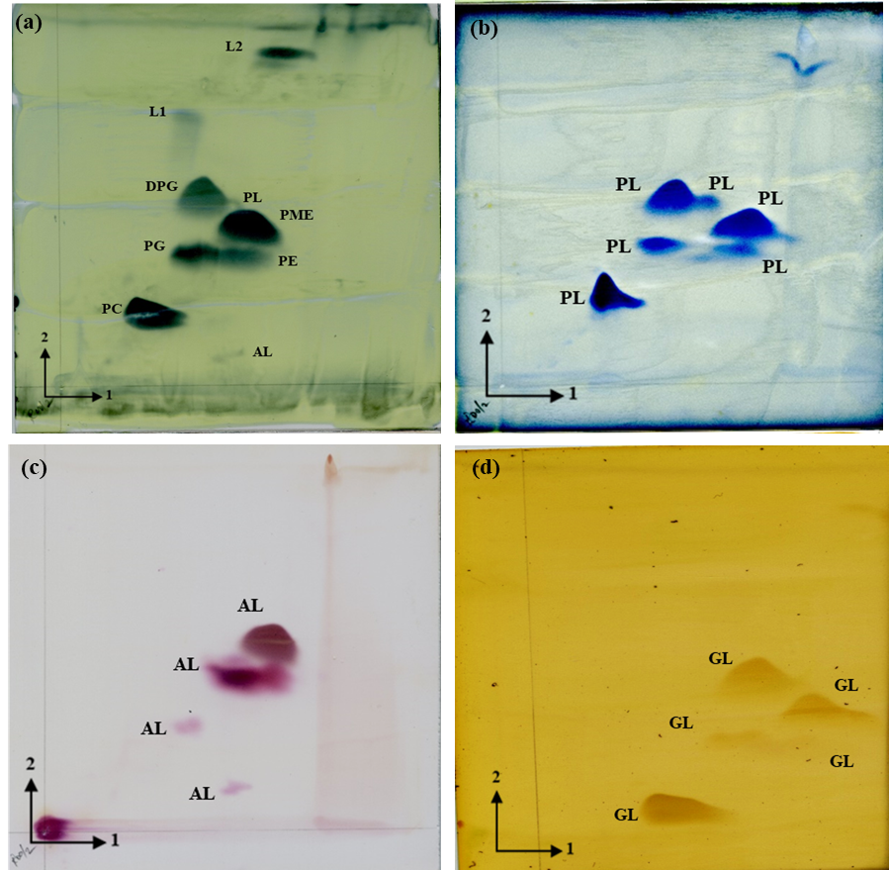

Fig. S6. Salkowski test for indole-3-acetic acid (IAA) produce by strain ROOL2^{T}. (a); bacterial supernatant without Salkowski’s reagent, (b); bacterial supernatant with Salkowski’s reagent (In the absence of tryptophan), (c); bacterial supernatant with Salkowski’s reagent (In the presence of tryptophan).

