Supplementary information

Autodisplay made easy: a plasmid toolbox for the surface display of recombinant proteins and its optimization.

Philip Röhe, Christoph Furtmann, Florian Lenz and Joachim Jose
University of Münster, Institute for Pharmaceutical & Medicinal Chemistry, PharmaCampus, Münster, Germany

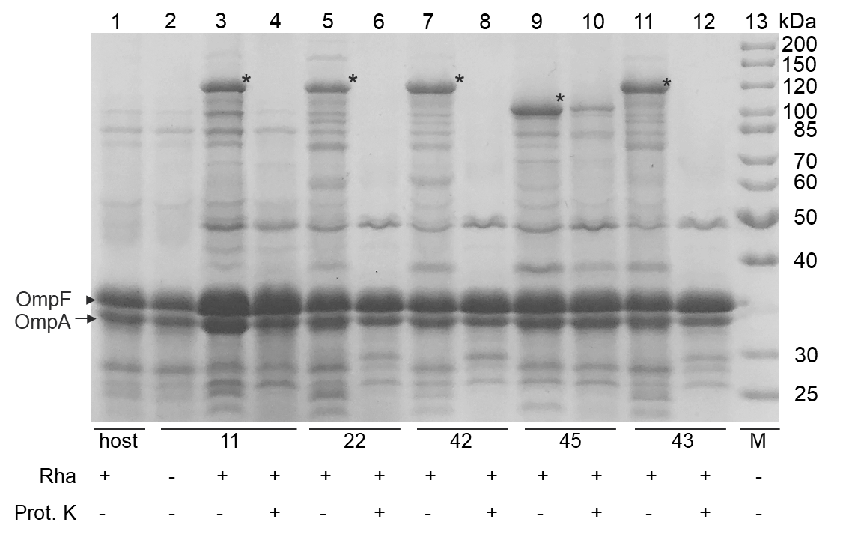
Supplementary Fig. 1: Analysis of β-Gluc surface display level. Membrane protein isolations (MPI) of E. coli UT5600 host cells (lane 1) and E. coli pATB-β-Gluc variants 11 (reference), 22, 42, 45, 43 (lane 2 – 12) were analysed via SDS PAGE followed by Coomassie Brilliant Blue staining. The samples encompassed cells cultivated in 200 mL LB medium (1 L shake flask scale) with (lanes 1 & 3 -12) or without (lane 2) addition of 2 mM rhamnose (final concentration, Rha) as inductor at cell suspension OD_{578nm} 0.5. Prior to the MPI, one fraction of cells per variant was subjected to proteinase K (Prot. K) digest (lane 4, 6, 8, 10, 12), to approve surface accessibility of β-Gluc. Since Prot. K cannot penetrate the outer membrane of intact cells, protein digest is limited to proteins presented on the surface. Bands corresponding to the endogenous outer membrane protein OmpA (35 kDa) were unaffected and none additional bands corresponding to digested OmpA occurred in these samples. OmpA encompasses a C-terminal, periplasmatic domain that can be proteolytically digested, if Prot. K has access to the periplasm. Unaffected OmpA indicated intact cell membranes. Asterisks: supposed AT-FP bands. M: protein marker.
Supplementary Tab. 1: Densitometric analysis of the SDS PAGE (Supplementary Fig. 1) for the separation of outer membrane fractions of E. coli pATB-β-Gluc variants 11, 22, 42, 43, 45 and E. coli UT5600 host cells.
1. Using the sorftware ImageJ, intensities were determined for the bands of supposed autotransporter fusion proteins (AT-FP) and OmpA of each lane of the SDS gel (C6-G6 & C7-G7).
2. The higher molecular weight (MW) of AT-FP compared to OmpA was taken into account (C8-G8).
3. OmpA served as internal standard with an assumed number of 10⁵ molecules per cell³ (B11).
4. Using the estimated number of OmpA molecules per cell (B11), the ratio of AT-FP & OmpA bandintensities (C8-G8) and the ratio of AT-FP & OmpA MWs (C10-G10), the β-Gluc molecules per cell for each variant were calculated (C11-G11).
5. The relative differences of β-Gluc molecules per cell compared to the reference 11 were calculated for each variant (C12-G12).
 | A | B | C | D | E | F | G
1 | Lane |  | 3 | 5 | 7 | 9 | 11
2 | Variant |  | 11 | 22 | 42 | 45 | 43
3 | Reference for enzyme count | OmpA
4 | Molecular weight (MW) (in kDA) | 35,18 | 111.95 | 110.84 | 111.66 | 97.2 | 112.62
5 | Determination of intensities from SDS gel
6 | Bandintensity of supposed AT-FP |  | 8,919,447 | 6,870,012 | 8,404,790 | 10,144,518 | 9,066,962
7 | Bandintensity of OmpA |  | 19,508,912 | 16,843,255 | 14,527,376 | 13,402,305 | 14,936,426
8 | Ratio AT-FP & OmpA bandintensities |  | 0.457 | 0.408 | 0.579 | 0.757 | 0.607
9 | Determination of molecules per cell
10 | Ratio AT-FP & OmpA MWs |  | 3.182 | 3.151 | 3.174 | 2.763 | 3.201
11 | β-Gluc molecules per cell | 100000 | 14,367 | 12,946 | 18,228 | 27,396 | 18,963
12 | Relative differences compared to reference 11 |  | 100% | 90% | 127% | 191% | 132%

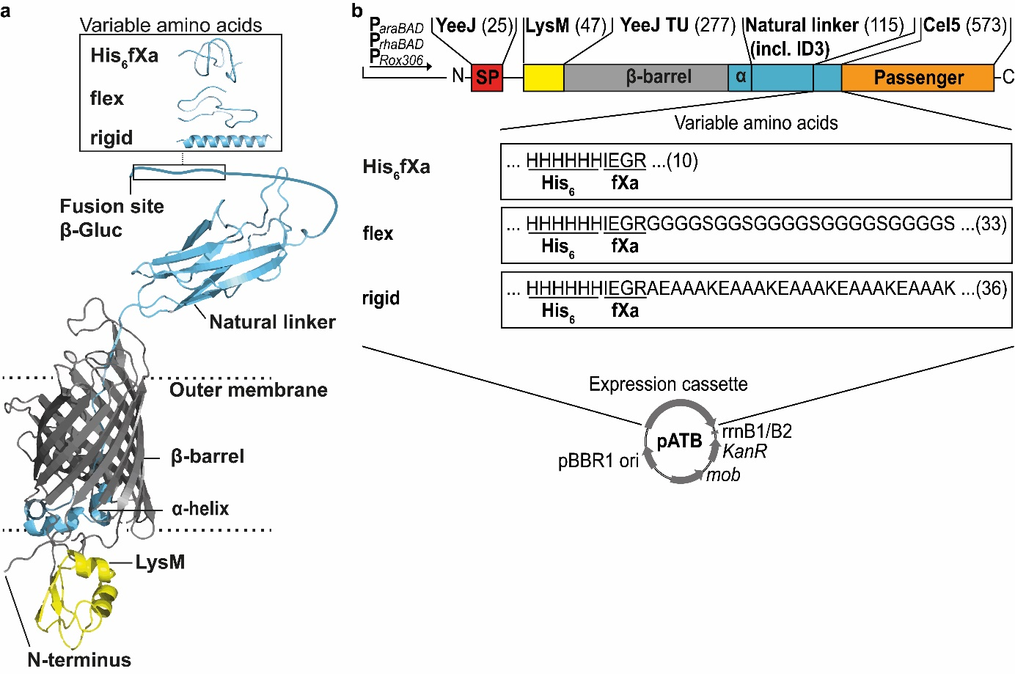
Supplementary Fig. 2: ATB fusion protein variants with inverse composition. a, The secondary structures of the lysin motif (LysM), the YeeJ translocation unit (YeeJ TU) and the natural linker were modeled with RaptorX¹ and the variable amino acids in the linker with PEP-FOLD3². b, Inverse autotransporter fusion proteins (AT-FP) contained N-terminal a YeeJ signal peptide (SP), LysM, the YeeJ TU, a linker (light blue) encompassing a natural linker with invasion domain 3 (ID3) and variable amino acids including a 6x His-epitope and fXa cleavage site (His₆fXa) or His₆fXa and G₄S-G₂S-(G₄S)₃ (flex) or His₆fXa and A(EAAAK)₅ (rigid). The number of the amino acids of the corresponding part of the AT-FP is given in brackets. All AT-FP variants are encoded by plasmids of the ATB (pATB). Combined with the three promoters (P_{araBAD}, P_{rhaBAD}, P_{Rox308}), this resulted in 9 different plasmids encoding the respective variants (pATB_x51 – pATB_x53) and led to a final amount of 81 pATB.
Supplementary Tab. 3: Sequences of oligonucleotides. pATBs denoted according to Tab. 1 (Plasmids of the Autodisplay-Toolbox)
Notation | Purpose | Nucleotide sequence (5` 3`)
774 (fw) | Construction of pATB_121-cel5 | CTCATCTCAGAAGAGGATCTGCTGACCAACAATGGCACG
770 (rv) | Construction of pATB_121-cel5 | CTCTTCTGAGATGAGTTTTTGTTCTTTAAAGTATTCCGGGATGCG
3289 (fw) | Construction of pATB_131-cel5, pATB_141-cel5, pATB_231-cel5, pATB_241-cel5, pATB_331-cel5, pATB_341-cel5 | CACCACCATCACCATCATATCGAAGGTCGT
3290 (fw) | Construction of pATB_131-cel5 & PATB_141-cel5 | GGCGGCGGTGACGACAACGCCGCGCCCGCCCACCACCATCACCAT
568 (fw) | Construction of pATB_211-cel5 | ATGATCAAACTGAAATTCGGCGTCTTCTTC
984 (rv) | Construction of pATB_211-cel5 | CGAGGCGGCTACAGCCGATAGTCTG
931 (fw) | Construction of pATB_211-cel5,  pATB_221-cel5 pATB_251-cel5, pATB_252-cel5, pATB_253-cel5, | GCTGTAGCCGCCTCGACATGTTCTTTCCTGCGTTA
534 (rv) | Construction of pATB_211-cel5 | TTTCAGTTTGATCATATGTATATCTCCTTCTTAAGAATTGTTCAT
3291 (fw) | Construction of pATB_212-cel5 | GGTGGAGGAGGTAGCGGCGGTTCAGGAGGTGGTGGATCCGGCGGTGGCGGTTCTGGTGGAGGTGGATCTCTGACCAACAATGGCACGC
3292 (rv) | Construction of pATB_212-cel5 | GCTACCTCCTCCACCGGTACCTTTCTGACC
2858 (fw) | Construction of pATB_213-cel5 | GAGGCGGCAGCAAAGCTGACCAACAATGGCACGC
2857 (rv) | Construction of pATB_213-cel5 | CTTTGCTGCCGCCTCTTTAGCGGCGGCTTCCTTCGCTGCAGCCTCTTTCGCGGCCGCTTCTTTGGCTGCCGCTTCCGCGGTACCTTTCTGACCTTTGG
878 (fw) | Construction of pATB_214-cel5 | CTGACCAACAATGGCACGC
879 (rv) | Construction of pATB_214-cel5 | GCCATTGTTGGTCAGGGTACCTTTCTGACCTTTGGTGATTTTGAACCAG
883 (fw) | Construction of pATB_215-cel5 | GGCCCGGAGCCTGATCCG
880 (rv) | Construction of pATB_215-cel5 | ATCAGGCTCCGGGCCGGTACCTTTCTGACCTTTGGTGATTTTGAACCAG
814 (fw) | Construction of pATB_216-cel5 | CCGACTCCGGGTCCGGACT
882 (rv) | Construction of pATB_216-cel5 | CGGACCCGGAGTCGGGGTACCTTTCTGACCTTTGGTGATTTTGAACCAG
1584 (fw) | Construction of pATB_221-cel5 | GAAGGAGATATACATATGAAACTGAAAAACACCTTGG
984 (rv) | Construction of pATB_221-cel5 | CGAGGCGGCTACAGCCGATAGTCTG
1568 (rv) | Construction of pATB_221-cel5 | ATGTATATCTCCTTCTTAAGAATTGTTCATTACG
3289 (fw) | Construction of pATB_331-cel5, pATB_341-cel5 | CACCACCATCACCATCATATCGAAGGTCGT
3290 (rv) | Construction of pATB_331-cel5, pATB_341-cel5 | GGCGGCGGTGACGACAACGCCGCGCCCGCCCACCACCATCACCAT
841 (fw) | Verification of pATBs with P_{araBAD} via colony PCR | GCGTCACACTTTGCTATGCC

565 (rv) | Verification of pATBs encoding epitope linker via colony PCR | TTTAAAGTATTCCGGGATGCGGCCCTC
2071 (rv) | Construction pATB_152-cel5, Verification of pATBs encoding flex linker via colony PCR | AGATCCACCTCCACCAGAAC
1075 (rv) | Verification of pATBs encoding ∆epitope linker via colony PCR | GCCCTTAACAACCAGAACGTTACCC
349 (rv) | Verification of pATBs encoding ∆epitope∆β1 & ∆epitope∆β1∆CR via colony PCR | CGCCTTTCACCGTATTATCG
2912 (rv) | Verification of pATBs encoding rigid linker via colony PCR | CTTTGCTGCCGCCTCTTTAG
1863 (fw) | Verification of pATBs with P_{rhaBAD} via colony PCR | GCATGCATCGATCACCACAA
1091 (rv) | Verification of pATBs with P_{rox306} via colony PCR | CGCACCCTGCCAGCCAGAC
3676 (fw) | Construction of pATB_152-CsbglA | GGTGGAGGTGGATCTCTCGAGAGCTTTCCGAAAG
3572 (rev) | Construction of pATB_152-CsbglA | GCTACCTCCTCCACCACGACCTTCGATATGATGGTGATG
1230 (fw) | Construction of pATB_152-CsbglA | GGTGGAGGAGGTAGCGGC
2071 (rev) | Construction of pATB_152-CsbglA | AGATCCACCTCCACCAGAAC
1815 (fw) | Construction of pATB_153-CsbglA | CTCGAGAGCTTTCCGAAAG
2532 (rev) | Construction of pATB_153-CsbglA | ACGACCTTCGATATGATGGTGATG
2537 (fw) | Construction of pATB_153-CsbglA | CATATCGAAGGTCGTGCGGAAGCGGCAGCC
3573 (rev) | Construction of pATB_153-CsbglA | CGGAAAGCTCTCGAGCTTTGCTGCCGCCTCTTTAG
3569 (fw) | Construction of pATB_251-CsbglA, pATB_252-CsbglA, pATB_253-CsbglA | GAAGGAGATATACATATGGGAATTAAACTACGCCGCTTAACTG
3570 (rev) | Construction of pATB_251-CsbglA, pATB_252-CsbglA, pATB_253-CsbglA, pATB_351-CsbglA, pATB_352-CsbglA, pATB_353-CsbglA | CGAGGCGGCTACAGCCG
932 (fw) | Construction of pATB_351-CsbglA, pATB_352-CsbglA, pATB_353-CsbglA | GCTGTAGCCGCCTCGGCCTCCTTTCGTGTTTCGCAGC
3544 (rev) | Construction of pATB_251-CsbglA, pATB_252-CsbglA, pATB_253-CsbglA | ATGTATATCTCCTTCTTAAGAATTGTTC

2531 (fw) | Construction of pATB_351-CsbglA, pATB_352-CsbglA, pATB_353-CsbglA | CCTGAGAGGTCGGTCATGGGAATTAAACTACGCCGC
915 (rev) | Construction of pATB_351-CsbglA, pATB_352-CsbglA, pATB_353-CsbglA | GACCGACCTCTCAGGTTTTTTATTGGAAG

References

1. Källberg, M. et al. Template-based protein structure modeling using the RaptorX web server. Nat. Protoc. 7, 1511-1522 (2012).
2. Lamiable, A. et al. PEP-FOLD3: faster de novo structure prediction for linear peptides in solution and in complex. Nucleic acids res. 44, W449-W454 (2016).
3. Koebnik, R., Locher, K.P. & Van Gelder, P. Structure and function of bacterial outer membrane proteins: Barrels in a nutshell. Mol. Microbiol. 37, 239-253 (2000).

