Design and in silico assessment of quinoxaline platinum complexes as ATPase competitive topoisomerase inhibitors.

Daniel W.M Pincher^{1*}, Shane M. Hickey¹, Sally E. Plush^{1*}

¹ Clinical and Health Sciences, University of South Australia, Adelaide, Australia
*Corresponding authors
Daniel.pincher@unisa.edu.au
Sally.plush@unisa.edu.au

Table of Contents Page

Figure S1: The calculated location of AMPPNP in the TOP2 ATPase domain 3
Figure S2: (6,6''-bis(2-(Piperidin-1-yl)ethoxy)-2,2':6',2''-terpyridine)chloro-platinum(II), 17, with reported and calculated orientation in minor groove of DNA 4
Figure S3: Region I and region II of the TOP2 ATPase domain. 5
Figure S4: The obverse side of region I (left) and region II (right) of the TOP2 ATPase domain. 6
Figure S5: The location of 11, within the TOP2 ATPase domain. 7
Figure S6: Average binding energy of EDA-quin complexes incorporating different amino acids. 8
Figure S7: Average binding energy of EDA-quin complexes incorporating different secondary ligands. 9
Figure S8. Location of the ligand 23 and ATP in the TOP2 ATPase domain. 10
Figure S9. Location of the isopropylamino ligand 28 and ATP in the TOP2 ATPase domain. 11
Figure S10. Location of the dodecylamino ligand 38 and ATP in the TOP2 ATPase domain. 12
Figure S11. Location of the benzylamino ligand 33 and ATP in the TOP2 ATPase domain. 13
Figure S12. The location of 30 and 35 in the TOP2 ATPase domain. 14
Figure S13. A comparison showing the similarity in binding pose
between the complexes 35 and 36. 15
Figure S14: Average binding energies of aminoethylamide complexes incorporating different quinoxaline functionalisations. 15
Figure S15: The location of the diamino platinum complex 25 in the TOP2 ATPase domain. 16
Figure S16: The location of the 1,10-phenanthroline platinum complex 27 in the TOP2 ATPase domain. 16
Figure S17: The location of the ethylenediamine platinum complex 39 and the diaminobenzene platinum complex 40 in the TOP2 ATPase domain. 17
Figure S18: The location of the 2,2ʹ-bipyridine platinum complex 41 and the 1,10-phenanthroline platinum complex 42 in the TOP2 ATPase domain. 17
References 18

Modelling software validation
To validate the docking software and parameters, control simulations of a range of compounds reported in the literature were performed and the resultant binding poses and binding energies were compared to the reported results. Calculated binding energies within 2 kcal/mol were considered to compare favourably to literature results as a value of ±2 kcal/mol is reported as the typical error of molecular modelling calculations [1,2]. A docking simulation of adenylyl-imidodiphosphate (AMPPNP), an unhydrolysable analogue of ATP, with the TOP2 ATPase domain compared favourably to that recorded in the crystal structure of TOP2 (Figure S1). The simulation gave a binding energy of −14.3 kcal/mol, which compared favourably to a previous validating simulation found within literature which gave a binding energy of −13.8 kcal/mol, despite using different modelling software [3].
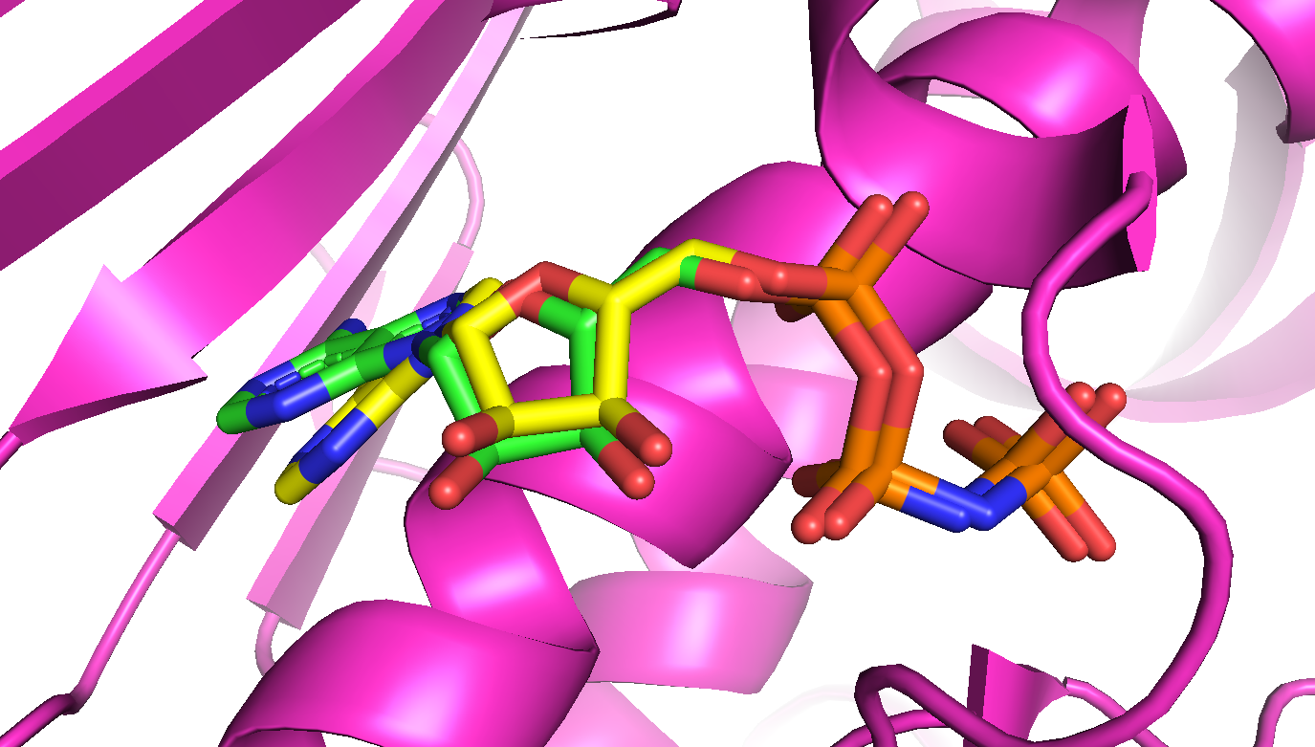
Figure S1: The calculated location of AMPPNP in the TOP2 ATPase domain (magenta) from literature orientation of PDB crystal structure (green) and calculated orientation from molecular modelling of this project (yellow).
To further validate the software and parameters, docking simulations of metal ion complexes reported in the literature were also performed. A (terpyridine)platinum(II) complex reported by Suntharalingam et al. (S1, Figure S2), was found to locate within the minor groove of DNA (PDB ID:1BNA) with a calculated binding energy of −12.18 kcal/mol, which compared favourably with the reported value of −10.83 kcal/mol, and bound to a similar position within the minor groove of DNA as that reported in the literature [4].
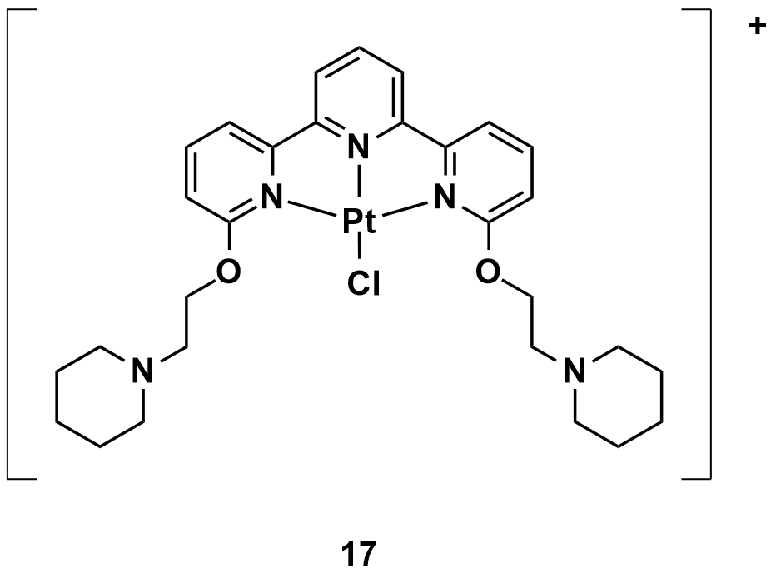
S1
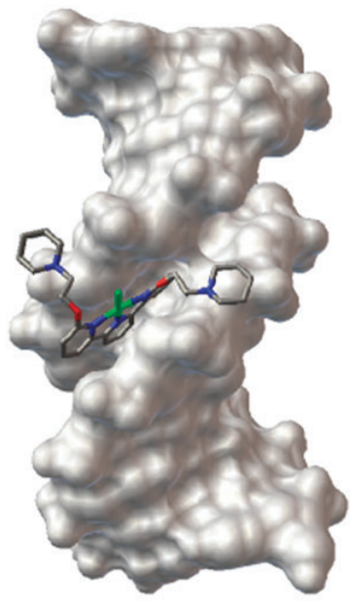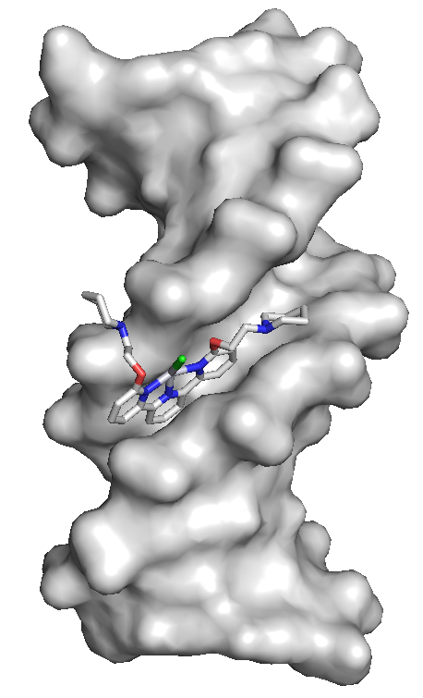
Figure S2: (6,6''-bis(2-(Piperidin-1-yl)ethoxy)-2,2':6',2''-terpyridine)chloro-platinum(II), S1, its reported orientation in minor groove of DNA (PDB ID: 1BNA) from literature (left), calculated orientation in minor groove of same DNA from molecular modelling of this project (right).

TOP2 ATPase domain regions
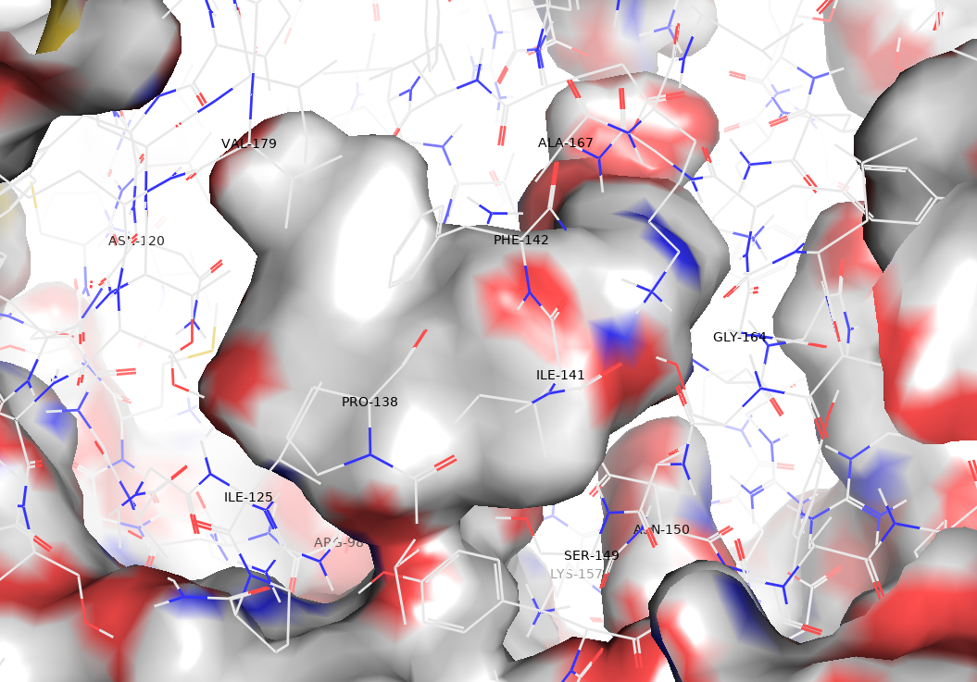
I
I
II
Figure S3: Region I, in which the aromatic structures of ATP and XK469 locate, shown to the left of this image, while region II, in which the hydrophilic tails of XK469 and ATP locate, shown to the right. In region I, a large hydrophobic area is shown by grey colouration due to the alkyl and aryl R groups of Phe142, Ile141 and Pro138. In region II, red and blue colouration of the protein surface shows the proximity of oxygen and nitrogen atoms.

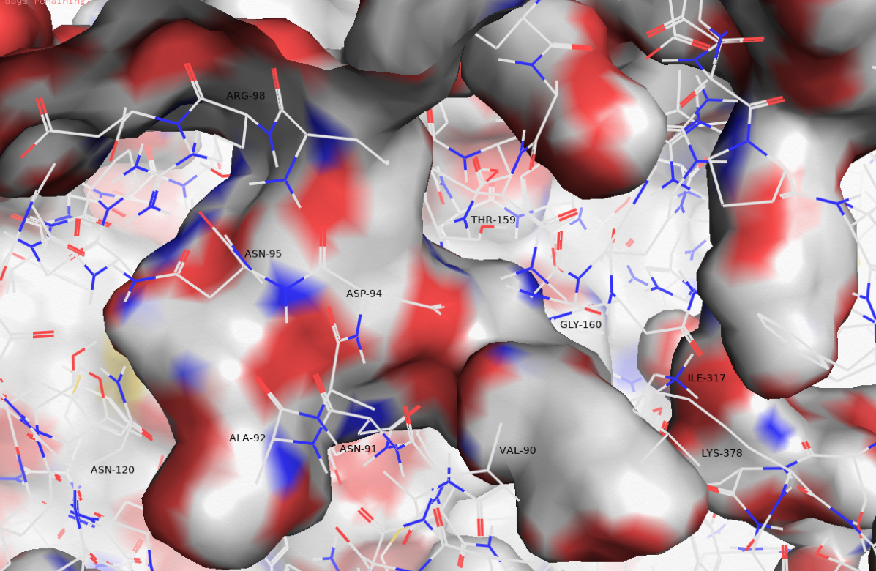
II
I
Figure S4: The obverse side of region I (left) and region II (right) of the TOP2 ATPase domain. The red and blue colouration of the protein surface shows the proximity of oxygen and nitrogen atoms in region I, while in region II an area of grey colouration shows the presence of hydrophobic alkyl R groups of the amino acids Val90, Lys378 and Ile317.

Modelled binding poses and energies.
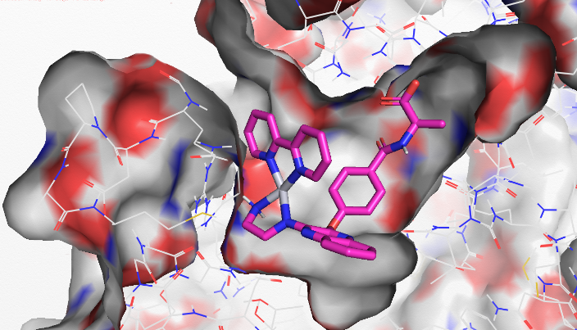
Figure S5: The location of the 2,2ʹ-bipyridine platinum complex 11, within the TOP2 ATPase domain

The use of different amino acids in the design of the EDA-quin complexes was found to have no noticeable effect on the complexes binding energies, with similar average binding energies between −12.75 and −12.77 kcal/mol for each group of complexes (Figure S6). One way ANOVA (f = 0.244, fcrit = 3.29, p = 0.864) showed that the difference between average binding energies for different amino acids was not statistically significant.

Figure S6: Average binding energy of EDA-quin complexes incorporating different amino acids. The error bars show standard deviation from the mean. The phenylalanine complexes show a lower average binding energy than complexes incorporating other amino acids.

The average binding energies of EDA-quin complexes with different coordinated secondary ligands as well as the uncoordinated EDA-quin compounds, were compared to see if there was any noticeable change to each groups average binding energy (Figure S7). One way ANOVA (f = 22.4, fcrit = 3.29, p = 0.000033) showed that the difference between average binding energies for different coordinated secondary ligands was statistically significant. Further analysis by Tukey’s HSD showed significant differences between ethylenediamine and diaminobenzene (p = 0.00812), bipyridine (p = 0.00006), and phenanthroline (p = 0.00007), and between benzenediamine and bipyridine (p = 0.04009) and phenanthroline (p = 0.04823).

***
*
*
***
**

Figure S7: Average binding energy of EDA-quin complexes incorporating different secondary ligands. The error bars show standard deviation from the mean. The ethylenediamine complexes show a higher average binding energy than other complexes, while the 2,2ʹ-bipyridine and 1,10-phenanthroline complexes show lower average binding energies.

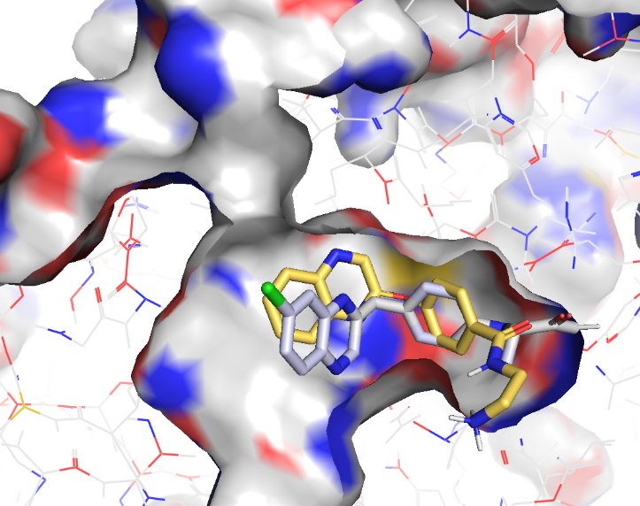
Figure S8. Location of the ligand 23 (yellow) and ATP (grey) in the TOP2 ATPase domain.

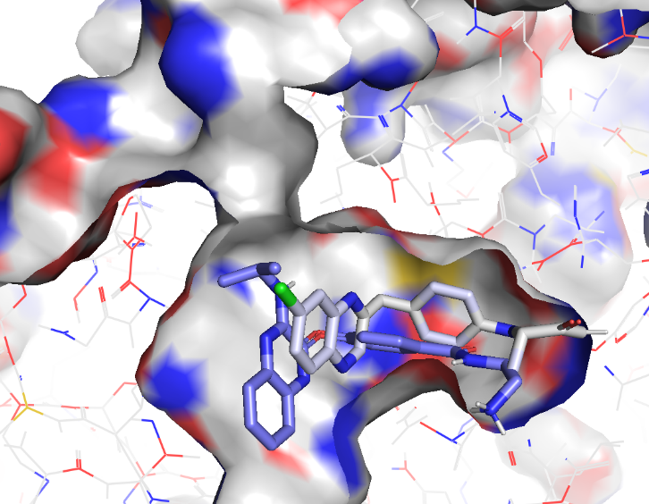
Figure S9. Location of the isopropylamino ligand 28 (purple) and ATP (grey) in the TOP2 ATPase domain.

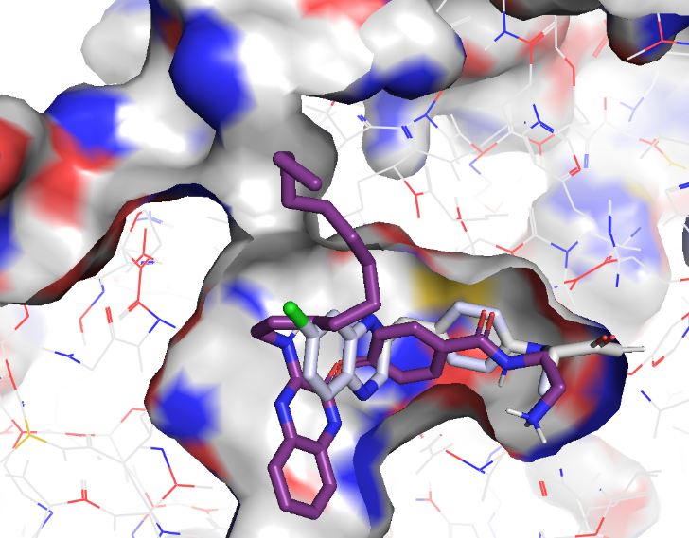
Figure S10. Location of the dodecylamino ligand 38 (purple) and ATP (grey) in the TOP2 ATPase domain.

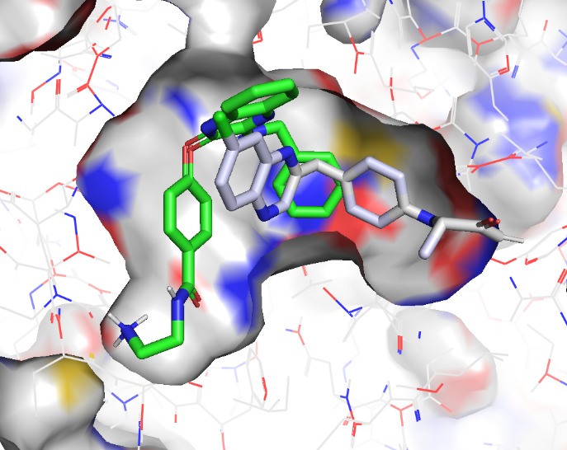
Figure S11. Location of the benzylamino ligand 33 (green) and ATP (grey) in the TOP2 ATPase domain.

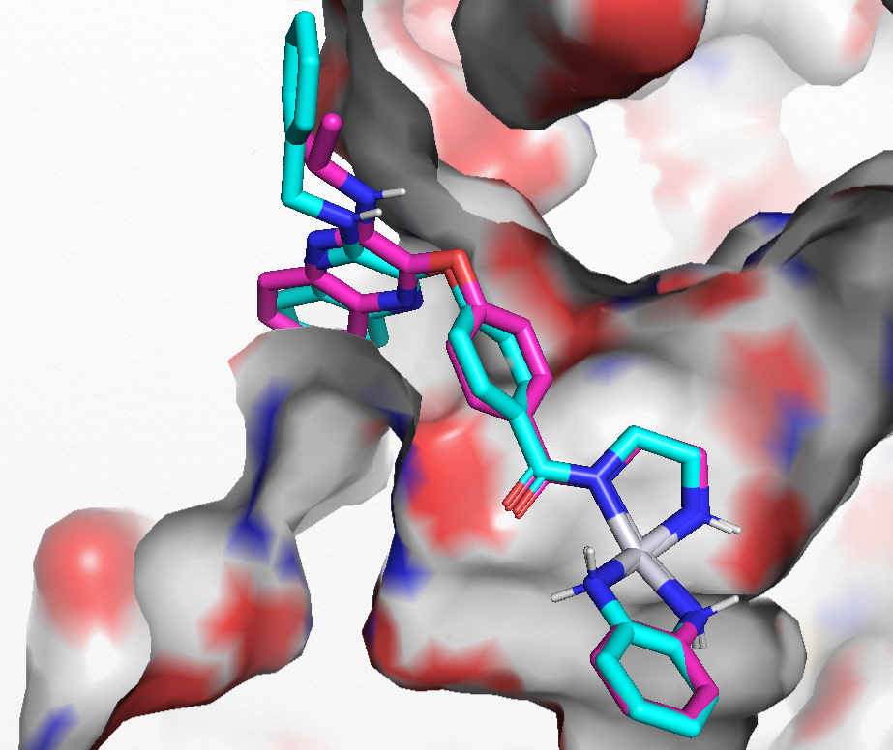
Figure S12. The location of isopropylamino complex 30 (magenta) and benzylamino complex 35 (cyan) in the TOP2 ATPase domain.
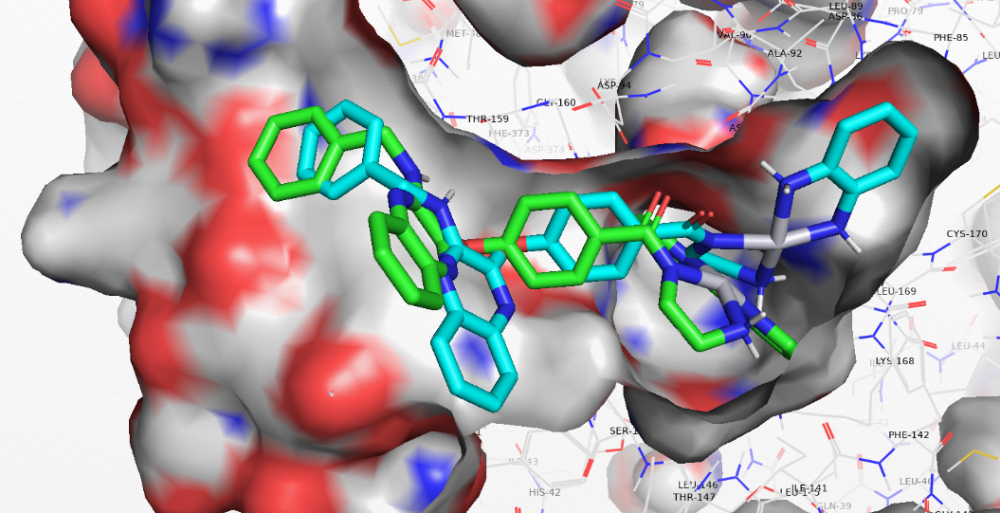
Figure S13. A comparison showing the similarity in binding pose between the diaminobenzene platinum complex 34 (cyan) and 2,2ʹ-bipyridine platinum complex 36 (green), showing similarity in the binding location of their benzylamine functionalised quinoxalines and oxybenzene linkers. Despite this similarity in binding pose, 34 does not show the same interactions with the ATPase domain as 36.
**

Figure S14: Average binding energies of aminoethylamide complexes incorporating different quinoxaline functionalisations. The error bars show the standard deviation from the mean. The dodecylamine and benzylamine functionalisation’s show markedly lower and higher average binding energies respectively.

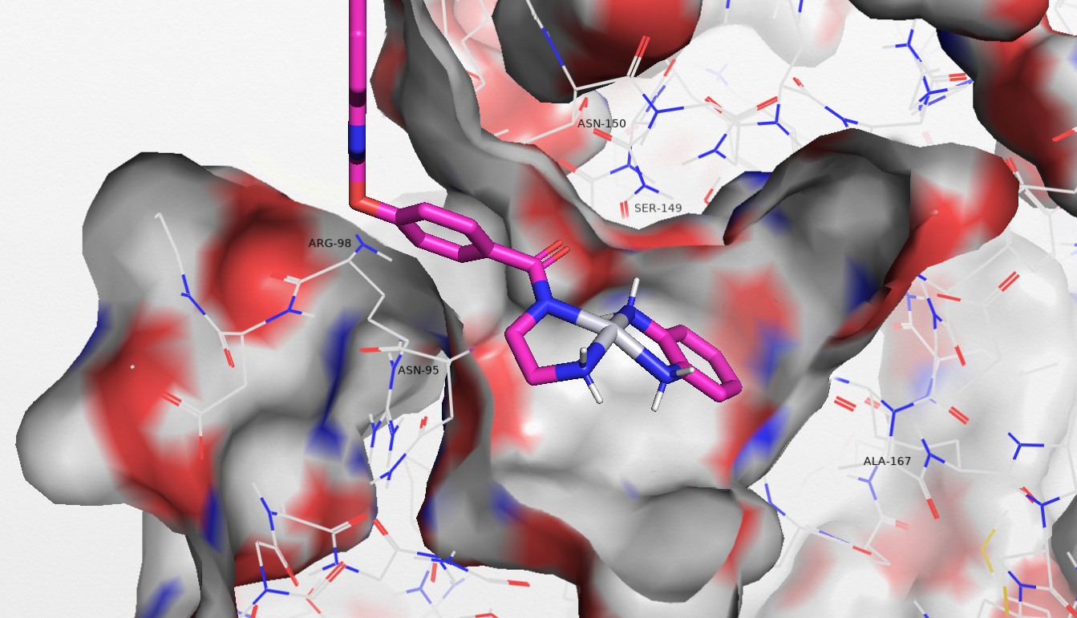
Figure S15: The location of the diaminobenzene platinum complex 25 in the TOP2 ATPase domain.

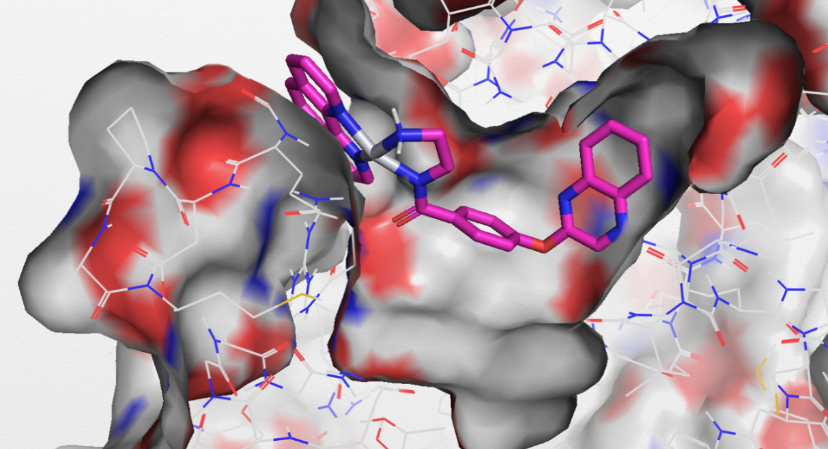
Figure S16: The location of the 1,10-phenanthroline platinum complex 27 in the TOP2 ATPase domain.
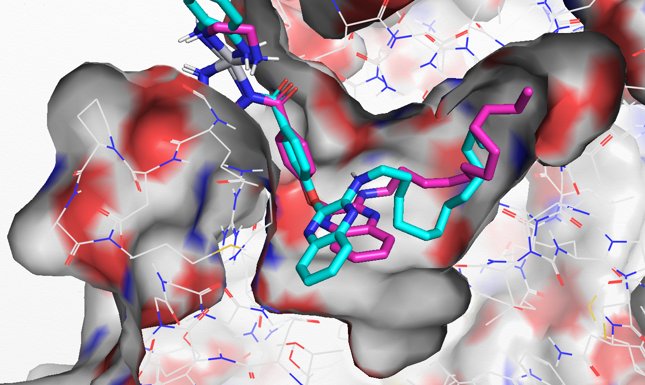
Figure S17: The location of the ethylenediamine platinum complex 39 (magenta) and the diaminobenzene platinum complex 40 (cyan) in the TOP2 ATPase domain.

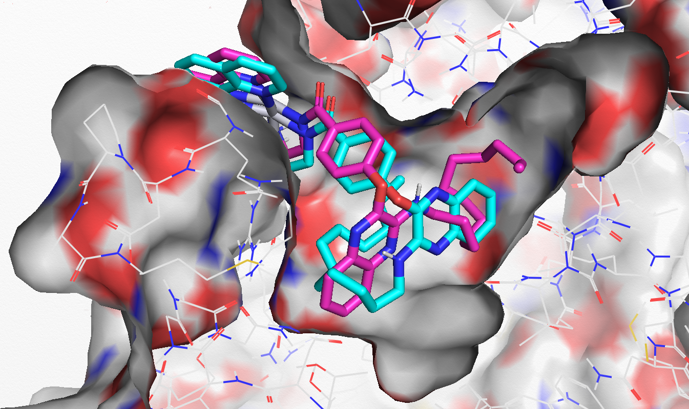
Figure S18: The location of the 2,2ʹ-bipyridine platinum complex 41 (magenta) and the 1,10-phenanthroline platinum complex 42 (cyan) in the TOP2 ATPase domain.

References

1. Cosconati, S, Forli, S, Perryman, A L, Harris, R, Goodsell, D S, Olson, A J, Expert Opinion on Drug Discovery, 2010, 5, 597-607.
2. Huey, R, Morris, G M, Olson, A J, Goodsell, D S, Journal of Computational Chemistry, 2007, 28, 1145-1152.
3. Bisceglie, F, Musiari, A, Pinelli, S, Alinovi, R, Menozzi, I, Polverini, E, Tarasconi, P, Tavone, M, Pelosi, G, Journal of Inorganic Biochemistry, 2015, 152, 10-19.
4. Suntharalingam, K, Mendoza, O, Duarte, A A, Mann, D J, Vilar, R, Metallomics, 2013, 5, 514-523.

