Supplementary Material 1
Mann-Kendall Contextual Method (CMK)
The Mann-Kendall Contextual Method (CMK) was used to analyze the trends of the temporal data. This method is an extension of the Mann-Kendall test, which is widely used to detect trends in hydrological and climatic time series.
Specific steps taken
1. Data collection and pre-processing:
The data were collected from reliable sources and organized into time series.
Data cleansing was performed to remove anomalous values and address potential gaps in the time series.
The data were normalized to ensure comparability between different data sets.
Application of the CMK Method:
The time series were divided into movable windows for contextual analysis.
In each window, the Kendall coefficient was calculated to detect the presence of monotonic trends.
Statistical significance analysis was performed to determine the reliability of the observed trends.
Interpretation of the results:
Trends detected in different windows were compared to identify temporal and spatial patterns.
The trends were classified according to their magnitude and significance.
Software and Tools Used
All statistical analyses were performed in the R environment version 3.4.3 (R Core Team, 2020). R is a programming language that is widely used for statistical analysis and data manipulation. R-specific packages used include:
trend: to run the Mann-Kendall test and its contextual variations.
Zoo: to manipulate time series.
DPLYR: for data cleansing and transformation.
ggplot2: for graphical visualization of the results.
Pre-processing of the data
The pre-processing of the data included the following steps:
Data Cleansing: Removal of missing values and outliers using dplyr package functions.
Normalization: Applying normalization techniques to standardize data, ensuring that different units were comparable.
Moving window splitting: Using the zoo package to create moving windows in time series, making contextual analysis easier.

Tendon Analysis

Table 2. Mann-Kendall trend test for the average annual ozone column concentrations (OCT) for the locations studied.
City | Annual |  | Summer |  | Autumn |  | Winter |  | Spring
City | Z | p-value | Z | p-value | Z | p-value | Z | p-value | Z | p-value
Arapiraca | 2,12 | 0,03* | -0,85 | 0,39 | -2,07 | 0,04* | 2,52 | 0,01* | -0,50 | 0,62
Coruripe | 1,75 | 0,08 | -0,19 | 0,85 | -2,57 | 0,01* | 1,95 | 0,05 | -1,00 | 0,31
Sugar Loaf | 1,94 | 0,05 | -0,66 | 0,51 | -2,26 | 0,02* | 1,77 | 0,08 | -0,41 | 0,68
Palmeiras dos Índios | 2,12 | 0,03* | -0,85 | 0,39 | -2,07 | 0,04* | 2,52 | 0,01* | -0,50 | 0,62
São Luis do Quitunde | 2,84 | 0,01* | -0,26 | 0,80 | -1,49 | 0,14 | 2,95 | 0,00* | -0,50 | 0,62
Maceió | 2,79 | 0,01* | -0,26 | 0,80 | -1,49 | 0,14 | 2,95 | 0,00* | -0,50 | 0,62
* - Significant at the level of 5%

Supplementary material 1.2

1. Normal (or Gaussian) Distribution
- Density Function:
$$f\left(x\right)=\frac{1}{\sqrt{2πσ^{2}}}exp\left(-\frac{{\left(x-μ \right)}^{2}}{2πσ^{2}}\right)$$
Where:
  - μ is the average of the distribution.
  - σ2 is variance.
- Features:
  - Symmetrical around the mean μμ.
  - The distribution is characterized by its mean and variance.
  - The shape of the distribution is a bell, known as the "bell-shaped curve" or "normal curve."
- Applications:
  - Modeling of continuous variables that are symmetrically distributed around the mean.
  - Used in statistics for inferences and hypothesis testing.

2. Lognormal Distribution
- Density Function:
$$f\left(x\right)=\frac{1}{xφ\sqrt{2π}}exp\left(-\frac{{\left(lnx-μ\right)}^{2}}{2σ^{2}}\right)$$
Where:
  - μ and σ2 are the parameters of the normal distribution of the logarithm of the random variable.
- Features:
  - Asymmetrical with a long tail on the right.
  - The variable X has a lognormal distribution if ln(X) follows a normal distribution.
- Applications:
  - Modeling data that is the product of many multiplicative factors, such as particle sizes, financial returns, and equipment lifetimes.

3. Logistics Distribution
- Density Function:
$$f\left(x\right)=\frac{exp\left(-\frac{(x-μ)}{s}\right)}{s{\left[1+exp\left(\frac{-x-μ}{s}\right)\right]}^{2}}$$
Where:
  - μ is the location parameter (average).
  - s is the scale parameter.
- Features:
  - Similar to the normal distribution, but with heavier tails.
  - The cumulative distribution function (CDF) is a sigmoidal function.
- Applications:
  - Used in logistic regression models and in analyses where growth or response is sigmoidal.

4. Weibull Distribution
- Density Function:
$$f\left(x\right)=\frac{β}{η}{\left(\frac{x}{η}\right)}^{β-1}exp⁡\left(-{\left(\frac{x}{η}\right)}^{β}\right)$$
Where:
  - η is the scale parameter.
  - β is the shape parameter.
- Features:
  - You can model failure times with different patterns depending on the β value:
    - β<1: Decreasing failure rate.
    - β=1: constant failure rate (similar to the exponential distribution).
    - β>1: Increasing failure rate.
- Applications:
  - Survivability and reliability analysis, product life modeling, and time to failure.

5. Kolmogorov-Smirnov (K-S) test
- Objective:
  - Compare an empirical distribution with a theoretical distribution or compare two empirical distributions to verify adequacy.
- Test Statistic:
  - The test calculates the maximum absolute difference between the empirical and theoretical distribution functions (or between two empirical distributions).
- Formula:
$$D=sup\left[F_{n}\left(x\right)-F(x)\right]$$
Where:
  - Fn(x) is the empirical distribution function.
  - F(x) is the theoretical distribution function.
- Features:
  - The test is nonparametric and does not require assumptions about the shape of the theoretical distribution.
  - The value of D is compared with critical values in a table to determine if the difference is statistically significant.
- Applications:
  - Verification of data compliance with a theoretical distribution.
  - Comparison of two samples to verify that they come from the same distribution.
These distributions and the Kolmogorov-Smirnov test are important tools in statistics and data analysis, each with its own characteristics and practical applications.

Table 2. Maximum likelihood estimates of the parameters.
City | Normal |  | Lognormal |  | Logistics |  | Weibull
City | μ | σ | μ | σ | μ | σ | one | b
Arapiraca | 263.041 | 9.881 | 263.041 | 9.868 | 262.986 | 10.371 | 26.111 | 267.843
Coruripe | 263.364 | 9.894 | 263.364 | 9.889 | 263.371 | 10.391 | 26.0835 | 268.141
Sugar Loaf | 262.742 | 9.938 | 262.741 | 9.9098 | 262.640 | 10.357 | 24.928 | 267.588
Palmeiras dos Índios | 263.041 | 9.881 | 263.041 | 9.868 | 262.986 | 10.371 | 26.111 | 267.843
São Luís do Quitunde | 263.664 | 9.93084 | 263.664 | 9.9176 | 263.629 | 10.4231 | 25.5917 | 268.473
Maceió | 263.664 | 9.93084 | 263.664 | 9.9176 | 263.629 | 10.4231 | 25.5917 | 268.473
Table 3. The results of the Kolmogorov-Smirnov test for the cities considered.

City | Normal | Lognormal | Logistics | Weibull
City | KS | KS | KS | KS
Arapiraca | 0.0359810 | 0.0425622 | 0.0458058 | 0.0766897
Coruripe | 0.0419108 | 0.0486879 | 0.049653 | 0.0747125
Sugar Loaf | 0.0356803 | 0.0369833 | 0.0450819 | 0.0864402
Palmeiras dos Índios | 0.0359810 | 0.0425622 | 0.0458058 | 0.0766897
São Luís do Quitunde | 0.0382296 | 0.0442023 | 0.0494535 | 0.0797962
Maceió | 0.0382296 | 0.0442023 | 0.0494535 | 0.0797962

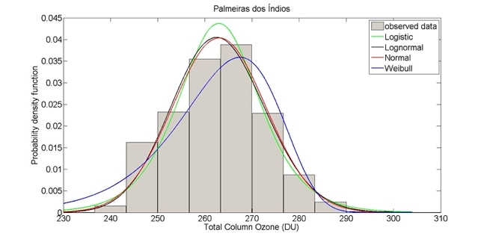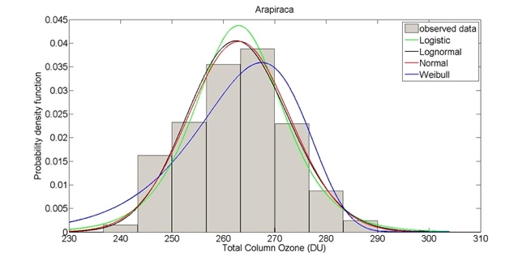

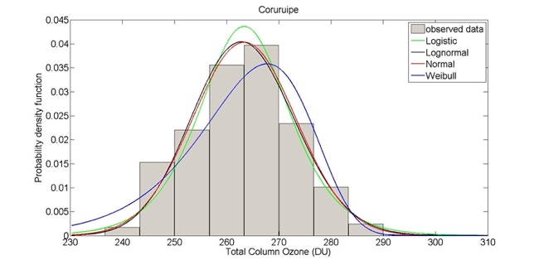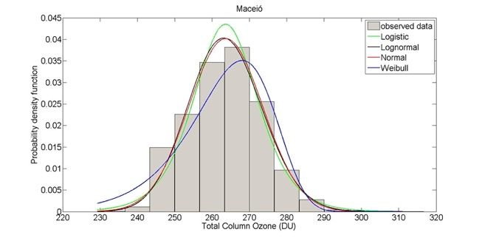

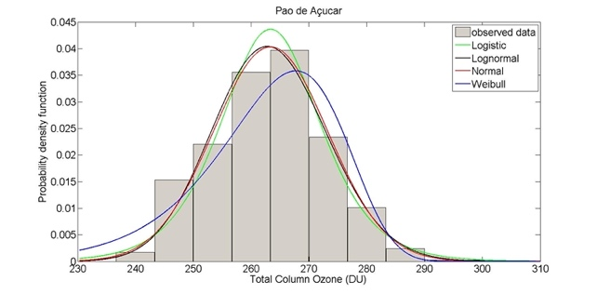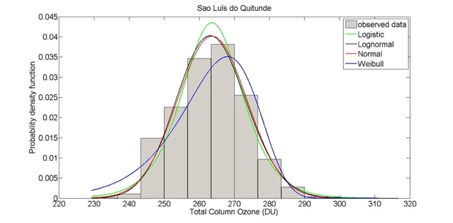

Figure 3. The logistic , lognormal, normal, and Weibull histograms and PDFs adjusted for the TCO data over a 9-year period (2008–2016) for all six cities in the study.

