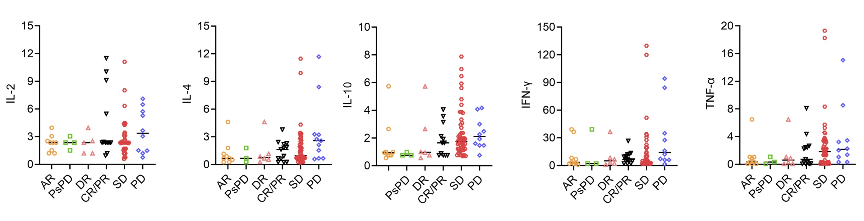
Supplementary Figure S1. Pre-treatment levels of cytokines in patients with AR, PsPD, DR, CR/PR, SD, and PD. AR, atypical response; PsPD: pseudoprogressive disease; DR: dissociated response; CR, complete response; PR: partial response; SD: stable disease; PD: progressive disease; NLR: neutrophil-to-lymphocyte ratio; dNLR: derived neutrophil-to-lymphocyte ratio; LDH: lactate dehydrogenase; IL-6: interleukin 6; IFN-γ: interferon-γ; TNF-α: tumor necrosis factor-α

