Identification of serum glycan signatures in three major gastrointestinal cancers by high-throughput N-glycome profiling
Si Liu,^{1, 2, ‡} Jianmin Huang,^{3, ‡} Yuanyuan Liu,² Jiajing Lin,² Haobo Zhang,² Liming Cheng,⁴ Weimin Ye, ^{1, *} Xin Liu ^{2, **}
¹Department of Epidemiology and Health Statistics, School of Public Health, Fujian Medical University, Fuzhou 350122, China
²The Key Laboratory for Biomedical Photonics of MOE at Wuhan National Laboratory for Optoelectronics-Hubei Bioinformatics & Molecular Imaging Key Laboratory, Systems Biology Theme, Department of Biomedical Engineering, College of Life Science and Technology, Huazhong University of Science and Technology, Wuhan 430074, China
³Digestive Endoscopy Center, South Branch of Fujian Provincial Hospital, Fuzhou 350000, China
⁴Department of Laboratory Medicine, Tongji Hospital, Tongji Medical College, Huazhong University of Science and Technology, Wuhan 430074, China
‡These authors contributed equally.
*Corresponding author

E-mail addresses: ywm@fjmu.edu.cn (W. Ye), xliu@mail.hust.edu.cn (X. Liu)
Table contents:
Supplementary Table S1. Demographic description of study populations in this study.
Supplementary Table S2. Evaluation of the reproducibility for the quantitation of representative N-glycans in serum by MALDI-MS.
Supplementary Table S3. Description of glycan derived traits between healthy controls and three major GI cancers.
Supplementary Table S4. Description of individual N-glycans in the comparison between healthy controls and GI cancers.
Supplementary Table S5. Evaluation of diagnostic performance of eight serum N-glycans altered similarly in three GI cancers.
Supplementary Table S6. Evaluation of diagnostic performance of specific N-glycans for those three GI cancers.

Figure captions:
Supplementary Figure S1. Representative MALDI-MS spectra of serum N-glycome in the comparison between controls and three GI cancers.
Supplementary Figure S2. Evaluation of the predictive potential of N-glycome profile for GI cancer patients.
Supplementary Figure S3. Evaluation of serum N-glycome for distinguishing three major GI cancers from each other.

Table S1. Demographic description of study populations in this study. IQR, inter-quartile range; TNM, tumor node metastasis; CA 72-4, carbohydrate antigen 72-4; PG1, pepsinogen 1; PG2, pepsinogen 2.
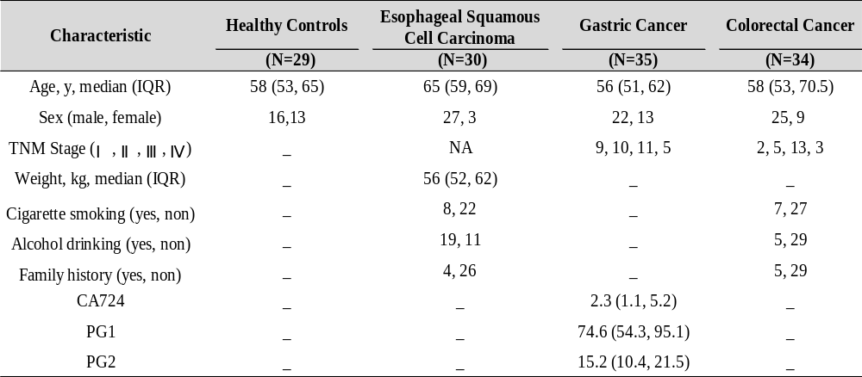
Table S2. Evaluation of the reproducibility for the quantitation of representative N-glycans in serum by MALDI-MS. SD, standard deviation; RSD, relative standard deviation. Symbols as presented as follows: blue square, N-acetylglucosamine; green circle, mannose; yellow circle, galactose; purple diamond, sialic acid; red triangle, fucose.
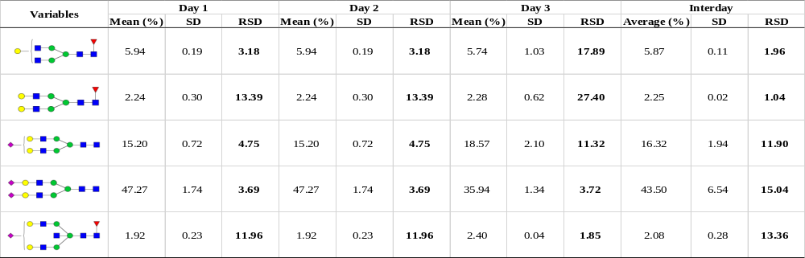
Table S3. Description of glycan derived traits between healthy controls and three major GI cancers. SD, standard deviation; CI, confidence interval.
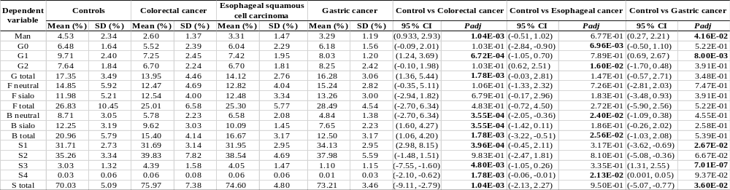
Table S4. Description of individual N-glycans in the comparison between healthy controls and GI cancers. SD, standard deviation; CI, confidence interval.
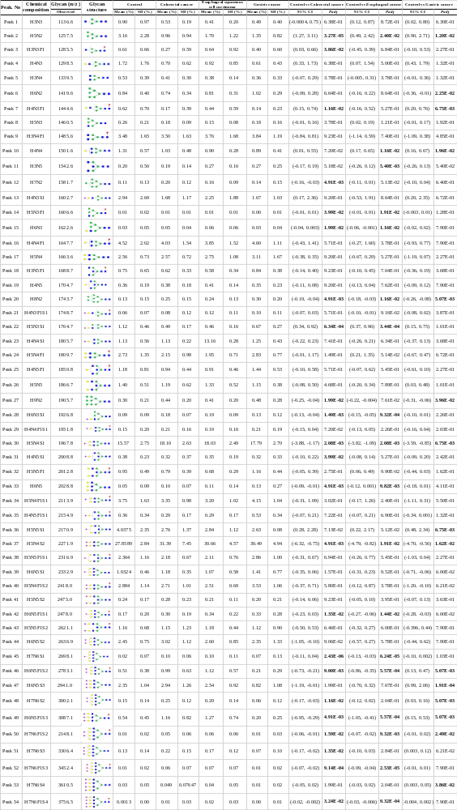
Table S5. Evaluation of diagnostic performance of eight serum N-glycans altered similarly in three GI cancers. AUC, area under the curve; CI, confidence interval. H, hexose; N, N-acetylglucosamine; F, fucose; S, sialic acid.
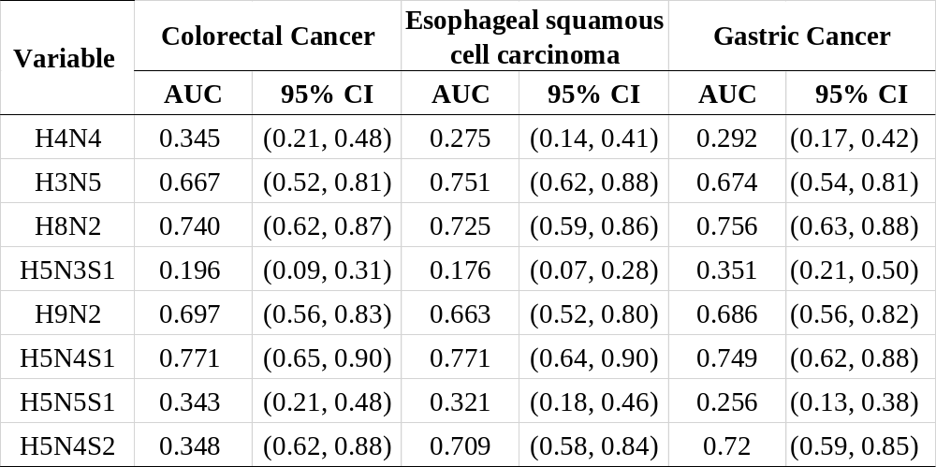
Table S6. Evaluation of diagnostic performance of specific N-glycans for those three GI cancers. AUC, area under the curve; CI, confidence interval.
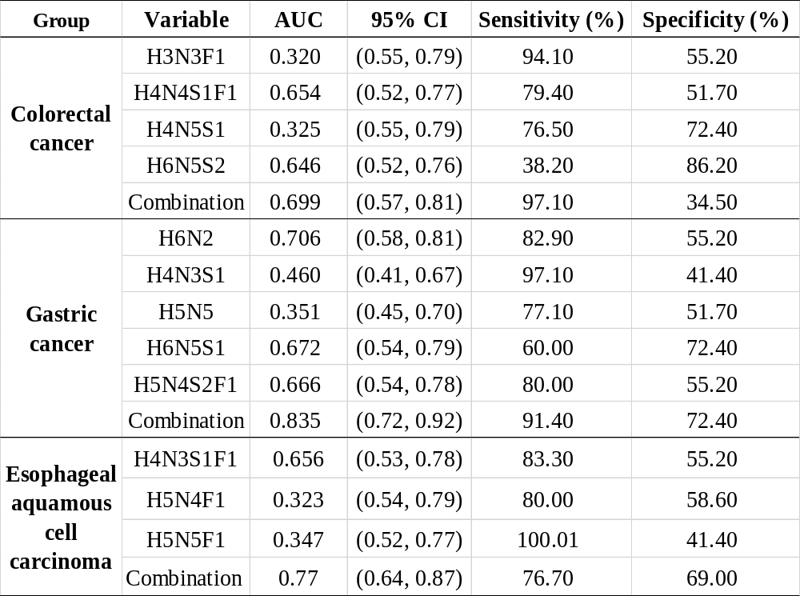
Fig S1. Representative MALDI-MS spectra of serum N-glycome in the comparison between controls and three GI cancers. The mass to charge ratio relevant glycan composition as listed in Table S4.
Fig S2. Evaluation of the predictive potential of N-glycome profile for GI cancer patients. (a-c) Principal component analysis of serum N-glycome for distinguishing GI cancer from healthy controls (HC); (d-f) Feature selection of N-glycans for the contribution to the differentiation between GI patients and HC by transfer learning model.
Fig S3. Discriminative models assessing the predictive potential of N-glycome profile for GI cancer patients.

