Supporting Information:
Comparative Assessment of Physics-Based In Silico Methods to Calculate Relative Solubilities
Adiran Garaizar Suarez^{b}, Andreas H. Göllerª, Michael E. Beck^{b}, Sadra Kashef Ol Gheta^{b}, Katharina Meier^{§a}
ª Bayer AG, Pharmaceuticals, Computational Molecular Design, Wuppertal, Germany
^{b} Bayer AG, Crop Science, Computational Life Science, Monheim, Germany

- Table of solute-solvent pairs evaluated in this work

Solvent | Solute
pentane | benzoic acid
2,2,4-trimethylpentane | 9-fluorenone
2,2,4-trimethylpentane | trans-stilbene
n-hexane | 9-fluorenone
n-hexane | benzoic acid
n-hexane | trans-stilbene
cyclohexane | benzoic acid
cyclohexane | xanthene
tert-butylcyclohexane | trans-stilbene
1,4-dioxane | 2,3-dimethyl-2,3-dinitrobutane
1,4-dioxane | 4-methoxybenzoic acid
1,4-dioxane | trans-stilbene
benzene | benzoic acid
benzene | trans-stilbene
2-xylene | anthracene
3-xylene | anthracene
3-xylene | trans-stilbene
toluene | benzoic acid
toluene | trans-stilbene
isopropyl ether | xanthene
diethyl ether | 9-fluorenone
diethyl ether | xanthene
ethyl acetate | 2,3-dimethyl-2,3-dinitrobutane
tetrahydrofuran | 2,3-dimethyl-2,3-dinitrobutane
tetrahydrofuran | 4-methoxybenzoic acid
tetrahydrofuran | trans-stilbene
cyclohexanone | 2,3-dimethyl-2,3-dinitrobutane
methylethyl ketone | 2,3-dimethyl-2,3-dinitrobutane
acetone | 2,3-dimethyl-2,3-dinitrobutane
acetone | caffeine
benzonitrile | anthracene
dimethylformamide | anthracene
acetonitrile | 2,3-dimethyl-2,3-dinitrobutane
acetonitrile | 9-fluorenone
acetonitrile | benzoic acid
n-pentanol | 4-methoxybenzoic acid
n-pentanol | 9-fluorenone
n-pentanol | trans-stilbene
cyclopentanol | 9-fluorenone
1-butanol | trans-stilbene
isobutyl alcohol | 4-methoxybenzoic acid
isobutyl alcohol | trans-stilbene
2-propanol | trans-stilbene
1-propanol | 9-fluorenone
1-propanol | trans-stilbene
ethanol | trans-stilbene
ethanol | xanthene
methanol | benzoic acid
methanol | caffeine
methanol | trans-stilbene
methanol | xanthene
ethylene glycol | benzoic acid
water | caffeine

Table T1 List of 53 solvent-solute pairs used to evaluate relative solubilities in this work. For each of the eight solutes, there are n different solvents with n solvation free energies resulting in n(n-1)/2 solvent pairs per molecule. These solvent pairs are used for evaluation of the different methods.

- Computational details of COSMO-RS-Brick-in-a-Pan calculations

Starting geometries of the solvent and solute molecules were created with Schrödinger’s Maestro package [MAESTRO2023], using the ligprep workflow. We only processed the lowest energy conformer. For more flexible molecules, we would recommend creating ensembles of conformers with a workflow like Grimme’s CREST[CREST2020].
The starting geometries were refined at DFT level of theory using Turbomole, version V7.5.1 [TURBO2020], using the BP86 functional [BP86] with Ahlrich’s def2-TZVP basis sets [TZVP2005] making use of the multipole accelerated resolution of identity approximation [MARIJ2003]. Solvent effects were taken care of via COSMO [COSMO1993], with a dielectric constant of 80.2, actually mimicking water. In practice, 80.2 is high enough to the numerical default 99, which is typically used to run COSMO calculations in perfect conductors. As the compounds in our set featured rather low flexibility, we did not perform elaborate scans of the conformational space in various dielectrics and used a single conformer except in the section where we explicitly study benzoic acid as described therein. The final cosmo-files were created with a single point calculation at the same level of theory, employing a dielectric constant of 99.
The cosmo-files thus created for the solutes and solvents were finally processed with COSMO-RS, using BIOVIA COSMOtherm 2021 [COSMOTHERM2021]. A sample COSMO-RS input file, calculating the solubility of the solute 9-fluorenone in the solvent cyclohexane at T=20°C reads:
<SET COSMO-RS CTD LICENSE PATHS> NOMIX
!! solubility screening run
f=<PATH>/9-fluorenone.infinity.cosmo eH=-575.67 DGfus=20 comp=9-fluorenone
f=<PATH>/cyclohexane.infinity.cosmo eH=-235.96 DGfus=0 comp=cyclohexane
tc=20 solub xs={0 1} nsolute=9-fluorenone

Note that the keyword DGfus=0 (hence $ΔG_{fusion}^{cyclohexane}=0$) ensures cyclohexane to be considered liquid, while with DGfus=20 the “Brick-in-a-pan” approximation is enforced for the solute, 9-fluorenone, i.e. assuming an unrealistically high value of $ΔG_{fusion}^{9-flourenone}≡20 kcal {mol}^{-1}$. The resulting solubility prediction will be far to low; however, we will only use this value to calculate relative solubities, e.g. $\lg{S_{cyclohexane}^{9-flourenone}-\lg{S_{methanol}^{9-flourenone}}}$. It is advisable to automize creation of input files and collecting calculation results. We employed a python script for that purpose.

- Multi-Conformer Consideration and Dimerization of Benzoic Acid in the COSMO-RS Method

Solvent 1 | Solvent 2 | Exp. | COSMO-RS singleConf | COSMO-RS multiConf | COSMO-RS dimer | Diff.
toluene | ethylene glycol | -0.73 | -2.28 | -3.29 | 5.08 | 8.38
toluene | benzene | -0.10 | -0.38 | -0.50 | -0.32 | 0.18
toluene | acetonitrile | -0.34 | -4.41 | -3.48 | 2.38 | 5.86
toluene | pentane | 2.58 | 2.25 | 2.25 | 1.51 | -0.73
toluene | n-hexane | 2.23 | 2.39 | 2.36 | 1.65 | -0.71
toluene | cyclohexane | 1.99 | 2.23 | 2.23 | 1.33 | -0.90
toluene | methanol | -1.25 | -4.68 | -4.40 | 2.53 | 6.93
ethylene glycol | benzene | 0.64 | 1.90 | 2.80 | -5.40 | -8.20
ethylene glycol | acetonitrile | 0.40 | -2.13 | -0.18 | -2.70 | -2.52
ethylene glycol | pentane | 3.32 | 4.53 | 5.54 | -3.57 | -9.11
ethylene glycol | n-hexane | 2.97 | 4.68 | 5.66 | -3.43 | -9.09
ethylene glycol | cyclohexane | 2.72 | 4.51 | 5.53 | -3.75 | -9.28
ethylene glycol | methanol | -0.52 | -2.40 | -1.10 | -2.55 | -1.45
benzene | acetonitrile | -0.24 | -4.04 | -2.98 | 2.70 | 5.68
benzene | pentane | 2.68 | 2.63 | 2.74 | 1.83 | -0.91
benzene | n-hexane | 2.33 | 2.77 | 2.86 | 1.97 | -0.89
benzene | cyclohexane | 2.08 | 2.61 | 2.73 | 1.65 | -1.08
benzene | methanol | -1.16 | -4.30 | -3.90 | 2.85 | 6.75
acetonitrile | pentane | 2.92 | 6.66 | 5.72 | -0.87 | -6.60
acetonitrile | n-hexane | 2.57 | 6.81 | 5.84 | -0.73 | -6.57
acetonitrile | cyclohexane | 2.33 | 6.64 | 5.71 | -1.05 | -6.76
acetonitrile | methanol | -0.91 | -0.27 | -0.92 | 0.15 | 1.07
pentane | n-hexane | -0.35 | 0.15 | 0.11 | 0.14 | 0.02
pentane | cyclohexane | -0.59 | -0.02 | -0.01 | -0.18 | -0.17
pentane | methanol | -3.83 | -6.93 | -6.64 | 1.02 | 7.66
n-hexane | cyclohexane | -0.25 | -0.17 | -0.13 | -0.32 | -0.19
n-hexane | methanol | -3.49 | -7.08 | -6.76 | 0.88 | 7.64
cyclohexane | methanol | -3.24 | -6.91 | -6.63 | 1.20 | 7.83
RMSD |  |  | 2.41 | 2.14 | 3.61
Table T2 The experimental relative solubility of benzoic acid between solvent 1 and solvent 2 (Exp.), along with calculated relative solubility using COSMO-RS method. The results for single conformer (singleConf), multiple conformer (multiConf) and the benzoic dimer are presented. The difference between “COSMO-RS multiConf” and “COSMO-RS dimer” columns are given in “Diff.” column. All values are given in natural Log units. The differences larger than 3 natural log units in the magnitude are given in red.

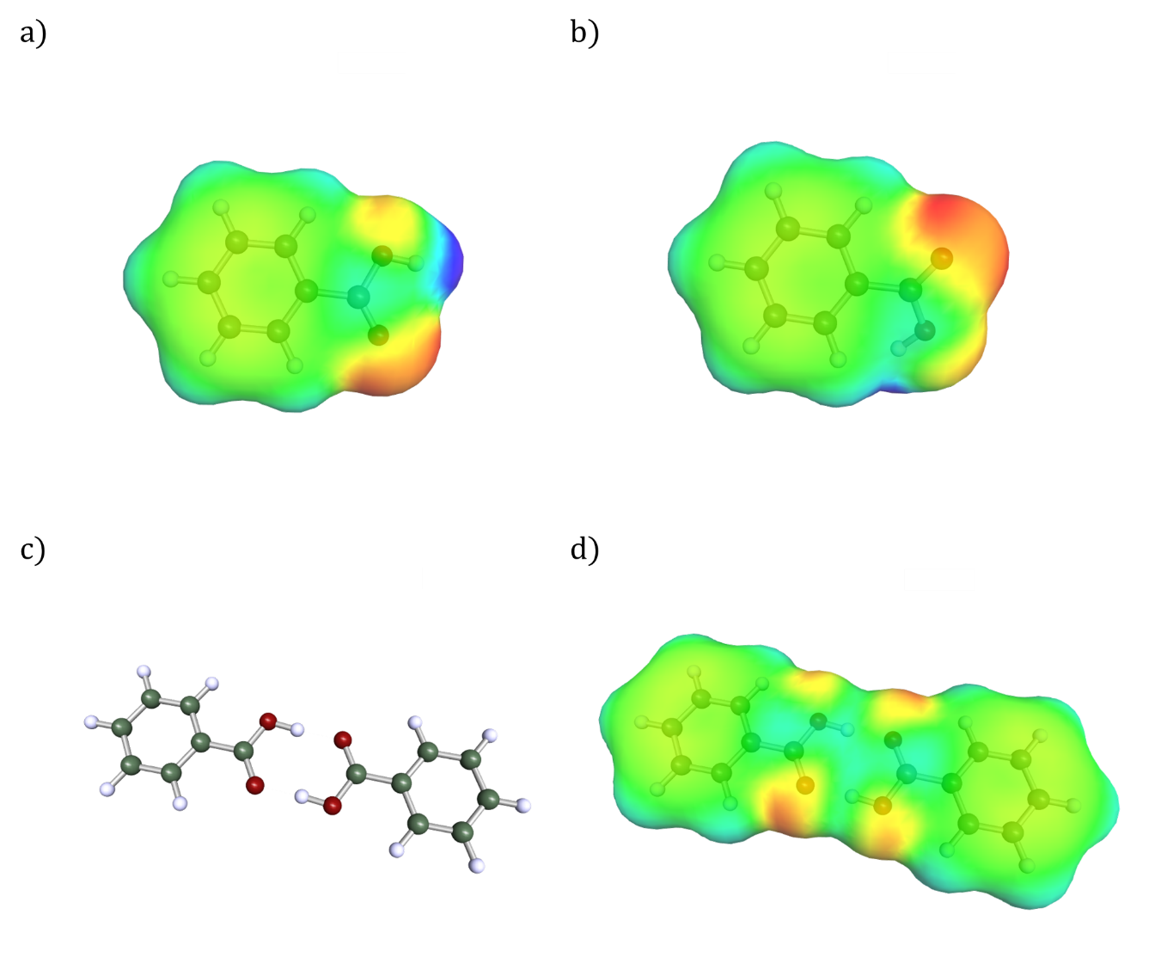
Figure F1. Sigma surfaces for the two most energetically relevant conformers of benzoic acid (a and b), as well as the optimized structure of the benzoic acid dimer (c) along with its corresponding sigma surface (d).

- Dimerization of 4-methoxybezoic acid in the COSMO-RS Method

Solvent 1 | Solvent 2 | Exp. | COSMO-RS | COSMO-RS dimer | Diff.
1,4-dioxane | n-pentanol | 1.36 | 2.41 | 3.28 | 0.88
1,4-dioxane | isobutyl alcohol | 1.58 | 2.48 | 3.19 | 0.72
1,4-dioxane | tetrahydrofuran | -0.59 | -0.46 | 0.11 | 0.58
n-pentanol | isobutyl alcohol | 0.22 | 0.07 | -0.09 | -0.16
n-pentanol | tetrahydrofuran | -1.95 | -2.87 | -3.17 | -0.30
isobutyl alcohol | tetrahydrofuran | -2.17 | -2.94 | -3.08 | -0.14
Table T3 The experimental relative solubility of 4-methoxybenzoic acid between solvent 1 and solvent 2 (Exp.), along with calculated relative solubility using COSMO-RS method. The results for the 4-methoxybenzoic acid and its dimer form are given in “COSMO-RS” and “COSMO-RS dimer", respectively. All numbers are given in natural log units. The difference between “COSMO-RS” and “COSMO-RS dimer” columns are given in “Diff.” column.

Solvent 1 | Solvent 2 | COSMO-RS | COSMO-RS dimer | Diff.
1,4-dioxane | n-pentanol | 1.76 | 1.89 | 0.13
1,4-dioxane | isobutyl alcohol | 1.75 | 1.94 | 0.19
1,4-dioxane | tetrahydrofuran | -0.21 | -0.58 | -0.37
n-pentanol | isobutyl alcohol | -0.01 | 0.06 | 0.06
n-pentanol | tetrahydrofuran | -1.96 | -2.47 | -0.50
isobutyl alcohol | tetrahydrofuran | -1.96 | -2.52 | -0.56
Table T4 The calculated relative solubility of benzoic acid in the same solvent pairs as those of 4-methoxybenzoic acid , using COSMO-RS method. The results for the benzoic acid and its dimer form are given in “COSMO-RS” and “COSMO-RS dimer", respectively. All numbers are given in natural log units. The difference between “COSMO-RS” and “COSMO-RS dimer” columns are given in “Diff.” column.

- Molecular Dynamics and FEP set up

GAFF Simulations
We start by reproducing the GAFF results from the reference paper from which (Supporting Material) we also obtain the solvated systems [LIU2014]. We try to remain as close as possible to the MD set up described therein.

The Molecular Dynamics protocol starts by running an energy minimization using a maximum force tolerance of 100 kJ/mol and an initial step of 0.01 nm subsequently followed by 3 equilibration runs. Firstly, an NVT ensemble simulation is carried out for 50 ps and a timestep of 0.002 ps. This is followed by a 50 ps NPT simulation with a Berendsen [BERENDSEN1984] isotropic barostat and a timestep of 0.002 ps at P = 1 bar with a compressibility of 4.5e-5 bar⁻¹ and a relaxation time of 1 ps. Finally, a 50 ps NPT simulation with an isotropic Parrinello-Rahman [PARRINELLO1981] barostat is performed at P = 1 bar, with a compressibility of 4.5e-5 bar⁻¹ and a relaxation time of 1 ps using a timestep of 0.002 ps. The 5 ns production NPT runs are carried out using the same Parrinello-Rahman [PARRINELLO1981] and isotropic barostat parameters, as well as timestep. Equations of motion are integrated with a leap-frog stochastic dynamics integrator with a relaxation time of 2-0.01 picoseconds. This protocol is carried out for each λ value. Van der Waals interactions where cut at 1.0 nm and electrostatic interactions where calculated using PME [EWALD1921] with a real space cutoff of 1.2 and a Fourier spacing of 0.1 nm, although this value is tuned at run time by GROMACS [ABRAHAM2015]. Long range dispersion corrections for Energy and Pressure were applied. To constrain the bonds to hydrogen LINCS of order 12 was used [HESS1997].

The Lambda grid used was λCoul = [0.0, 0.25, 0.5, 0.75, 1.0, 1.0, 1.0, 1.0, 1.0, 1.0, 1.0, 1.0, 1.0, 1.0, 1.0, 1.0, 1.0, 1.0, 1.0, 1.0] for electrostatic interactions and λLJ = [0.0, 0.00, 0.0, 0.00, 0.0, 0.05, 0.1, 0.2, 0.3, 0.4, 0.5, 0.6, 0.65, 0.7, 0.75, 0.8, 0.85, 0.9, 0.95, 1.0] for Lennard-Jones interactions.

Free energy differences are calculated using gmx bar, based on the Bennett’s acceptance ratio [BENNETT1976] method with a minimum amount of 5 blocks and a maximum of 20 blocks for error estimation. This set up validates our free energy protocol in GROMACS obtaining a MAE = 0.21 kJ/mol​ with respect to the original study.

OpenFF Simulations
To generate the openFF systems we use openFF Interchange within the openFF toolkit [WAGNER2023] together. We generate conformers for the solvent and solute molecules with the “generate_conformers()” method from the openFF toolkit and apply the openFF Sage 2.0.0 forcefield [BOOTHOROYD2023] using the “ForceField()” method from the openFF toolkit. We then use Interchange to generate GROMACS-compatible topologies for the solute and the solvent. The solute is solvated using gmx solvate [ABRAHAM2015] in 1000 solvent molecules, which results in cubic boxes of 4-6nm of length, enough to prevent compound self-interaction through the Periodic Boundary Conditions. Using the same first two steps in the equilibration protocol described above, we run an energy minimization using a maximum force tolerance of 100kJ/mol and an initial step of 0.01 nm subsequently followed by an NVT ensemble simulation for 50 ps and a timestep of 0.002 ps. Equations of motion are integrated with a leap-frog stochastic dynamics integrator with a relaxation time of 0.01 picoseconds to initially relax the solvated systems and avoid steric clashes.

For the FEP runs, we then build up on the same protocol described for the GAFF simulations, exchanging the GAFF topologies and systems by their equivalent openFF ones. We then use the same equilibration and production protocol as described above.

OPLS4 Simulations

For OPLS4 [LU2021] we followed Schrodinger guidance and created systems composed of 500 solvent molecules and 1 solute molecule. 20 different replicates of the system were built to increase sampling and gather convergence statistics using the “tangled chain” option from Schrodinger Materials Studio [MAESTRO2023]. The estimated free energy vs time for an example run with 20 replicates can be seen in Fig F2..

For the FEP calculations, we use the default set up which creates 12 λ windows. Lambda hopping is activated so that exchange between these λ simulations is attempted every 1.2 ps. Such hopping can be observed in Fig F3 for an example simulation.

To relax the system, we run a ladder of different equilibration simulations, as recommended by Schrodinger, in the solvation protocol:

NVT Brownian Dynamics for 0.1 ns at 10.0 K and a timestep of 1 fs
Molecular Dynamics 0.024 ns/NVT/300.0 K/1 fs
Molecular Dynamics 0.24 ns/NVT/700.0 K/1 fs
Molecular Dynamics 0.024 ns/NPT/1.01325 bar/300.0 K/1 fs
Molecular Dynamics 0.24 ns/NPT/1.01325 bar/300.0 K/2 fs
Molecular Dynamics 20 ns/NPT/1013.25 bar/300.0 K/2 fs

And finally, the “lambda hopping” FEP production stage:
Molecular Dynamics 10 ns/NPT/1013.25 bar/300.0 K/2 fs

Temperature is kept constant using a Nose-Hoover [NOSE1984] chain thermostat with a relaxation time of 1 ps and the pressure is kept constant with an MTK barostat [MARTYNA1996] with a relaxation time of 2 ps. Equations of motion are integrated using RESPA [TUCKERMAN1992], and short-range columbic interactions are cut at 0.9nm.

Free energies are also estimated with the BAR [TUCKERMANN1992] method, using the fep_analysis script from Schrodinger tool set.
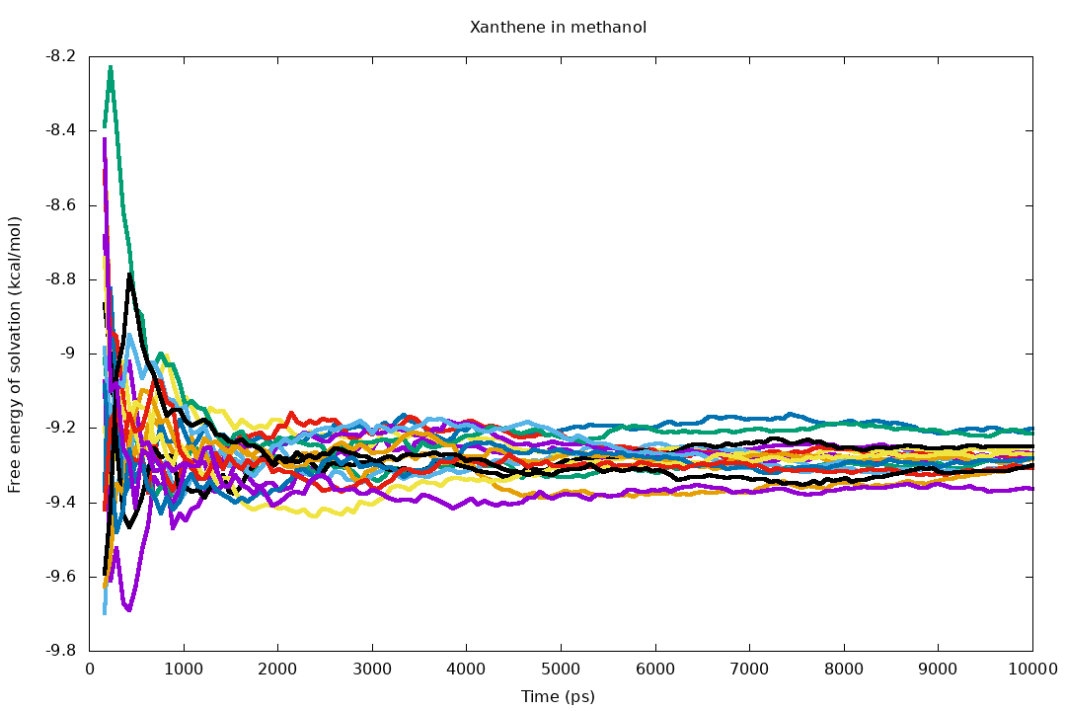
Figure F2. Free energy of solvation vs time for each of the 20-replicate (each with one colour) simulations for xanthene in methanol. Replicates tend to converge with increasing simulation time. The differences between the free energy of solvation can be used to estimate the variance due to the simulation protocol. Note that this variance is only reflective of the simulation convergence and not of the error with respect to the real experimental value.

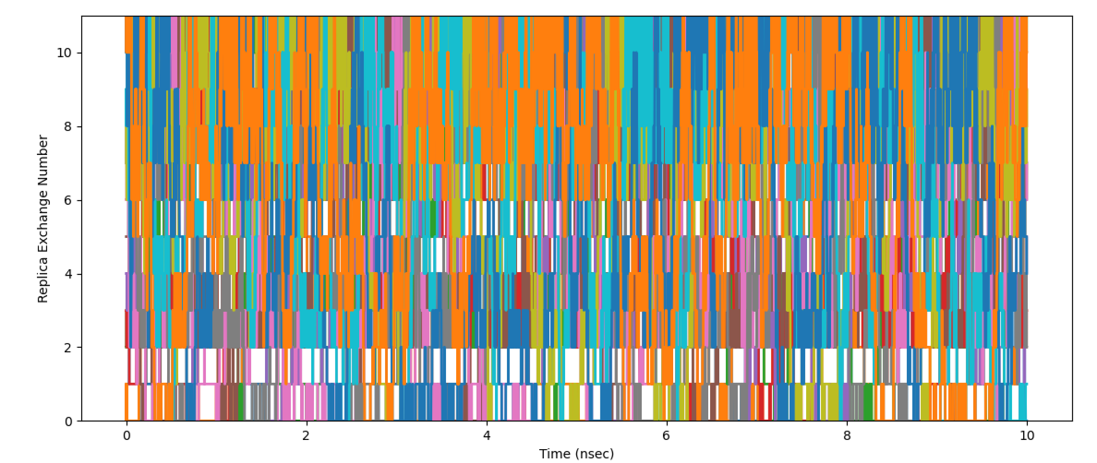
Figure F3. Graphical representation of Lambda hopping between the 12 lambda windows of each of the 20 replicates. Each colour represents one of the 12 lambda windows and the y axis at a given time point represents the different Hamiltonians. There is good exchange with lambda windows visiting each Hamiltonian several times along the simulation. This promotes good sampling of the conformational space of the molecules.

  - References:
MAESTRO2023: Schrödinger Release 2023-1: Maestro, Schrödinger, LLC, New York, NY, 2023.
CREST2020: Ph. Pracht, F. Bohle, S. Grimme, „Automated exploration of the low-energy chemical space with fast quantum chemical methods“, Phys. Chem. Chem. Phys., 22, 7169-7192 (2020); https://doi.org/10.1039/C9CP06869D
COSMO1993: Klamt, A.; Schürmann, G. COSMO: A new approach to dielectric screening in solvents with explicit expressions for the screening energy and its gradient. J. Chem. Soc., Perkin Trans., 2, 799−805 (1993); https://doi.org/10.1039/P29930000799
TURBO2020: S.G. Balasubramani, G. P. Chen, S. Coriani, M. Diedenhofen, M.S. Frank, Y.J. Franzke, F. Furche, R. Grotjahn, M. E. Harding, Ch. Hättig, A. Hellweg, B. Helmich-Paris, Ch. Holzer, U. Huniar, M. Kaupp, A. M. Khah, S. Karbalaei Khani, Th. Müller, F. Mack, B. D. Nguyen, S. M. Parker, E. Perlt, D. Rappoport, K. Reiter, S. Roy, M. Rückert, G. Schmitz, M. Sierka, E. Tapavicza, D. P. Tew, Ch. van Wüllen, V.K. Voora, F. Weigend, A. Wodyński, J. M. Yu; „TURBOMOLE: Modular program suite for ab initio quantum-chemical and condensed-matter simulations.“ J. Chem. Phys. 14 May 2020; 152 (18): 184107. (2020); https://doi.org/10.1063/5.0004635

TZVP2005: F. Weigend, R. Ahlrichs, „Balanced basis sets of split valence, triple zeta valence and quadruple zeta valence quality for H to Rn: Design and assessment of accuracy”. Phys. Chem. Chem. Phys. 7, 3297 (2005); https://doi.org/10.1039/b508541a

MARIJ2003: M. Sierka, A. Hogekamp and R. Ahlrichs, Fast evaluation of the Coulomb potential for electron densities using multipole accelerated resolution of identity approximation, J. Chem. Phys. 118: 9136 (2003); https://doi.org/10.1063/1.1567253

COSMOTHERM2021: BIOVIA, Dassault Systèmes, CosmoTherm 2021, Version 21.0.0, San Diego: Dassault Systèmes, 2021

BERENDSEN1984: Berendsen, H. J., Postma, J. V., Van Gunsteren, W. F., DiNola, A. R. H. J., & Haak, J. R. (1984). Molecular dynamics with coupling to an external bath. The Journal of chemical physics, 81(8), 3684-3690; https://doi.org/10.1063/1.448118

PARRINELLO1981: Parrinello, M., & Rahman, A. (1981). Polymorphic transitions in single crystals: A new molecular dynamics method. Journal of Applied physics, 52(12), 7182-7190; https://doi.org/10.1063/1.328693

EWALD1921: Ewald, P. P. (1921). Die Berechnung optischer und elektrostatischer Gitterpotentiale. Annalen der physik, 369(3), 253-287. https://doi.org/10.1002/andp.19213690304

ABRAHAM2015: Abraham, M. J., Murtola, T., Schulz, R., Páll, S., Smith, J. C., Hess, B., & Lindahl, E. (2015). GROMACS: High performance molecular simulations through multi-level parallelism from laptops to supercomputers. SoftwareX, 1, 19-25. https://doi.org/10.1016/j.softx.2015.06.001

HESS1997: Hess, B., Bekker, H., Berendsen, H. J., & Fraaije, J. G. (1997). LINCS: a linear constraint solver for molecular simulations. Journal of computational chemistry, 18(12), 1463-1472. https://doi.org/10.1002/(SICI)1096-987X(199709)18:12<1463::AID-JCC4>3.0.CO;2-H

BENNETT1976: Bennett, C. H. (1976). Efficient estimation of free energy differences from Monte Carlo data. Journal of Computational Physics, 22(2), 245-268. https://doi.org/10.1016/0021-9991(76)90078-4

WAGNER2023: Jeff Wagner, Matt Thompson, David L. Mobley, John Chodera, Caitlin Bannan, Andrea Rizzi, trevorgokey, David L. Dotson, Josh A. Mitchell, jaimergp, Camila, Pavan Behara, Christopher Bayly, JoshHorton, Lily Wang, Iván Pulido, Victoria Lim, Sukanya Sasmal, SimonBoothroyd, … Yutong Zhao. (2023). openforcefield/openff-toolkit: 0.14.5 Minor feature release (0.14.5). Zenodo; https://doi.org/10.5281/zenodo.10103216

BOOTHOROYD2023: Boothroyd, S., Behara, P. K., Madin, O. C., Hahn, D. F., Jang, H., Gapsys, V., ... & Mobley, D. L. (2023). Development and benchmarking of open force field 2.0. 0: the Sage small molecule force field. Journal of chemical theory and computation, 19(11), 3251-3275.Boothroyd, S., Behara, P. K., Madin, O. C., Hahn, D. F., Jang, H., Gapsys, V., ... & Mobley, D. L. (2023). Development and benchmarking of open force field 2.0. 0: the Sage small molecule force field. Journal of chemical theory and computation, 19(11), 3251-3275. https://doi.org/10.1021/acs.jctc.3c00039

LU2021: Lu, C., Wu, C., Ghoreishi, D., Chen, W., Wang, L., Damm, W., ... & Harder, E. D. (2021). OPLS4: Improving force field accuracy on challenging regimes of chemical space. Journal of chemical theory and computation, 17(7), 4291-4300. https://doi.org/10.1021/acs.jctc.1c00302

NOSE1984: Nosé, S. (1984). A unified formulation of the constant temperature molecular dynamics methods. The Journal of chemical physics, 81(1), 511-519. https://doi.org/10.1063/1.447334

MARTYNA1996: Martyna, G. J., Tuckerman, M. E., Tobias, D. J., & Klein, M. L. (1996). Explicit reversible integrators for extended systems dynamics. Molecular Physics, 87(5), 1117-1157. https://doi.org/10.1063/1.447334

TUCKERMANN1992: Tuckerman, M. B. B. J. M., Berne, B. J., & Martyna, G. J. (1992). Reversible multiple time scale molecular dynamics. The Journal of chemical physics, 97(3), 1990-2001. https://doi.org/10.1063/1.463137

LIU2014: Liu, S., Cao, S., Hoang, K., Young, K. L., Paluch, A. S., & Mobley, D. L. (2016). Using MD simulations to calculate how solvents modulate solubility. Journal of Chemical Theory and Computation, 12(4), 1930-1941. https://doi.org/10.1021/acs.jctc.5b00934

