Appendix 1.

Fig. S1 Homogenous zones and sampling locations in the study area

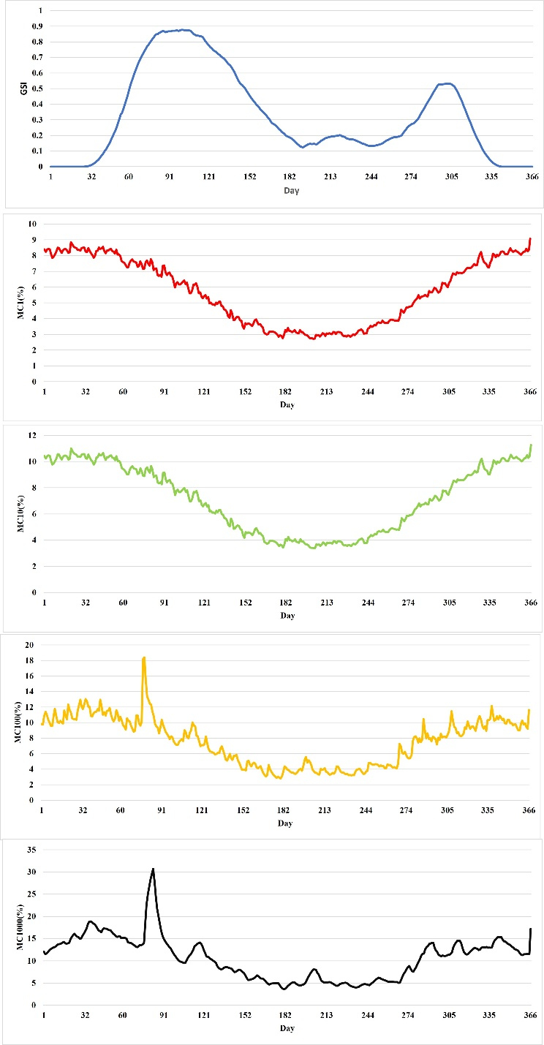
Fig. S2 Average fuel moisture content (MC) expressed as percent dry weight in different size classes (1-h, 10-h, 100-h, and 1000-h timelag) and the Growing Season Index (GSI) values for each day for ten years

Appendix 2.
Table S1 Means and standard deviations of fuel model parameters in each cluster
Fuel parameters |  |  | Cluster
 |  |  | 1 | 2 | 3 | 4 | 5 | 6 | 7 | 8 | 9 | 10
Surface fuel load (Mg/ha) | Dead fuel load | 1-hr | 7.5±1.6 | 4.3±0.93 | 4.89±1 | 3.8±1.35 | 4.71±0.75 | 3.2±1 | 1.1±0.14 | 2.5±0.9 | 1.46±0.98 | 0.7±0.23
Surface fuel load (Mg/ha) | Dead fuel load | 10-hr | 5.24±1.3 | 2.44±1.02 | 3.3±1.64 | 3.12±1.7 | 3.36±1.08 | 2.22±1.14 | 0.07±0.12 | 0.08±0.12 | 0.24±0.42 | 0±0
Surface fuel load (Mg/ha) | Dead fuel load | 100-hr | 2.94±1.2 | 2.39±1.37 | 2.7±2.17 | 4.2±4.33 | 1.93±1.08 | 2.46±1.72 | 0±0 | 0.08±0.11 | 0.06±0.19 | 0±0
Surface fuel load (Mg/ha) | Dead fuel load | 1000-hr | 3.47±0.62 | 3.21±2.25 | 1.67±1.66 | 0.79±0.74 | 2.18±1.67 | 0±0 | 0±0 | 0±0 | 00±0 | 0±0
Surface fuel load (Mg/ha) | Live fuel load | LiveH | 0±0 | 0.37±0.33 | 1.15±0.51 | 1.28±0.19 | 0.54±0.42 | 0.99±0.73 | 0.46±0.41 | 2.36±0.43 | 0.58±0.55 | 1.2±0.2
Surface fuel load (Mg/ha) | Live fuel load | LiveW | 0±0 | 1.06±0.91 | 1.56±0.81 | 2.3±1.67 | 1.14±0.72 | 1.71±0.56 | 4.41±0.23 | 0.7±0.99 | 0.35±0.52 | 0±0
Surface fuel load (Mg/ha) | Litter |  | 5.5±1.6 | 3.33±1.01 | 3.3±1.22 | 2.21±0.91 | 3.24±0.67 | 1.58±1.2 | 0.13±0.15 | 0±0 | 0±0 | 0±0
Surface fuel load (Mg/ha) | Duff |  | 2.12±3.13 | 2.94±1.93 | 3.42±2.5 | 1.88±0.31 | 3.06±1.52 | 0.58±0.41 | 0.23±0.25 | 0±0 | 0±0 | 0±0
Fuel height  (cm) | Understory (Shrubs) |  | 0±0 | 86.61±41.72 | 102.61±34.14 | 107.18±22.67 | 83.01±17.59 | 113.76±19.27 | 130±76.38 | 0±0 | 56.19±71.78 | 35.15±10.17
Fuel height  (cm) | Litter |  | 5.33±2.23 | 2.27±0.82 | 1.91±1.1 | 1.42±0.82 | 1.65±0.89 | 1.57±0.57 | 0.17±0.29 | 0±0 | 0.25±0.53 | 0±0
Fuel height  (cm) | Duff |  | 2.62±1.7 | 1.34±0.71 | 1.6±1.43 | 1.16±0.72 | 1.04±0.77 | 0.67±1.09 | 0.17±0.29 | 0±0 | 0±0 | 0±0
Fuel height  (cm) | Fuel bed |  | 24.49±10.13 | 43.34±16.01 | 52.38±10.26 | 62.1±9.05 | 45.3±15.63 | 77.21±23.94 | 98.16±9.65 | 34.98±13.16 | 23.39±17.44 | 18±5.72
SAV (cm⁻¹) | 1-hr |  | 67.89±11.5 | 65.24±9.82 | 57.96±10.9 | 67.36±0.89 | 67.83±0.77 | 53.99±28.66 | 19.59±19.41 | 58.77±3.21 | 58.8±17.02 | 53.22±16.02
SAV (cm⁻¹) | 10-hr |  | 3.84±0.86 | 3.85±0.95 | 2.77±1.33 | 3.51±0.55 | 3.54±0.35 | 4.09±0.99 | 1.33±0.32 | 1.62±0.97 | 3.14±1.79 | 0±0
SAV (cm⁻¹) | 100-hr |  | 1.32±0.21 | 1.08±0.22 | 0.99±0.21 | 1.16±0.3 | 1.17±0.19 | 1.14±0.11 | 0±0 | 0.84±0.12 | 1.25±0.12 | 0±0
SAV (cm⁻¹) | LiveH |  | 67.5±0 | 54.95±28.17 | 58.01±28.7 | 50.63±33.75 | 54±28.46 | 70.71±6.42 | 26.47±25.21 | 57.5±7.08 | 51.92±29.45 | 58.01±5.52
SAV (cm⁻¹) | LiveW |  | 62.5±0 | 52.41±22.24 | 58.46±30.44 | 46.88±31.25 | 50±26.35 | 62.33±0.35 | 41.8±36.2 | 31.5±44.54 | 24.91±29.94 | 0±0
Canopy cover (%) |  |  | 90±5.23 | 77.9±8.72 | 80.83±6.65 | 55±10.36 | 51.59±8.36 | 27.48±15.12 | 10±8.66 | 7.5±10.61 | 6.11±7.82 | 0±0

