Supplementary Document
Table S1 Customized LC classification system in LC-COM and reclassification of the existing LULC products
Customized LC class | LC-COM code | DW code | WC code | LULCM code | CLCD code | GLC-FCS30 code
Water body | 1 | 0 | 80 | 1 | 5 | 210
Grassland | 2 | 2 | 30,100 | 3 | 4 | 130,153,140
Forest land | 3 | 1,5 | 10,20 | 2,6 | 2,3 | 12,51,52,61,62,71,72,81,82, 91,92,120,121,122,150,152
Cropland | 4 | 4 | 40 | 5 | 1 | 10,11,20
ISA | 5 | 6 | 50 | 7 | 8 | 190
Barren land | 6 | 7 | 60 | 8 | 7 | 200,201,202
ice | 7 | 8 | 70 | 9 | 6 | 220
wetland | 8 | 3 | 90,95 | 4 | 9 | 180
nodata | 0 | nodata | —— | 10 | —— | 250

Table S2 Spectral indices used in LC-COM for classification
Spectral Index | Formula | Reference
Normalized Difference Vegetation Index  (NDVI) | (NIR-Red)/(NIR+Red) | Tucker [1]
Normalized Difference Built-up Index  (NDBI) | (SWIR1-NIR)/(SWIR1+NIR) | Zha, Gao and S. [2]
Modified Normalized Difference Water Index  (MNDWI) | (Green- NIR )/(Green+ NIR ) | Xu [3]
Bare Soil Index (BSI) | ((SWIR2+Red)-(NIR+Blue))/  ((WIR2+Red)+(NIR+Blue)) | Diek, Fornallaz, Schaepman and De Jong [4]
Advanced Plastic Greenhouse Index  (APGI) | 100*Coastal *Red*(2*NIR-Red-SWIR2)/  (2*NIR+Red+SWIR2) | Zhang, Du, Guo, Zhang, Tang, Chen and Zheng [5]

Table S3 Criteria of spectral indexes for reconciling the customized Landsat imagery
LC class | Criteria
Water body | MNDWI>0.2
Ice | NDSI>0.2
Wetland | NDVI>0.2,MNDWI>0.2
Barren land | -0.25<BSI<0

Table S4 Criteria of spectral indexes for refining the training samples
Customized LC class | spectral index
Water body | NDWI>0.2, NDVI＜0
Grassland | NDVI>0.2, NDWI＜0
Forest land | NDVI>0.2, NDWI＜0
Cropland | NDWI<0, NDBI<-0.1, NDVI>0.2, 0.1<APGI<0.18
ISA | NDVI<0.2,NDBI>0.1
Barren land | BSI>-0.25, NDVI<0，NDWI<0.2
Ice | NDWI>0.5, NDVI<0，BSI<-0.25
Wetland | NDVI>0.2, NDWI>0.2
Nodata | ——

Text S1 Generation of training samples of wetland
Wetlands, as a class differs greatly in the cover type [6]. Given that the five existing products of the wetland class do not cover a common area, but there are currently two international and seven provincial wetland reserves based on the official report, we accordingly removed one dataset and substituted it with the official wetland reserves to generate training samples of wetland. The basic rule of this removing process is that the dataset would have less consistency and suitability if it has less common area with the officially designated domain of wetland reserves. Here are the specific procedures:
Step 1. Based on the official documents, the minimum enclosing rectangle (MER) of each wetland reserve was derived from its longitude and latitude ranges (Fig.S1).
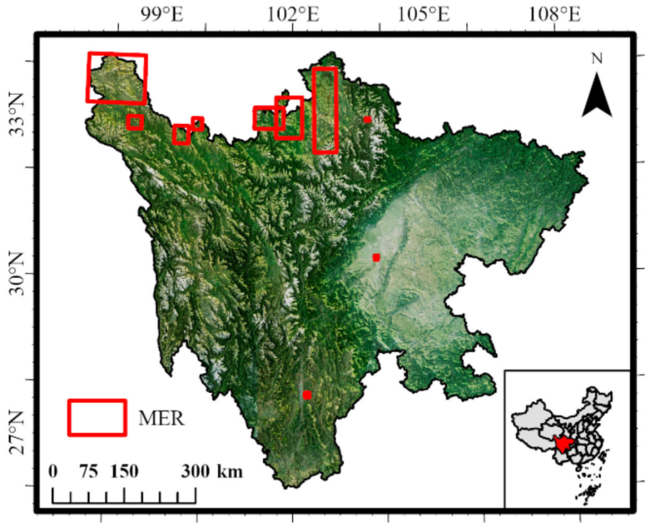

Fig.S1 minimum enclosing rectangle (MER) of the official wetland reserves
2. The wetlands of the five existing datasets were extracted individually with the mask of these MERs, and the one with the least number of wetland pixels would be removed (GLC-FCS30, Table S5).

Table S5 Number of pixels of each dataset after extraction
Dataset | Number of pixels
DW | 1682395
LCM | 667283
CLCD | 619299
WC | 49421
GLC-FCS30 | 636

3. The common area of wetland from the rest datasets was extracted. When the number of pixels in the common area is more than 1050, that is 1000 training samples and 50 verification samples can be obtained, to meet the minimum requirements; otherwise, repeat the above steps until the requirements are met.

Website of Sichuan Ruoergai Wetland National Nature Reserve:
https://rsis.ramsar.org/ris/1731
https://rsis.ramsar.org/RISapp/files/RISrep/CN1731RIS.pdf
Sichuan Changshagongma Wetlands
https://rsis.ramsar.org/ris/2348

Table S6 Customized LU classification system in LC-COM and reclassification of the existing LULC products
Customized LU class | LC-COM code | DW code | WC code | LULCM code | CLCD code | GLC-FCS30 code | China Statistical Yearbook
Water body | 1 | 0 | 80 | 1 | 5 | 210 | Land used for water and water conservancy facilities
Grassland | 2 | 2 | 30,100 | 3 | 4 | 130,153,140 | Grassland
Forest land | 3 | 1,5 | 10,20 | 2,6 | 2,3 | 51,52,61,62,71,72,81,82, 91,92,120,121,122,150,152 | Forest land
Cropland | 4 | 4 | 40 | 5 | 1 | 10,11,20 | Cultivated land
Settlements | 5 | 6 | 50 | 7 | 8 | 190 | Land used for urban,rural, industrial and mining activities; Land used for transport
unused land | 6,7 | 7,8 | 60,70 | 8,9 | 6,7 | 200,201,202,220 | Other land
wetland | 8 | 3 | 90,95 | 4 | 9 | 180 | Wetland
Garden land | -- | -- | -- | -- | -- | 12 | Garden land
nodata | 0 | nodata | -- | 10 | -- | 250 | --

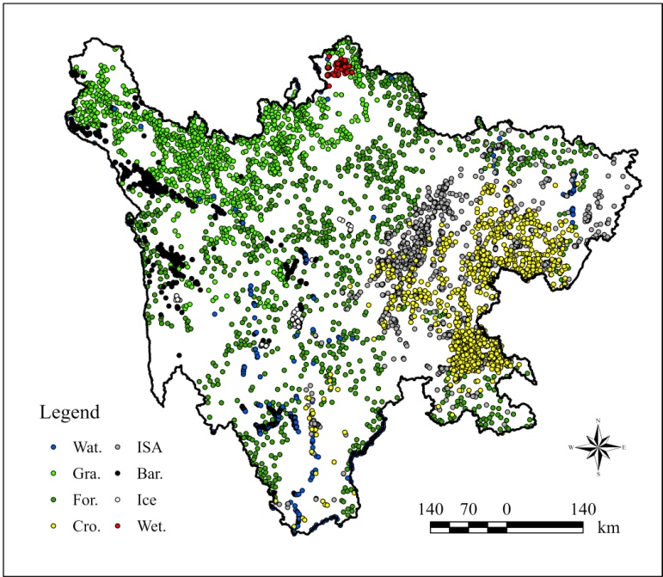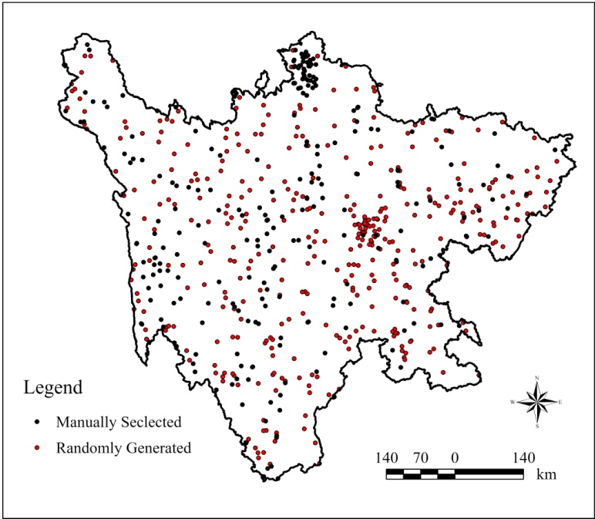
Fig.S2 Spatial distribution of generated samples, (a) training samples and (b) validation samples.

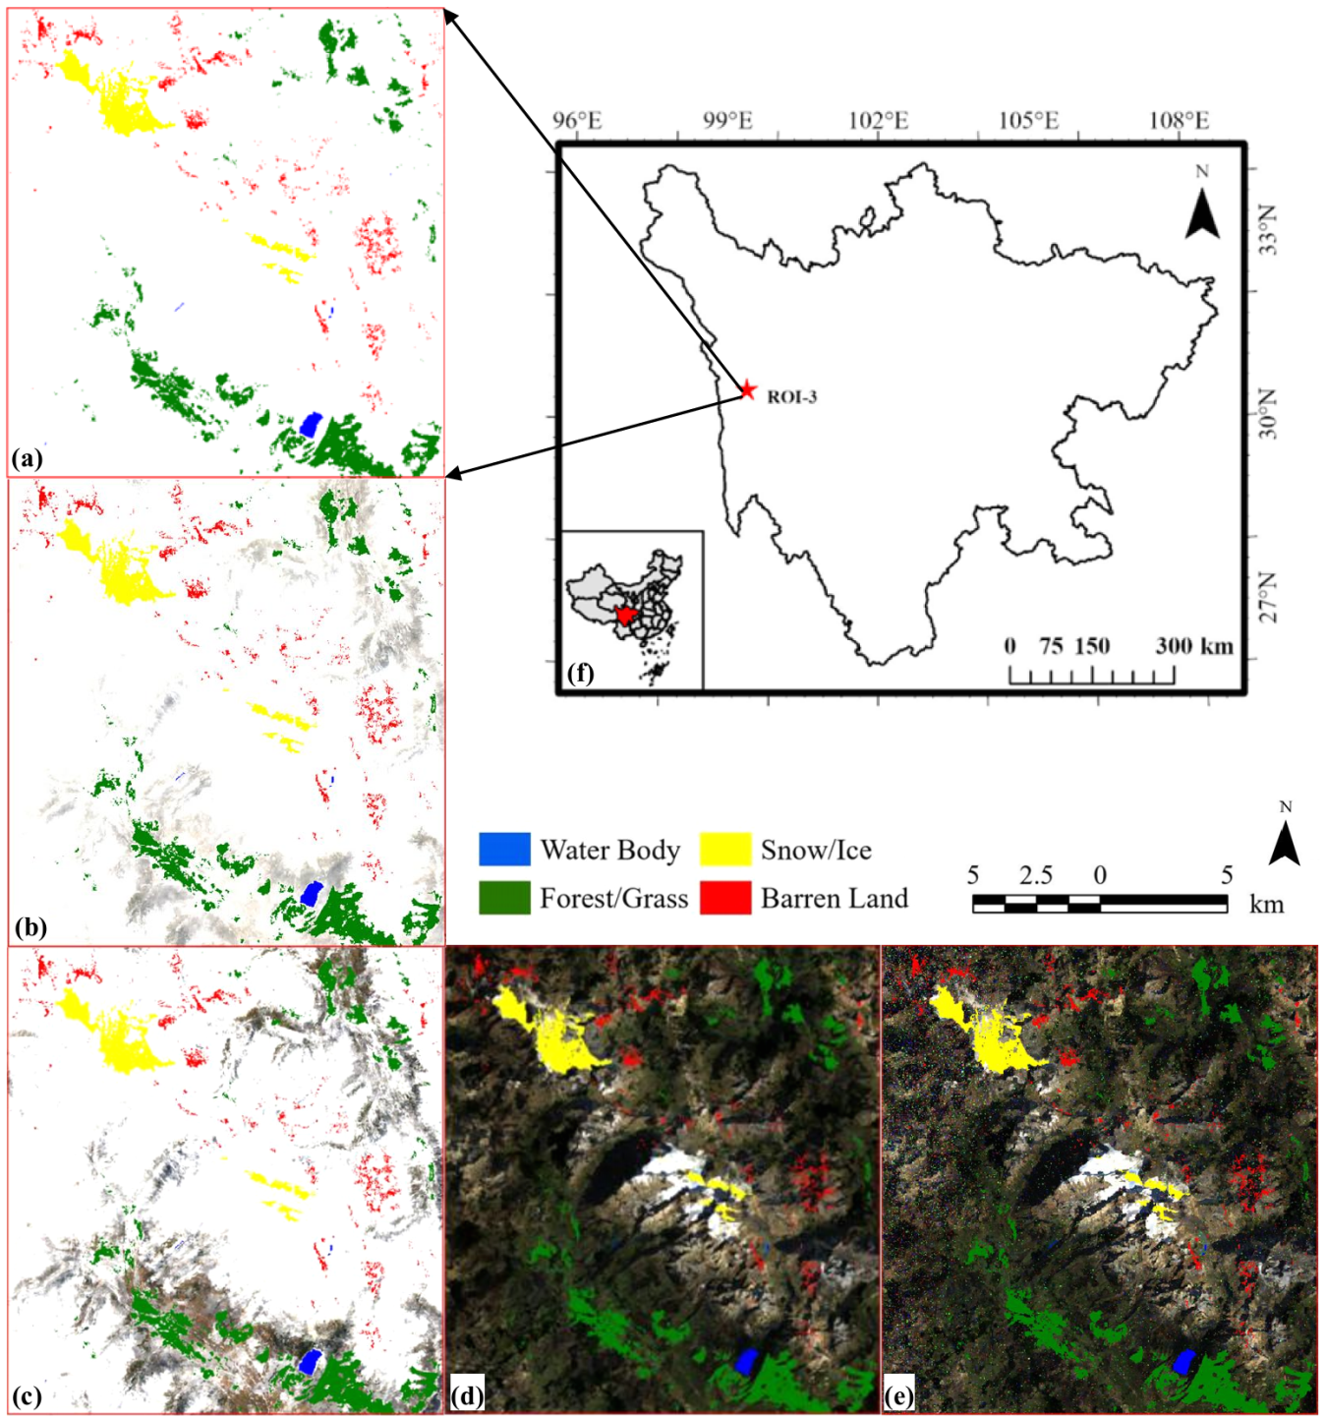
Fig.S3 Comparison of composite imageries with the common areas of selected LC classes extracted by the spectral indexes: (a) max-value, (b) mean-value, (c) median-value, (d) min-value, (e) mode-value, (f) location of the ROI.
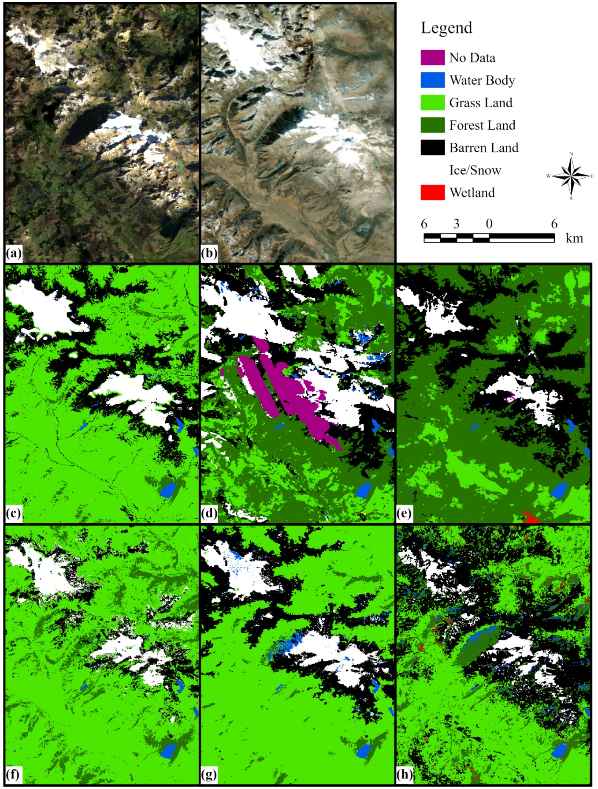
Fig. S4 Classification results in a typical snow and barren land (99.5012°E, 30.5882°N), (a) is the composite Landsat image of 2020 for classification; (b) is historical image from World Imagery Wayback, 12/16/2020; (c) is the classification result from ESA’s WC; (d) is result from Google’s DW; (e), ESRI’s LULCM; (f), CAS’s GLC-FCS30; (g), WHU’s CLCD; (h) is classification result of naive Bayes (NB) from GEE, the best one of the six classifiers’ results.

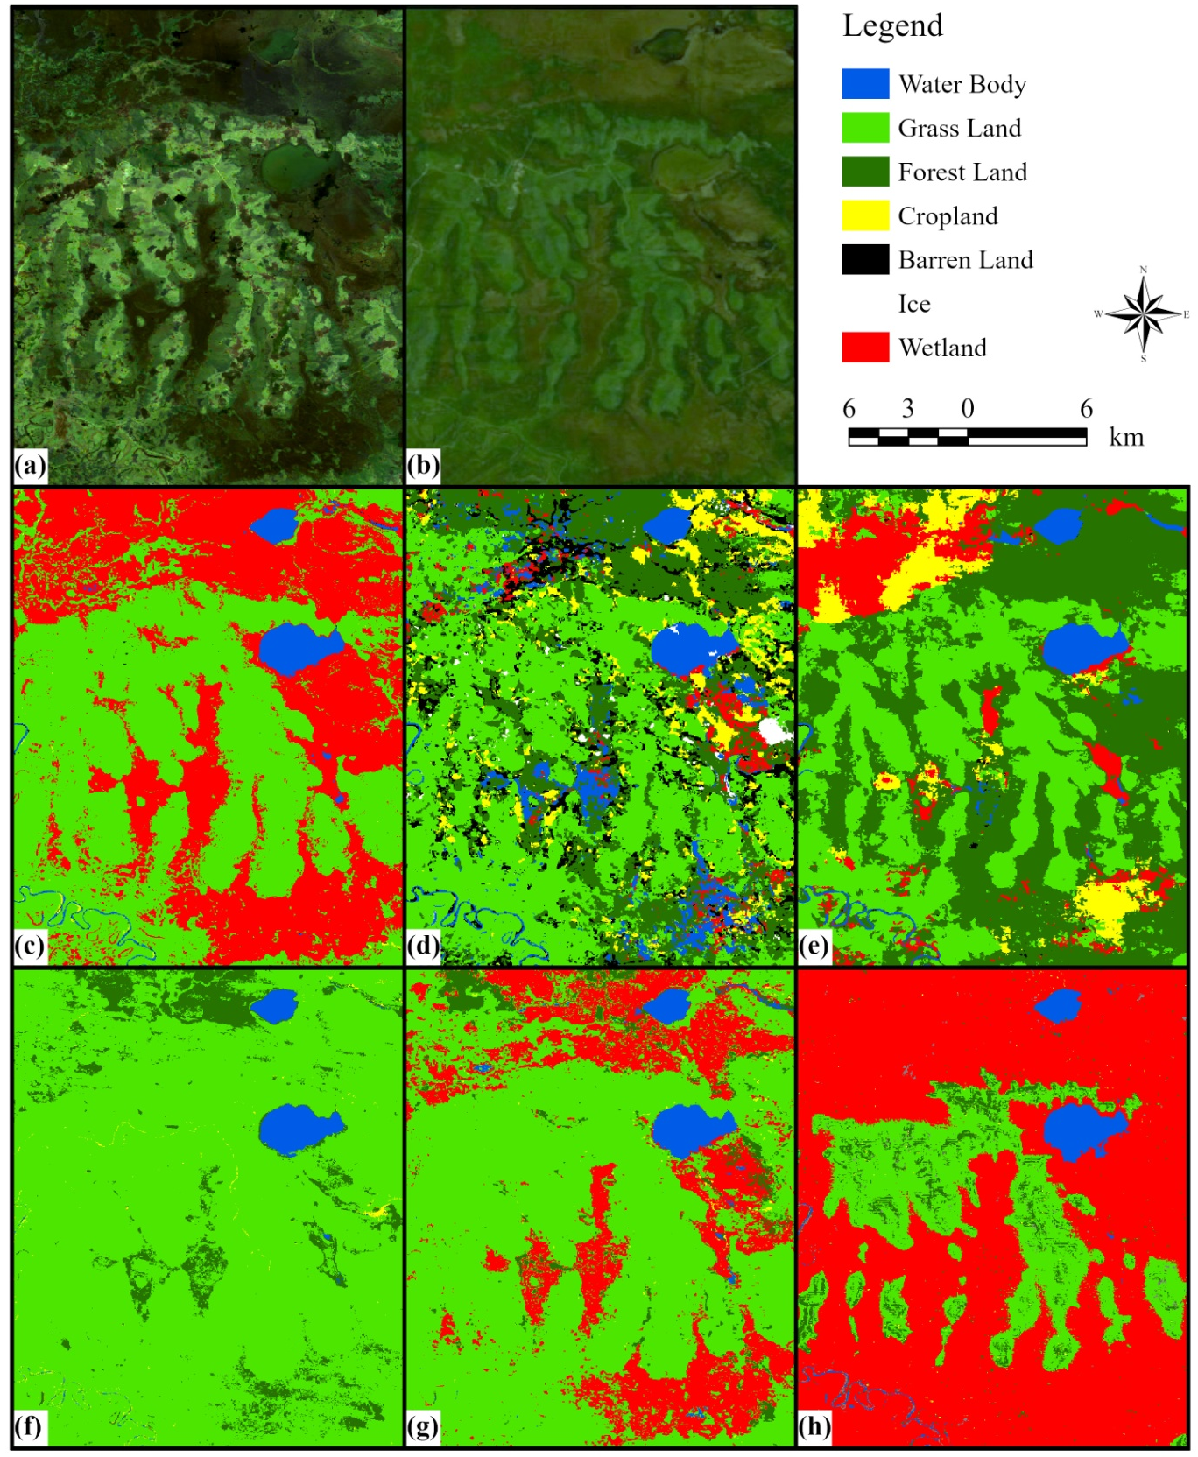
Fig.S5 Classification results in a typical snow and barren land (102.7843°E, 33.8254°N), (a) is the composite Landsat image of 2020 for classification; (b) is historical image from World Imagery Wayback, 12/16/2020; (c) is the classification result from ESA’s WC; (d) is result from Google’s DW; (e), ESRI’s LULCM; (f), CAS’s GLC-FCS30; (g), WHU’s CLCD; (h) is classification result of gradient tree boosting(GTB) from GEE, the best one of the six classifiers’ results.

Table S7 Matching accuracy of each classification dataset in the LC integration.
Dataset | Wat. B. | Gra. L | For.L | Far. L | ISA | Bar. L | Ice | Wet L
ESA | 30 | 30 | 20 | 15 | 50 | 1 | 1 | 30
DW | 15 | 15 | 1 | 1 | 1 | 1 | 1 | 1
RSRI | 15 | 15 | 1 | 1 | 1 | 1 | 1 | 1
GLC | 1 | 1 | 1 | 1 | 1 | 1 | 1 | 1
CLCD | 1 | 1 | 1 | 1 | 1 | 1 | 1 | 1
MD | 1 | 1 | 1 | 1 | 1 | 1 | 1 | 1
NB | 1 | 1 | 1 | 1 | 1 | 30 | 30 | 1
RF | 1 | 1 | 5 | 15 | 1 | 1 | 1 | 1
GTB | 1 | 1 | 1 | 1 | 1 | 1 | 1 | 1
SVM | 1 | 1 | 1 | 1 | 1 | 1 | 1 | 1
CART | 1 | 1 | 1 | 1 | 1 | 1 | 1 | 1

References
[1] C. J. Tucker, “Red and photographic infrared linear combinations for monitoring vegetation,” Remote sensing of Environment, vol. 8, no. 2, pp. 127-150, 1979.
[2] Y. Zha, J. Gao, and N. I. S., “Use of normalized difference built-up index in automatically mapping urban areas from TM imagery,” International Journal of Remote Sensing, vol. 24, no. 3, pp. 583-594, 2003.
[3] H. Xu, “Modification of normalised difference water index (NDWI) to enhance open water features in remotely sensed imagery,” International journal of remote sensing, vol. 27, no. 14, pp. 3025-3033, 2006.
[4] S. Diek, F. Fornallaz, M. E. Schaepman, and R. De Jong, “Barest pixel composite for agricultural areas using landsat time series,” Remote Sensing, vol. 9, no. 12, pp. 1245, 2017.
[5] P. Zhang, P. Du, S. Guo, W. Zhang, P. Tang, J. Chen, and H. Zheng, “A novel index for robust and large-scale mapping of plastic greenhouse from Sentinel-2 images,” Remote Sensing of Environment, vol. 276, pp. 113042, 2022.
[6] Y. Yang, P. Xiao, X. Feng, and H. Li, “Accuracy assessment of seven global land cover datasets over China,” ISPRS Journal of Photogrammetry Remote Sensing, vol. 125, pp. 156-173, 2017.

