Table. S1 Basic characteristics, stratified by CRP levels (n=42514)

 | Low CRP (<3mg/L) | High CRP (≥3mg/L) | P-value
N | 34118 | 8396
Sex, n (%) |  |  | 0.006
Woman | 8103(23.7) | 2116(25.2)
Man | 26015(76.3) | 6280(74.8)
Age | 52.44(11.58) | 56.50(11.86) | <0.001
Education, n (%) |  |  | <0.001
Low | 25535(74.8) | 6832(81.4)
High | 8583(25.2) | 1564(18.7)
Income, n (%) |  |  | <0.001
Low | 31477(92.3) | 7917(94.3)
High | 2641(7.7) | 479(5.7)
Smoke, n (%) |  |  | <0.001
No | 21466(62.9) | 5725(68.2)
Current and past | 12652(37.1) | 2671(31.8)
Alcohol intake, n (%) |  |  | <0.001
No | 19425(56.9) | 5590(66.6)
Yes | 14693(43.1) | 2806(33.4)
Physical exercise, n (%) |  |  | <0.001
No | 3385(9.9) | 585(7.0)
Yes | 30733(90.1) | 7811(93.0)
BMI | 24.91(3.25) | 26.18(3.61) | <0.001
FBG | 5.61(1.59) | 5.91(1.98) | <0.001
TG | 1.27[0.89,1.89] | 1.44[0.98,2.15] | <0.001
Mean CRP | 1.17[0.70,1.77] | 4.39[3.58,5.48] | <0.001

Notes: Continuous variables were presented as mean ± standard deviation (SD). Continuous variables that were not normally distributed were expressed as the median (interquartile range). Categorical variables were presented as numbers and percentages. Differences in normally and non-normally distributed baseline characteristics were compared using the chi-square test or t-test and Wilcoxon rank sum test, respectively. PA, physical activity; BMI, body mass index; CRP, C reactive protein; TG, triglyceride; Fbg, fasting blood-glucose; CV, coefficient of variation.

Table. S2 Number of cases of cancer during the follow-up period

 | CV of CRP
 | Overall | Lowest tertile | Middle tertile | Highest tertile
Head and neck | 133 | 33 | 56 | 44
Esophagus | 61 | 14 | 28 | 19
Gastrointestinal | 149 | 44 | 55 | 50
Colorectal | 264 | 102 | 83 | 79
Liver and gallbladder | 155 | 48 | 67 | 40
Pancreatic | 39 | 8 | 13 | 18
Lung | 502 | 197 | 149 | 156
Breast | 143 | 58 | 50 | 35
Uterus and ovaries | 55 | 18 | 19 | 18
Prostate | 72 | 32 | 18 | 22
Kidnet | 74 | 25 | 29 | 20
Urinary bladder | 56 | 21 | 20 | 15
Hematology* | 54 | 23 | 18 | 13

Notes: CV, coefficient of variation; CRP, C reactive protein.
*Tumors of the hematology include lymphoma and leukemia.

Table. S3 The association between coefficient of variation of C-reactive protein and death

 |  | Model A |  | Model B |  | Model C
 | Case | HR (95%CI) | p-value | HR (95%CI) | p-value | HR (95%CI) | p-value
Death
Low | 1344 | ref. |  | ref. |  | ref.
Moderate | 1330 | 0.99(0.911.06) | 0.707 | 1(0.93,1.08) | 0.933 | 1(0.92,1.08) | 0.931
High | 1107 | 0.81(0.750.88) | <0.001 | 0.93(0.86,1.01) | 0.071 | 0.92(0.85,1) | 0.056
Cancer-specific death
Low | 267 | ref. |  | ref. |  | ref.
Moderate | 262 | 0.98(0.831.16) | 0.807 | 0.98(0.82,1.16) | 0.782 | 0.98(0.82,1.16) | 0.777
High | 228 | 0.85(0.711.01) | 0.064 | 0.89(0.74,1.06) | 0.194 | 0.89(0.75,1.07) | 0.209

Notes: Data are presented as hazard ratios (95% confidence intervals).
Model A: unadjusted; Model B: adjusted for sex, age, education, income; Model C: additionally adjusted for BMI, smoke, alcohol intake, physical exercise based on Model B.
CV, coefficient of variation; CRP, C reactive protein; HR, hazard ratio; CI, confidence interval; P-value, probability.

Figure. S1 Trajectories of CRP from 2006-2010
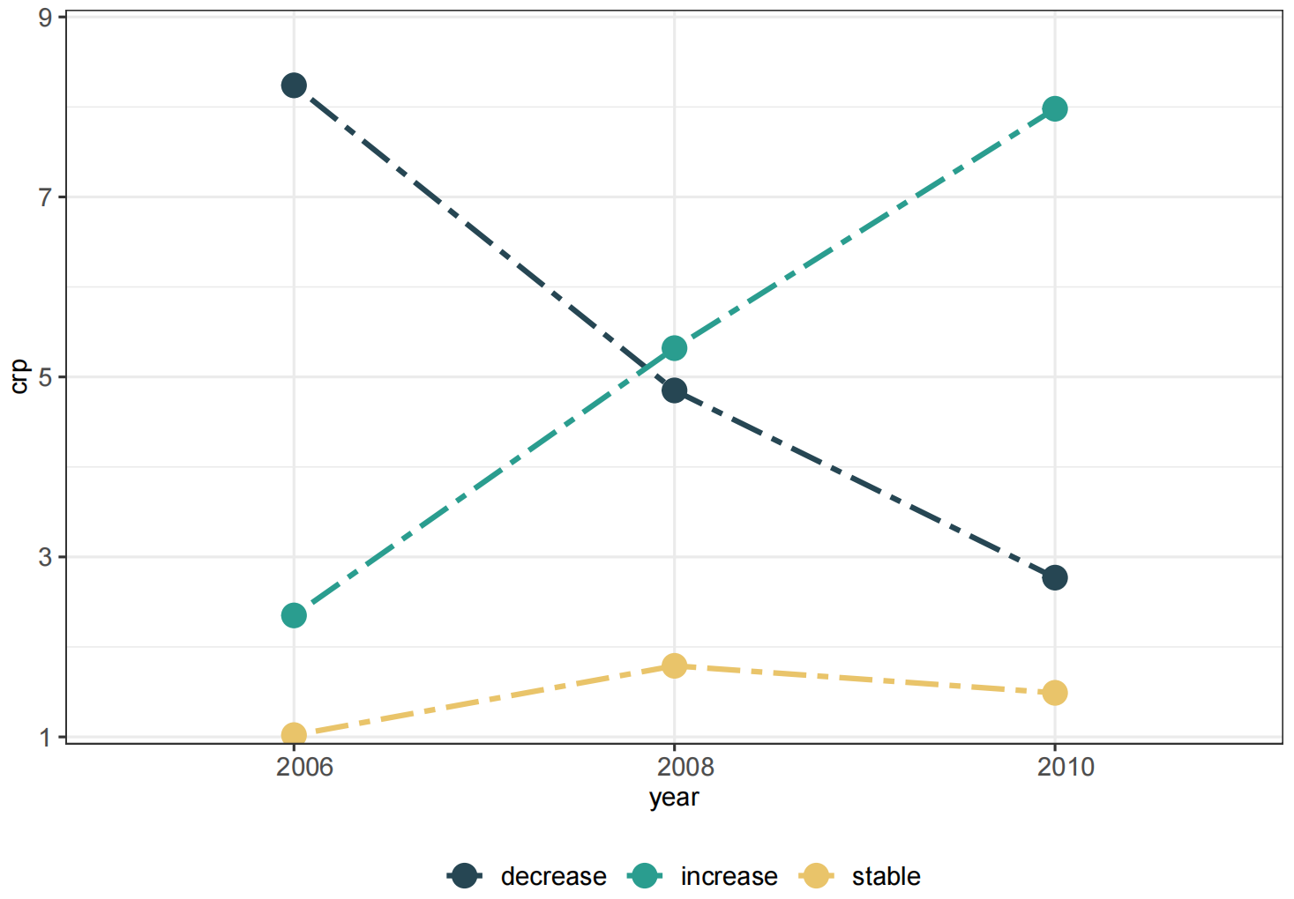

Figure. S2 Relationship between coefficient of variation and independent of the mean and cancer risk
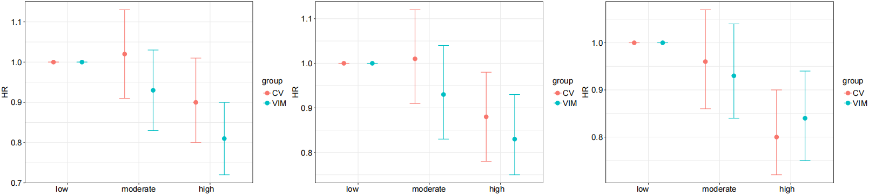

Notes: HR, hazard ratio; CV, coefficient of variability; VIM, variation independent of the mean.
- Model A: unadjusted; (b) Model B: adjusted for sex, age, education, income; (c) Model C: additionally adjusted for BMI, smoke, alcohol intake, physical activity based on Model B.

Figure. S3 Cumulative incidence of cancer and death

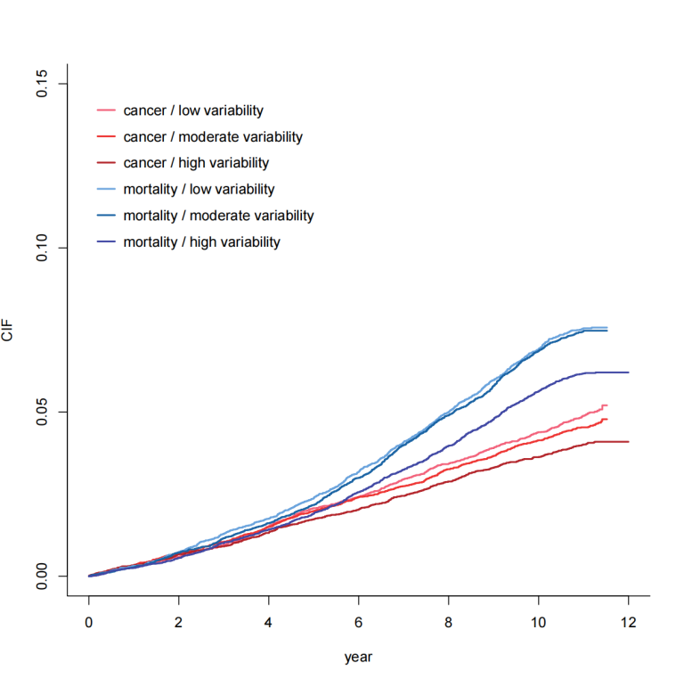

Notes: CIF, Cumulative Incidence Function

