A Comprehensive analysis of the prognostic value, expression characteristics and immune correlation of MKI67 in cancers
Xiaolan Pan^{1#}, Caibiao Wei^{1#}, Jingyu Su^{2#}, Min Fang¹ ，Qiumei Lin¹, Yuling Qin¹, Jie Gao¹, Jie Zhao^{2*} ,Huiliu Zhao^{1*}, Fengfei Liu^{1*}

¹ Department of Clinical Laboratory, Guangxi Medical University Cancer Hospital, Nanning, China
² Genetic Metabolism Center laboratory, Guangxi Zhuang Autonomous Region Maternal and Child Health Care Hospital, Nanning, China
³ Department of Medical Records, Guangxi Medical University Cancer Hospital, Nanning, China

#These authors contributed equally to this work.
*Corresponding Authors: Jie Zhao, E-mail:zhubogxnn@126.com
Huiliu Zhao, E-mail: zhl200308@163.com
Fengfei Liu, E-mail: fengfeiliu_faye@126.com

Patient clinical parameters with MKI67 expression in BRCA. (Table S1) ………………..S 2
Patient clinical parameters with MKI67 expression in LUADLUSC. (Table S2) …………S 3
Patient clinical parameters with MKI67 expression in LIHC. (Table S3)………………….S 4
Patient clinical parameter with MKI67 expression in COADREAD. (Table S4)………….S 5
Patient clinical parameters with MKI67 expression in STAD. (Table S5)………………...S 6
Patient clinical parameters with MKI67 expression in ESCA. (Table S6)………………...S 7
Patient clinical parameters with MKI67 expression in CESC. (Table S7)…………….…..S 8
Correlation analysis of MKI67 expression with TMB and MSI (Fig. S1) ………….…….S9
MKI67 co-expression network (Fig. S2) …………………………………………….….. S10
The correlation of top 10 MKI67-correlated genes (Fig. S3) ……………………….……S10
GO and KEGG analyses for these 100 genes (Fig. S4) ………………………………….S10
Abbreviations……………………………………………………………………………..S11

Table S1. Patient clinical parameters and their association with MKI67 expression in BRCA.
Clinical parameters | n | MKI67
Clinical parameters | n | Positive | Negative | p-Value
T classiffcation |  |  |  | <0.001
T1 | 631 | 228 | 403
T2 | 1144 | 539 | 575
T3+T4 | 320 | 172 | 148
N classiffcation |  |  |  | <0.001
N0 | 1021 | 403 | 609
N1+N2+N3 | 1053 | 536 | 517
M classiffcation
M0 | 1967 | 872 | 1095 | <0.001
M1 | 98 | 67 | 31
Clinical stage |  |  |  | <0.001
Ⅰ | 490 | 161 | 329
Ⅱ | 1083 | 503 | 580
Ⅲ+Ⅳ | 493 | 218 | 275
Molecular classification |  |  |  | <0.001
Triple-Negative | 189 | 146 | 43
Luminal A | 255 | 13 | 242
Lnminal B | 1309 | 585 | 724
Her-2 overexpression | 312 | 195 | 117
Differentiated degree |  |  |  | <0.001
G1 | 253 | 99 | 154
G2 | 948 | 322 | 626
G3 | 864 | 518 | 346
Age (years) |  |  |  | 0.026
≤60 | 1791 | 832 | 959
>60 | 274 | 107 | 167

Table S2. Patient clinical parameters and their association with MKI67 expression in LUADLUSC.
Clinical parameters | n | MKI67
Clinical parameters | n | Positive | Negative | p-Value
T classiffcation |  |  |  | <0.001
T1 | 536 | 193 | 343
T2 | 731 | 461 | 270
T3 | 364 | 271 | 93
T4 | 759 | 542 | 217
N classiffcation |  |  |  | <0.001
N0 | 606 | 218 | 388
N1 | 171 | 119 | 52
N2 | 709 | 479 | 230
N3 | 883 | 641 | 242
M classiffcation |  |  |  | <0.001
M0 | 1139 | 636 | 503
M1 | 1200 | 790 | 410
Clinical stage |  |  |  | <0.001
Ⅰ | 343 | 90 | 253
Ⅱ | 107 | 70 | 37
Ⅲ | 463 | 356 | 107
Ⅳ | 1166 | 764 | 402
Age (years) |  |  |  | 0.344
≤60 | 1474 | 901 | 573
>60 | 1660 | 1042 | 618
Gender |  |  |  | <0.001
Males | 2025 | 1365 | 660
Females | 1109 | 578 | 531
Pathological type |  |  |  | <0.001
LUAD | 2519 | 1378 | 1141
LUSC | 615 | 565 | 50

Table S3. Patient clinical parameters and their association with MKI67 expression in LIHC.
Clinical parameters | n | MKI67
Clinical parameters | n | Positive | Negative | p-Value
BCLA stage |  |  |  | <0.001
A | 687 | 256 | 431
B | 228 | 94 | 134
C | 302 | 181 | 121
Tumor size(cm) |  |  |  | 0.002
≥5 | 626 | 313 | 313
<5 | 453 | 184 | 269
Liver cirrhosis
Yes | 723 | 332 | 391 | 0.972
No | 731 | 335 | 396
Edmondson grade |  |  |  | <0.001
Ⅰ+Ⅱ | 549 | 196 | 380
Ⅲ+Ⅳ | 490 | 301 | 189
Node numbber |  |  |  | <0.001
≥2 | 241 | 125 | 116
1 | 1208 | 538 | 670
MVI |  |  |  | <0.001
Negativ | 586 | 198 | 388
Positive | 740 | 421 | 319
Age (years) |  |  |  | 0.001
≤60 | 1145 | 552 | 593
>60 | 309 | 115 | 194
Gender |  |  |  | 0.572
Males | 1334 | 609 | 725
Females | 120 | 58 | 62
Clonorchis sinensis |  |  |  | 0.842
Yes | 85 | 38 | 47
No | 1369 | 629 | 740

Table S4. Patient clinical parameters and their association with MKI67 expression in COADREAD.
Clinical parameters | n | MKI67
Clinical parameters | n | Positive |  | Negative |  | p-Value
T classiffcation |  |  |  |  | 0.086
T1+ T2 | 277 | 164 | 113
T3 | 659 | 352 | 307
T4 | 280 | 140 | 140
N classiffcation |  |  |  |  | 0.007
N0 | 629 | 286 | 343
N1 | 385 | 214 | 171
N2 | 200 | 97 | 103
M classiffcation |  |  |  |  | <0.001
M0 | 1104 | 615 | 489
M1 | 112 | 41 | 71
Clinical stage |  |  |  |  | 0.507
Ⅰ+Ⅱ | 952 | 520 | 432
Ⅲ+Ⅳ | 260 | 136 | 124
Age (years) |  |  |  |  | 0.162
≤60 | 643 | 359 | 284
>60 | 573 | 297 | 276
Gender |  |  |  |  | 0.782
Males | 731 | 392 | 339
Females | 485 | 264 | 221
Pathological type |  |  |  |  | 0.001
CR | 624 | 364 | 260
CC | 589 | 290 | 299
Differentiated degree |  |  |  |  | 0.048
Low | 151 | 81 | 70
Medium | 964 | 533 | 431
High | 95 | 40 | 55

Table S5. Patient clinical parameters and their association with MKI67 expression in STAD.
Clinical parameters | n | MKI67
Clinical parameters | n | Positive | Negative | p-Value
T classiffcation |  |  |  | 0.562
T1+T2 | 89 | 40 | 49
T3+T4 | 361 | 150 | 211
N classiffcation |  |  |  | 0.211
N0+N1 | 199 | 77 | 122
N2+N3 | 166 | 75 | 91
M classiffcation |  |  |  | 0.468
M0 | 345 | 145 | 200
M1 | 102 | 47 | 55
Clinical stage |  |  |  | 0.472
Ⅰ+Ⅱ | 69 | 28 | 41
Ⅲ+Ⅳ | 193 | 88 | 105
Age (years)
≤60 | 470 | 187 | 283 | <0.001
>60 | 434 | 225 | 209
Gender |  |  |  | 0.062
Males | 612 | 292 | 320
Females | 292 | 120 | 172

Table S6. Patient clinical parameters and their association with MKI67 expression in ESCA.
Clinical parameters | n | MKI67
Clinical parameters | n | Positive | Negative | p-Value
T classiffcation |  |  |  | 0.945
T1+ T2 | 17 | 9 | 8
T3 | 47 | 27 | 20
T4 | 20 | 11 | 9
N classiffcation |  |  |  | 0.571
N0 | 29 | 15 | 14
N1+N2+N3 | 55 | 32 | 23
M classiffcation |  |  |  | 0.135
M0 | 69 | 36 | 33
M1 | 15 | 11 | 4
Clinical stage |  |  |  | 0.917
Ⅰ+Ⅱ | 29 | 16 | 13
Ⅲ+Ⅳ | 55 | 31 | 24
Age (years) |  |  |  | 0.422
≤60 | 39 | 20 | 19
>60 | 45 | 27 | 18
Gender |  |  |  | 0.928
Males | 71 | 42 | 29
Females | 13 | 5 | 8

Table S7. Patient clinical parameters and their association with MKI67 expression in CESC.
Clinical parameters | n | MKI67
Clinical parameters | n | Positive | Negative | p-Value
Pathological type |  |  |  | 0.464
Cervical endocervical adenocarcinoma | 727 | 404 | 323
Cervical squamous cell carcinoma | 235 | 137 | 98
Clinical stage |  |  |  | 0.535
Ⅰ | 531 | 290 | 241
Ⅱ | 185 | 108 | 77
Ⅳ+Ⅲ | 243 | 136 | 98
Age (years) |  |  |  | <0.001
≤60 | 525 | 435 | 90
>60 | 197 | 106 | 91
Gender
Females | 962 | 541 | 421

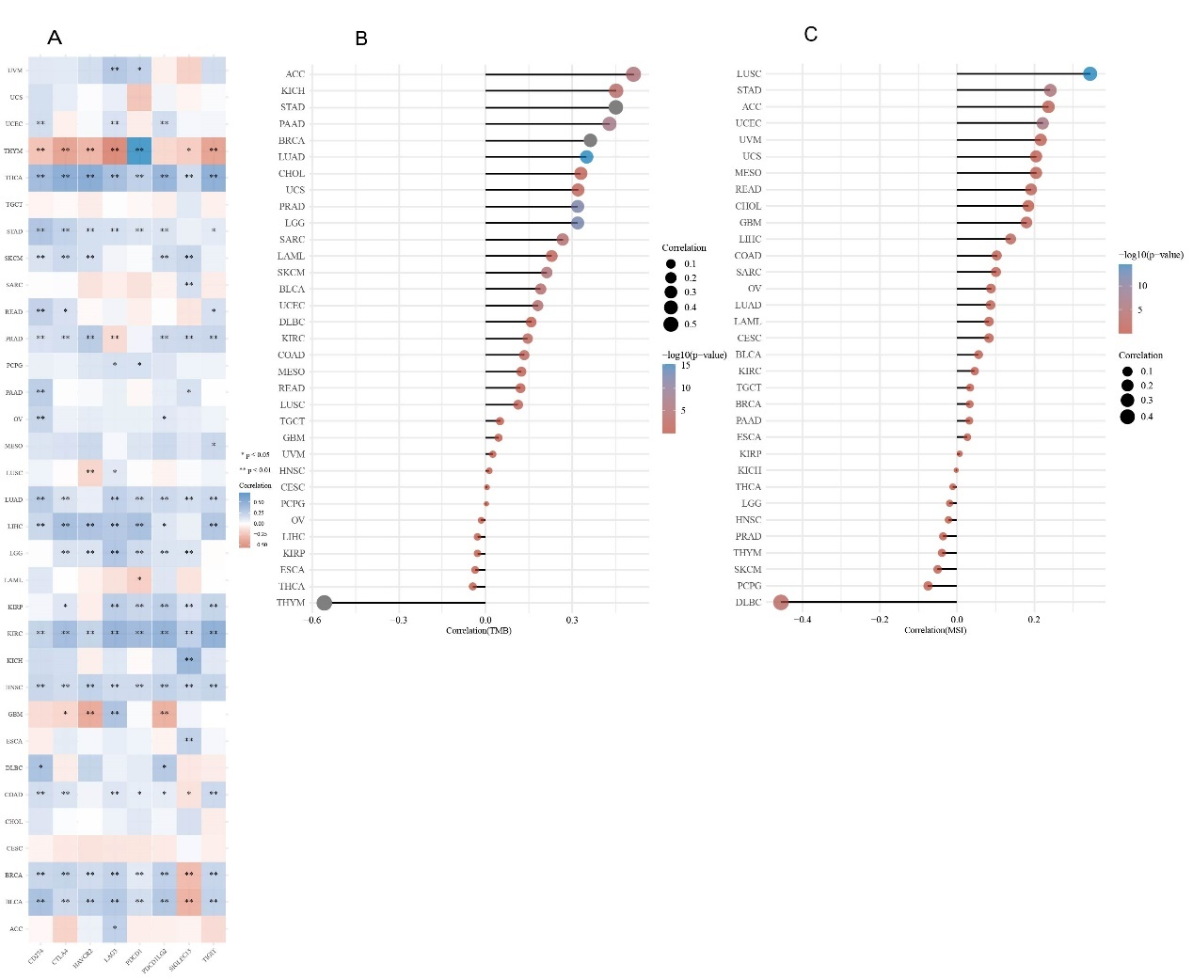
Fig.S1. (A) correlation analyses of the MKI67 expression with immune checkpoint genes in pan-cancer. (B) A stick chart shows the relationship between the MKI67 gene expression and TMB in pan-cancer. (C) A stick chart shows the association between the MKI67 gene expression and MSI in pan-cancer. ∗p < 0.05, ∗∗p < 0.01, ∗∗∗p < 0.001, and ∗∗∗∗p < 0.0001.

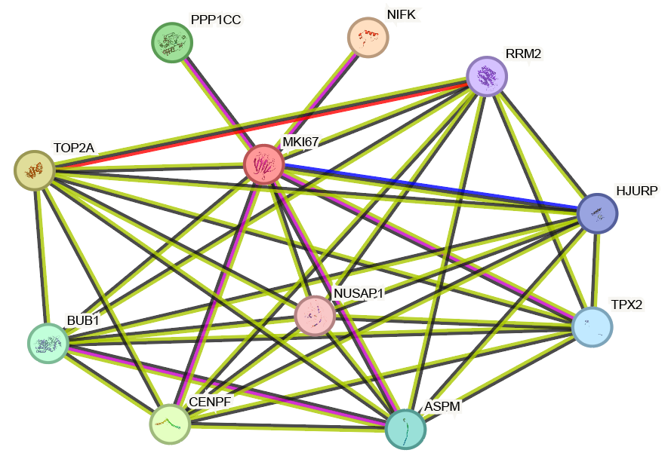
Fig S2. MKI67 co-expression network.
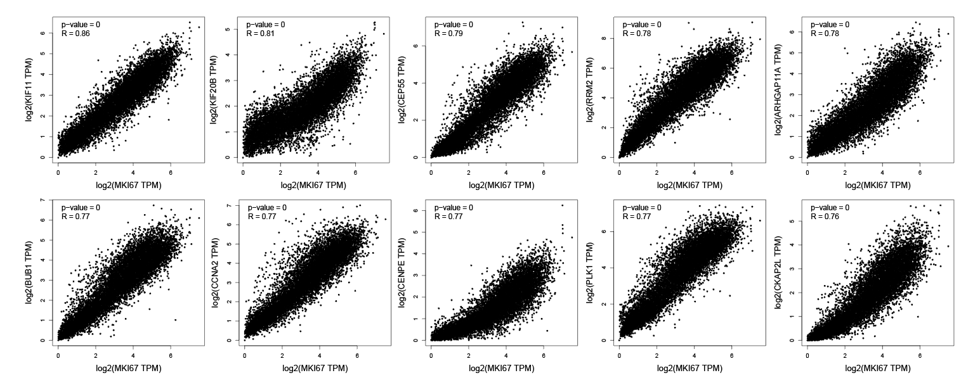
Fig S3. The correlation of top 10 MKI67-correlated genes, including KIF11, KIF20B, CEP55, RRM2, ARHGAP11A, BUB1, CCNA2, CENPE, PLK and CKAP2L.
Fig S4. (A) GO_BP analysis, GO_CC analysis and GO_MF analysis. (B) KEGG pathway analysis.
Abbreviations
MKI67 | Marker of proliferation Ki-67
ACC | Adrenocortical carcinoma
BLCA | Bladder Urothelial Carcinoma
CESC | Cervical squamous cell carcinoma and endocervical adenocarcinoma
CHOL | Cholangiocarcinoma
COAD | Colon adenocarcinoma
DLBC | Lymphoid Neoplasm Diffuse Large B-cell Lymphoma
GBM | Glioblastoma multiforme
HNSC | Head and Neck squamous cell carcinoma
KICH | Kidney Chromophobe
KIRC | Kidney renal clear cell carcinoma
KIRP | Kidney renal papillary cell carcinoma
LGG | Brain Lower Grade Glioma
LUAD | Lung adenocarcinoma
LUSC | Lung squamous cell carcinoma
MESO | Mesothelioma
OV | Ovarian serous cystadenocarcinoma
PCPG | Pheochromocytoma and Paraganglioma
READ | Rectum adenocarcinoma
SKCM | Skin Cutaneous Melanoma
STAD | Stomach adenocarcinoma
THYM | Thymoma
UCEC | Uterine Corpus Endometrial Carcinoma
UCS | Uterine Carcinosarcoma
UVM | Uveal Melanoma

