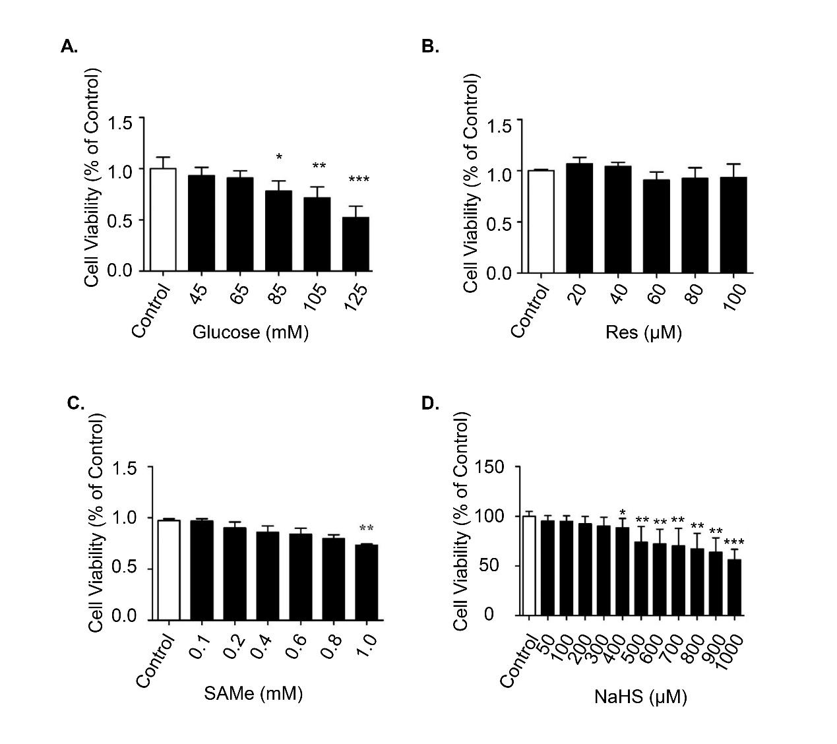
Figure S1 Effects of (A) glucose, (B) RES, (C) SAMe and (D) NaHS treatment on the cell viability of HT-22 cells. Cells were treated with a variety of concentrations of these compounds (as shown in the graph) for 24 h and cell viability was estimated by MTT assay. Data are presented as mean ± SD (n = 3). *P < 0.05, **P < 0.01, ***P < 0.001 vs control group. RES, resveratrol.

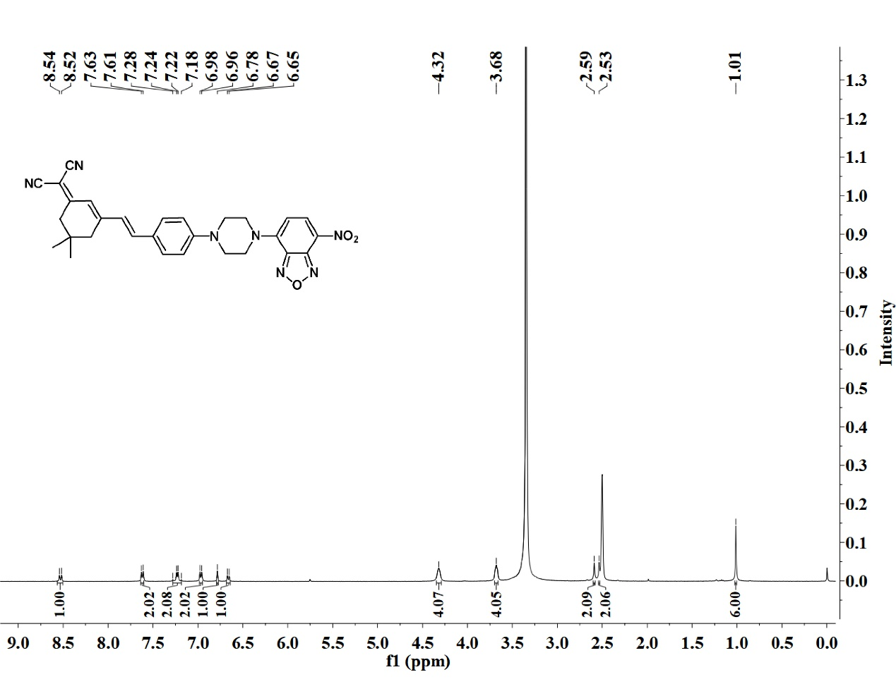
Figure S2 ¹H NMR spectrum of compound NIR-NP

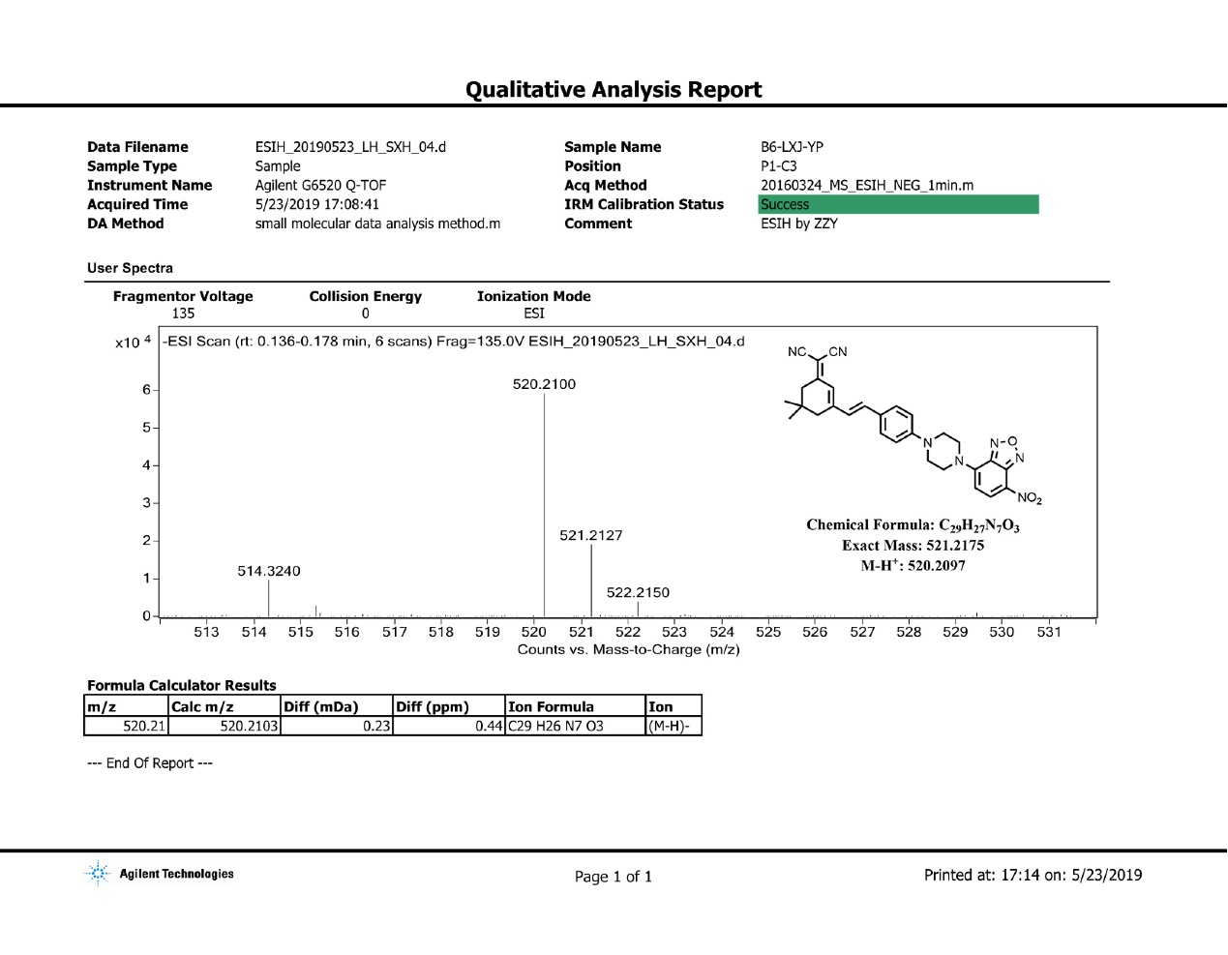
Figure S3 HRMS spectrum of compound NIR-NP.

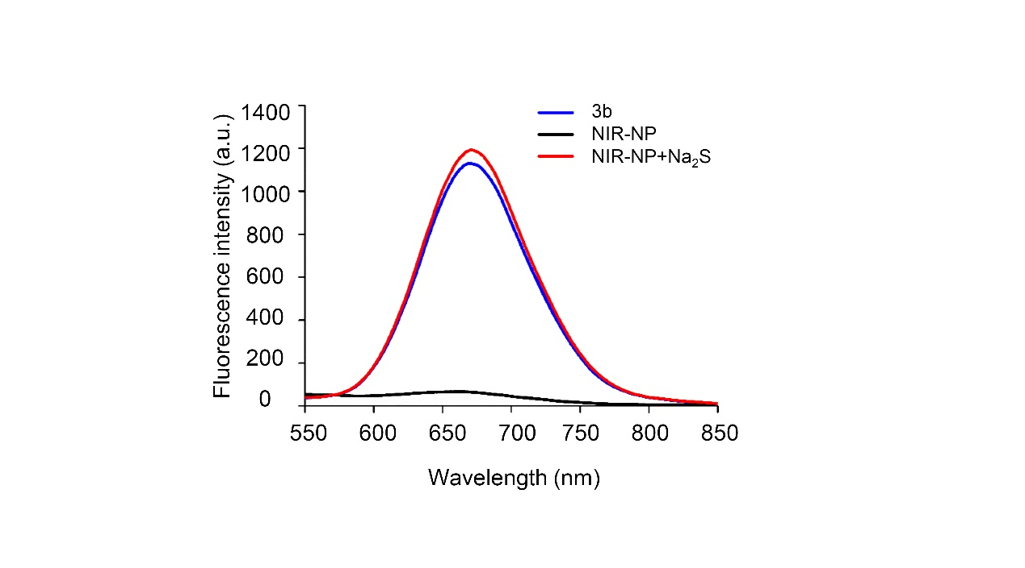
Figure S4 Fluorescence spectra of NIR-NP (10 μM) with Na₂S (100 μM) in PBS buffer (10 mM, pH = 7.4, 20% DMSO) at 37 ℃ for 20 min. Black line: NIR-NP; red line: NIR-NP + Na₂S; blue line: compound 3b (the corresponding fluorophore of NIR-NP).

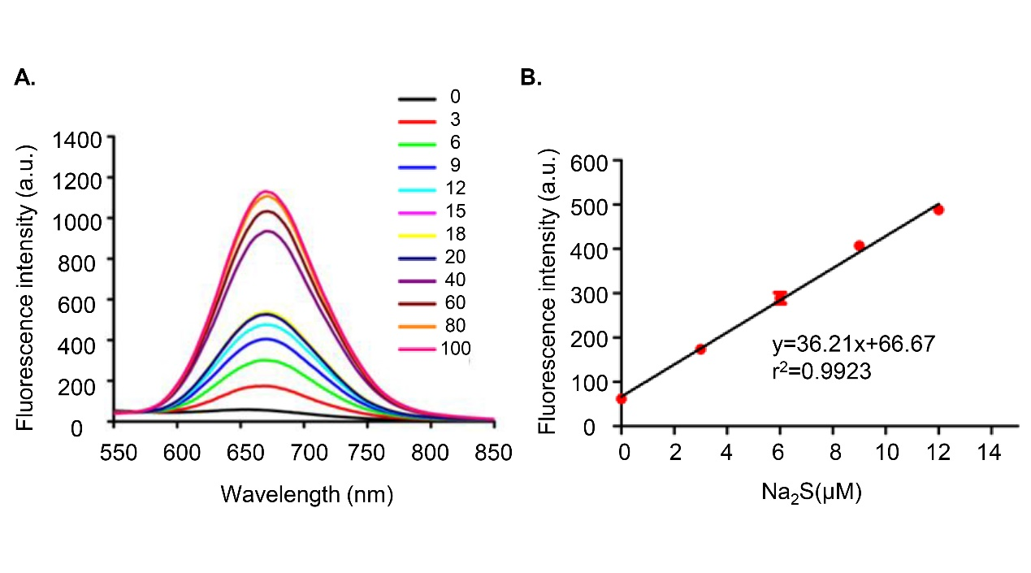
Figure S5 Fluorescence spectra of NIR-NP with different concentrations of Na₂S. (A) Fluorescence spectra of NIR-NP (10 μM) with Na₂S (0, 3, 6, 9, 12, 15, 18, 20, 40, 60, 80 and 100 μM) in PBS buffer (10 mM, pH = 7.4, 20% DMSO) at 37 ℃ for 20 min. (B) The linear relationship between the fluorescence responses of NIR-NP (10 μM) at 670 nm and the concentration of Na₂S (0 - 12 μM) in PBS buffer. Data are presented as mean ± SD (n = 3).

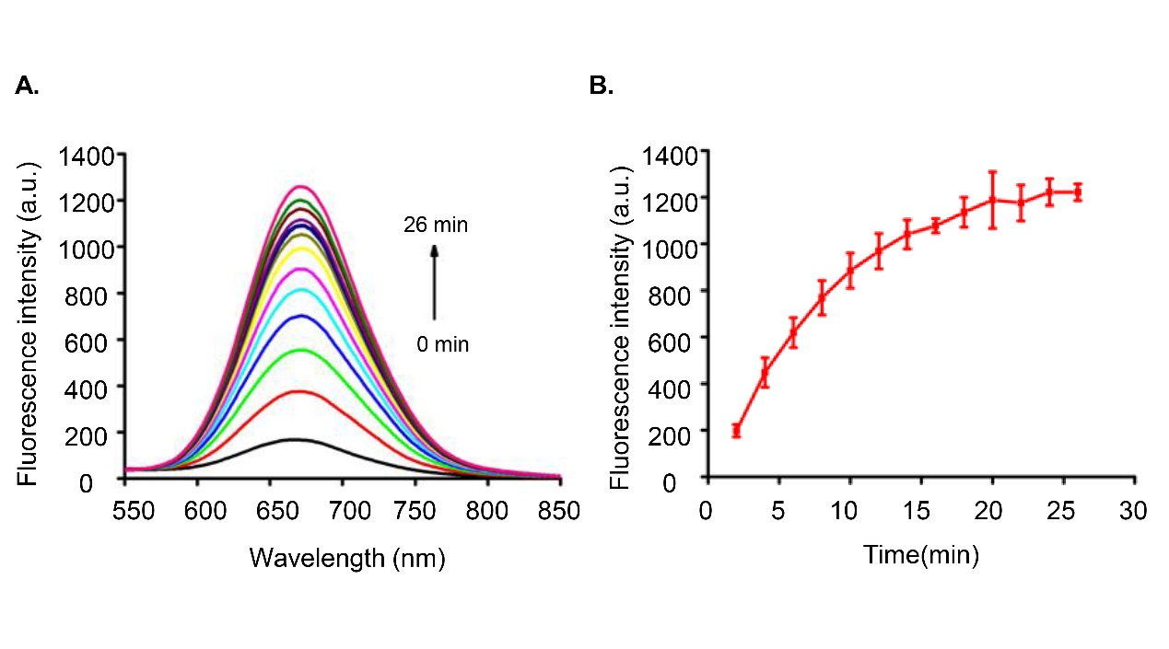
Figure S6 Time dependent fluorescent spectra of NIP-NP towards Na₂S. (A) Fluorescence emission spectrum of NIR-NP (10 μM) to Na₂S (100 μM) in PBS buffer (10 mΜ, pH = 7.4, 20% DMSO) at 37 ℃ for 2, 4, 6, 8, 10, 12, 14, 16, 18, 20, 22, 24 and 26 min. (B) Time profile of NIR-NP (10 μM) toward Na₂S (100 μM) in PBS buffer (10 mM, pH = 7.4, 20% DMSO) at 37 ℃ for 2, 4, 6, 8, 10, 12, 14, 16, 18, 20, 22, 24 and 26 min. Data are presented as mean ± SD (n = 3).

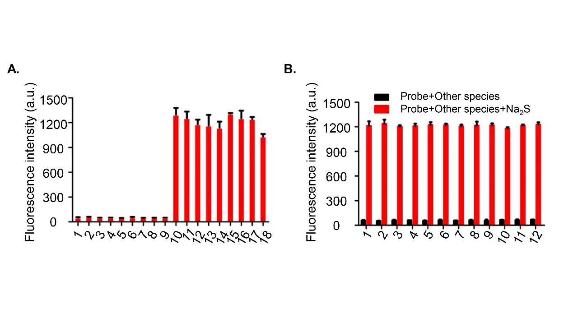
Figure S7 The effect of biothiols and other biological species on the fluorescence spectra of NIR-NP towards Na₂S. (A) Fluorescence spectra of NIR-NP (10 μM) towards Na₂S (100 μM) and various biothiols after 20 min of incubation at 37 ℃. (1) Na₂S (0 μM); (2) Hcy (100 μM); (3) GSH (100 μM); (4) Cys (100 μM); (5) S₂O₃²⁻ (100 μM); (6) Hcy (1 mM); (7) GSH (1 mM); (8) Cys (1 mM); (9) S₂O₃²⁻ (1 mM); (10) Na₂S (100 μM); (11) Na₂S (100 μM) + Hcy (100 μM); (12) Na₂S (100 μM) + Hcy (1 mM); (13) Na₂S (100 μM) + GSH (100 μM); (14) Na₂S (100 μM) + GSH (1 mM); (15) Na₂S (100 μM) + Cys (100 μM); (16) Na₂S (100 μM) + Cys (1 mM); (17) Na₂S (100 μM) + S₂O₃²⁻ (100 μM); (18) Na₂S (100 μM) + S₂O₃²⁻ (1 mM). (B) Fluorescence responses of NIR-NP (10 μM) towards Na₂S (100 μM) and other biological species after 20 min of incubation. (1) NaCl (100 μM); (2) KCl (100 μM); (3) FeCl₃ (100 μM); (4) AlCl₃ (100 μM); (5) NaClO (100 μM); (6) NaSCN (100 μM); (7) NaNO₃ (100 μM); (8) NaNO₂ (100 μM); (9) Na₂CO₃ (100 μM); (10) CH₃COONa (100 μM); (11) O₂⁻ (100 μM); (12) ·OH (100 μM); Data are presented as the mean ± SD (n = 3).
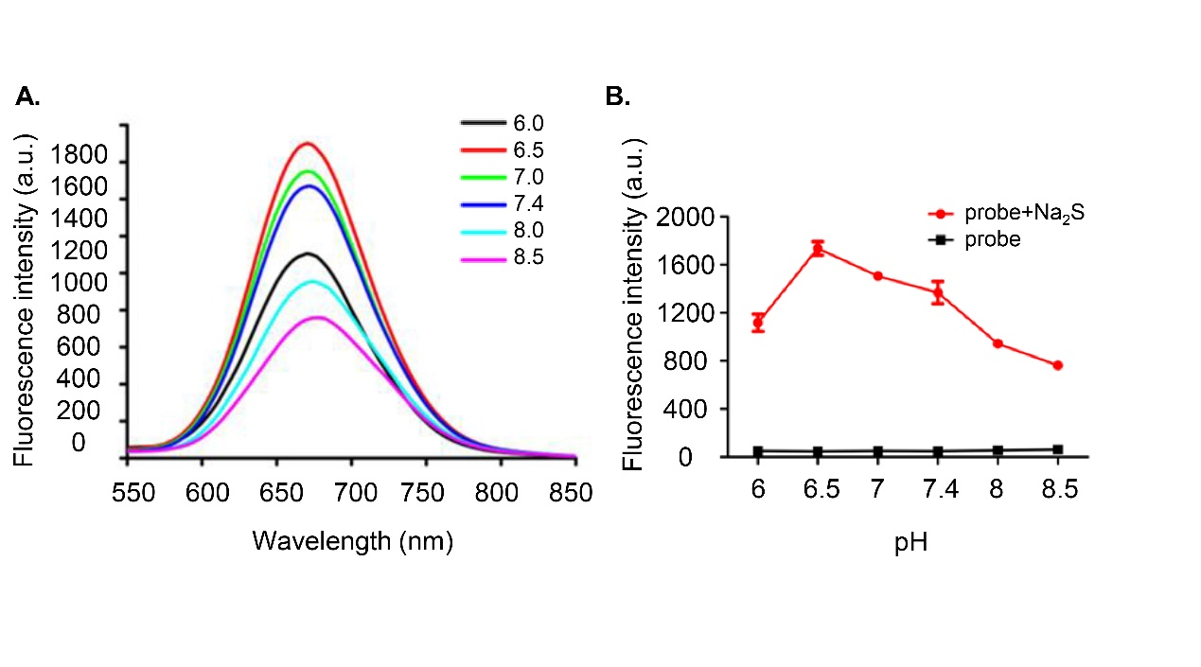
Figure S8 The effect of pH on NIR-NP toward Na₂S. (A) Fluorescence emission spectrum of NIR-NP (10 μM) towards Na₂S (100 μM) in different pH buffer (6 - 8.5) at 37 ℃ for 20 min. (B) pH profile of NIR-NP (10 μM) toward Na₂S (100 μM) in PBS buffer at different pH at 37 ℃ for 20 min. Data are presented as mean ± SD (n = 3).

