Supporting Information for
Photocatalytic hydrogen peroxide production with an external quantum yield of almost 500%

Yaozong Yan,¹ Shin-ichi Naya,²* Hisashi Sugime,^{1,3} Hiroaki Tada⁴* & Tetsuro Soejima^{1,3}*
¹ Graduate School of Science and Engineering, Kindai University, 3-4-1, Kowakae, Higashi-Osaka, Osaka 577-8502, Japan.
² Environmental Research Laboratory, Kindai University, 3-4-1, Kowakae, Higashi-Osaka, Osaka 577-8502, Japan.
³ Department of Applied Chemistry, Faculty of Science and Engineering, Kindai University, 3-4-1, Kowakae, Higashi-Osaka, Osaka 577-8502, Japan.
⁴ Institutes of Innovation for Future Society, Nagoya University, Furo-cho, Chikusa-ku, Nagoya, Aichi 464-8603, Japan.

* To whom correspondence should be addressed: Prof. Hiroaki Tada
E-mail: htada0409@gmail.com

Table of Contents
Supplementary Fig. 1 | Adsorption and decomposition properties of various metal oxides in dark. The decrement in H₂O₂ concentration of the solution (0.1 mM, 10 mL) in the presence of various metal oxide particles (100 mg) at 298 K. S4
Supplementary Fig. 2 | Morphologies of the hybrid photocatalyst components. SEM images of ATO (a) and ZnO (b). S4
Supplementary Fig. 3 | Morphology of ATO particles. TEM images of ATO particles observed at different magnifications. S5
Supplementary Fig. 4 | Morphology of ht-ATO-CL/ZnO particles. TEM-EDS analysis for ht-ATO-CL/ZnO particles. S5
Supplementary Fig. 5 | Junction state of ht-ATO-CL(100)/ZnO(50). HR-TEM image of ht-ATO-CL(100)/ZnO(50). S6
Supplementary Fig. 6 | Optical properties of the samples. Kubelka-Munk-transformed UV-Vis-NIR absorption spectra of ZnO, ATO, and ATO-CL(100)/ZnO(50). S6
Supplementary Fig. 7 | Band gap determination. Tauc plots for ZnO (a) and ATO (b). S7
Supplementary Fig. 8 | Relationship between the mixing ratio of ATO-CL(x)/ZnO(50) and photocatalytic activity for H₂O₂ production. Plots of the H₂O₂ concentration generated after 12 h irradiation vs. ATO content. The values in the abscissa show the x values with the y value fixed at 50 mg. S7
Supplementary Fig. 9 | Catalytic activity and photocatalytic activity for H₂O₂ decomposition. Time courses for the H₂O₂ concentration in the presence of Au/TiO₂ and ATO-CL(100)/ZnO₂(50) in dark and under UV-light irradiation (λ = 365 nm) using two LED lamps (each light intensity = 120 mW cm⁻²). S8
Supplementary Fig. 10 | Kinetic isotope effect of H₂O₂ production. Time courses for ATO-CL(100)/ZnO(50)-photocatalyzed H₂O₂ production in the 4 vol% C₂H₅OH and C₂D₅OD aqueous solutions at 288 K. S8

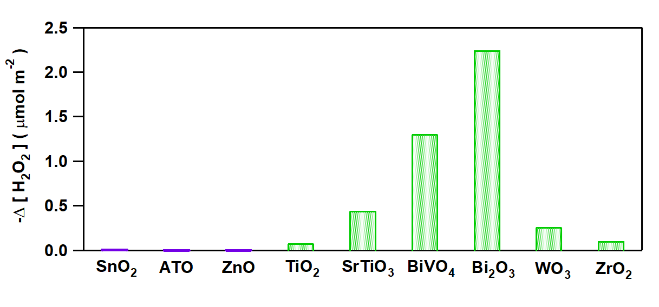

Supplementary Fig. 1 | Adsorption and decomposition properties of various metal oxides in dark. The decrement in H₂O₂ concentration of the solution (0.1 mM, 10 mL) in the presence of various metal oxide particles (100 mg) at 298 K.

Supplementary Fig. 2 | Morphology of ZnO particles. TEM images of ZnO particles observed at different magnifications.

Supplementary Fig. 3 | Morphology of ATO particles. TEM images of ATO particles observed at different magnifications.

Supplementary Fig. 4 | Morphology of ht-ATO-CL/ZnO particles. TEM-EDS analysis for ht-ATO-CL/ZnO particles.

Supplementary Fig. 5 | Junction state of ht-ATO-CL(100)/ZnO(50). HR-TEM image of ht-ATO-CL(100)/ZnO(50).

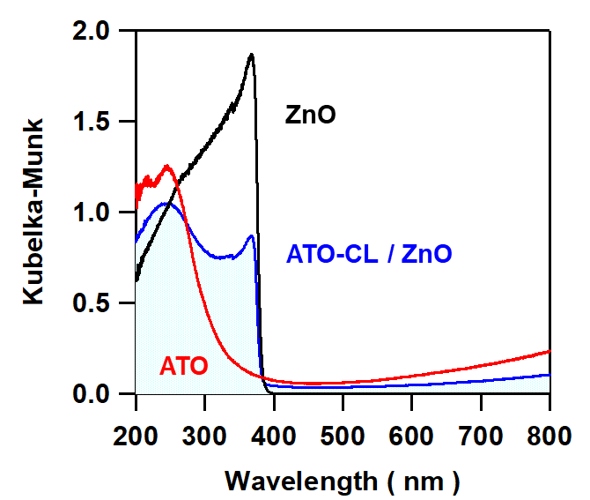

Supplementary Fig. 6 | Optical properties of the samples. Kubelka-Munk-transformed UV-Vis-NIR absorption spectra of ZnO, ATO, and ATO-CL(100)/ZnO(50).

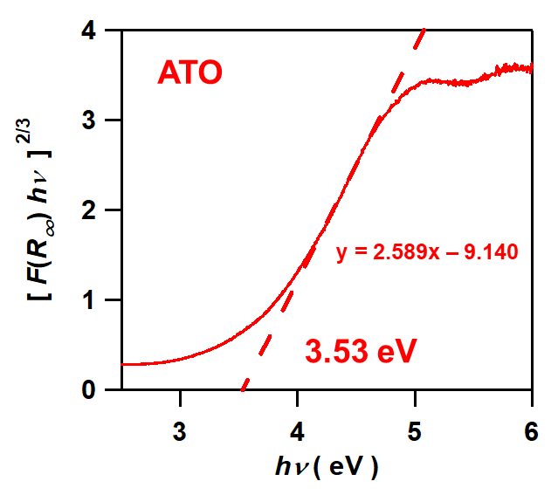
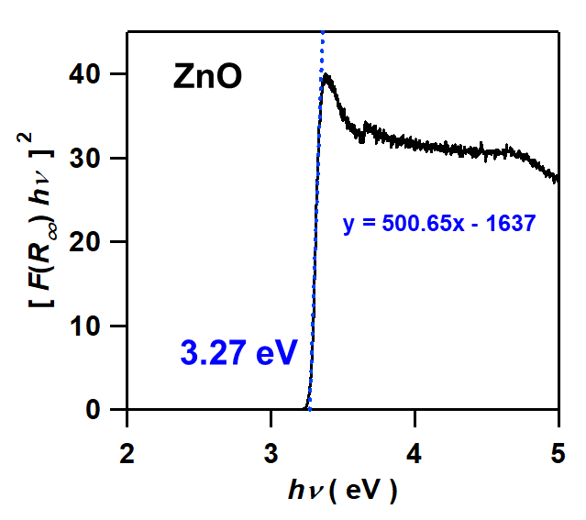
- (b)

Supplementary Fig. 7 | Optical band gaps of the samples. Tauc plots of ZnO (a) and ATO (b).

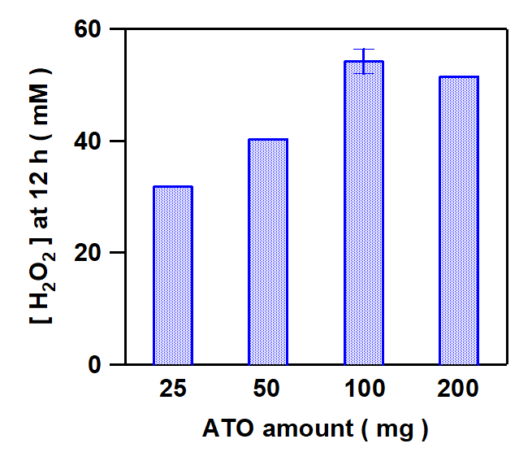

Supplementary Fig. 8 | Relationship between the mixing ratio of ATO-CL(x)/ZnO(50) and photocatalytic activity for H₂O₂ production. Plots of the H₂O₂ concentration generated after 12 h irradiation vs. ATO content. The values in the abscissa show the x values with the y value fixed at 50 mg.

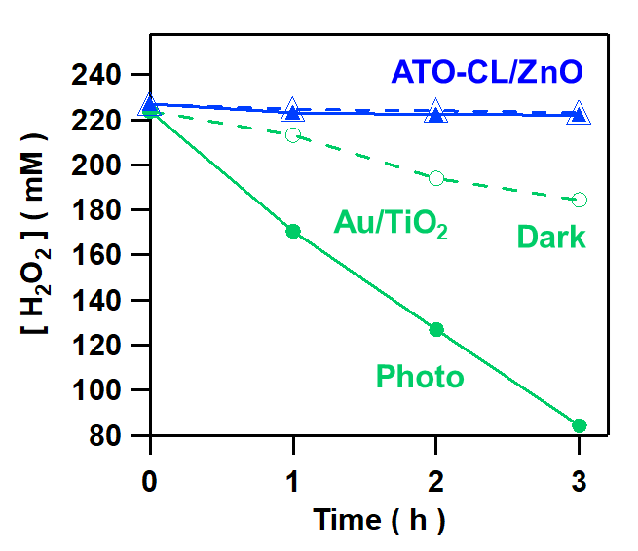

Supplementary Fig. 9 | Catalytic activity and photocatalytic activity for H₂O₂ decomposition. Time courses for the H₂O₂ concentration in the presence of Au/TiO₂ and ATO-CL(100)/ZnO₂(50) in dark and under UV-light irradiation (λ = 365 nm) using two LED lamps (each light intensity = 120 mW cm⁻²).
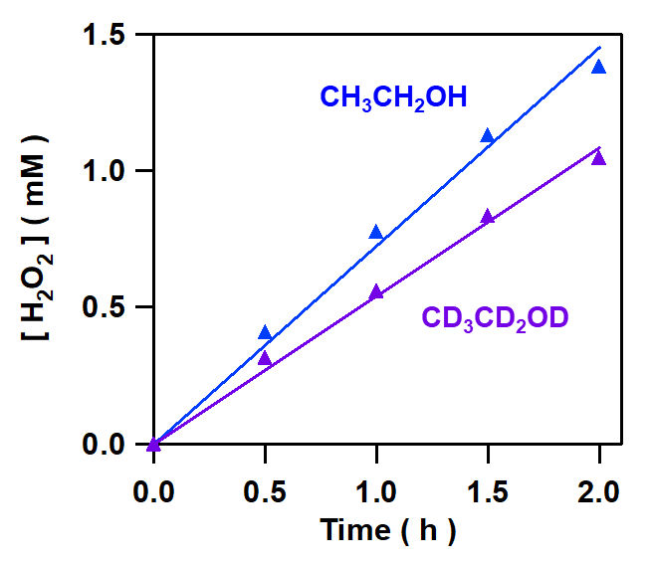

Supplementary Fig. 10 | Kinetic isotope effect of H₂O₂ production. Time courses for ATO-CL(100)/ZnO(50)-photocatalyzed H₂O₂ production in the 4 vol% C₂H₅OH and C₂D₅OD aqueous solutions at 288 K.

