Supplemental information

Increased matrix stiffness promotes fibrogenesis of hepatic stellate cells
through AP-1-induced chromatin priming
Wenxue Zhao, Weihong Yuan, Tian Dong, Wei Qi, Zhijie Feng, Cheng Li, Yujie Sun

Supplementary Figure 1
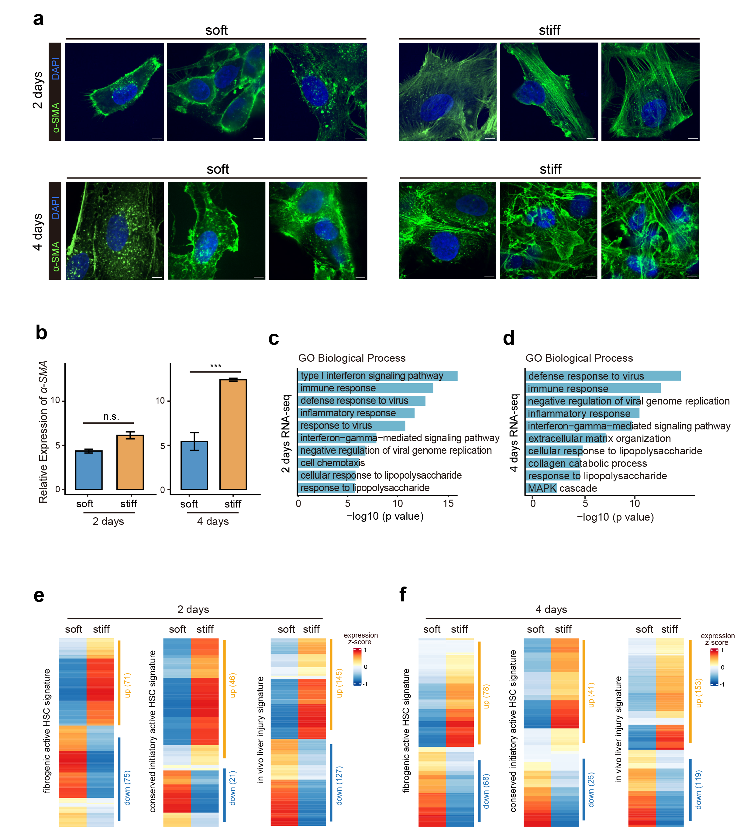

Fig S1. Different matrix stiffness facilitates HSC fibrogenesis as revealed by transcriptome profiling.
- Representative immunofluorescence images of LX-2 cells cultured on different matrices for two (up panel) or four days (bottom panel). scale bar, 10 μm.
- qPCR showing the relative expression of α-SMA in cells cultured in different matrixes for two or four days. The relative expression results were normalized to GAPDH.
- GO enrichment analysis of downregulated genes in cells cultured in the stiff matrix for two days (adjusted p value < 0.05).
- GO enrichment analysis of downregulated genes in cells cultured in the stiff matrix for four days (adjusted p value < 0.05).
- Heatmaps showing the gene expression level of the active fibrogenic HSC signature, conserved initiatory HSC signature, and in vivo liver injury signature for cells cultured in the soft or stiff matrix for two days.
- Heatmaps showing the gene expression level of the active fibrogenic HSC signature, conserved initiatory HSC signature, and in vivo liver injury signature for cells cultured in the soft or stiff matrix for four days.

Supplementary Figure 2
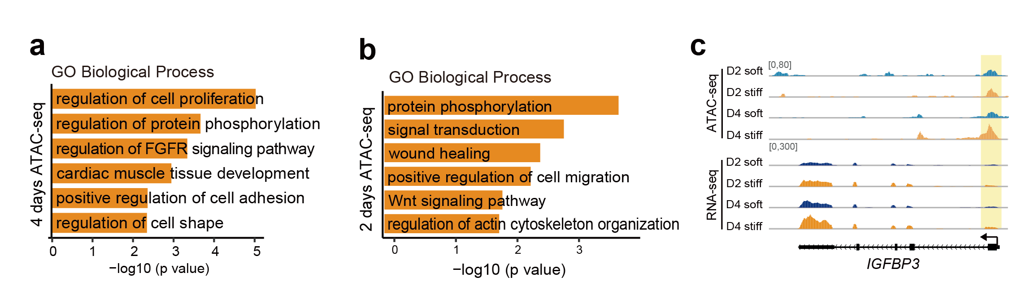
Fig S2. ATAC-seq analysis of specific chromatin accessibility clusters and adjacent gene function annotation.
- Top enriched GO (Gene Ontology) terms for peaks (adjusted p value < 0.05) in increased accessible chromatin regions in cells cultured in the stiff matrix for four days.
- Top enriched GO (Gene Ontology) terms for peaks (adjusted p value < 0.05) in increased accessible chromatin regions in cells cultured in stiff matrix for two days.
- Normalized ATAC-seq signal profiles at a locus in IGFBP3 (“D4 stiff” cluster) in cells cultured in the soft or stiff matrix, shown together with a normalized RNA-seq profile.

Supplementary Figure 3
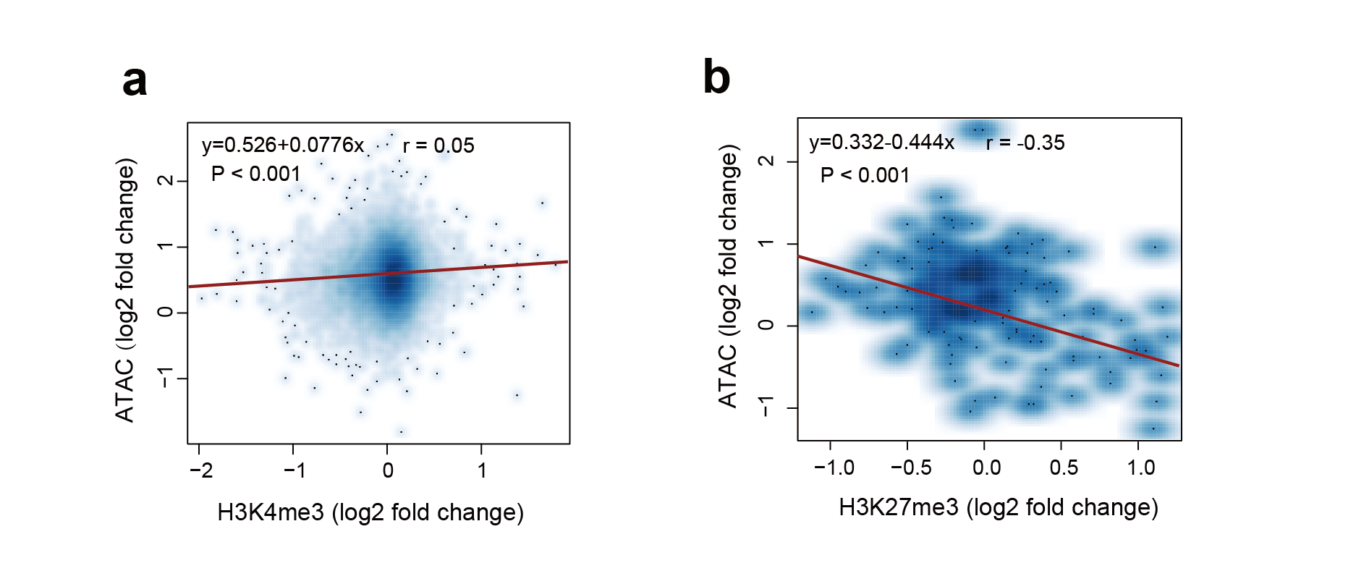

Fig. S3 Characteristics of histone modification levels around primed chromatin (defined in Figure 2).
- The correlation between chromatin accessibility and the H3K4me3 histone modification in all primed chromatin regions in response to mechanical stimuli (2 independent experiments).
- The correlation between chromatin accessibility and the H3K27me3 histone modification in all primed chromatin regions in response to mechanical stimuli (2 independent experiments).

Supplementary Figure 4
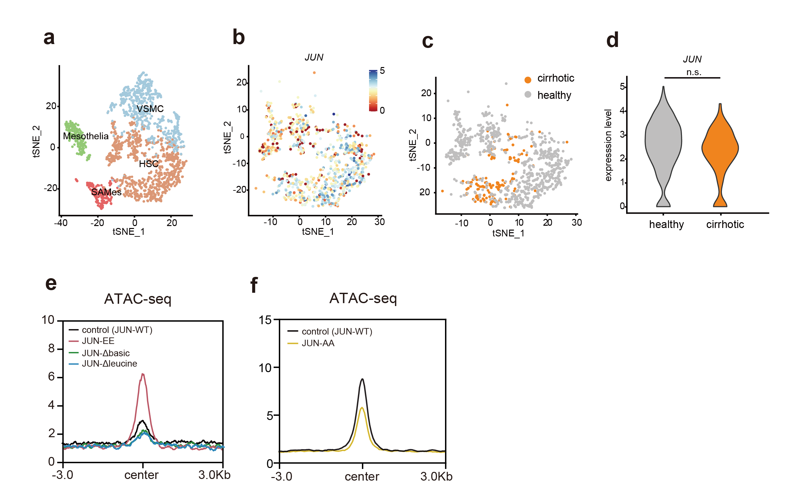

Fig. S4 p-JUN contributes to the maintenance of primed chromatin accessibility related to fibrosis.
- Clustering of 2,031 mesenchymal cells from healthy (n = 4) and cirrhotic (n = 3) human livers identified the HSC cluster.
- Expression of JUN across 946 HSCs from healthy (n = 4) and cirrhotic (n = 3) human livers (red, high; blue, low).
- Annotation of HSC injury condition (healthy or cirrhotic).
- Violin plot showing the expression of c-jun across HSCs from healthy (n = 4) and cirrhotic (n = 3) human livers. (unpaired wilcoxon test; two-tailed), p < 0.05, *; p < 0.01, **; p < 0.001, ***.
- Normalized ATAC-seq signal profiles in the chromatin regions excluding primed chromatin following the expression of JUN-EE, JUN-EE-Δbasic and JUN-EE-Δleucine shown in Fig. 5a.
- Normalized ATAC-seq signal profiles in the chromatin regions excluding primed chromatin following the expression of JUN-AA shown in Fig. 5a.

Supplementary Figure 5
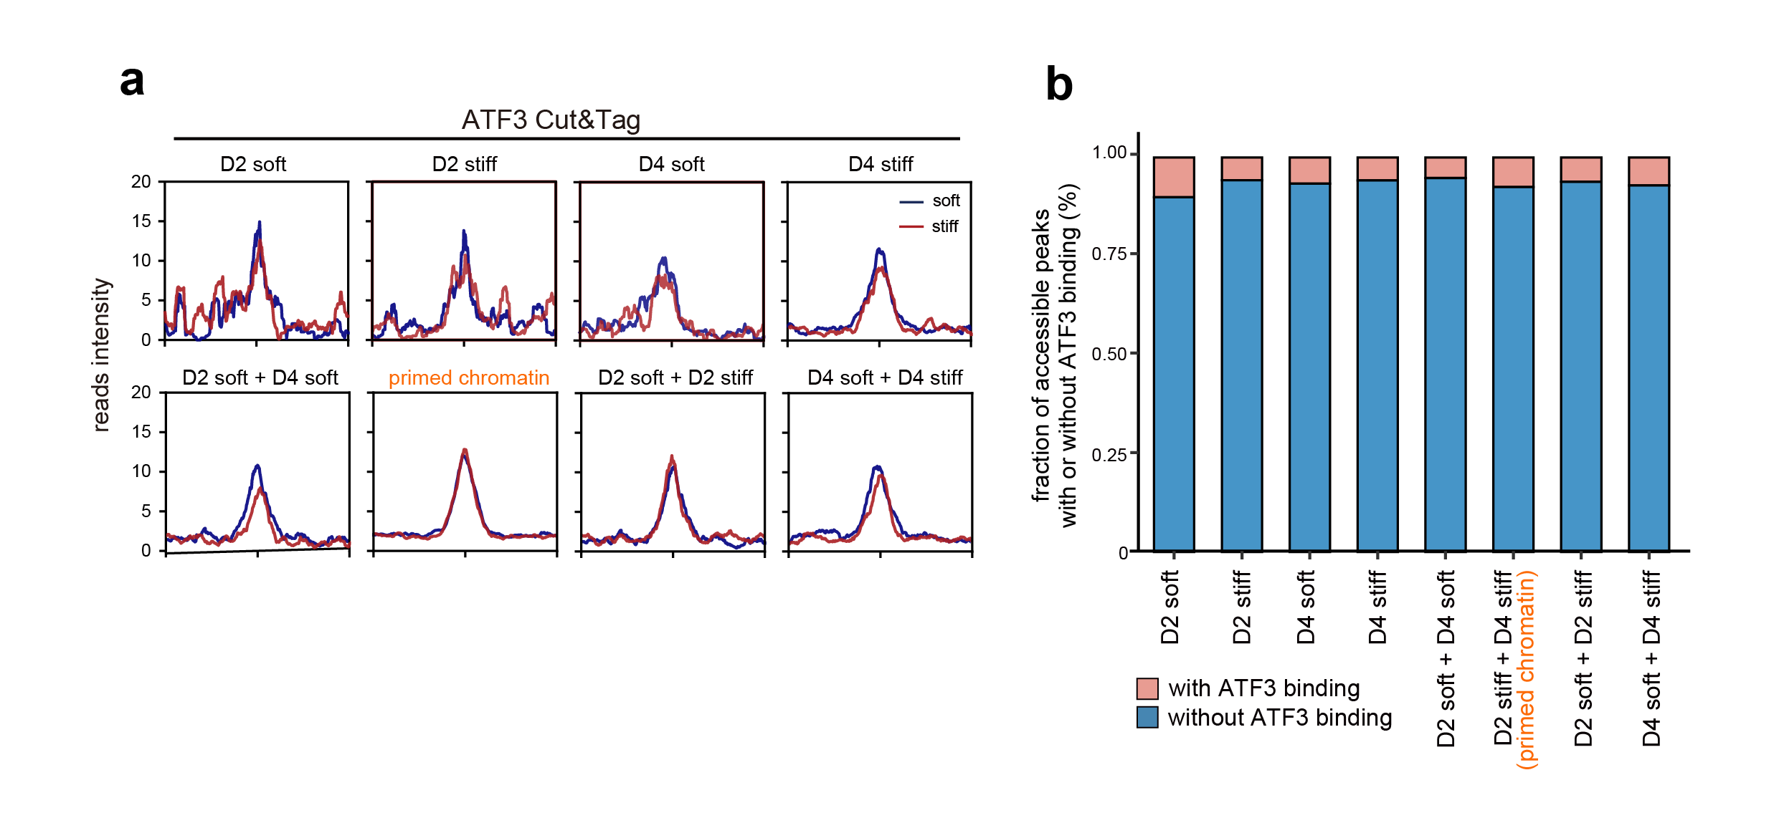

Fig. S5 Enrichment profile of ATF3 AP-1 TFs in the global and primed chromatin regions.
- Cut&Tag signal showing the binding of ATF3 in different chromatin region clusters defined in Fig. 2a.
- Stacked bar plots showing the binding faction of ATF3 in defined chromatin region clusters. Primed chromatin is highlighted in yellow.

Supplementary Figure 6
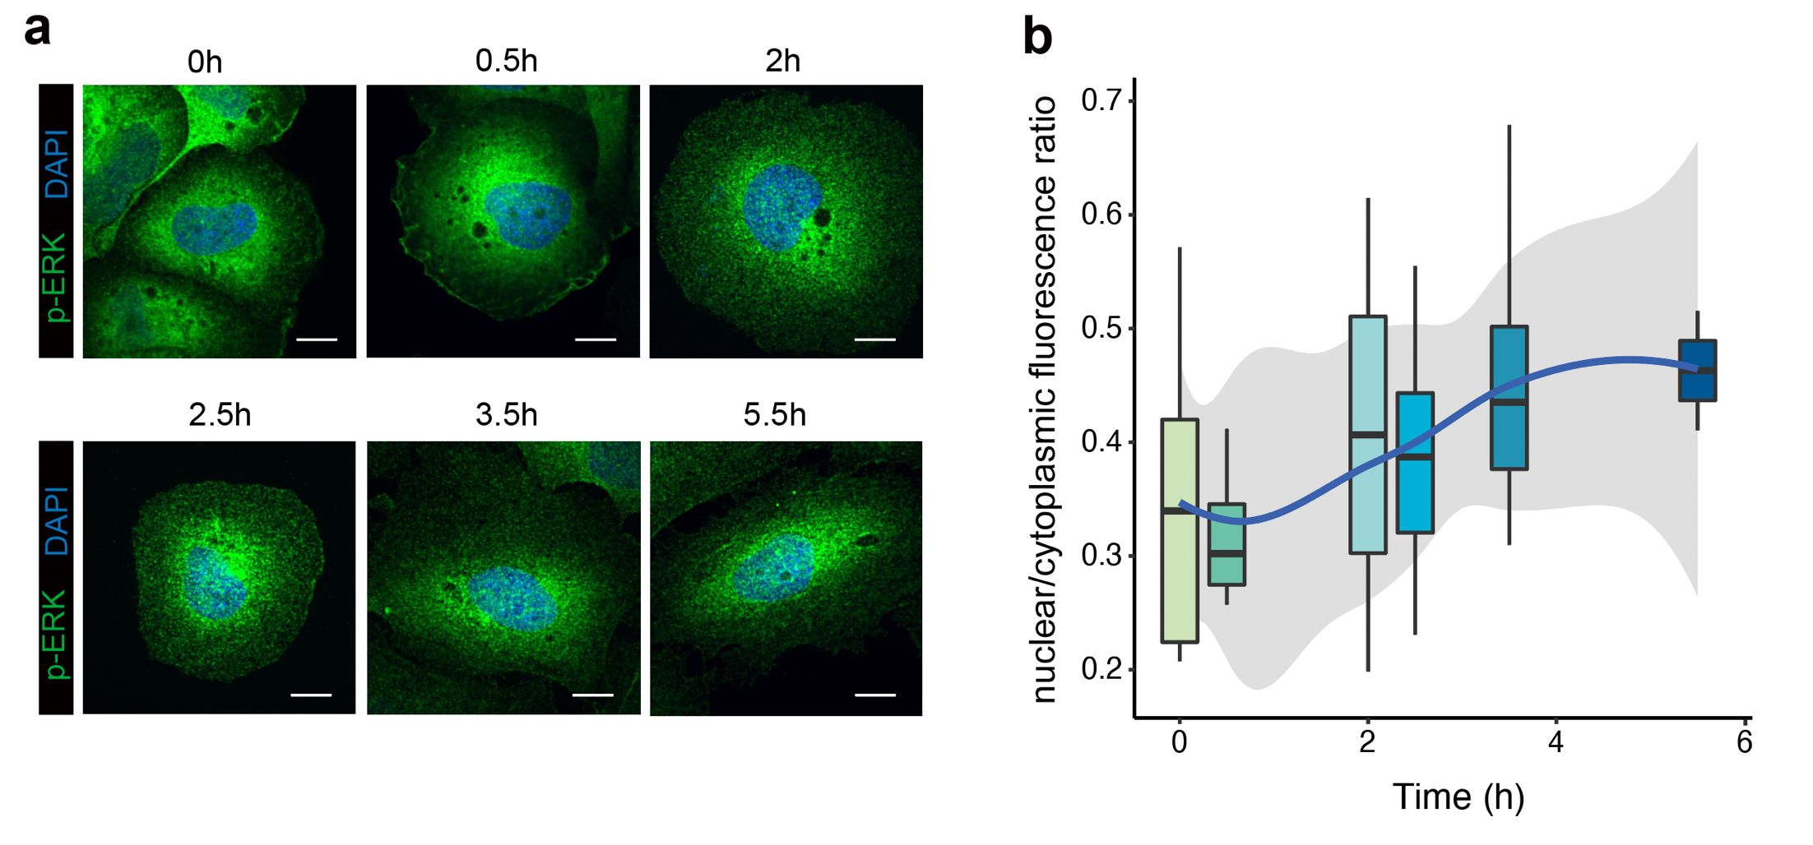

Fig. S6 Timing and duration of the nuclear ERK activity.
- Nuclear localization of p-ERK1/2 in cells transferred to the stiff matrixes after two-day culturation on the soft matrix (scale bar, 5 μm).
- Quantitative analysis of nuclear/cytoplasmic fluorescence ratios showing a higher p-ERK nuclear localization rate in the stiff matrix (at least 5 images per condition).

Table S1.
Primer | Sequence
JUN-F | GCATAGCCAGAATACGCTGC
JUN-R | GTTGCTGAGGTTGGCGTAGA
α-SMA-F | GCCATGTTCTATCGGGTACTTC
α-SMA-R | CAGGGCTGTTTTCCCATCCAT
GAPDH-F | ACCCAGAAGACTGTGGATGG
GAPDH-R | TTCAGCTCAGGGATGACCTT

Table S1. qPCR primer sequence
The qPCR primers designed for genes of interest to detect their expression.

