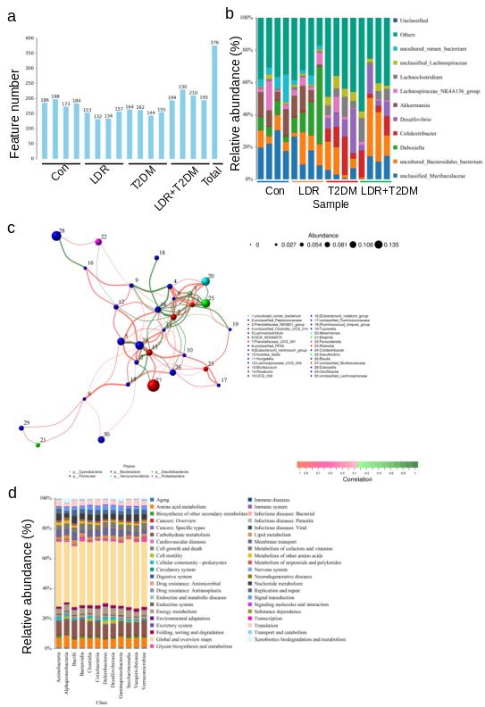
Fig. S1 LDR ameliorates gut microbiota dysbiosis induced by T2DM. (a) Distribution diagram of the number of features in all samples of different groups. (b) Analysis of the different communities comprising the gut microbiota at the genus level among four groups. (c) The network diagram of correlation analysis among key gut microbiota at phylum level. (d) KEGG metabolic pathway chart in all samples at class level.

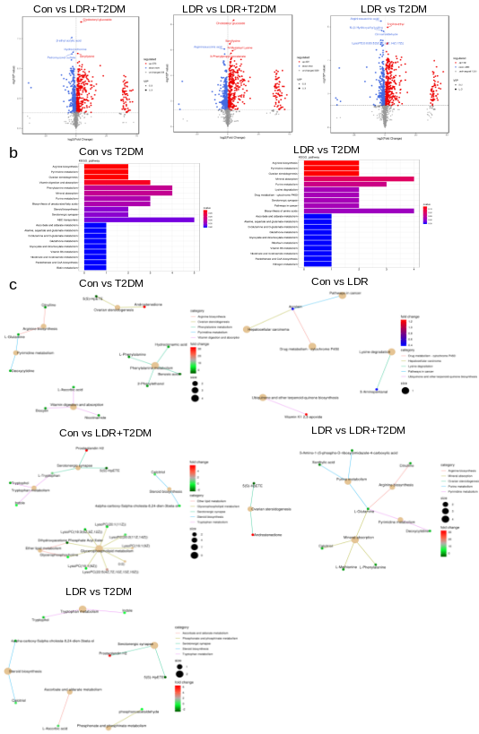
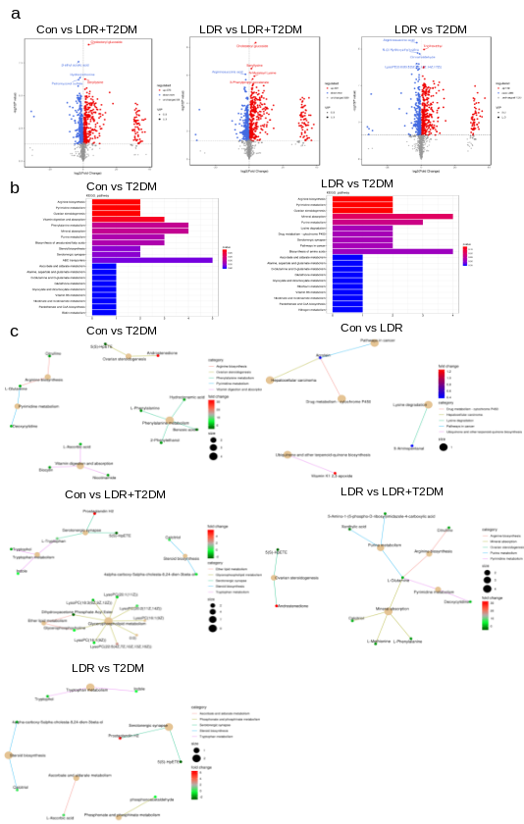
Fig. S2 LDR altered metabolites in T2DM under positive ion mode. (a) Volcano plot of metabolites from four groups, Con vs LDR+T2DM, LDR vs LDR+T2DM and LDR vs T2DM was shown. (b) The enrichment analysis of differential metabolite KEGG pathway, Con vs T2DM and LDR vs T2DM was shown. The abscissa represents the numbers of differential metabolites, the ordinate represents the pathway. (c) Network diagram of metabolite enrichment, the pale yellow nodes represent pathway, and the small nodes connected to them represent the specific metabolites annotated to the pathway, Con vs T2DM, Con vs LDR, Con vs LDR+T2DM, LDR vs LDR+T2DM and LDR vs T2DM were shown.

