Supplementary Information for

A Directional Tensile Superelasticity in Ceramic Crystal via Reversible Shuffle Twinning

Chong Wang^{1†}, Zeya Li^{2,3†}, Yingchun Cheng^{1†}, Xiao-Ji Weng¹*, Kun Zhai¹, Tianyu Xue¹, Anmin Nie¹*, Hongtao Yuan^{2,3}*, Xiang-Feng Zhou¹, Hongtao Wang⁴,
Yongjun Tian¹, Zhongyuan Liu¹
- Center for High Pressure Science, State Key Laboratory of Metastable Materials Science and Technology, Yanshan University; Qinhuangdao, 066044, China.
- National Laboratory of Solid State Microstructures, and Collaborative Innovation Center of Advanced Microstructures, Nanjing University, Nanjing 210093, China.
- College of Engineering and Applied Sciences, and Jiangsu Key Laboratory of Artificial Functional Materials, Nanjing University, Nanjing 210023, China.
- Center for X-mechanics, School of Aeronautics and Astronautics, Zhejiang University, Hangzhou 310027, China.

† These authors contributed equally to this work.
*Corresponding author.

E-mail: anmin@ysu.edu.cn.edu.cn (A.N.); htyuan@nju.edu.cn (H.T.Y.); xjweng@ysu.edu.cn (X.J.W.).

Outline:
- Fabrication of GeSe samples for in-situ TEM tensile testing
- Critical strain for twin domain generation in GeSe ceramic crystal
- Growth of twin domain and twin boundary motion in superelastic GeSe
- Shuffle twinning mechanism of GeSe under tensile strain
- Molecular dynamic simulation for twin domain generation and superelasticity of GeSe
- Determination of GeSe lattice parameters under uniaxial tensile strain
- Young’s modulus and mechanical strength of GeSe and other materials
- TEM confirmation of the directional nature of superelasticity in GeSe
- Anisotropic mechanical properties of GeSe

- Fabrication of GeSe samples for in-situ TEM tensile testing
We utilized two different mechanical testing methods to investigate the superelasticity in GeSe: a) The push-to-pull (PTP) method¹ and b) The direct tensile (DT) method². The PTP method offers the stability to apply strain on very thin samples (~50 nm) and thus is suitable for HRTEM measurements, while the DT method facilitates the direct stress-strain measurement. The detailed information about the tested samples is listed in Supplementary Table 1.
Microfabrication of PTP devices for tensile testing. We prepared the PTP devices by taking the following steps. First, a thin lamella was milled from a piece of GeSe crystal by using a focused ion beam (FIB, Helios G5, Thermo Fisher Scientific), and then it was cut and transferred onto the TEM half-grid fixed by Pt welding (Extended Data Fig. 2a-c). Second, the lamella was laterally narrowed to a width of 3 μm (Extended Data Fig. 2d) and further shaped into a PTP device with a width of 200-300 nm, length of 700-1000 nm, and thickness of ~50 nm (Extended Data Fig. 2e). The energy dispersive spectroscopy (EDS) mapping of the PTP device revealed a uniform distribution of Ge and Se elements, indicating that the fabricated sample well retained the chemical composition of GeSe with no observable FIB-induced contamination. Third, with a diamond punch pushing the convex pillars at the two ends, an approximately uniaxial tensile strain can be generated on the middle tiny bridge (Extended Data Fig. 2f). Such a PTP device is widely used for in-situ HRTEM observation during tensile strain testing.
Microfabrication of the GeSe nanobridge for DT testing. DT testing samples were fabricated with FIB from as-grown GeSe single crystals. Gallium ion beam currents ranging from 9.3 nA to 10 pA (working voltage 30 kV) were used for initial engraving to final refinement. Before microfabrication of DT samples with a specific orientation, the orientation of the GeSe crystal placed on the stage was determined by electron backscatter diffraction (EBSD). The fabrication process of GeSe nanobridges for direct tensile testing was similar to that for the PTP method. We prepared the DT devices by taking the following steps. First, a thin lamella was milled from one GeSe crystal, and then it was cut and transferred onto a TEM half-grid fixed by Pt welding. Second, the lamella was laterally narrowed to a width of 3 μm and further shaped into a T-shaped nanobridge with a width of 100–300 nm and length of 1–3 μm (Extended Data Fig. 3g). Third, the diamond gripper was sculpted on the nanobridge with a diamond indenter tip. The head of the nanobridge was shaped as a triangle to ensure full connection between the triangle head and the diamond gripper (Extended Data Fig. 3h). The high-precision mechanical sensor (Bruker PI95) was connected with the diamond gripper, and two bulges on the nanobridge were used for strain evaluation. Finally, by shifting the diamond gripper, the GeSe nanobridge was tensile‒strained, allowing for the load-displacement curve measurements and the corresponding stress-strain curve measurements (Extended Data Fig. 3i).

- Critical strain for twin domain generation in GeSe ceramic crystal
Note that 40 GeSe samples were tested under uniaxial tensile strain along the zigzag direction, and the critical values of strain (under which twin domains start to appear) were determined in Supplementary Fig. 1. An average critical strain of ~2.5% can be determined, as indicated by the red dashed line in Supplementary Fig. 1. Note that the observed critical stress of ~1.0 GPa for triggering superelasticity in GeSe crystal is even lower than that reported for shape memory alloys and shape memory ceramics.

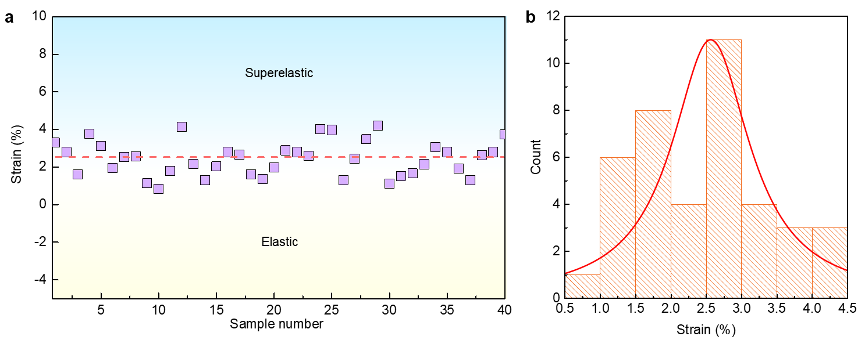
Supplementary Figure 1. Determination of the critical strains for the emergence of stripy domains in GeSe samples. (a) The critical values of strain for the appearance of twin domains in 40 GeSe samples. The measured critical strains are also listed in Supplementary Table 1. (b) Statistical distribution of the critical strains obtained from 40 GeSe samples.

Supplementary Table 1. Detailed information of 40 microfabricated GeSe samples with different bridge widths under zigzag direction loading
Sample | $ε_{c}$ (%) | $W_{domain}$ (nm) | $θ_{domain}$ (°) | Domain orientation | $L_{sample}$ (nm) |  | Method
1 | 4.11 | 35 | 47.5 | $$\left[110\right]$$ | 285 | PTP
2 | 2.80 | 31 | 47.9 | $$\left[110\right]$$ | 366 | DT
3 | 3.81 | 30 | 47.3, 132.5 | $$\left[110\right],\left[1\overline{1}0\right]$$ | 301 | PTP
4 | 3.13 | 41 | 48.1 | $$\left[110\right]$$ | 323 | PTP
5 | 1.96 | 28 | 47.7 | $$\left[110\right]$$ | 470 | DT
6 | 2.55 | 34 | 47.3, 132.6 | $$\left[110\right],\left[1\overline{1}0\right]$$ | 435 | DT
7 | 2.58 | 28 | 47.6 | $$\left[110\right]$$ | 450 | DT
8 | 1.14 | 25 | 47.0 | $$\left[110\right]$$ | 535 | DT
9 | 4.22 | 29 | 133.6 | $$\left[1\overline{1}0\right]$$ | 288 | PTP
10 | 3.92 | 28 | 46.7, 133.1 | $$\left[110\right],\left[1\overline{1}0\right]$$ | 311 | PTP
11 | 1.26 | 32 | 47.5 | $$\left[110\right]$$ | 530 | DT
12 | 2.16 | 25 | 47.3 | $$\left[110\right]$$ | 403 | DT
13 | 3.33 | 28 | 47 | $$\left[110\right]$$ | 167 | PTP
14 | 3.02 | 31 | 132.4 | $$\left[1\overline{1}0\right]$$ | 225 | PTP
15 | 2.61 | 29 | 46.8 | $$\left[110\right]$$ | 210 | PTP
16 | 1.95 | 32 | 47.5 | $$\left[110\right]$$ | 470 | DT
17 | 2.31 | 33 | 46.3, 132.8 | $$\left[110\right],\left[1\overline{1}0\right]$$ | 480 | DT
18 | 3.76 | 29 | 46.5 | $$\left[110\right]$$ | 296 | PTP
19 | 3.13 | 39 | 46.3 | $$\left[110\right]$$ | 255 | PTP
20 | 1.31 | 25 | 46.9 | $$\left[110\right]$$ | 453 | DT
21 | 2.04 | 30 | 133.8 | $$\left[1\overline{1}0\right]$$ | 301 | DT
22 | 2.83 | 33 | 135.0 | $$\left[1\overline{1}0\right]$$ | 298 | PTP
23 | 2.66 | 29 | 45.8 | $$\left[110\right]$$ | 323 | DT
24 | 1.65 | 38 | 46.9 | $$\left[110\right]$$ | 408 | DT
25 | 1.36 | 35 | 47.1 | $$\left[110\right]$$ | 515 | DT
26 | 1.97 | 29 | 46.0 | $$\left[110\right]$$ | 553 | PTP
27 | 2.89 | 28 | 45.8 | $$\left[110\right]$$ | 335 | PTP
28 | 2.82 | 29 | 46.3, 132.5 | $$\left[110\right],\left[1\overline{1}0\right]$$ | 303 | PTP
29 | 2.61 | 33 | 133.7 | $$\left[1\overline{1}0\right]$$ | 283 | PTP
30 | 4.02 | 28 | 47.3 | $$\left[110\right]$$ | 173 | PTP
31 | 3.97 | 25 | 46.5 | $$\left[110\right]$$ | 205 | PTP
32 | 1.32 | 19 | 44.8 | $$\left[110\right]$$ | 521 | DT
33 | 2.43 | 23 | 46.3 | $$\left[110\right]$$ | 435 | DT
34 | 3.48 | 31 | 133.1 | $$\left[1\overline{1}0\right]$$ | 198 | PTP
35 | 4.2 | 27 | 45.7 | $$\left[110\right]$$ | 153 | PTP
36 | 1.13 | 35 | 46.0 | $$\left[110\right]$$ | 553 | DT
37 | 4.08 | 33 | 45.2 | $$\left[110\right]$$ | 232 | PTP
38 | 3.88 | 35 | 45.8 | $$\left[110\right]$$ | 165 | PTP
39 | 2.87 | 35 | 46.9 | $$\left[110\right]$$ | 321 | PTP
40 | 1.91 | 28 | 131.5 | $$\left[1\overline{1}0\right]$$ | 532 | DT
$ε_{c}$ is the critical strain for the emergence of the twin domain, $W_{domain}$ is the maximum width of the twin domain, $θ_{domain}$ is the angle between the domain and zigzag direction of GeSe, and $L_{sample}$ is the length of the pristine GeSe sample before testing.

- Growth of twin domain and twin boundary motion in superelastic GeSe
To investigate the microscopic mechanism about the formation of stripy domain in superelastic GeSe, we traced the dynamic process for the growth of a twin domain under loading strain. Interestingly, we observed in the in-situ TEM experiments that there exist two types of twin boundaries under tensile loading: the sharp one with a width of approximately ~0.5 nm and the wide one with a width of approximately ~1 nm (Supplementary Fig. 2a-d). By examining the side views of the twin boundary (Extended Data Fig. 4), we observed the occasional variations of the twin boundary in different layers at some in-plane locations. In such cases, the twinned parts of some layers partially overlap with the non-twinned part of the other layers near the twin boundary, resulting in a wider boundary area when viewed from the top, as illustrated in Supplementary Fig. 2d. These findings indicate that the interlayer resonance is weaker than the intralayer resonance arising from in-plane atom displacements, agreeing with the argument that interlayer interactions (van der Waals interactions) are much weaker than intralayer interactions (covalent or metavalent bonds) in GeSe. More importantly, our observation suggests that superelasticity is an intrinsic property of monolayer GeSe, and the different stacking of adjacent layers in bulk GeSe is the origin of the observed variety of twin boundary structures.
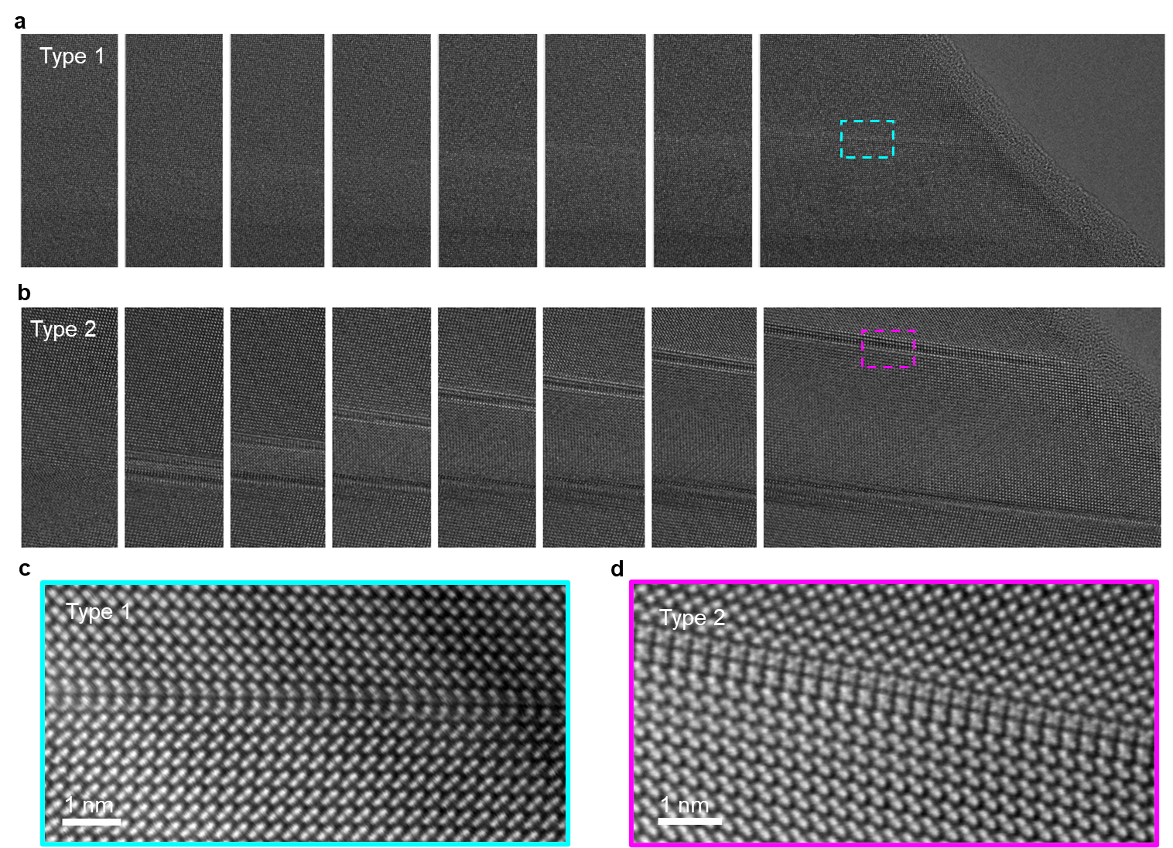
Supplementary Figure 2. Migration of the twin boundary during the growth of the stripy domain in GeSe under tensile loading. (a) HRTEM snapshots captured to show migration of the sharp twin boundary (Type 1). (b) HRTEM snapshots captured to illustrate the migration of the wide twin boundary (Type 2). (c, d) Amplified HAADF-STEM images of the areas marked with dashed rectangles in (a) and (b), respectively, revealing the atomic configurations of the sharp and wide twin boundaries more clearly.

- Shuffle twinning mechanism of GeSe under tensile strain
To understand the strain-dependent twinning at the atomic scale, the transformation pathways were searched for a periodic GeSe model containing 32 atoms in a cell. The initial state was set as an intrinsic GeSe under a certain strain along the zigzag direction, while the final state was set as a configuration containing a twin domain. The atomic configurations along the pathways reveal a process that the Ge-Se atom pairs along the [110] direction collectively rotate, that is, a “shuffle twinning”. By comparing the local structure between the initial state and the final state, a “Z-shaped” to “anti-Z-shaped” bond switching occurs through bond breaking and reforming (Supplementary Fig. 3a). The structure after bond breaking and before bond reforming, as a transition state, contributes an energy barrier in the pathway. This barrier decreases with increasing strain, indicating that milder external conditions are needed to trigger twinning at large strains, as discussed in Fig. 2 in the main text.
In the GeSe lattice with the absence of strain (initial state), each Ge atom is surrounded by five Se atoms, and two types of bands are formed between Ge and its surrounding Se atoms, i.e., the in-plane type of Ge1-Se1 bond with a larger bond length of 2.73 Å and the out-of-plane type of Ge1-Se3 bond with a shorter bond length of 2.52 Å. Under tensile strain along the zigzag direction, the in-plane Ge1-Se1 bond lies along the zigzag direction is stretched to a larger length and the out-of-plane Ge-Se bonds tend to slightly rotate away from the armchair direction. Supplementary Fig. 3b,c shows the distance change of the Ge1-Se1 and Ge1-Se2 atoms during the twinning process at strains of 5% and 6%. One can see that under tensile strain along the zigzag direction, the distance between Ge1-Se1 atoms gradually increases, while that between Ge1-Se2 atoms decreases, leading to the breaking of the Ge1-Se1 bond and the formation of a new Ge1-Se2 bond. This unique “Z-shaped”-“anti-Z-shaped” bond switching, which results from the collective rotation of Ge-Se atom pairs along the [110] direction, directly leads to “shuffle” twinning in GeSe. Interestingly, the bond length of the reformed bond (D2) in the final state is longer than that of the broken bond (D1) in the initial state under small strain but shorter under large strain (Supplementary Fig. 3d), which directly corresponds to the energy decrease of the twinning structure at larger strain. This indicates that the twinning structure is more stable at large strains. Therefore, through twinning, GeSe can reach a more thermodynamically stable state by restoring part of the bond length.
More importantly, upon unloading, the detwinning energy barrier decreases from a large value of 7.7 meV/atom to almost zero as the strain decreases to 4%. On the one hand, the large detwinning energy barrier at large strains prohibits the detwinning and results in the elastic behavior at the initial unloading, as shown in Fig. 2a in main text. On the other hand, the rapid decrease in the detwinning energy barrier with strain well explain the spontaneous detwinning of the lattice at lower strains.
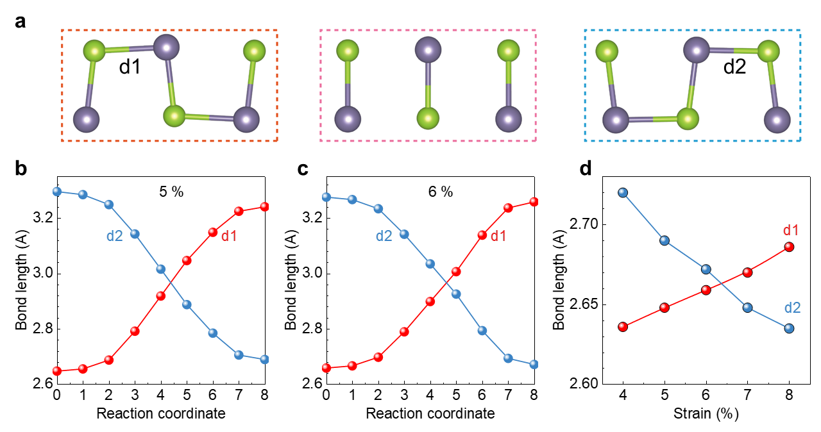
Supplementary Figure 3. Shuffle twinning of GeSe under tensile strain. (a) The local structure of GeSe before twinning (left), after twinning (right), and at the energy saddle point in the transformation pathway (middle) for a strain of 7% along the zigzag direction. (b, c) The distance change of Ge1-Se1 and Ge1-Se2 atoms during the twinning process at strains of 5% (b) and 6% (c). (d) The variation in the bond lengths marked in (a) with strain.

- Molecular dynamic simulation for twin domain generation and superelasticity of GeSe
To deep understand the twinning-induced superelasticity in GeSe, we performed ab initio molecular dynamics (AIMD) simulations to simulate the twinning process, as shown in Fig. 3a in the main text. Here, we provide more details about the simulated twinning process of GeSe. When the strain is below 5%, the GeSe structure remains dynamically stable, with all atoms vibrating near their initial equilibrium positions, leading to a typical elastic deformation with a linear stress‒strain curve and a parabolic energy-strain curve. The fitted Young’s modulus is ~42 GPa, which is close to the experimental value. Supplementary Fig. 4 shows the structure of certain frames (indexed by time) in the molecular dynamics of GeSe under 6% strain along the [100] direction. One can see that the initial structure is unstable and significant structure transition take place. As implied by the microscope photo, the twin is generated through the rotation of the Ge–Se atom pairs. Specifically, for intrinsic GeSe, the [001]-projections of the atom pairs should be along the [100] direction, while some deviate from the [100] direction due to vibrations or structural transitions. The pairs with larger rotation angles (θ_{rotate} > 45°) are highlighted in Supplementary Fig. 4. Before the emergence of the twin boundary, some pairs occasionally rotate at a large angle but maintain a very short lifetime (~0.1 ps) and return to their initial equilibrium positions (as highlighted at 2.00 ps in Supplementary Fig. 4). In contrast, if a column of atom pairs along the <110> direction rotates together in a relatively short time, the collective rotation mode would be retained (from 2.25~3.00 ps) owing to the decrease in energy. Subsequently, column by column, atom pairs rotate to form new twin boundaries or expand the width of twins (Fig. 3a in the main text). Since Pnma-GeSe has AB-stacking, the adjacent columns of atom pairs are alternately contributed by the A-layer and B-layer. The rotations of the atom pairs in the A-layer and B-layer are sometimes successive and sometimes simultaneous (Fig. 3a in the main text). The randomness and independence of the transition in different layers are mainly due to the weak van der Waals interlayer interactions. However, because the bond switching would lead to local lattice distortion, the atom pairs close to the twin boundaries are more likely to rotate subsequently. As a result, one twin domain with one-period width and another with two-periods width are generated in the 20-picosecond simulation, revealing a superfast transition process.

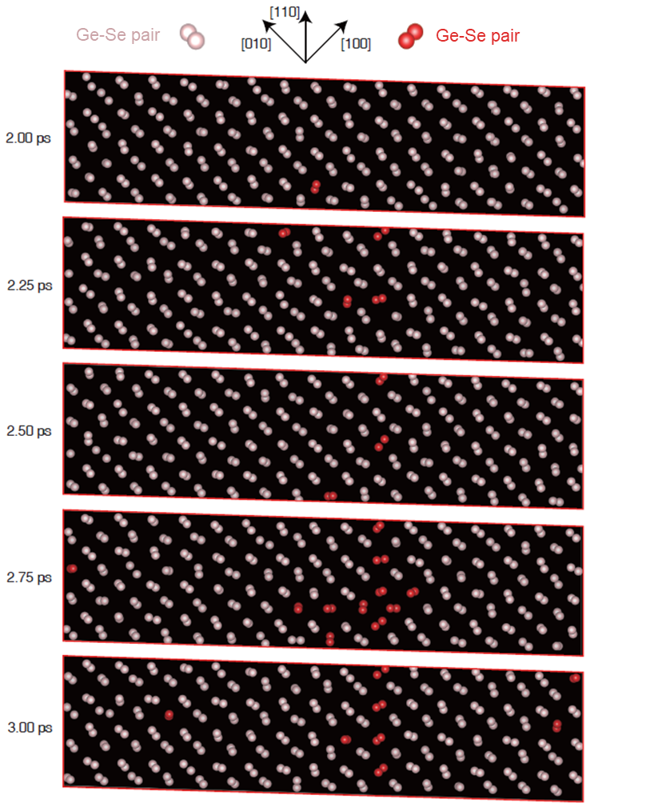
Supplementary Figure 4. Structure of certain frames (indexed by time) in the molecular dynamics of GeSe under 6% strain along the [100] direction. The red balls represent the Ge-Se atom pairs with rotation angles larger than 45°. The pink balls represent the Ge-Se atom pairs with rotation angles smaller than 45°.

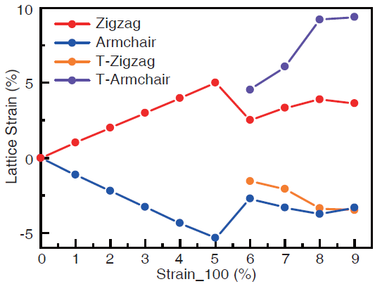
Supplementary Figure 5. Evolution of the lattice parameters in the GeSe model during loading simulation.
Supplementary Figure 5 shows the lattice parameters of the local domains in the GeSe model during twinning. One can see that the strain is partly recovered (back to ~2.5%) in the matrix regions, and the twin domains are stretched in the armchair direction. These results are both consistent with the experimental observations. Supplementary Figure 6 shows the structure of the GeSe model after molecular dynamics under 9% strain along the [100] direction. One can see that another two columns of atom pairs in the cell (compared to the 6% case in the main text) rotate during the MD calculation. Interestingly, in the B-layer, the newly rotating pairs are directly adjacent to the previous twin boundary and lead to the growth of the twin, while in the A-layer, the rotating pairs contribute a new set of twin boundaries. These results again illustrate relatively independent behaviors and weak interactions between layers. Similar to the case with 6% strain, the energy of the system and the tensile stress decrease due to the formation of twins in the AIMD simulation (Fig. 3b in the main text). The results for strains from 6% to 9% indicate that in the superelastic stage, the generation of twin boundaries and the growth of twin domains occur alternately or simultaneously from the microscale perspective. Through twinning, part of the structure (the twin domains) is stretched in the armchair direction instead of the zigzag direction. On the one hand, the Young’s modulus along the armchair direction is lower than that along the zigzag direction. On the other hand, the lattice parameter along the armchair direction is much longer than that in the zigzag direction. Therefore, the stress required to achieve a target strain is remarkably reduced after twinning, compared to linear elasticity, that is, a nonlinear process in the superelastic phenomenon. It should be noted that here, molecular dynamics are carried out based on a cell with 256 atoms and on the picosecond scale. For a real system, most changes in the lattice and stress induced by the microscopic transition would be averaged out in a large system. Thus, the stress‒strain curve in the experiment appears smoother than the simulated one.
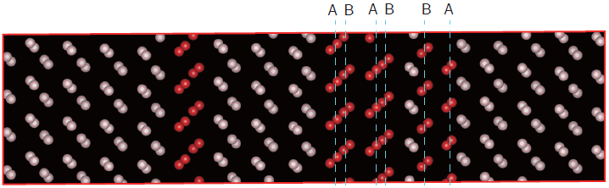
Supplementary Figure 6. Structure of the GeSe model after molecular dynamics simulation under 9% strain along the [100] direction. The red and pink balls represent the Ge-Se atom pairs in twin domain and Matrix.
More importantly, such a nonlinear deformation response is fully reversible upon loading‒unloading, which provides additional evidence for the superelastic nature of GeSe ceramic crystal (Extended Data Fig. 6b). At the early stage of unloading (strain of 4~5%), the structure maintains the same atomic configuration as that in the loading step of 6%~8% strain, leading to a typical elastic deformation with a linear stress‒strain curve and parabolic energy-strain curve upon initial unloading (Fig. 3b in the main text). The fitted Young’s modulus is ~32 GPa, which is lower than the value for intrinsic GeSe. As discussed above, this decrease is attributed to the twin domains that are stretched roughly along the armchair direction with a Young’s modulus of only 17 GPa. Note that the energy of the system at a strain of 4% in the unloading process is higher than that at the same strain in the loading process, indicating that the system would not return immediately to the according ground state at a certain strain. The energy barrier for shuffle twinning or detwinning should be responsible for this, which results in a hysteresis stress‒strain curve during loading and unloading. As the strain is decreased to 3%, the twinning domain with one lattice period vanishes (Extended Data Fig. 6b). In succession, the twin domain with two lattice periods is narrowed when the system is unloaded to 2% strain and completely vanishes at 0% strain. As a result, the stress-strain curve deviates from linear behavior and shows nonlinear behavior when the strain is lower than 3%. Correspondingly, the energy-strain curve deviates from parabolic behavior, and the energy always accumulates to a relatively high level before the system becomes unstable and transitions to a thermodynamically metastable state.
In short, AIMD simulations at room temperature were carried out for the GeSe structure at different strain steps during the loading and unloading process. The generation, growth, and vanishing of the twin domain based on the rotation of Ge–Se atom pairs spontaneously occur in the simulation. The evolution of the stress and local lattice parameters with strain agrees well with the experimental results, including some abrupt changes accompanied with twinning of the lattice, which contributes to the superelasticity. The twinning process is driven by the release of elastic energy in the matrix.

- Determination of GeSe lattice parameters under uniaxial tensile strain
We have presented the lattice strains in the matrix and twinned domain in Fig. 3e of the main text, which were calculated from the measured lattice parameters during tensile loading. Here, we provide the details about the measurement of local lattice parameters. Without losing the generality, we take a snapshot at 373 s (Extended Data Fig. 8a) from Supplementary Video 6 as an example to illustrate the procedure for extracting lattice parameters. Eight different regions in the matrix and eight different regions in the stripy domain are randomly selected. In each region, ten unit cells along the armchair and zigzag directions are measured (Extended Data Fig. 8b and Supplementary Fig. 7). Subsequently, the lattice parameters along the armchair and zigzag directions are determined. The mean and standard deviation statistics for the determined lattice parameters are listed in Supplementary Table 2.
As discussed in Fig. 3e in the main text, the evolutions of in-plane lattice strain in each loading–unloading cycle can be divided into four regions, including two linear regions on the initial loading (L1) and unloading (L2) and two superelastic regions on loading (S1) and unloading (S2). In region L1, under the increased stress within the linear elastic limit, the Matrix lattice exhibits the simultaneous expansion and contraction along the zigzag and armchair directions, eventually inducing an increased tensile strain to ~4.2% and a compressive strain to ~2.5% (Fig. 3e in the main text). In region S1, the formation of twin domains triggers a nonlinear superelastic response on loading. Because of the observed twinning angle of about 82.5° (Fig. 2b in the main text), the applied stress becomes nearly along the armchair direction in the formed twin domains. In the GeSe crystal, the lattice parameter along the armchair direction ($b$ = 4.38 Å) is much larger than that along the zigzag direction ($a$= 3.81 Å). Specifically, once the twin domain is formed, the lattice parameter along the armchair direction shows a sharp increase to ~4.57 Å, and further stretched to ~4.61 Å by the applied stress accompanying the fast growth of twin domain. Correspondingly, a maximum local lattice strain of ~5.8% is reached along the armchair direction in the twin domain. Therefore, the formation and fast growth of twin domains in width are able to enhance the deformation of GeSe and thus result in the observed superelasticity along the zigzag direction of Matrix. In region L2 for the detwinning process where the twin domain shows a negligible change in width at the initial stage of unloading (Fig. 3f in the main text), the lattice strains in both and twin domains along their zigzag directions show negligible changes, while those in the armchair direction exhibit remarkable decreases. Such a persisting recovery of partial lattice strain along the armchair direction in the twin domain might be the dominant origin for the observed initial linear elastic response to unloading in the stress‒strain curve (Fig. 1e in the main text). In region S2 where twin domain exhibits quick drop in width until its disappearance (Fig. 3e in the main text), the lattice strains of Matrix along both the zigzag and armchair directions are nearly restored to the original values even at the initial stage of region S2 and change little with unloading. This indicates that in region S2 the residual lattice strains in Matrix are not large enough to maintain the twin domain, which results in the fast decrease of twin domain width and the simultaneous recovery of lattice strains (Fig. 3a,b in the main text) and eventually generate the nonlinear superelastic response on unloading in the stress-strain curve (Fig. 1e in the main text).
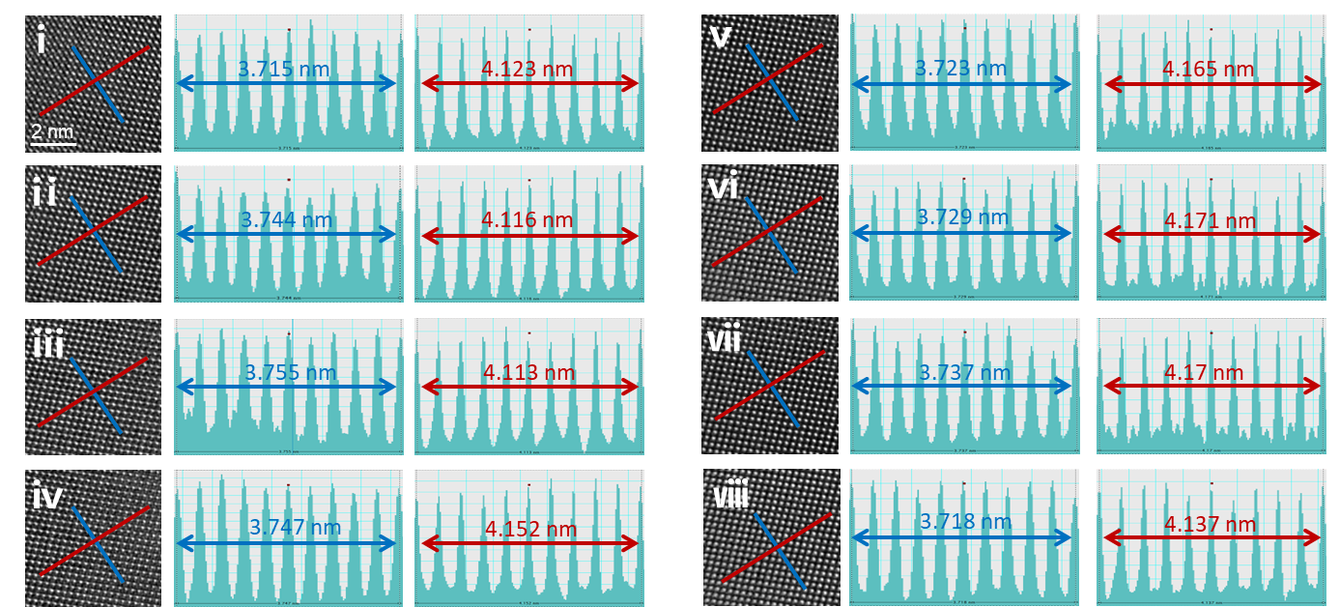
Supplementary Figure 7. Determination of the lattice parameters of GeSe under tensile strain in Matrix region. HRTEM images of eight randomly selected regions (i-viii) as marked out with white squares in Extended Data Fig. 8a, in which the blue and red solid lines represent the zigzag and armchair directions, respectively. In each selected region, ten unit cells were taken along the zigzag (middle column) and armchair (right column) directions for determination of the lattice parameters under tensile strain.

Lattice parameter (Å)
Time | Zigzag |  | Armchair | T-zigzag | T-armchair
373 s |  | 3.715 | 4.123 | 3.597 | 4.373
 |  | 3.744 | 4.116 | 3.587 | 4.375
 |  | 3.755 | 4.113 | 3.568 | 4.361
 |  | 3.747 | 4.152 | 3.595 | 4.359
 |  | 3.723 | 4.165 | 3.58 | 4.352
 |  | 3.729 | 4.171 | 3.555 | 4.361
 |  | 3.737 | 4.17 | 3.59 | 4.35
 |  | 3.718 | 4.137 | 3.592 | 4.335
Mean |  | 3.734 | 4.143 | 3.583 | 4.358
Standard deviation |  | 0.0145 | 0.0243 | 0.0147 | 0.0129
Supplementary Table 2. Determined lattice parameters and standard deviations
The lattice parameters measured from the matrix are listed as “zigzag (a)” and “armchair (b)”, while those measured from the twinned domain are listed as “T-zigzag (a)” and “t-armchair (b)”, respectively.

- Young’s modulus and mechanical strength of GeSe and other materials
To confirm the deformation capability of superelastic GeSe, we performed in-situ TEM tensile testing on a GeSe sample with strain along the zigzag direction until it ultimately fractured (Extended Data Fig. 9). Remarkably, a maximum strain of ~12.8% can be reached before fracture. It should be addressed that, for those mechanically deformed materials, a small Young’s modulus and a high strength are highly desirable for realizing a large strain under low stress. By linear fitting of the initial linear elastic response upon loading (Fig. 1e in the main text), the Young’s modulus $k_{zz}$ along the zigzag direction in the GeSe crystal was determined to be ~45 GPa, which is lower than that reported for most shape memory alloys and ceramics and even one order of magnitude lower than that reported for graphene, h-BN and other transition metal dichalcogenides³⁻⁶. Compared to other layered materials, GeSe, with the remarkably small Young’s modulus, exhibits a large limit of strain (Supplementary Fig. 8 and Table 3) due to the presence of twinning-induced superelasticity, which is highly desirable for realizing large deformation and potential sensitive mechanical applications under extremely small stresses.
Generally, the strain in a material under stress is defined as:
$$ε=\frac{ΔL}{L} (1)$$
where $ΔL$ is the change in length and $L$ is the original length of the material. For a GeSe sample that contains $N$ lattice periods along zigzag direction, the initial length should be $L_{initial}=Na$. Considering the GeSe final structure in which some of the Matrix region is transformed to twin domain under strain, the final length of such a twinning GeSe should be:
$$L_{Final}=L_{Twin}+L_{Matrix}=Nx{b(1+ε}_{Twin}^{ac})+N(1-x){a(1+ε}_{Matrix}^{zz}) (2)$$
where x is the weight of the stripy twin domain region, $ε_{Twin}^{ac}$ and $ε_{Matrix}^{zz}$ are the local strains in the twin domain (along the armchair direction) and Matrix (along the zigzag direction) regions. As a result, the superelastic strain for a twinning GeSe under stress should be:
$$ε=\frac{L_{Twin}+L_{Matrix}-L_{initial}}{L_{initial}}=\frac{x{b(1+ε}_{Twin}^{ac})+(1-x){a(1+ε}_{Matrix}^{zz})}{a}-1 (3)$$
Therefore, the theoretical superelastic strain limit should be:
$${ ε}_{max}=\frac{x{b(1+ε}_{max}^{ac})+(1-x){a(1+ε}_{max}^{zz})}{a}-1 (4)$$
where $ε_{max}^{ac}$ and $ε_{max}^{zz}$ are the maximum local strains that can be reached before the fracture along the armchair and zigzag directions. As shown in Fig. 3e, the observed largest values of $ε_{max}^{ac}$ and $ε_{max}^{zz}$ can be estimated to be ~5.8% and ~2.9%. If we assume half of the Matrix will be transformed to the stripy twin domains (x = 0.5), the maximum superelastic strain is theoretically expected to reach a value as large as ~12.3% according to Equation (4). This result is in good agreement with the experimental value.

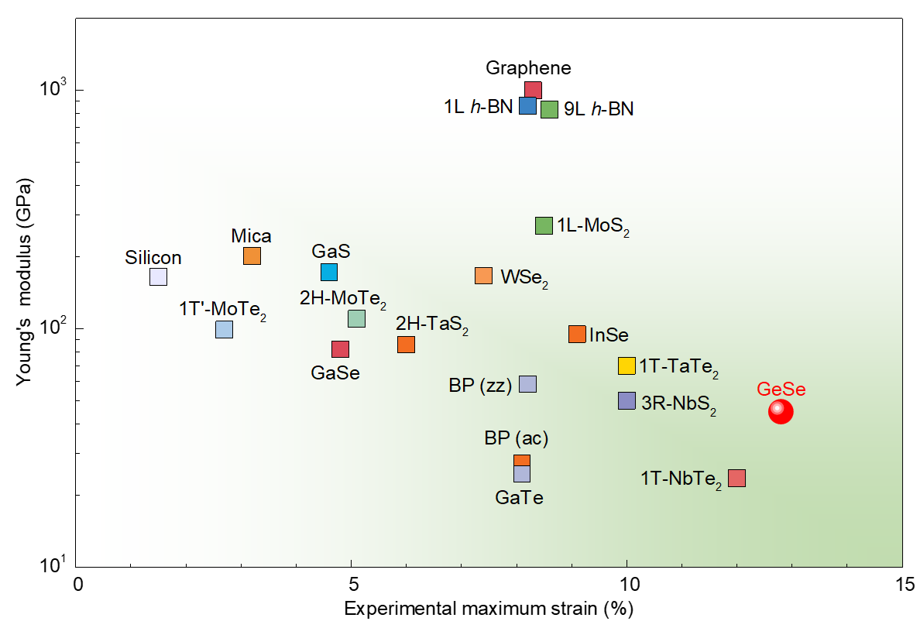
Supplementary Figure 8. Comparison of the Young’s modulus and mechanical strength of GeSe and other materials³⁻¹⁵.

Supplementary Table 3. A comparison of the Young’s modulus and strength of 2D materials
Material | $$d$$ | Young’s modulus (GPa) | Strength (GPa) | $ε_{max}$ (%) | Deformation |  | Refs.
GeSe (zz) | ~50 nm | 40 | 5.1 | 12.8 | superelastic | This work
GeSe (ac) | ~50 nm | 27 | 1.4 | 5.0 | elastic | This work
MoS₂ | 1 L | 270±100 | 16-30 | 11 | elastic | 4
WSe₂ | Few layer | 167.3±6.7 | 12.4 | 7.3 | elastic | 13
Graphene | 1 L | 1000 | 55 | 5.5 | elastic | 5
Graphene | 1 L | 997 | 111 | 11.1 | elastic | 7
BP (zz) | 14-28 nm | 58.6±11.7 | 4.79±1.43 | 8.2 | elastic | 8
BP (ac) | 14-28 nm | 27.2±4.1 | 2.31±0.71 | 8.4 | elastic | 8
h-BN | 1 L | 860 | 70.5 | 8.2 | elastic | 3
h-BN | 4 L | 830 | 72 | 8.7 | elastic | 3
h-BN | 9 L | 830 | 72 | 8.7 | elastic | 3
2H-TaS₂ | 3.5-12.6 nm | 85.9±10.6 | 5.01±0.1 | 6±1 | elastic | 9
1T-TaTe₂ | Few layer | 70±14 | 7.18±0.4 | 10±3 | elastic | 9
3R-NbS₂ | Few layer | 49.4±3.0 | 5.0±1.5 | 10±4 | elastic | 9
1T-NbTe₂ | Few layer | 23.6±1.6 | 2.9±0.3 | 12±2 | elastic | 9
2H-MoTe₂ | 6 nm | 112.5 | 7.0 | 6.2 | elastic | 12
1T’-MoTe₂ | 9 nm | 104 | 2.8 | 2.7 | elastic | 12
T_{d}- MoTe₂ | 10.5 nm | 103.3 | 3.2 | 3.1 | elastic | 12
GaS | 10 nm | 173±15 | 8 | 4.5 | elastic | 15
GaSe | 10 nm | 81.9±12.7 | 4 | 5 | elastic | 15
GaTe | 10 nm | 24.6±16 | 2 | 7 | elastic | 15
InSe | 6-14 layer | 95.3-110.1 | 8.68 | 9.1 | elastic | 11
Mica | 2-14 layer | 202±22 | 4-9 | 4.4 | elastic | 14
Bi₂Te₃ | 5-14 nm | 18.7±7 | 0.4 | 2.1 | elastic | 16

- TEM confirmation of the directional nature of the superelasticity in GeSe
To investigate the role of stress direction on superelasticity in GeSe crystal, we also performed tensile strain measurements on microfabricated bridge GeSe samples along the armchair direction (Supplementary Fig. 9). Cyclic loading was applied on the armchair sample, and its stress‒strain curves displayed a linear relationship, indicating typical elastic deformation. From the stress‒strain curves, the Young's modulus of the armchair sample was determined to be approximately 27 GPa. In contrast to the observed superelastic behavior under strain along the zigzag direction, the tested GeSe sample under strain loading along the armchair direction exhibited only elastic deformation, without the formation of any stripy domains before it ultimately broke at approximately 5%. This suggests that the occurrence of superelasticity in GeSe crystal is highly dependent on the direction of loading strain.
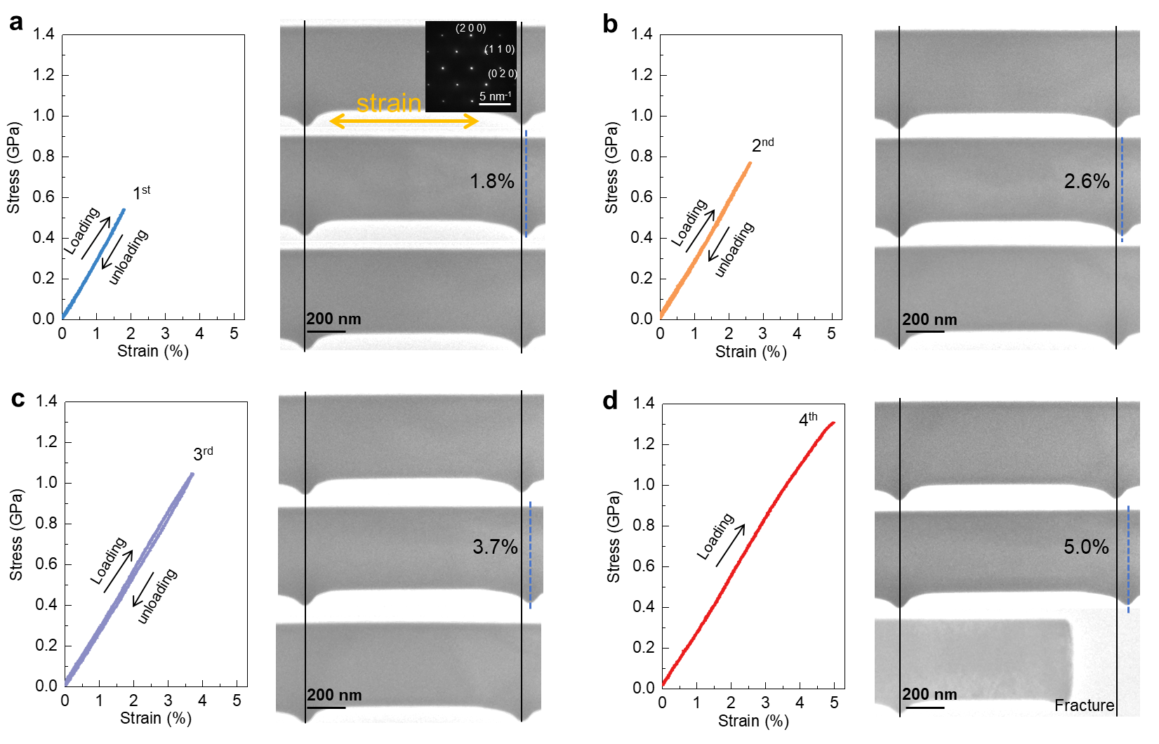
Supplementary Figure 9. Tensile testing of the microfabricated GeSe bridge sample along the armchair direction. (a) Stress‒strain curve for the first loading‒unloading cycle. TEM snapshots illustrate the sample pre-loading, at maximum loading, and post-unloading, with the inset showing SAED patterns. (b and c) Stress‒strain curves for the second and third cycles, along with corresponding TEM snapshots. (d) Stress‒strain curve for the fourth loading, leading to sample fracture at ~5% strain. The simultaneous TEM snapshots show that no stripy domains appear in the sample during the entire loading process.
- Anisotropic mechanical property of GeSe
To explain the direction-dependent superelasticity in the experiment, the anisotropic mechanical properties of GeSe were calculated. The elastic tensor was determined by performing finite distortions of the lattice and deriving the elastic constants from the strain‒stress relationship, as implemented in the VASP code. Based on the elastic tensor, the Poisson’s ratio and Young’s modulus for any strain direction can be obtained. The Poisson’s ratio shown in Supplementary Fig. 10 exhibits the strain response in the perpendicular direction in (001) plane. For example, the value at 0° indicates that the -strain_{[010]}/strain_{[100]} is 1.13 when the uniaxial strain is along the [100] direction, while the value at 90° means that the -strain_{[-100]}/strain_{[010]} is 0.39 when the uniaxial strain is along the [010] direction. For GeSe, the lattice vector in the [010] (armchair) direction is about 17% longer than that in the [100] (zigzag) direction. Due to the positive Poisson’s ratio, the difference in the vector lengths between these two directions would be increased under a [010] tension while decrease under [100] tension. Furthermore, the large value of Poisson’s ratio in the [100] direction makes this response more remarkable. Therefore, a tension along near [100] direction seems to be beneficial for quickly exchanging the zigzag and armchair orientations of the structure and leading to the emergence of twins.
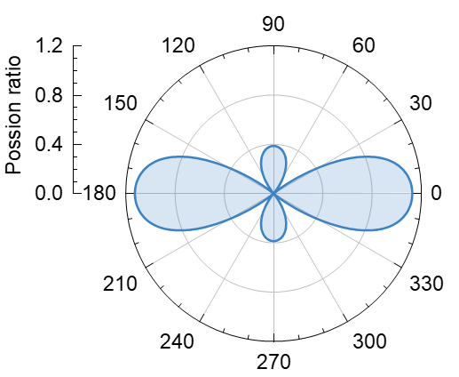
Supplementary Figure 10. The Poisson’s ratio of GeSe along different directions. Angle of 0° indicates the strain along the zigzag ([100]) direction.

To understand the mechanism of the observed anisotropic superelasticity in GeSe, we compared the Young’s modulus of the matrix and twin domains along certain tensile directions in Fig. 4b in the main text. The Young’s modulus increases from 49.4 GPa at 0° (zigzag direction) to a maximum value of 82.4 GPa at 33°, and then decreases to 16.9 GPa at 90° (armchair direction). Since the angle between the zigzag direction of matrix and twin domain is about 98.8°, the angle between the twin’s zigzag direction and the tensile direction should be 98.8°-θ (denoted as q with θ the angle between tensile direction and the matrix’s zigzag direction). Therefore, the Young’s modulus of the matrix and twin domains along a certain tensile direction can be compared in Fig. 4. Specifically, as $q$ increase from 0° to 42.5°, the Young’s modulus of the matrix domain is much larger than that of the twin domain. Such a difference rapidly decreases to zero as $q$ further increase to 49.4°, and eventually the Young’s modulus of the matrix domain becomes smaller than that of the twin domain for $q$ from 49.4° to 90°. Compared with the experiment result where the twinning is allowable for $q$ below ~45°, our calculated results indicate a threshold value of the difference in Young’s modulus between the matrix and twin is required to trigger the twinning and the resultant superelasticity.
To understand the effect of twinning on the mechanical properties of GeSe, we calculated the directional Young’s modulus for the GeSe model with 50% twinning, which was constructed by rotating half of the Ge-Se pairs (Supplementary Fig. 11). Three important things need to be addressed here. First, the Young’s modulus along the [100] and [010] directions is balanced through twinning with lattice rotation. Compared to that of intrinsic GeSe, the Young’s modulus along the [100] direction (the original stretching direction, 0°) decreases to 35.5 GPa, and the value in the [010] direction (90°) increases to 32.5 GPa. Second, the Young’s modulus along the [-110] direction is dramatically increased owing to twinning, and that along the [110] direction shows negligible changes. Compared to that of intrinsic GeSe, the Young’s moduli along the [110] and [-110] directions are 56.0 and 77.9 GPa, slightly larger and significantly larger than the value in the intrinsic structure (50.6 GPa). One can see that in the calculated model the density of the twin boundary is almost 100%. The bonding along the boundary direction is similar to that along the [110] direction in the intrinsic structure, leading to almost no change in the Young’s modulus along the [110] direction. However, the bonding along the [-110] direction, based on alternating twin and matrix domains, is significantly different from that in the intrinsic structure, resulting in a dramatic increase in the Young’s modulus along the [110] direction. This indicates that the structure is most difficult to stretch in the direction perpendicular to the twin boundary. Our results demonstrate that shuffle twinning not only serves as a new mechanism to induce superelasticity in ceramic crystals such as GeSe but also provides a powerful technical platform for modulating the mechanical properties therein.
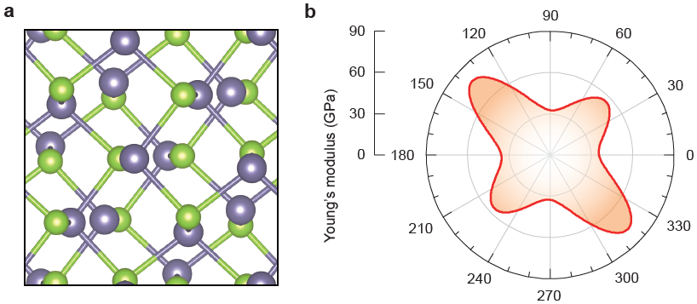
Supplementary Figure 11. (a) GeSe structure model with 50% twins. (b) The directional Young’s modulus calculated for the model in (a).

References

- Lin, W. T. et al. Highly pressurized helium nanobubbles promote stacking-fault-mediated deformation in FeNiCoCr high-entropy alloy. Acta Mater. 210, 116843 (2021).
- Dang, C. et al. Achieving large uniform tensile elasticity in microfabricated diamond. Science 371, 76‒78 (2021).
- Falin, A. et al. Mechanical properties of atomically thin boron nitride and the role of interlayer interactions. Nat. Commun. 8, 15815 (2017).
- Bertolazzi, S., Brivio, J. & Kis, A. Stretching and breaking of ultrathin MoS₂. ACS Nano 5, 9703‒9709 (2011).
- Lee, C., Wei, X., Kysar, J. W. & Hone, J. Measurement of the elastic properties and intrinsic strength of monolayer graphene. Science 321, 385‒388 (2008).
- Kim, J. H., Jeong, J. H., Kim, N., Joshi, R. & Lee, G.-H. Mechanical properties of two-dimensional materials and their applications. J. Phys. D: Appl. Phys. 52, 1361‒6463 (2019).
- Lee, G.-H. et al. High-strength chemical-vapor–deposited graphene and grain boundaries. Science 340, 1073‒1076 (2013).
- Tao, J. et al. Mechanical and electrical anisotropy of few-layer black phosphorus. ACS Nano 9, 11362‒11370 (2015).
- Sheraz, A. et al. High elasticity and strength of ultra-thin metallic transition metal dichalcogenides. Nanoscale Adv. 3, 3894‒3899 (2021).
- Jiang, H., Zheng, L., Liu, Z. & Wang, X. Two‐dimensional materials: From mechanical properties to flexible mechanical sensors. InfoMat 2, 1077‒1094 (2019).
- Li, Y. et al. Elastic properties and intrinsic strength of two-dimensional InSe flakes. Nanotechnol. 30, 1361‒6528 (2019).
- Sun, Y. et al. Elastic properties and fracture behaviors of biaxially deformed, polymorphic MoTe₂. Nano Lett. 19, 761‒769 (2019).
- Zhang, R., Koutsos, V. & Cheung, R. Elastic properties of suspended multilayer WSe₂. Appl. Phys. Lett. 108, 042104 (2016).
- Castellanos-Gomez, A. et al. Mechanical properties of freely suspended atomically thin dielectric layers of mica. Nano Research 5, 550‒557 (2012).
- Chitara, B. & Ya'akobovitz, A. Elastic properties and breaking strengths of GaS, GaSe and GaTe nanosheets. Nanoscale 10, 13022‒13027 (2018).
- Guo, L. et al. Elastic properties of van der Waals epitaxy grown bismuth telluride 2D nanosheets. Nanoscale 7, 11915‒11921 (2015).

