SUPPLEMENTARY INFORMATION

An enzymatic reaction-based phenylboronic acid-modified microporous array chip for chiral differentiation and high-throughput detection of D-amino acids
Feng Lu ^{b}, Limao Li ª, Kang Shen ^{c}, Yayun Qian ^{c}, Pengfei Zhang ª, Yan Yang ª, Qunshan Zhu ª, Yong Huang ª, Chunxiang Yan ^{a *} and Wei Wei ^{a *}
ª Department of Gastrointestinal Surgery, Jiangdu People’s Hospital affiliated to Yangzhou University, Yangzhou 225001, PR China.
^{b} Affiliated Huishan Hospital of medical College, Yangzhou University, Wuxi Huishan District People’s Hospital, Wuxi, 214187, PR China.
^{c} Institute of Translational Medicine, Medical College, Yangzhou University, Yangzhou 225001, PR China.
*: Corresponding authors
E-mail addresses: jd.k.kenny@163.com (W. Wei), 18952531176@yzu.edu.cn (C. Yan).

- Results and discussion
  - Experimental parameters optimization
To obtain better detection performance, the study was carried out to optimize the 3-MPBA concentration, incubation time of Au/SiNCA with 3-MPBA solution and reaction system pH and temperature. As indicated in Fig. S1a, as the concentration of 3-MPBA increased, I₈₈₂/I₉₉₈ gradually increased, indicating a more complete reaction. When the concentration of 3-MPBA reached 2.5 mM, a strong SERS signal could be obtained, and 2.5 mM was taken as the optimal modification concentration to save cost. In Fig. S1b, when Au/SiNCA was co-incubated with 3-MPBA (2.5 mM) for 2 h, I₈₈₂/I₉₉₈ gradually increased from 0.121 to a maximum of 0.514, thus 2 h was chosen as the optimal incubation time for 3-MPBA. Excessive incubation time may lead to detachment of sputter-deposited AuNPs on the Au/SiNCA surface, resulting in unstable SERS performance of the substrate. I₈₈₂/I₉₉₈ peaked at pH = 7.4 and 37 ℃, and decreased significantly with the increase of pH and temperature (Fig. S1c and d). The results demonstrated that pH = 7.4 and 37 ℃ were the optimum pH and optimum temperature for this reaction system.
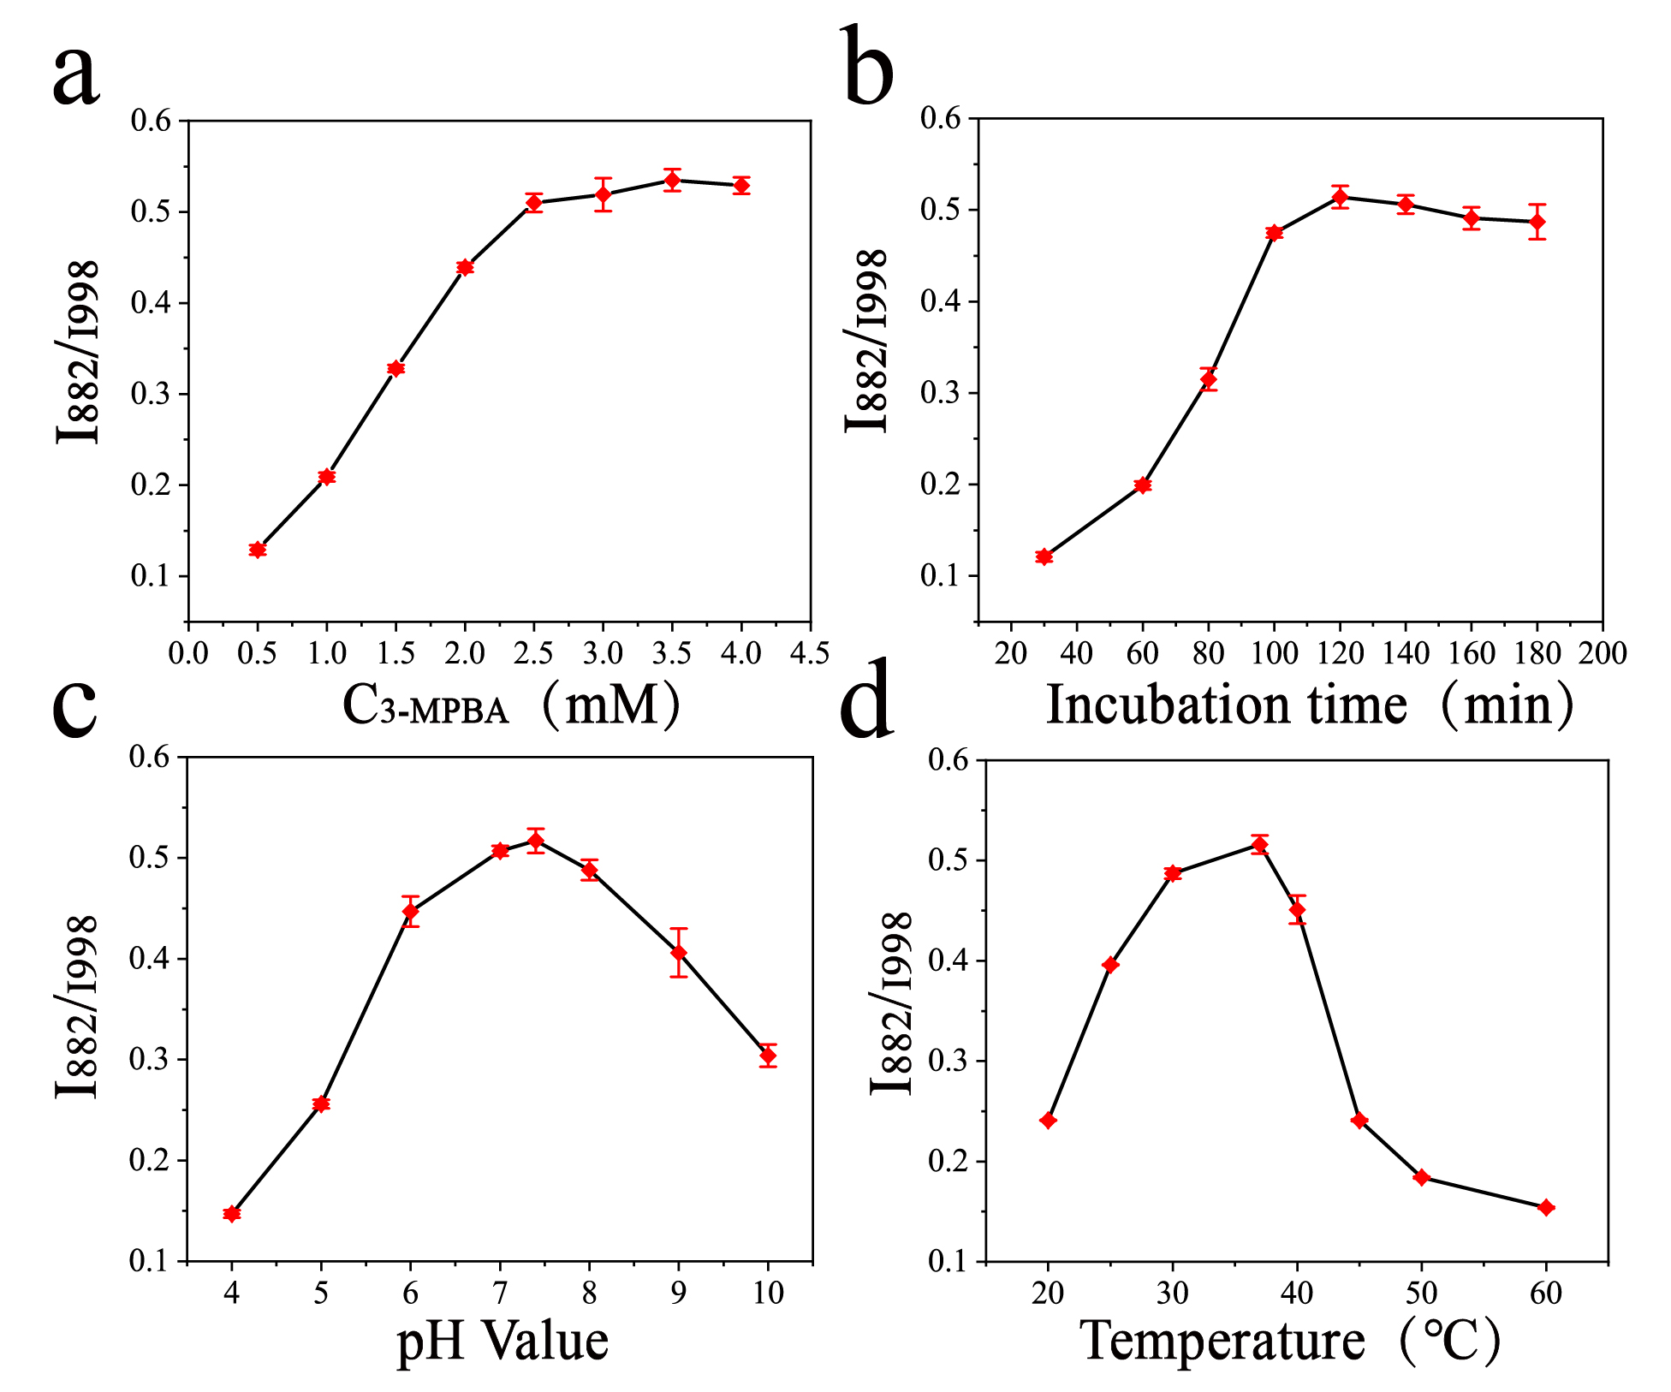
Fig. S1 The ratio of Raman intensity (I₈₈₂/I₉₉₈) (a) with different concentrations of 3-MPBA on the ratiometric SERS sensor. (b) with different incubation times of Au/SiNCA and 3-MPBA. (c) with different pH values of the reaction system. (d) with different reaction temperatures.

