Biochemical Tests for Presumptive Isolate Identification

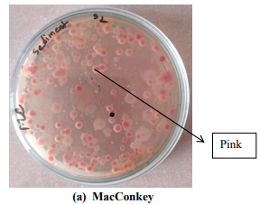
Fig. 1: Culturing samples on MacConkey agar

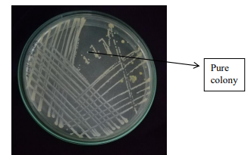
Fig. 2: Subculturing on Nutrient Agar

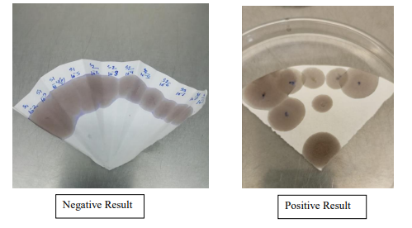
Fig. 3: Oxidase Test

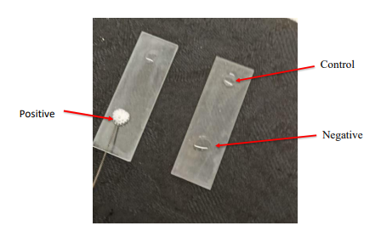
Fig. 4: Catalase Test
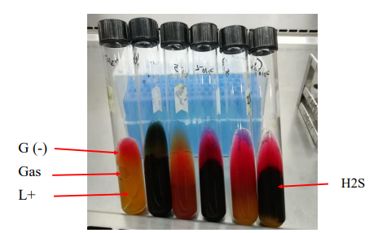
Fig. 5: KIA Test

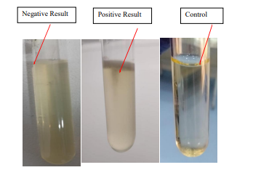
Fig. 6: Motility Test

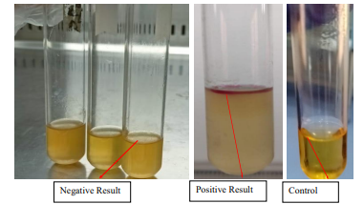
Fig. 7: Indole Test

