Supporting Information
Table of Contents
- Nobel Prize Winners, Scientists, and General Population Statistics
- Similarity and Social Distance Survey
  - Supporting Information Figure 1
  - Supporting Information Figure 2
- General Social Survey Data
  - Supporting Information Figure 3
  - Supporting Information Figure 4
- Trust and COVID-19 Outcomes
  - Supporting Information Table 1
  - Supporting Information Table 2
  - Supporting Information Table 3
  - Supporting Information Table 4
  - Supporting Information Table 5
- Building Trust Experiment
  - Supporting Information Table 6
  - Supporting Information Table 7
  - Supporting Information Table 8
  - Supporting Information Table 9
  - Supporting Information Table 10
  - Supporting Information Table 11
  - Supporting Information Table 12
  - Supporting Information Table 13
- Conjoint Survey Experiment Questions

Nobel Prize Winners, Scientists, and General Population Statistics
For the Nobel prize classifications, we focused exclusively on those who were born in the United States. We recognize that many scientists came to the country to conduct research at American institutions, but our focus is on relative comparisons to the population, most of whom are native born. Further, this approach is more applicable to understanding pathways to success in science in the United States. We included the four science categories of Chemistry, Medicine, Physics, and Economics; our science theme meant we excluded the Literature and Peace prizes. For identifying (counting nationalities) and classifying the Nobel Prize winners, we relied mostly on autobiographical articles on the Nobel Prize website and obituaries published in The New York Times. One caveat regarding the number of prizes won is that, once accounting for population size, Americans have not won the most prizes (Britons have).
We defined parental education (e.g., first- or second-generation college student) in terms of whether either parent attended a higher education institution (i.e., the focus is on the highest educated parent). (The sources do not generally specify whether a parent graduated from the institution attended.) For instance, first-generation is defined as neither parent having attended a higher education institution. If the aforementioned sources did not specify whether the parents had attended a higher education institution, we inferred based on parental occupations (e.g., doctor, lawyer, factory worker). We included religious education as higher education. Consequently, we did not consider many of the early Nobel Prize winners as first generation since they had fathers who were clergy. We were unable to identify sufficient information for 20 winners, and they were excluded from the data for this computation. For rurality, we used places of birth. Rural areas are incorporated with less than 2,500 residents and are outside of urban metropolitan areas (in accordance with Census policy from 1950 through 2020). All else is urban (also in accordance with Census policy). For gender and race, we used a combination of the aforementioned sources as well as Wikipedia sources (38, 39) that include information on the racial and gender backgrounds of Nobel Prize winners. We classified the one Latino winner (Luis Alvarez) separately from the white winners.
Comparison of the Nobel Prize winners with the scientific workforce and/or the general population is complicated by the over-time nature of the Nobel Prizes (combined with demographic population shifts). With that caveat in mind, we focus on contemporary statistics. For the scientific workforce statistics, we used the term “approximately” in the text because there is not a definitive contemporary source for all the statistics we cite. We compiled the statistics as follows. For gender and race, we relied on the 2019 Science and Engineering Indicators (40: Figure LBR-20, LBR-23), which provides the composition of the science, technology, engineering, and mathematics (STEM) workforce. For rurality, we used a 2022 survey of physician scientists (41; also see 42). For parental education, we used data provided by Schultz and Stansbury (43). The scientific workforce parental education percentage looks at the number of Ph.D. recipients, while the population parental education percentage is restricted to those with a college degree. If we instead looked at the entire population regardless of a college degree, the percentage drops to 34%. The scientific workforce parental education percentage (which is 74%) is similar to what is provided by the National Center for Science and Engineers Statistics, who in 2014, reported a percentage of 69.5% (44). For religious beliefs, we used a Pew Research Center report (45) that drew on a survey of more than 2,500 scientists who are members of the American Association for the Advancement of Science. The results are consistent with a 1996 survey (46), and a 2005 survey (47). They are lower than a 1914 survey (48) and 2015 survey (49), both of which state that roughly 60% of scientists are atheists.
For the general population, the percentages for gender identity, race, and non-rural came from the 2020 census (50). For socioeconomic status, we used data from Schultz and Stansbury (43). The percentage of “no religion” came from the 2022 General Social Survey (weighted) respondents who replied with “no religion.” As mentioned, this likely substantially over-stated the percentage of atheists (the statistic given for the scientific workforce).
Similarity and Social Distance Survey
The survey results regarding perceptions of difference and ties to scientists come from a COVID States Project survey. The data were collected via the PureSpectrum survey recruitment platform, which aggregates and deduplicates paid panelists from multiple online survey sources. Though not a probability sample, the large scale of the sample and its demographic breadth provides the necessary flexibility for including quotas for gender, race, and age at the state level and reweighting of observations to match official U.S. Census figures. Emerging evidence suggests this methodology can perform as well as traditional probability sampling (51–53). The similarity and social distance survey data were collected between June 28, 2023, and August 1, 2023 (N = 27,960).
Respondent gender (61% female), race (12% African American or Black, 4% Asian American, 10% Hispanic or Latino, 69% white non-Hispanic or Latino, 4% Other), and age (mean = 46.9, std. dev. = 17.7) were provided by the recruitment platform. To identify respondents living in rural, suburban, and urban areas, we used the Urban-Rural Classification Scheme for Counties designed by the National Center for Health Statistics (NCHS). Respondent religion was recorded by asking “What is your religion or faith-based practice?”. Categories were recoded as Catholic (20%), Evangelical (28%), Non-Evangelical Protestant (16%), and Other Religion (14%). The comparison category included people who selected “Atheist,” “Agnostic,” or “None” for religion. Other than the descriptive statistics above, the results are based on analyses using post-stratification weights for gender, age, race and ethnicity, education, region, rurality, and vote choice in the 2020 election.
To evaluate similarity to scientists, the survey asked “Do you think that people in the following professions are different from you or similar to you? Please answer on a scale from 0 to 100 where 0 is ‘very different’ and 100 is ‘very similar’.” Respondents rated twelve professions (e.g., politician, bartender, teacher in grade school, or police officer). The focus here is on scores representing respondent similarity to the profession of “Scientist” (mean = 36.4, SD = 31.9).
The average score on similarity to scientists for women is 31.6 (SD. = 30.3), while for men it is 41.6 (SD = 32.7), a statistically significant difference of 10 percentage points (p < .01). The scores for groups based on race and ethnicity are 37.4 (SD = 32.1) for African American or Black respondents, 41.8 (SD = 31.0) for Asian American respondents, 35.8 (SD = 32.3) for Hispanic or Latino respondents, and 35.9 (SD = 31.8) for white non-Hispanic or Latino respondents. Thus, we did not find increased similarity among white respondents relative to non-white respondents. Respondents in rural areas score on average 32.3 (SD = 30.8) for similarity to scientists, compared to 35.3 (SD = 31.6) for suburban and 40.5 (SD = 32.6) for urban respondents (p < .01). Religious respondents scored 35.9 (SD = 31.9) compared to non-religious ones at 37.7 (SD = 31.8), also a significant difference (p < .01).
In a regression model predicting trust in scientists with controls for demographic and political variables and fixed effects for U.S. state of residence, similarity to scientists emerges as an important predictor (β = .15, p < .01), along with being a Republican (β = -.13, p < .01), Independent (β = -.13, p < .01), or Other political identification (β = -.13, p < .01), income (β = .07, p < .01), and holding a graduate degree (β = .05, p < .01) (see Supporting Information Figure 1).
Supporting Information Figure 1
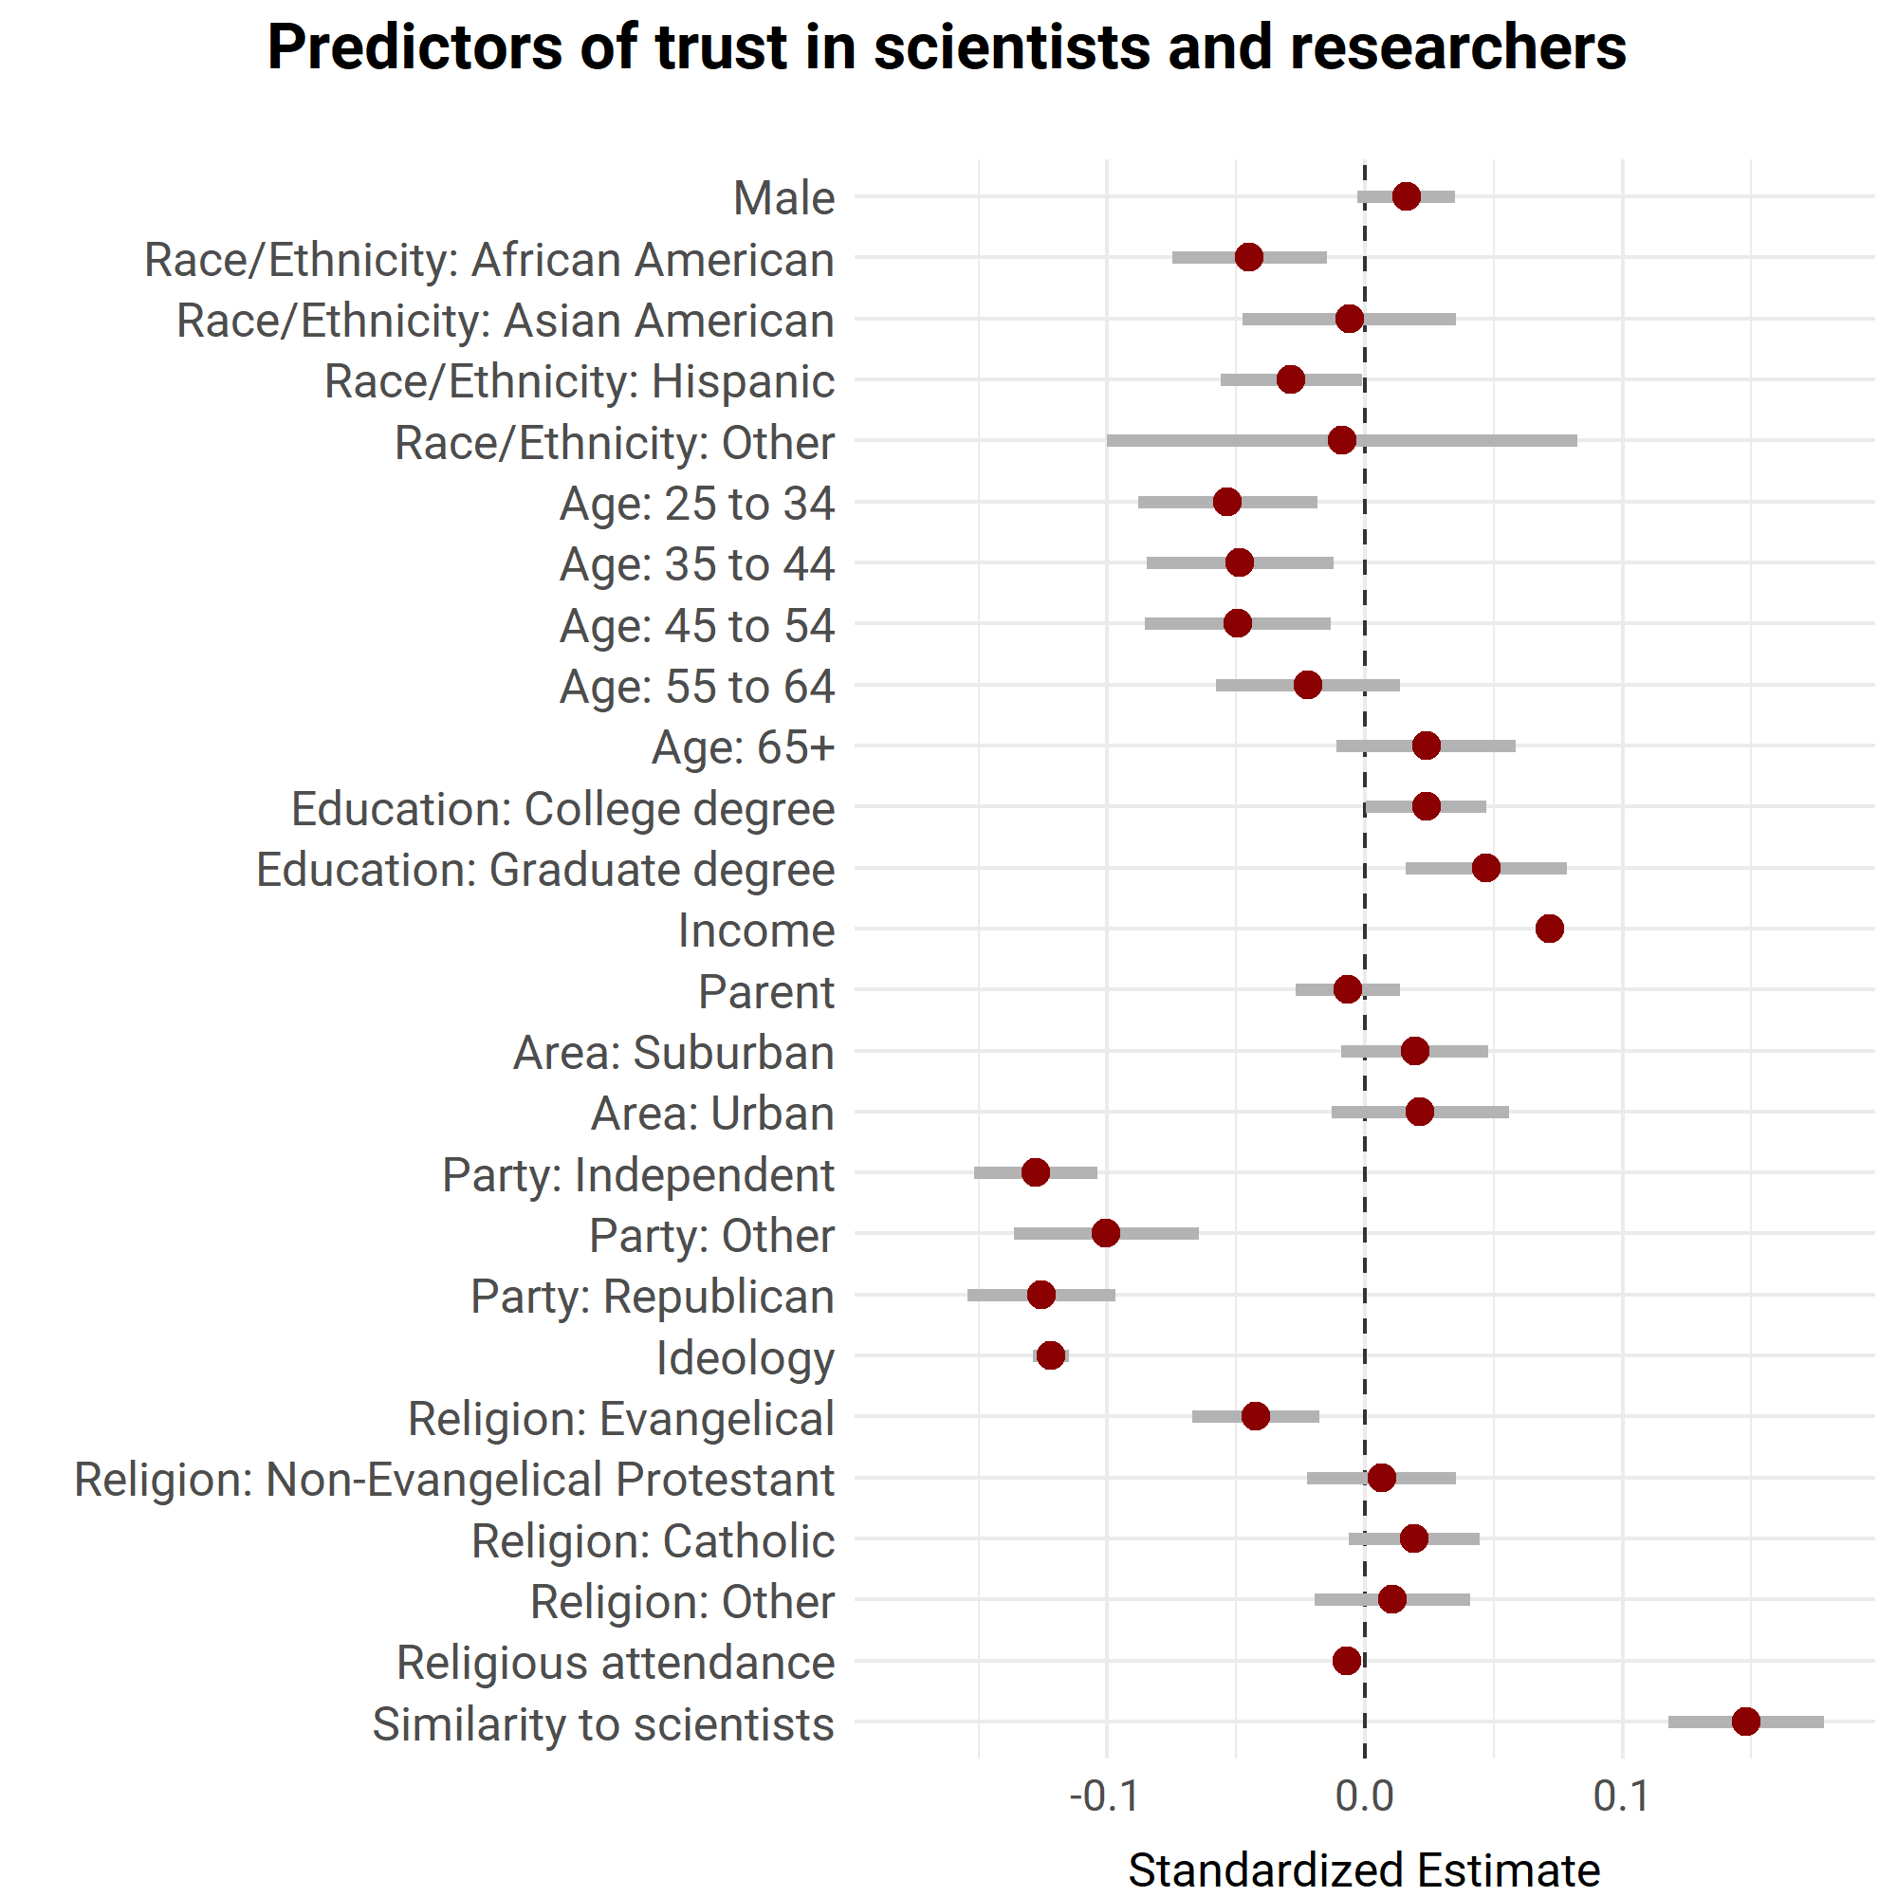
Note: The figure displays OLS coefficients and 95% intervals for a regression of trust in scientists on the listed variables. Data are from the COVID States Project from June 28, 2023, and August 1, 2023. Details are provided in the text of the supporting information.
To examine the role of social ties with scientists, we asked respondents if the people around them had one of several different jobs. Those professions included “Scientist working at a company” and “Professor at a college or university.” In total, 28% (95% confidence interval = 27%–28%) of respondents reported having a friend or family member in one of those two categories.
Among women, the percentage who have friend or family ties to scientists is 25% (24%–26%), compared to 31% (30%–32%) among men (p < .01). The percentages among groups based on race and ethnicity are 28% (26%–30%) for African American or Black respondents, 36% (33%–40%) for Asian American respondents, 26% (24%–28%) for Hispanic or Latino respondents, and 27% (26%–28%) for white non-Hispanic or Latino respondents. Asian American respondents are significantly more likely than other groups to have ties to scientists (p < .01), while the rest of the groups are relatively similar to one another.
Among respondents in rural areas, the percentage of those with ties to scientists is 22% (21%–24%), compared to 27% (26%–27%) for suburban respondents and 33% (31%–34%) for urban respondents (p < .01). The percentage is 24% [23%–26%] for religious respondents, compared to 29% (28%–30%) for non-religious ones, also a significant difference (p < .01).
In a regression model predicting trust in scientists with controls for demographic and political variables and fixed effects for U.S. state, having a family member or friend who is a scientist is a significant positive correlate (β = .04, p < .01) (Supporting Information Figure 2). When both similarity to scientists and ties to scientists are included in the model, the latter variable is no longer significant (β = .01, p > .05), while the similarity variable remains positive and significant at (β = .15, p < .01).
Supporting Information Figure 2
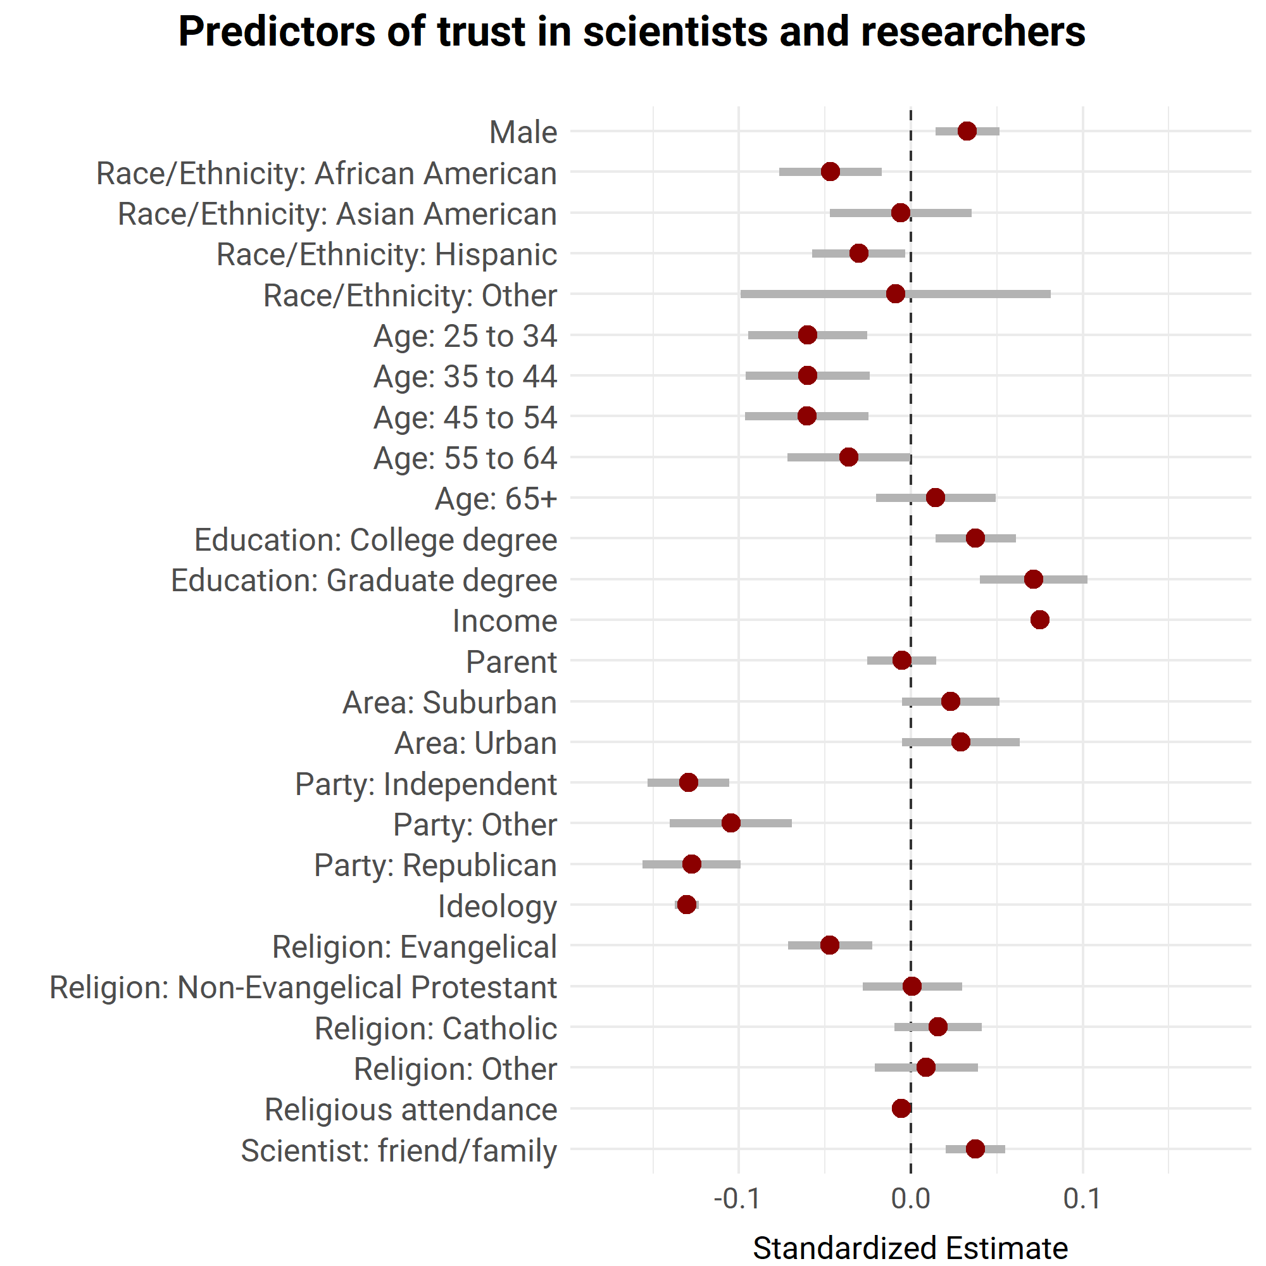
Note: The figure displays OLS coefficients and 95% intervals for a regression of trust in scientists on the listed variables. Data are from the COVID States Project from June 28, 2023, and August 1, 2023. Details are provided in the text of the supporting information.
General Social Survey Data
The data for tracking trust in scientists over time comes from the General Social Survey (GSS), a probability, face-to-face sample survey that charts social change in the US. Since 1973, it has included a question that asks whether respondents have a great deal of confidence, only some confidence, or hardly any confidence at all in the scientific community. The figure in the paper (Figure 1) plots the percentage by group who exhibited a great deal of confidence in each year the survey collected data. We included data through 2022 and used weighted data (using the “wtssall” weight). The unweighted Ns for each year are as follows: 1973 (1504), 1974 (1484), 1975 (1490), 1976 (1499), 1977 (1530), 1978 (1532), 1980 (1468), 1982 (1860), 1983 (1599), 1984 (1473), 1986 (1470), 1987 (1819), 1988 (1481), 1989 (1537), 1990 (1372), 1991 (1517), 1993 (1606), 1994 (2992), 1996 (2904), 1998 (2832), 2000 (2817), 2004 (2765), 2006 (4510), 2008 (2023), 2010 (2044), 2012 (1974), 2014 (2538), 2016 (2867), 2018 (2348), 2021 (4032), and 2022 (3544).
We operationalized the groups in the confidence in scientists figure (Figure 1) as follows. For gender, we used the respondent sex variable that codes male or female. (2021 was the first year that some respondents were coded as “inapplicable,” “no answer,” “do not know/cannot choose,” or “skipped.”) For race, we used the race question that asks “What race do you consider yourself?” Interviewers also could answer if they had “no doubt” in their minds of the respondent’s race. Over time, the GSS only includes “White,” “Black,” and “Other.” 2021 was the first year some respondents were coded as “inapplicable.” The number of “Other” respondents was quite small in early years; we exclude that group given it is surely heterogeneous. For rurality, we used the coding of the size of the place where the respondent lives, coding rural as including not living in a standard metropolitan statistical area or a small city; or as living in a town or village with 2,500 to 9,999 people, an incorporated area with less than 2,500, an unincorporated area of 1,000 to 2,499 people, or open country. For education, we used the respondent’s highest degree. For religion, we used the question that asked “What is your religious preference,” coding not religious if the respondent stated none. For class, we used a question that asked “If you were asked to use one of four names for your social class, which would you say you belong in…” We combined lower class and working class, and middle and upper class (upper class generally had very few respondents). Recall that for data on the Nobel prize winners and scientific workforce, we used parental education. If we use parental education instead of class or education, we find the same trust divide (as measured with the parents’ highest years of schooling). These results appear in Supporting Information Figure 3.

Supporting Information Figure 3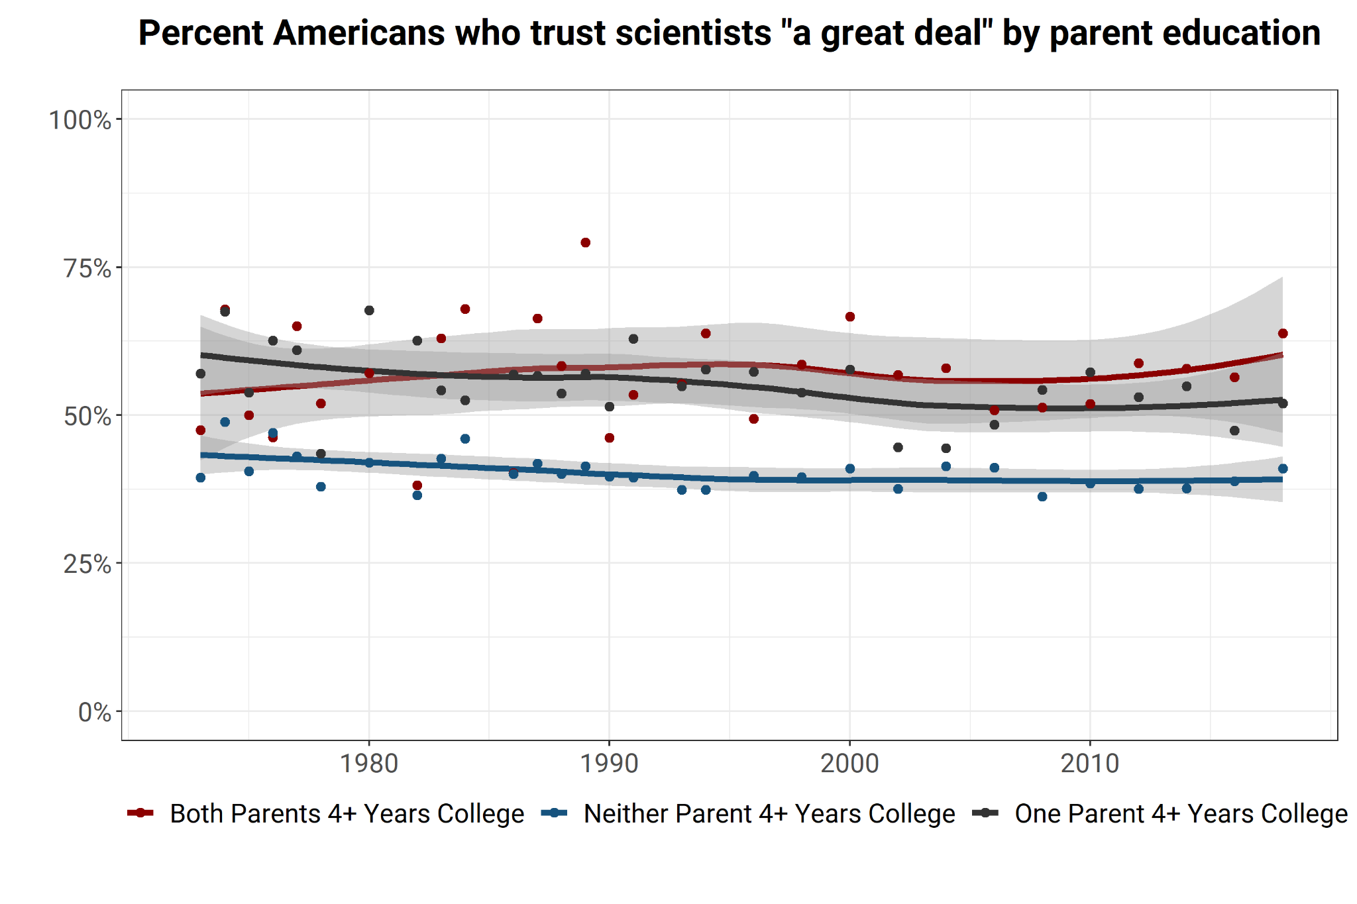Note: The figure displays the weighted percentage of respondents from the given group in a given year who stated that they had a “great deal of confidence” in the scientific community (with the answer options also including “only some confidence” and “hardly any confidence”). Data are from the General Social Survey; details are provided in the text of the supporting information.
Supporting Information Figure 4 displays the regression coefficients from a trust in scientists model with each variable as a coefficient, highlighting the remarkable stability of the relationships over time.
Supporting Information Figure 4

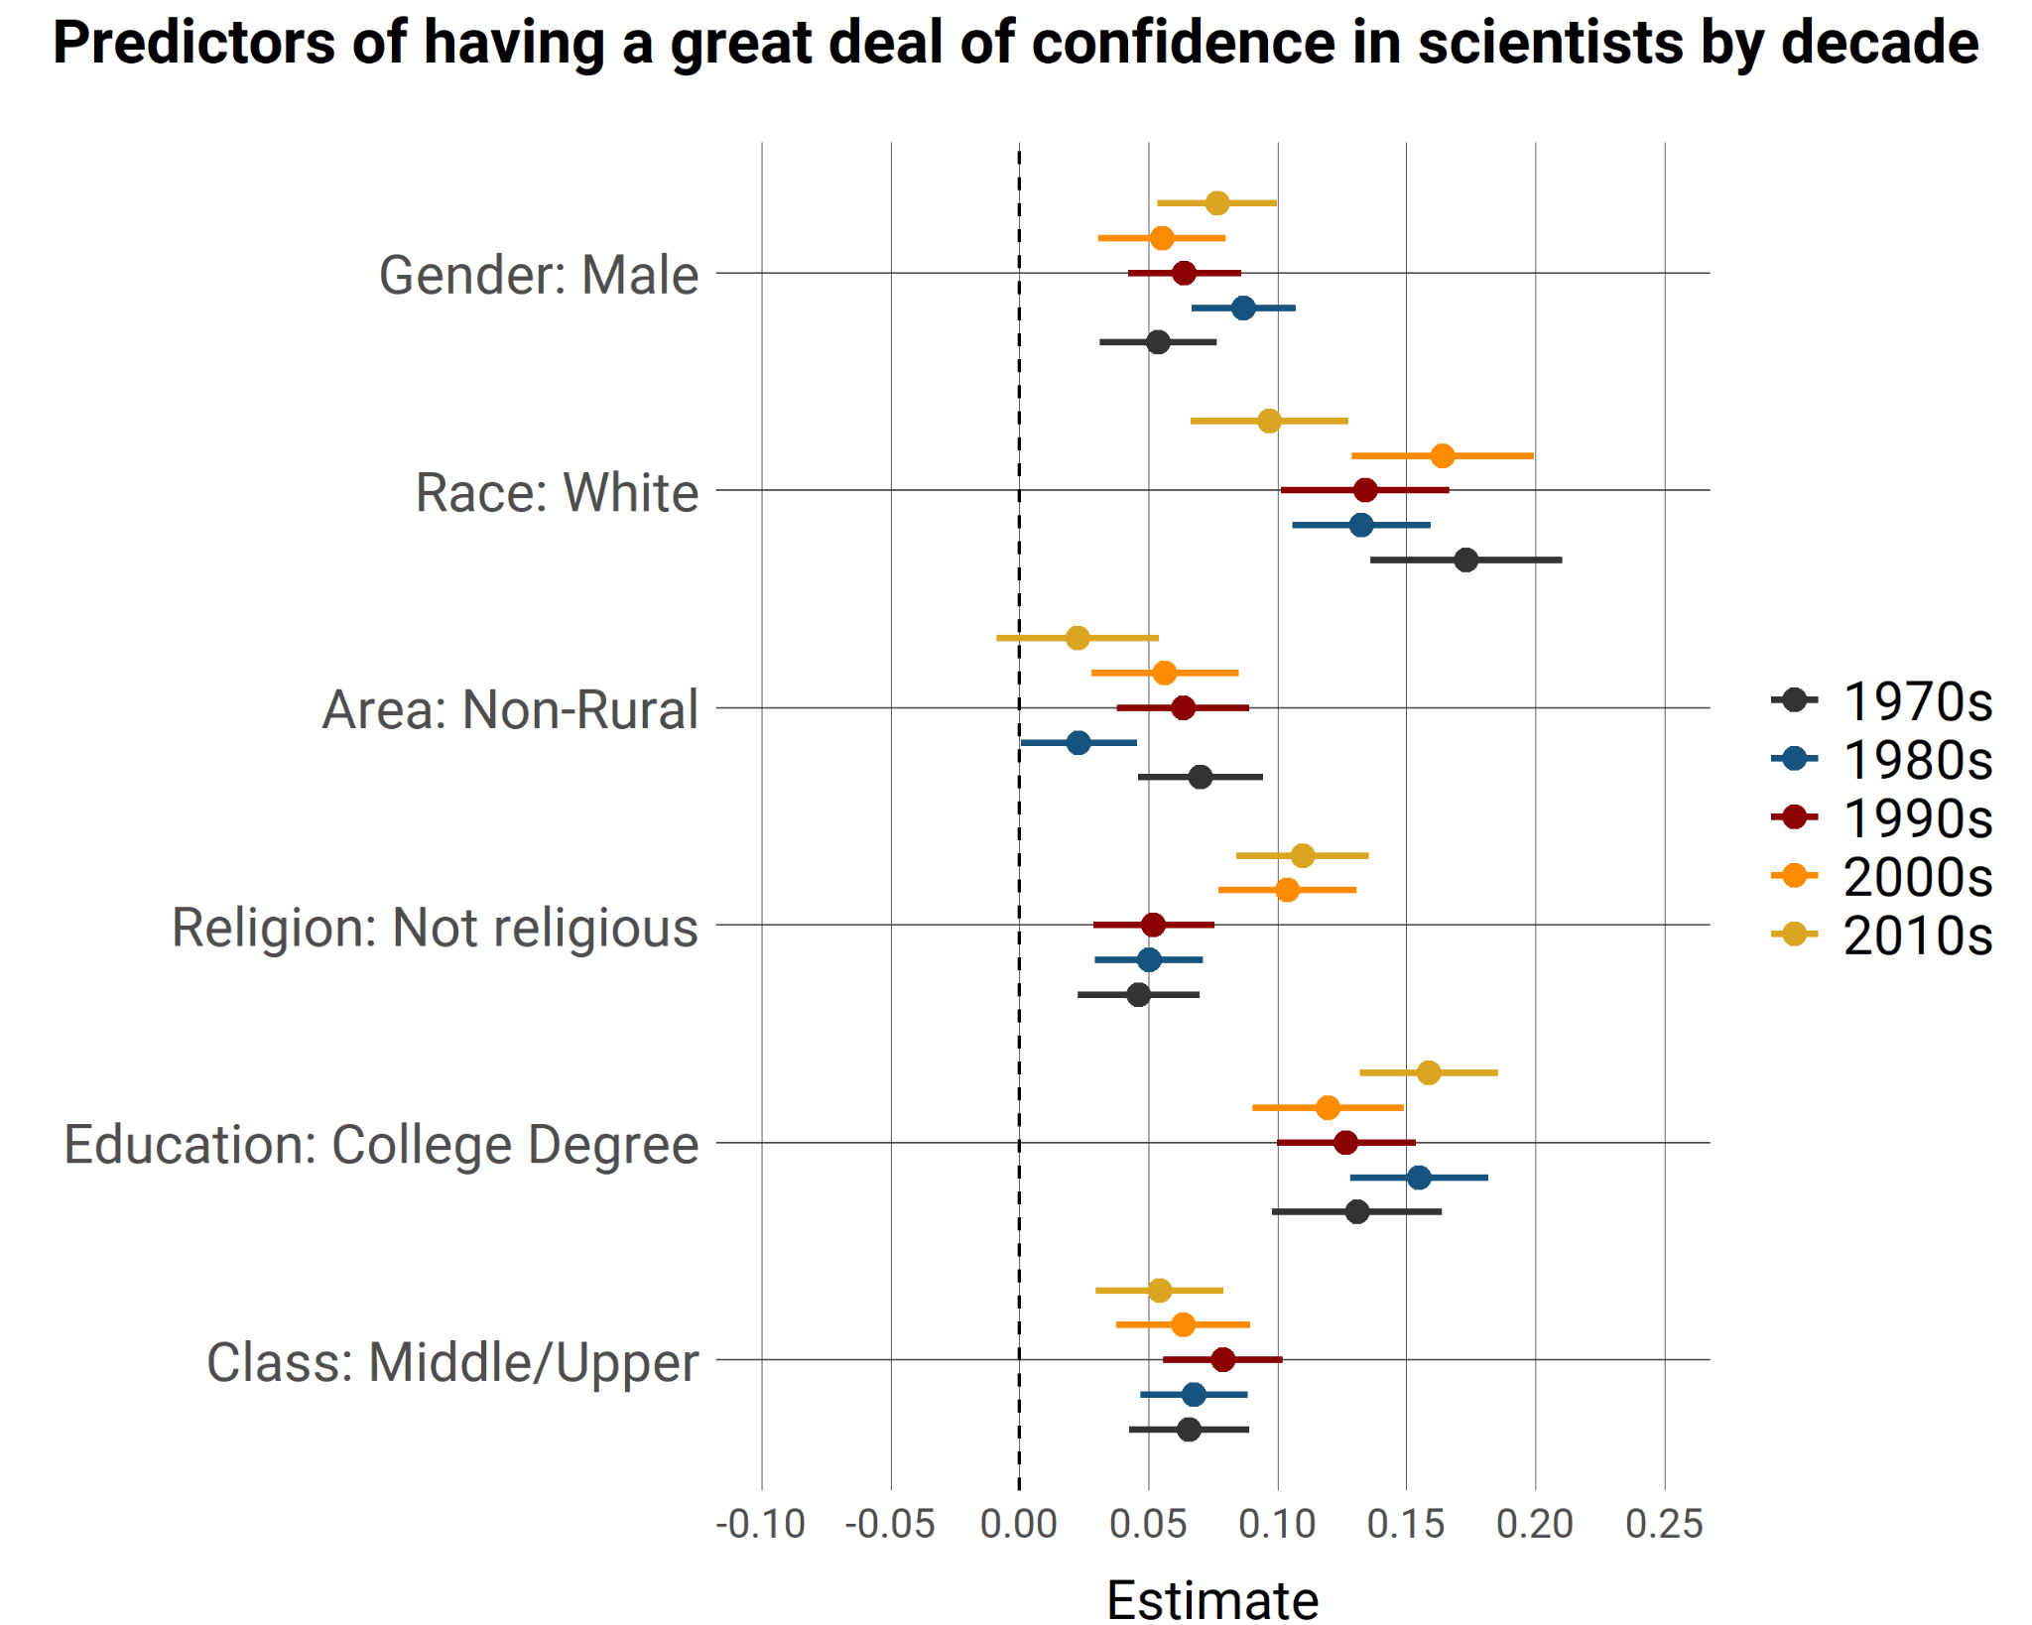
Note: The figure displays OLS coefficients and 95% intervals for a regression of having a “great deal of confidence” in the scientific community (or not) on the listed variables for the given decade. Data (which are weighted) are from the General Social Survey; details are provided in the text of the supporting information.
Trust and COVID-19 Outcomes
The data underlying Figures 2-3 come from the COVID States Project (as discussed in a prior Supporting Information section). Figures 2A (N = 2,941) and 2B (N = 1,372) use trust data from four survey waves of survey collection that occurred between May 2020 and August 2020. The vaccination data come from May-July 2021, and include only individuals who were also in the earlier surveys to measure trust. This was not a panel data collection; rather, the data were repeated cross-sections but the large size of the waves and the use of a common vendor and recruitment strategy meant each data collection included a non-trivial number of repeat respondents (by design).
The vaccination outcome variable asked, “Have you received a COVID-19 vaccine?,” with answers being 1 = Yes, one dose; 2 = Yes, two doses; and 3 = No. We recoded it into a binary variable: participants who answered 1 or 2 were considered to have received at least one COVID-19 vaccine dose (1) and participants who answered 3 were considered to not have received a dose (0). The trust in scientists measure asked, “How much do you trust the following people and organizations to do the right thing to best handle the current coronavirus (COVID-19) outbreak?”, with one of the evaluative targets being “Scientists and researchers.” The answer options were 4 = A lot, 3 = Some, 2 = Not too much, and 1 = Not at all.
Figure 2A presents the percentage of respondents, providing a given trust response, who reported being vaccinated. Figure 2B reports the regression results of the vaccination variable on trust in scientists and various control variables, measured as follows. Partisanship asked “Generally speaking, do you think of yourself as a…,” with answer options being 1 = Republican, 2 = Democrat, 3 = Independent, and 4 = Other. Those who answered Republican or Democrat were then asked if they considered themselves as a “strong” identifier or a “not very strong” identifier. Those who answered Independent or Other were asked whether they think of themselves as closer to the Republican Party, Democratic Party, or neither. Responses to these questions were combined into a 7-point partisanship scale, with higher values indicating Stronger Republican. Age was calculated from “I was born in [Month, Year]”, then converted into age brackets: 1 = 18 to 24, 2 = 25 to 44, 3 = 45 to 64, and 4 = 65 and over. Race was queried with “My ethnic background is…,” with the answer options being white, Hispanic, African American, Asian, American Indian, Middle Eastern, and Other ethnicity. We then recoded it so that American Indian and Middle Eastern was combined with “Other race” to create the following: 1 = white, 2 = Hispanic, 3 = African American or Black, 4 = Asian, and 5 = Other. Gender was measured with “I’m a…” with the answer options being male or female. Education level was measured with “My highest level of education is…” with the answer options being “Some high school or less,” “High school graduate,” “Some college,” “Bachelor’s degree,” “Master’s degree,” and “Doctorate degree.” We recoded “Master’s degree” and “Doctorate degree” into a single “Graduate Degree” category. Region was categorized according to participant-reported state of residence using the four US Census regions: Northeast, Midwest, South, and West. Religious services was measured with “How often do you attend religious services?,” with the answer options being: 1 = More than once a week, 2 = Once a week, 3 = Once or twice a month, 4 = A few times a year, 5 = Once a year or less, and 6 = Never. Household income was measured with “My household earns approximately $[______] per year,” with the answer options being: 1 = Under $15,000; 2 = $15,000 to $24,999; 3 = $25,000 to $34,999; 4 = $35,000 to $49,999; 5 = $50,000 to $74,999; 6 = $75,000 to $99,999; 7 = $100,000 to $149,999; 8 = $150,000 to $199,999; and 9 = $200,000 or more. We relied on the NSCH Urban-Rural Designation based on the respondent’s county of residence (54), with the options being 1 = Large central metro, 2 = Large fringe metro, 3 = Medium metro, 4 = Small metro, 5 = Micropolitan, and 6 = Non-core. The (linear probability) model is in the below table. All independent variables were scaled from 0 to 1.
Supporting Information Table 1
Vaccine Dosage and Trust in Scientists
Vaccination Status
Trust in Scientists | 0.347***  (0.047)
Age 18 to 24 | -0.266***  (0.071)
Age 25 to 44 | -0.299***  (0.031)
Age 45 to 64 | -0.143***  (0.025)
Race = African American | -0.078*  (0.041)
Race = Asian American | 0.163***  (0.055)
Race = Hispanic | -0.030  (0.059)
Race = Other Race | -0.188**  (0.092)
Male | 0.030  (0.024)
Graduate Degree | 0.267**  (0.105)
College Degree | 0.246**  (0.101)
Some College | 0.180*  (0.102)
High School Degree | 0.188*  (0.102)
Midwest | 0.006  (0.032)
Northeast | 0.072**  (0.033)
South | -0.020  (0.030)
Religious Serv. Attendance | 0.022  (0.033)
Income Level | 0.238***  (0.051)
NCHS Urban-Rural | -0.097***  (0.037)
Partisanship (Republican) | -0.138***  (0.032)
Constant | 0.331***  (0.117)
Observations | 1,372
R-squared | 0.217
Standard errors in parentheses. *p<0.01; **p<0.05; ***p<0.01
To generate Figure 2C (and Figure 3B and Figure 3D), we created a synthetic variable that predicted trust levels from the 1970s GSS data. Specifically, we aggregated the GSS data from the 1970s (N = 10,652) and ran an OLS regression with a binary variable for having a great deal of confidence in the scientific community (1 if yes, 0 if no) as the dependent variable. The independent variables were a measure of gender and marital status (i.e., married man, married woman, unmarried man, unmarried woman), age, race, rurality, income, education, religion, and religious service attendance. We then matched each of these categories in the COVID States Project data to align with the GSS categories. From there, we used the “predict” function in R to generate predicted values, derived from the GSS coefficients from the 1970s, for COVID States Project survey respondents in for the April 1, 2021 to May 3, 2021 data. The results from this predict() function create a synthetic variable score for each respondent in the COVID States Project dataset, predicting the probability (ranging from 0 to 1) that they would have a great deal of confidence in scientists based on the 1970s GSS coefficients. For these analyses, we thus used a binary version of the COVID States Project trust measure so as to match the GSS version (specifically, we coded the “A lot” answer as equal to 1 and all others as equal to 0). Additionally, we did not lag the predicted trust measure since it is, in essence, lagged by virtue of being imputed from 1970s data.
Figure 2C is at the individual level. We grouped respondents into trust deciles and plotted the percent of respondents in the decile who had received at least one COVID-19 vaccination (operationalized as detailed above). The vaccination data we used come from the COVID States project from April 1 to May 3, 2021. We shifted vaccination periods compared to Figure 2A and 2B because we use the data here to also look at state level mortality (in Figure 3) in the period from when vaccines became eligible to all adults in every state until the post-Omicron variant period (and vaccines became widely available by roughly April, 2021). (The results in Figure 2A and Figure 2B are the same if we use the April-May time period.) In the below table (Supporting Information Table 2), we provide a regression with the same control variables as used in the prior table.
Supporting Information Table 2
Vaccine Dosage and Predicted Trust in Scientists

 | Vaccination Status
Predicted Trust in Scientists | -0.013***
Decile | (-0.004)
Age 18 to 24 | -0.380***
 | (-0.015)
Age 25 to 44 | -0.418***
 | (-0.012)
Age 45 to 64 | -0.225***
 | (-0.013)
Race = African American | -0.115***
 | (-0.019)
Race = Asian American | 0.111***
 | (-0.019)
Race = Hispanic | 0.054***
 | (-0.017)
Race = Other Race | -0.075**
 | (-0.03)
Male | 0.002
 | (-0.01)
Graduate Degree | 0.378***
 | (-0.03)
College Degree | 0.304***
 | (-0.029)
Some College | 0.150***
 | (-0.023)
High School Degree | 0.094***
 | (-0.023)
Midwest | 0.023**
 | (-0.011)
Northeast | 0.037***
 | (-0.012)
South | -0.003
 | (-0.01)
Religious Serv. Attendance | -0.002
 | (-0.003)
Income Level | 0.00000***
 | (0)
NCHS Urban-Rural | -0.070***
 | (-0.012)
Partisanship (Republican) | -0.111***
 | (-0.009)
Constant | 0.616***
 | (-0.028)
Observations | 14,931
R-squared | 0.141
Standard errors in parentheses. *p<0.01; **p<0.05; ***p<0.01
Figure 3 uses state level data. The vaccination data (Figure 3A and Figure 3B) are from the COVID States project from April 1 to May 3, 2021, averaged by state. The mortality data (Figure 3C and Figure 3D) are the state level total deaths in the post-vaccine year April, 2021–May, 2022, using data from The New York Times (55). The trust in scientists variable is the same wording as detailed above, averaged at the state level and from an earlier (lagged) time period (rescaled to be between 0 and 100), specifically from data collected from April 16–30, 2020 (N = 21,414), and May 1–21, 2020 (N = 23,826). The predicted trust in scientists data (Figure 3B and Figure 3D) are the same as just described but averaged for each state. As mentioned, we chose this period for trust in scientists data since it envelops when vaccines became eligible to all adults in every state. We do not look at a longer vaccination time period since we are interested in initial uptake. We look at a longer period of mortality since we are interested in the downstream effects of trust and vaccines from the point of general vaccine availability to the post-Omicron variant period (which provided a boost in natural immunity).
For each panel in Figure 3, we ran a regression to assess the robustness of the relationship in the presence of control variables. These include the percent of the state identifying as Republican in 2016 from Gallup polling (56), the percent of the state aged 65 and older (from the 2019 American Community Survey), and state-level pandemic policy from the National Academy for State Health Policy (57) that coded whether the state had a mandated exemption from vaccine requirements (1 if yes, 0 if no).
The below table, Supporting Information Table 3, shows that relationships documented in Figure 3A (model 1) and Figure 3B (model 2) are robust to the inclusion of control variables.
Supporting Information Table 3
Vaccination and Trust in Scientists Regression
 | Percent Vaccinated  (1) | Percent Vaccinated  (2)
Trust in Scientists | 0.09***
 | (0.03)
Predicted Trust in Scientists |  | 0.68***  (0.24)
Percent Age 65+ | -0.14 | 0.15
 | (0.31) | (0.32)
Percent Republican 2016 | -0.36*** | -0.40***
 | (0.11) | (0.10)
Vaccine Exemptions | 1.03 | 1.64
 | (1.37) | (1.39)
Constant | 59.03*** | 25.08
 | (8.35) | (17.84)
Observations | 50 | 50
R-squared | 0.53 | 0.52
Standard errors in parentheses. | *p<0.1; **p<0.05; ***p<0.01
The first model in Supporting Information Table 4 shows the results relevant to Figure 3C. It reports two models. The first one (model 1) includes percent vaccinated as an independent variable. Here we see that trust is not significant but percent vaccinated is and is negative (indicating reduced mortality as vaccination rates increase). This accords with our statement in the text that vaccine uptake correlates with state mortality. The second one (model 2) displays the result without percent vaccinated, leading trust in scientists to become significant. In essence, this is suggestive evidence that the relationship displayed in Figure 3C is robust to a point—trust in scientists seems to influence mortality but does so via vaccination.
Supporting Information Table 4
Mortality and Trust in Scientists Regressions
 | Deaths per 1,000 people Deaths per 1,000 people
 | (1) | (2)
Trust in Scientists | -0.31 | -0.64**
 | (0.24) | (0.24)
Percent Age 65+ | 7.55*** | 8.05***
 | (2.34) | (2.57)
Percent Republican 2016 | 1.03 | 2.34**
 | (0.91) | (0.89)
Vaccine Exemptions | 7.85 | 4.10
 | (10.57) | (11.53)
Percent Vaccinated | -3.63***
 | (1.14)
Constant | 125.60 | -88.95
 | (92.70) | (70.02)
Observations | 50 | 50
R-squared | 0.58 | 0.49
Standard errors in parentheses. | *p<0.1; **p<0.05; ***p<0.01

The next table, Supporting Information Table 5, underlies Figure 3D. The bi-variate correlation in Figure 3D is statistically significant (p<0.01). Yet, the regressions show that with control variables, it falls short of significance. With percent vaccinated, p=.32; without it, p=.15. Thus, there is some question whether the predicted trust effect via vaccination (e.g., Supporting Information Table 3) robustly leads to death.
Supporting Information Table 5
 | Deaths per 1,000 people Deaths per 1,000 people
 | (1) | (2)
Predicted Trust in Scientists | 2.38 | -3.64
 | (2.39) | (2.49)
Percent Age 65+ | 5.72** | 6.30**
 | (2.27) | (2.78)
Percent Republicans 2016 | -1.89 | 2.70***
 | (1.25) | (1.00)
Vaccine Exemptions | 0.02 | 0.03
 | (0.10) | (0.12)
Percent Vaccinated | -6.52***
 | (1.35)
Constant | 4.49** | 0.84
 | (1.67) | (1.82)
Observations | 50 | 50
R-squared | 0.63 | 0.44
Note: | *p<0.1; **p<0.05; ***p<0.01
Building Trust Experiment
We collected data from Bovitz Inc.’s Forthright panel, which provides US nationally representative (non-probability, quota-based) samples. Our sample included 1,220 respondents, and we collected the data from December 11, 2023, to December 15, 2023. (We discuss statistical power below.)
To ensure sufficient variance in features that correlate with representation in science (gender, race, education, religiosity, rurality, and class), we used quotas to draw our sample. In terms of gender, 47.46% of participants identified as male, 51.31% as female, and 1.23% as gender non-conforming or other. For race, we focused on two underrepresented groups (Black and Hispanic or Latino individuals) and one overrepresented group (white individuals). Specifically, the sample only included those who primarily identified as Black (34.51%), Hispanic or Latino (19.75%), or white (45.74%). For education, 2.05% had less than a high school diploma, 21.39% had a high school diploma, 36.23% had some college, 28.69% had a college degree, and 11.64% had an advanced degree. For religiosity, we used attendance: 6.72% reported attending religious services more than once a week, 18.85% reported attending once a week, 8.11% reported attending once or twice a month, 13.44% reported attending a few times a year, 17.54% reported attending once a year, and 35.33% reporting never attending. For rural-urban residency, 30.25% described their primary living area as very urban, 21.48% identified it as somewhat urban, 12.87% identified it as more urban than rural, 13.52% identified it as more rural than urban, 11.97% identified it as somewhat rural, and 9.92% identified it as very rural. For class, 13.03% identified as lower class, 34.26% identified as working class, 38.20% identified as middle class, 13.52% identified as upper-middle class, and 0.98% identified as upper class. (We describe how we operationalize our precise variables below.)
We used a conjoint experiment, a common method in the social sciences for identifying factors that shape beliefs or preferences (e.g., 58). The study began with a pre-treatment survey that queried demographics as well as trust in scientists, doctors, and pharmaceutical companies (it also included an attention check that terminated participation if failed). (Question wordings appear later in the Supporting Information.) Then, respondents learned that they would be making a choice between two doctors to be their primary care physician. We told them that they would learn about various characteristics of the doctors and then choose which doctor they would prefer. We did not allow respondents to say “neither” because our interest lies in relative comparisons of trust, rather than overall trust (i.e., we care about what increases trust even if it does not cross a threshold for making a choice per se). They next received a table that listed the characteristics of two doctors across seven attributes and chose which doctor they would prefer. They did this five times (i.e., five independent paired conjoint profiles and choices). Then they did a similar exercise, but this time they made a choice about which of two scientists’ advice they would follow when it comes to the safety of a new vaccine. These scientists varied across the same set of attributes; respondents did this five times as well for a total of 10 decisions. In the text, we presented merged results for the doctor and scientist choices since the results are generally consistent across them. Here we will present results merged and broken out.
To identify the exact characteristics and attributes, we conducted a set of cognitive interviews where we invited a small number of individuals to discuss how they made decisions about which scientists and doctors to trust. We put forth the variables that interested us (i.e., the demographic features) and queried how people thought of them. We also inquired about other crucial criteria (see 59). Our goal was to identify how to operationalize the demographic variables of interest in ways that were sensible to individuals and to identify any other crucial criteria.
This led us to the operationalizations described in the below table (Supporting Information Table 6). First, gender and race were relatively straightforward. As mentioned, we opted to confine our sample to white, Black, and Hispanic respondents to keep the sample needs reasonable. We introduced an Asian American scientist/doctor option for some variance and given the sizable presence of Asian American scientists and doctors. Second, we learned from our interviews that a main consideration is a scientist’s or doctor’s experience; thus, we added experience as an attribute, varying it as being either 3 or 10 years. This also serves as a useful baseline of comparison to see the extent to which demographics influence choices (trust) relative to experience. Third, education is somewhat difficult given scientists and doctors are, by definition, educated. We operationalized education via prestige by describing the scientist (doctor) as having attended either a large public school or an Ivy League school. The idea is that those who are more educated may put more weight on prestige education. Fourth, religion also was not straightforward to incorporate. We did so via “professional activities” that involve either speaking with congregations or civic organizations. The former signals some religiosity (relative to none). Fifth, our interest in geography concerns background rather than current living situation, and thus we described the scientist (doctor) as having grown up in a farming community or a major city. Finally, like education, class is challenging given limited variation in class standing among scientists and doctors. We thus focused, again, on background, operationalized as parental class in terms of their jobs. We specifically described the scientist’s (doctor’s) motivation for their career as stemming from their parents who worked in professions that denote upper/middle-upper class (business, foundation), middle class (service industry), or working/lower class (no stable job).
Supporting Information Table 6
Conjoint Attributes and Levels
Attribute | Levels
Gender | Male  Female
Race | White  Asian American  Black  Hispanic or Latino
Experience | 3 Years in Research (for scientist) / Practice (for Dr.)  10 Years in Research (for scientist) / Practice (for Dr.)
Schooling | Attended a large public college and graduate school (for scientist) / medical school (for Dr.).  Attended an Ivy league college and graduate school (for scientist) / medical school (for Dr.).
Professional Activity | Regularly speaks to congregations about faith and science (for scientist) / medicine (for Dr.).  Regularly speaks with civic organizations about science (for scientist) / medicine (for Dr.).
Where Grew Up | A farming community where they spent much of their life.  A major city where they spent much of their life.
Career Motivation | Motivated by hardworking parents, one of whom started a highly profitable business and the other who manages the family’s art foundation.  Motivated by hardworking parents who worked in the service industry.  Motivated by hardworking parents who had to work many jobs to keep food on the table.

Our interest lies in whether an increase in social similarity generates an increased likelihood of choosing a given scientist or doctor. In order to characterize a given choice as socially similar or dissimilar, we first had to classify respondents’ demographic profiles. Then, we identified when an attribute’s level would “match” (be similar to) the respondent. (If not a “match,” it was coded as no match.) For gender, we classified a demographic match for male respondents to “male” and female respondents to “female.” Respondents who identified as non-binary or other did not have a gender match. For race, a match occurred in a straightforward manner (white to “white,” Black to “Black,” and Hispanic or Latino to “Hispanic or Latino”; all respondents classified themselves into one of these categories). Experience was an unmatched variable, coded as inexperienced (3 years) or experienced (10 years). For education, we classified anyone with less than a college degree as a match when they received the “Public” education level and anyone with a college or advanced degree as a match when they received the “Ivy League” education level. For religion, those who attended services once or twice a month or more were matched when they received the “speaks to congregation” level, while those who attended a few times a year or less were matched when they received the “civic organizations” level. For rurality, those who reported spending most of their time (i.e., living or working) in a rural area (at least more than urban) were matched when they received the “farming community” level, and those who reported spending most of their time in an urban area (at least more than rural) were matched when they received the “major city” level. For class, those who identified as upper or upper-middle class had a match with the “business and foundation” level, those who identified as middle class had a match with the “service industry” level, and those who identified as working or lower class had a match with the “many jobs” level.
Respondents received a particular level of a given attribute with a fixed probability. The exact frequency of the levels marginally differed in practice due to random variance. Specifically, the gender of the scientist (doctor) was male or female, with .5 probability each. Regarding race, the scientist (doctor) had a .5 probability of being white and a .167 probability of being, each, Black, Hispanic, or Asian American. We employed these probabilities because they were realistic—that is, vastly over-representing non-white scientists (doctors) could have primed non-white respondents to overly attend to race. We ensured sufficient statistical power by oversampling non-white respondents, as mentioned. For education, each scientist (doctor) had a .5 probability of being an Ivy League graduate and a .5 probability of being from a large public college. For religiosity, which we operationalized via professional activity, the probability of being religious (i.e., regularly speaking to congregations) was .5, and the probability of being non-religious (i.e., regularly speaking with civic organizations) was .5. For rurality, the scientist (doctor) had a .5 probability of having grown up in a farming community and a .5 probability of having grown up in a major city. For class, which we operationalized via career motivation, for upper- or upper-middle-class respondents and for working- or lower-class respondents, the scientist (doctor) had a .5 probability of being from an upper/upper-middle-class background (i.e., having parents who worked in business and managed a family art foundation), and a .5 probability of being from a lower/working-class background (i.e., having parents who worked many jobs to keep food on the table). For middle class respondents, the scientist (doctor) had a .5 probability of being from a middle-class background (having parents who worked in the service industry) and a .25 probability, each, of being from an upper/upper-middle-class background or lower/working-class background. Finally, for all respondents, a scientist (doctor) had a .5 probability of having 3 years of experience and a .5 probability of having 10 years of experience.
Our main data analysis treats each conjoint profile separately, and thus we have a total of 12,220 observations (1,220 * 10). To analyze the data, for each conjoint, we created variables to indicate whether a given choice (e.g., Scientist A) was “matched” on the given variable (e.g., matched gender). We then regressed the choice of scientist (doctor)—specifically, with Scientist/Doctor B = 1 and Scientist/Doctor A = 0—on variables indicating the presence of a match across the attributes (for each choice—that is, for example, Scientist A and Scientist B) as well as a variable indicating whether the choice was experienced. We used clustered standard errors. The nature of our design means that the baseline for every comparison is the absence of a match from the given choice (Scientist A and Scientist B). Note that the variables for each choice (Scientist A and Scientist B) are literal mirrors of one another as they always, all else constant, indicate the effect or probability change of having a match versus not a match in choosing (trusting) a scientist (doctor). Our analyses of the overrepresented and underrepresented subgroups entailed adding dummy variables to the regression to indicate the underrepresented groups (female, Black, Hispanic or Latino, non-college educated, religious, rural, and lower/working class) as well as interactions between each of those dummy variables and the relevant match (e.g., gender match X female). The overrepresented figure comes from the main effect matching coefficients while the underrepresented figure comes from the main effects plus the interaction effects. The exact models appear in the next Supporting Information section.
Finally, returning to our sample size, we arrived at our N by conducting a power analysis using Schuessler and Freitag (60)’s package cjpowR. The focus here is on the number of levels (rather than the number of attributes). We conservatively calculated it for eight tasks because the first and fifth profiles of our ten tasks were identical, to assess measurement error (61) (the accounting for which only strengthens our results). When considering two levels (which is the case for five of our attributes), we find that we need a sample of 612 for .80 power, assuming an AMCE of .04 (the authors suggest .05, and thus we are being conservative). When considering four levels (which is the case for our race attribute), we find that we need a sample of 1,224 for .80 power, assuming an AMCE of .04. Given we were being conservative in our estimates, we felt confident with a sample of 1,220.
Results Underlying Figure 4
The first table (Supporting Information Table 7) presents the regressions underlying Figure 4. The first model shows that the matches have consistent significant effects for gender, race, experience, religion, and rurality. The second model shows that those effects are stronger for female respondents (and not significant for male respondents), Black and Hispanic respondents, rural respondents (and not significant for non-rural respondents), and lower/working-class respondents (and not consistently significant for middle/upper-class respondents). Interestingly, an education match only matters for highly educated respondents. Additionally, both religious and non-religious respondents prefer a religiosity match, but it is more important to non-religious respondents.
Supporting Information Table 7
Conjoint Results
 | (1) | (2)
 | Scientist/Dr. Choice | Scientist/Dr. Choice
Gender Match A | -0.04*** | 0.02
 | (0.01) | (0.01)
Gender Match B | 0.05*** | 0.00
 | (0.01) | (0.01)
Race Match A | -0.09*** | -0.04***
 | (0.01) | (0.01)
Race Match B | 0.10*** | 0.04***
 | (0.01) | (0.01)
Experience A | -0.24*** | -0.24***
 | (0.01) | (0.01)
Experience B | 0.23*** | 0.23***
 | (0.01) | (0.01)
Education Match A | -0.01 | -0.04***
 | (0.01) | (0.01)
Education Match B | -0.01 | 0.03**
 | (0.01) | (0.01)
Religiosity Match A | -0.07*** | -0.09***
 | (0.01) | (0.01)
Religiosity Match B | 0.08*** | 0.10***
 | (0.01) | (0.01)
Rurality Match A | -0.03*** | -0.01
 | (0.01) | (0.01)
Rurality Match B | 0.03*** | 0.01
 | (0.01) | (0.01)
Class Match A | -0.01 | 0.03**
 | (0.01) | (0.01)
Class Match B | 0.02** | -0.02
 | (0.01) | (0.01)
Female |  | 0.05***
 |  | (0.02)
Gender Match A * Female |  | -0.12***
 |  | (0.02)
Gender Match B * Female |  | 0.09***
 |  | (0.02)
Black |  | 0.00
 |  | (0.01)
Race Match A * Black |  | -0.14***
 |  | (0.02)
Race Match B * Black |  | 0.18***
 |  | (0.02)
Hispanic or Latino |  | -0.01
 |  | (0.02)
Race Match A * Hispanic or Latino |  | -0.06**
 |  | (0.03)
Race Match B * Hispanic or Latino |  | 0.10***
 |  | (0.03)
Low Education |  | 0.00
 |  | (0.02)
Education Match A * |  | 0.04**
Low Education |  | (0.02)
Education Match B * |  | -0.06***
Low Education |  | (0.02)
Religiosity |  | 0.00
 |  | (0.02)
Relig. Match A * Relig. |  | 0.05**
 |  | (0.02)
Relig. Match B * Relig. |  | -0.06***
 |  | (0.02)
Rurality |  | -0.01
 |  | (0.01)
Rurality Match A * Rurality |  | -0.05***
 |  | (0.02)
Rurality Match B * Rurality |  | 0.06***
 |  | (0.02)
Lower Class |  | 0.01
 |  | (0.01)
Class Match A * Lower |  | -0.08***
Class |  | (0.02)
Class Match B * Lower |  | 0.09***
Class |  | (0.02)
Constant | 0.49*** | 0.47***
 | (0.02) | (0.02)
Observations | 12,200 | 12,200
R-squared | 0.14 | 0.16
Standard errors in parentheses.*p<0.1; **p<0.05; ***p<0.01

We calculated the 24 percentage point increase (mentioned in the text) from matching across all attributes and then, approximately, summing the coefficient sizes for the significant attributes: gender (.04), race (.1), religiosity (.07), and rurality (.03).
The below table (Supporting Information Table 8) presents the main effect results (analogous to Figure 4A) separately for the doctor choice and the scientist choice. It shows that the results are highly consistent. The only exception is that a class match is marginally significant for the scientist choice but not the doctor choice. The next table (Supporting Information Table 9) presents the interaction effect results (analogous to Figures 4B and 4C) separately for the doctor choice and the scientist choice. It shows some statistical inconsistencies, looking at the interactions, although the results are directionally consistent in every case for the interactions.
Supporting Information Table 8
Conjoint Results by Scientists and Doctors
 | (1) | (2)
 | Scientists | Doctors
Gender Match A | -0.03*** | -0.05***
 | (0.01) | (0.01)
Gender Match B | 0.04*** | 0.05***
 | (0.01) | (0.01)
Race Match A | -0.09*** | -0.10***
 | (0.01) | (0.01)
Race Match B | 0.09*** | 0.11***
 | (0.01) | (0.01)
Experience A | -0.25*** | -0.22***
 | (0.01) | (0.01)
Experience B | 0.25*** | 0.22***
 | (0.01) | (0.01)
Education Match A | -0.01 | -0.01
 | (0.01) | (0.01)
Education Match B | 0.00 | -0.01
 | (0.01) | (0.01)
Religiosity Match A | -0.07*** | -0.07***
 | (0.01) | (0.01)
Religiosity Match B | 0.08*** | 0.07***
 | (0.01) | (0.01)
Rurality Match A | -0.02* | -0.05***
 | (0.01) | (0.01)
Rurality Match B | 0.04*** | 0.03***
 | (0.01) | (0.01)
Class Match A | -0.02* | -0.01
 | (0.01) | (0.01)
Class Match B | 0.02* | 0.02
 | (0.01) | (0.01)
Constant | 0.48*** | 0.50***
 | (0.02) | (0.02)
Observations | 6,100 | 6,100
R-squared | 0.15 | 0.14
Standard errors in parentheses.*p<0.1; **p<0.05; ***p<0.01

Supporting Information Table 9
Conjoint Results by Scientists and Doctors with Interactions
 | (1) | (2)
 | Scientists | Doctors
Gender Match A | 0.00 | 0.04**
 | (0.02) | (0.02)
Gender Match B | 0.01 | -0.01
 | (0.02) | (0.02)
Race Match A | -0.05*** | -0.04**
 | (0.02) | (0.02)
Race Match B | 0.02 | 0.06***
 | (0.02) | (0.02)
Experience A | -0.26*** | -0.22***
 | (0.01) | (0.01)
Experience B | 0.25*** | 0.22***
 | (0.01) | (0.01)
Education Match A | -0.03* | -0.04**
 | (0.02) | (0.02)
Education Match B | 0.02 | 0.04*
 | (0.02) | (0.02)
Religiosity Match A | -0.08*** | -0.10***
 | (0.02) | (0.02)
Religiosity Match B | 0.10*** | 0.09***
 | (0.02) | (0.02)
Rurality Match A | -0.01 | -0.02
 | (0.02) | (0.01)
Rurality Match B | 0.01 | 0.02
 | (0.02) | (0.02)
Class Match A | 0.00 | 0.05***
 | (0.02) | (0.02)
Class Match B | 0.00 | -0.03**
 | (0.02) | (0.02)
Female | 0.05** | 0.05**
 | (0.02) | (0.02)
Gender Match A * Female | -0.06** | -0.17***
 | (0.02) | (0.03)
Gender Match B * Female | 0.05** | 0.13***
 | (0.02) | (0.03)
Black | -0.04** | 0.03*
 | (0.02) | (0.02)
Race Match A * Black | -0.12*** | -0.17***
 | (0.03) | (0.03)
Race Match B * Black | 0.20*** | 0.17***
 | (0.03) | (0.03)
Hispanic or Latino | -0.03 | 0.02
 | (0.02) | (0.02)
Race Match A * Hispanic or Latino | -0.07* | -0.05
 | (0.04) | (0.04)
Race Match B * Hispanic or Latino | 0.12*** | 0.07*
 | (0.04) | (0.04)
Low Education | 0.01 | -0.01
 | (0.02) | (0.02)
Education Match A * | 0.03 | 0.06**
Low Education | (0.02) | (0.02)
Education Match B * | -0.05** | -0.08***
Low Education | (0.02) | (0.02)
Religiosity | 0.03 | -0.03
 | (0.02) | (0.02)
Relig. Match A * Relig. | 0.02 | 0.07***
 | (0.03) | (0.03)
Relig. Match B * Relig. | -0.07*** | -0.05*
 | (0.03) | (0.03)
Rurality | -0.01 | -0.01
 | (0.02) | (0.02)
Rurality Match A * Rurality | -0.04 | -0.06**
 | (0.03) | (0.03)
Rurality Match B * Rurality | 0.06** | 0.05*
 | (0.03) | (0.03)
Lower Class | 0.01 | 0.01
 | (0.02) | (0.02)
Class Match A * Lower | -0.05** | -0.12***
Class | (0.02) | (0.02)
Class Match B * Lower | 0.05** | 0.12***
Class | (0.02) | (0.02)
Constant | 0.47*** | 0.47***
 | (0.03) | (0.03)
Observations | 6,100 | 6,100
R-squared | 0.17 | 0.17
Standard errors in parentheses.*p<0.1; **p<0.05; ***p<0.01

Demographic Match Effects on Overall Trust Results
We measured trust in scientists, doctors, and pharmaceutical companies prior to the conjoint treatments and then after them. The precise questions were as follows (this also appears later in the Supporting Information, in the question wording section).
How much do you trust the following people and organizations to do what is right?
 | Not at all | Somewhat | A lot

 | 0 | 10 | 20 | 30 | 40 | 50 | 60 | 70 | 80 | 90 | 100

Hospitals and doctors | 
Pharmaceutical companies
Scientists and researchers

The pre-treatment means scores for scientists, doctors, and pharmaceutical companies (all Ns = 1,220) are 64.26 (SD = 26.72), 66.10 (23.99), and 44.95 (29.56). The respective post-treatment means are 72.94 (23.63), 73.56 (21.83), and 49.16 (29.87). This is a statistically significant increase for all three, respectively, t₁₂₁₉ = 17.02, p < .01, t₁₂₁₉ = 15.79; p < .01, and t₁₂₁₉ = 8.76; p < .01. We are interested in whether there is a relationship between the number of matches to which a respondent is exposed and change in trust from pre- to post-treatment. The respective average change scores are 8.69 (17.83), 7.47 (16.52), and 4.21 (16.80). For our analyses, we also look at a merged scientist and doctor trust variable (pre-treatment alpha = .80, post-treatment alpha = .81; the change of this merged variable is 8.08 (14.60)). For our analyses, we look at the impact on trust change of the number of each type of match.
Recall each respondent participates in ten conjoint scenarios. In each conjoint, there is the possibility of two matches on a given variable (e.g. both options are female for female respondents). Thus, theoretically, each variable has a possibility of 20 matches. In practice, the mean number of matches for gender, education, religiosity, rurality, and class is roughly around 10 (with maximums of 17 or 18). The average for race is 6.44 (this is lower because there were four possible races for each option). Also, it may be puzzling to see positive relationships with female, Black, Hispanic or Latino, religious, and lower class; recall this is change in trust and not overall trust. That said, when we look only at the pre-treatment trust variable, we do not see the consistent demographic relationships reported in the General Social Survey data, which is surprising.
The below table (Supporting Information Table 10) looks at the merged trust change variable. The first model shows that as the number of gender, race, rurality, and class matches increases, so does the change in trust. The second model adds interactions, revealing that those effects are particularly pronounced among female, Black, and religious respondents.
Supporting Information Table 10
Conjoint Results for Change in Trust
 | (1) | (2)
 | Merged (Scientists/Dr.) | Merged (Scientists/Dr.)
Gender Matches | 0.28* | -0.21
 | (0.15) | (0.20)
Race Matches | 0.48*** | 0.12
 | (0.19) | (0.24)
Education Matches | 0.17 | 0.14
 | (0.17) | (0.26)
Religiosity Matches | 0.08 | -0.29
 | (0.17) | (0.21)
Rurality Matches | 0.50*** | 0.35*
 | (0.17) | (0.20)
Class Matches | 0.42** | 0.29
 | (0.17) | (0.23)
Female | 3.70*** | -7.17**
 | (0.82) | (3.18)
Black | 6.73*** | 0.94
 | (1.52) | (2.81)
Hispanic or Latino | 4.75*** | -0.09
 | (1.62) | (3.10)
Rurality | 0.77 | -3.32
 | (0.88) | (3.56)
Religiosity | 4.02*** | -5.56
 | (0.88) | (3.38)
Low Education | 1.26 | 1.14
 | (0.94) | (3.56)
Lower Class | 2.22** | -0.88
 | (0.91) | (3.32)
Gender Matches* Female |  | 1.10***
 |  | (0.31)
Race Matches* Black |  | 1.04**
 |  | (0.44)
Race Matches * Hispanic or Latino |  | 0.73  (0.541)
Rurality Matches * |  | 0.39
Rurality |  | (0.35)
Religiosity Matches * |  | 1.08***
Religiosity |  | (0.36)
Education Matches * Low |  | 0.04
Education |  | (0.34)
Class Matches * Lower Class |  | 0.31
 |  | (0.33)
Constant | -17.90*** | -3.32
 | (4.20) | (5.42)
Observations | 1,220 | 1,220
R-squared | 0.08 | 0.10
Standard errors in parentheses.*p<0.1; **p<0.05; ***p<0.01

The next table (Supporting Information Table 11) reports the results for the matches’ influence, separately for trust in scientists and trust in doctors. The results are similar, most importantly showing again match effects concentrated among female, Black, and religious respondents.

Supporting Information Table 11
Conjoint Results for Change in Trust by Scientists and Doctors

 | (1) | (2) | (3) | (4)
 | Scientists | Scientists | Doctors | Doctors
Gender Matches | 0.23 | -0.28 | 0.34* | -0.13
 | (0.19) | (0.25) | (0.18) | (0.23)
Race Matches | 0.55** | 0.16 | 0.42** | 0.08
 | (0.23) | (0.29) | (0.21) | (0.27)
Education Matches | 0.10 | 0.15 | 0.24 | 0.13
 | (0.21) | (0.33) | (0.20) | (0.30)
Religiosity Matches | 0.07 | -0.29 | 0.10 | -0.28
 | (0.21) | (0.26) | (0.20) | (0.24)
Rurality Matches | 0.55*** | 0.44* | 0.45** | 0.25
 | (0.20) | (0.25) | (0.19) | (0.23)
Class Matches | 0.62*** | 0.56* | 0.21 | 0.02
 | (0.21) | (0.28) | (0.19) | (0.26)
Female | 2.90*** | -8.41** | 4.50*** | -5.93
 | (1.01) | (3.93) | (0.94) | (3.65)
Black | 7.23*** | 0.59 | 6.23*** | 1.28
 | (1.87) | (3.47) | (1.74) | (3.23)
Hispanic or Latino | 4.65** | 0.41 | 4.85*** | -0.60
 | (1.99) | (3.83) | (1.86) | (3.56)
Rurality | 0.35 | -2.41 | 1.20 | -4.24
 | (1.08) | (4.39) | (1.00) | (4.08)
Religiosity | 5.79*** | -3.52 | 2.24** | -7.59*
 | (1.08) | (4.17) | (1.01) | (3.88)
Low Education | 1.83 | 3.18 | 0.69 | -0.91
 | (1.15) | (4.40) | (1.07) | (4.09)
Lower Class | 2.27** | 0.28 | 2.18** | -2.03
 | (1.11) | (4.10) | (1.04) | (3.81)
Gender Matches* Female |  | 1.14*** |  | 1.06***
 |  | (0.38) |  | (0.36)
Race Matches* Black |  | 1.24** |  | 0.83*
 |  | (0.54) |  | (0.50)
Race Matches * Hispanic |  | 0.52 |  | 0.94
or Latino |  | (0.67) |  | (0.62)
Rurality Matches * |  | 0.26 |  | 0.53
Rurality |  | (0.43) |  | (0.40)
Religiosity Matches * |  | 1.05** |  | 1.11***
Religiosity |  | (0.44) |  | (0.41)
Education Matches * Low |  | -0.11 |  | 0.18
Education |  | (0.42) |  | (0.39)
Class Matches * Lower |  | 0.19 |  | 0.42
Class |  | (0.41) |  | (0.38)
Constant | -19.30*** | -6.25 | -16.506*** | -0.39
 | (5.16) | (6.69) | (4.808) | (6.22)
Observations | 1,220 | 1,220 | 1,220 | 1,220
R-squared | 0.06 | 0.08 | 0.05 | 0.07
Standard errors in parentheses.*p<0.1; **p<0.05; ***p<0.01

The below table (Supporting Information Table 12) runs the same models but with a focus on trust in pharmaceutical companies. We find some marginal significance in the first model but no significant results in the second model. Most important for us, though, is that the precise dynamics we find for scientists and doctors do not replicate for pharmaceutical companies.

Supporting Information Table 12
Conjoint Results for Change in Trust for Pharmaceutical Companies
 | (1) | (2)
 | Pharm. | Pharm.
Gender Matches | 0.31* | 0.33
 | (0.18) | (0.24)
Race Matches | 0.17 | 0.27
 | (0.22) | (0.28)
Education Matches | 0.34* | 0.46
 | (0.20) | (0.32)
Religiosity Matches | -0.18 | -0.22
 | (0.21) | (0.25)
Rurality Matches | -0.02 | 0.02
 | (0.20) | (0.24)
Class Matches | 0.13 | 0.21
 | (0.20) | (0.28)
Female | 1.70* | 2.38
 | (0.98) | (3.83)
Black | 2.86 | 3.06
 | (1.80) | (3.38)
Hispanic or Latino | 1.71 | 5.45
 | (1.93) | (3.73)
Rurality | 0.55 | 1.52
 | (1.04) | (4.28)
Religiosity | -0.95 | -1.68
 | (1.05) | (4.06)
Low Education | 0.01 | 2.04
 | (1.12) | (4.29)
Lower Class | 1.36 | 2.90
 | (1.08) | (3.99)
Gender Matches* Female |  | -0.08
 |  | (0.37)
Race Matches* Black |  | 0.12
 |  | (0.53)
Race Matches * Hispanic |  | -0.89
or Latino |  | (0.65)
Rurality Matches * |  | -0.09
Rurality |  | (0.42)
Religiosity Matches * |  | 0.07
Religiosity |  | (0.43)
Education Matches * Low |  | -0.20
Education |  | (0.41)
Class Matches * Lower |  | -0.16
Class |  | (0.40)
Constant | -5.46 | -8.64
 | (4.99) | (6.52)
Observations | 1,220 | 1,220
R-squared | 0.01 | 0.02
Standard errors in parentheses.*p<0.1; **p<0.05; ***p<0.01

Finally, we added up the total number of matches across all conjoint scenarios for each respondent. (The average number of matches is 55.02 (6.76). In each conjoint scenario, the respondent could experience up to 12 matches (6 for each choice) and thus, in theory, could have had 120 matches (12 * 10 scenarios). In practice, though, the minimum is 34 and the maximum is 81.) The below table (Supporting Information Table 13) shows that for the merged variables and the separate scientists and doctors variables, as the total number of matches increases, so does trust in science/doctors. For each increase match, there is a sizable, roughly .3 increase in trust (which is quite large given the total average change is only about 8). There is no total match effect for pharmaceutical companies.
Supporting Information Table 13
Conjoint Results for Change in Trust by Total Matches
 | (1) | (2) | (3) | (4)
 | Merged  (Scientists/Dr.) | Scientists | Doctors | Pharm.
Total Matches | 0.32*** | 0.35*** | 0.30*** | 0.13
 | (0.07) | (0.09) | (0.08) | (0.08)
Female | 3.59*** | 2.69*** | 4.49*** | 1.77*
 | (0.82) | (1.00) | (0.93) | (0.97)
Black | 5.77*** | 6.03*** | 5.50*** | 2.53**
 | (1.03) | (1.27) | (1.18) | (1.23)
Hispanic | 3.72*** | 3.40** | 4.04*** | 1.37
 | (1.18) | (1.45) | (1.35) | (1.40)
Rurality | 0.78 | 0.39 | 1.16 | 0.51
 | (0.87) | (1.08) | (1.00) | (1.04)
Religiosity | 3.97*** | 5.74*** | 2.20** | -0.99
 | (0.88) | (1.08) | (1.00) | (1.04)
Low Education | 1.29 | 1.89 | 0.68 | 0.05
 | (0.94) | (1.15) | (1.07) | (1.11)
Lower Class | 2.22** | 2.23** | 2.21** | 1.28
 | (0.90) | (1.11) | (1.03) | (1.07)
Constant | -17.68*** | -18.90*** | -16.45*** | -5.29
 | (4.16) | (5.12) | (4.76) | (4.95)
Observations | 1,220 | 1,220 | 1,220 | 1,220
R-squared | 0.07 | 0.06 | 0.05 | 0.01
Standard errors in parentheses.*p<0.1; **p<0.05; ***p<0.01

Conjoint Survey Experiment Questions
How would you describe your gender identity?
- Man (1)
- Woman (2)
- Nonbinary (3)
- Another gender identity

If you were asked to use one of five names for your social class, which would you say you belong in: the lower class, the working class, the middle class, the upper-middle class, or the upper class?
- Lower class (1)
- Working class (2)
- Middle class (3)
- Upper-middle class (4)
- Upper class (5)

If you had to choose one primary racial or ethnic group that best describes you, which of the following would you choose?
- Asian or Asian American (1)
- Black or African American (2)
- Hispanic or Latino (3)
- Native American or Alaska Native (4)
- Pacific Islander or Native Hawaiian (5)
- White or Caucasian (6)
- Other

How much do you trust the following people and organizations to do what is right?
 | Not at all | Somewhat | A lot

 | 0 | 10 | 20 | 30 | 40 | 50 | 60 | 70 | 80 | 90 | 100

Hospitals and doctors
Pharmaceutical companies
Scientists and researchers
What is your religion or faith-based practice? (If you identify with more than one faith, please choose the one with which you most closely identify.)
- Protestant (1)
- Catholic (2)
- Jewish (3)
- Muslim (4)
- Hindu (5)
- Other (6)
- Not religious (7)

How often do you attend religious services?
- More than once a week (1)
- Once a week (2)
- Once or twice a month (3)
- A few times a year (4)
- Once a year or less (5)
- Never (6)

What is your age?
________________________________________________________________

Thinking about the place where you spend most of your time (such as living or working), would you describe your area as ...
- Very urban (1)
- Somewhat urban (2)
- More urban than rural (3)
- More rural than urban (4)
- Somewhat rural (5)
- Very rural (6)

What is the highest level of education you have completed?
- Less than high school (1)
- High school graduate (2)
- Some college (3)
- 4 year college degree (4)
- Advanced degree (5)

Generally speaking, do you think of yourself as a...
- Republican (1)
- Democrat (2)
- Independent (3)
- Other: (4) __________________________________________________

IF INDEPENDENT OR OTHER:
Do you think of yourself as closer to the...
- Republican Party (1)
- Democratic Party (2)
- Neither (3)
IF DEMOCRAT
Do you consider yourself to be a ...
- Strong Democrat (1)
- Not very strong Democrat (2)
IF REPUBLICAN
Do you consider yourself to be a ...
- Strong Republican (1)
- Not very strong Republican (2)
This is a question to make sure you are paying attention. Please answer the question by choosing '0' on the slider.

 | 0 | 10 | 20 | 30 | 40 | 50 | 60 | 70 | 80 | 90 | 100

We are next going to present you with hypothetical scenarios and ask you to make some choices.
Suppose you are choosing a primary care medical doctor (i.e., the doctor you see for physicals and general health issues). In making this decision, you typically can access information about multiple doctors, such as learning about their backgrounds and activities. In what follows, we present you with the choice between two doctors who differ from one another in some of these characteristics.
We will ask you to choose which you would opt to see. We will ask you to do this five times – that is, we will ask you to choose between two different doctors, five times.
For each choice, you can scroll on the page to look at the descriptions while making your choice.

…. PROFILE

Which doctor would you select as your primary care physician?
- Doctor A (1)
- Doctor B (2)

…..

Next, we ask you to do a similar exercise, but this time with a scientific researcher instead of a medical doctor. Here, suppose that two scientists have offered advice about the safety of a new vaccine. As before you have access to various characteristics of the scientists and we will ask you to choose which scientist’s advice you would follow.
We will again ask you to do this five times – that is, we will ask you to choose between two different scientists, five times.
For each choice, you can scroll on the page to look at the descriptions while making your choice.

…. PROFILE

Which scientist’s advice would you follow?
- Scientist C (1) *In the paper, we referred to these choices as A and B for simplicity.
- Scientist D (2)

…..

Generally speaking, how much do you trust the following people and organizations to do what is right?
Hospitals and Doctors
 | Not at all | Somewhat | A lot

 | 0 | 10 | 20 | 30 | 40 | 50 | 60 | 70 | 80 | 90 | 100

Pharmaceutical Companies
 | Not at all | Somewhat | A lot

 | 0 | 10 | 20 | 30 | 40 | 50 | 60 | 70 | 80 | 90 | 100

Scientists and Researchers
 | Not at all | Somewhat | A lot

 | 0 | 10 | 20 | 30 | 40 | 50 | 60 | 70 | 80 | 90 | 100

The different Ns for Figure 2A and 2B stem from item non-response on the independent variables in the regression.
Recall the trust in scientists variable could take on four values whereas as the predicted trust in scientists variable is the probability of having ‘“a lot” of trust. Thus, the variables are on different scales.

