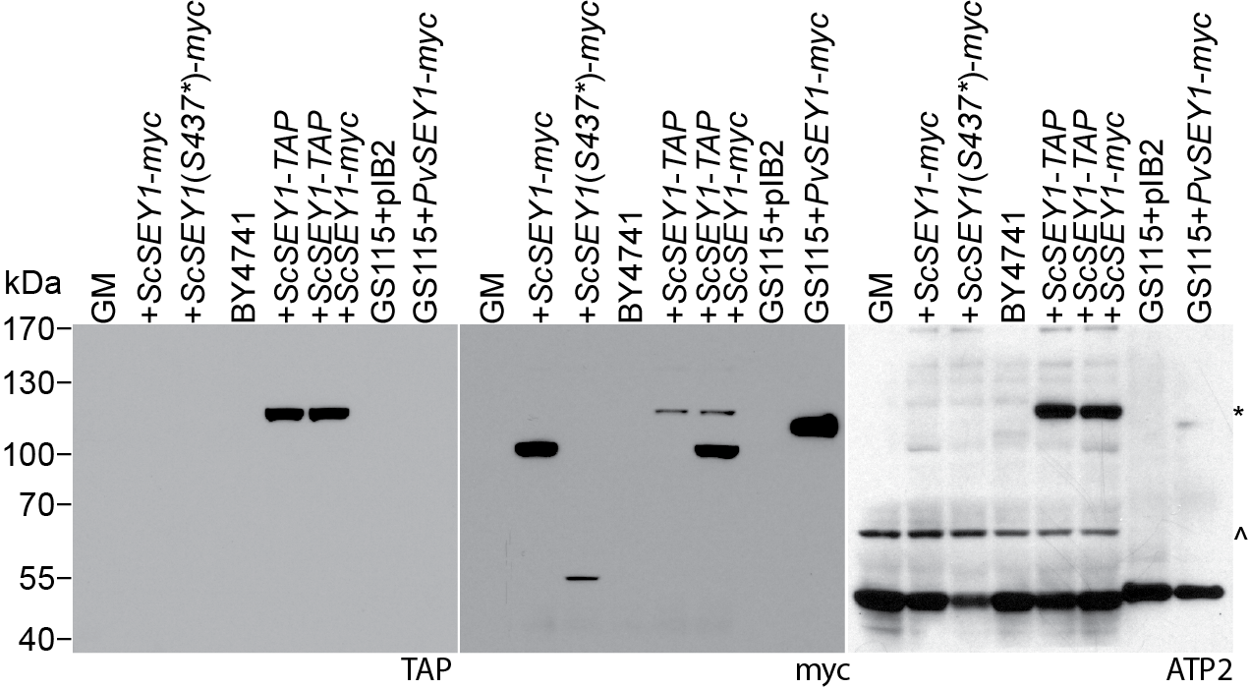
Supplementary Figure 1. Full Western blot of protein lysates from the yeast strains used in this study. Left panel displays the membrane first probed with rabbit anti-TAP antibody. In the middle panel, the same membrane was stripped and probed with mouse anti-myc antibody. In the right panel, the membrane was stripped again and probed with rabbit anti-ScATP2 antibody for loading control; this protein is 54kDa. The asterisk marks residual TAP signal, whereas the caret marks a nonspecific signal. ScSEY1-myc, ScSEY1(S437*)-myc, ScSEY1-TAP, and PvSEY1-myc proteins are 92kDa, 52kDa, 110kDa, and 105kDa, respectively.
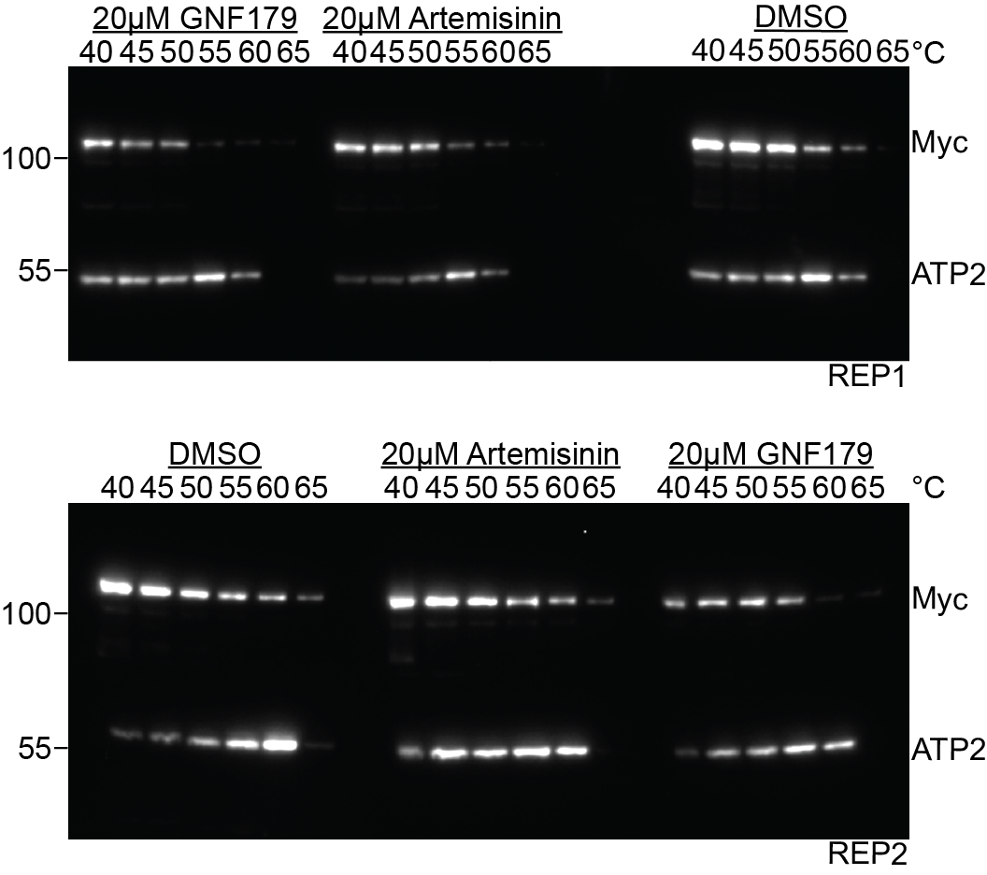
Supplementary Figure 2. Full Western blots of protein lysates from cellular thermal shift assay experiments. Abundance of PvSEY1-myc remaining in whole cell lysates from GS115+PvSEY1-myc after treatment with 20µM artemisinin or GNF179, and subsequent thermal challenge from 40°C to 65°C, detected with anti-myc antibody; anti-ScATP2 antibody was used for loading control. Both replicates, REP1 and REP2, are displayed.

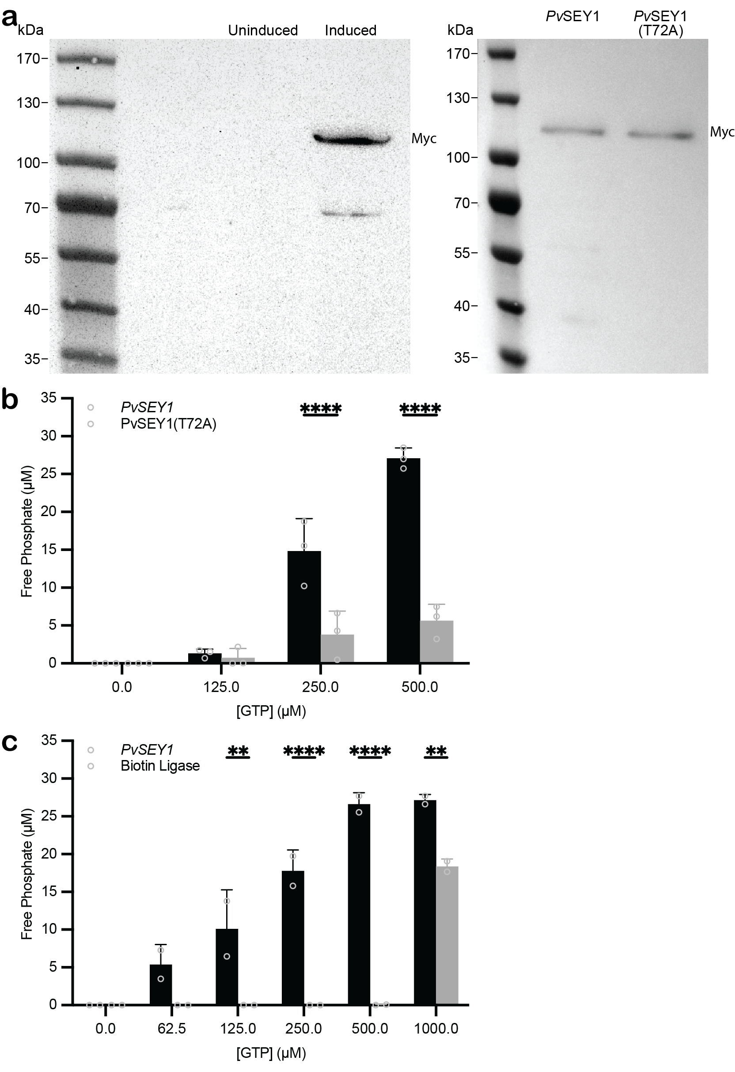
Supplementary Figure 3. Wild-type PvSEY1, but not PvSEY1(T72A), possess GTPase activity. a. Western blot of the 106kDa PvSEY1-myc protein upon IPTG induction (left); PvSEY1-myc-His and PvSEY1(T72A)-myc-His are detected in protein eluates off the Ni-NTA column (right). b. Protein lysates containing PvSEY1-myc-His or PvSEY1(T72A)-myc-His are tested for GTPase activity by measuring free phosphate production with increasing GTP concentrations; data represents biological duplicates analyzed using Sidak test, noting comparisons with p-value<0.05. b. Protein lysates containing His-tagged PvSEY1-myc or Biotin ligase are tested for GTPase activity; data represents biological duplicates analyzed using Sidak test, noting comparisons with p-value<0.05.

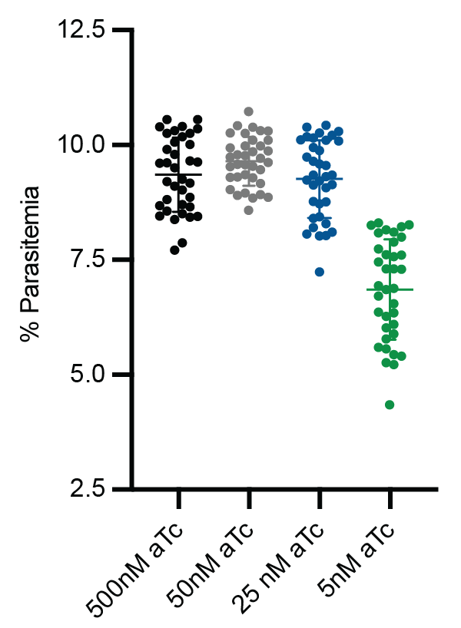
Supplementary Figure 4. Low concentration of aTc reduces viability of the TetR-DOZI-based PfSEY1 knockdown mutant. The PfSEY1 knockdown mutant was grown under normal translation conditions (500nM aTc), washed, split to 1% parasitemia, and then grown with various aTc concentrations, from 5nM to 500nM aTc. Each biological duplicate was tested in technical triplicates; each triplicate was divided into twelve wells. Parasitemia was measured after 48 hours for each of the 36 samples within each aTc condition.

Experiment number | Compound immobilized on beads (on-bead concentration) | "Free" compound added to extract for competition | Material for protein extract preparation
X034870 | GNF179 (1mM) | GNF179 | Plasmodium falciparum  (standard 0.8% NP40)
X034871 | GNF179 (1mM) | GNF179 | Plasmodium falciparum  (standard 0.8% NP40)
X035202 | Compound X (1mM) | GNF179 | Plasmodium falciparum  (low detergent 0.02% NP40)
X035203 | Compound X (1mM) | GNF179 | Plasmodium falciparum  (low detergent 0.02% NP40)
X035857 | GNF179 (1mM) | GNF179 | Human: HEK293/K-562/Placenta/HepG2
X035858 | GNF179 (1mM) | GNF179 | Human: HEK293/K-562/Placenta/HepG2
X035927 | GNF179 (1mM) | GNF179 | Plasmodium falciparum  (low detergent 0.02% NP40)
X035928 | GNF179 (1mM) | GNF179 | Plasmodium falciparum  (low detergent 0.02% NP40)
X035929 | GNF179 (0.2mM) | GNF179 | Plasmodium falciparum  (standard 0.8% NP40)
X035930 | GNF179 (0.2mM) | GNF179 | Plasmodium falciparum  (standard 0.8% NP40)
X035931 | GNF179 (0.1mM) | GNF179 | Plasmodium falciparum  (standard 0.8% NP40)
X035932 | GNF179 (0.1mM) | GNF179 | Plasmodium falciparum  (standard 0.8% NP40)
Supplementary Table 1. Setup of Proteomic Affinity Chromatography. Each of the 12 experiments comprised 10 treatments: vehicle control (n=1), 0µM; vehicle control (n=2), 0µM; re-binding of non-bound fraction (NBF) to fresh beads (n=1), 0µM; rebinding of NBF to fresh beads (n=2), 0µM; dose response competition over six concentrations – 20.0µM, 6.67µM, 2.22µM, 0.74µM, 0.25µM, and 0.08µM.

Protein description | Species (genetic screen) | Gene name in P. falciparum | Allelic change | Potential as target
Heat shock protein 90 | S. cer. | PF3D7_0708400 | S17I | Likely
Karyopherin beta | S. cer. | PF3D7_0524000 | G427R | No
Protein SEY1 homolog | S. cer. | PF3D7_1416100 | S437* | Likely
Calcium-dependent protein kinase 1 | S. cer. | PF3D7_0217500 | K365T | Likely
Ras-related protein Rab-11A | P. fal. | PF3D7_1320600 | D139Y | Likely
Uncharacterized protein | P. fal. | PF3D7_1366300 | Y3425fs  G3416fs | No
Uncharacterized protein | P. fal. | PF3D7_0410800 | M360I | No
Bifunctional dihydrofolate reductase-thymidylate synthase | S. cer. | PF3D7_0417200 | I279S | Likely
Gas41 homologue, putative | P. fal. | PF3D7_0807000 | S24Y | Likely
Acetyl-CoA transporter, putative | P. fal. | PF3D7_1036800 | E272fs  M487fs  S242*  A94T  R108K  S110R  L5fs  I411N  L253*  C193*  D165N  G559R* | No
Uncharacterized protein | P. fal. | PF3D7_0727900 | R789I | No
Uncharacterized protein | P. fal. | PF3D7_1136600 | S1088N | No
UDP-galactose transporter, putative | P. fal. | PF3D7_1113300 | F37V | No
Pfmc-2TM Maurer's cleft two transmembrane protein | P. fal. | PF3D7_0222100 | M44I | No
Nucleolar GTP-binding protein 2 | S. cer. | PF3D7_1423000 | R468R | Likely
Supplementary Table 3. Genes identified through genetic and proteomic experiments. Allelic changes occur in the species (S. cerevisiae or P. falciparum) used in the genetic screen; asterisks refer to nonsense mutations, and “fs” notations refer to frame shifts (insertion or deletion events). Target likelihood is based on predicted essentiality in P. falciparum, as well as presence of known ligand-binding domains.

Strain | Species | Genotype
GM | Sc | MATa adp1∆ snq2∆ ycf1∆ pdr15∆ yor1∆ vmr1∆ pdr11∆ nft1∆ bpt1∆ ybt1∆ ynr070w∆ yol075c∆ aus1∆ pdr5∆ pdr10∆ pdr12can1∆::GMToolkit-a lyp1∆ his3∆1 leu2∆0 ura3∆0 met15∆0 (deletions for the ABC transporter genes are marked with [tetO2pr-GFP, URA3]).
GM+ScSEY1-myc | Sc | MATa adp1∆ snq2∆ ycf1∆ pdr15∆ yor1∆ vmr1∆ pdr11∆ nft1∆ bpt1∆ ybt1∆ ynr070w∆ yol075c∆ aus1∆ pdr5∆ pdr10∆ pdr12can1∆::GMToolkit-a lyp1∆ his3∆1 leu2∆0 ura3∆0 met15∆0 (deletions for the ABC transporter genes are marked with [tetO2pr-GFP, URA3]) SEY1::ScSEY1-myc, BleoR.
GM+ScSEY1(S437*)-myc | Sc | MATa adp1∆ snq2∆ ycf1∆ pdr15∆ yor1∆ vmr1∆ pdr11∆ nft1∆ bpt1∆ ybt1∆ ynr070w∆ yol075c∆ aus1∆ pdr5∆ pdr10∆ pdr12can1∆::GMToolkit-a lyp1∆ his3∆1 leu2∆0 ura3∆0 met15∆0 (deletions for the ABC transporter genes are marked with [tetO2pr-GFP, URA3]) SEY1::ScSEY1(S437*)-myc, BleoR.
BY4741 | Sc | MATa his3Δ1 met15Δ0 ura3Δ0 leu2Δ0.
BY4741+ScSEY1-TAP | Sc | MATa his3Δ1 met15Δ0 ura3Δ0 leu2Δ0 SEY1::ScSEY1-TAP, HIS3.
BY4741+ScSEY1-TAP+P_{SEY1}-ScSEY1-myc | Sc | MATa his3Δ1 met15Δ0 ura3Δ0 leu2Δ0::P_{SEY1}-ScSEY1-myc, BleoR SEY1::ScSEY1-TAP, HIS3.
GS115+pIB2 | Kp | his4::HIS4.
GS115+  P_{GAPDH}-PvSEY1-myc | Kp | his4::P_{GAPDH}-PvSEY1-myc, HIS4.
Supplementary Table 5. Yeast strains used in this study. For species, Sc and Kp refer to S. cerevisiae and K. phaffii, respectively.

