Supplementary file
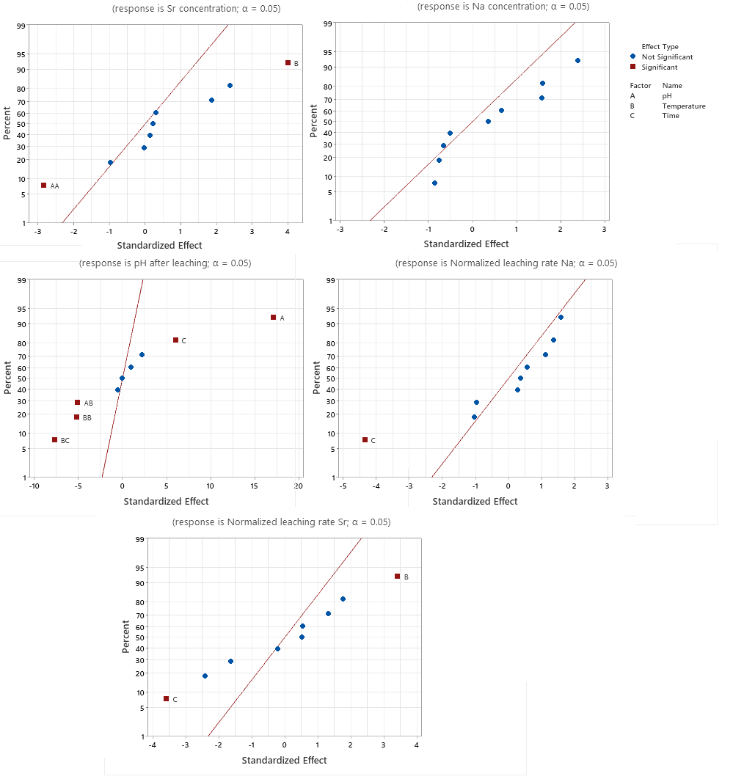

Fig. S.1 Normal probability effects for the studied outputs
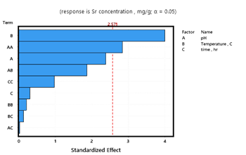
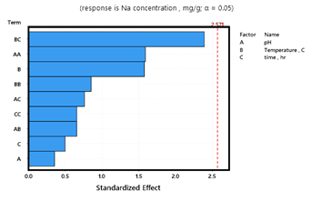

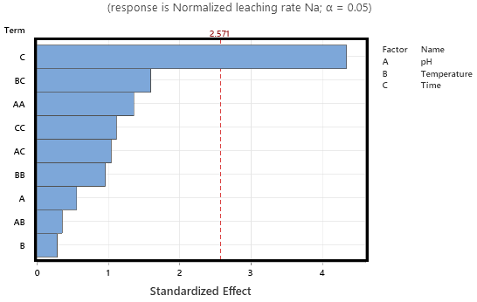
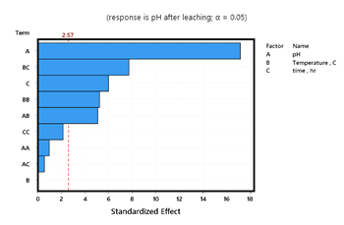

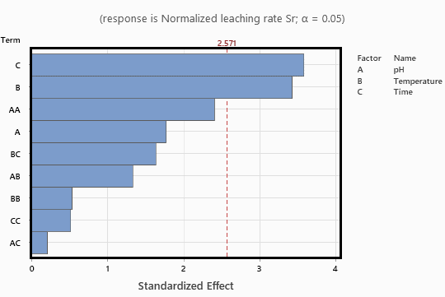

Fig. S.2 pareto charts of effects for the studied outputs

Table S.1.Normalized ion release rate from different vitrified samples (mg/(cm² d)).
Glass sample , x 10⁻⁴ | Sr | B | Na | References
ABS-Waste (17) | 4.47 | 36.02 | 28.301 | [9]
MABS-Waste (20) | 3.447 | 31.54 | 22.256 | [9]
ABS-Waste (25) | 1.226 | 20.121 | 40.363 | [9]
Simulated Magnox-modified | - | 130.68 | 19.42 | [61]
Sr-ABS | 1.95 | - | 1.25 | This study

