High frequency chest wall oscillation vs. oscillation and lung expansion on lung recruitment in hypersecretive mechanically ventilated patients: a randomized crossover study
Hao Wang^{1#}, Yi Li^{2#}, Guangyu Niu²,Qian Liu², Liying Wang², Jianing Xi², Hongying Jiang^{2*}
1. Beijing Rehabilitation Hospital, Capital Medical University, China
2. Department of Pulmonary and Critical Care Medicine, Beijing Rehabilitation Hospital, Capital Medical University, China

# Authors contributed equally to this work
* Corresponding authors
Dr. Hongying Jiang, Department of Pulmonary and Critical Care Medicine, Beijing Rehabilitation Hospital, Capital Medical University, Xixiazhuang, Badachu Road, Shijingshan District, Beijing 100144, China
Email address: 6jhy@163.com

Methods
EIT measurements and Procedures
This randomised cross-over study was conducted within the Department of Pulmonary and Critical Care Medicine at the Beijing Rehabilitation Hospital of Capital Medical University in China following approval from the local Ethical Committee (Ethical Committee Approval number 2023bkky-031, issued on June 7, 2023). The patients were positioned either in bed at 30 or 45 degrees with the 16 EIT electrode belt around their chest between the 4th and 5th intercostal space and connected to an EIT device (PulmoVista 500; Draeger Medical GmbH, Lübeck, Germany)^{[1]}. As patient position has been shown to have an impact on ventilation distribution^{[2]}, we ensured that there no changes in patient positioning throughout the data collection. Then record the position of EIT belt, in order to avoid its displacement during the whole study period^{[3]}. In other aspects, Ventilatory mode and parameters were according to the attending physicians, while heated humidifier was set at 37℃ and relative humidity at 100% (i.e. 44 mg/L of absolute humidity). Settings of ventilator parameters and clinical plans were not modified throughout the entire study protocol.
It is a routine protocol at Beijing rehabilitation hospital for hypersecretive mechanically ventilated patients to use OLE or HFCWO along with any type of airway clearance system. This has been previously decided by the medical provider and respiratory therapist at our department. The HFCWO oscillation device used was VEST System—Model 205 by Hill Rom which was connected by two tubes. As most of these patients were mechanical ventilation, they were started on low vest pressure settings between 3 and 5on (Hill Room Vest arbitrary 1–10 scale) and low frequency (10–15 Hz), and then gradually were increased according to patients’ tolerance under the supervision of a certified respiratory therapist. The exact settings and frequency of use were determined by the patient’s individual need and tolerance of the treatment procedure, under the supervision of a certified respiratory therapist. An OLE system is used for mobilization of secretions, lung expansion therapy, and also has the ability to provide supplemental oxygen when used with compressed oxygen. It utilizes a controller and a single patient use circuit to deliver three therapy modes; (1.) CPEP for the delivery of aerosolized medications combined with continuous positive pressure to assist in stenting open and expanding the airways, (2.) continuous high-frequency oscillation for the delivery of medicated aerosol while oscillating the airways with continuous pulses of positive pressure, (3.)aerosol delivered in both lung expansion and secretion clearance^{[4]}.
After baseline record (T0), HFCWO or OLE was applied for 10 min. Soon after the end of the treatment (T1) or after 1h (T2) and 2h (T3), EIT data were recorded for 10 min, and tracheostomy suctioning was assured throughout a closed aspiration system. At the end of each step of the protocol, closed tracheostomy suctioning was performed. Predefined criteria for protocol interruption were asfollows: (1) onset of haemodynamic instability, (2) life threatening arrhythmias or electrocardiographic signs of ischaemia, and (3) worsening of oxygen saturation.

Randomisation and masking
A computer-generated randomization chart was obtained and the participants were randomized to receive OLE first either by HFCWO (n = 10) or by OLE (n = 10). Concealment was done using identical, opaque, sealed envelopes. Thus, half the patients received OLE first followed by the HFCWO 4 hours later. The other half received HFCWO and later crossed over to OLE after 4 hours of washout (Fig. 1). Each session of physical therapy lasted for 10 minutes. A qualified respiratory therapist with >5 years experience performed the therapy procedure in all participants using above techniques.
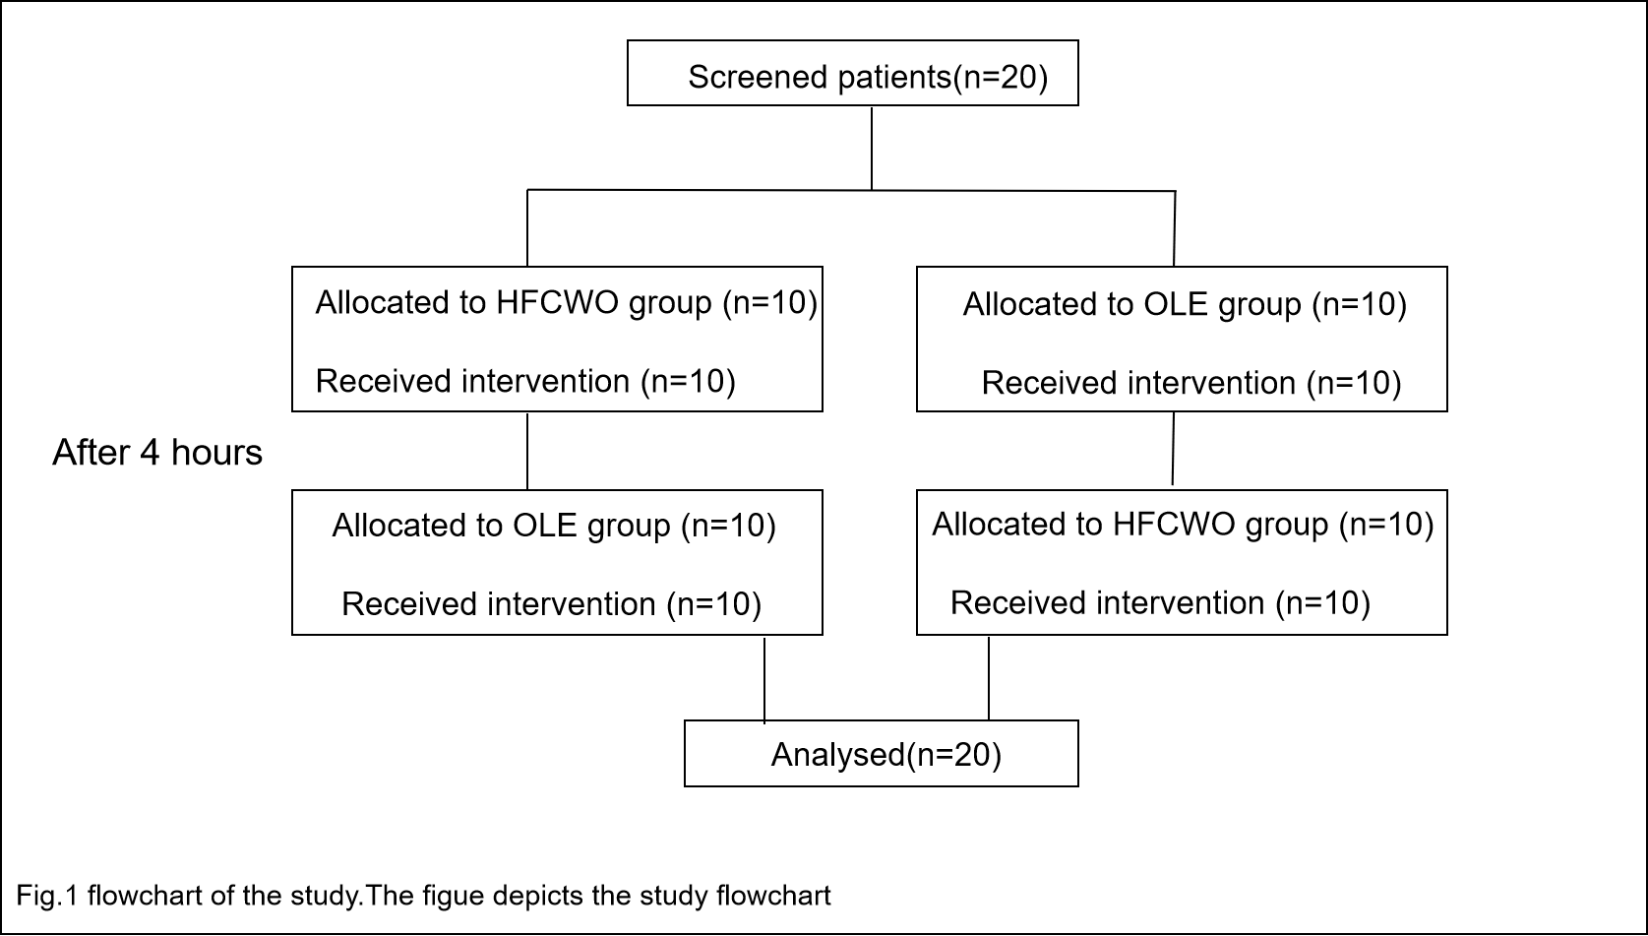

Patients
We considered eligible any patients with airway hypersecretion≥18 years who was admitted to the ICU and received more than 48h of invasive mechanical ventilation(iMV). Eligible patients were defined as“hypersecretion”was based on the criteria adopted in previously published studies, which means patients who required two or more aspiration in the previous 8 h Suction occurred only if auscultation revealed secretions in the larger airway, if the airway pressure wave form indicated fluid in the system and/or the peak airway pressures increased ^{[5,6]}.
Patients meeting the eligibility criteria were enrolled. The exclusion criteria were 1. malignant arrhythmia; 2. acute myocardial ischemia; 3. pneumothorax, pulmonary bulla and barotrauma and other lung diseases; 4. hemorrhagic disease or abnormal coagulation mechanism with bleeding tendency; 5. skin trauma on the chest; 6. pulmonary embolism; 7. pulmonary embolism; 8.untreated spinal and rib fractures; 9. for any reasons, they could not be included in this study or the researchers considered it inappropriate to include this study. All participants provided written informed consent.

Outcome measures and data analysis
The primary endpoint is end-expiratory lung impedance (EELI). EELI is a surrogated measure for the functional residual capacity. Linear correlation between changes in the EELI and changes in end-expiratory lung volume (EELV) was demonstrated previously. Therefore, EELI can be used to measure the degree of lung recruitment^{[7]}. Tidal variation (TV) and EELI were also calculated in two regions of interest (ROIs) with the same size (ventral and dorsal). The global inhomogeneity (GI) and regional ventilation delay (RVD) were calculated according to previous publications^{[8,9]}. GI and RVD can reflect whether the ventilation is uniform^{[10]}. In addition, clinical indexs such as oxygen saturation SpO₂ at 30% fraction of inspired oxygen (FiO₂), heart rate and respiratory rate were also recorded. Sputum samples were collected and analyzed.
Normally distributed continuous data were described as means and standard deviation (SD) and non-normal distributed data were described as median (IQR). Normality of continuous data was assessed through the Kolmogorov-Smirnov test. Comparisons between groups were performed by using the Paired t-test or the Mann-Whitney U test, for the continuous variables normally or non-normally distributed, respectively. Categorical variables were reported as numbers and percentages and compared with a chi-square test or Fisher test. All statistical analyses was done with SPSS 17.0 (IBM, USA). Significant differences between groups or across time were reported at the alpha level of 0.05. All reported p values are two-sided.

Results
A total of 20 patients were included in this treatment, and all patients were mechanically ventilated by tracheotomy, among which 14 patients were under Synchronized intermittent mandatory ventilation (SIMV) mode, 6 patients were under pressure support ventilation (PSV) mode. Demographic, anthropometric, and clinical characteristics of included patients are presented in Table 1. OLE group showed higher EELI at T1,T2 and T3, as opposed to the respective time points in HFCWO group, and OLE group had a higher value in TV of the participants than HFCWO group at T1 and T2. Moreover,the global inhomogeneity (GI) values of both groups decreased significantly, and the difference was statistically significant. Further, no differences in regional ventilation delay (RVD) and vital parameters were found between OLE and HFCWO sessions at all time points. In addition, all patients completed the study protocol without any complication and were included in data analysis.
Table 1 Participant baseline characteristics
Baseline characteristics N=20
Age, yr, mean±SD | 72±12
Sex,n(％)
F | 8(40)
M | 12(60)
BMI, mean±SD | 22.96±3.27
Cause of admission, n(％)
Repiratory | 18(90)
Trauma/brun/other | 2(10)
Comorbidities, n(％)
Hypertension | 10(50)
COPD | 3(15)
Diabetes mellitus | 6(30)
Other | 1(50
APACHE-Ⅱ, mean±SD | 13±7
Mode of ventilation(SIMV/PSV) | 14/6
PEEP, median(IQR) | 5(5)
Duration of mechanical ventilation,days,mean±SD | 27±18
Tracheostomy , n(％) | 20(100)
BMI body mass index, COPD chronic obstructive pulmonary disease, APACHE II Acute Physiology and Chronic Health Disease Classification System II, PSV Pressure support ventilation, SIMV Synchronized Intermittent Mandatory Ventilation.

References
[1]Koldova K, Rara A, Muller M, et al. Cranial Electrode Belt Position Improves Diagnostic Possibilities of Electrical Impedance Tomography during Laparoscopic Surgery with Capnoperitoneum. Sensors (Basel). 2023;23(20):8644. Published 2023 Oct 23.
[2]Yang L, Gao Z, Cao X, et al. The influence of gravity on electrical impedance tomography measurements during upper body position change. Heliyon. 2023;9(5):e15910. Published 2023 May 1.
[3]Zhao Z, Chen TF, Teng HC, et al. Is there a need for individualized adjustment of electrode belt position during EIT-guided titration of positive end-expiratory pressure?. Physiol Meas. 2022;43(6):10.1088/1361-6579/ac73d6. Published 2022 Jun 28.
[4]Huynh TT, Liesching TN, Cereda M, et al. Efficacy of Oscillation and Lung Expansion in Reducing Postoperative Pulmonary Complication. J Am Coll Surg. 2019;229(5):458-466.e1.
[5]Hernández Martínez G, Rodriguez ML, Vaquero MC, et al. High-Flow Oxygen with Capping or Suctioning for Tracheostomy Decannulation. N Engl J Med. 2020;383(11):1009-1017.
[6]Longhini F, Bruni A, Garofalo E, et al. Chest physiotherapy improves lung aeration in hypersecretive critically ill patients: a pilot randomized physiological study. Crit Care. 2020;24(1):479. Published 2020 Aug 3.
[7]Plens GM, Droghi MT, Alcala GC, et al. Expiratory Muscle Activity Counteracts Positive End-Expiratory Pressure and Is Associated with Fentanyl Dose in Patients with Acute Respiratory Distress Syndrome. Am J Respir Crit Care Med. 2024;209(5):563-572.
[8]Heines SJH, de Jongh SAM, Strauch U, et al. The global inhomogeneity index assessed by electrical impedance tomography overestimates PEEP requirement in patients with ARDS: an observational study. BMC Anesthesiol. 2022;22(1):258. Published 2022 Aug 15.
[9]Spatenkova V, Teschner E, Jedlicka J. Evaluation of regional ventilation by electric impedance tomography during percutaneous dilatational tracheostomy in neurocritical care: a pilot study. BMC Neurol. 2020;20(1):374. Published 2020 Oct 12.
[10]Öner Ö, Ergan B, Kizil AS, et al. Investigation of high flow nasal cannule efficiency with electric impedance tomography based parameters in COVID-19 adults patients: a retrospective study. PeerJ. 2023;11:e15555. Published 2023 Jul 14.

