Supplementary Information
Next-Gen LH2 Transportation: Extending Dormancy Period to 400 Days with Highly Effective MOF Adsorbents
Jaewoo Park†, Junsu Ha‡, Hong Kyu Lee†, Hyunlim Kim†, Sungyeop Jung†, Minji Jung†, Taeung Park^{Π}, Monica Jiménez-Ruiz$, Margarita Russina⊥, Hoi Ri Moon*‡, Jitae T. Park*∥, and Hyunchul Oh*,†,^{Π}
† Department of Chemistry, Ulsan National Institute of Science and Technology (UNIST), Ulsan 44919, Republic of Korea
‡ Department of Chemistry and Nanoscience, Ewha Womans University, 52 Ewhayeodae-gil, Seoul 03760, Republic of Korea
^{Π} Graduate School of Carbon Neutrality, Ulsan National Institute of Science and Technology, Ulsan 44919, Republic of Korea
$ Institut Laue-Langevin, Av. des Martyrs 71, 38042 Grenoble Cedex 9, France
⊥ Helmholtz-Zentrum Berlin für Materialien und Energie, Lise-Meitner-Campus, Hahn-Meitner-Platz 1, 14109 Berlin, Germany
∥ Heinz Maier-Leibnitz Zentrum (MLZ), Technische Universität München, 85747 Garching, Germany

*Corresponding author:
Hoi Ri Moon: hoirimoon@ewha.ac.kr
Jitae T. Park: jitae.park@frm2.tum.de
Hyunchul Oh: hcoh@unist.ac.kr
Experimental Methods
Characterization
X-ray diffraction patterns: The powder XRD analyses were performed with a Bruker D2 phaser diffractometer with Cu Kα radiation (30 kV, 10 mA).
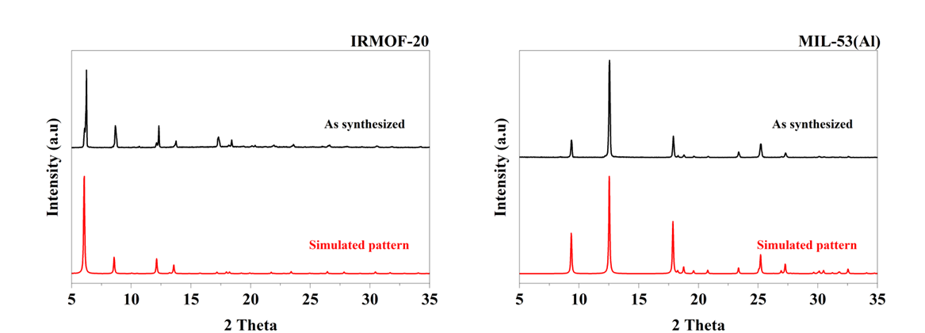
Figure S1. Simulated and measured X-ray Diffraction (XRD) data for IRMOF-20 and MIL-53

N₂ and H₂ Specific surface area measurements:
Specific surface area measurements were carried out using Autosorb iQ, 2MP-Xr equipped with a Cryo-cooler (Quantachrome Instruments, USA) with N₂ and H₂ gas at 77 K and 20 K, respectively. Before measurement, the powder samples were degassed at the specific temperature and duration [IRMOF-20 (60 °C, 12 h), and MIL-53 (120 °C, 12 h)] under a dynamic high vacuum. The Brunauer-Emmett-Teller (BET) method estimated the specific surface area by choosing the relative pressure range according to Rouquerol’s suggestions.
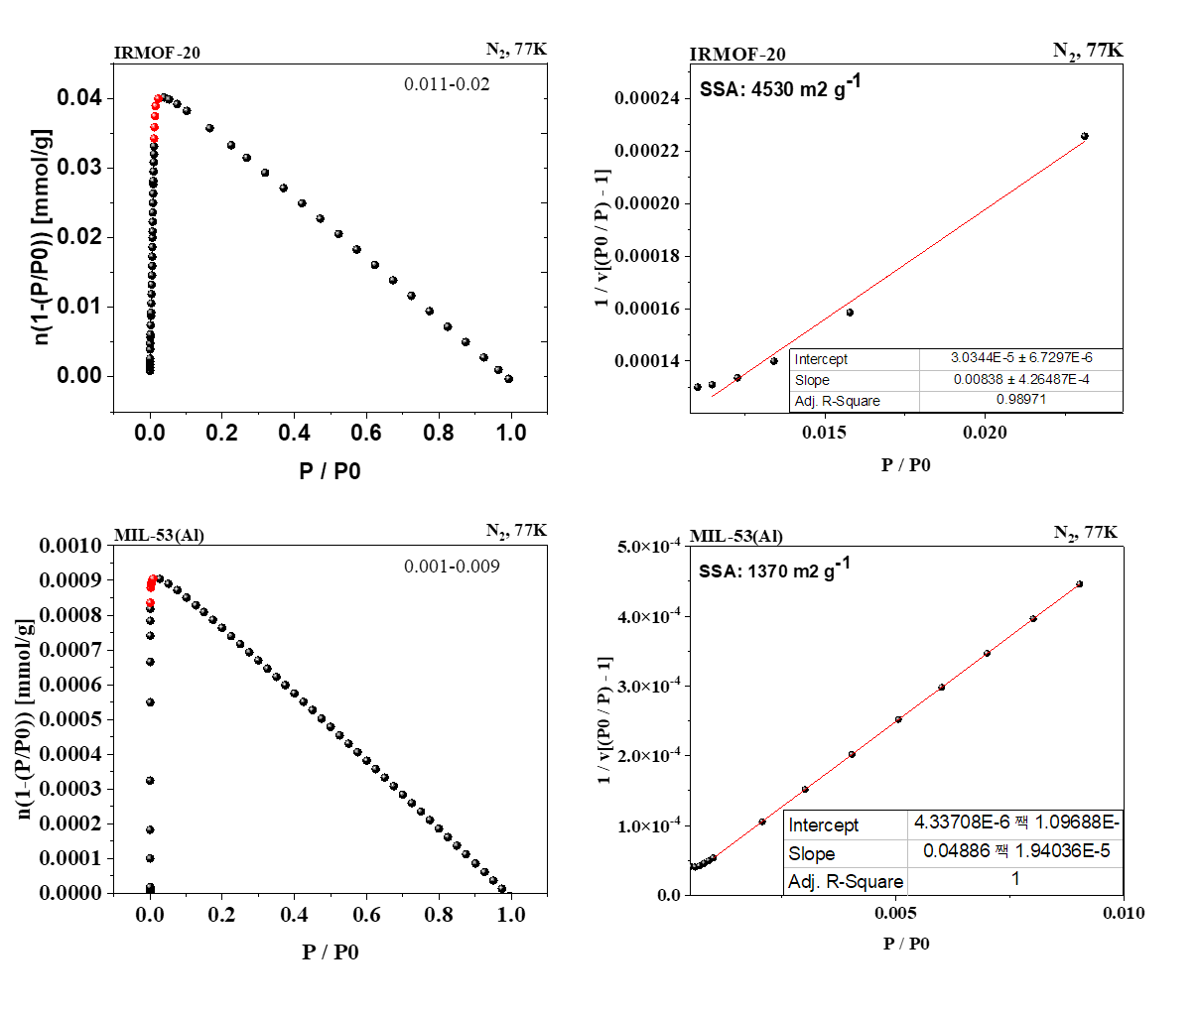
Figure S2. BET plot of the nitrogen adsorption on IRMOF-20 and MIL-53

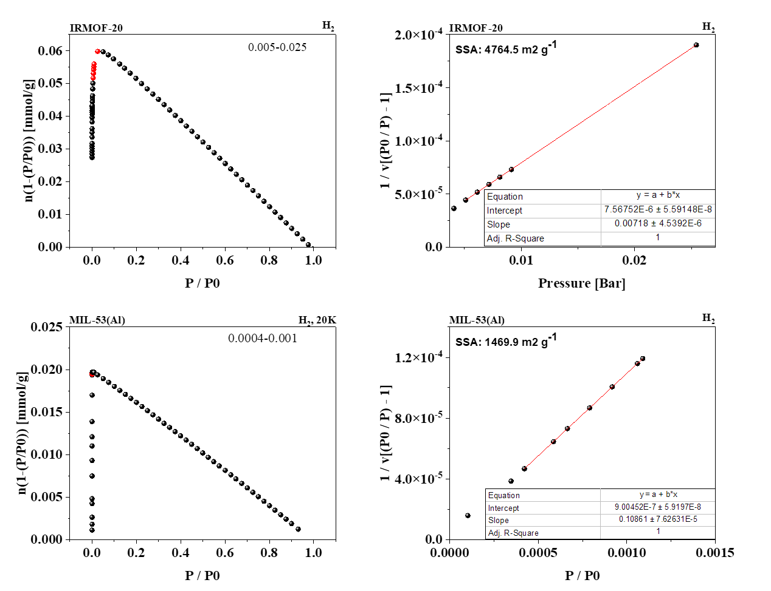
Figure S3. BET plot of the hydrogen adsorption on IRMOF-20 and MIL-53

Hydrogen isochoric measurement procedure
In the isochoric procedure, a specific amount of H₂ was filled relative to the total H₂ uptake capacity. Prior to gas filling, the sample cell was cooled to the liquefaction temperature of hydrogen (20 K), followed by gas injection. The increase in pressure, up to 800 torr, was recorded due to heating at a rate of 3 K/min.
An immediate phase transition from liquid to gas is observed in the case of the empty sample cell (Figure S4 and S5). The rapid increase in pressure in the empty sample cell resembles the H₂ boil-off phenomenon in the LH2 container or tank. Therefore, the inevitable heat leakage (heat inflow from the outside) in any container system storing LH2 leads to the vaporization of LH2, which increases the internal pressure of the LH2 tank.
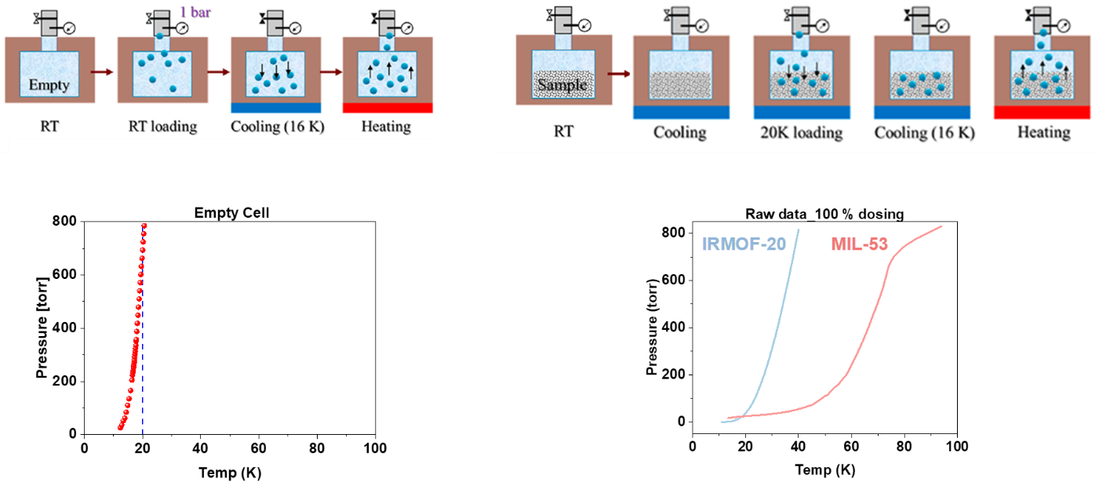
Figure S4. Overall isochoric experimental process of an empty vessel (mimicking boil-off expansion(left) and vessel with filler MOF sample(right), and isochoric result of each process

Normalization is necessary for comparison due to variations in MOF sorption properties and dead volume occupied by MOF in the Tank.
1) The temperature was measured according to the pressure change when injected hydrogen was boiled off from the LH2 tank, and it was set as a reference point. Afterward, when the MOF-filled tank was filled with hydrogen, the desorption temperature change (del T) at the same pressure (as the empty LH2 tank) was measured (Figure S5a).
2) When comparing different MOFs, the amount of MOF required to completely fill a 1L tank was assumed and calculated based on the crystal density of each MOF (Figure S5b).
3) Considering parameters such as the specified 1 L volume, the required amount of MOF to fill the 1 L volume of the liquefied hydrogen tank, experimentally determined the maximum sorption amount of hydrogen for each MOF, and the anticipated pressure change in the tank up to 10 bars could be predicted and compared (Figure S5c).
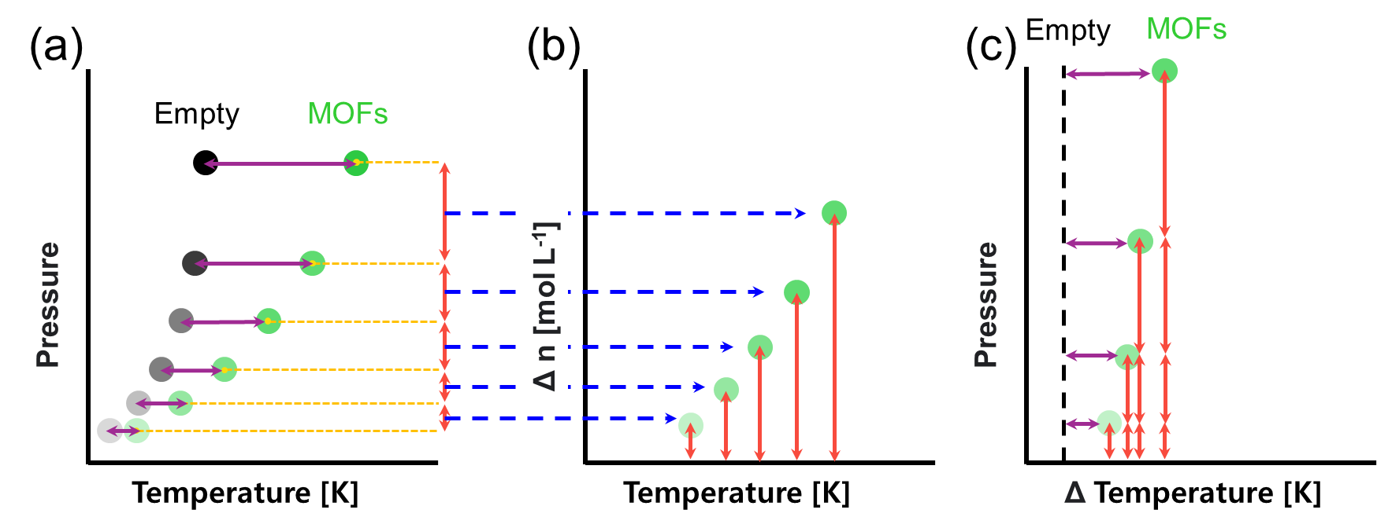
Figure S5. Normalization process schematic for isochoric measurement process with different sample volumes: (a) Unit conversion of actual measured results, (b) Normalization for 1 L container, and (c) Final normalization result.
Para-hydrogen in situ inelastic neutron scattering (INS) experiments.

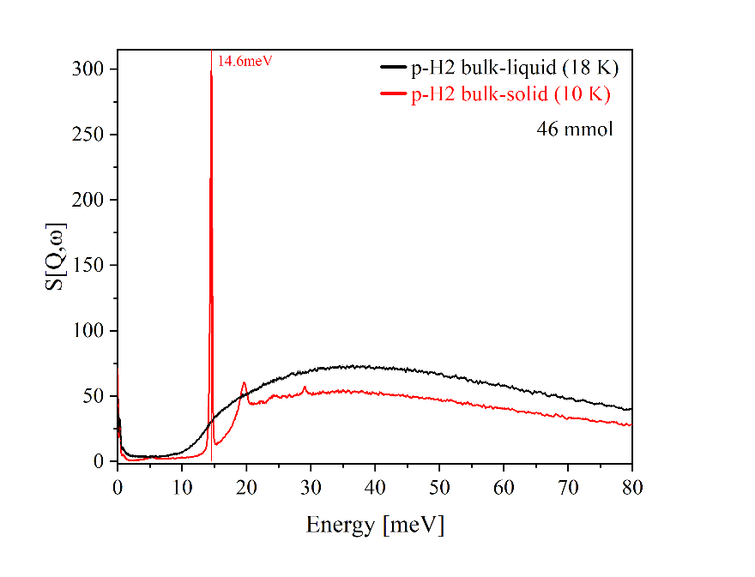
Figure S6. INS spectrum for para-hydrogen bulk solid and para-hydrogen bulk liquid measured at 10 and 18 K, respectively.

Inelastic neutron scattering is a spectroscopic technique used to study materials' dynamic properties at the atomic and molecular levels. It involves measuring the inelastic scattering between neutrons and atoms in a sample, which provides valuable structural and dynamic information about the sample. However, it's important to correct for unwanted signals in the data. For example, structural signals from the sample's framework occur in a low-energy region, while signals from unreacted hydrogen in the sample produce a broad signal in a higher-energy region. These unwanted signals need to be removed to investigate the sample's hydrogen signal. The removed icons for different temperatures are shown in detail in Figure S7-S9.

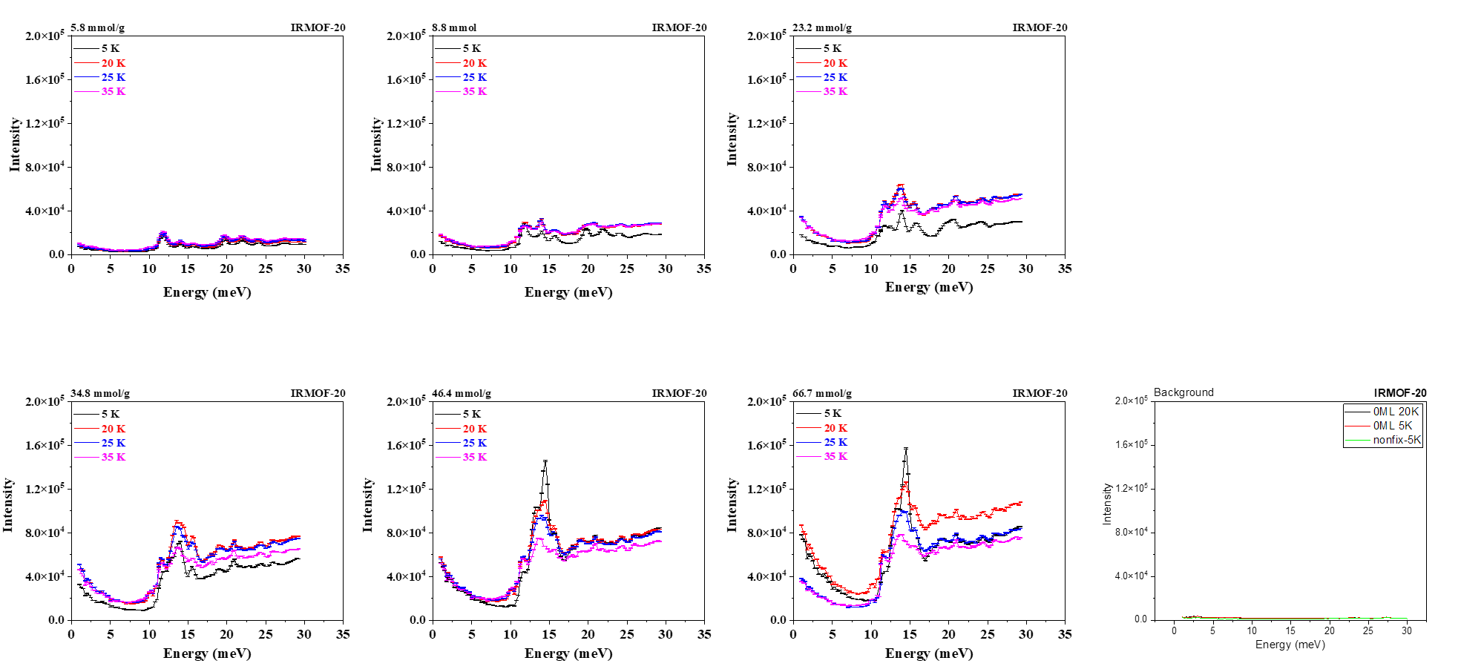
Figure S7. Inelastic neutron scattering spectra of IRMOF-20 loaded with different amounts of para-hydrogen at various temperatures (5 K, 20 K, 25 K, 35 K)
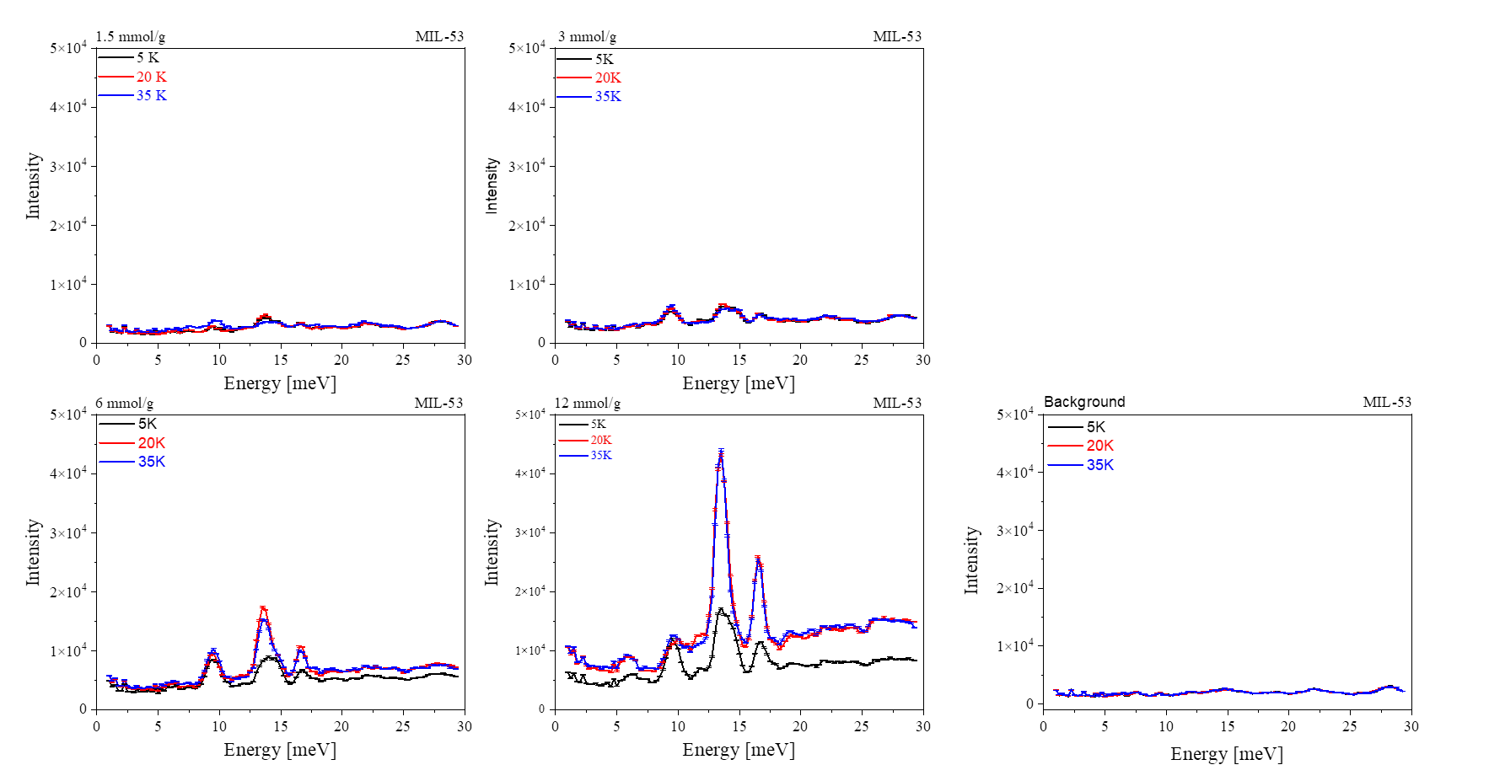
Figure S8. Inelastic neutron scattering spectra of MIL-53 loaded with different amounts of para-hydrogen at various temperatures (5 K, 20 K, 35 K, 77K)

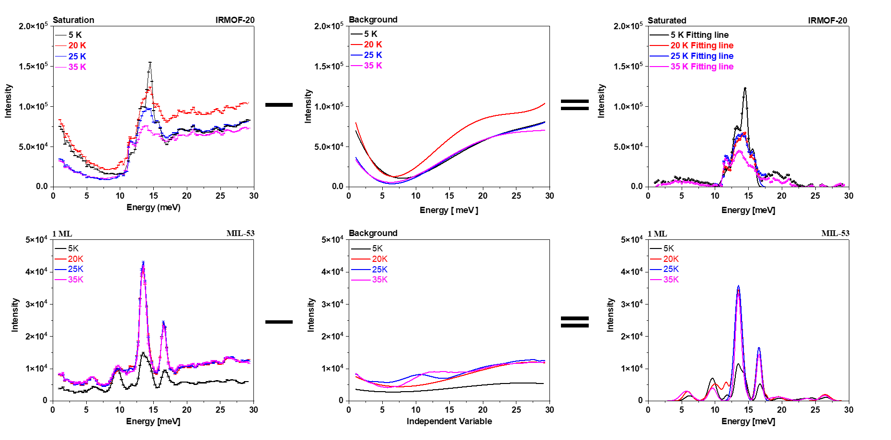
Figure S9. Calibration process for background from equipment and liquid hydrogen

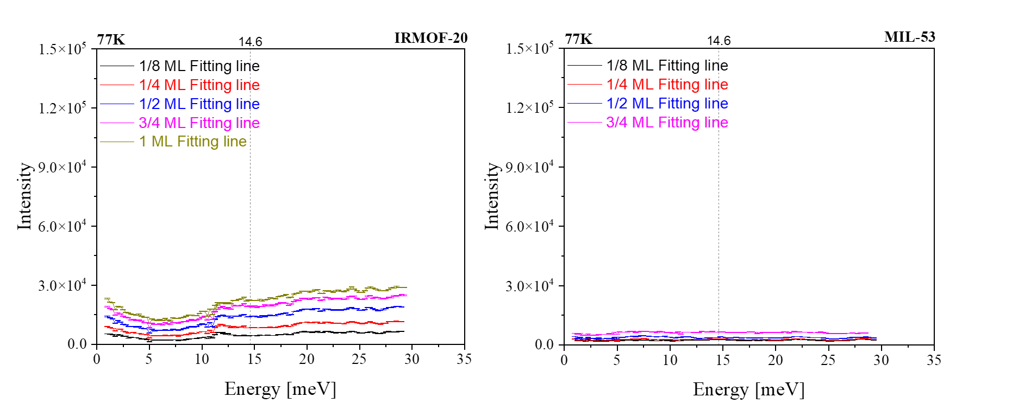
Figure S10. Neutron scattering spectrum used for analysis through calibration at 77K
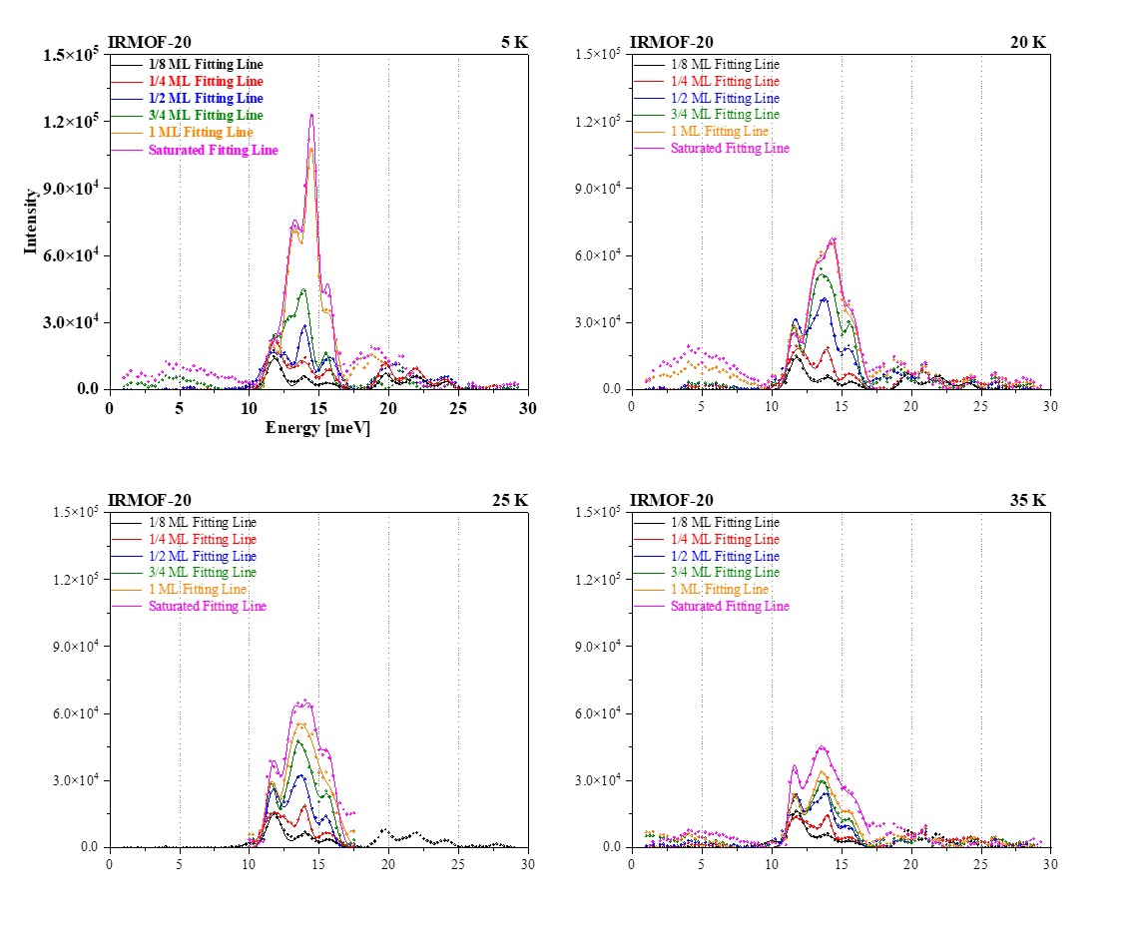
Figure S11. Neutron scattering spectrum used for analysis through calibration of IRMOF-20
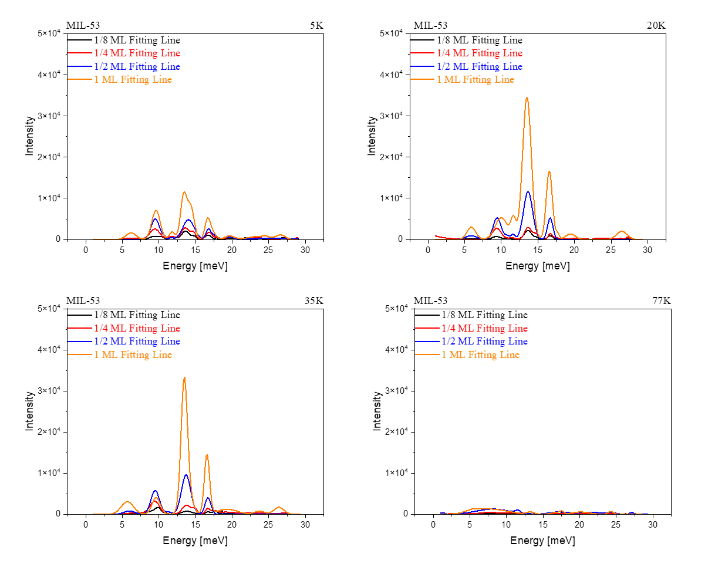
Figure S12. Neutron scattering spectrum used for analysis through calibration of MIL-53

Figure S13-20 shows well-defined peaks, which are assigned to the disturbed rotation transition J:0➝1. The difference in energy from the free-rotor energy (14.6 meV) arises from specific interaction strengths at localized adsorption positions. As loading increases, peak splitting occurs. This can be explained by the new hydrogen adsorption state energy. It can be confirmed that this state of hydrogen exists even at critical temperatures.
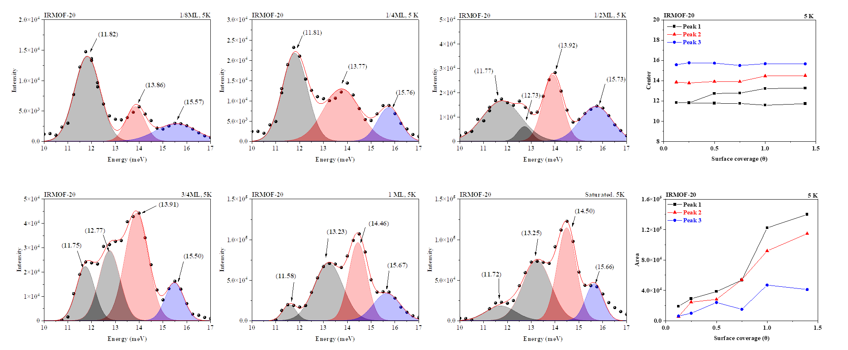
Figure S13. Inelastic neutron scattering spectrum of IRMOF-20 loaded with different amounts of para-hydrogen at 5 K
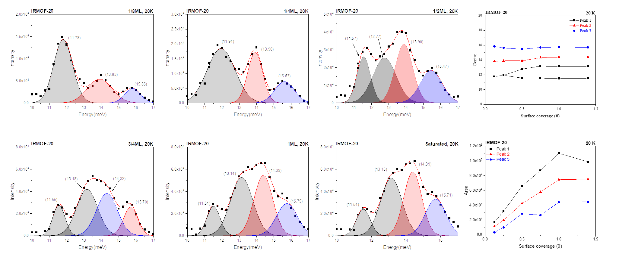
Figure S14. Inelastic neutron scattering spectrum of IRMOF-20 loaded with different amounts of para-hydrogen at 20 K
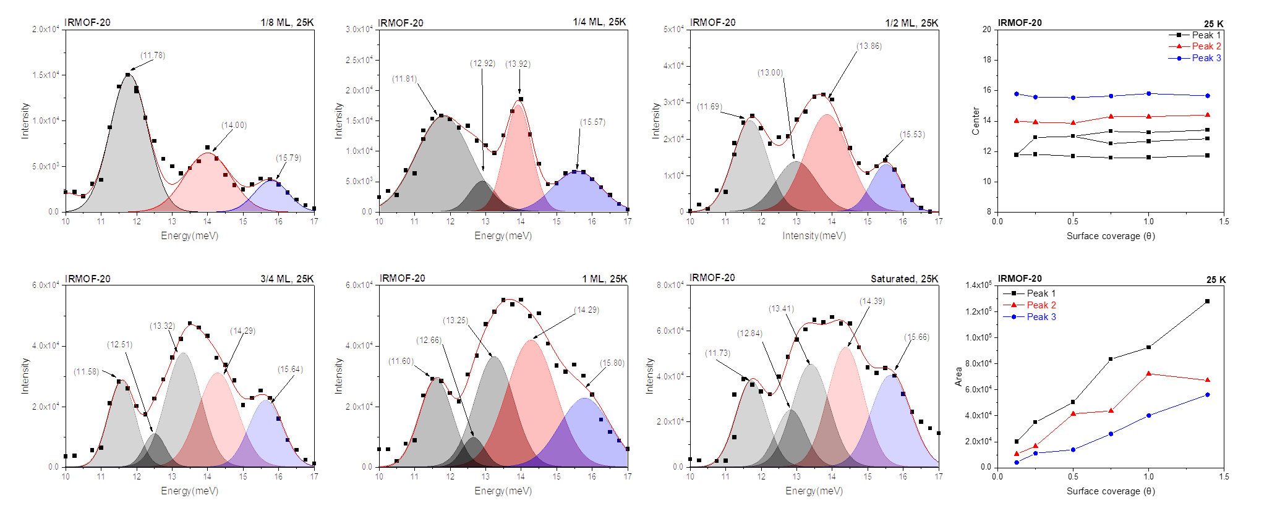
Figure S15. Inelastic neutron scattering spectrum of IRMOF-20 loaded with different amounts of para-hydrogen at 25 K
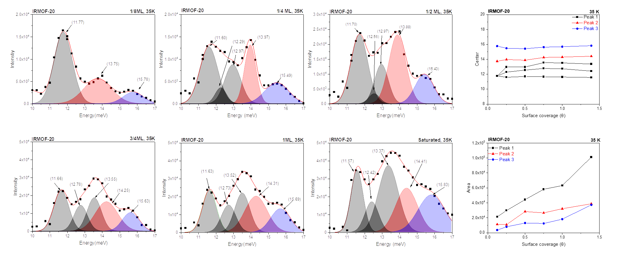
Figure S16. Inelastic neutron scattering spectrum of IRMOF-20 loaded with different amounts of para-hydrogen at 35 K
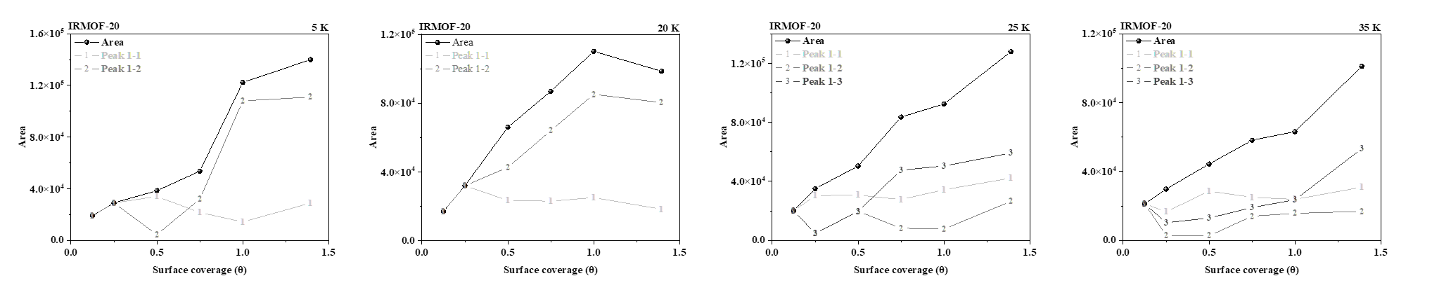
Figure S17. Dependence of IRMOF-20 peak splitting on varying parahydrogen amounts and temperatures (5 K, 20 K, 25 K, 35 K).
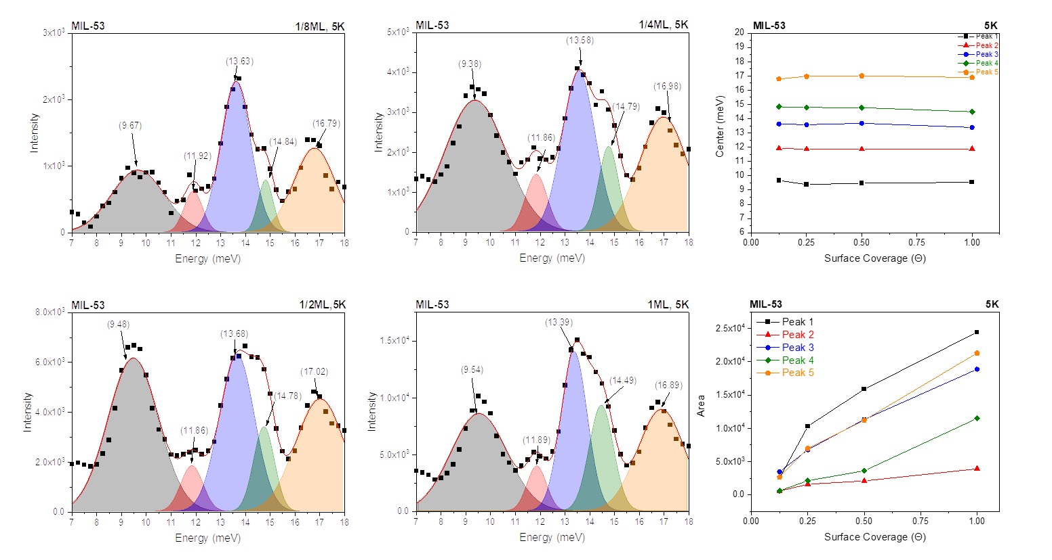
Figure S18. Inelastic neutron scattering spectrum of MIL-53(Al) loaded with different amounts of para-hydrogen at 5 K
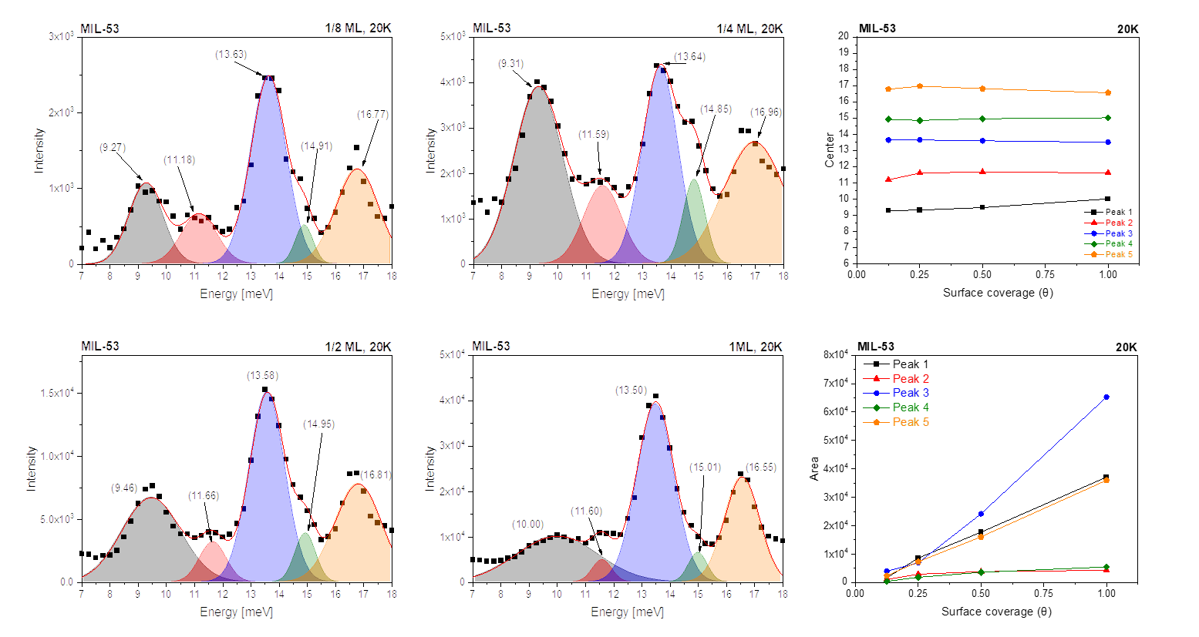
Figure S19. Inelastic neutron scattering spectrum of MIL-53(Al) loaded with different amounts of para-hydrogen at 20 K

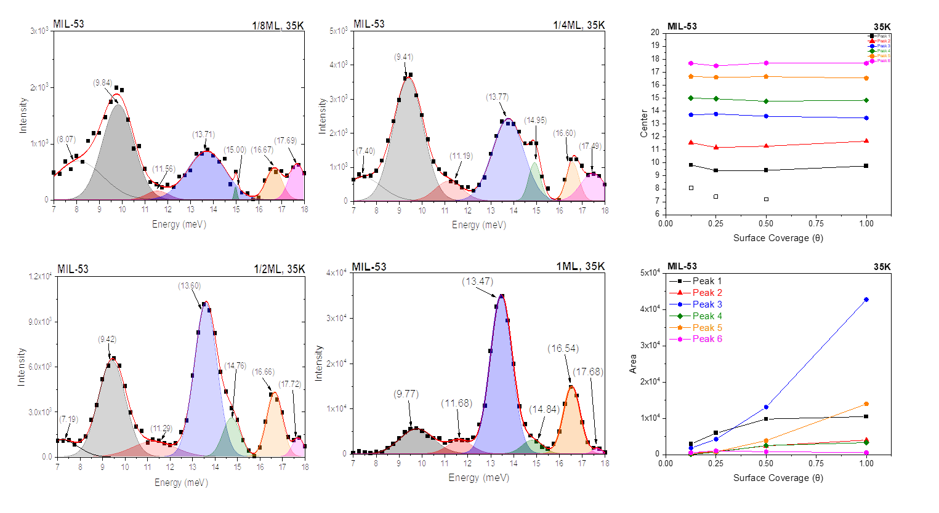
Figure S20. Inelastic neutron scattering spectrum of MIL-53 loaded with different amounts of para-hydrogen at 25 K

